Korean female tennis player angry after winning Olympic gold medal.

An Se-young hinted that she might retire from the South Korean badminton team after winning the 2024 Olympic gold medal, citing her poor handling of a knee injury.

An Se-young defeated Chinese player He Bingjiao 21-13, 21-16 in the women's singles final on the evening of August 4. She said she had to play with a tight knee and was tormented by pain.

The incident happened 10 months before An won the 19th Asian Games gold medal in China, then suffered a torn ligament in her right knee. The 2002-born player accused the team's coaching staff of initially taking her injury lightly.

"The injury was more serious than I thought and it will take a while to recover," An Se-young told Yonhap news agency. "It was taken lightly and I can't forget how disappointed I was."

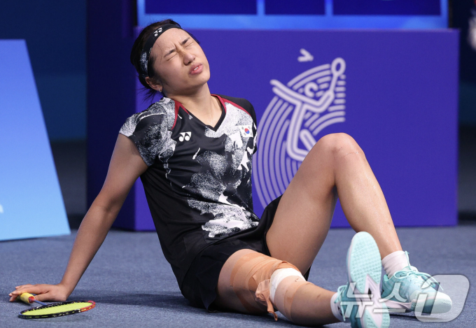

An Se-young competes in the 2024 Paris Olympics with her right knee wrapped in bandages.

An said she was misdiagnosed with an injury and continued to compete despite the pain. After the 19th Asian Games, the team said she would only need two to five weeks of rehabilitation. But when she was examined at the end of the year, the situation was much more serious, but surgery would cost her the chance to compete in the 2024 Olympics. In the end, An had to endure the pain to go to Paris.

When asked if she would retire from the national team, An Se-young said there was a time when she felt it was difficult to continue playing here. However, she still wanted to continue for the benefit of Korean badminton and for her own achievements. "I don't know what the federation will do," An said. "As long as I play badminton, I can endure any situation."

If not in the national team, the athlete will not have the opportunity to participate in the next major tournaments, especially the Olympics. But An said it would be heartless to not let the athlete participate in the Olympics, just because they are not in the national team.

The 22-year-old said she would have a careful discussion with the federation about her future in the national team, but stressed that she was very disappointed. An Se-young believes that Korean badminton can develop further, instead of just winning a gold medal at Paris 2024. She will also not attend the press conference on August 6, organized by the Korea Sports Association, which will be attended by only mixed doubles silver medalists Kim Won-ho and Jeong Na-eun.

An Se-young is the second Korean player to win the Olympic women's singles, after Bang Soo-hyun in 1996. An is also the world number one and won the 2023 world championship.

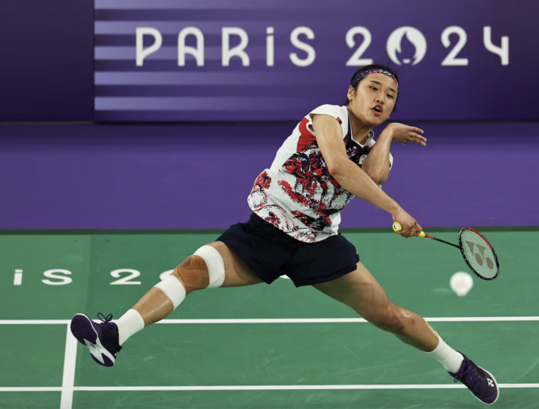

An Se-young competes in the women's singles badminton final at the 2024 Paris Olympics.

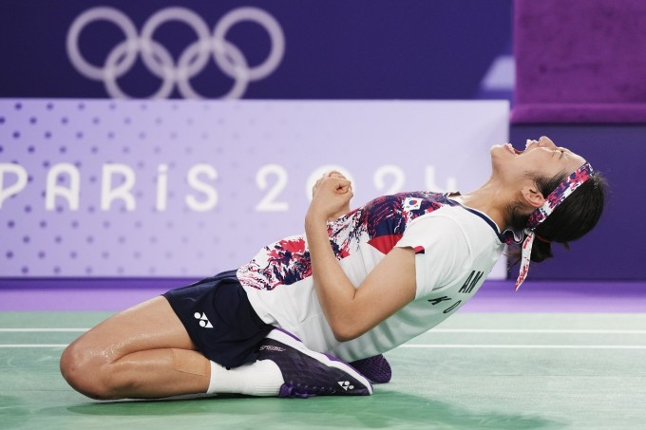

An Se-young shouts loudly to celebrate her victory over He Bingjiao in the women's singles badminton final of the 2024 Paris Olympics.

An Se-young's statement right after winning the Olympic gold medal was likened by the Korean newspaper Chosun to "a bomb". Meanwhile, President of the Korean Badminton Federation Kim Taek-gyu said that there would be discussions to resolve the conflict, but did not think it could be resolved immediately.

However, Mr. Kim affirmed that the Federation would never allow a situation where an athlete was forced to compete or practice when injured. The Federation's stance is to provide the best support within its capacity. The Federation used its own money to hire a personal coach for An Se-young, and then sent a doctor of oriental medicine to Paris to help the athlete.

Head coach of the Korean badminton team Kim Hak-gyun felt sad after what happened, although there was no conflict with the athlete. After the press conference of the women's singles final, he met An Se-young and received the answer "what needs to change will change". The two talked about the injury, but also pointed out the problems in the federation’s overall system.

Meanwhile, An Se-young’s father, An Jung-hyun, learned about the incident through the press. The former boxer thought his daughter and the federation would handle it well.

