Le Duc Phat and Nguyen Hai Dang missed the final of the Bangladesh badminton tournament.

Vietnam badminton officially ended its journey at the Bangladesh International Challenge 2024 after the defeat of Le Duc Phat and Nguyen Hai Dang.

The two leading badminton players in Vietnam - Le Duc Phat and Nguyen Hai Dang could not make it to the final match of the Bangladesh International Challenge 2024 after losing in the two semi-finals that took place yesterday evening (December 20) Hanoi time.

Nguyen Hai Dang had to accept a relatively regrettable defeat against the Chinese-Canadian player - Sheng Xiaodong with the same score of 18-21. This was a match in which Hai Dang played with great effort, fighting for each point with his opponent in both games, but Sheng was the one who was calmer at the key moments to get a valuable victory.

In the semi-final, Le Duc Phat lost to Viren Nettasinghe (Sri Lanka) with a big score of 7-21; 12-21. Duc Phat had a relatively weak match, he could not show much against a Nettasinghe who played with great form and determination. The Sri Lankan player is not a strange name to Vietnamese badminton fans, he had faced and lost to Hai Dang before, and was also the one competing with Duc Phat for a ticket to Paris to attend the Olympics.

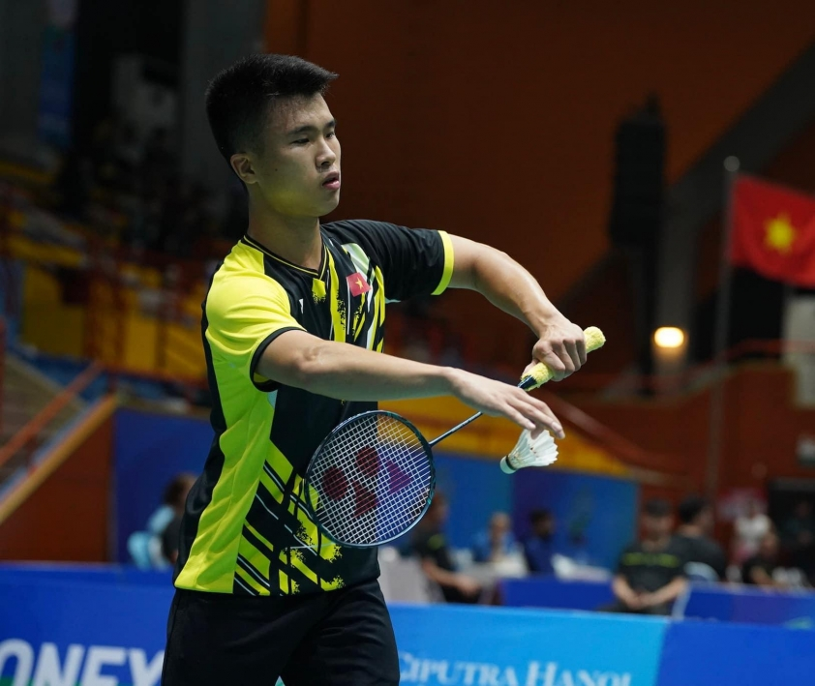

Nguyen Hai Dang and Le Duc Phat cannot meet in the final of Bangladesh International Challenge 2024 (Photo: Nguyen Hai Dang)

Duc Phat and Hai Dang are the No. 1 and No. 2 seeds at the Bangladesh International Challenge 2024, respectively, and the chance for both of them to participate in the all-Vietnam final is relatively high as this tournament does not gather strong players. However, this prospect could not become a reality when the two leading badminton players of Vietnam fell before the "gates of heaven".

Vietnam's badminton team has another representative competing in this year's Bangladesh International Challenge with Vu Thi Anh Thu, but the No. 2 female tennis player of Vietnam according to the BWF (Badminton World Federation) rankings stopped at the quarterfinals.

After finishing their journey in Bangladesh, Le Duc Phat and Nguyen Hai Dang will travel to the Nepal International Challenge from December 23 to December 26.

