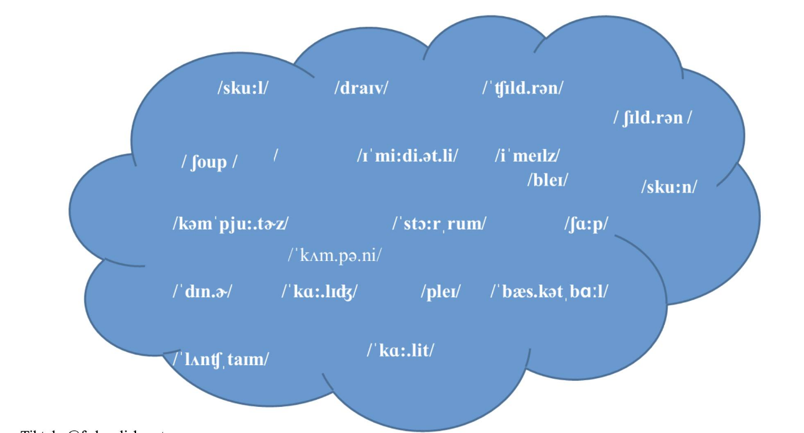



Drive -  /draɪv/

School - /skuːl/

Children - /ˈtʃɪl.drən/

Company -  /ˈkʌm.pə.ni/

Computers - /kəmˈpjuː.t̬ɚz/

Sharp -  /ʃɑːp/

Dinner -  /ˈdɪn.ɚ/

Play - /pleɪ/

Basketball -  /ˈbæs.kət.bɑːl/

Lunchtime - /ˈlʌntʃ.taɪm/

College - /ˈkɑː.lɪdʒ/