PNETLab User Management System
- Structure of {Họ và tên}
PNETLab uses the Mysql database with root account: root/pnetlab. Database name: pnetlab_db
There are 3 tables in User management system: user_role, users, user_permission
  - user_roles Table
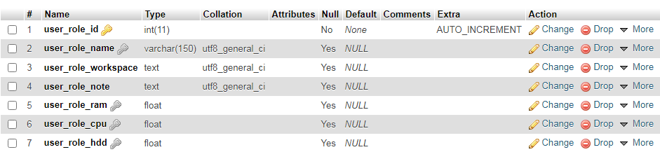
- user_role_id: ID of role
- user_role_name: name of role
- user_role_workspace: workspace of role, if is set user in this role will be limit in this workspace only.
- user_role_note: Role description
- user_role_ram: Ram Limit (%)
- user_role_cpu: CPU Limit (%)
- user_role_hdd: HDD Limit (MB)

  - user_permission table
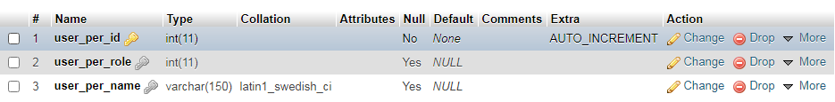
Define permissions for each role
- user_per_role: ID of role in user_roles table
- user_per_name: Name of permission:
  - DELETE_FOLDER: Delete a folder in user’s workspace
  - ADD_FOLDER: Add a folder in user’s workspace
  - EDIT_FOLDER: Edit a folder in user’s workspace
  - DELETE_LAB: Delete a Lab in user’s workspace
  - ADD_LAB: Add a new Lab in user’s workspace
  - IMPORT_LAB: Import a new Lab in user’s workspace
  - EXPORT_LAB: Export a Lab in user’s workspace
  - MOVE_LAB: Move a Lab in user’s workspace
  - CLONE_LAB: Clone a Lab in user’s workspace

  - Users table
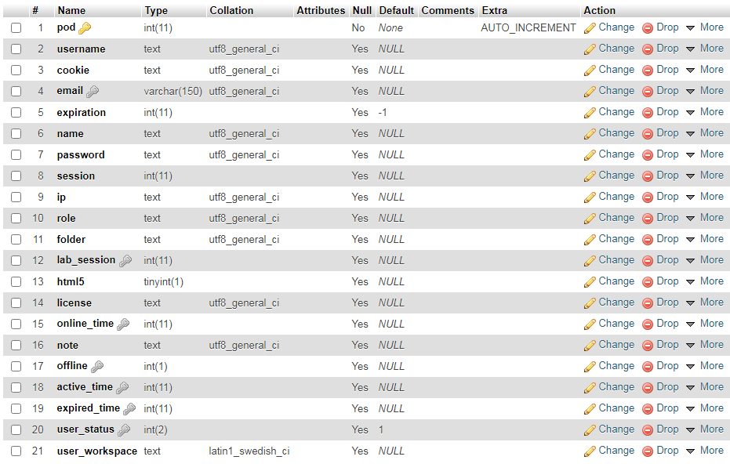
- pod: User identify, this is a number unique for each user.
- username: username using for login
- email: email of user
- password: Password of user. Password field is encrypted by sha256
- note: User description
- offline: The type of account, fill 1 for offline account.
- active_time: Time point user account effective. This field in unix timestamp seconds. Refer: https://www.unixtimestamp.com/index.php
- expired_time: Time point user account is inactive. This field in unix timestamp seconds
- role: ID of a role in role table
- user_status: status of Account: 1: active, 0: unactive
- user_workspace: workspace of user. If it is set, user cans only working on this folder. (final workspace = workspace of role + workspace of user)

- Manage Account by Command line
- To execute a mysql command in PNETLab {ten} the below format:
mysql -uroot -ppnetlab -e “[mysql command]”
- Refer 2.1, 2.2 and 2.3 to get mysql commands
- Run command in console of PNETLab

  - Add new user
- Add new role (user_role_id = 2)
INSERT INTO user_roles (user_role_id, user_role_name, user_role_workspace) VALUES ('2', 'user2', '/Lab Share');
- Add Permission for Role
INSERT INTO user_permission (user_per_role, user_per_name) VALUES ('2', 'ADD_FOLDER');
INSERT INTO user_permission (user_per_role, user_per_name) VALUES ('2', 'DELETE_FOLDER');
…..
- Add new user
INSERT INTO users (pod, username, password, role, note, offline, active_time, expired_time, user_status, user_workspace) VALUES ('4', 'user2', SHA2('password', 256), '2', 'Note', '1', '1603617060', '1603962660', '1', '/New Folder');

  - Edit user
UPDATE users SET user_status = '0' WHERE pod = 4;

  - Delete user
DELETE FROM users WHERE pod = 4;

