**Chapter 2**

**First steps**

### 2.1.5 Installing Node

Once the installation is complete, open terminal and type

### 2.1.6 Installing Sails

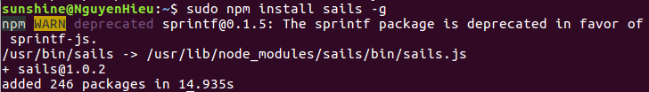We use the Node package manager (**npm**) to install the Sails framework

The **–g** flag means that npm will install Sails **globally**, allowing you to **generate Sails projects from anywhere in your file system**.

**this sails version is 1.0.2 ( maybe not compatible in Chapter 6)**

And when you need to uninstall **sails**, type

and check

sails is uninstalled completely.

### 2.2.2 Creating our first Sails application

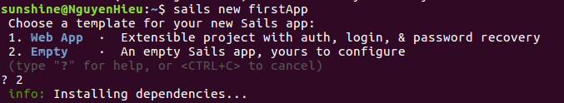Choose **2** to create empty firstApp

Next let’s install **the-ultimate-question** module into the ***firstApp*** project by typing:

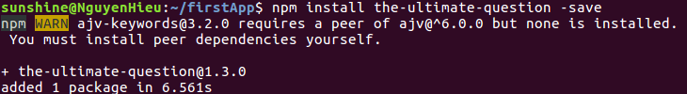

to handle this WARN, you must install **npm** **ajv@^6.0.0** by typing:

when you had **npm ajv@^6.0.0**, this is the result when you install **npm the-ultimate-question**

**Now let’s generate a controller by typing:**

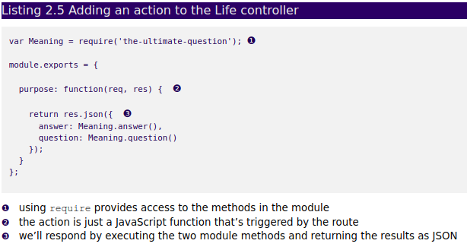In Sublime, open **firstApp/api/controllers/LifeController.js** and add the following code in listing 2.5.

### 2.2.4 Starting the Sails server

If you navigate your browser to **localhost:1337/life/purpose**, unfortunately it’s not working.