|  |  |
| --- | --- |
|  | **MINISTRY OF EDUCATION AND TRAINING** |

**FPT UNIVERSITY**

|  |  |
| --- | --- |
| Project Document | |
| ***Exception and Error Log Recording***  ***and Management Application*** | |
|  | |
| **Hà Group** | |
| **Group members** | Đào Ngọc Tiến (SE63513)  Lê Bùi Hoàng Minh (SE130128)  Hồ Thanh Tùng (SE130344)  Phạm Thị Ngọc Hà (SE130460) |
| **Supervisor** | Mr. Ngô Đăng Hà An |
| **Ext. Supervisor** | N/A |
| **Project code** | ELRM |

– Hochiminh City, ***January 13, 2020*** –

**Table of Content**

**1. User Requirement Specification** 6

**1.1. Administrator Requirement** 6

**1.2. Manager Requirement** 6

**1.3. Employee Requirement** 7

**2. System Requirement Specification** 7

**2.1. External Interface Requirement** 7

2.1.1. User Interface 7

2.1.2. Hardware Interface: 11

2.1.3. Software Interface 12

2.1.4. Communication Protocol 12

**2.2. System Overview Use Case** 14

**3. Software System Attribute** 15

**3.1. Usability** 15

3.1.1. Interface 15

3.1.2. Administrator 15

3.1.3. Manager 15

3.1.4. Employee 15

**3.2. Reliability** 15

**3.3. Availability** 15

**3.4. Security** 16

**3.5. Maintainability** 16

**3.6. Portability** 16

**3.7. Performance** 16

3.7.1. Front end 16

3.7.2. Backend 17

**4. Database Diagram** 18

**4.1. Database Entities Relationship Diagram** 18

**4.2. Data Dictionary** 19

**List of Tables**

Table 1. Data Dictionary……………………..………………………………………………19

**List of Figures**

Figure 1. Login page…………………………………………………………………………..8

Figure 2a. Dashboard………………………………………………………………………….8

Figure 2b. Dashboard………………………………………………………………………….9

Figure 3a. User’s Profile page…………………………………………………………………9

Figure 3b. User’s Profile page………………………………………………………………..10

Figure 4a. Server page………………………………………………………………………..10

Figure 4b. Server page………………………………………………………………………..11

Figure 4c. Server page………………………………………………………………………..11

Figure 5. Samples of API format……………………………………………………………..12

Figure 6. Samples of API endpoints………………………………………………………….12

Figure 7. Sample of API...……………………………………………………………………13

Figure 8. Prototype of API ..………………………………………………………………….13

Figure 9. System overview use case………….………………………………………………14

Figure 10. Entities Relationship Diagram……………………………………………………18

**Report No. 3: Software Requirement Specification**

# **1. User Requirement Specification**

## **1.1.** **Administrator Requirement**

Administrators (admin) are people who manage the whole exception log report system.

Admin can use following functions:

* Login
* Register
* Reset forgotten password
* Change password
* View user’s profile
* Edit user’s profile (including edit information and change avatar)
* Logout
* Create Server
* Edit server information
* View server information
* Disable server
* Create Application
* Edit application information
* View application information
* Disable application
* Create Application instance
* Edit application instance information
* View application instance information
* Disable application instance
* View log information
* Edit log fixing status
* Create manager
* Edit manager profile
* View manager profile
* View employee profile
* Edit employee profile

## **1.2. Manager Requirement**

Managers are people who have authorization to modify applications’or application instances’ information. Managers may be Project Managers, Product Owners,…

Managers can use following functions:

* Login
* Register
* Reset forgotten password
* Change password
* View user’s profile
* Edit user’s profile (including edit information and change avatar)
* Logout
* View log information
* Edit log fixing status
* Create Application
* Edit application information
* View application information
* Disable application
* Create Application instance
* Edit application instance information
* View application instance information
* Disable application instance
* Create Employee
* View employee profile
* Edit employee profile

## **1.3. Employee Requirement**

Employees are people who will maintain or fix bugs from applications or application instances base on the exception log report. Employees may be deverlopers, testers,…

Employees can use following functions:

* Login
* Register
* Reset forgotten password
* Change password
* View user’s profile
* Edit user’s profile (including edit information and change avatar)
* Logout
* View log information
* Edit log fixing status

# **2. System Requirement Specification**

## **2.1. External Interface Requirement**

### 2.1.1. User Interface

Login page (demo layout):

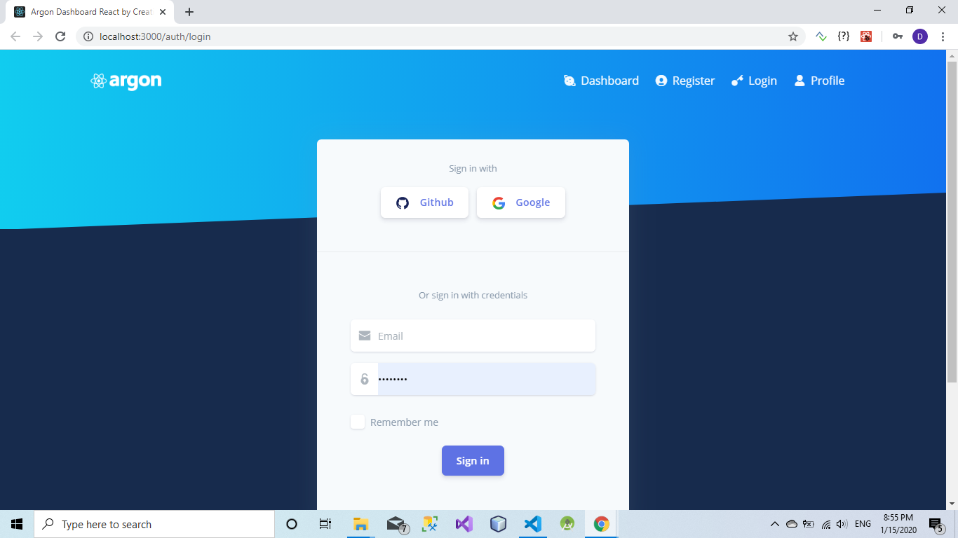

*Figure 1. Login page*

Dashboard (demo layout):

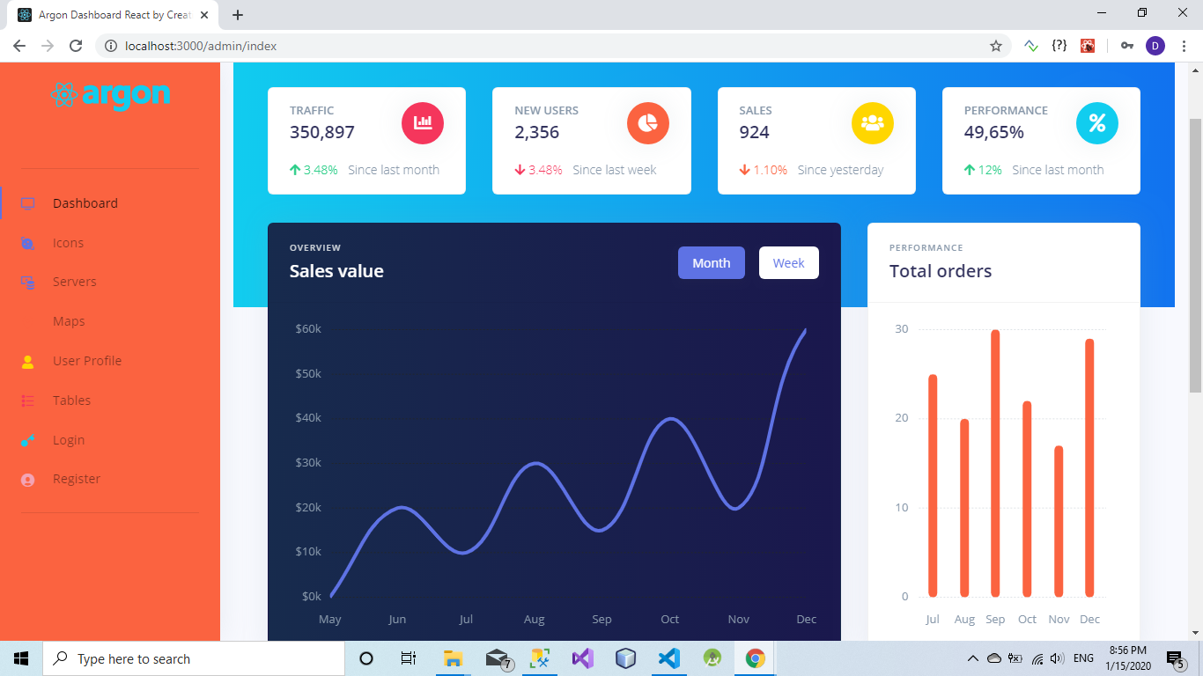

*Figure 2a. Dashboard*

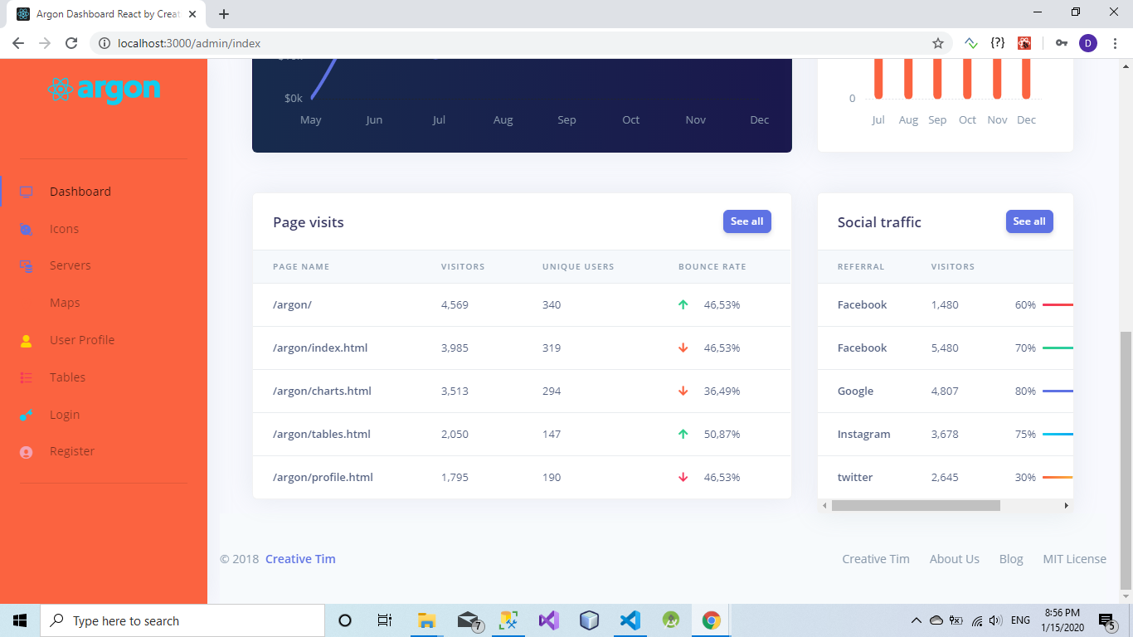

*Figure 2b. Dashboard*

User’s Profile page (demo layout):

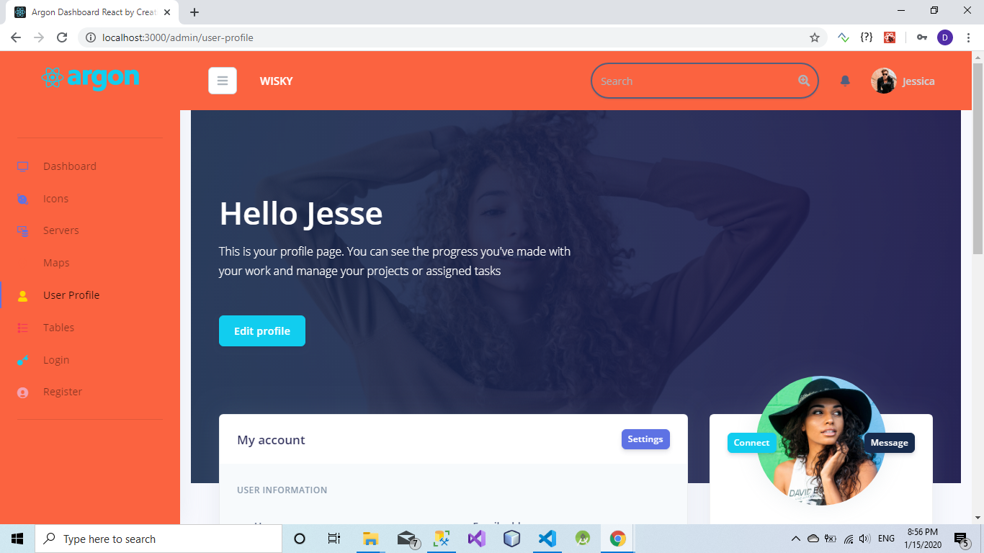

*Figure 3a. User’s Profile page*

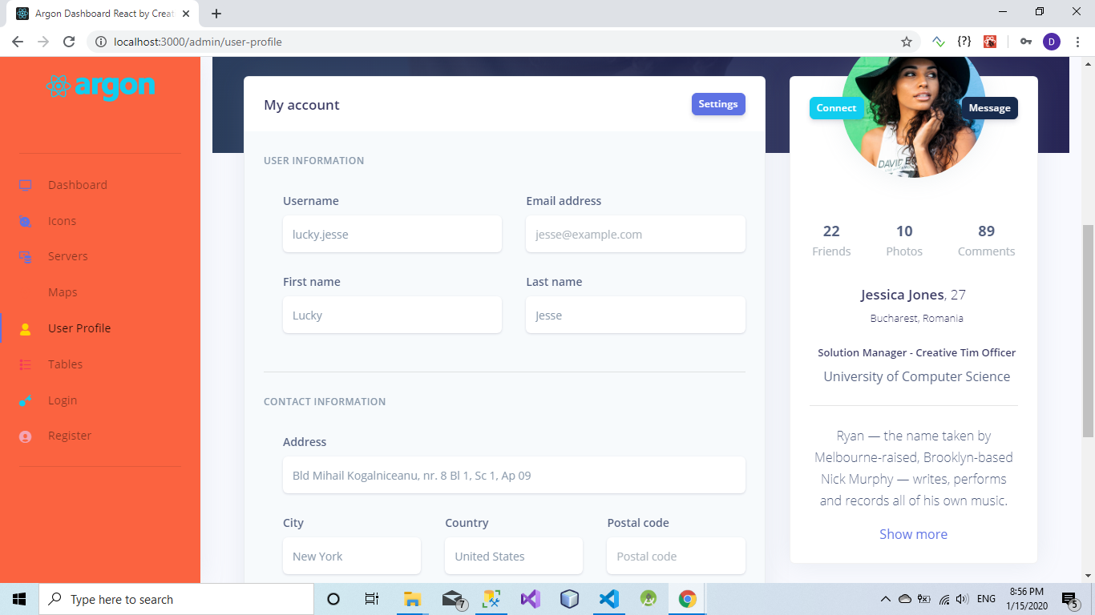

*Figure 3b. User’s Profile page*

Main components (Server, Application, Application Intance, Log) (demo layout):

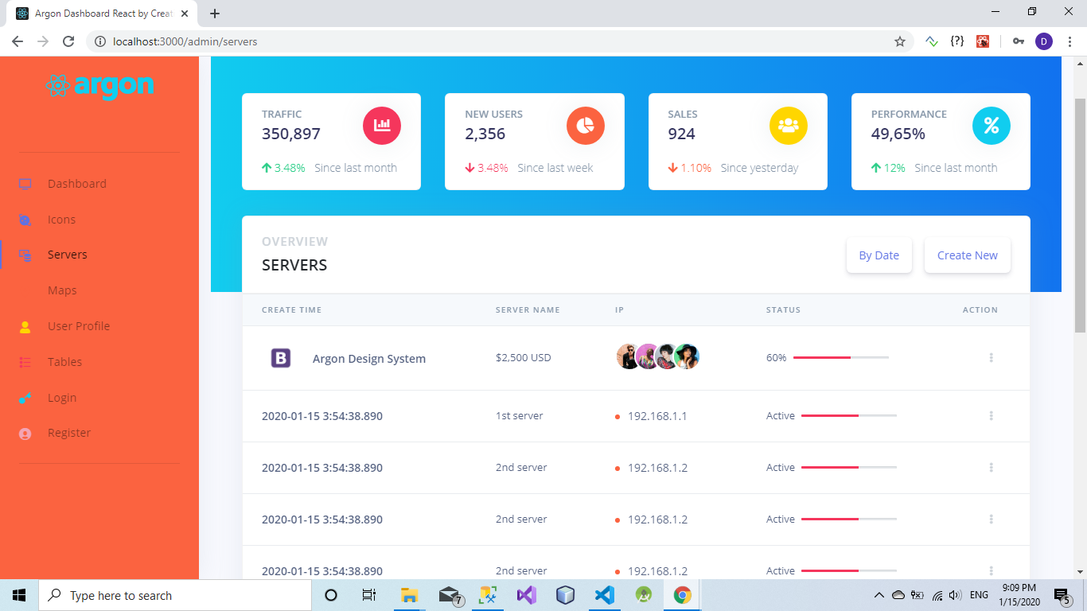

*Figure 4a. Server page*

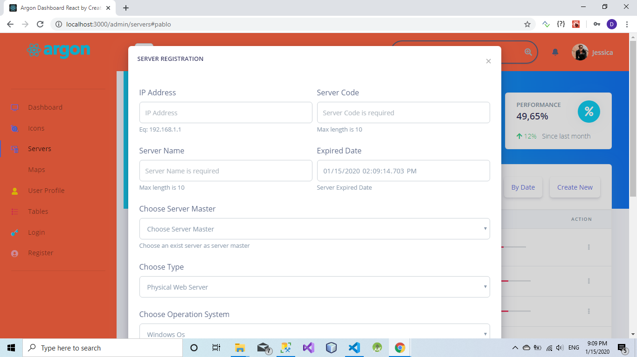

*Figure 4b. Server page*

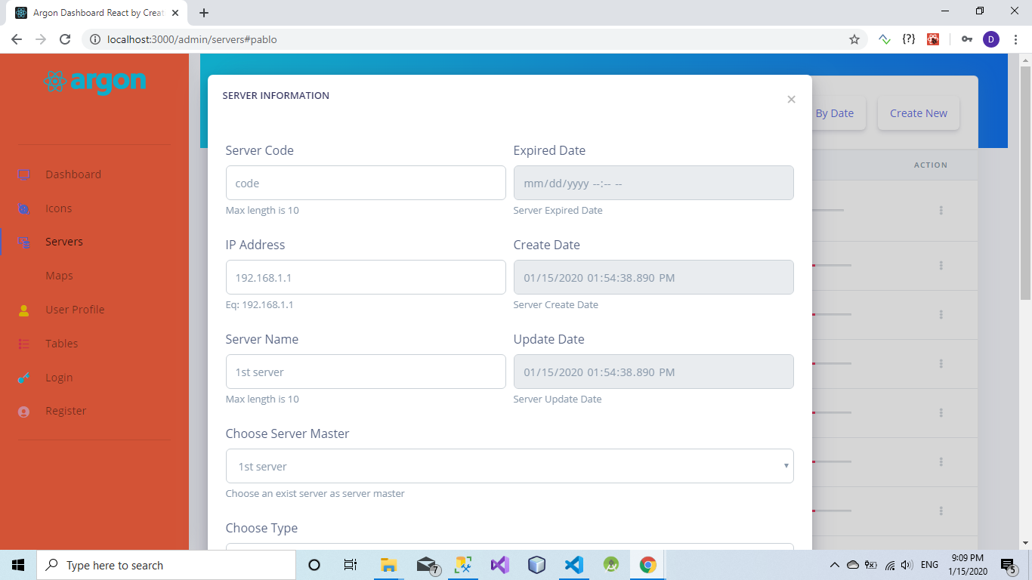

*Figure 4c. Server page*

### 2.1.2. Hardware Interface:

* Enterprise Server Install: Minimum 4GB available disk space, 2GB RAM (4GB recommended).
* Minimum 1.4 GHz Processor Speed (2.0 GHz or faster recommended).
* Enterprise Client Install: minimum 1GB available disk space.
* Smartphone supports Android Operating System (Android 4.15 and above).
* PC or Mac which supports Browsers (Chromium required):
  + Chrome
  + Firefox
  + Opera
  + Microsoft Edge Insider (from 2019 and above)

### 2.1.3. Software Interface

Smartphone with Android Operation System from version 4.1.5 or above.

PC or Mac which supports Browser.

### 2.1.4. Communication Protocol

Restful API (follow the format of Shopify API):

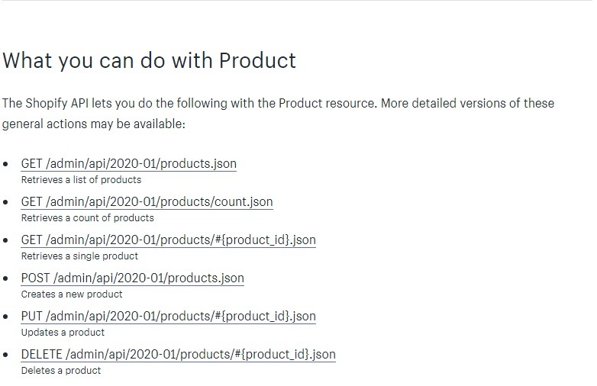

*Figure 5. Samples of API format*

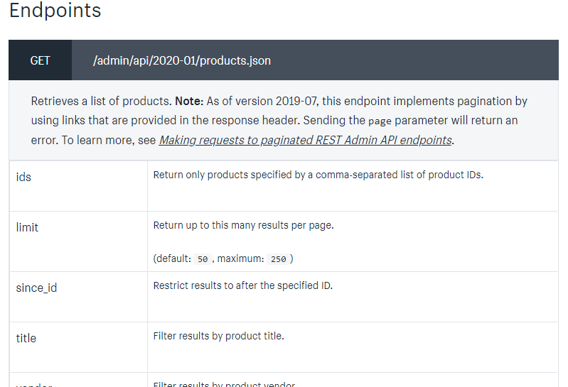

*Figure 6. Sample of API endpoints*

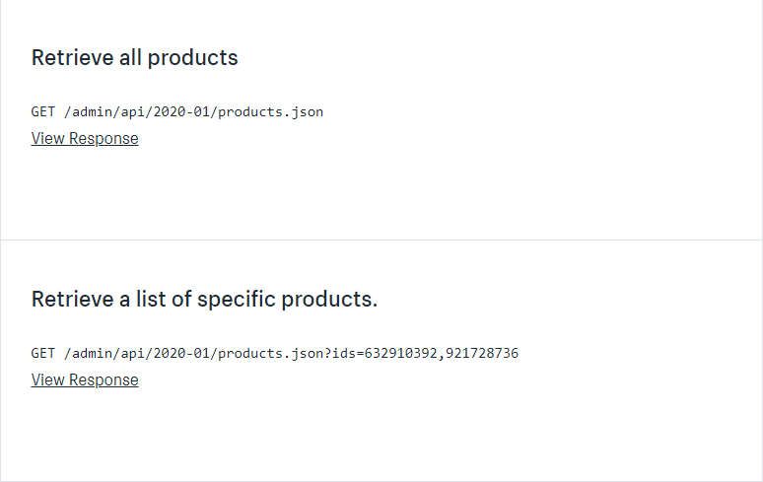

*Figure 7. Sample of API*

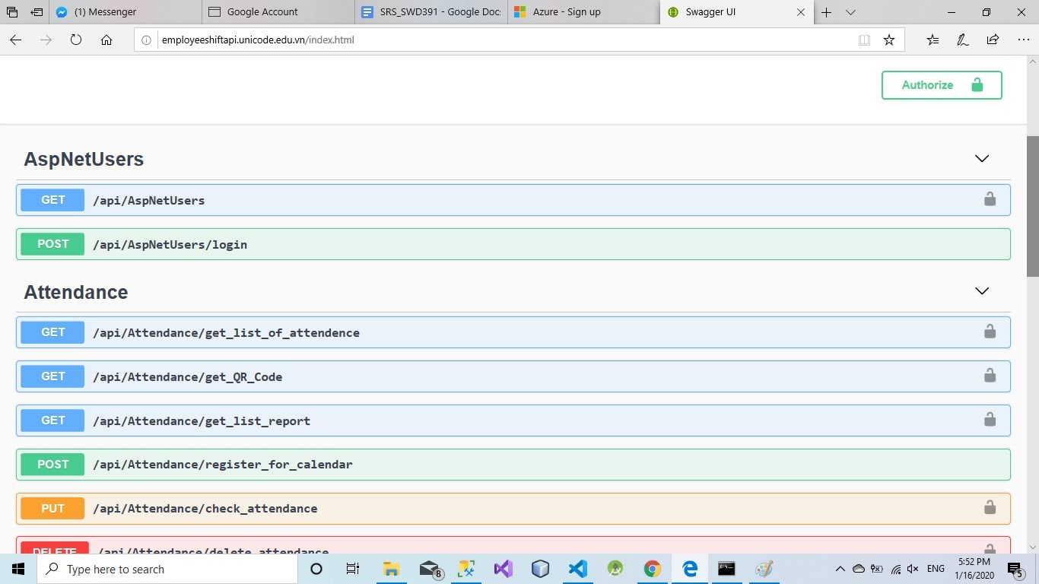

*Figure 8. Prototype of API*

## **2.2. System Overview Use Case**

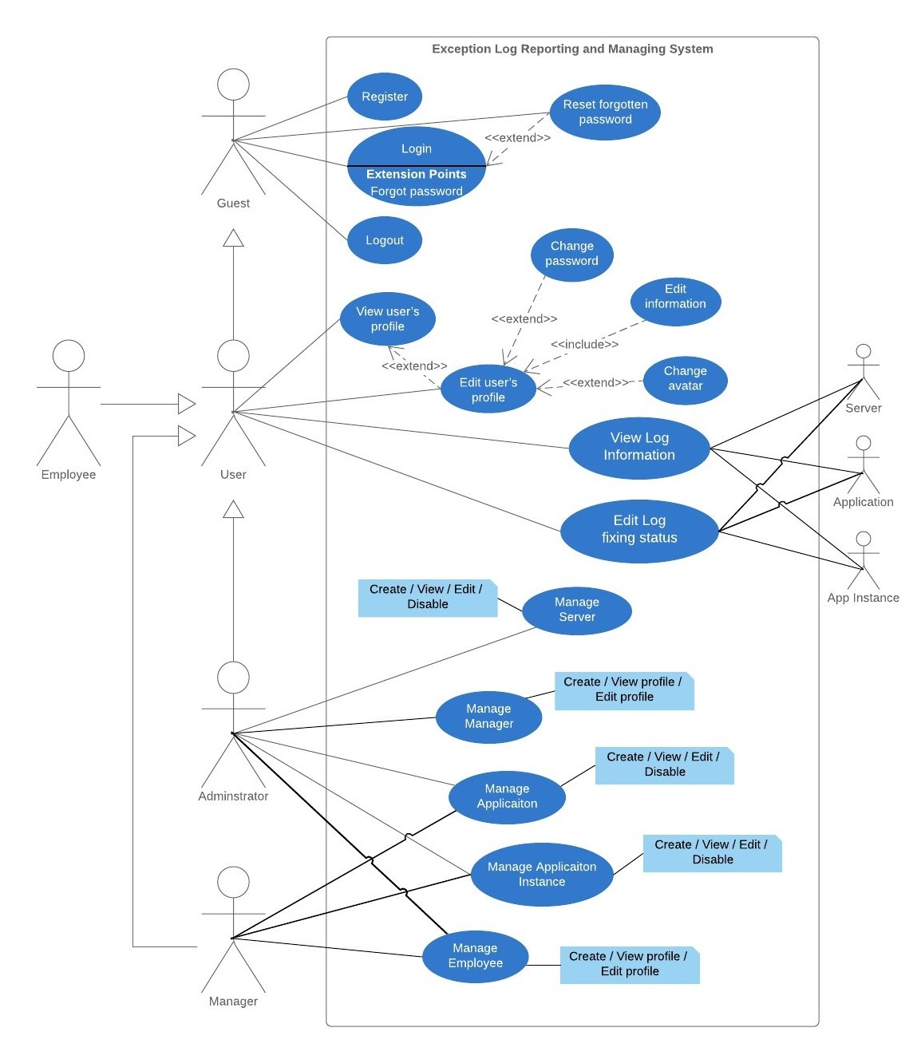

*Figure 9. System overview use case*

# **3.** **Software System Attribute**

## **3.1. Usability**

### 3.1.1. Interface

* *Login screen* is easily to use with common feature: login by account, by Facebook, by Gmail.
* *Dashboard*: statistics and report on error, exception, visitor, server, application daily is intuitive and vivid, easy to understand.
* *Table and form component*: Eye-catching, easy to sympathize with bright and intuitive colors
* *Profile*: display full information with personalized photos and wallpapers
* *Search engine*: search item in main component with fast speed in ideal condition of internet and fluent protocol pipeline of client-server-client relationship.

### 3.1.2. Administrator (Admin)

* Admin can learn to manage main component (server, application, application instance, log, user) in short time (measure about under 10 minutes).
* Admin can understand the structure of company’s software and hardware resource with information on main component.

### 3.1.3. Manager

* Manager can focus on managing application, application instance, log status, employee without knowledge about company’s resources in hardware and software.
* Manager can control projects in charge easily with power in assigned.
* Only manager can active / deactive log status.

### 3.1.4. Employee

* Employee can only edit profile and see log, get incoming log appear notification so employees can focus on log report.
* Employee can view info on all main components to get to understand the right assignments.

## **3.2. Reliability**

* System for internal usage only.
* Users’ information, profile, company’s structure, api, application, application instance, server will not be public.

## **3.3. Availability**

* Connection fail / error
* Server lost / Cannot connected
* Invalid input
* Invalid roles
* Front-end / UI missing layout
* Push notification not working
* Browsers policies/socket fail
* Authentication failed
* Client/server connection fail

## **3.4. Security**

* Only specific role can have specific right to use specific function:
* Administrator: full right to create, update, edit, all components except deactive / active log status.
* Manager: except server component, have the full right.
* Employee: can only view all components, edit profile.
* User can not enter unassigned area and use other’s specific power.
* Only logged user can enter resource from record log system.
* Authentication in client and server side is secured and guaranteed.
* Server can defense against unauthorized intrusion, other protocol attack.
* Company’s hardware and software resources are protected in secret and secured.

## **3.5. Maintainability**

System record own error, defect, exception.

* Source code have full information and easy to understand comments.
* System will be deployed in git brand: develop, test, deploy, production to prevent DDOS and unreliable Internet connection.
* System operating team has 3 sub teams: developing and testing team, managing team, operating team to maintain system under crisis situations.
* System has document, SRS, SDD (both in book and e-book).

## **3.6. Portability**

Web version is on React JS, required low version browser to run.

* Mobile version is on Android, cover major mobile devices and run on low version of Android.
* API is on C#, Restful API, request and response in JSON so API can accept other programing or any request on Restful API standard.
* Server is on SQL Server, when data become larger, considering change to Cassandra.
* System currently accepts all applications on C# programing language.

## **3.7. Performance**

### 3.7.1. Front end

* Expect low response time in reload, loading: < 2 second
* Expect get data, forward data, edit data information: ≤ 5 second.
* Expect auto reload main page / dashboard: every 10 minutes.
* Expect log recording push notification: ≤ 3 minutes since a log is recorded.

### 3.7.2. Backend

* Expect server response time: maximum 5 seconds.
* Expect API response time: from 1 to 10 seconds.

**4. Database Diagram**

## **4.1. Database Entities Relationship Diagram**

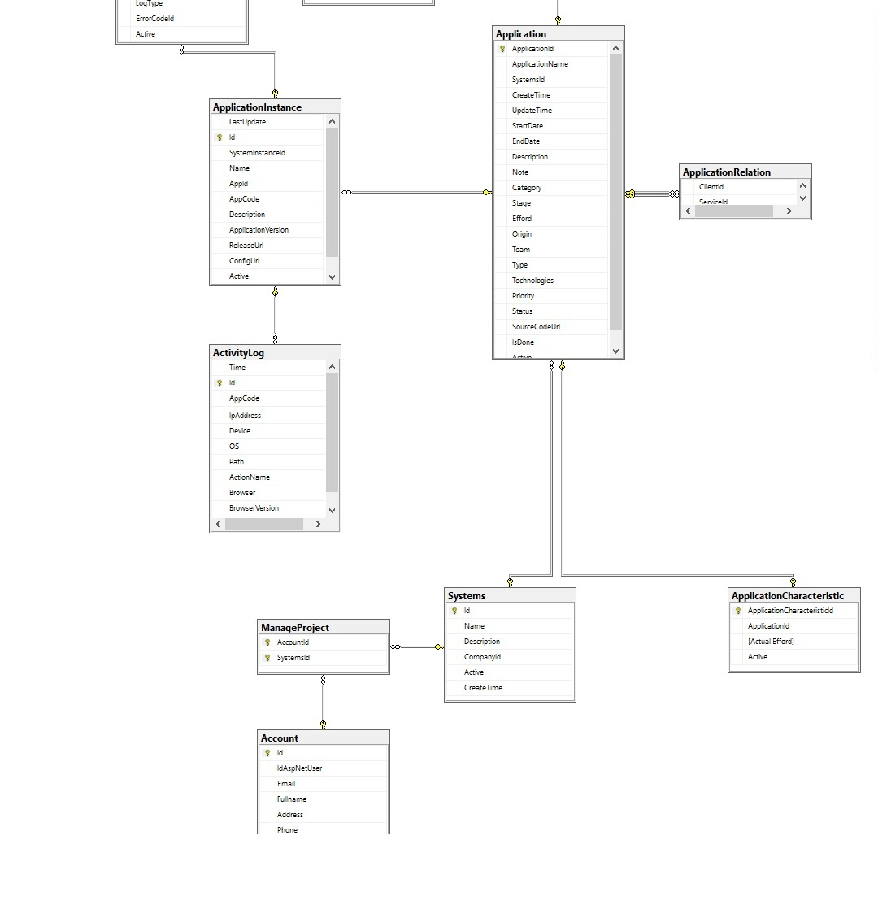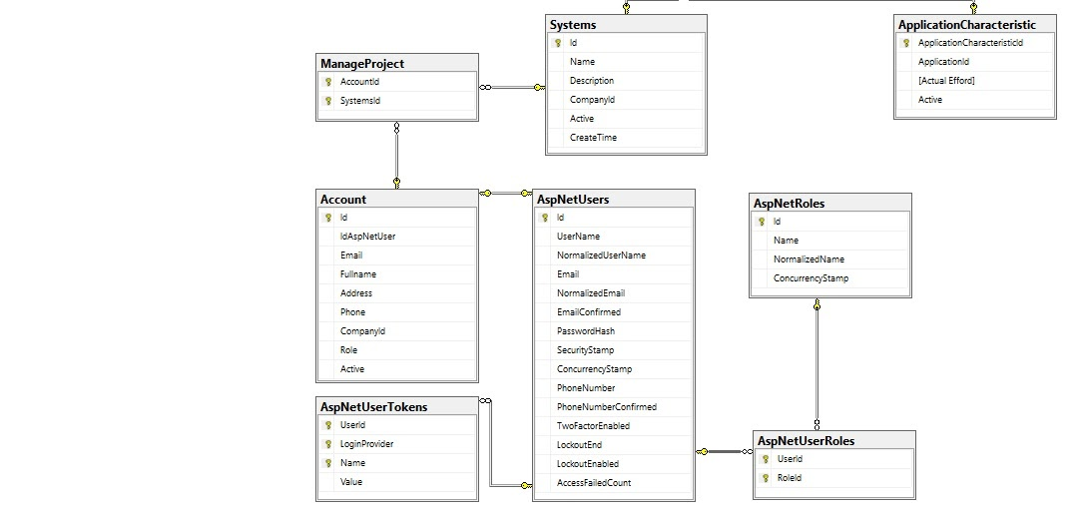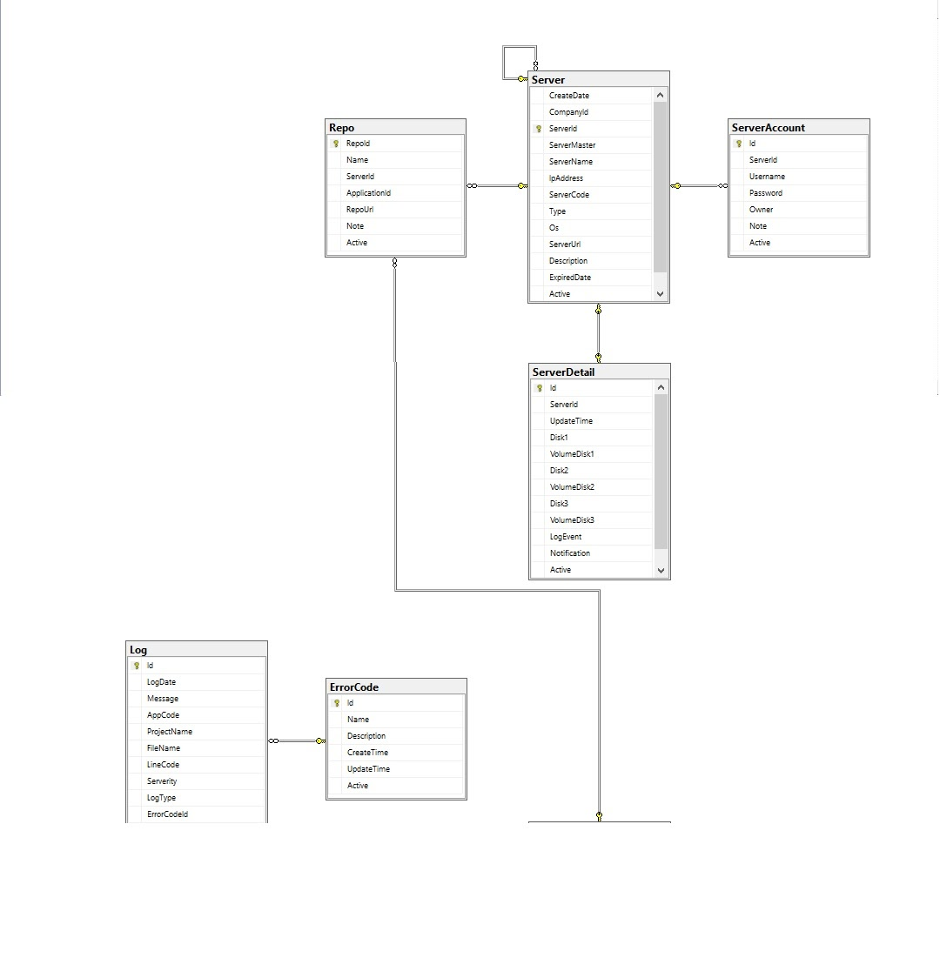

Figure 10. Entities Relationship Diagram

## **4.2. Data Dictionary**

|  |  |  |
| --- | --- | --- |
| ***Entity Data Dictionary: Describe content of all entities*** | | |
| ***No.*** | ***Entity Name*** | ***Description*** |
| 1 | Server | Server general detail |
| 2 | ServerDetail | Server specific detail |
| 3 | ServerAccount | Account and password to log into server |
| 4 | Repo | Repository held source code of application |
| 5 | Application | Application general detail |
| 6 | ApplicationInstance | Application instance detail |
| 7 | ApplicationRelation | Relation between application (server is one kind of application, product is one kind of application, so product is client and server is service) |
| 8 | Log | Log record general detail |
| 9 | ErrorCode | Detail about error / defect / error in log |
| 10 | ActivityLog | (future enhancement) Record all activity of application’s operating time |
| 11 | ApplicationCharacteristic | Effort values on application’s lifetime |
| 12 | System | System where application is deployed |
| 13 | ManageProject | Determine which application in charge of which user |
| 14 | Account | General detail of account |
| 15 | AspNetUsers | Specific detail of account |
| 16 | AspNetRoles | Role of account |
| 17 | AspNetUserTokens | Authentication, reset password token |
| 18 | AspNetUserRoles | Connect user and their role, 1 user can have many roles |

Table 1. Data Dictionary