1) Tag the current game server
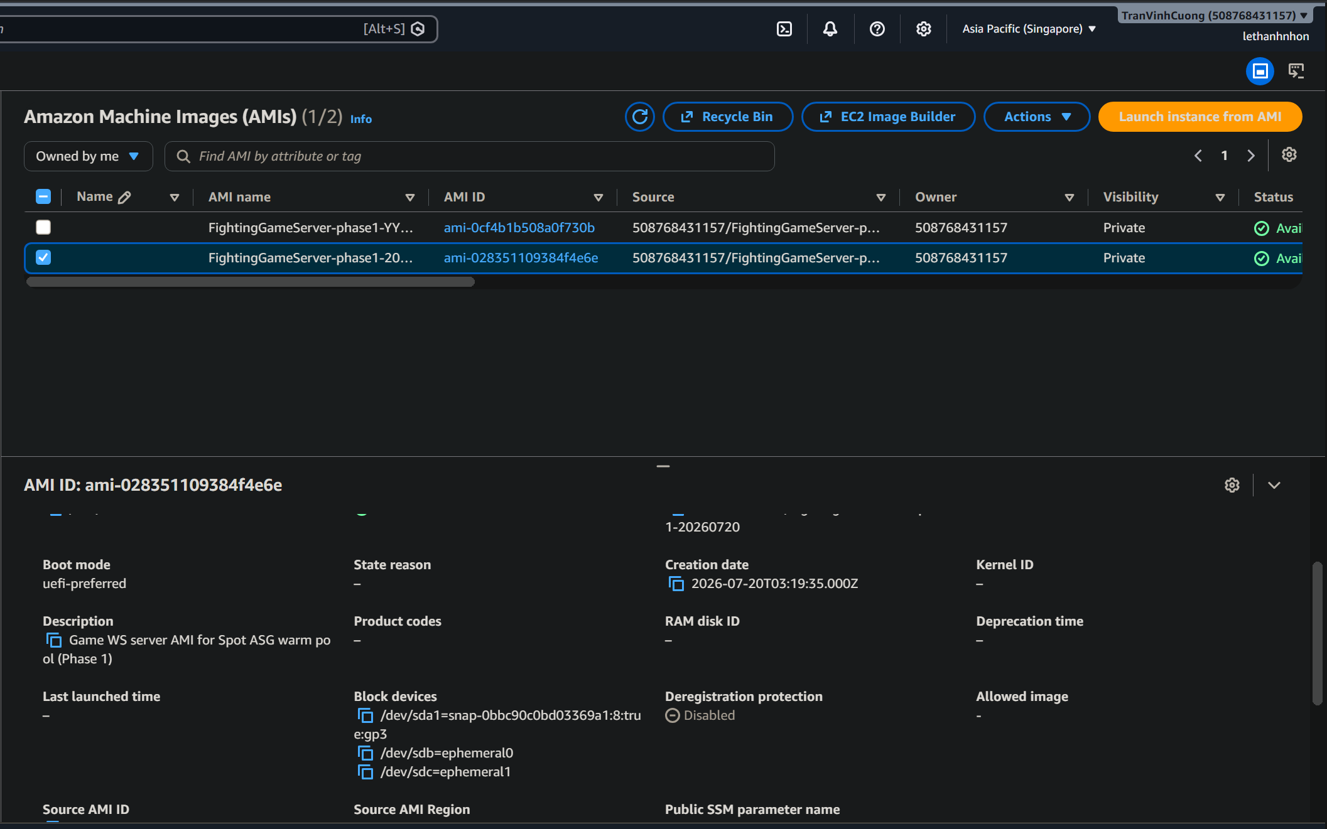
2) Bake AMI from that instance (if AMI not ready)
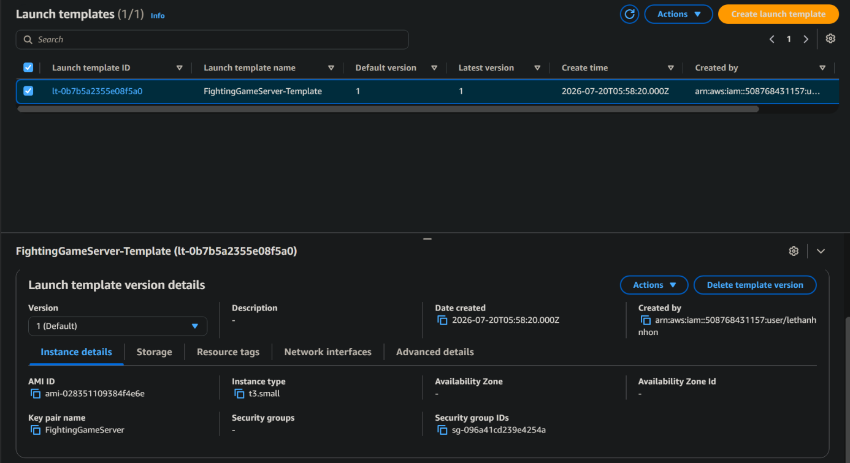
3) Create launch template (Spot)
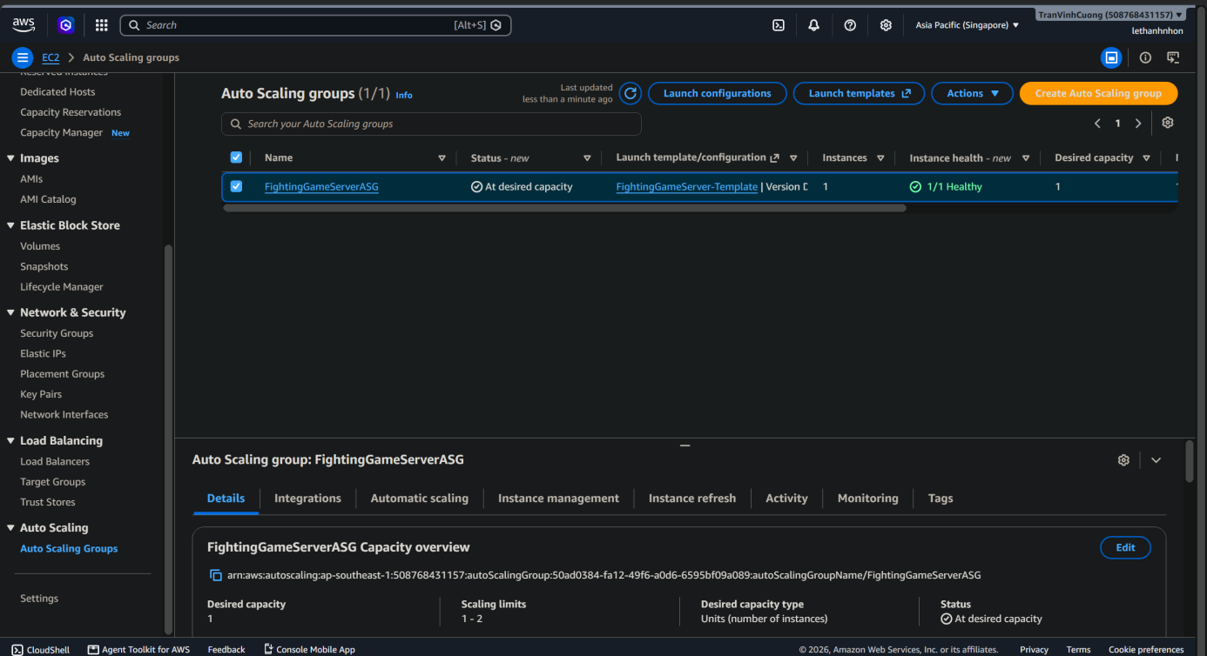
4) Create ASG warm pool
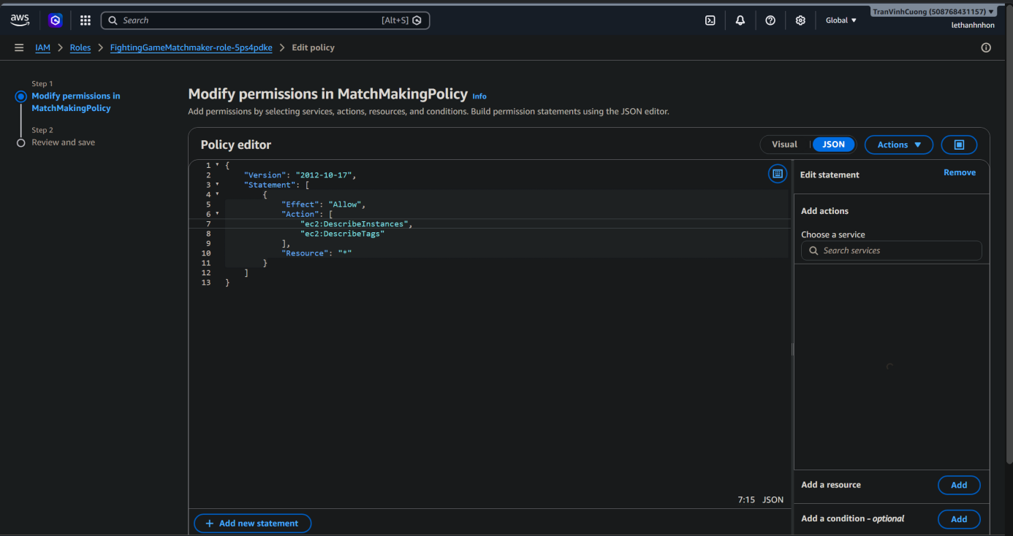
5) IAM for MatchMaker
6)Create the S3 bucket and configure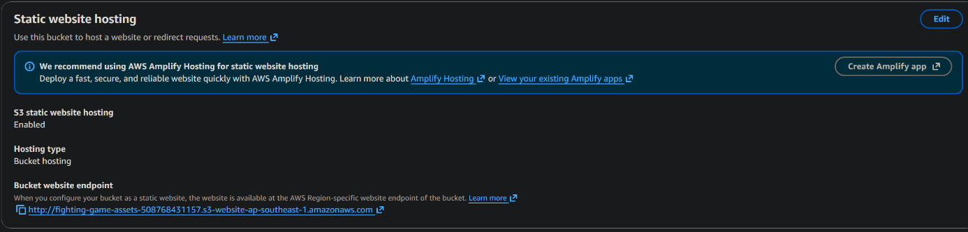
Static website hosting
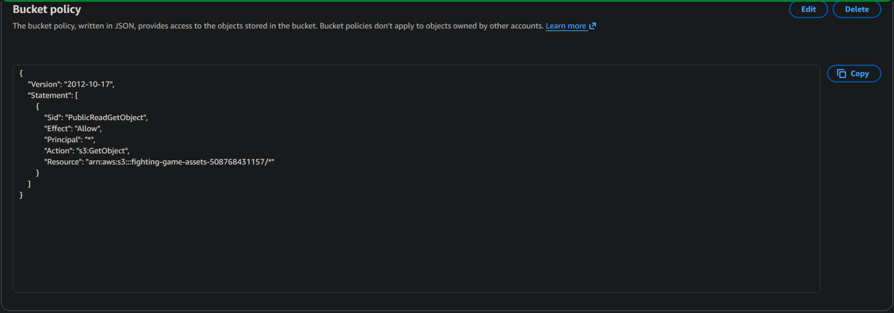
Bucket policy (public read for demo)
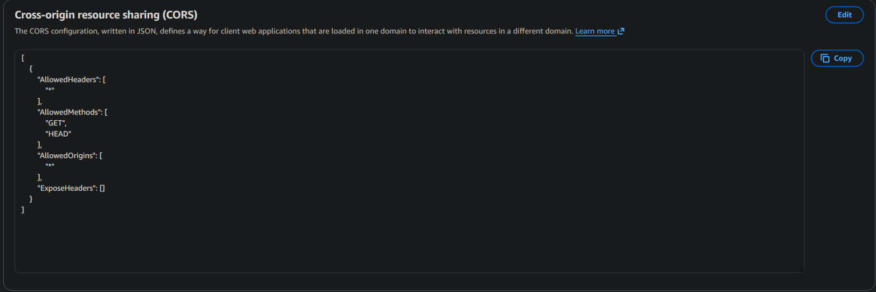
CORS (if login/API calls fail from browser)

7)GitHub OIDC → AWS (no long-lived access keys)
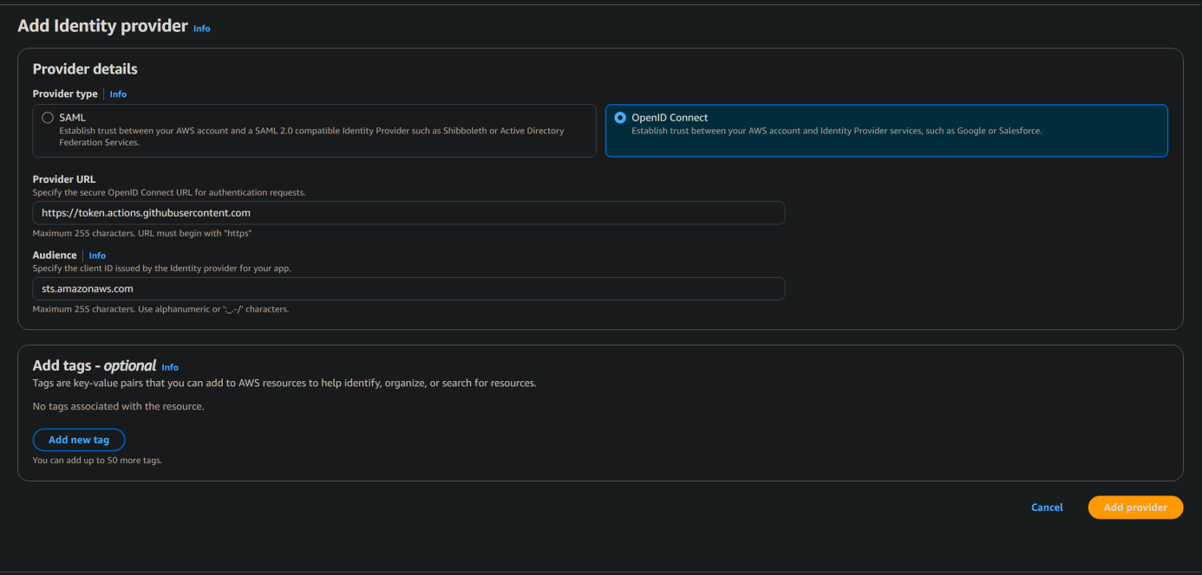
Add GitHub as OIDC provide
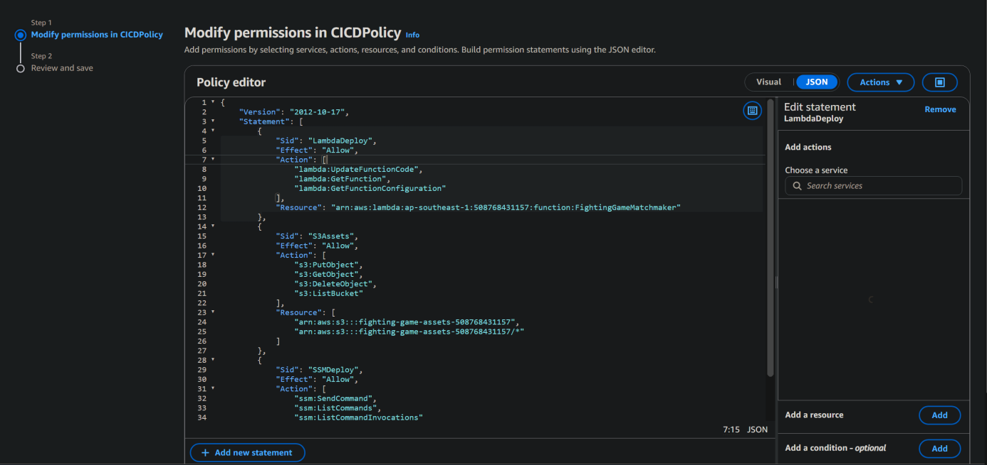
Attach permissions policy to role
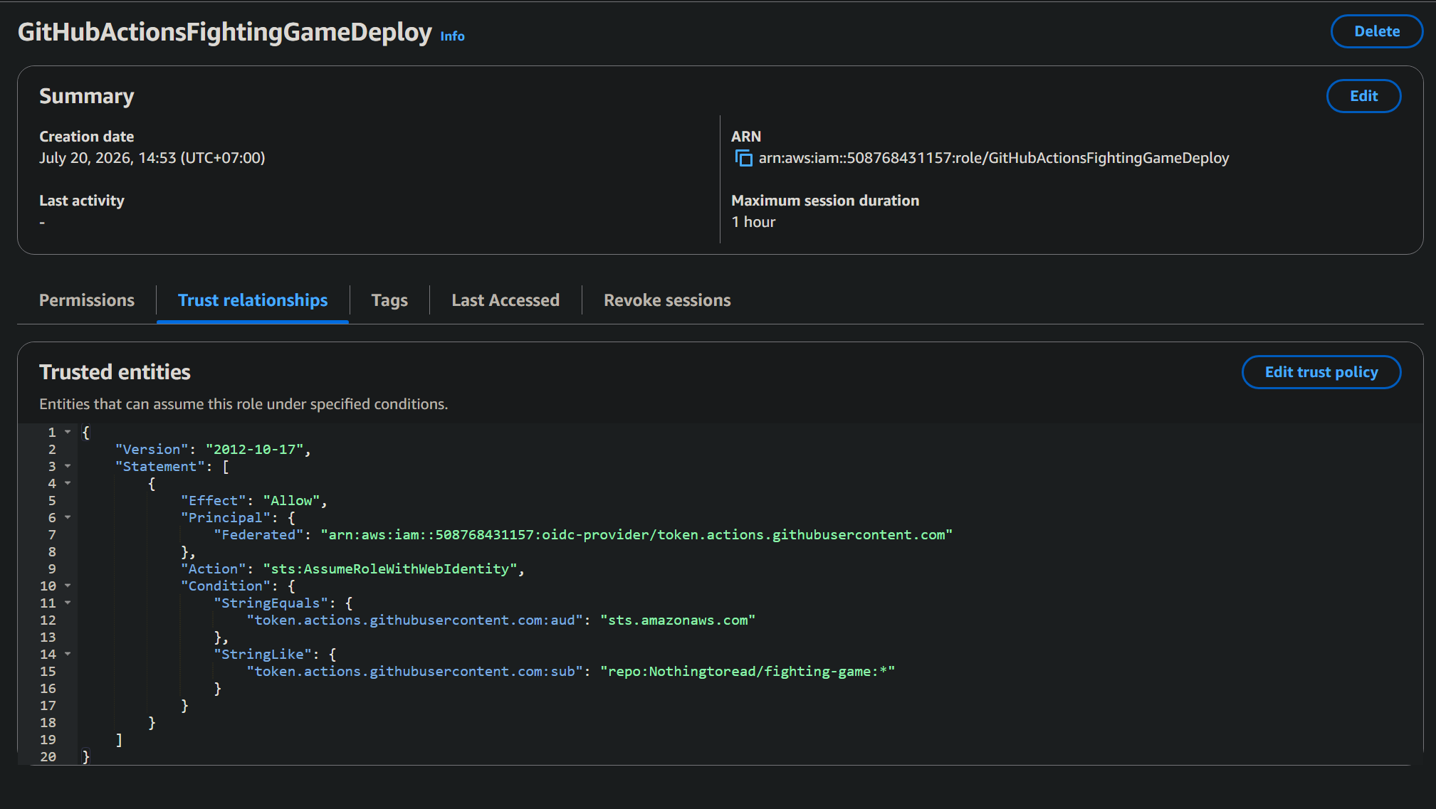
Role Trust policy
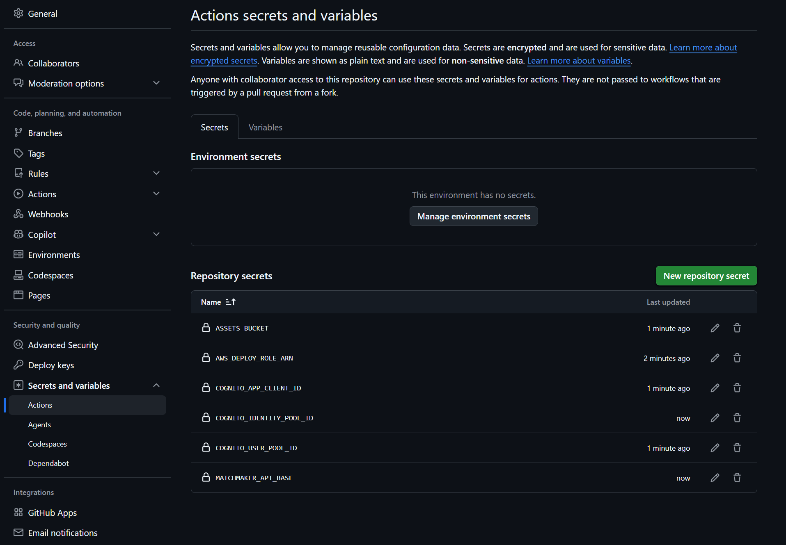
Repo secret
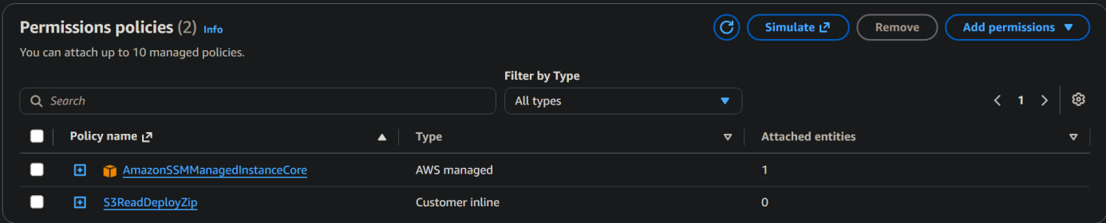
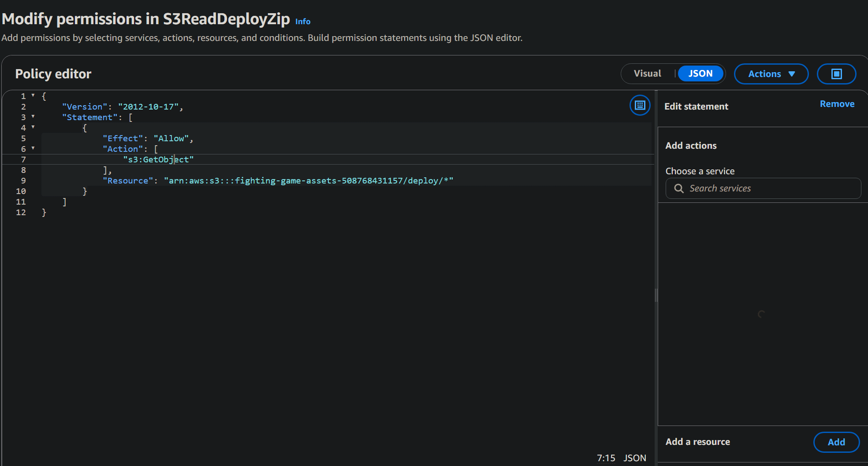
Roles for FightingGameServerInstanceRole
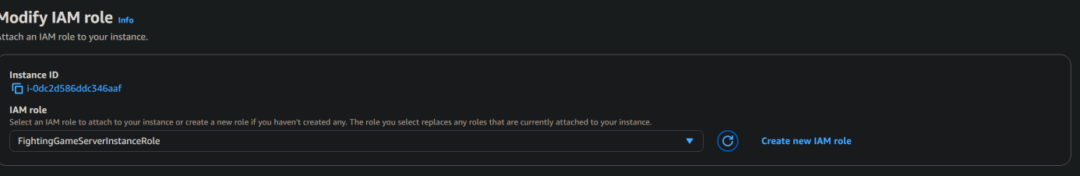
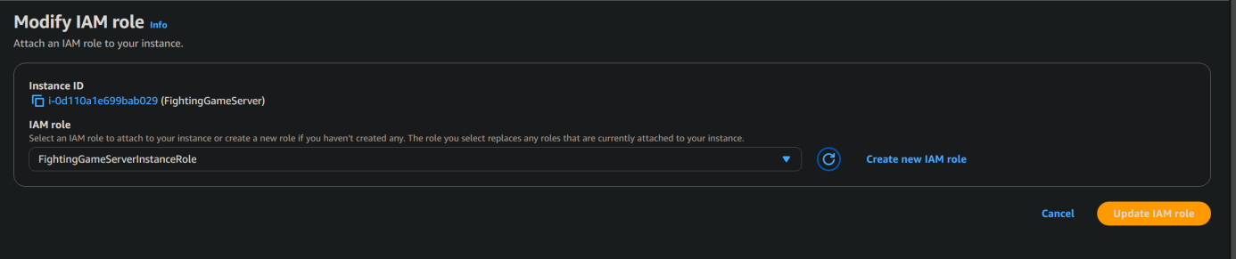
Modify IAM role

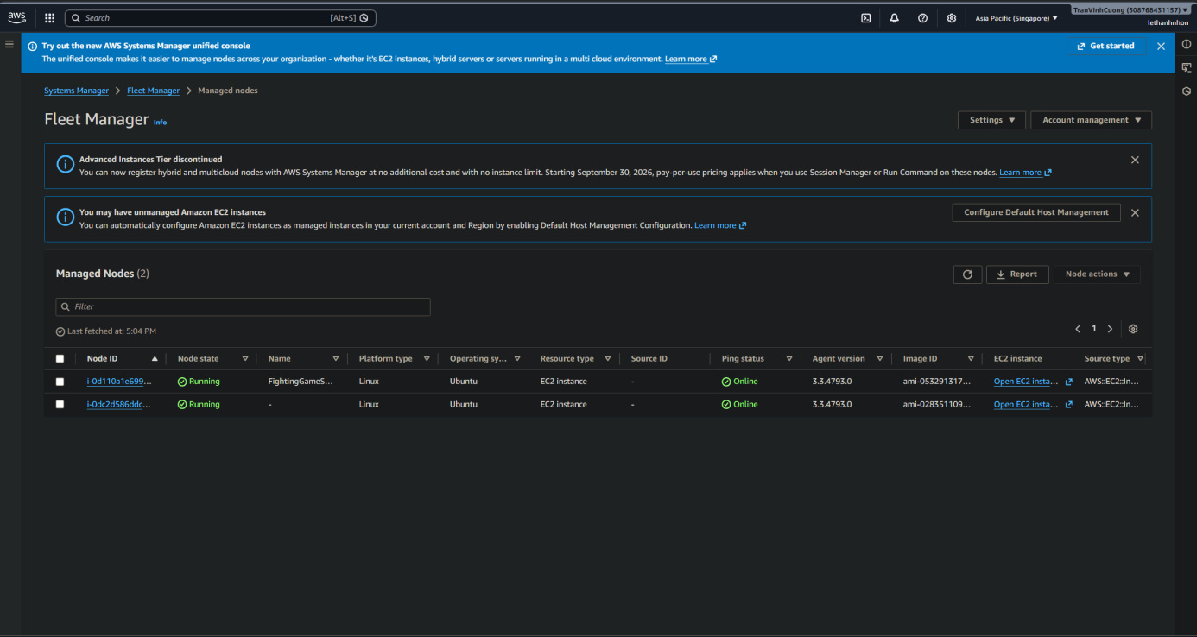
Fleet working
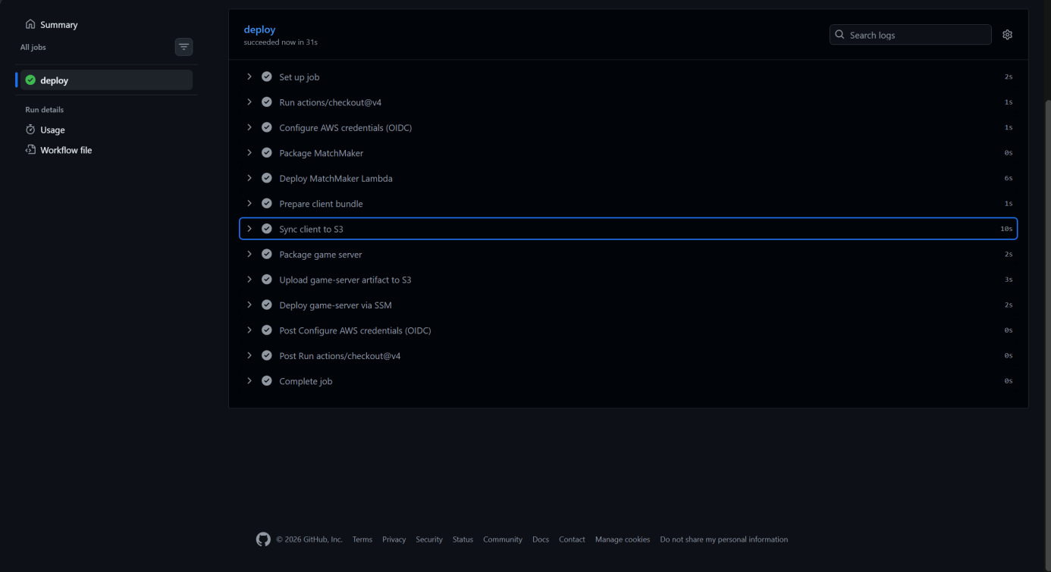
Deploy Success
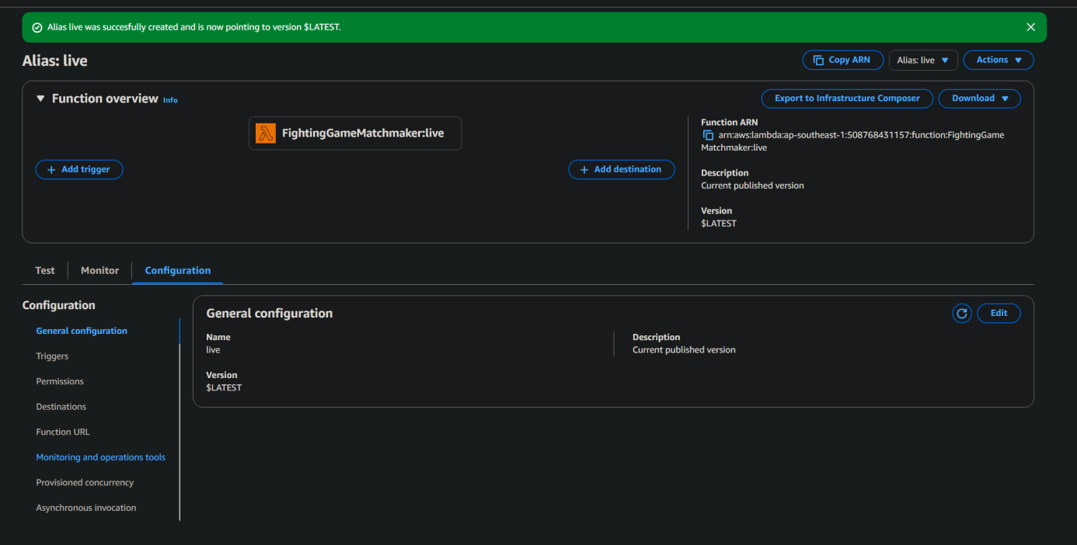
Publishing new version
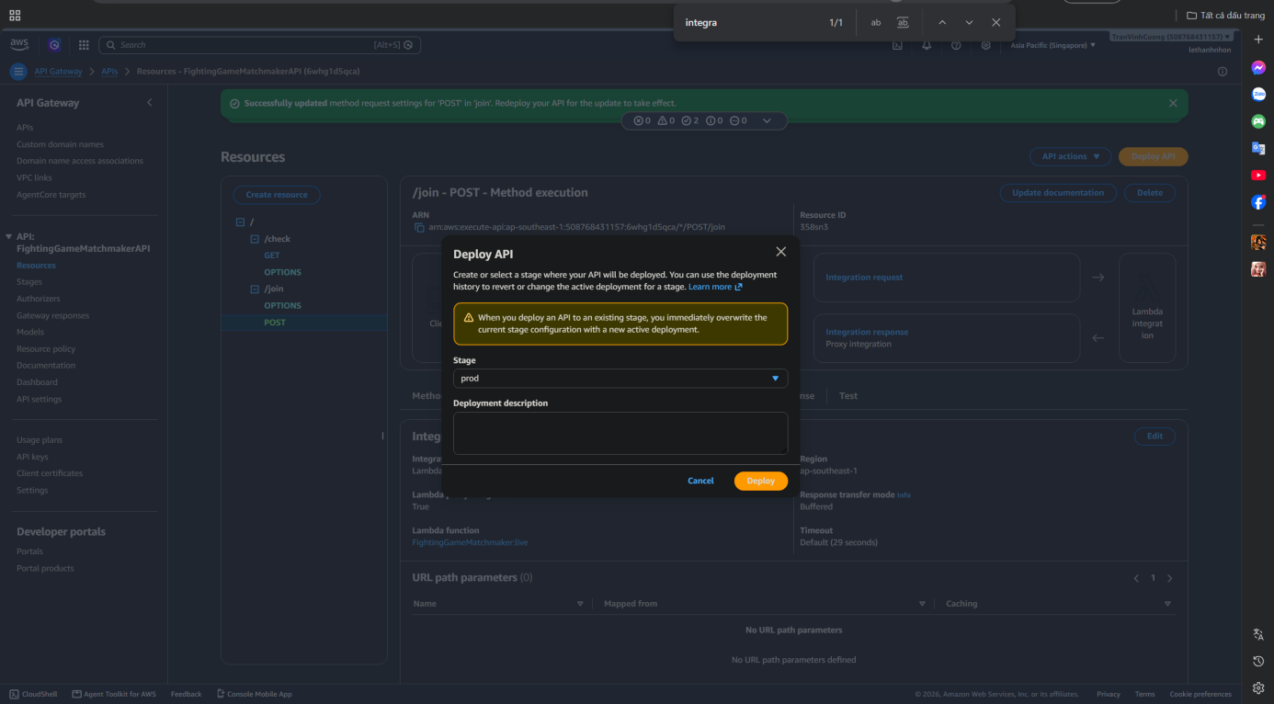
Redeploy for live versioning
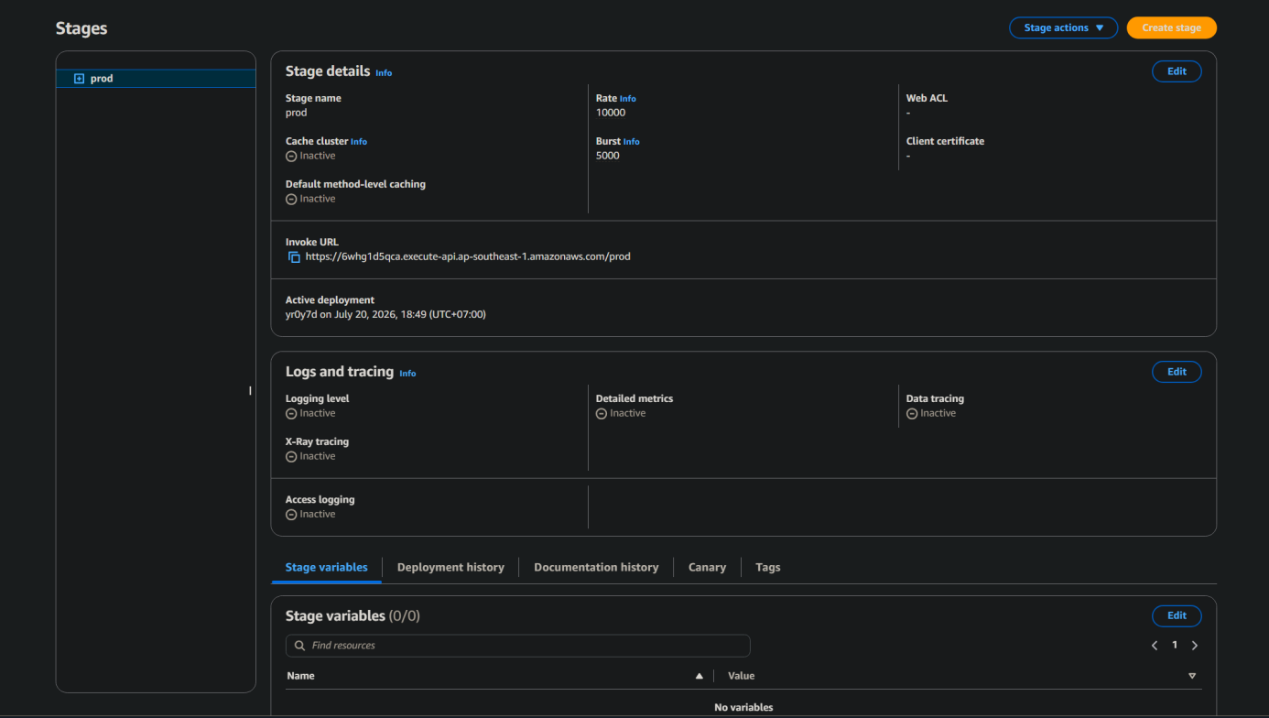
Dormant Prod Stage
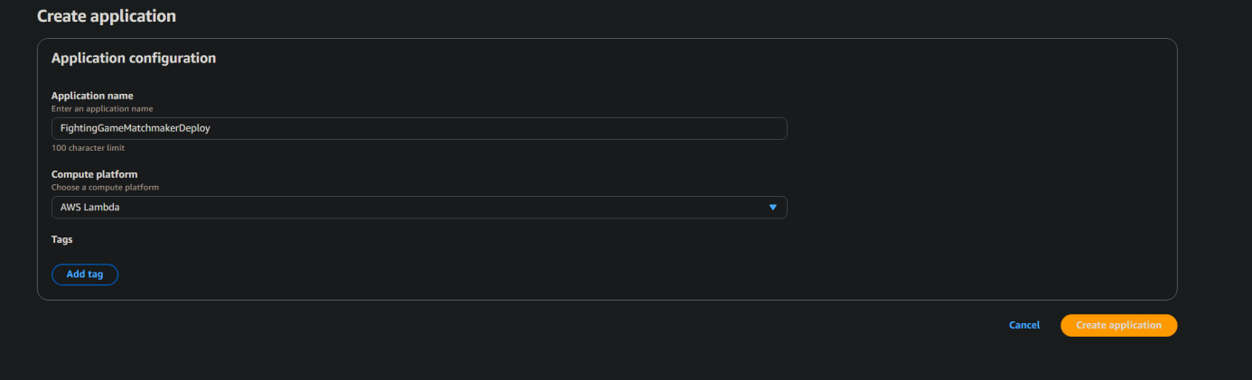
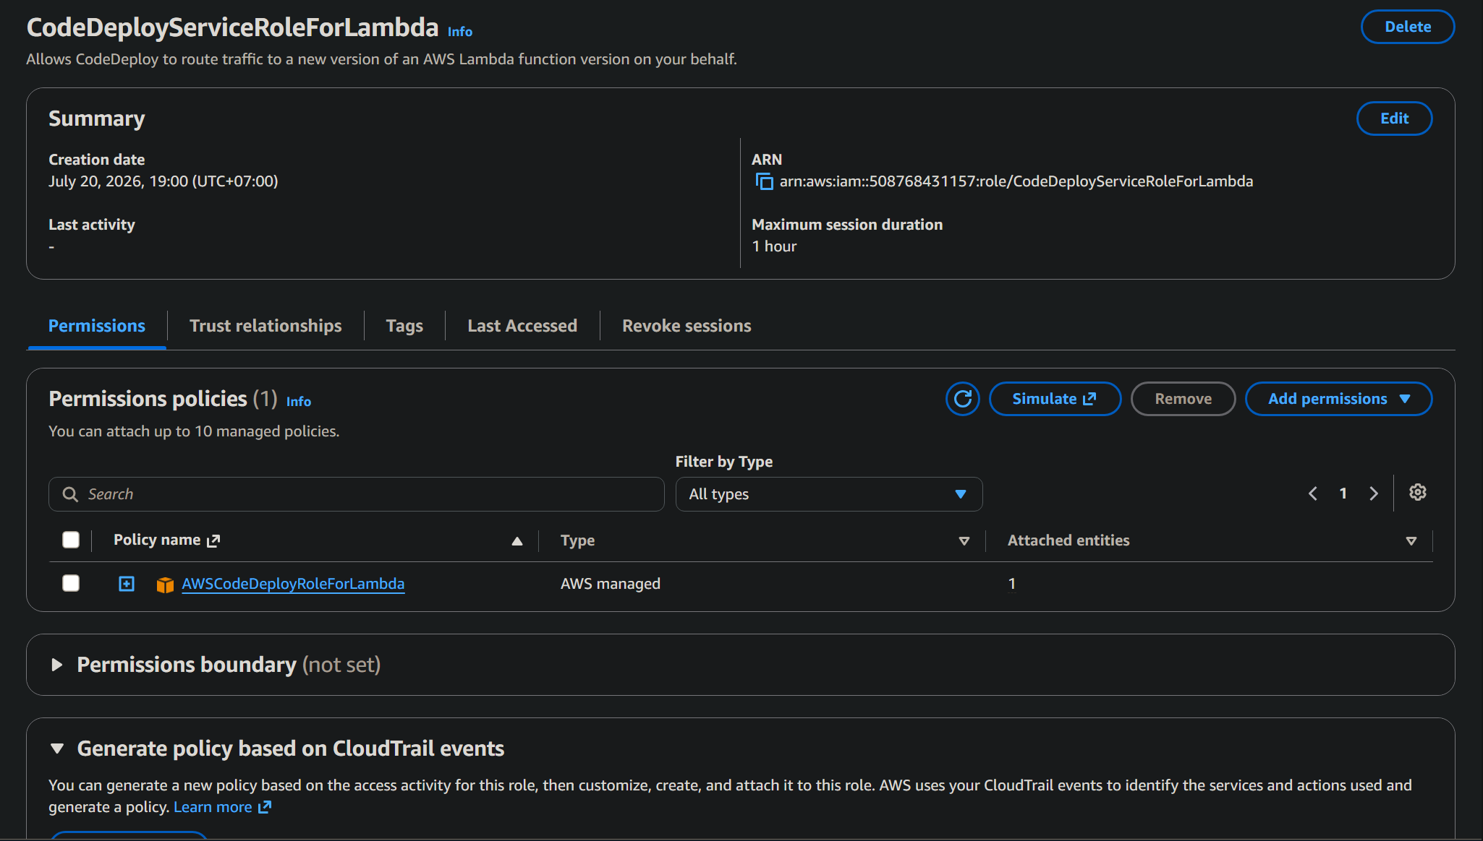
Create Role for CodeDeploy
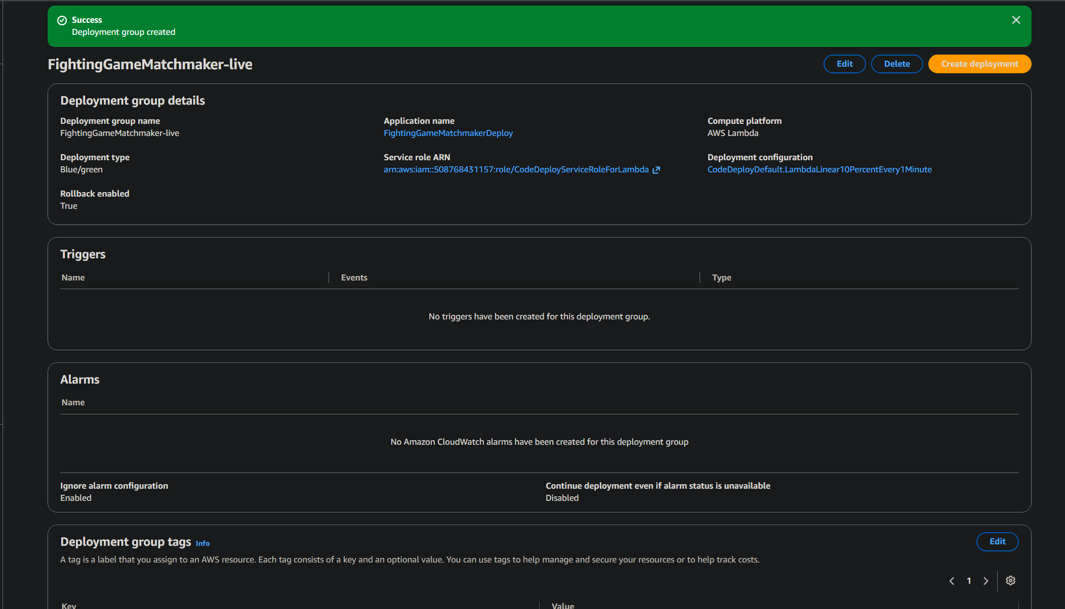
Deployment Group creation
# 1. Install prerequisites
sudo apt-get update && sudo apt-get install -y ruby-full ruby-webrick wget gdebi-core

# 2. Download raw .deb package directly
cd /tmp
wget https://aws-codedeploy-ap-southeast-1.s3.ap-southeast-1.amazonaws.com/releases/codedeploy-agent_1.8.1-26_all.deb

# 3. Unpack, fix Ruby dependency declaration, and repack
dpkg-deb -R codedeploy-agent_1.8.1-26_all.deb /tmp/codedeploy-extracted
sed -i "s/ruby3.2/ruby3.3/g" /tmp/codedeploy-extracted/DEBIAN/control
dpkg-deb -b /tmp/codedeploy-extracted /tmp/codedeploy-agent_fixed.deb

# 4. Install patched package and start service
sudo dpkg -i /tmp/codedeploy-agent_fixed.deb
sudo systemctl enable codedeploy-agent
sudo systemctl start codedeploy-agent
sudo systemctl status codedeploy-agent

Update Launch Template, Warm instance và spot instance với code deploy agent
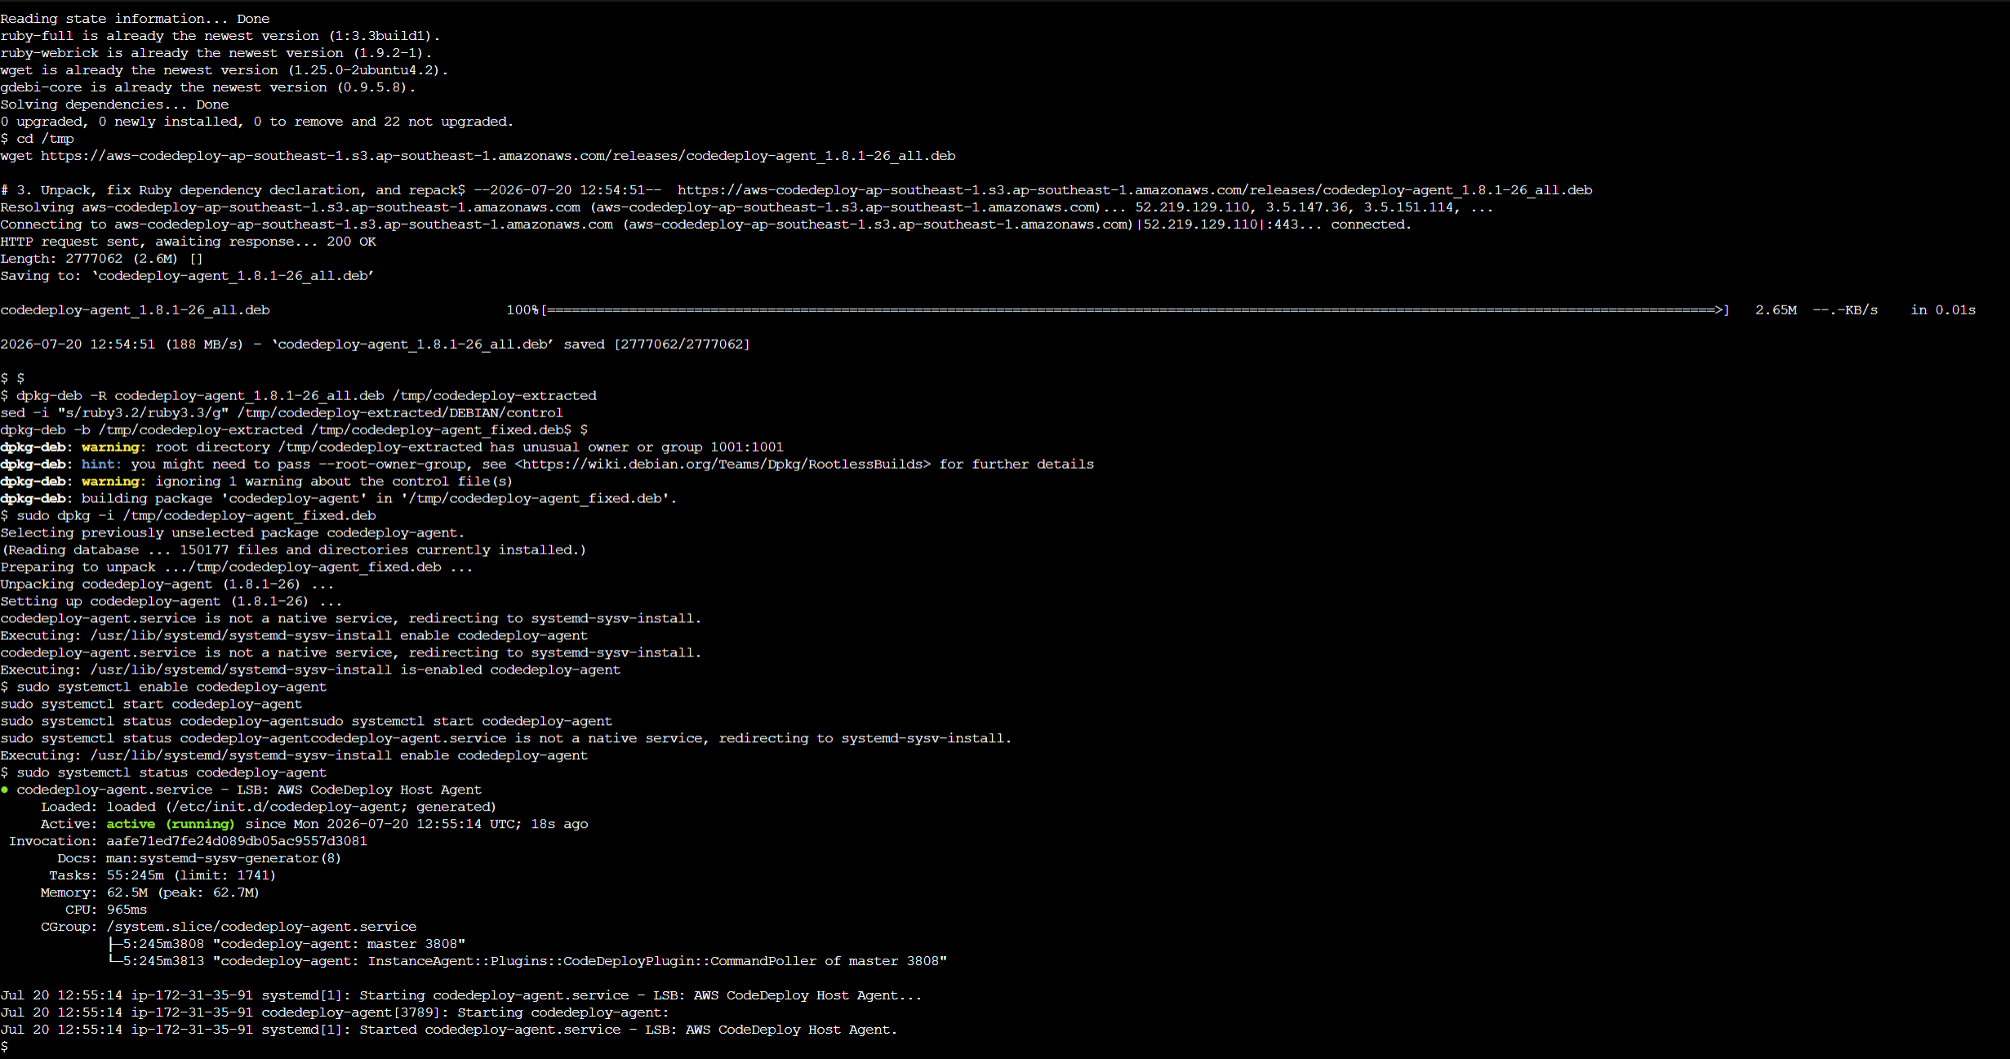
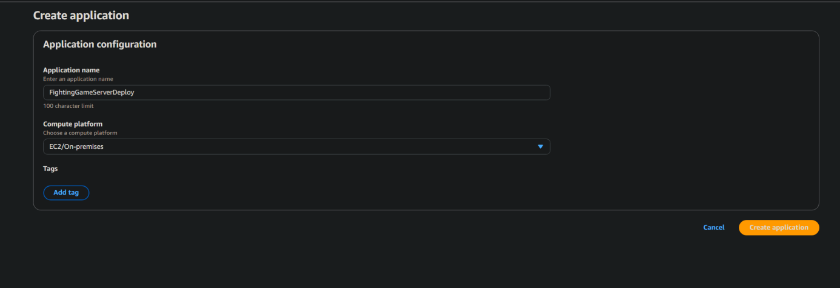
Create CodeDeploy EC2 application
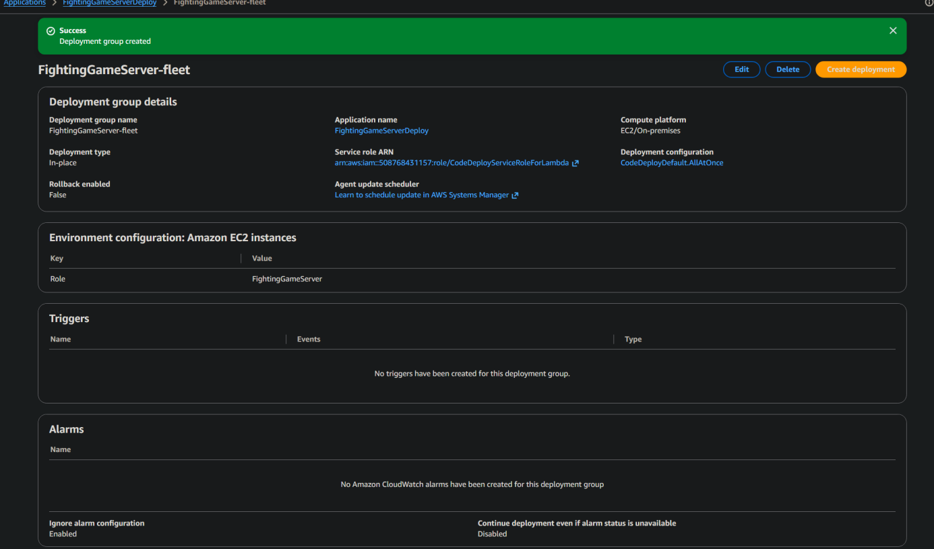
EC2 Deployment group config
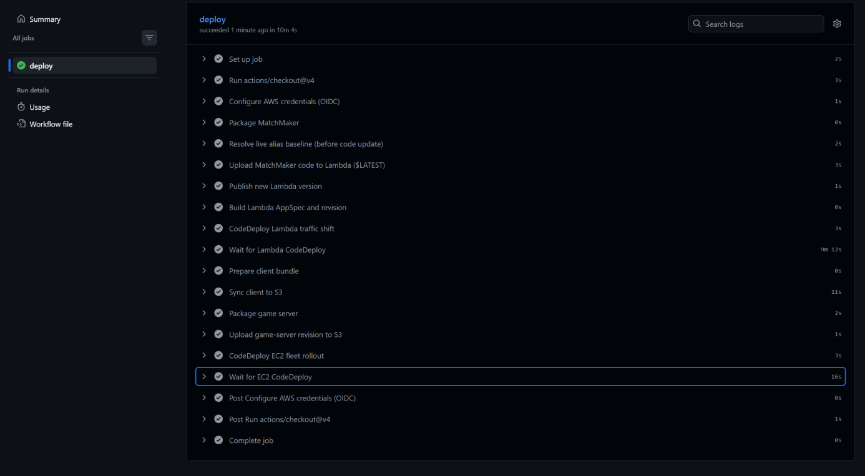
Successful CodeDeploy Job
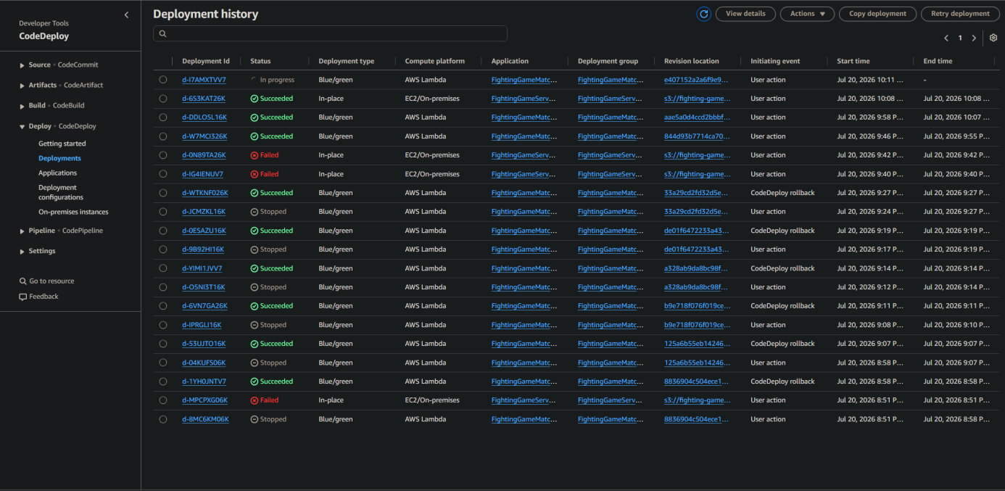
Deployment history
8)Async Processing
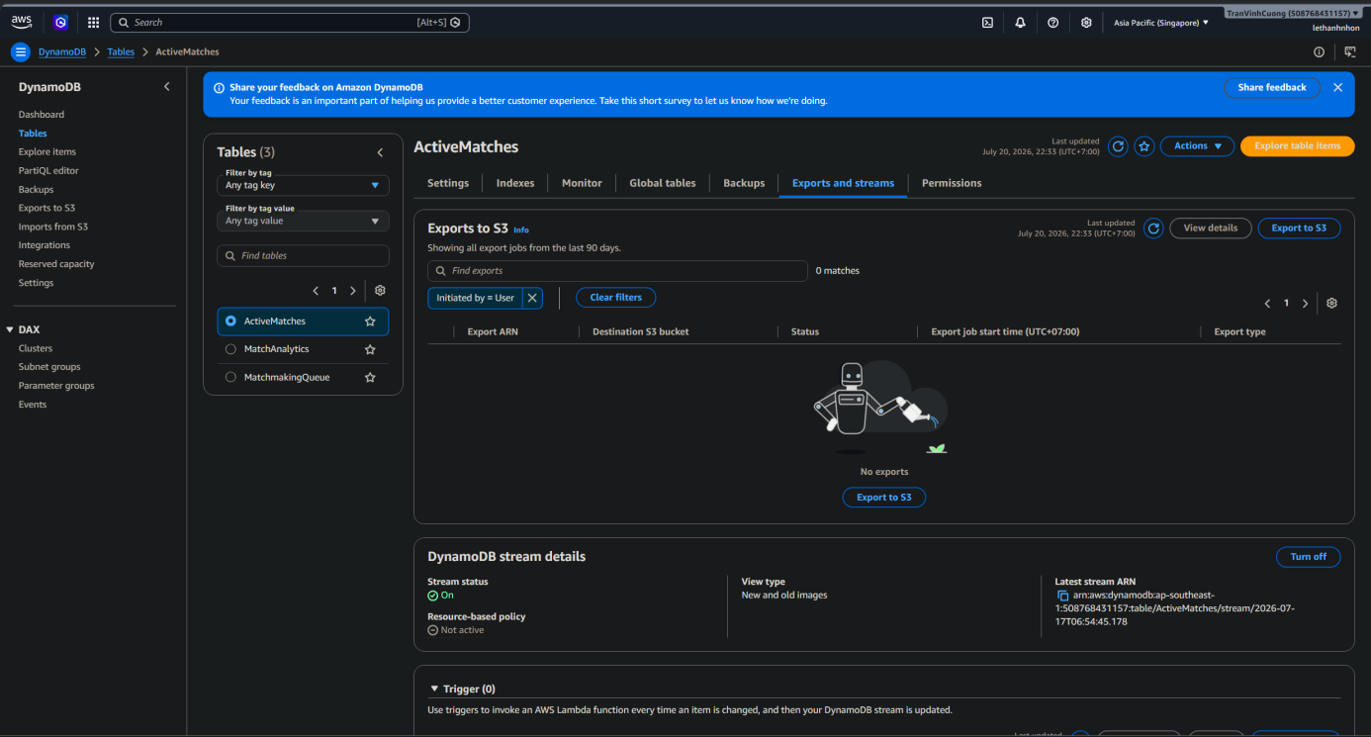
DynamoDB setup
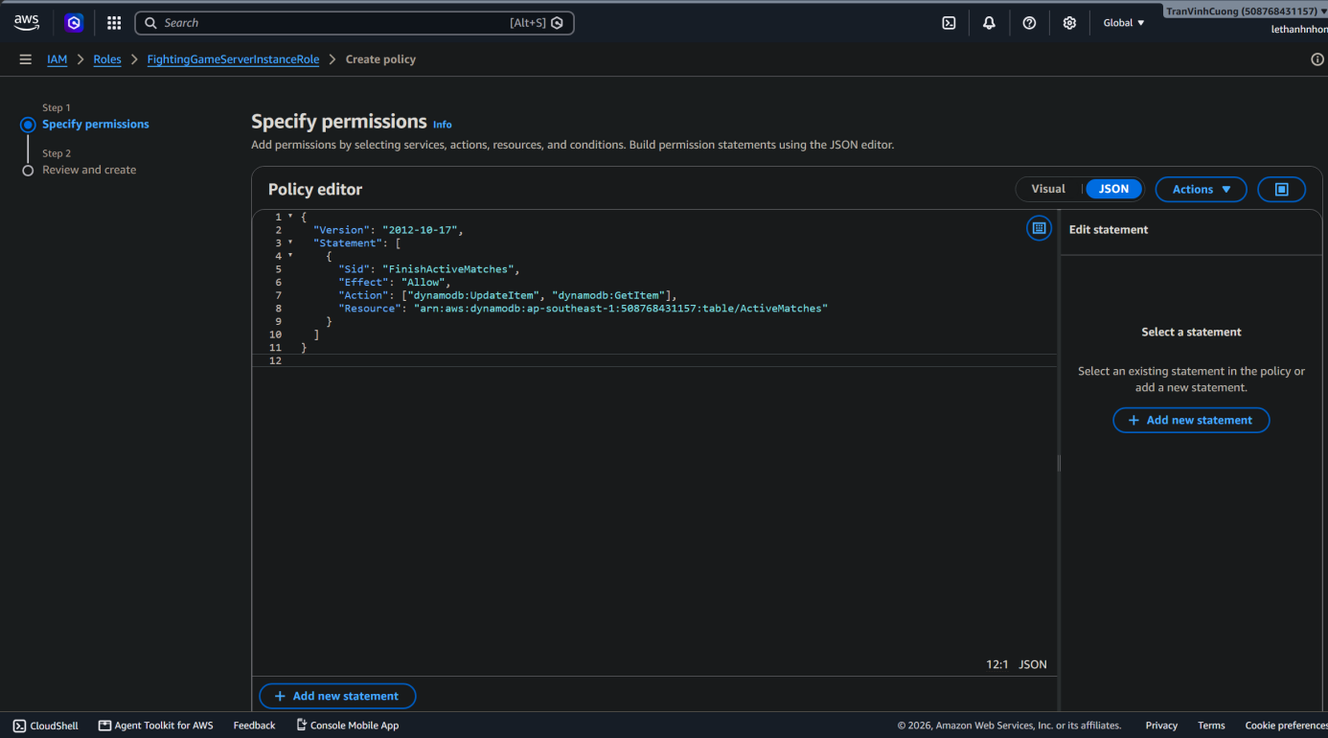
Finished State application to DynamoDB
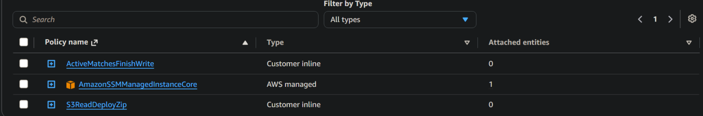
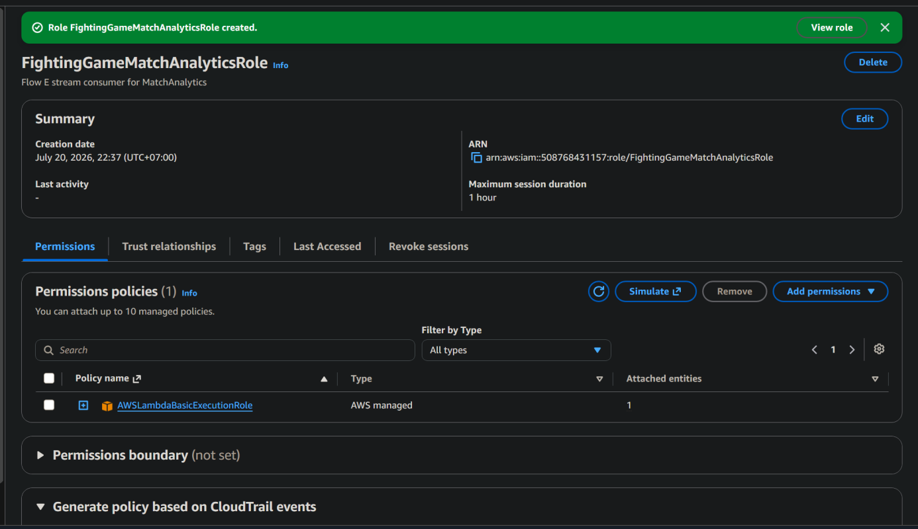
Created new Match analytic role
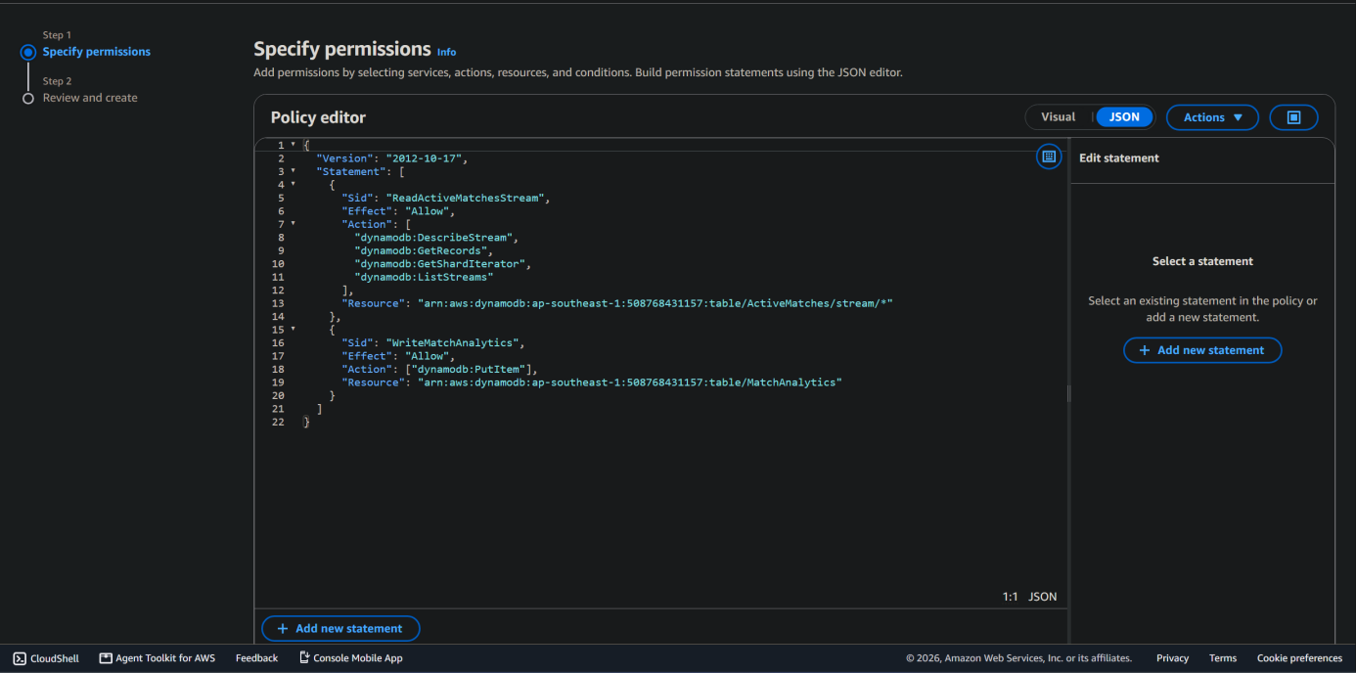
Created Active stream reading Policy

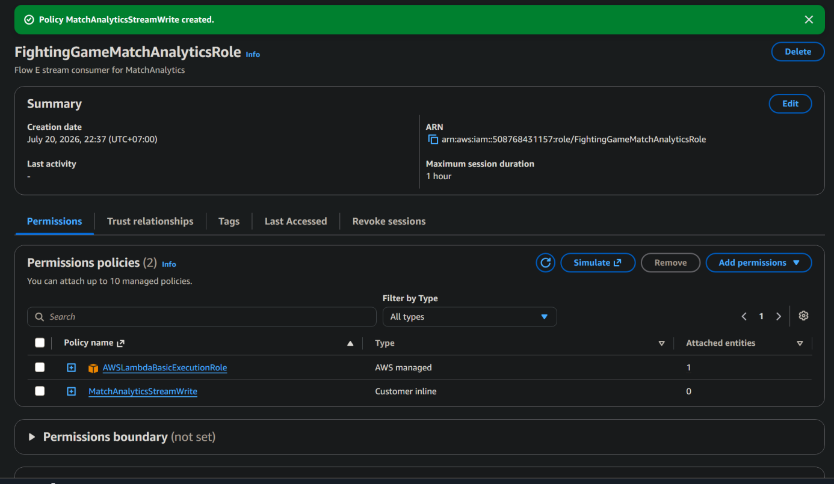
Created Role for MatchAnalytic Lambda
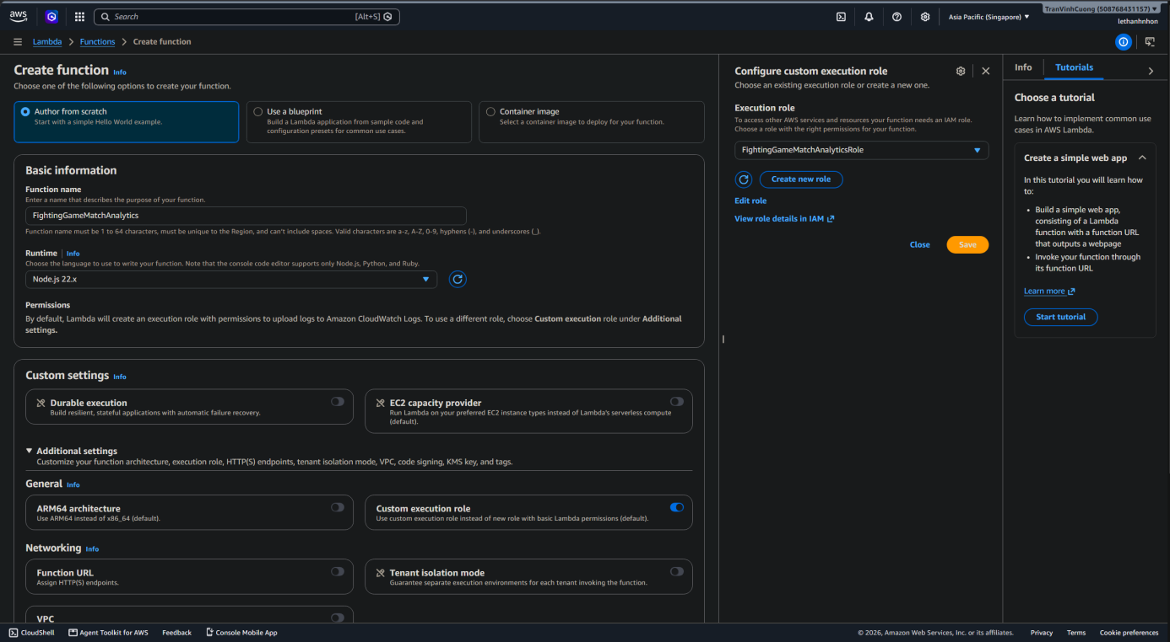
Created Match Analytic Lambda
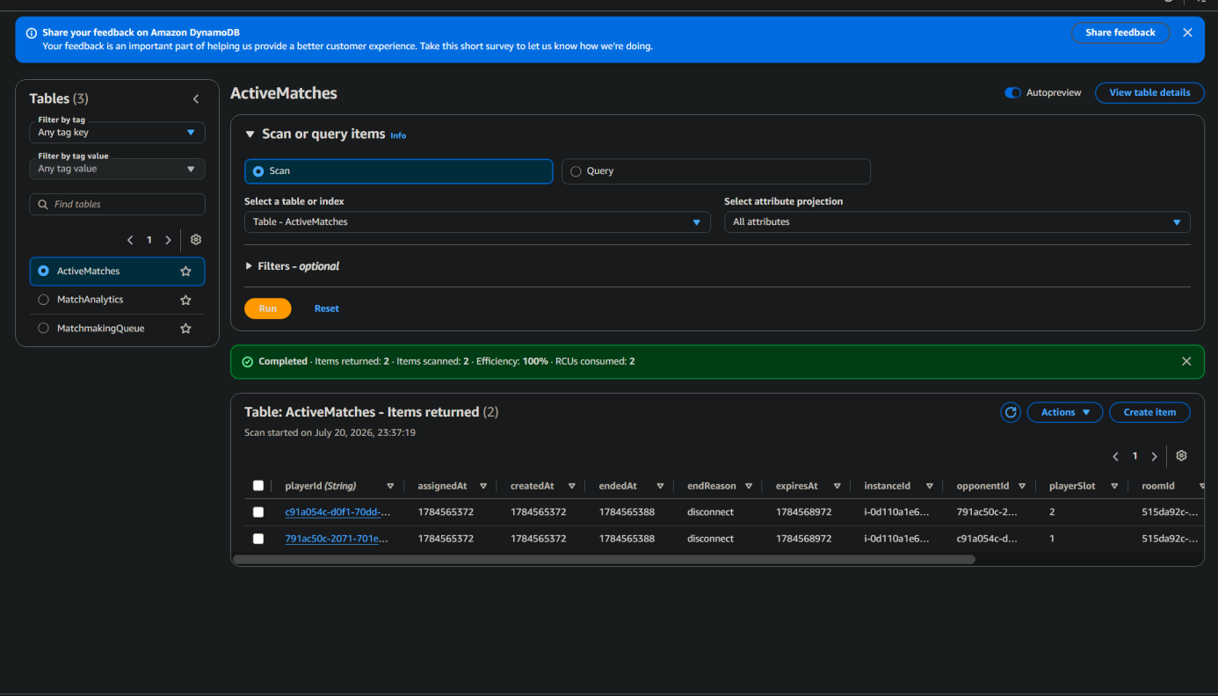
DynamoDB Data
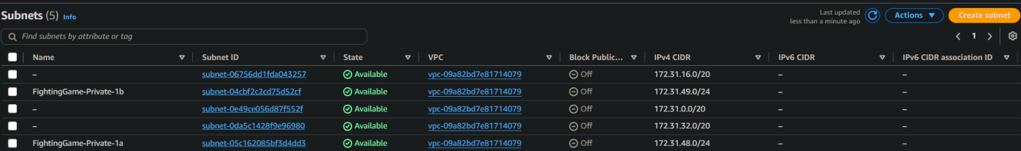
Subnet Table

