A. Cashier

time limit per test

2 seconds

memory limit per test

256 megabytes

input

standard input

output

standard output

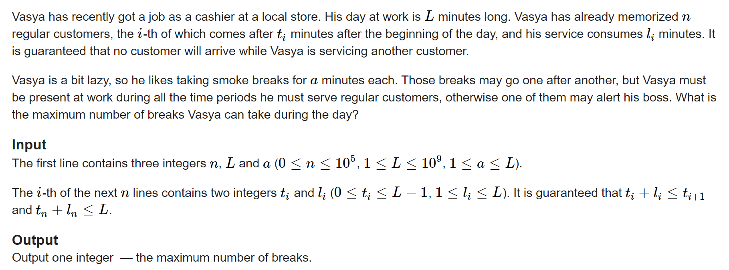

**Examples**

**input**

**Copy**

2 11 3  
0 1  
1 1

**output**

**Copy**

3

**input**

**Copy**

0 5 2

**output**

**Copy**

2

**input**

**Copy**

1 3 2  
1 2

**output**

**Copy**

0

**Note**

In the first sample Vasya can take 3 breaks starting after 2, 5 and 8 minutes after the beginning of the day.

In the second sample Vasya can take 2 breaks starting after 0 and 2 minutes after the beginning of the day.

In the third sample Vasya can't take any breaks.