B. Discounts

time limit per test: 2.5 seconds

memory limit per test: 256 megabytes

input: standard input

output: standard output

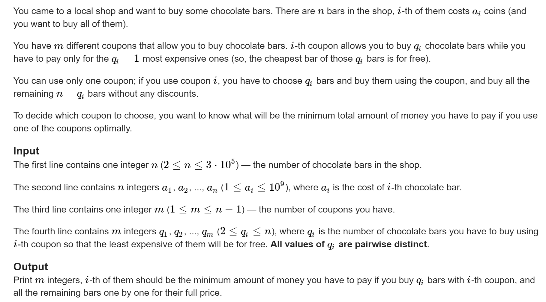

**Example**

**input**

**Copy**

7

7 1 3 1 4 10 8

2

3 4

**output**

**Copy**

27

30

**Note**

Consider the first example.

If we use the first coupon, we may choose chocolate bars having indices 1, 6 and 7, and we pay 18 coins for them and 9 coins for all other bars.

If we use the second coupon, we may choose chocolate bars having indices 1, 5, 6 and 7, and we pay 25 coins for them and 5 coins for all other bars.