To be filled by the applicant: | Name: Nguyen Vo  Role: QA Assistant Manager |  | Signature
Deviation N°: DR00 | Date: 4/1/2022 |  | Deviation:  x  Internal External
Code of finished goods involved: 9906 Trimmer |  | Period of deviaton: 19/10/2020  Quantities:
Reason: Top housing short shot.
Corrective Actions: Checking molding tool and follow up next batch

Detail Deviation \ description: short shot at battery contact holding point
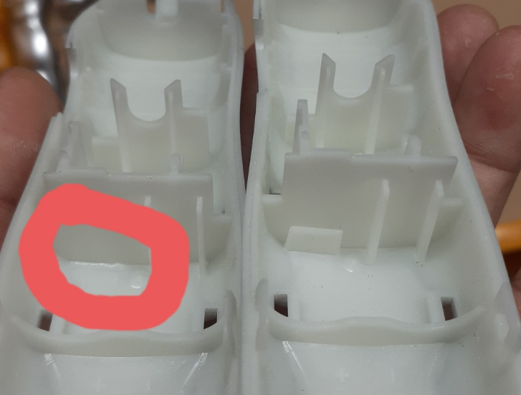

To be filled by approvers
Department | Comment: | Approved | Date | Signature
QC |  | YES NO
NPI |  | YES NO
Prod |  | YES NO
SOURCING (SQA) |  | YES NO
Others |  | YES NO  x  x  x  x  x  x  x  x  x  x
Request for specific identification or other: NA |  |  | Final Decision:  YES NO  x  x  Date: ____________  MD Signature: ___________

