Guangdong Yunshui Technology Co., Ltd

Product quotation List（2026 Foreign Trade Channel Edition）
Address : Building 13, West Zone, Twelve Pu Exploration Brigade, Sanshui District, Foshan City, Guangdong Province Te l:+86 17324597077 WhatsApp：+86 17324597077 Email : ychealthtech@gmail.com

Category | Model | Picture | Parameter | Funct ion | Pr ice
Float Tank | Relax P1 | 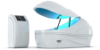 | Host: 550*650*1200 (mm)  Packaging : 750*850*1400 (mm)  Gross weight: 60kg  Tank: 2420*1370*1270 (outer) 2220*1190*1050 (inside)  Packaging : 2620*1570*1470 (mm)  Gross weight: 120kg  Total power : 4100W  Maximum working power : 4000W  Working voltage : 220V  Small host, without independent water tank  Tank material: PMMA Insulated tank she ll Magnetic Drive Pump Titanium Heater | 1、Pumping  2、Heater (Host heater)  3、Constant temperature (Host heater)  4、Photo catalytic UV technology  5、Music (SD card)  6、LED lighting lamp（Cab in button ）  7、Ozone Sterilizer (in cabin)  8、Screen control  9、Constant Temperature Electric Heat Tracing Tape  10、Fresh air system  11、1-Micron Filter  12、Filter change monitoring  13、Handrails and shel ving | ＄4,700.00

Float Tank | Relax P2 | 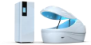 | Host: 700*1000*1900 (mm)  Packaging : 900*1200*2100 (mm)  Gross weight: 140kg  Tank:2420*1370*1270 (outer)  2220*1190*1050 (inside)  Packaging : 2620*1570*1470 (mm)  Gross weight: 120kg  Total power : 8300W  Maximum working power : 8000W  Working voltage : 220V  Tank mater ia l: PMMA Water tank  Insulated tank she ll Magnetic Drive Pump Titanium Heater | 1、Pumping (automatic stop)  2、Heater (Host heater)  3、Constant temperature (Tank heater)  4、UV d is infect ion  5、Music (manage and up load over cloud)  6、LED lighting（Cab in button and screen control）  7、Ozone Sterilizer (in cabin)  8、Ozone aeration decomposition system  9、Screen control  10、Tab let control（multi-pod mangerment interface）  11、Fresh air system  12、Automatic dosing  13、Water f i l ration system: 1 Micron Fil ration +UV+Hydrogen peroxide  14、Filter change monitoring  15、Cabin intercom system  16、Handrails and shelving  17、Dry burning stop | $7,800.00

Float Tank | Whale P3 | 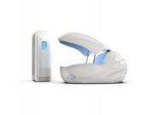 | Host: 620*1060*1890 (mm)  Packaging : 820*1260*2090 (mm)  Gross weight: 140kg  Tank: 2530*1530*1280 (external) 2250*1380*1110 (inside)  Packaging :2730*1730*1480 (mm)  Gross weight: 120kg  Total power : 8300W  Maximum working power : 8000W  Working voltage : 220V  Tank material: FRP  Water tank  Insulated tank shell Magnetic Drive Pump Titanium Heater | 1、Pumping (automatic stop)  2、Heater （Host heater）  3、Constant temperature (Tank heater)  4、UV disinfection  5、Music (manage and up load over cloud)  6、LED lighting（Cab in button and screen control）  7、Ozone sterilization ( Cab in Inside)  8、NFT Sleep Chip  9、Screen control  10、Tablet control  11、Automatic sewage discharge  12、Fresh air system  13、Automatic dosing  14、Water filration system:0.1 Micron Filration+ 1 Micron Filration +UV+Hydrogen peroxide  15、Filter change monitoring  16、Cabin intercom system  17、Handrails and shelving  18、Whale pod  19、Ultrasound Therapy  20、High pressure cleaning water gun  21、Dry burning stop  22、Water quality monitoring  23、Sleeping quality report  24、Electric door (manually operated without power)  25、Voice control  26、 Underwater Ultrasound Massage Underwater Ultrasound Massage | $21,500.00

Cryo chamber | Aurora D1 | 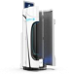 | Cooling method： liquid nitrogen  Chamber Size: 890*990*2430 (mm)  Packaging : 1670*1350*2560 (mm)  Gross weight: 140kg Nitrogen tank s ize:  600*600*1600 (mm)  Packaging : 800*800*1800 (mm)  Weight: :120KG  Total power : 1800W  Maximum working power : 1000W  Working voltage : 220V  Cab in mater ia l: FRP  Maximum cooling: -180 ℃ | 1、tab let control  2、15.6 touch screen  3、Interior Light Strip Decoration  4、 Precise temperature control  5、Extremely fast pre-cooling  6、Blood oxygen and heart beat monitoring  7、Low-temperature equilibrium surround  8、No need Drying  9、Humanized regulation  10、Escalators  11、 Intelligent voice control  12、Dual-system liquid nitrogen tank  13、Oxygen monitoring  14、Temperature controls  15、Emergency stop buttons  16、 Heart-rate monitor  17、Pressure regulator | $20,000.00
Cryochamber | Aurora D2 | 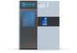 | Cool ing method：electricity  External :2350*830*2350 mm  Internal :840*550*1980 mm  Weight: :1020 KG  Power : 15000W  Working voltage : 380V  Remote control tab let  accommodation space：1 persons  Maximum cooling: -130 ℃ | 1、tablet control  2、15.6 touch screen  3、Interior Light Strip Decoration  4、Precise temperature control  5、Extremely fast pre-cooing （-90℃ need 60mins； -130℃need 90mins）  6、Blood oxygen and heart beat monitoring  7、Low-temperature equilibrium surround  8、No need Drying  9、Humanized regulation  11、Oxygen monitoring  12、Temperature controls  13、Emergency stop buttons  14、Heart-rate monitor | ＄35,000.00

Cryo chamber | Aurora D3 | 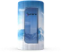 | Cooling method：liquid nitrogen  chamber size:  1020*1040*1800 (mm) Weight:9KG  Nitrogen tank size:  600*600*1000 (mm)  Weight: :30KG  Working voltage : 220V  She ll material：Oxford c loth  Maximum cooling: -180 ℃ | 1、7 inches touch screen  2、 Precise temperature control  3、Extremely fast pre-cooling  4、Low-temperature equilibrium surround 5、No need Drying  6、Humanized regulation  7、 liquid nitrogen tank  8、Temperature controls  9、Emergency stop buttons | $7,000.00

Water  massage bed | Noah B1 | 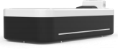 | Bed size: 2450*1150*800 (mm)  Packaging : 2600*1400*1100 (mm)  Gross weight: 140kg  Working voltage : 220V  Total power : 1200W  Maximum working power : 1000W  Bed materia l: FMMA | 1. Massage area: 1980 * 820  2. Control system: PLC  3. Protect ion level : lp54  4. Inlet water pressure: 0.2~0.5 Mpa  5. Massage water pressure: 0.4 Mpa  6. Maximum load capacity: 300kg  7. Water volume: 380L  8. Massage area: Whole body/Head/Waist/Legs  9. Massage type: Parallel massage  10. Massage intensity : 0.4Mpa  11. Music : Bluetooth/USB drive | ＄5,900.00
Water  massage bed | Noah B2 | 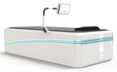 | Bed size: 2450*1150*800 (mm)  Packaging : 2600*1400*1100 (mm)  Gross weight: 140kg  Working voltage : 220V  Total power : 1200W  Maximum working power : 1000W  Bed material: FMMA  Mode: Heating and Cooling  Maximum heating temperature : 42 °C  Maximum cooling temperature: 4°C | 1.Massage area: 1980 * 820  2.Control System: Android  3.Protect ion level : lp54  4.Inlet water pressure: 0.2~0.5 Mpa  5.Massage water pressure: 0.4~0.6 Mpa  6.Maximum load capacity: 300kg  7.Water volume: 380L  8.Massage area: Full body/Head/Waist/Legs/Custom area/Height matching  9.Massage type: Parallel massage/Mirror  massage/Circular massage/Custom hand drawn path  10.Massage intensity : 0.4~0.6Mpa  11.Music : Bluetooth/USB/WiFi  12.Multi functional hood  13.Physical sign monitoring  14.Cold and hot mode  15.Video playback | $19,800.00
 | Noah B3 | 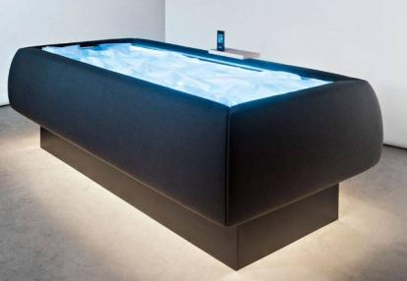 | Dimensions: L232 × W112 × H74 cm  Voltage: 220 V  Max power consumption: 2500 W / 10.86 A  Frequency: 50/60 Hz  Max load: 130 kg  Net weight: 200 kg  Operating weight: 600 kg  Water capacity: 400 L  Minimum temperature: 4℃ | - With lifting platform: Yes  - Internal construction: Stainless steel  - Operation mode: Touch screen control | $7,800.00
Red Light Therapy Bed | Dawn | 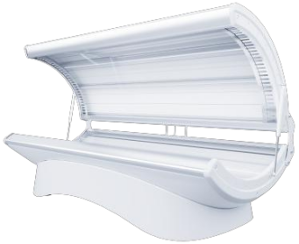 | Customized band: 633  LED chip configuration: Regular 10600  Encryption 21600 | Light source: multi-composite light  LED light board: 18 light strips (9 on each side)  Specification: Regular, Encrypted 0.2W  Shell color: white, black  Control system: PulseIoT  Voltage: 220V  Equipment dimensions: 1940*860*820mm  Net weight: 80KG  Packaging size: 2010*970*950mm  Packaging weight: 150KG | ＄11,000.00
Red Light Therapy Bed | Dawn Ultra | 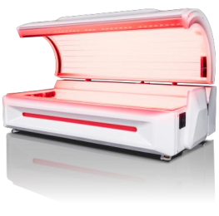 | Customized band: 633+850 (1:1)  LED configuration: Regular 18720  Encryption 41600 | Light source: multi-composite light  LED light panel: 26 light strips (upper compartment 13, side compartments)  3 Lower warehouse 10)  Specification: Regular, Encrypted 0.2W  Shell color: white, black  Control system: Pulse IoT  Voltage: 220V/380V  Equipment dimensions: 2280*1250*1150mm  Net weight: 380KG  Packaging size: 2360*1330*1310mm  Packaging weight: 450KG | ＄16,520.00

Hyperbar ic oxygen  chamber | Reiki H1 | 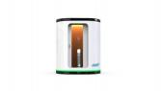 | chamber size:  1550*900*1850 (mm)  Weight: :240KG  Control Cab in size:  600*600*1600 (mm)  Weight: :80KG  Oxygen Concentration: ≥93%  Noise:≤58db  Wattage:2800W | 1.Pressure: adjustable from 1.0 to 1.99 ATA ;  2.Over pressure air interruption technology;  3.In-cabin touch screen + remote control via tablet;  4.Silent operat ion, noise level < 60 db;  5.Reinforced with high-strength titanium alloy steel ;  6.Reinforced glass window for the polycarbonate sliding door;  7.Dehumidifier + automatic condensation drainage + water-cooled air conditioner ;  8.Oxygen flow rate: 10 L per minute;  9.Oxygen concentration : 96% ;  10.Dual physical emergency safety valves ;  11.Gas proportional valve, supporting step less pressure adjustment with an adjustable precis ion of 0.01 ATA ;  12.Large in-cabin entertainment screen;  13.One-touch adjustable zero-gravity sofa ;  14.Aviation dual-system redundancy ;  15.Equipped with carbon dioxide and oxygen  sensors, and an automatic ear pressure balance device;  16.Designed with a constant communication mode;  17.Diffused oxygen content : 23% ;  18.One-year quality guarantee | ＄21,500.00

Remarks:
(1) The above quotation is ex factory pr ice and does not include logistics, invoice tax points, on-site service and other fees.
(2) Quotation validity period: Within 7 working days from the date of quotation.
(3) Settlement method: 70% deposit for product ion orders, and the remaining 30% to be sett led before shipment.
(5) The delivery time for the machine is 20 days.

