VIETNAM NATIONAL UNIVERSITY OF HO CHI MINH CITY
THE INTERNATIONAL UNIVERSITY


SUBJECT: DATA SCIENCE AND DATA VISUALIZATION
TEACHER: Tran Thanh Tung
TOPIC: US Police Shootings from 2015-2022

https://github.com/nguyenhoangbao2112/US-Police-Shootings-from-2015-2022/tree/main

Name | Student ID
Nguyễn Hoàng Bảo | ITDSIU23004
Table of Contents
- Introduction
1.1 Background and Motivation
1.2 Project Objectives
1.3 Project Schedule
- Data Understanding and Preparation
2.1 Dataset Collection
2.2 Dataset Overview
2.3 Data Preprocessing
2.3.1 Removing Duplicates
2.3.2 Handling Missing Value
2.4 EDA
2.5 Correlation Matrix
2.6 Brainstorm
- Sketch
- Interactive Website Analysis
4.1 Global Controls and State Logic
4.2 Geographic Visualization
4.3 The Info Panel
4.4 Multi-Dimensional Statistical Charts
- Data Analysis and Finding
5.1 Key Performance Metrics Analysis
5.2 Demographic and Behavioral Trends
5.3 State-Level and Longitudinal Trends
- Conclusion

Beginning

1. Introduction

1.1 Background and Motivation
In a transparent society, accountability in safety and law enforcement is crucial. The public deserves insight into police shootings so lawmakers, researchers, and citizens can discuss these incidents within a framework of justice and equity. Using visual data from police reports, we can encapsulate and simplify the raw data from the reports. We wish to go beyond the surface of media reports. We wish to know the details of the police shootings and the impact they have on people.

1.2 Project Objectives
- How do shooting occurrences fluctuate across different states from 2015 to 2022 ?
- Is there a significant correlation between specific attributes and the frequency of incidents within a given year ?
- How can I visualize specific factors ?

1.3 Project Schedule

STAGE | WORK | MEMBER
Planning | Topic Confirmation | Bảo
 | Dataset Exploration | Bảo
 | Proposal Writing | Bảo
Data Preprocessing | Data cleaning | Bảo
 | Handling missing value | Bảo
 | Exploration Data Analysis (EDA) | Bảo
 | Extracting insights | Bảo
Conceptual Design | Define system requirements | Bảo
 | Visualization technique selection | Bảo
 | Dashboard structure planning | Bảo
Implementation | Front-end development / Coding | Bảo
 | Data visualization integration | Bảo
 | Testing and debugging | Bảo
Presentation & Deployment | Report writing | Bảo
 | Slide preparation | Bảo
 | Final & GitHub submission | Bảo

2. Data Understanding and Preparation

2.1 Data Collection
The dataset for this project comes from Kaggle (specifically the dataset “US Police Shootings from 2015-2022”). This dataset gives organized and structured data that has been peer-reviewed and is ready for both academic and statistical research.

2.2 Raw Data Overview
The data contains 7729 samples with 17 features, which include both categorical (Race, State, Gender, Manner of Death,…) and numerical / date (Age, Date) features. The main measure to be calculated is the Frequency (Count) of events.
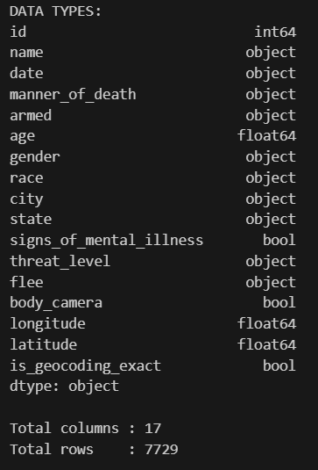
In order to keep the final charts clear and meaningful, I applied a bit of attribute pruning.
- I deleted id and name because they are unique identifiers and do not contribute to any aggregate trends.
- I removed city, longitude, latitude, and is_geocoding_exact. As the analysis is at a higher regional level, the state attribute offers sufficient geographic-scale information without the distraction of longitude and latitude.
To keep the chart readable, I added a rule to skip the nominal attributes that have more than 10 unique values.
- The armed feature has 104 distinct values, which will produce a "visual noise" in a frequency plot.
- I’m keeping the state, despite the 51 distinct values. State-level information is essential for analyzing regional differences and is commonly used in demographic studies based in the US.
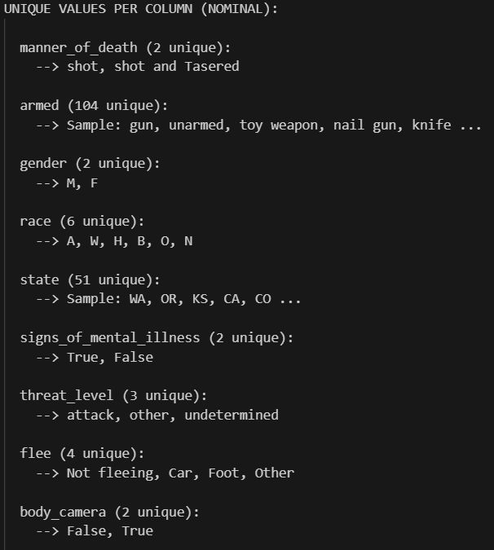
The clean dataset has 7729 rows and 10 essential attribute (Date, Age, Manner of Death, Gender, Race, State, Mental Illness, Threat Level, Flee, and Body Camera).
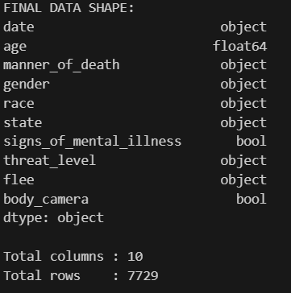

2.3 Data Preprocessing
This section illustrates how the data is cleaned/structured for visual analysis. Efficient preprocessing converts raw data into a refined format and minimizes conflicts so that any final presentations remain transparent, trustworthy, and informative.

2.3.1 Removing Duplicates
The dataset was audited for redundancy. 5 duplicate records were identified and removed to prevent the "double-counting" of incidents, which would otherwise skew the frequency totals.

2.3.2 Handling Missing Value
Missing values were handled differently depending on whether the attribute was categorical or numerical:

- Numeric attributes:
Missing numeric values were replaced with the mean of the respective column. For age-related data, the mean value was rounded to maintain realistic integer representation.
- Nominal attributes:
Missing categorical values were replaced using the mode (most frequent category) to preserve distribution consistency.
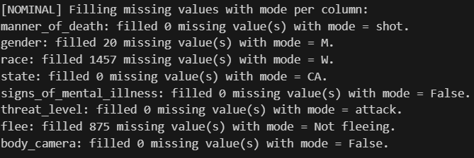

2.4 EDA
Based on the charts they give an overview of all features. By looking at the patterns in these charts we can see which customer behaviors and demographics are warning signs. This section is about what the data shows us away through the charts before using complicated math.
- Age: The average age is 37.2 while the middle age is 36.0. Most incidents involve people between 20 and 40 years old with incidents as age increases.
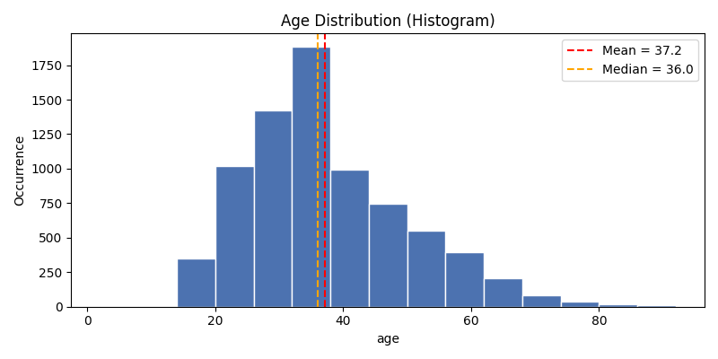
- Gender: There is a difference in gender. 95% Of instances (7,376) involve males while females make up a much smaller part of the data (348);
Manner of Death: Most incidents are classified as "shot" (7,385) with a number involving both a gun and a Taser (339).
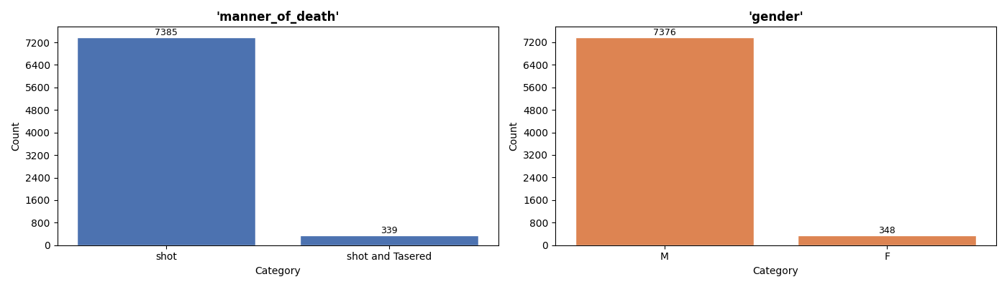
- Race: White people are the group at 4,655 followed by Black people at 1,684 and Hispanic people at 1,128;
State (Top 10): California (1,112) Texas (693) and Florida (493) are the three states. These states have the populations in the U.S. And they are the main areas to focus on.
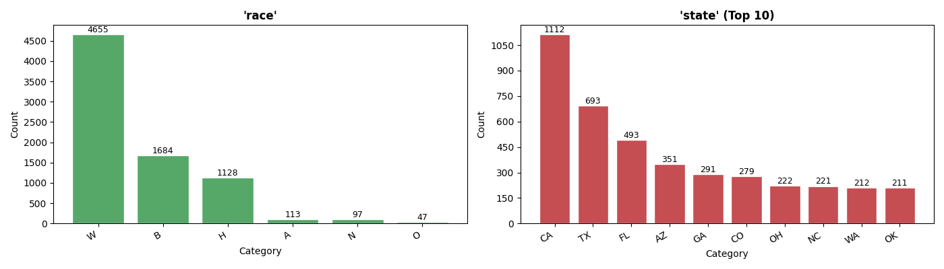
- Signs of Mental Illness: 21% (1,639) of people showed signs of mental illness while most (6,085) did not;
Threat Level: 4,872 cases were an attack when the incident happened.
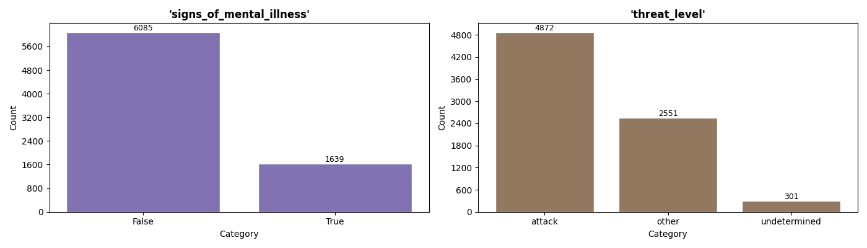

- Flee: Most people (5,208) were not fleeing, which means most incidents happened during a confrontation;
Body Camera: In 86% of cases (6,618) the officer did not wear a body camera. This shows a gap in visual evidence, for most incidents.
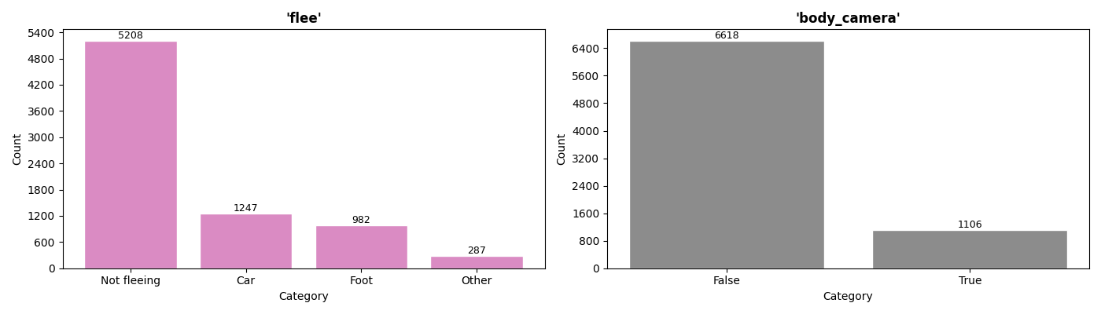

2.5 Correlation Matrix (CRAMÉR'S V)
This heatmap represents the value of Cramer’s V between categorical variables of the data set: US_Police_Shootings. Whereas regular correlation seeks linear relationships, Cramér’s V indicates the extent to which the knowledge of a category in one variable can be used to predict the category in another variable, its values range from 0 (no association) to 1 (perfect association).
- The most notable association exists between race and state (0.30)
- There is a moderate association between mental illness and flee (0.20)
- A slight association appears between state and body camera (0.17)
- Most other variables, such as gender and manner of death, show near-zero association with other factors
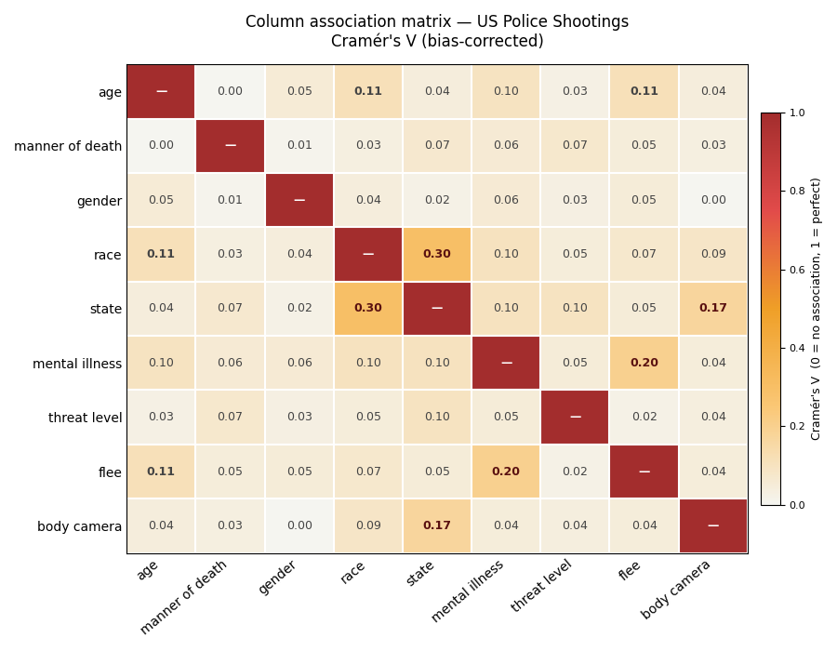

2.6 BrainStorm
After extracting insights and analyzing relationships between features, I have a clear plan for the final dashboard. The aim is to apply a filter for complexity by cleaning out the "background noise" of the "signals" using the Cramér's V threshold of 0.10.
- A plot for multidimensional comparisons will be drawn for those variables with the strength of association > 0.10. (Race vs. State; Mental Illness vs. Flee; State vs. Body Camera, Age vs. Race/Flee)
- Those with an association less than 0.10 also imply that the behavior of such attributes are mostly independent of the others in the dataset. (Gender, Manner of Death, and Threat Level.)

3. Sketch
Across all visualizations, I will add an interactive year filter so users can see how the patterns and differences between groups change from year to year.
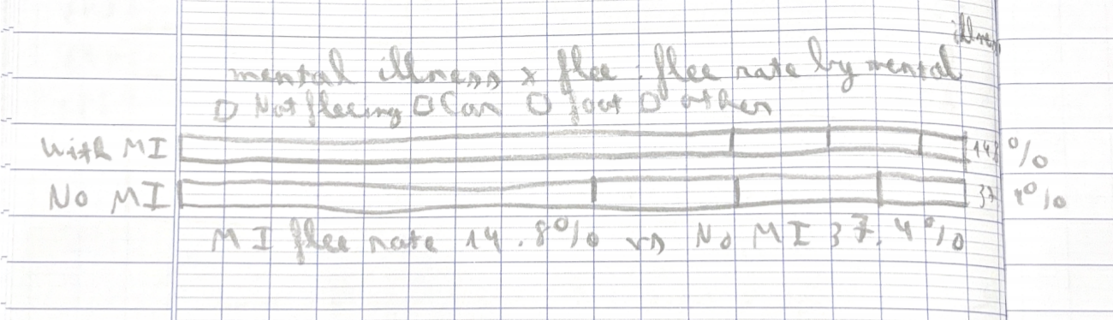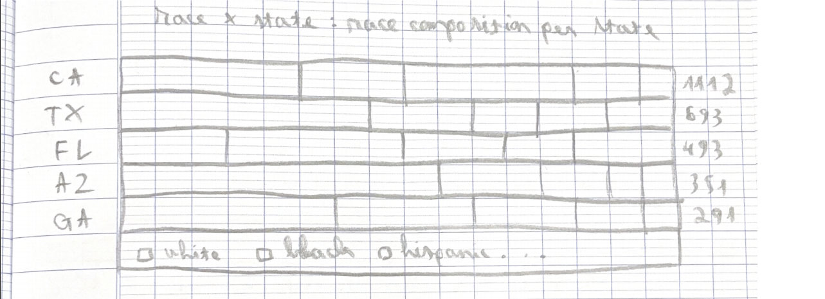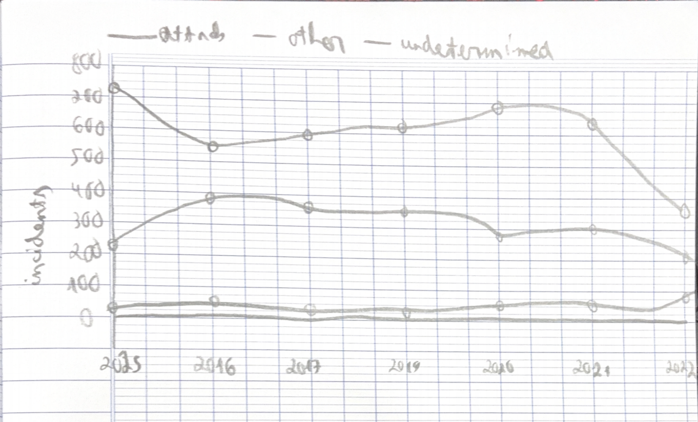

4. Interactive Website Analysis
The core of this project is a high-performance interactive dashboard (Dashboard.htm) that transforms the cleaned dataset into a dynamic exploratory tool. The frontend leverages D3.js (v7) for data-driven manipulation and TopoJSON for efficient geographic rendering.

4.1 Global Controls and State Logic
The application utilizes a "Centralized State" architecture, where all visual components are synchronized through shared global variables.
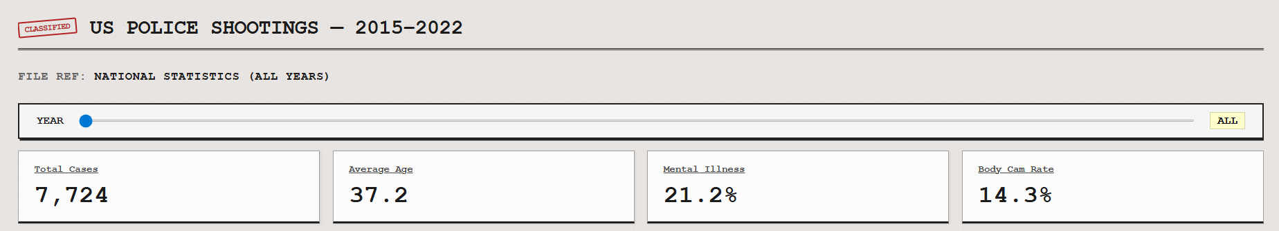
- Year Slider: An input range control allows users to navigate the timeline from 2015 to 2022.
- Synchronized Updates: Every user interaction (sliding the year or clicking a state) invokes the updateDashboard() function. This triggers a cascading update across the KPI panel and the active statistical chart using D3's enter-update-exit pattern.
- Chart Navigation: Unlike static reports, the dashboard features a Tabbed Navigation System (.chart-nav). Users can toggle between different analytical lenses (Top States, Race, Threat, etc.), with the interface dynamically re-rendering the active selection based on the current filters.

4.2 Geographic Visualization (The Map)
The primary interface is an interactive Choropleth Map rendered using the d3.geoAlbersUsa() projection.
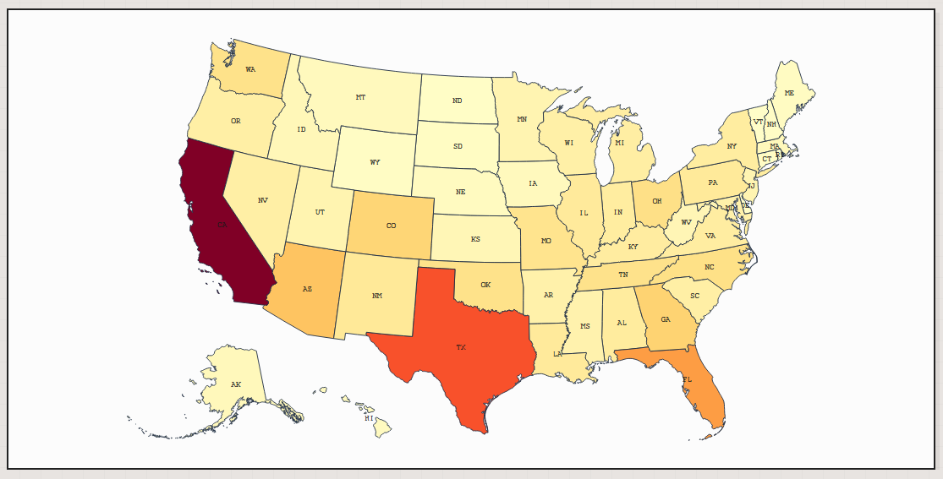
- Color Encoding: States are shaded based on incident density. The visual theme uses a sophisticated "Paper & Ink" palette defined in Dashboard.css, utilizing deep reds (--accent: #b22222) against off-white surfaces to highlight hotspots like California and Texas.
- Interactivity: The map features a Click-to-Zoom mechanic. Clicking a state focuses the projection and sets a centered state variable, which automatically filters the associated statistical charts to display only that specific state’s data.

4.3 The Info Panel (Key Performance Indicators)
Located at the top of the layout, a dynamic grid provides immediate context through four synchronized KPIs:
- Total Cases: Real-time count of incidents based on filters.
- Average Age: Calculated dynamically as filters are applied.
- Mental Illness Rate: Displays the percentage of cases involving known mental health issues.
- Body Camera Rate: Highlights the percentage of transparency (officers wearing cameras).

4.4 Multi-Dimensional Statistical Charts
The statistical panel provides five specialized D3 visualizations designed to reveal the correlations identified in the Cramér’s V analysis:
- Top 5 States by Cases (Multi-series Line Chart): Tracks the annual frequency of incidents for the five highest-volume states over time. This highlights temporal trends rather than static counts.
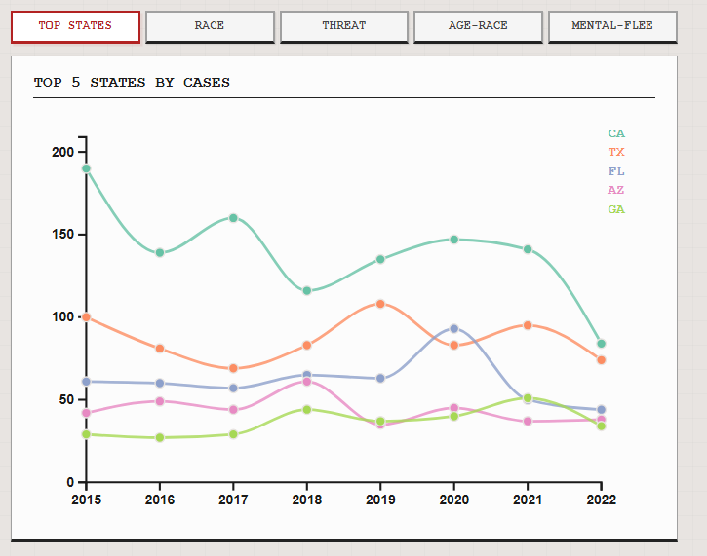
- Race Distribution (Bar Chart): A horizontal bar chart that visualizes the frequency of cases across racial groups, highlighting the significant disparities found in the data.
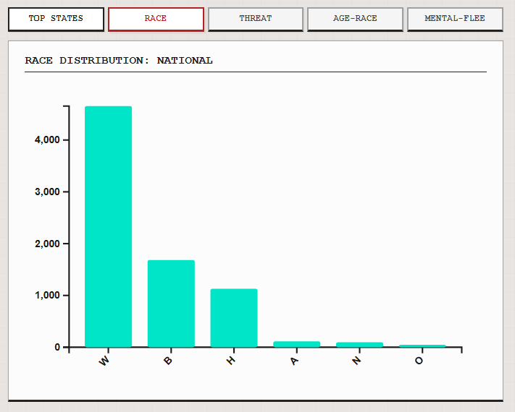
- Threat Level Distribution (Donut Chart): A proportional visualization that categorizes incidents into "Attack," "Other," or "Undetermined" to provide behavioral context for the confrontations.
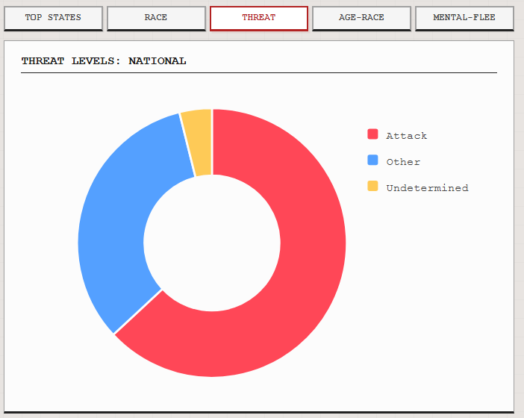
- Age by Race (Box Plot): A sophisticated chart that visualizes the median age and interquartile range for each racial group, allowing for an analysis of demographic outliers.
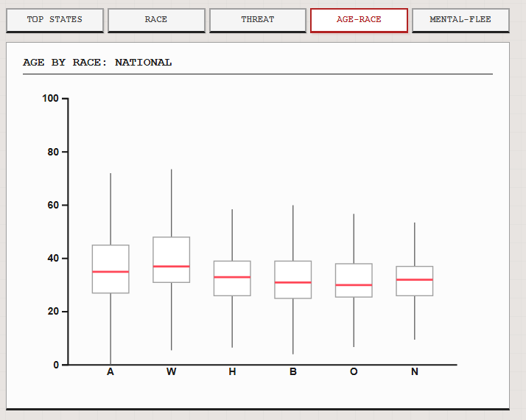
- Mental Illness vs. Fleeing (Grouped Bar Chart): It compares the behavior of individuals (Not fleeing, Car, Foot, etc.) against their mental health status, revealing critical patterns in high-stress police encounters.
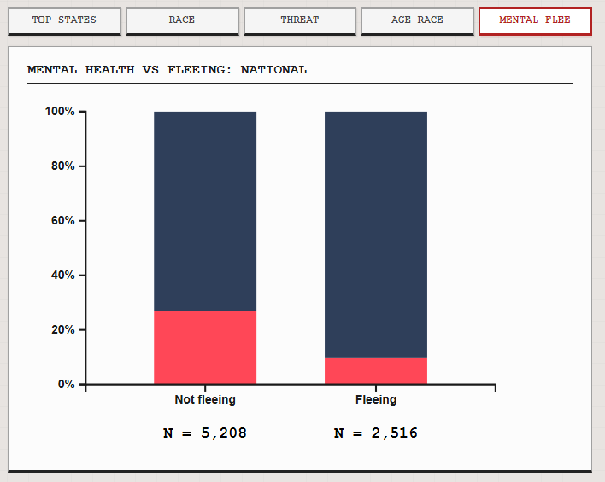

5. Data Analysis and Finding
This section provides an overview of the complete analysis on the data collected from 2015 to 2022, interpreting patterns based on statistical indicators and observed distributions illustrated in previous sections.

5.1 Key Performance Metrics Analysis
The overall data demonstrates a few key areas of concern in regard to policing transparency and public health:
- Transparency gap: The body camera rate from all the recorded data is 14.32% and shows that there are still visual transparency gaps in many jurisdictions between the years of 2014 to 2022.
- Mental health crisis response: This variable revealed that 21.22% of all subjects showed signs of mental illness making it clear that reform is to be within this pivotal area in police intervention service provision.
- Volume & Stability: Fatal shootings remained surprisingly stable — a time-series average of 950–1,050 per year suggesting an enduring national matter.
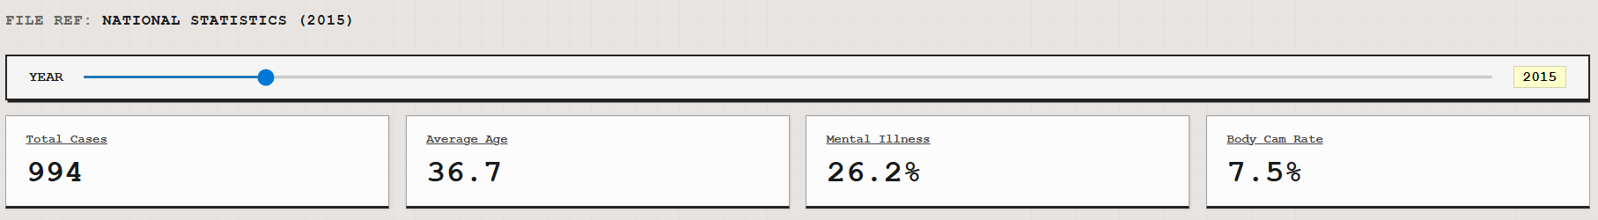
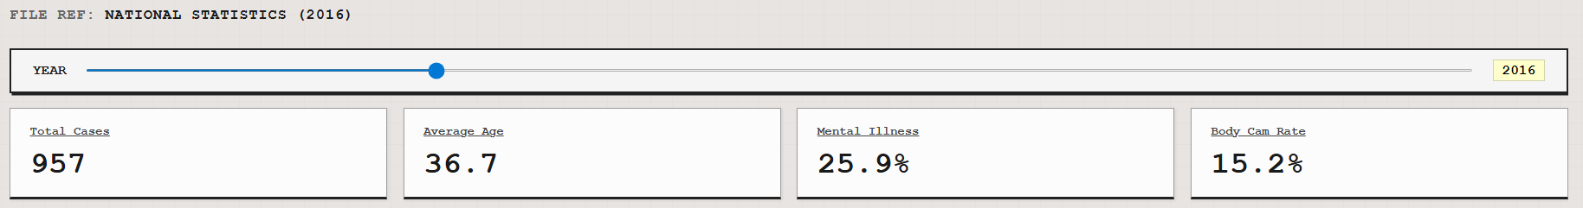
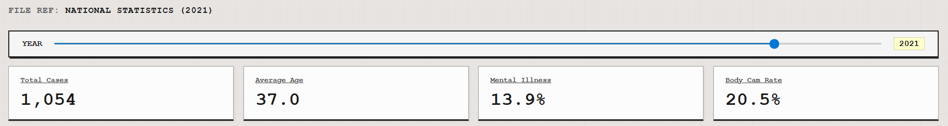

5.2 Demographic and Behavioral Trends
- Racial Disproportionality: While the highest number of cases by race is among Whites (4,655), Blacks and Hispanics are disproportionately represented relative to their share of the total US population.
- Age and Race Correlation: Black and Hispanic subjects (mean ages 31 and 33 respectively) engaged in the use of these Type A weapons are statistically younger than White subjects (mean age = 37).
- The freeze response: The data suggests that individuals experiencing a mental health crisis are far less likely to attempt to escape than those who are not in crisis. These statistics support the observation that those in a mental health crisis are significantly more likely to remain stationary potentially experiencing a "freeze" response rather than fleeing the scene during a confrontation.
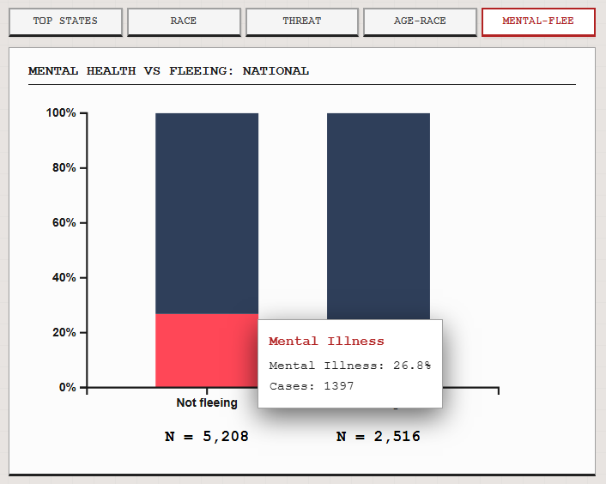
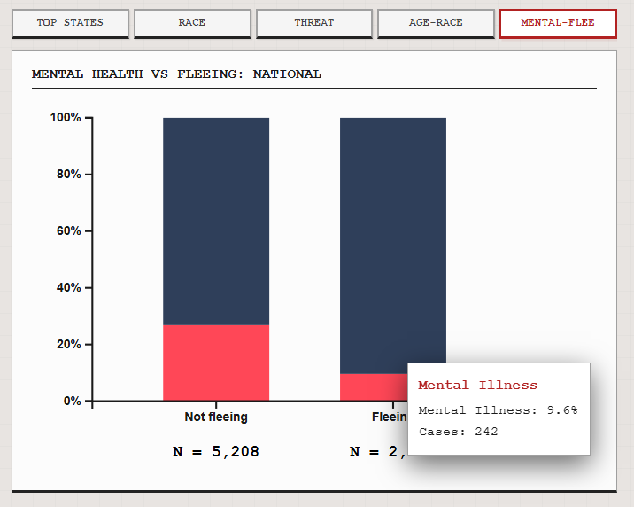

5.3 State-Level and Longitudinal Trends
- Regional Differences: Then there are the "Big Three" — California, Texas and Florida. The decline from the high level in 2015 in California indicates state-level policy changes may have an effect, meanwhile, Florida saw a nearly fifty percent increase over previous years for cases during 2020.
- Evolution of Transparency: National transparency is increasing, with the police use of body cameras growing from 9% in 2015 to a peak of 20.5% in 2021.
- Changing Methods of Reporting: The reporting of signs of mental illness is trailing off, but this could just be due to higher standards for documentation or classifying such events over the years than a reduction in these incidents.
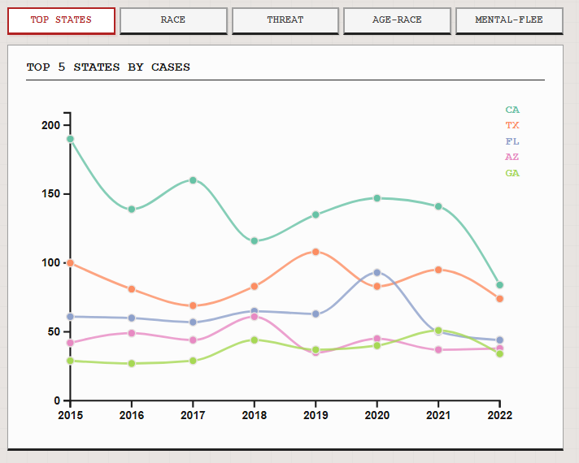

6. Conclusion
Using a dataset of 7,729 incidents aggregated over time and space to create an interactive visual narrative that shines light on the salient features marked in patterns of US law enforcement engagements. How to utilize data-cleansing tasks and advanced visualizations via D3. In Python js, we went a lot deeper than the media reports from news agencies and looked for behavioral and demographical patterns.
Thus, the consistent number of police shootings almost exactly 1,000 a year is indicative of it being an ongoing national problem as opposed to isolated incidents. The interactive dashboard built for this project will be an indispensable research and policy tool, allowing researchers and policymakers to provide the evidence needed to advocate for reforms related to policing, mental health support, and public transparency.

References
Dataset
[1] Mandyam, A. (2023). US Police Shootings from 2015–2022. Kaggle. Retrieved from https://www.kaggle.com/datasets/ahsen1831/uspoliceshooting
Tools & Libraries
[2] Bostock, M., Ogievetsky, V., & Heer, J. (2011). D³: Data-Driven Documents. IEEE Transactions on Visualization and Computer Graphics, 17(12), 2301–2309. https://doi.org/10.1109/TVCG.2011.185
[3] Observable / D3.js Community. (2023). D3.js — Data-Driven Documents (Version 7) [JavaScript library]. Retrieved from https://d3js.org
[4] Bostock, M. (2023). TopoJSON (Version 3) [JavaScript library]. GitHub. Retrieved from https://github.com/topojson/topojson
Statistical Methods
[5] Cramér, H. (1946). Mathematical Methods of Statistics. Princeton University Press.
[6] Cohen, J. (1988). Statistical Power Analysis for the Behavioral Sciences (2nd ed.). Lawrence Erlbaum Associates.
[7] Tukey, J. W. (1977). Exploratory Data Analysis. Addison-Wesley.

