Course: PRF192 - Programming Fundamentals

CAR RENTAL & CUSTOMER MANAGEMENT SYSTEM

Group No: 1
Group Members | Nguyễn Hoàng Duy – SE201125  ……….  ……….
Lecturer
Class

Ho Chi Minh, April – 2026

Table of Contents

Table of Contents 2
1. Introduction 3
1.1. Project Description 3
1.2. Project Team 3
2. Requirement Analysis & Decomposition 3
2.1. Data 3
2.2. Functions 3
3. Algorithm Design & Flowcharts 3
4. Implementation of Basic Functions 3
5. Structure Design 4
6. File I/O & Testing 4
7. Experimental Results 4
8. Appendix 4

1. Introduction

1.1. Project Description
The project develops a Car rental and customer Management System using the C programming language.
The program allows managing the car rental and their customer, check the time for car rental, calculate the cost rental car of the customer and other basic functions.
Name of this system is RC-NHD

1.2. Personal Project
# | Student ID | Full Name | Completion Level | Tasks Performed
1 | SE201125 | Nguyễn Hoàng Duy | … | Do all Project (personal project)  - Describe personal project and decompost functions of system.  - Draw flowchart to present logic the manage system will run.

2. Requirement Analysis & Decomposition

2.1. Data
2.1.1 Vehicle Invetory
# | Name | Description
1 | CarID | Each Car has a ID unique
2 | Brand | Brand of the car like Toyota, Ford,…
3 | Model | Model of the brand car
4 | Year | Year product that car
5 | DailyRate | The cost rent car for a day
6 | Available(0) | A car is not rented
7 | Rented(1) | A car is rented
8 | Maintenance(2) | A car is maintenance
9 | Password | The password only Admin can access the Rental car system to edit and update
10 | listCar | List rental cars

2.1.2 Rental Tracking
# | Name | Description
1 | RentalID | Each rental car has a ID unique and it is used for customer
2 | CustomerName | Name of the customer rent car
3 | CarID | Each Car has a ID unique
4 | Duration | The time rental car of the customer
5 | customerInfor | Require information of customer include Name, phone number, ID card.
6 | Status | Have 3 status: available (0), rented(1), maintenance (2)
7 | DailyRate | The fee for rental call in a day
8 | Cost | The cost for customer Pay
9 | FinalCost | Final cost of customer when they apply their discount
10 | Discount | Discount for customer when they rent car in a long time
11 | totalRevenue | Total revenue of the shop
12 | Price (Luxury, Premium, Medium) | Luxury: 1500$/day  Premium: 1000$/day  Medium: 500$/day
13 | listRental | List cars are rented by customer

2.2. Functions
2.2.1 Vehicle Inventory
# | Function | Description
1 | addVehicles | Add new car into inventory
2 | removeCar | Remove the Car in the Inventory
3 | updateRentalRate | Update the cost rental car (>=500$/day)

2.2.2 Rental Operations
# | Function | Description
1 | calculateCostRental | Calculate the cost for a rental car of customer (based brand, duration, model), Cost = DailyRate * Duration
2 | rentalDiscount | If the rental period is longer than 7 days, a 10% discount is offered. If the rental period is longer than 30 days, a 20% discount is offered.
3 | returnCar | Update status for a car is available

2.2.3 Search & Reports & sort
# | Function | Description
1 | SearchByBrand | Find the car by Brand
2 | SearchByCarID | Find the car by ID car, car ID has code is RCXXX, ex: RC001
3 | SearchByRentalID | Find infor customer by rental ID, it has code is NHDXXX, ex: NHD002
4 | SortByBrand | Sort cars by brand
5 | checkMaintenance | Check the car each 6 month need fix and update
6 | revenueReport | Calculate all revenue of the rental car completed, this help shop can control the cost

2.2.4 Rental Tracking
# | Function | Description
1 | assignCar | Assign a car for customer rental
2 | displayRentalCarList | Display status of each rental car, it like display list of rental car for customer rent
3 | fileterByPrice | Allow customer input their money they have and system will display the rental car suit with them

2.2.5 File
# | Function | Description
1 | saveCars | Save car data into a file list car after finish program
2 | saveRentals | Save rental data into file rentalsList about infor of customer and complete transaction between customer and NC-NHD shop

2.2.6 Menu: Logic of the manage system when it runs.

3. Algorithm Design & Flowcharts
3.1 Menu_RC-NHD
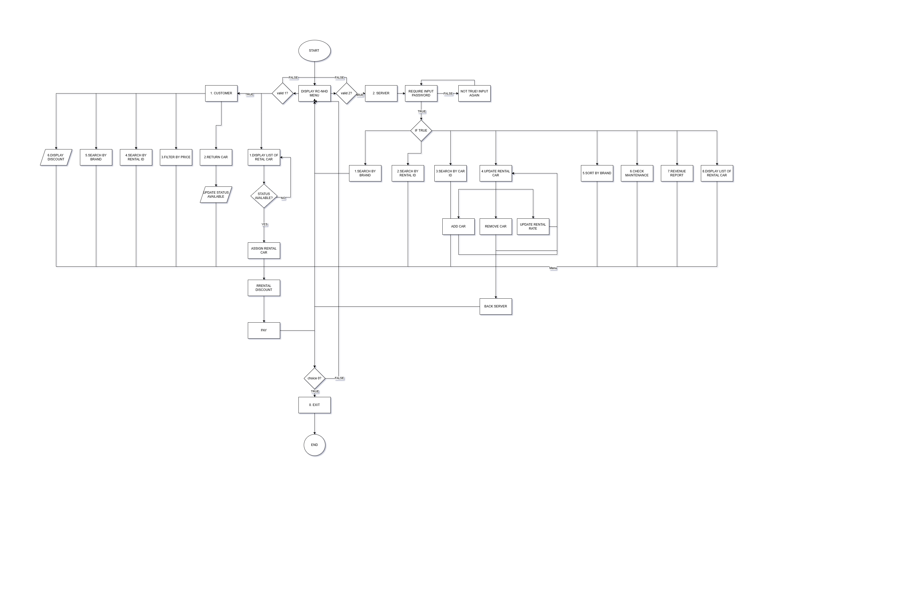
3.2 addVehicle
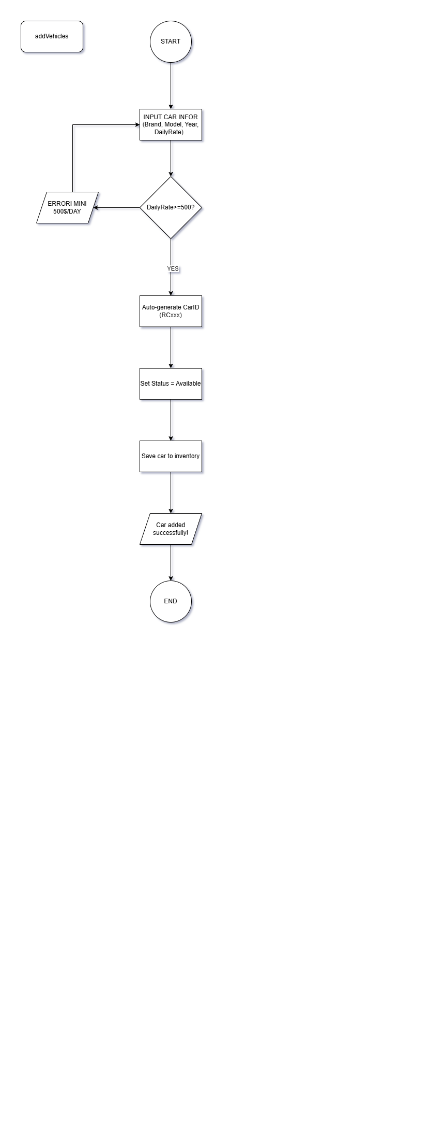
3.3 removeCar
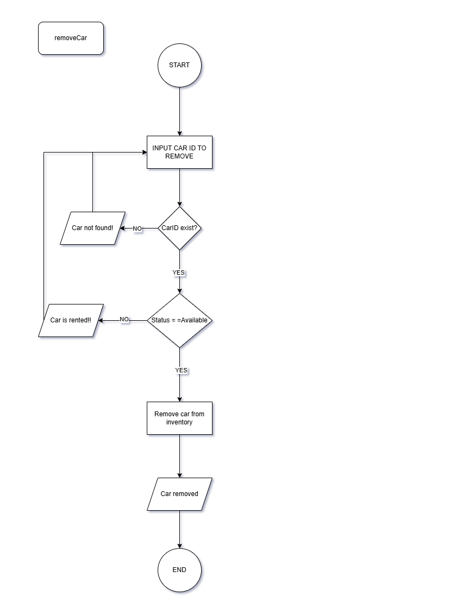
3.4 updateRentalRate
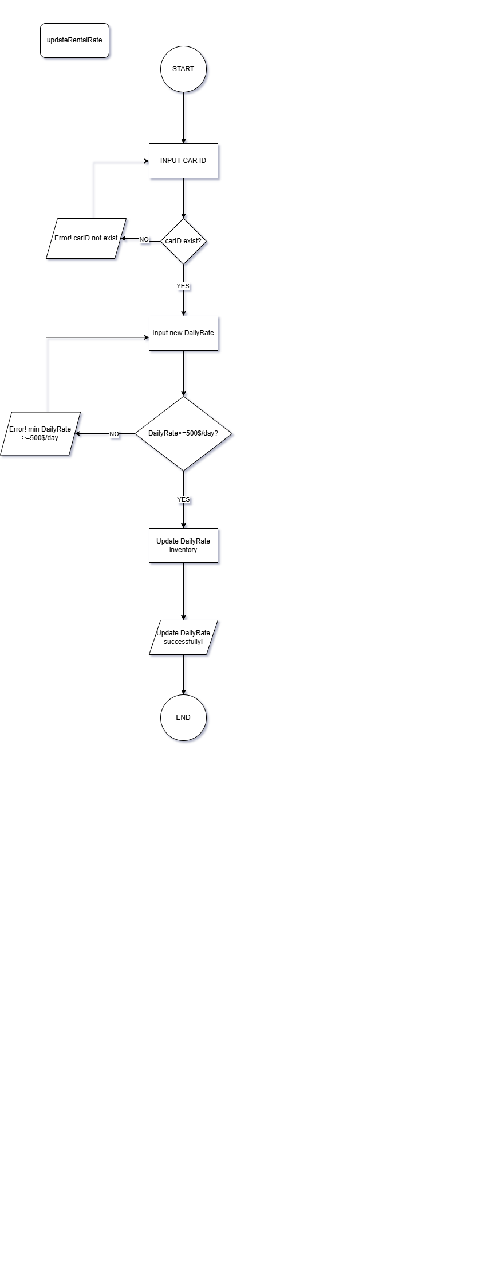
3.5 calculateCostRental
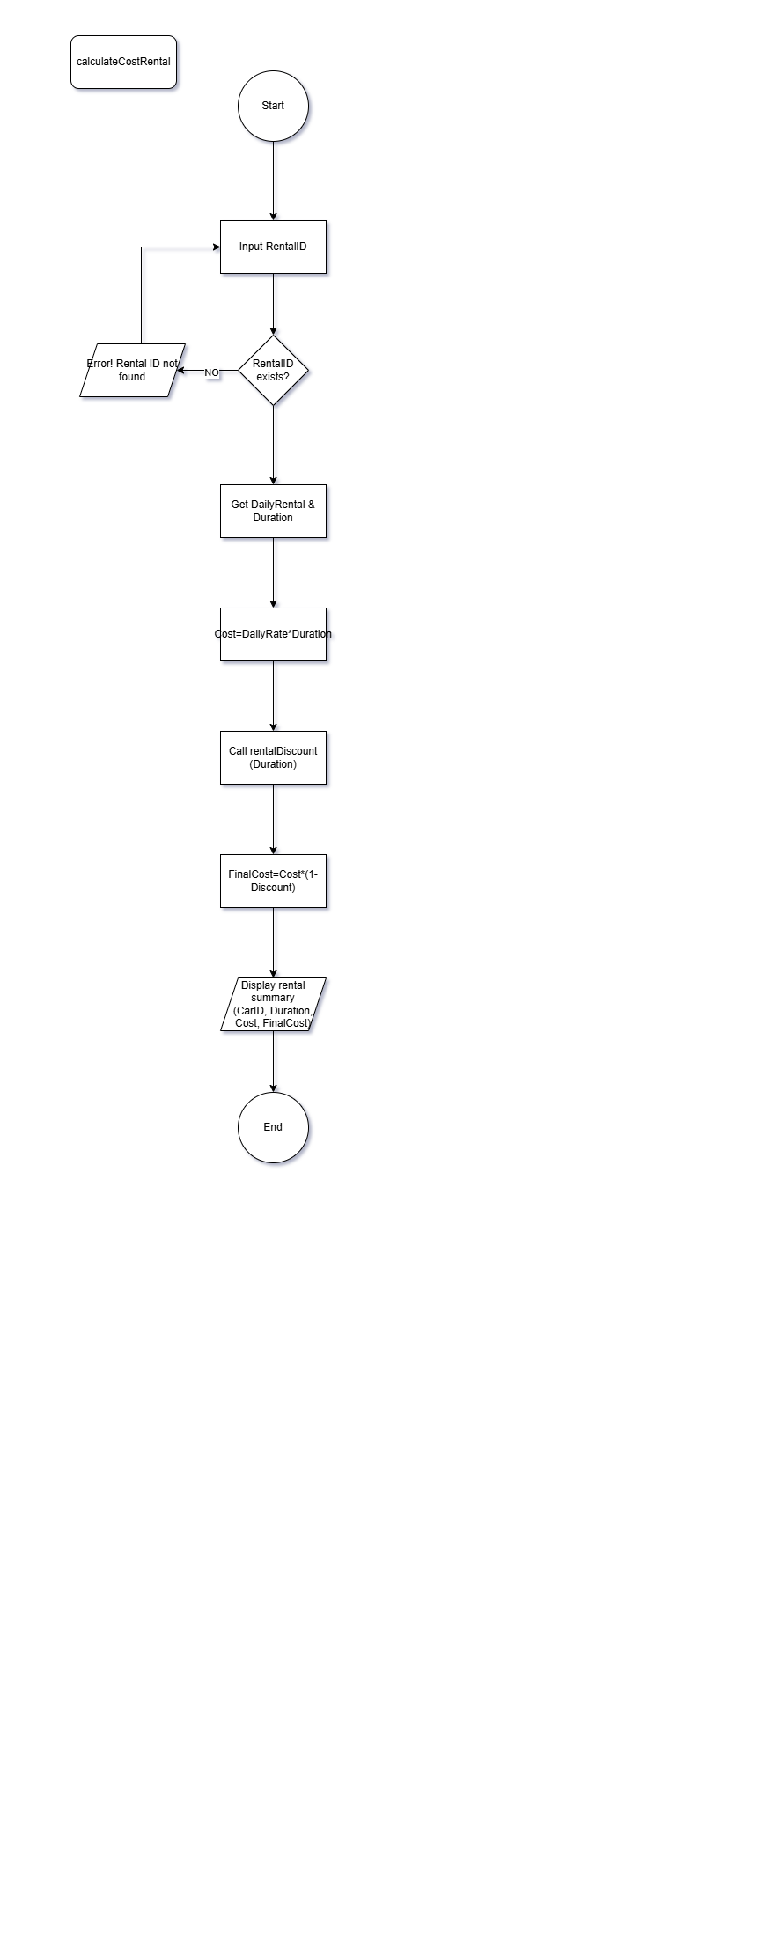
3.6 rentalDiscount
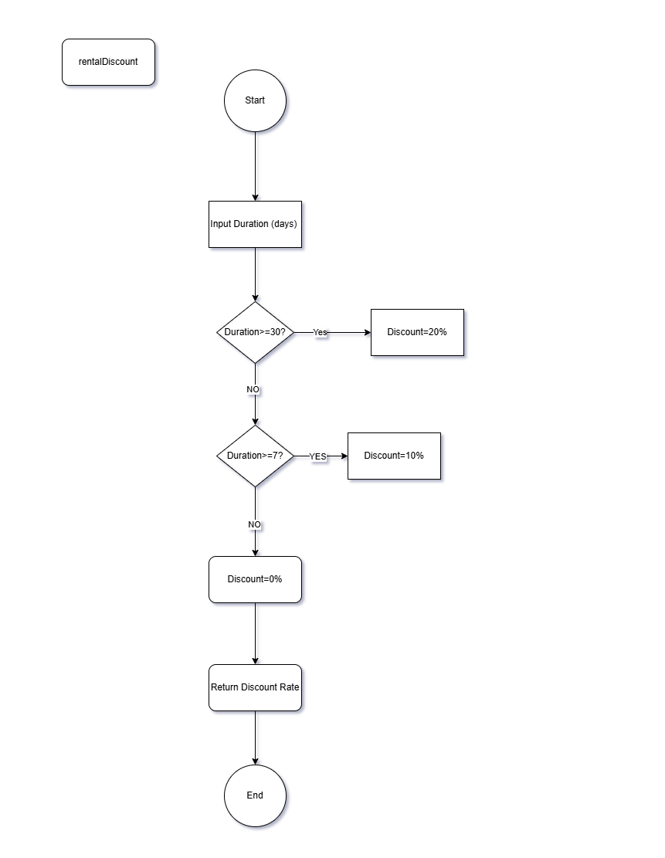
3.7 returnCar
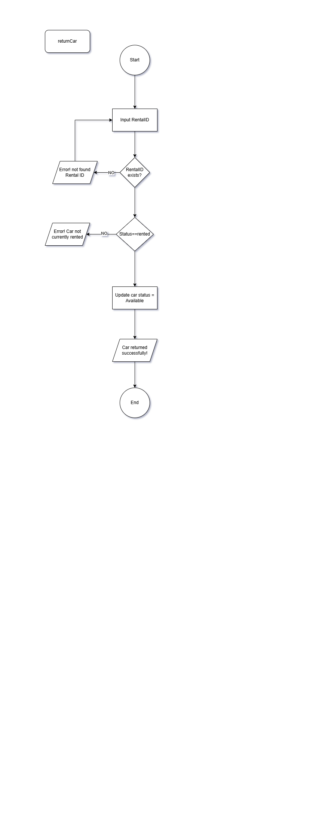
3.8 searchByBrand
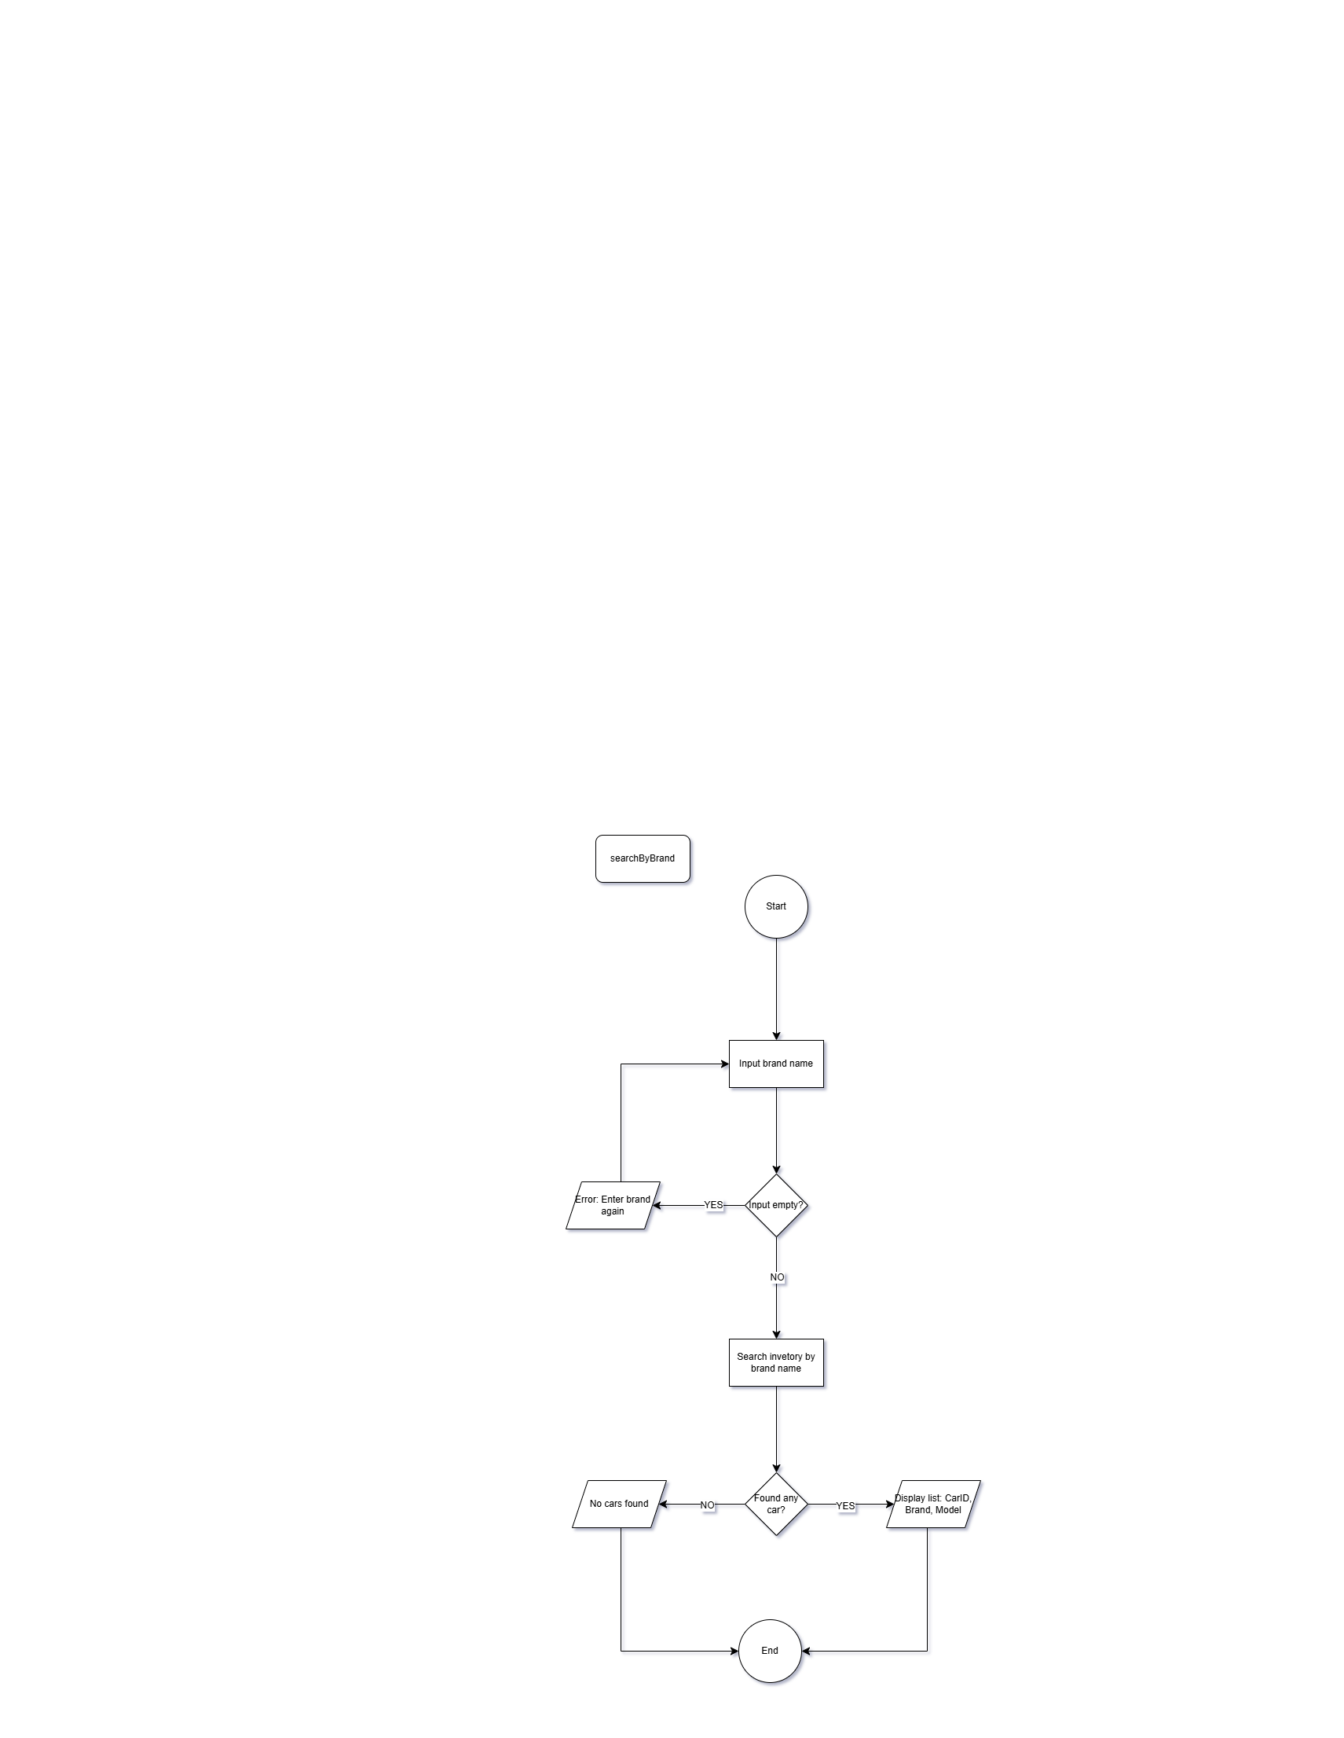

3.9 searchByCarID
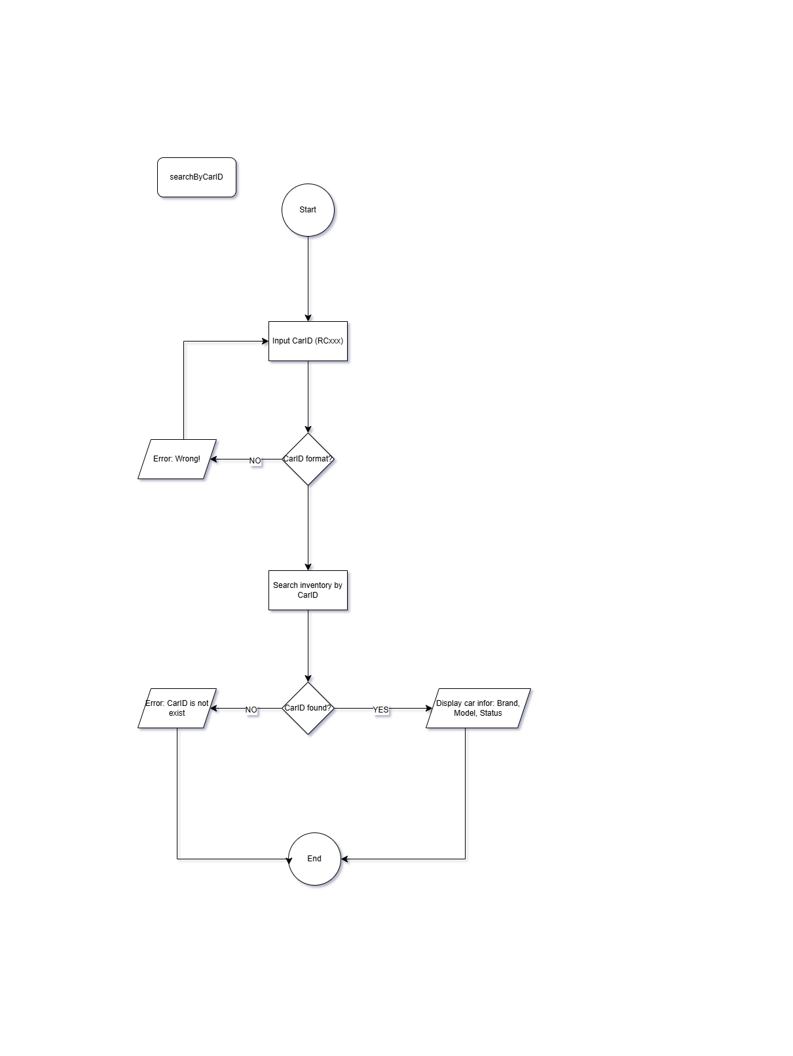
3.10 searchByRentalID
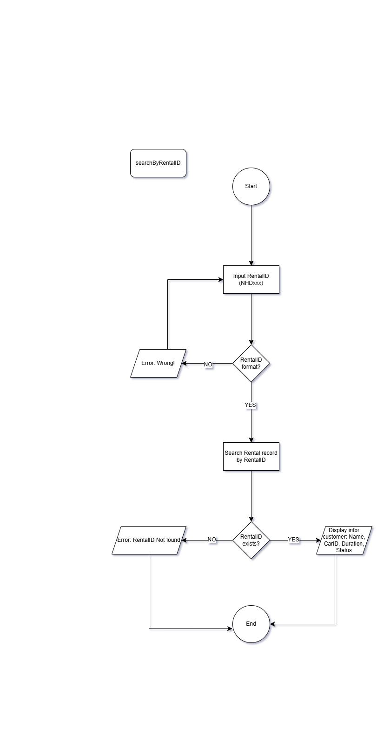
3.11 sortByBrand
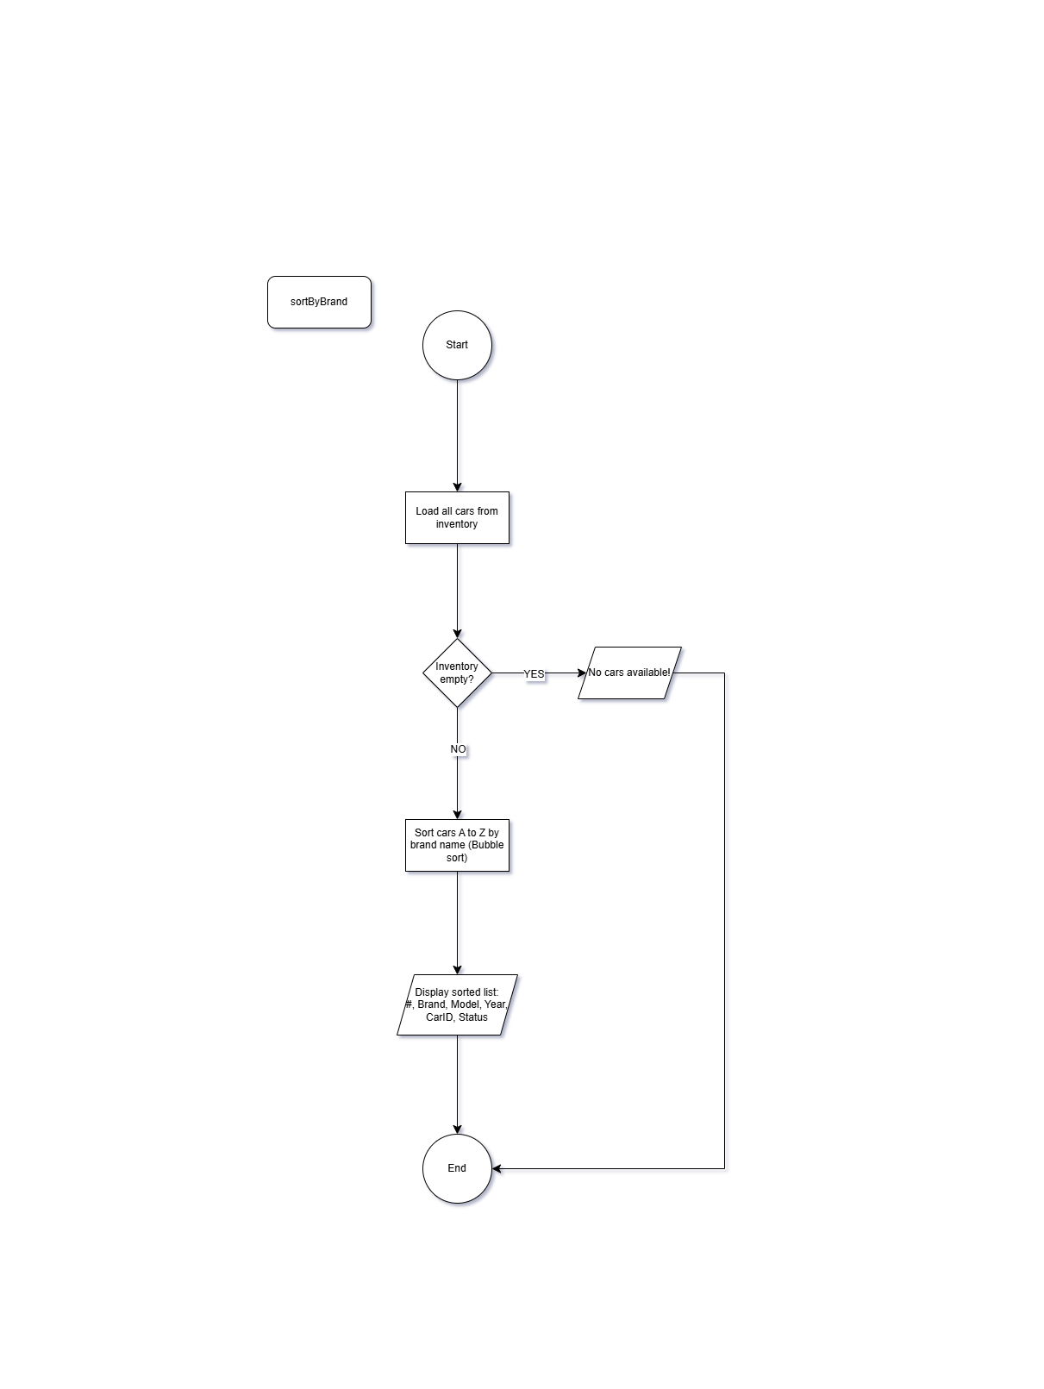
3.12 checkMaintenance
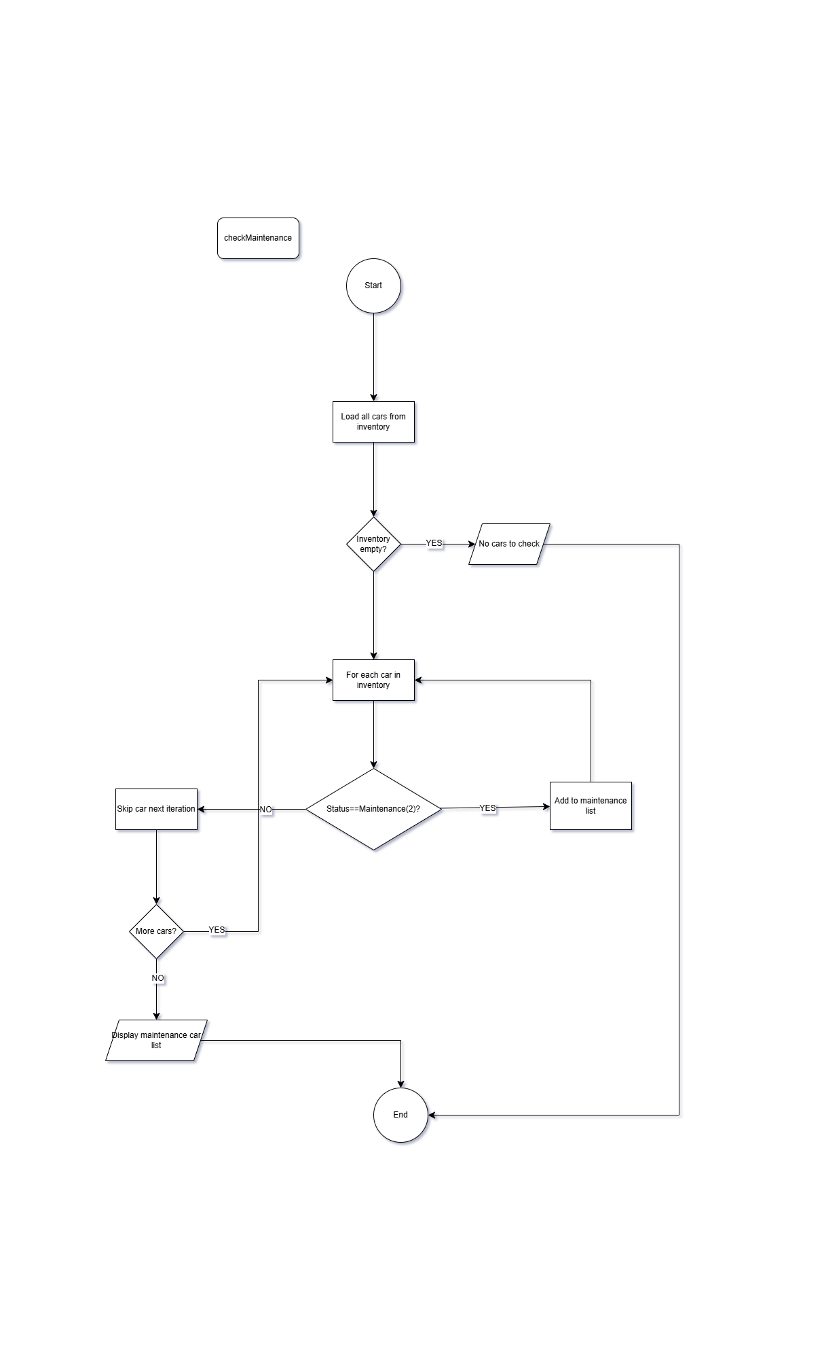
3.13 revenueReport
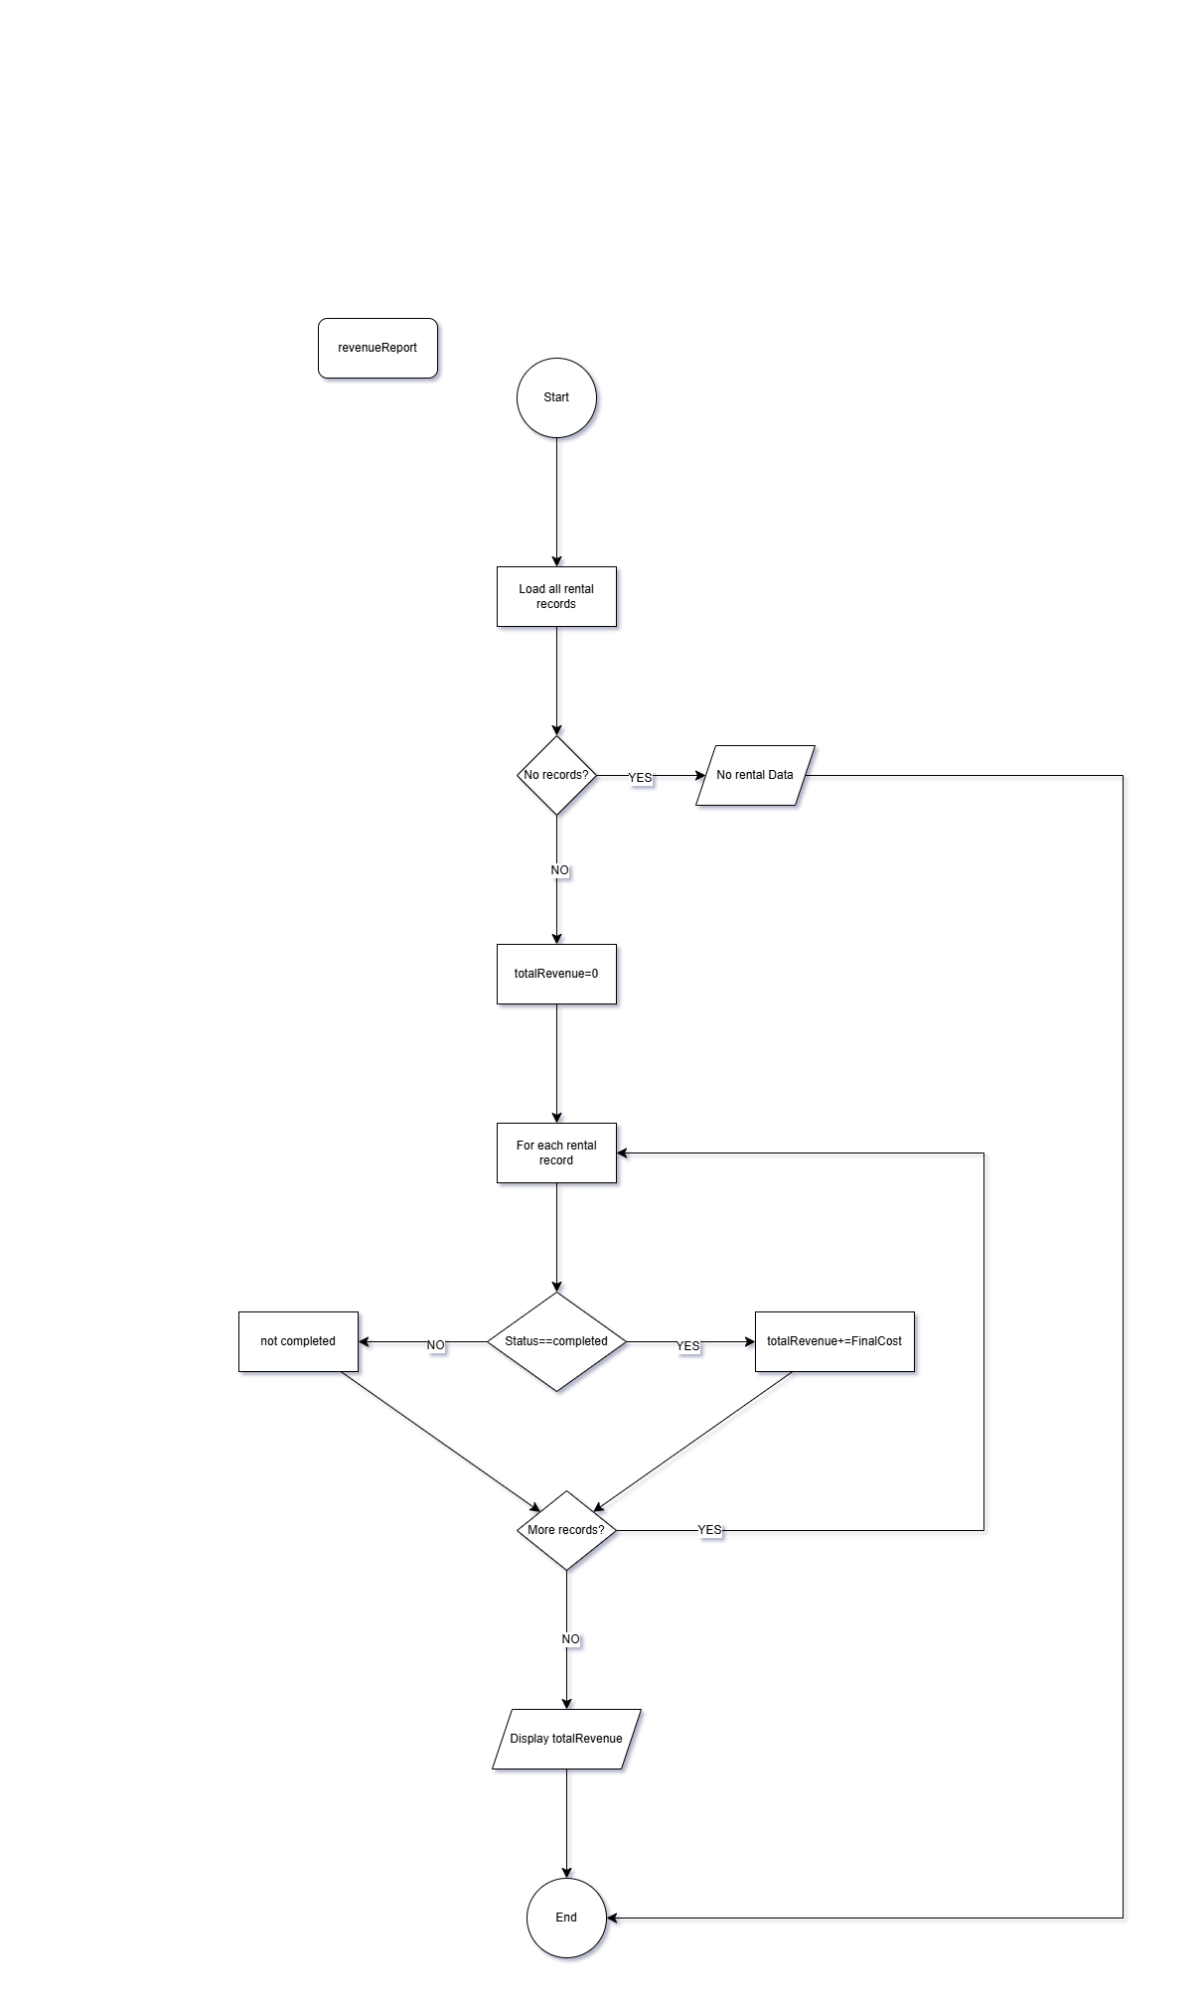
3.14 assignCar
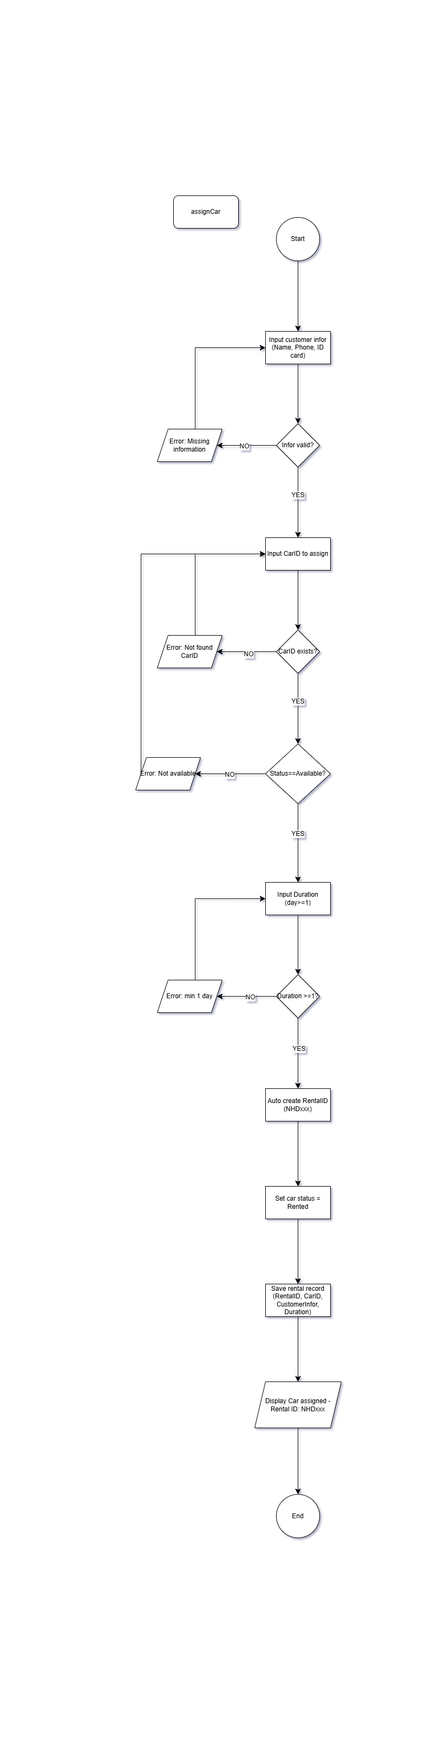
3.15 displayStatusRentalCar
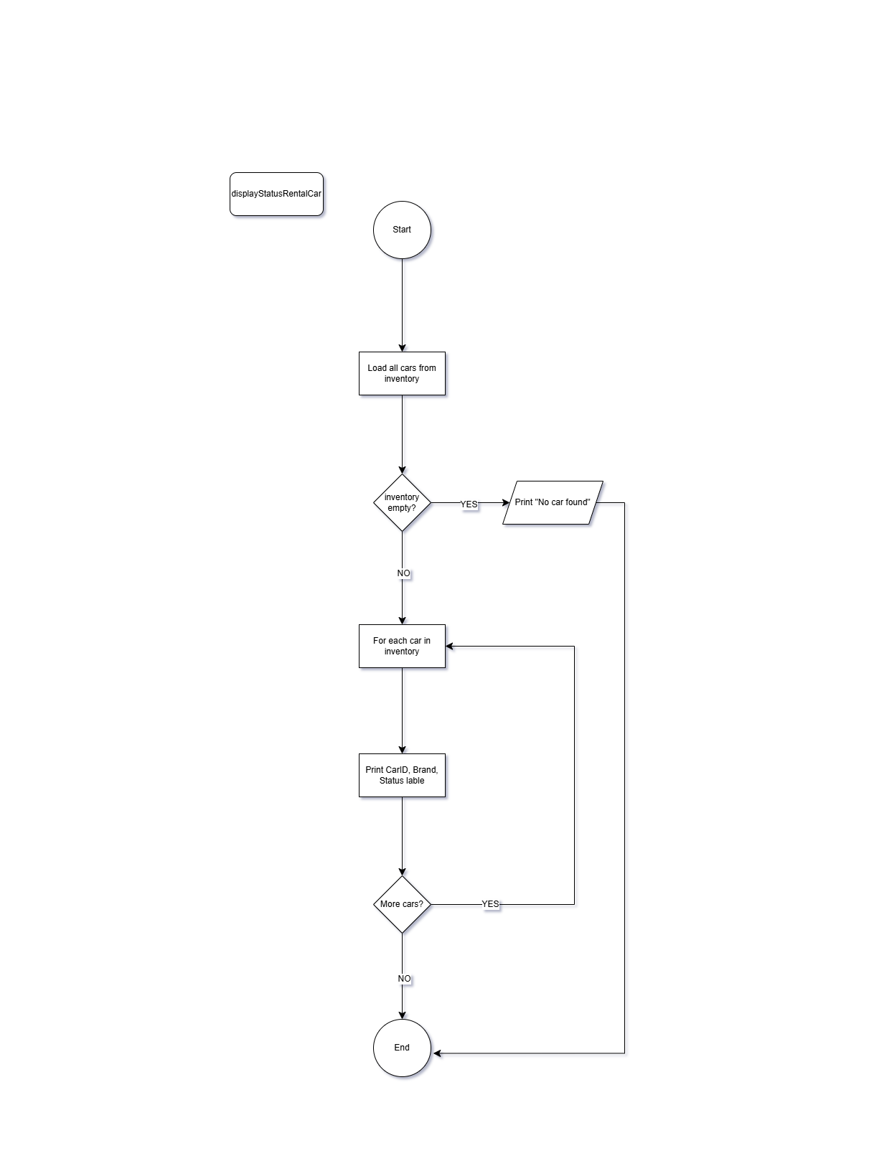
3.16 filterByPrice
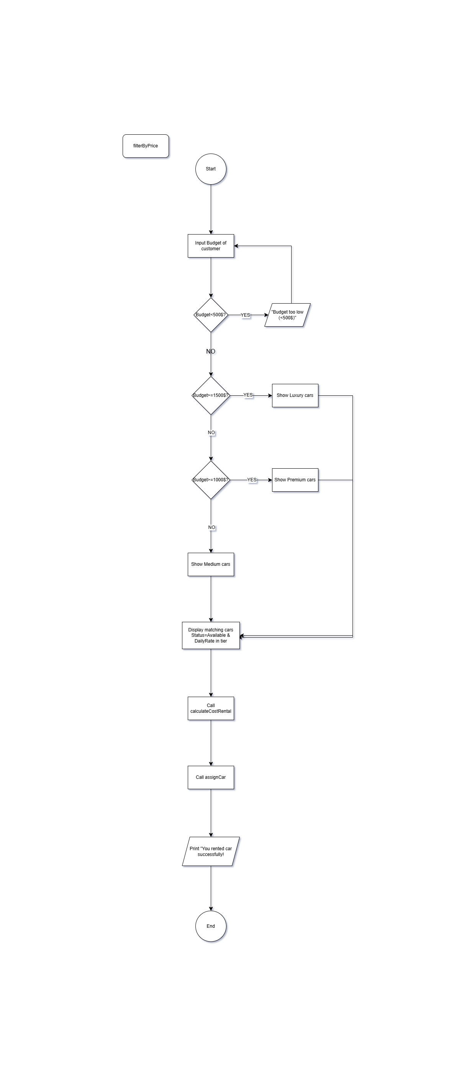

4. Implementation of Basic Functions

5. Structures Design
The program uses files:

6. File I/O & Testing

7. Experimental Results

8. Appendix

