**ĐẠI HỌC QUỐC GIA THÀNH PHỐ HỒ CHÍ MINH**

**TRƯỜNG ĐẠI HỌC CÔNG NGHỆ THÔNG TIN**



**BÁO CÁO ĐỒ ÁN CUỐI KỲ**

**MÔN NHẬP MÔN CÔNG NGHỆ PHẦN MỀM**

**NHÓM 12**

**Sinh viên**

**Nguyễn Hoàng Hải**

**Phan Tiến Lào**

Bank Management System – Team 12

1. Class diagram 3

2. Sequence diagram 4

2.1 – Login 4

2.2 – UML sequence diagram 5

3. Use Cases 6

**Use case diagram** 6

3.1 – Deposit 7

3.2 – Transfer 8

3.3 – Withdraw 9

3.4 – Check balance 10

4.Activity diagram 11

5.State diagram 12

1. Class diagram

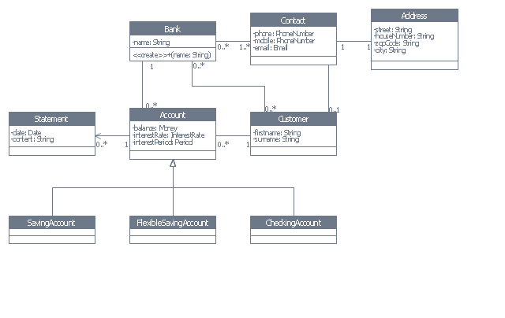

1. Sequence diagram
   1. – Login

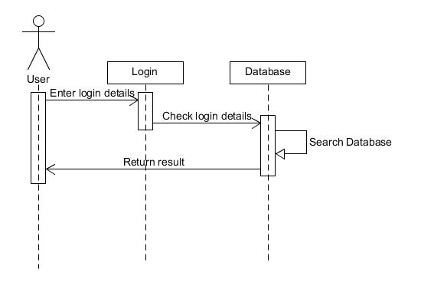

* 1. – Deposit:

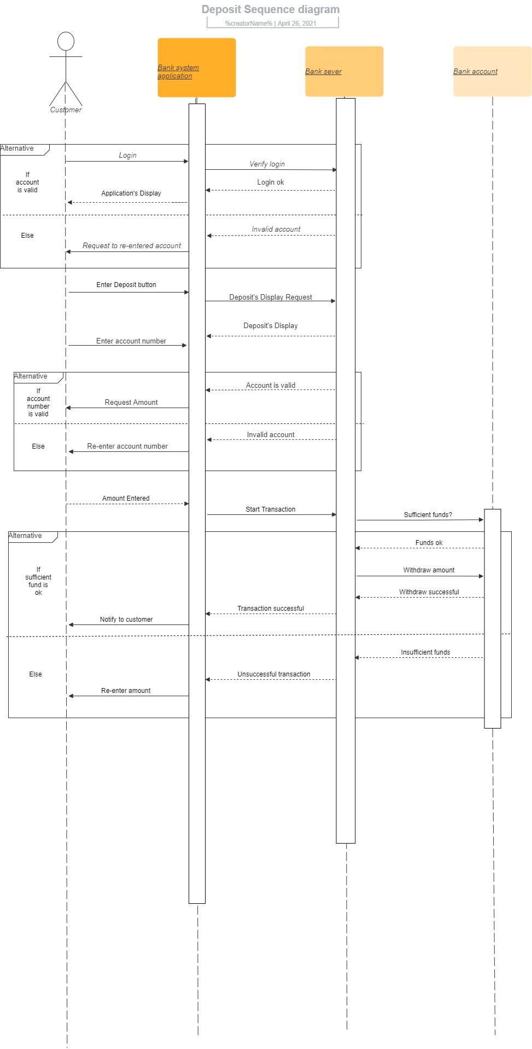

2.3-Transfer:

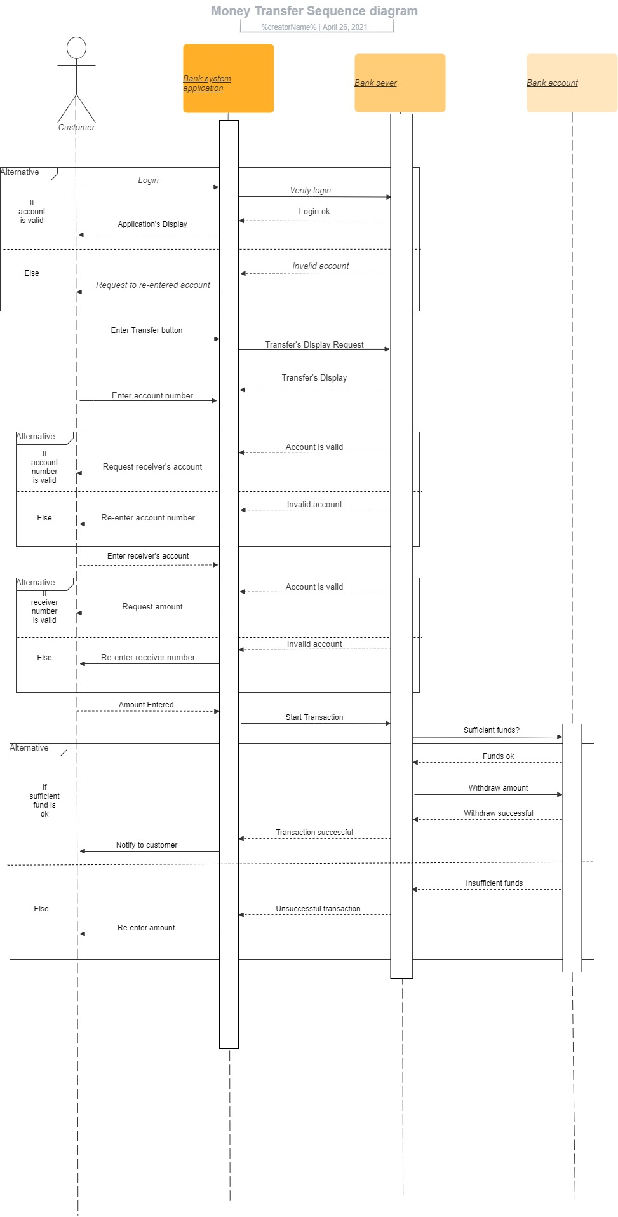

1. Usecase diagram

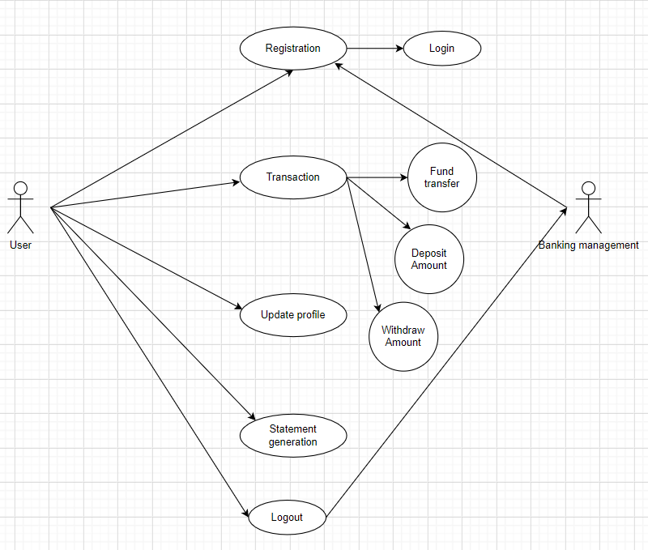

Use-case specification:

* 1. – Deposit

|  |  |  |  |
| --- | --- | --- | --- |
| ID and Name: | **Deposit** | | |
| Created By: | Lào | Date Created: | 4/4/2021 |
| Primary Actor: | User | Secondary Actors: |  |
| Description: | User use this function to search the information of the value they have deposited and to deposit their money | | |
| Trigger: | User want to deposit their money | | |
| Preconditions: | User search their information and fill in the deposit field | | |
| Postconditions: | POST-1. The information gets processed, and their integrity checked.  POST-2. The information will appear in the field  POST-3. User change the deposit amount and the inventory gets updated | | |
| Alternative Flows: | None | | |
| Exceptions: | None | | |
| Priority: | High | | |
| Frequency of Use: | Approximately 20 users, average of one usage per day. Peak usage load for this use case is between 9:00 A.M. and 4 P.M. local time. | | |

* 1. – Transfer

|  |  |  |  |
| --- | --- | --- | --- |
| ID and Name: | **Transfer** | | |
| Created By: | Hải | Date Created: | 4/5/2021 |
| Primary Actor: | User | Secondary Actors: |  |
| Description: | User use this function to transfer the money to another user | | |
| Trigger: | User want to transfer their money | | |
| Preconditions: | User search their information and the transferred user information then fill in the transfer amount, click confirm | | |
| Postconditions: | POST-1. The information gets processed, and their integrity checked.  POST-2. The information will appear in the field  POST-3. User change the transfer amount and the inventory gets updated | | |
| Alternative Flows: | None | | |
| Exceptions: | None | | |
| Priority: | High | | |
| Frequency of Use: | Approximately 20 users, average of one usage per day. Peak usage load for this use case is between 9:00 A.M. and 4 P.M. local time. | | |

* 1. – Withdraw

|  |  |  |  |
| --- | --- | --- | --- |
| ID and Name: | **Withdraw** | | |
| Created By: | Hải | Date Created: | 5/5/2021 |
| Primary Actor: | User | Secondary Actors: |  |
| Description: | User use this function withdraw their money | | |
| Trigger: | User want to withdraw their money | | |
| Preconditions: | User search their information and fill in the withdraw field | | |
| Postconditions: | POST-1. The information gets processed, and their integrity checked.  POST-2. The information will appear in the field  POST-3. User change the withdraw amount and the inventory gets updated | | |
| Alternative Flows: | None | | |
| Exceptions: | None | | |
| Priority: | High | | |
| Frequency of Use: | Approximately 20 users, average of one usage per day. Peak usage load for this use case is between 9:00 A.M. and 4 P.M. local time. | | |

* 1. – Check balance

|  |  |  |  |
| --- | --- | --- | --- |
| ID and Name: | **Check balance** | | |
| Created By: | Lào | Date Created: | 4/4/2021 |
| Primary Actor: | User | Secondary Actors: |  |
| Description: | User use this function to search the information of the money they have in their account | | |
| Trigger: | User want to search the balance in their account | | |
| Preconditions: | User search their information and click search | | |
| Postconditions: | POST-1. The information gets processed, and their integrity checked.  POST-2. The information will appear in the field | | |
| Alternative Flows: | None | | |
| Exceptions: | None | | |
| Priority: | High | | |
| Frequency of Use: | Approximately 20 users, average of one usage per day. Peak usage load for this use case is between 9:00 A.M. and 4 P.M. local time. | | |

1. Activity diagram

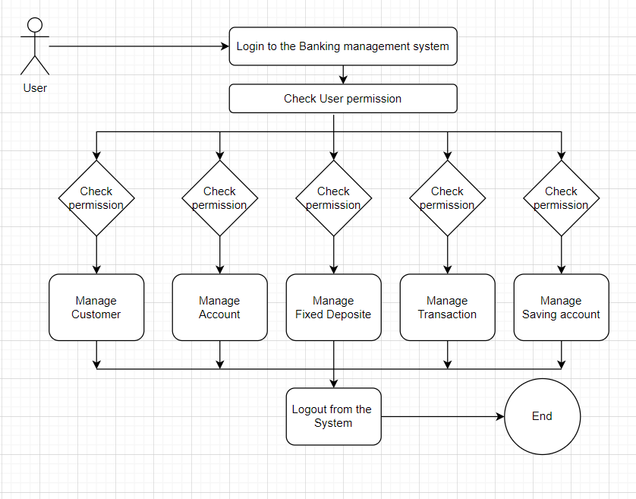

1. State diagram

