Bài Lab 04
Nguyễn Hoàng Khang 22718451
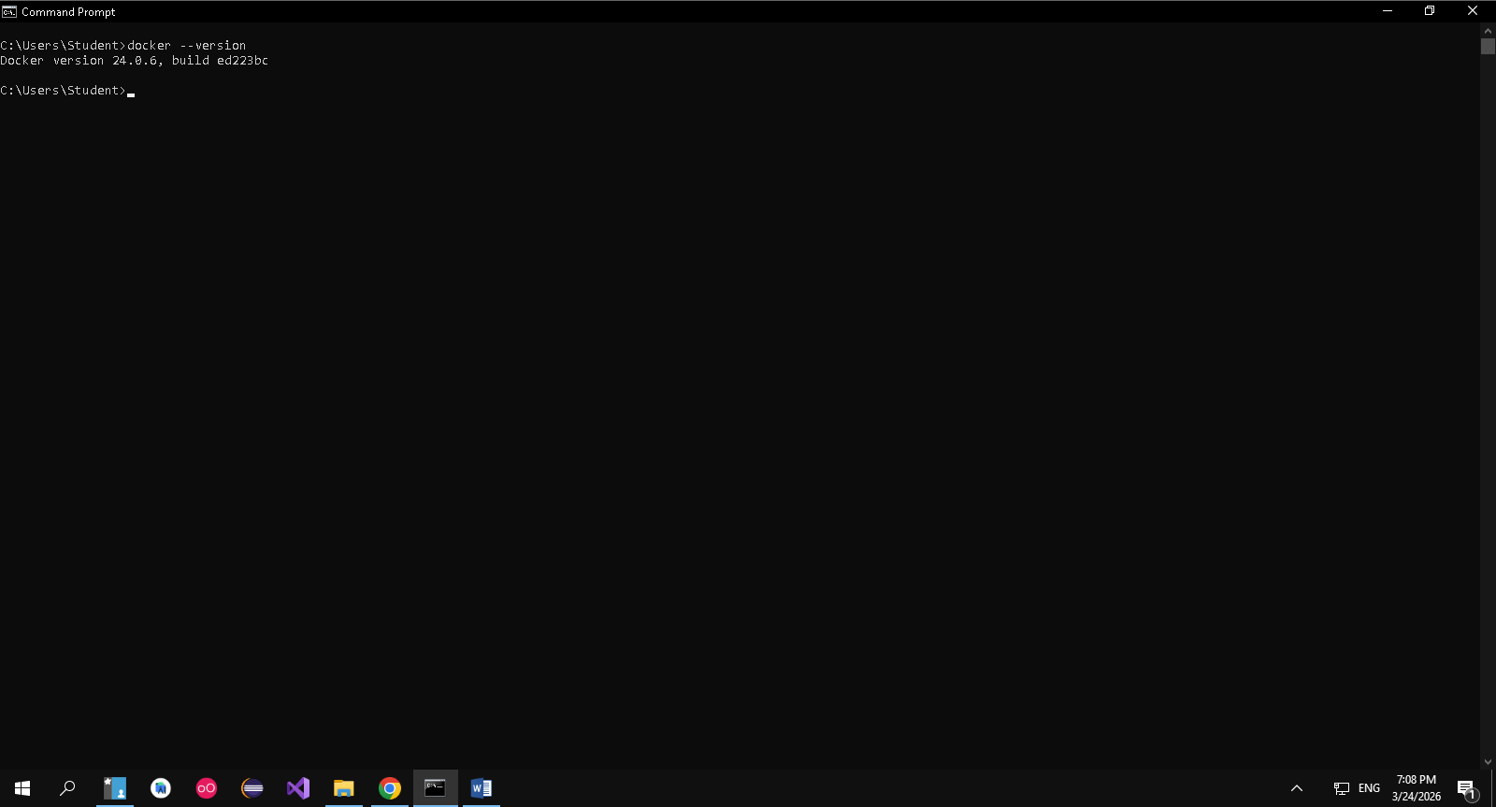
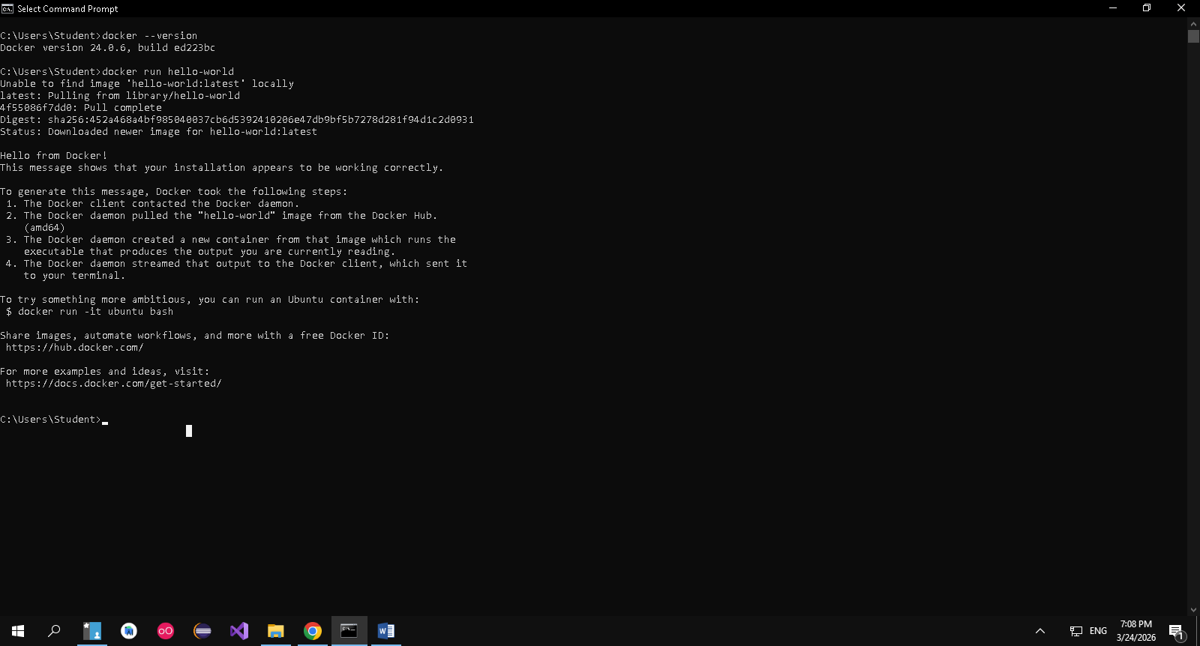
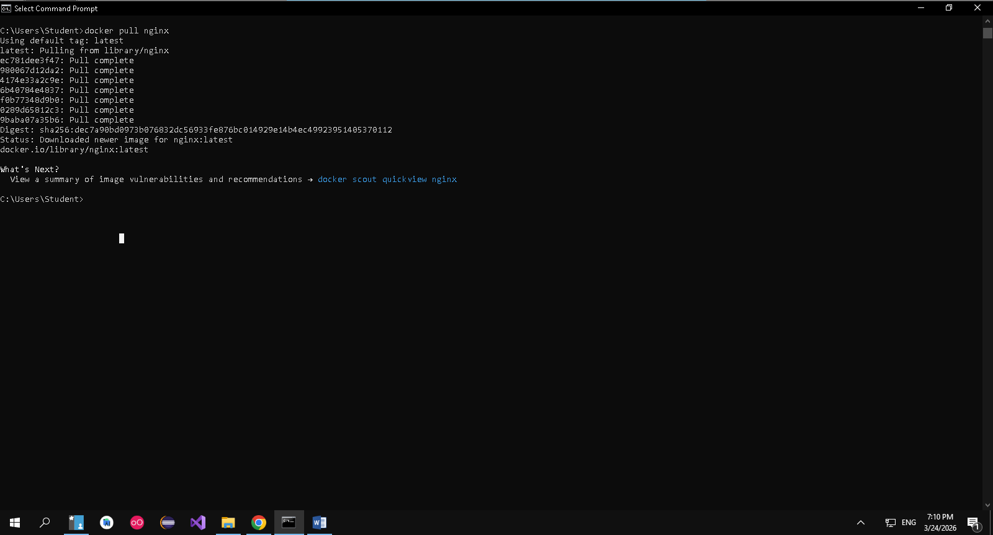
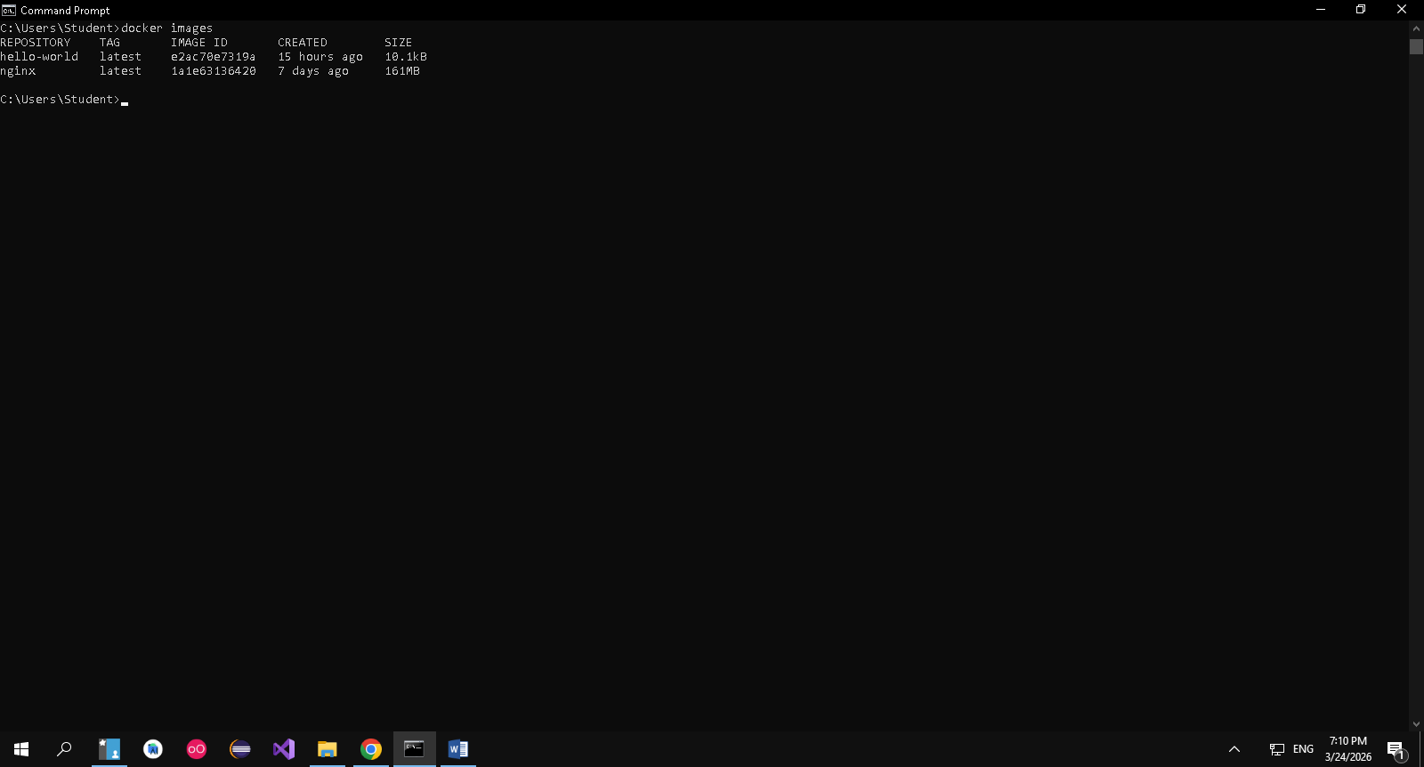
Docker run –d nginx
Docker ps
Docker ps –a
Docker logs <containerid>
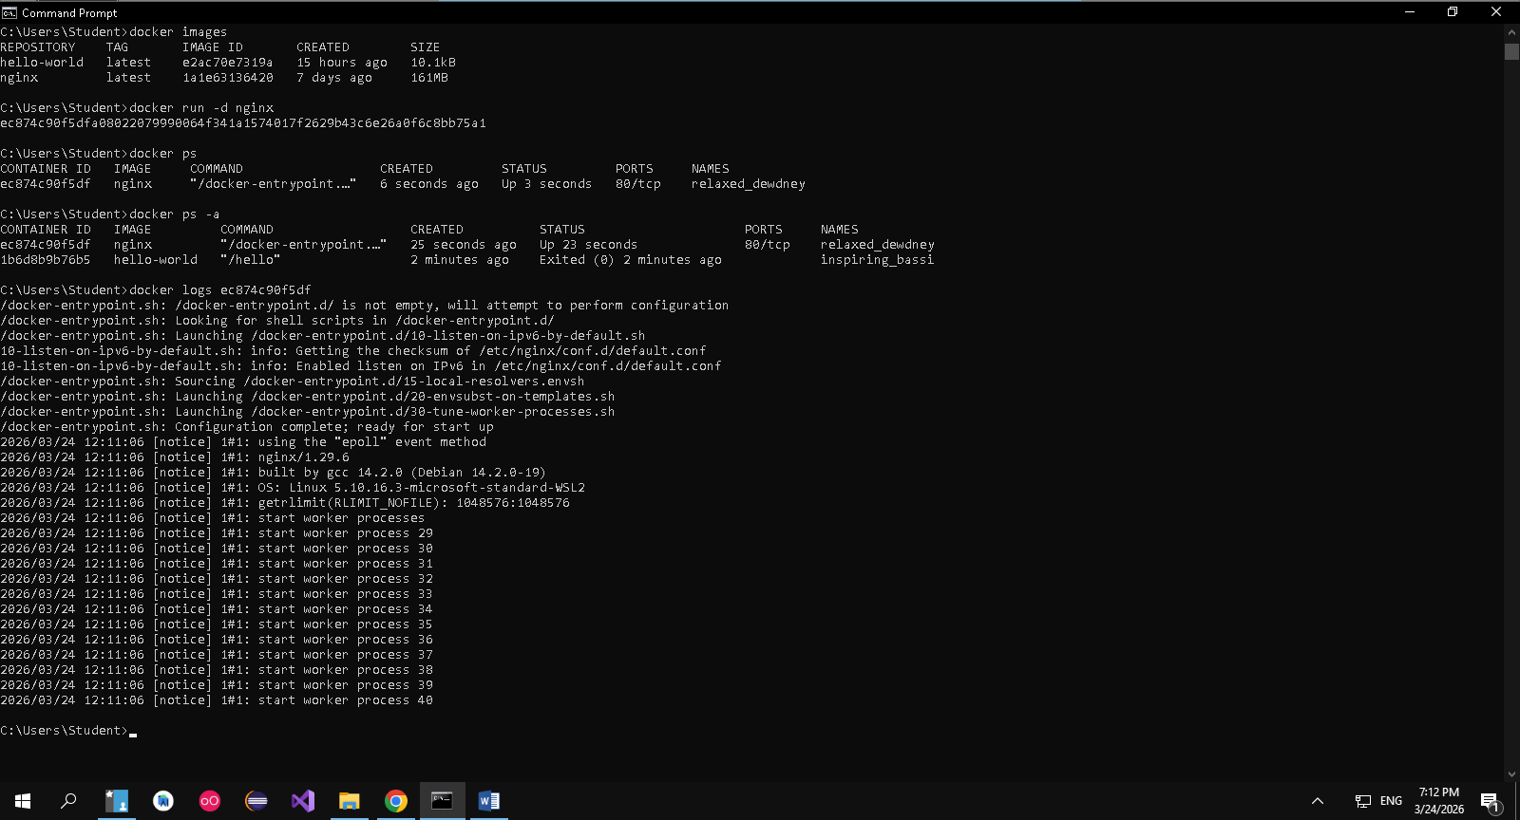
Docker exec –it <containerid>
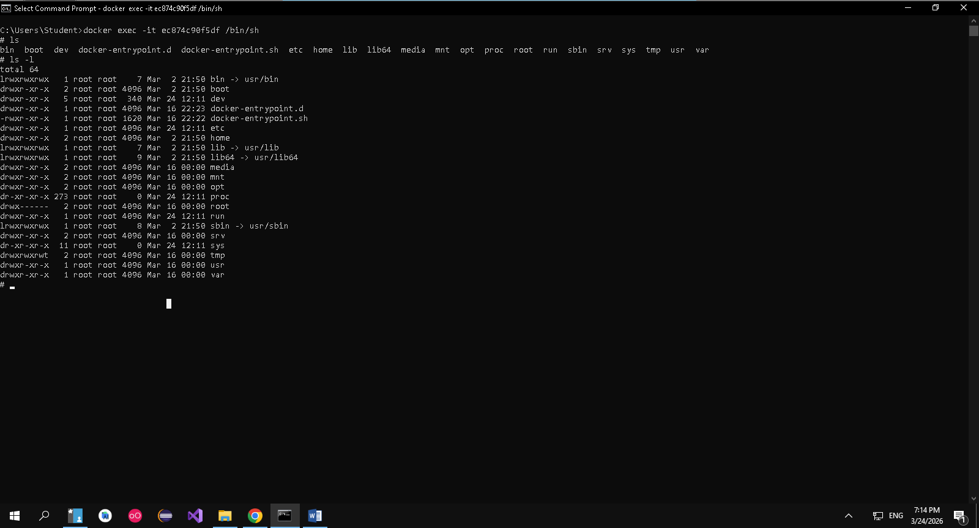
Docker stop <containerid>
Docker restart <containerid>
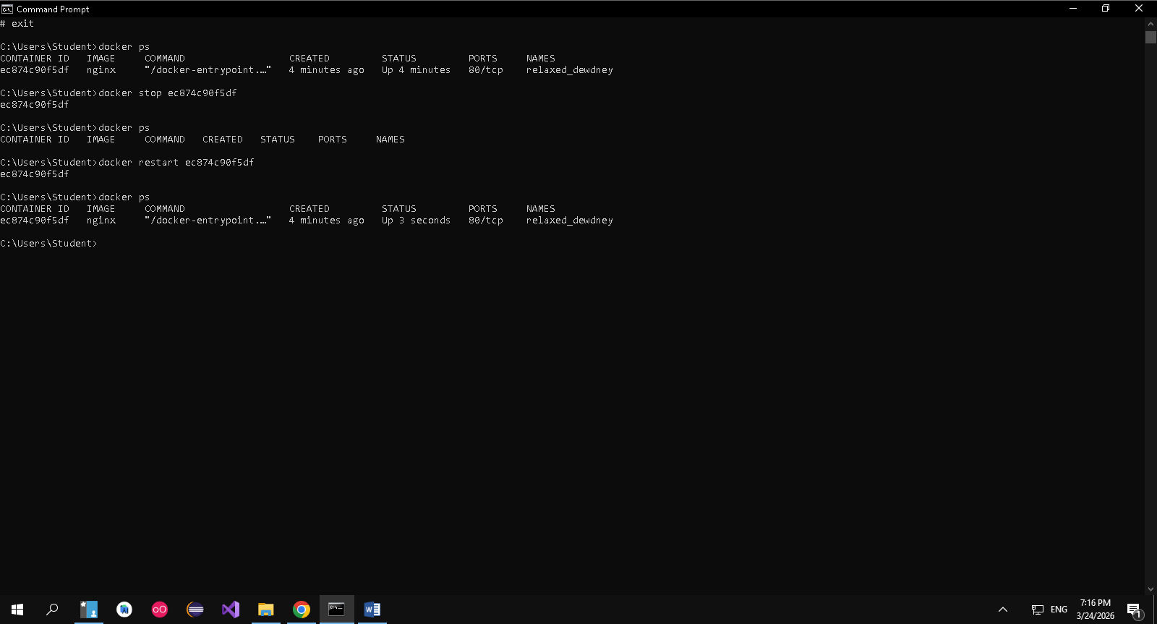
Docker rm <containerid>
Docker container prune
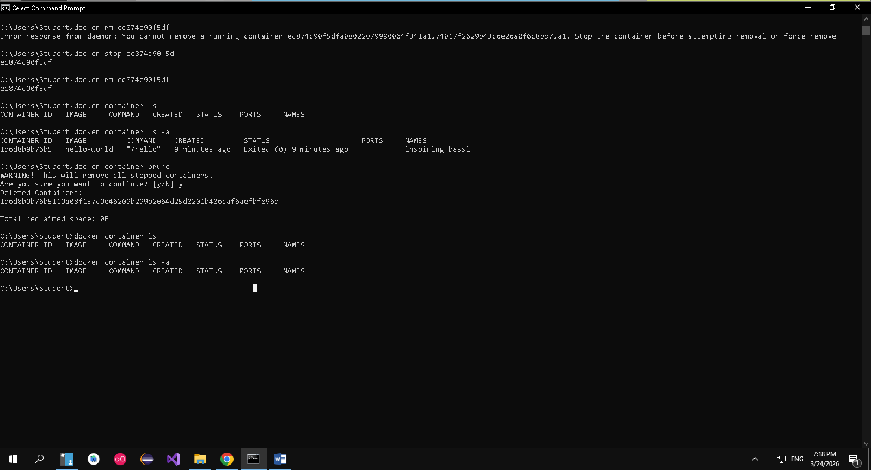
Docker image rm <imageid>
Docker image prune –a
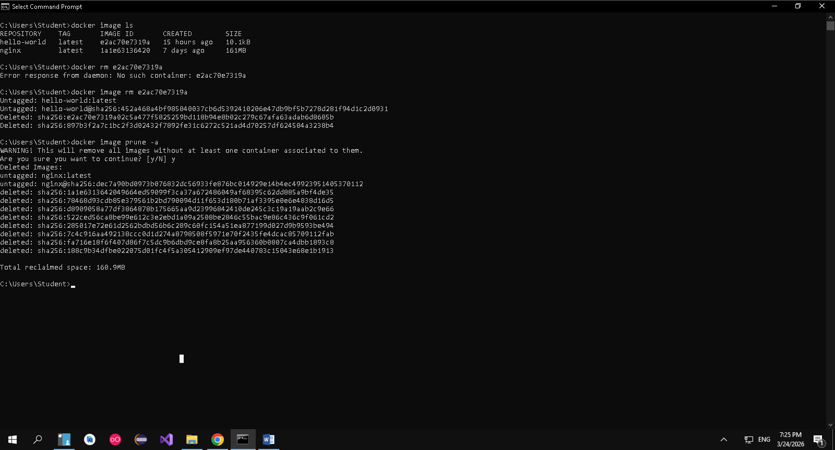
Docker run –d –p 8080:80 nginx
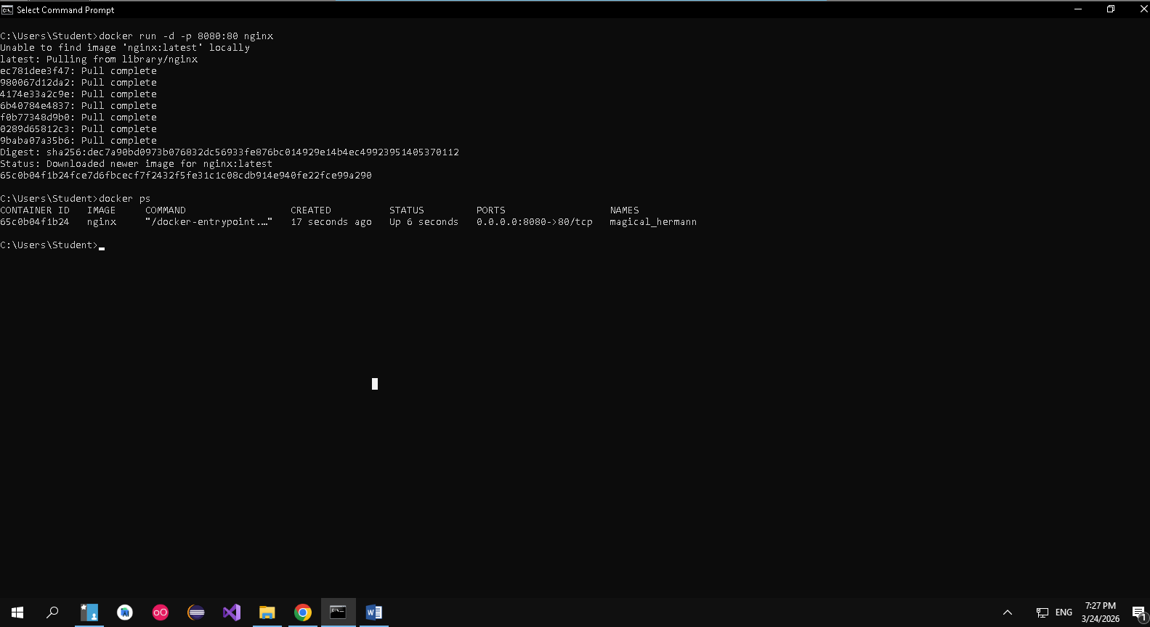
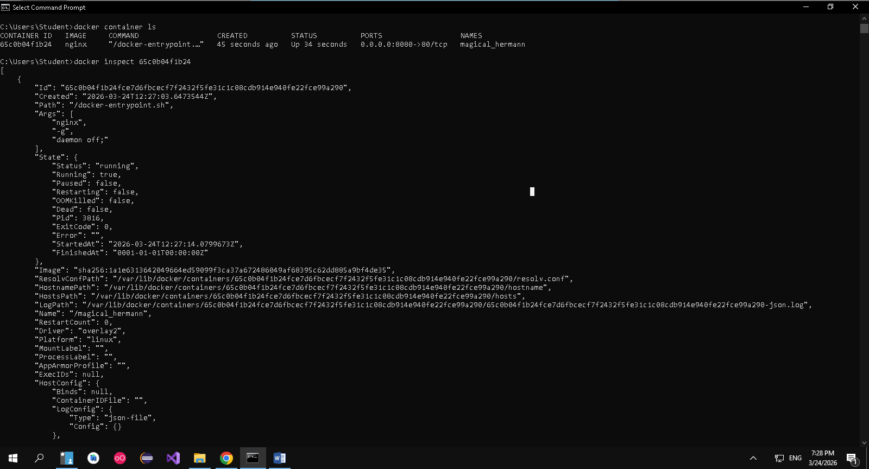
Docker run –d –v mydata:/data nginx
Docker volume ls
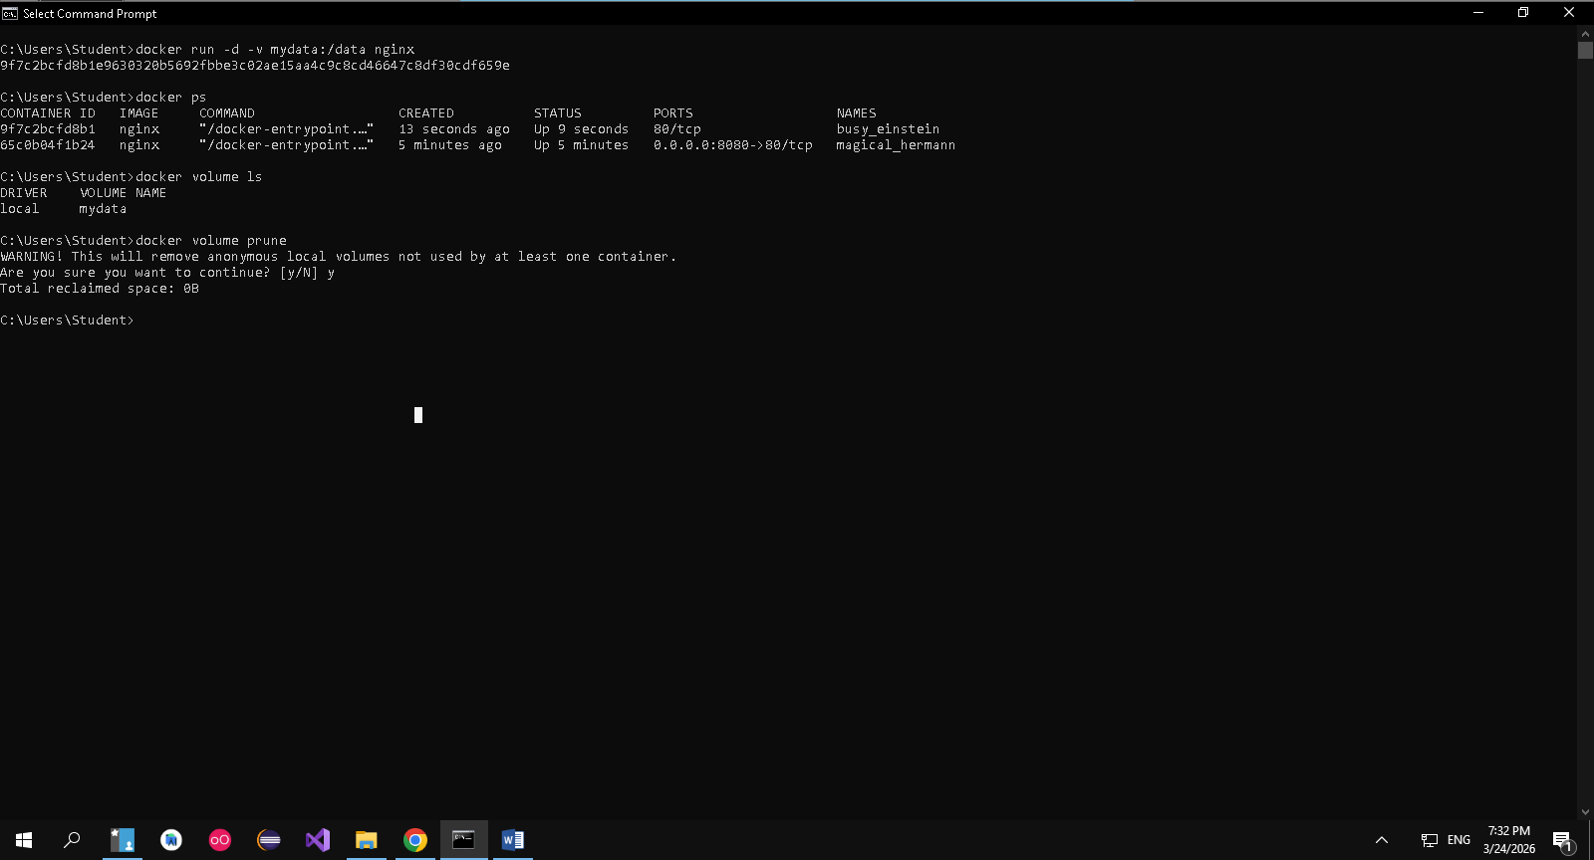
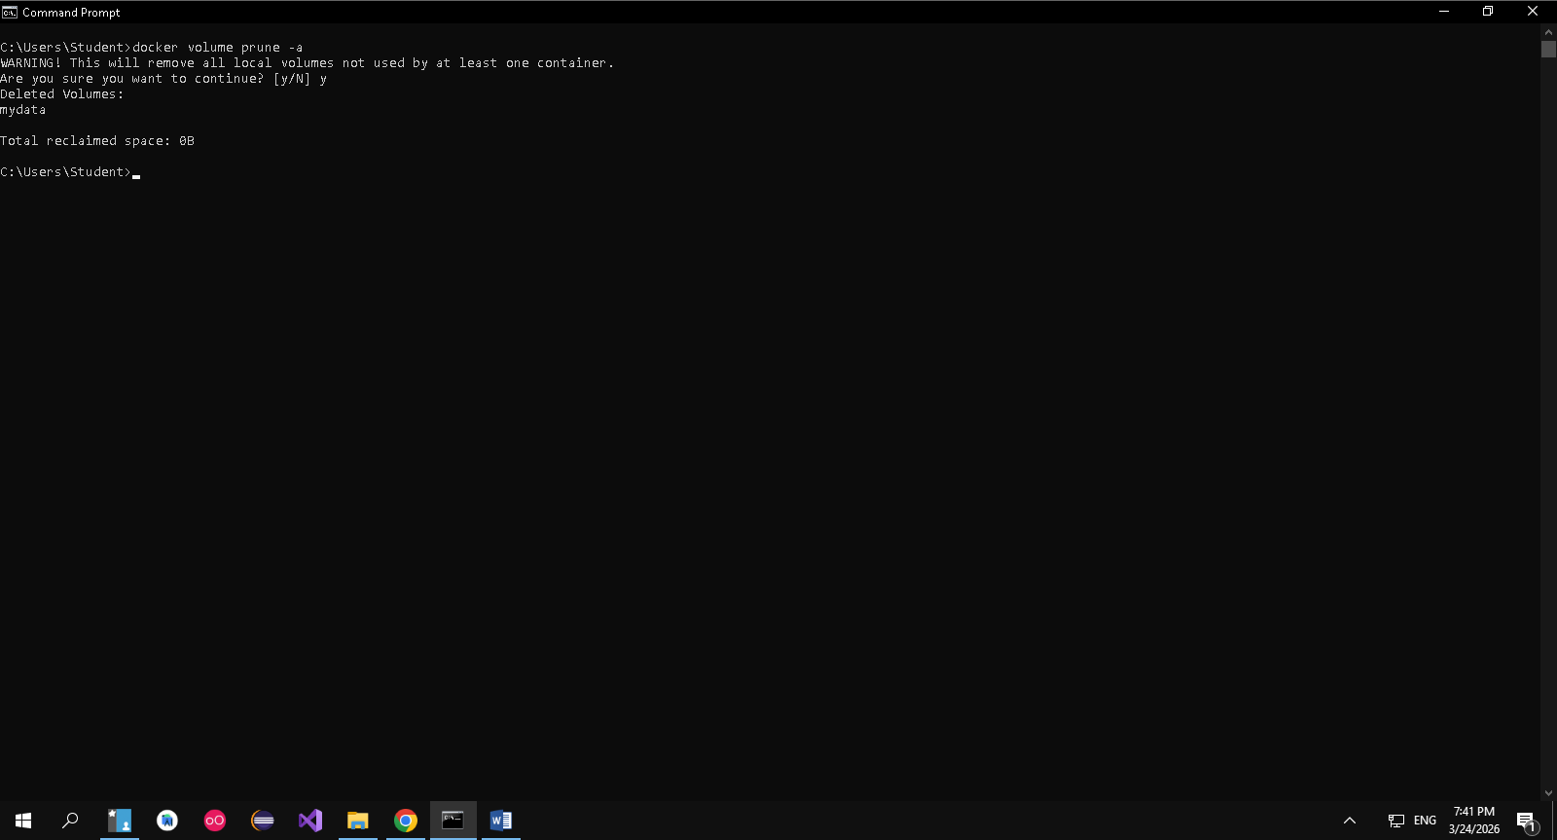
Docker run –d –name my_nginx nginx
Docker stats
Docker network ls
Docker network create my_network
