**BỘ THÔNG TIN VÀ TRUYỀN THÔNG**

**HỌC VIỆN CÔNG NGHỆ BƯU CHÍNH VIỄN THÔNG**

**CƠ SỞ TẠI THÀNH PHỐ HỒ CHÍ MINH**

**PHÁT TRIỂN CÁC ỨNG DỤNG CHO THIẾT BỊ DI ĐỘNG**

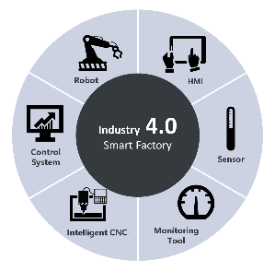**ĐỀ TÀI GIỮA KÌ: QUẢN LÝ VẬN TẢI**

**NHÓM 13**

**Giảng viên hướng dẫn: Ths.Trương Bá Thái**

**Lớp: D17CQCP02-N**

**Sinh viên thực hiện:**

|  |  |  |
| --- | --- | --- |
| **Họ tên** | **Mã sinh viên** | **Đóng góp** |
| **Nguyễn Hoàng Nam** | **N17DCCN102** | **25%** |
| **Dương Tấn Phát** | **N17DCCN121** | **25%** |
| **Trần Hoài Nam** | **N17DCCN106** | **25%** |
| **Võ Trọng Minh** | **N17DCCN097** | **25%** |

**LỜI NÓI ĐẦU**

Trong quá trình làm bài báo cáo, khó tránh khỏi sai sót, rất mong Thầy bỏ qua, đồng thời do trình độ lý luận cũng như kinh nghiệm thực tiễn còn hạn chế nên bài báo cáo không thể tránh khỏi những thiếu sót, nhóm rất mong nhận được ý kiến đóng góp của Thầy để nhóm học thêm được nhiều kinh nghiệm và sẽ hoàn thành tốt hơn những bài báo cáo sau. Nhóm xin chân thành cảm ơn!

**NHẬN XÉT CỦA GIẢNG VIÊN**

**……………………………………………………………………………………………………………………………………………………………………………………………………………………………………………………………………………………………………………………………………………………………………………………………………………………………………………………………………………………………………………………………………………………………………………………………………………………………………………………………………………………………………………………………………………………………………………………………………………………………………………………………………………………………………………………………………………………………………………………………………………………………………………………………………………………………………………………………………………………………………………………………………………………………………………………………………………………………………………………………………………………………………………………………………………………………………………………………………………………………………………………………………………………………………………………………………………………………………………………………………………………………………………………………………………………………………………………………………………………………………………………………………………………………………………………………………………………………………………………………………………………………………………………………………………………………………………………………………………………………………………………………………………............**

* **Yêu cầu của thầy về đề tài giữa kỳ**
* **Quản lý liên quan tới các bảng dữ liệu (Xe, Tài Xế, Chuyến Xe, Phân Công).**
* **Phần quản lý xe phải có hình ảnh xe.**
* **Phần quản lý chuyến xe cho chọn nơi bắt đầu và nơi kết thúc.**
* **Phần phân công xe: chọn xe phân công phải có hình ảnh đi kèm (Custom spiner); bắt lỗi nghiệp vụ liên quan.**
* **Có demo phần menubar**
* **Có animation (tại 1 form)**
* **Bắt lỗi thao tác thêm/sửa/xóa theo từng From**
* **Có ứng dụng biểu đồ trong thống kê (làm thêm)**
* **Phân công nhiệm vụ từng thành viên**

|  |  |  |  |  |
| --- | --- | --- | --- | --- |
| **STT** | **HỌ TÊN** | **NHIỆM VỤ** | **ĐIỂM LẦN 1** | **ĐIỂM LẦN 2** |
| **1** | **Nguyễn Hoàng Nam**  **N17DCCN102** | **Form Phân Công: custom spiner, bắt lỗi**  **nghiệp vụ**  **Form Thống Kê: Tần xuất các xe hoạt động**  **trong bảng phân công** | **8** |  |
| **2** | **Dương Tấn Phát**  **N17DCCN121** | **Form Xe: Load hình trực tiếp từ thiết bị**  **Form Giới thiệu thành viên nhóm** | **8** |  |
| **3** | **Trần Hoài Nam**  **N17DCCN106** | **Form Chuyến Xe**  **Làm phần demo có MenuBar** | **8** |  |
| **4** | **Võ Trọng Minh**  **N17DCCN097** | **Form Tài xế**  **Có animation trong danh sách tài xế, có đổi**  **màu button.** | **8** |  |

1. **Mockup đề tài**

* Giao diện chung:

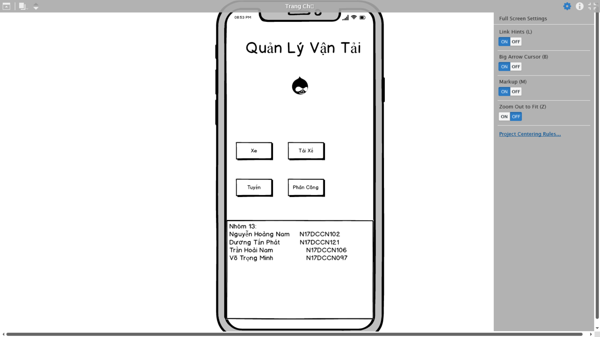

* Khi click vào nút Xe sang giao diện Quản Lý Xe bao gồm 1 danh sách các xe và kèm thêm các sự kiện thêm sửa xóa (có bắt lỗi nghiệp vụ, lỗi về liên kết khóa ngoại).

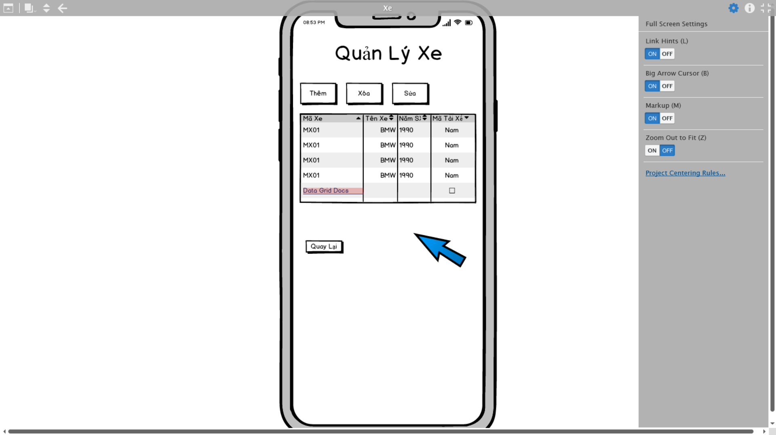

Bấm vào nút thêm xe hiện ra dialog để nhập các thông tin của xe. Nút sửa sẽ hiện tương ứng ở item xe và nút xóa cùng nằm chung với nút sửa trong mỗi item xe.

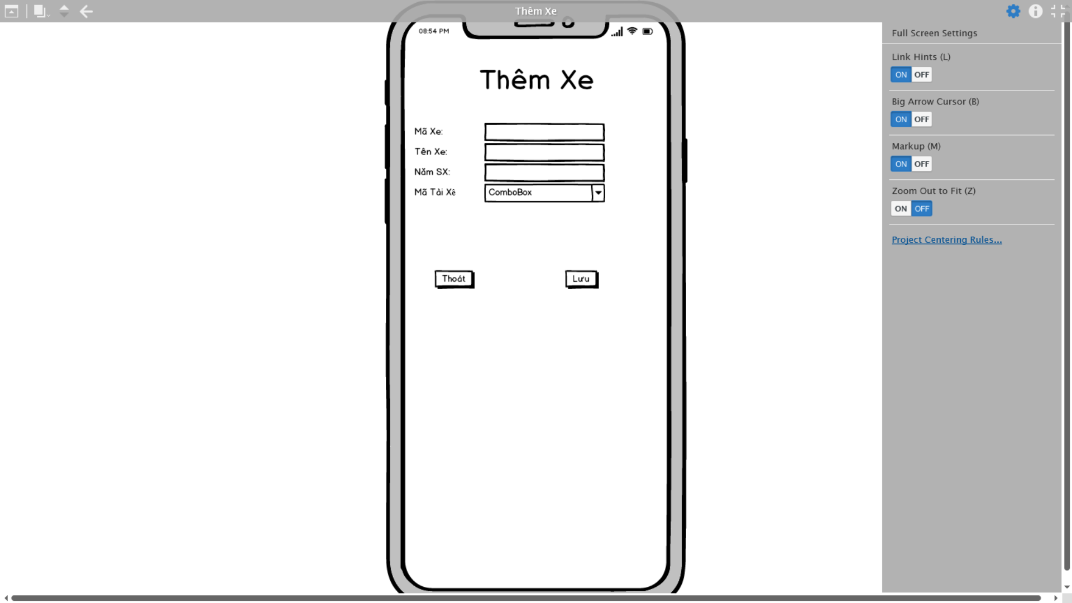

Thêm thành công sẽ hiện thông báo. Sửa và xóa cũng tương tự.

* Phần quản lý tài xế, tuyến xe và phân công cũng tương tự như quản lý xe:
* Quản Lý Tài Xế:

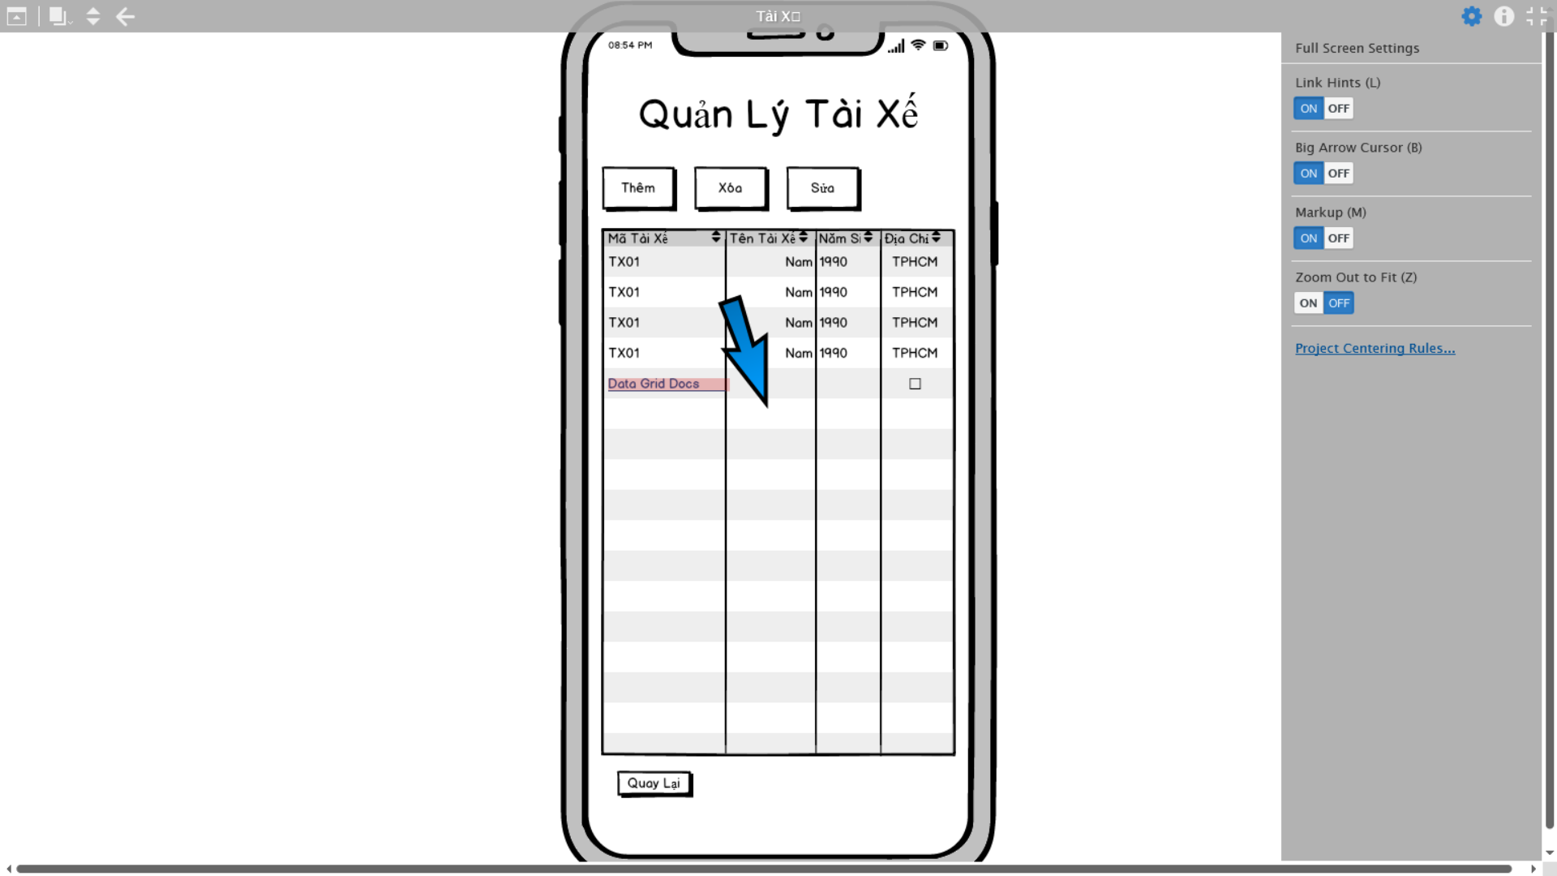

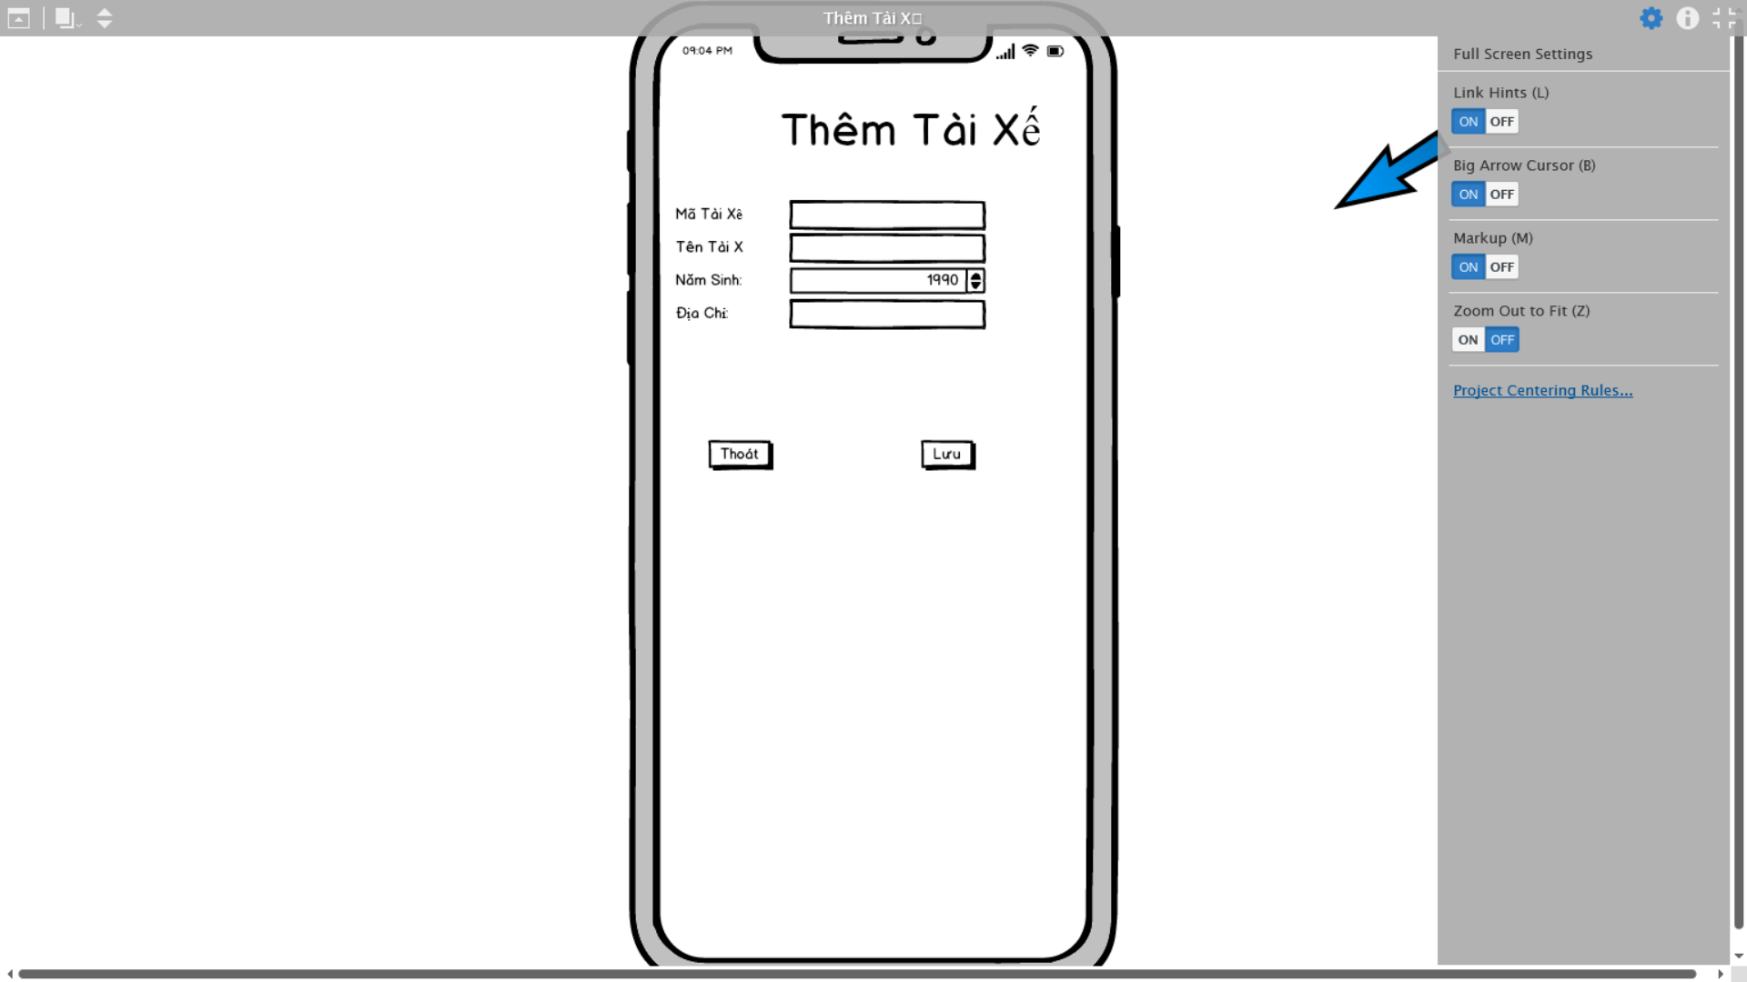

* Quản Lý Tuyến Xe

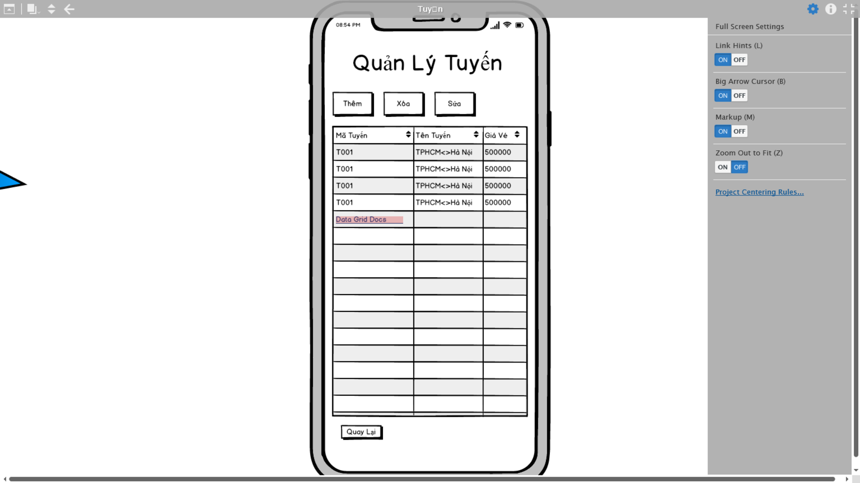

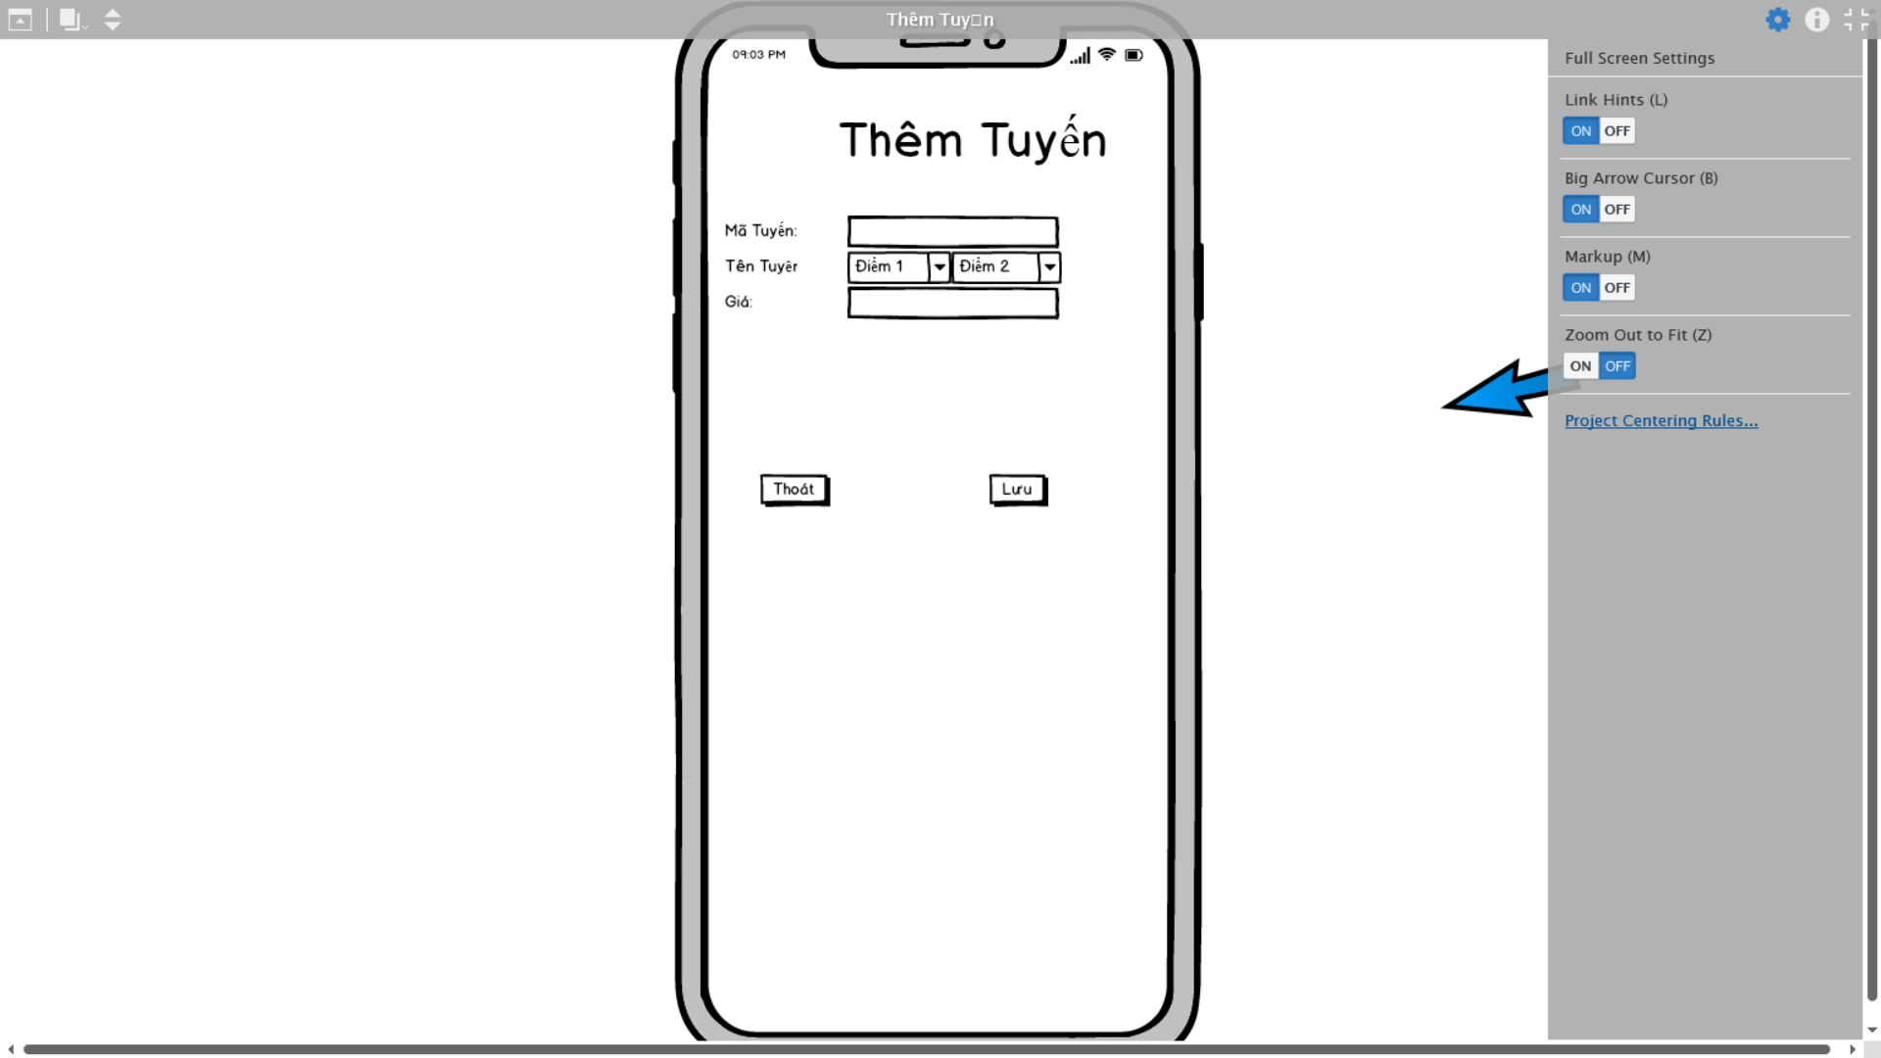

* Quản Lý Phân Công

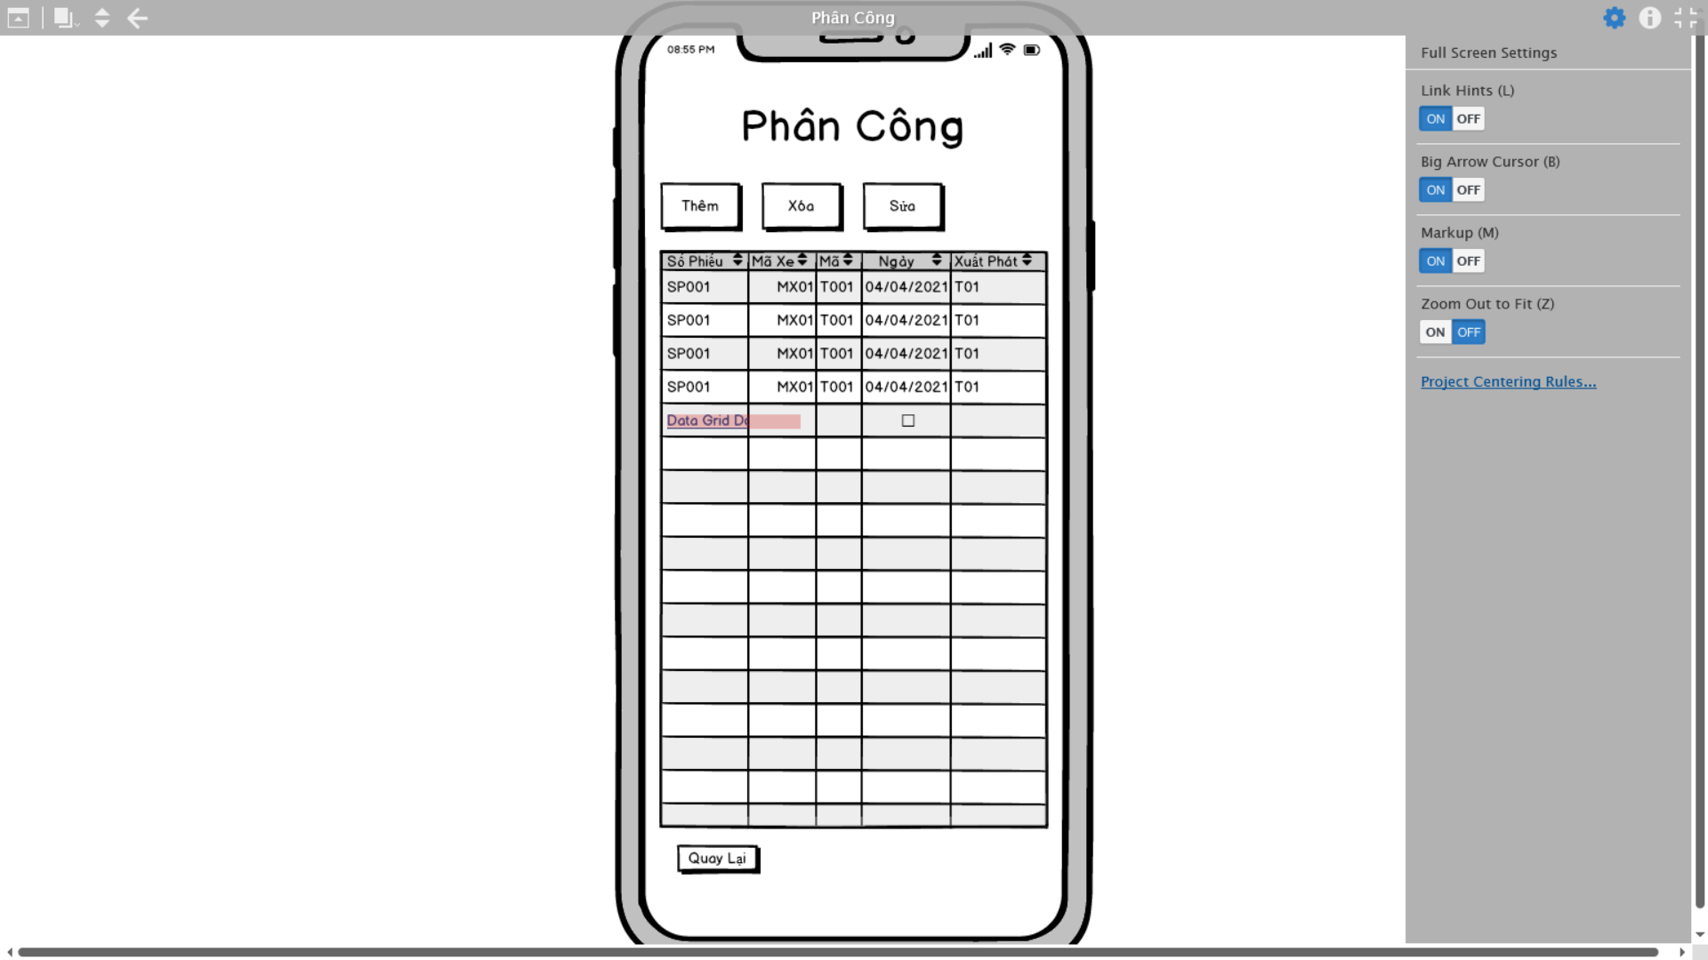

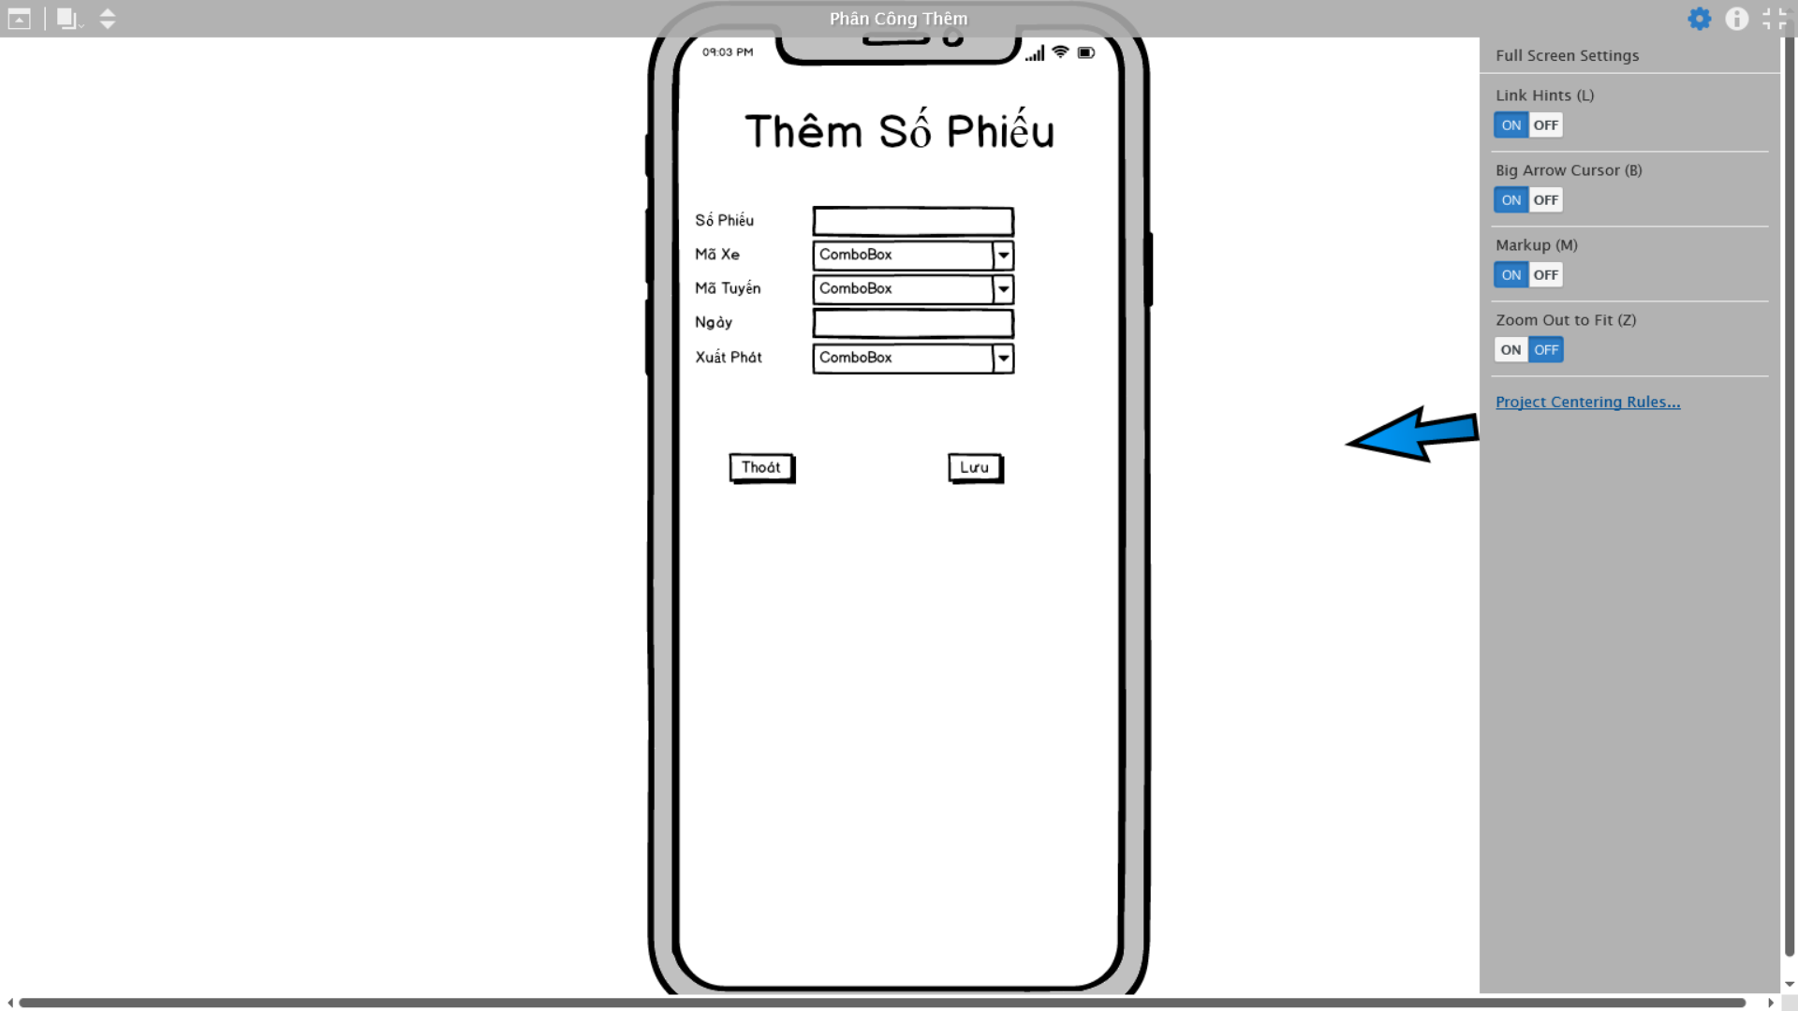

1. **Code chương trình**
2. Phần LayOut

* Activity_main.xml

*<?*xml version="1.0" encoding="utf-8"*?>*<LinearLayout  
 xmlns:android="http://schemas.android.com/apk/res/android"  
 xmlns:app="http://schemas.android.com/apk/res-auto"  
 xmlns:tools="http://schemas.android.com/tools"  
 android:layout_width="match_parent"  
 android:background="#C3D8AA"  
 android:orientation="vertical"  
 android:layout_height="match_parent"  
 tools:context=".MainActivity">  
  
 <TextView  
 android:layout_width="match_parent"  
 android:layout_height="wrap_content"  
 android:text="NHÓM 13"  
 android:textSize="40sp"  
 android:textColor="#DA4141"  
 android:gravity="center"  
 />  
 <TextView  
 android:layout_width="match_parent"  
 android:layout_height="wrap_content"  
 android:text="Quản Lý Vận Tải"  
 android:textSize="40sp"  
 android:textColor="#DA4141"  
 android:gravity="center"  
 />  
  
 <LinearLayout  
 android:layout_marginTop="20sp"  
 android:layout_width="match_parent"  
 android:layout_height="wrap_content"  
 android:orientation="horizontal"  
 android:weightSum="2"  
 >  
 <Button  
 android:id="@+id/btnXe"  
 android:layout_width="0dp"  
 android:layout_weight="1"  
 android:text="Quản Lý Xe"  
 android:layout_margin="20dp"  
 android:layout_height="wrap_content"/>  
 <Button  
 android:id="@+id/btnPhanCong"  
 android:layout_width="0dp"  
 android:layout_weight="1"  
 android:text="Phân Công"  
 android:layout_margin="20dp"  
 android:layout_height="wrap_content"/>  
  
 </LinearLayout>  
  
 <LinearLayout  
 android:layout_marginTop="20sp"  
 android:layout_width="match_parent"  
 android:layout_height="wrap_content"  
 android:orientation="horizontal"  
 android:weightSum="2"  
 >  
 <Button  
 android:id="@+id/btnChuyen"  
 android:layout_width="0dp"  
 android:layout_weight="1"  
 android:text="Quản Lý Chuyến"  
 android:layout_margin="20dp"  
 android:layout_height="wrap_content"/>  
 <Button  
 android:id="@+id/btnTaiXe"  
 android:layout_width="0dp"  
 android:layout_weight="1"  
 android:layout_margin="20dp"  
 android:text="Quản Lý Tài Xế"  
  
 android:layout_height="wrap_content"/>  
  
 </LinearLayout>  
  
 <LinearLayout  
 android:layout_margin="20dp"  
 android:layout_width="match_parent"  
 android:layout_height="wrap_content"  
 android:orientation="horizontal"  
 >  
 <Button  
 android:id="@+id/btnThongTin"  
 android:layout_width="match_parent"  
 android:layout_height="wrap_content"  
 android:text="THÔNG TIN NHÓM"  
 android:textSize="15sp"  
 />  
  
 </LinearLayout>  
  
</LinearLayout>

* Activity_phan_cong.xml

*<?*xml version="1.0" encoding="utf-8"*?>*<LinearLayout  
 xmlns:android="http://schemas.android.com/apk/res/android"  
 xmlns:app="http://schemas.android.com/apk/res-auto"  
 xmlns:tools="http://schemas.android.com/tools"  
 android:layout_width="match_parent"  
 android:layout_height="match_parent"  
 android:orientation="vertical"  
 tools:context=".TaiXeActivity">  
 <LinearLayout  
 android:layout_width="match_parent"  
 android:layout_height="wrap_content"  
 android:weightSum="2"  
 >  
 <Button  
 android:id="@+id/btnThemPhanCong"  
 android:text="Thêm Phân Công"  
 android:textSize="15sp"  
 android:layout_marginLeft="10dp"  
 android:layout_marginRight="30dp"  
 android:layout_width="wrap_content"  
 android:layout_height="wrap_content"  
 />  
 <Button  
 android:id="@+id/btnThoatPhanCong"  
 android:text="Thoát"  
 android:textSize="15sp"  
 android:layout_width="wrap_content"  
 android:layout_height="wrap_content"  
 />  
  
 </LinearLayout>  
  
  
 <LinearLayout  
 android:layout_marginTop="20dp"  
 android:layout_width="match_parent"  
 android:orientation="vertical"  
 android:layout_height="wrap_content">  
 <TextView  
 android:layout_width="match_parent"  
 android:layout_height="wrap_content"  
 android:text="DANH SÁCH PHÂN CÔNG"  
 android:textSize="30sp"  
 android:textStyle="bold"  
 android:textColor="#000"  
 android:background="#AEDD77"  
 />  
 <ListView  
 android:id="@+id/lvDSPhanCong"  
 android:layout_width="wrap_content"  
 android:layout_height="wrap_content"  
  
 />  
  
 </LinearLayout>  
  
</LinearLayout>

* Activity_tai_xe.xml

*<?*xml version="1.0" encoding="utf-8"*?>*<LinearLayout  
 xmlns:android="http://schemas.android.com/apk/res/android"  
 xmlns:app="http://schemas.android.com/apk/res-auto"  
 xmlns:tools="http://schemas.android.com/tools"  
 android:layout_width="match_parent"  
 android:layout_height="match_parent"  
 android:orientation="vertical"  
 tools:context=".TaiXeActivity">  
 <LinearLayout  
 android:layout_width="match_parent"  
 android:layout_height="wrap_content"  
 android:weightSum="2"  
 >  
 <Button  
 android:id="@+id/btnThemTX"  
 android:text="Thêm Tài Xế"  
 android:textSize="20sp"  
 android:layout_marginLeft="30dp"  
 android:layout_marginRight="30dp"  
 android:layout_width="wrap_content"  
 android:layout_height="wrap_content"  
 />  
 <Button  
 android:id="@+id/btnThoat"  
 android:text="Thoát"  
 android:textSize="20sp"  
 android:layout_width="wrap_content"  
 android:layout_height="wrap_content"  
 />  
  
 </LinearLayout>  
  
  
 <LinearLayout  
 android:layout_marginTop="20dp"  
 android:layout_width="match_parent"  
 android:orientation="vertical"  
 android:layout_height="wrap_content">  
 <TextView  
 android:layout_width="match_parent"  
 android:layout_height="wrap_content"  
 android:text="DANH SÁCH TÀI XẾ"  
 android:textSize="30sp"  
 android:textStyle="bold"  
 android:textColor="#000"  
 android:background="#AEDD77"  
 />  
 <ListView  
 android:id="@+id/lvDSTX"  
 android:layout_width="wrap_content"  
 android:layout_height="wrap_content"  
  
 />  
  
 </LinearLayout>  
  
</LinearLayout>

* Activity_thong_tin.xml

*<?*xml version="1.0" encoding="utf-8"*?>*<LinearLayout  
 xmlns:android="http://schemas.android.com/apk/res/android"  
 xmlns:app="http://schemas.android.com/apk/res-auto"  
 xmlns:tools="http://schemas.android.com/tools"  
 android:layout_width="match_parent"  
 android:layout_height="match_parent"  
 android:background="#BEE690"  
 android:orientation="vertical"  
 tools:context=".ThongTinActivity">  
  
 <LinearLayout  
 android:layout_margin="20dp"  
 android:layout_width="match_parent"  
 android:layout_height="wrap_content"  
 android:orientation="horizontal"  
 android:weightSum="3"  
 >  
 <TextView  
 android:layout_width="0dp"  
 android:layout_weight="0.5"  
 android:text="1."  
 android:textSize="25sp"  
 android:textColor="#000"  
 android:gravity="center"  
 android:layout_height="wrap_content"/>  
 <TextView  
 android:layout_width="0dp"  
 android:layout_weight="2.5"  
 android:text="Nguyễn Hoàng Nam"  
 android:textSize="25sp"  
 android:textColor="#000"  
 android:gravity="left"  
 android:layout_height="wrap_content"/>  
 </LinearLayout>  
  
 <LinearLayout  
 android:layout_margin="20dp"  
 android:layout_width="match_parent"  
 android:layout_height="wrap_content"  
 android:orientation="horizontal"  
 android:weightSum="3"  
 >  
 <TextView  
 android:layout_width="0dp"  
 android:layout_weight="0.5"  
 android:text="2."  
 android:textSize="25sp"  
 android:textColor="#000"  
 android:gravity="center"  
 android:layout_height="wrap_content"/>  
 <TextView  
 android:layout_width="0dp"  
 android:layout_weight="2.5"  
 android:text="Dương Tấn Phát"  
 android:textSize="25sp"  
 android:textColor="#000"  
 android:gravity="left"  
 android:layout_height="wrap_content"/>  
 </LinearLayout>  
  
 <LinearLayout  
 android:layout_margin="20dp"  
 android:layout_width="match_parent"  
 android:layout_height="wrap_content"  
 android:orientation="horizontal"  
 android:weightSum="3"  
 >  
 <TextView  
 android:layout_width="0dp"  
 android:layout_weight="0.5"  
 android:text="3."  
 android:textSize="25sp"  
 android:textColor="#000"  
 android:gravity="center"  
 android:layout_height="wrap_content"/>  
 <TextView  
 android:layout_width="0dp"  
 android:layout_weight="2.5"  
 android:text="Trần Hoài Nam"  
 android:textSize="25sp"  
 android:textColor="#000"  
 android:gravity="left"  
 android:layout_height="wrap_content"/>  
 </LinearLayout>  
  
 <LinearLayout  
 android:layout_margin="20dp"  
 android:layout_width="match_parent"  
 android:layout_height="wrap_content"  
 android:orientation="horizontal"  
 android:weightSum="3"  
 >  
 <TextView  
 android:layout_width="0dp"  
 android:layout_weight="0.5"  
 android:text="4."  
 android:textSize="25sp"  
 android:textColor="#000"  
 android:gravity="center"  
 android:layout_height="wrap_content"/>  
 <TextView  
 android:layout_width="0dp"  
 android:layout_weight="2.5"  
 android:text="Võ Trọng Minh"  
 android:textSize="25sp"  
 android:textColor="#000"  
 android:gravity="left"  
 android:layout_height="wrap_content"/>  
 </LinearLayout>  
  
 <LinearLayout  
 android:layout_margin="20dp"  
 android:layout_width="match_parent"  
 android:layout_height="wrap_content"  
 android:orientation="horizontal"  
 >  
 <Button  
 android:id="@+id/btnThoat"  
 android:layout_width="match_parent"  
 android:layout_height="wrap_content"  
 android:text="THOÁT"  
 android:textSize="25sp"  
 />  
 </LinearLayout>  
</LinearLayout>

* Activity_tuyen_xe.xml

*<?*xml version="1.0" encoding="utf-8"*?>*<LinearLayout  
 xmlns:android="http://schemas.android.com/apk/res/android"  
 xmlns:app="http://schemas.android.com/apk/res-auto"  
 xmlns:tools="http://schemas.android.com/tools"  
 android:layout_width="match_parent"  
 android:layout_height="match_parent"  
 android:orientation="vertical"  
 tools:context=".TuyenXeActivity">  
 <LinearLayout  
 android:layout_width="match_parent"  
 android:layout_height="wrap_content"  
 android:weightSum="2"  
 >  
 <Button  
 android:id="@+id/btnThemTuyen"  
 android:text="Thêm"  
 android:textSize="20sp"  
 android:layout_marginLeft="30dp"  
 android:layout_marginRight="30dp"  
 android:layout_width="wrap_content"  
 android:layout_height="wrap_content"  
 />  
 <Button  
 android:id="@+id/btnThoatTuyen"  
 android:text="Thoát"  
 android:textSize="20sp"  
 android:layout_width="wrap_content"  
 android:layout_height="wrap_content"  
 />  
  
 </LinearLayout>  
  
  
 <LinearLayout  
 android:layout_marginTop="20dp"  
 android:layout_width="match_parent"  
 android:orientation="vertical"  
 android:layout_height="wrap_content">  
 <TextView  
 android:layout_width="match_parent"  
 android:layout_height="wrap_content"  
 android:text="DANH SÁCH CÁC TUYẾN XE"  
 android:textSize="25sp"  
 android:textStyle="bold"  
 android:textColor="#000"  
 android:background="#AEDD77"  
 />  
 <ListView  
 android:id="@+id/lvDSTuyenXe"  
 android:layout_width="wrap_content"  
 android:layout_height="wrap_content"  
  
 />  
  
 </LinearLayout>  
</LinearLayout>

* Activity_xe.xml

*<?*xml version="1.0" encoding="utf-8"*?>*<LinearLayout  
 xmlns:android="http://schemas.android.com/apk/res/android"  
 xmlns:app="http://schemas.android.com/apk/res-auto"  
 xmlns:tools="http://schemas.android.com/tools"  
 android:layout_width="match_parent"  
 android:layout_height="match_parent"  
 tools:context=".XeActivity"  
 android:orientation="vertical"  
 >  
 <LinearLayout  
 android:layout_width="match_parent"  
 android:layout_height="wrap_content"  
 android:weightSum="2"  
 >  
 <Button  
 android:id="@+id/btnThemXe"  
 android:text="Thêm Xe"  
 android:textSize="20sp"  
 android:layout_marginLeft="30dp"  
 android:layout_marginRight="30dp"  
 android:layout_width="wrap_content"  
 android:layout_height="wrap_content"  
 />  
 <Button  
 android:id="@+id/btnThoatXe"  
 android:text="Thoát"  
 android:textSize="20sp"  
 android:layout_width="wrap_content"  
 android:layout_height="wrap_content"  
 />  
  
 </LinearLayout>  
  
  
 <LinearLayout  
 android:layout_marginTop="20dp"  
 android:layout_width="match_parent"  
 android:orientation="vertical"  
 android:layout_height="wrap_content">  
 <TextView  
 android:layout_width="match_parent"  
 android:layout_height="wrap_content"  
 android:text="DANH SÁCH XE"  
 android:textSize="30sp"  
 android:textStyle="bold"  
 android:textColor="#000"  
 android:background="#AEDD77"  
 />  
 <ListView  
 android:id="@+id/lvDSXe"  
 android:layout_width="wrap_content"  
 android:layout_height="wrap_content"  
  
 />  
  
 </LinearLayout>  
  
</LinearLayout>

* Activity_Thong_ke.xml

*<?*xml version="1.0" encoding="utf-8"*?>*<LinearLayout xmlns:android="http://schemas.android.com/apk/res/android"  
 xmlns:app="http://schemas.android.com/apk/res-auto"  
 xmlns:tools="http://schemas.android.com/tools"  
 android:layout_width="match_parent"  
 android:layout_height="match_parent"  
 android:orientation="vertical"  
 android:weightSum="2"  
 tools:context=".ThongKeActivity">  
  
 <com.github.mikephil.charting.charts.BarChart  
 android:id="@+id/barChart"  
 android:layout_width="match_parent"  
 android:layout_weight="1.9"  
 android:layout_height="wrap_content"/>  
 <Button  
 android:id="@+id/btnThoatCHart"  
 android:layout_width="match_parent"  
 android:layout_weight="0.1"  
 android:text="Thoát"  
 android:layout_height="wrap_content"/>  
</LinearLayout>

* Xe_spiner_row.xml

*<?*xml version="1.0" encoding="utf-8"*?>*<LinearLayout  
 xmlns:android="http://schemas.android.com/apk/res/android" android:layout_width="match_parent"  
 android:layout_height="match_parent"  
 android:orientation="vertical"  
 >  
 <LinearLayout  
 android:layout_width="match_parent"  
 android:layout_height="wrap_content"  
 android:orientation="horizontal"  
 android:weightSum="2"  
 >  
 <ImageView  
 android:id="@+id/spnAnhXe"  
 android:layout_width="0dp"  
 android:layout_weight="1"  
 android:layout_height="wrap_content"/>  
 <TextView  
 android:id="@+id/spnTenXe"  
 android:layout_width="0dp"  
 android:layout_weight="1"  
 android:layout_height="wrap_content"/>  
 </LinearLayout>  
</LinearLayout>

* Dialog_them_phan_cong.xml

*<?*xml version="1.0" encoding="utf-8"*?>*<LinearLayout  
 xmlns:android="http://schemas.android.com/apk/res/android"  
 android:layout_width="match_parent"  
 android:layout_height="match_parent"  
 android:orientation="vertical"  
 >  
 <TextView  
 android:id="@+id/tvTieuDe"  
 android:layout_width="match_parent"  
 android:layout_height="wrap_content"  
 android:text="THÊM PHÂN CÔNG"  
 android:textSize="25sp"  
 android:textColor="#D31C1C"  
 android:textStyle="bold"  
 android:gravity="center"  
 />  
 <TextView  
 android:id="@+id/tvTenChuyen"  
 android:layout_width="match_parent"  
 android:layout_height="wrap_content"  
 android:text="Tên Chuyến: "  
 android:textSize="25sp"  
 />  
 <Spinner  
 android:id="@+id/spnChuyen"  
 android:layout_width="match_parent"  
 android:layout_height="wrap_content"  
 android:layout_margin="10dp"/>  
 <TextView  
 android:id="@+id/tvTenXe"  
 android:layout_width="match_parent"  
 android:layout_height="wrap_content"  
 android:text="Tên Xe: "  
 android:textSize="25sp"  
 />  
 <Spinner  
 android:id="@+id/spnXe"  
 android:layout_width="match_parent"  
 android:layout_height="wrap_content"  
 android:layout_margin="10dp"/>  
 <TextView  
 android:id="@+id/tvTaiXe"  
 android:layout_width="match_parent"  
 android:layout_height="wrap_content"  
 android:text="Tên Tài Xế: "  
 android:textSize="25sp"  
 />  
 <Spinner  
 android:id="@+id/spnTaiXe"  
 android:layout_width="match_parent"  
 android:layout_height="wrap_content"  
 android:layout_margin="10dp"/>  
  
 <EditText  
 android:id="@+id/edtBD"  
 android:layout_width="match_parent"  
 android:layout_height="wrap_content"  
 android:hint="Thời gian bắt đầu"  
 android:inputType="date" />  
  
 <EditText  
 android:id="@+id/edtKT"  
 android:layout_width="match_parent"  
 android:layout_height="wrap_content"  
 android:hint="Thời gian kết thúc"  
 android:inputType="date" />  
 <LinearLayout  
 android:layout_width="match_parent"  
 android:layout_height="wrap_content"  
 android:orientation="horizontal"  
 android:padding="15dp"  
 android:weightSum="2"  
 >  
 <Button  
 android:id="@+id/btnLuu"  
 android:layout_width="0dp"  
 android:layout_height="wrap_content"  
 android:layout_weight="1"  
 android:layout_margin="5dp"  
 android:text="Lưu"  
 />  
 <Button  
 android:id="@+id/btnHuy"  
 android:layout_width="0dp"  
 android:layout_height="wrap_content"  
 android:layout_weight="1"  
 android:layout_margin="5dp"  
 android:text="Hủy"  
 />  
  
 </LinearLayout>  
</LinearLayout>

* Dialog_them_tai_xe.xml

*<?*xml version="1.0" encoding="utf-8"*?>*<LinearLayout  
 xmlns:android="http://schemas.android.com/apk/res/android"  
 android:layout_width="match_parent"  
 android:layout_height="match_parent"  
 android:padding="10dp"  
 android:orientation="vertical"  
 >  
 <TextView  
 android:id="@+id/tvTieuDe"  
 android:layout_width="match_parent"  
 android:layout_height="wrap_content"  
 android:text="THÊM MỚI TÀI XẾ"  
 android:textSize="30sp"  
 android:gravity="center"  
 android:textStyle="bold"  
 android:textColor="#EC0F0F"  
 />  
 <EditText  
 android:layout_width="match_parent"  
 android:layout_height="wrap_content"  
 android:hint="Tên Tài Xế"  
 android:textColor="#000"  
 android:textSize="20sp"  
 android:id="@+id/edtTenTX"  
 />  
  
 <EditText  
 android:id="@+id/edtNgaySinh"  
 android:layout_width="match_parent"  
 android:layout_height="wrap_content"  
 android:hint="Ngày Sinh"  
 android:inputType="date"  
 android:textColor="#000"  
 android:textSize="20sp" />  
 <EditText  
 android:layout_width="match_parent"  
 android:layout_height="wrap_content"  
 android:hint="Địa Chỉ"  
 android:textColor="#000"  
 android:textSize="20sp"  
 android:id="@+id/edtDiaChi"  
 />  
 <LinearLayout  
 android:layout_width="match_parent"  
 android:layout_height="wrap_content"  
 android:orientation="horizontal"  
 android:padding="15dp"  
 android:weightSum="2"  
 >  
 <Button  
 android:id="@+id/btnLuu"  
 android:layout_width="0dp"  
 android:layout_height="wrap_content"  
 android:layout_weight="1"  
 android:layout_margin="5dp"  
 android:text="Lưu"  
 />  
 <Button  
 android:id="@+id/btnHuy"  
 android:layout_width="0dp"  
 android:layout_height="wrap_content"  
 android:layout_weight="1"  
 android:layout_margin="5dp"  
 android:text="Hủy"  
 />  
  
 </LinearLayout>  
</LinearLayout>

* Dialog_them_tuyen_xe.xml

*<?*xml version="1.0" encoding="utf-8"*?>*<LinearLayout  
 xmlns:android="http://schemas.android.com/apk/res/android"  
 android:layout_width="match_parent"  
 android:layout_height="match_parent"  
 android:padding="10dp"  
 android:orientation="vertical"  
 >  
 <TextView  
 android:id="@+id/tvTieuDe"  
 android:layout_width="match_parent"  
 android:layout_height="wrap_content"  
 android:text="THÊM MỚI TUYẾN XE"  
 android:textSize="30sp"  
 android:gravity="center"  
 android:textStyle="bold"  
 android:textColor="#EC0F0F"  
 />  
 <TextView  
 android:layout_width="match_parent"  
 android:layout_height="wrap_content"  
 android:text="Từ: "  
 android:textSize="20sp"  
 android:textColor="#000"  
 />  
 <Spinner  
 android:id="@+id/spnDiemBD"  
 android:layout_width="match_parent"  
 android:layout_height="wrap_content"  
 android:entries="@array/DiaDiem"  
 />  
 <TextView  
 android:layout_width="match_parent"  
 android:layout_height="wrap_content"  
 android:text="Đến: "  
 android:textSize="20sp"  
 android:textColor="#000"  
 />  
 <Spinner  
 android:id="@+id/spnDiemKT"  
 android:layout_width="match_parent"  
 android:layout_height="wrap_content"  
 android:entries="@array/DiaDiem"  
 />  
  
 <EditText  
 android:id="@+id/edtGia"  
 android:layout_width="match_parent"  
 android:layout_height="wrap_content"  
 android:hint="Giá"  
 android:inputType="number"  
 android:textColor="#000"  
 android:textSize="20sp" />  
 <LinearLayout  
 android:layout_width="match_parent"  
 android:layout_height="wrap_content"  
 android:orientation="horizontal"  
 android:padding="15dp"  
 android:weightSum="2"  
 >  
 <Button  
 android:id="@+id/btnLuu1"  
 android:layout_width="0dp"  
 android:layout_height="wrap_content"  
 android:layout_weight="1"  
 android:layout_margin="5dp"  
 android:text="Lưu"  
 />  
 <Button  
 android:id="@+id/btnHuy1"  
 android:layout_width="0dp"  
 android:layout_height="wrap_content"  
 android:layout_weight="1"  
 android:layout_margin="5dp"  
 android:text="Hủy"  
 />  
  
 </LinearLayout>  
</LinearLayout>

* Dialog_them_xe.xml

*<?*xml version="1.0" encoding="utf-8"*?>*<LinearLayout  
 xmlns:android="http://schemas.android.com/apk/res/android"  
 android:layout_width="match_parent"  
 android:layout_height="match_parent"  
 android:padding="10dp"  
 android:orientation="vertical"  
 >  
 <TextView  
 android:id="@+id/tvTieuDe"  
 android:layout_width="match_parent"  
 android:layout_height="wrap_content"  
 android:text="THÊM MỚI XE"  
 android:textSize="30sp"  
 android:gravity="center"  
 android:textStyle="bold"  
 android:textColor="#EC0F0F"  
 />  
 <EditText  
 android:layout_width="match_parent"  
 android:layout_height="wrap_content"  
 android:hint="Tên Xe"  
 android:textColor="#000"  
 android:textSize="20sp"  
 android:id="@+id/edtTenXe"  
 />  
  
 <EditText  
 android:id="@+id/edtNamSanXuat"  
 android:layout_width="match_parent"  
 android:layout_height="wrap_content"  
 android:hint="Năm Sản Xuất"  
 android:inputType="number"  
 android:textColor="#000"  
 android:textSize="20sp" />  
 <LinearLayout  
 android:layout_width="match_parent"  
 android:layout_height="wrap_content"  
 android:orientation="horizontal"  
 android:weightSum="2">  
 <ImageView  
 android:id="@+id/imgAnhXe"  
 android:layout_width="0dp"  
 android:layout_weight="1"  
 android:layout_height="wrap_content"/>  
 <Button  
 android:id="@+id/btnAnhXe"  
 android:layout_width="0dp"  
 android:layout_weight="0.8"  
 android:text="Chọn Hình"  
 android:layout_height="wrap_content"/>  
 </LinearLayout>  
 <LinearLayout  
 android:layout_width="match_parent"  
 android:layout_height="wrap_content"  
 android:orientation="horizontal"  
 android:padding="15dp"  
 android:weightSum="2"  
 >  
 <Button  
 android:id="@+id/btnLuu"  
 android:layout_width="0dp"  
 android:layout_height="wrap_content"  
 android:layout_weight="1"  
 android:layout_margin="5dp"  
 android:text="Lưu"  
 />  
 <Button  
 android:id="@+id/btnHuy"  
 android:layout_width="0dp"  
 android:layout_height="wrap_content"  
 android:layout_weight="1"  
 android:layout_margin="5dp"  
 android:text="Hủy"  
 />  
  
 </LinearLayout>  
</LinearLayout>

* Item_phan_cong.xml

*<?*xml version="1.0" encoding="utf-8"*?>*<LinearLayout  
 xmlns:android="http://schemas.android.com/apk/res/android"  
 android:layout_width="match_parent"  
 android:layout_height="match_parent"  
 android:weightSum="4"  
 android:orientation="horizontal"  
 android:padding="10dp"  
 >  
 <LinearLayout  
 android:layout_width="0dp"  
 android:layout_weight="1"  
 android:orientation="vertical"  
 android:layout_height="wrap_content">  
 <ImageView  
 android:layout_marginTop="28dp"  
 android:layout_width="match_parent"  
 android:layout_height="wrap_content"  
 android:src="@drawable/tkb"/>  
  
 </LinearLayout>  
 <LinearLayout  
 android:layout_marginLeft="10dp"  
 android:layout_width="0dp"  
 android:layout_weight="3"  
 android:layout_height="wrap_content"  
 android:orientation="vertical"  
 >  
  
 <TextView  
 android:layout_width="300dp"  
 android:layout_height="wrap_content"  
 android:id="@+id/tvTenChuyen"  
 android:text="Tên Chuyến"  
 android:textColor="#000"  
 android:textSize="15sp"  
 />  
 <TextView  
 android:layout_width="300dp"  
 android:layout_height="wrap_content"  
 android:id="@+id/tvTenXe"  
 android:text="Tên Xe"  
 android:textColor="#000"  
 android:textSize="15sp"  
 />  
 <TextView  
 android:layout_width="300dp"  
 android:layout_height="wrap_content"  
 android:id="@+id/tvTenTaiXe"  
 android:text="Tên Tài Xế"  
 android:textColor="#000"  
 android:textSize="15sp"  
 />  
 <TextView  
 android:layout_width="300dp"  
 android:layout_height="wrap_content"  
 android:id="@+id/tvNgayBD"  
 android:text="Ngày Bắt Đầu"  
 android:textColor="#000"  
 android:textSize="15sp"  
 />  
 <TextView  
 android:layout_width="300dp"  
 android:layout_height="wrap_content"  
 android:id="@+id/tvNgayKT"  
 android:text="Ngày Kết Thúc"  
 android:textColor="#000"  
 android:textSize="15sp"  
 />  
 </LinearLayout>  
  
 <LinearLayout  
 android:layout_width="wrap_content"  
 android:layout_height="wrap_content"  
 android:orientation="horizontal"  
 android:gravity="center"  
 android:layout_marginTop="50dp"  
 android:weightSum="2"  
 >  
 <ImageView  
 android:id="@+id/imgSua"  
 android:layout_width="0dp"  
 android:layout_weight="1"  
 android:layout_height="wrap_content"  
 android:src="@drawable/ic_action_edit"  
 />  
 <ImageView  
 android:id="@+id/imgXoa"  
 android:layout_width="0dp"  
 android:layout_weight="1"  
 android:layout_height="wrap_content"  
 android:src="@drawable/ic_action_delete"  
 />  
  
 </LinearLayout>  
</LinearLayout>

* Item_tai_xe.xml

*<?*xml version="1.0" encoding="utf-8"*?>*<LinearLayout  
 xmlns:android="http://schemas.android.com/apk/res/android"  
 android:layout_width="match_parent"  
 android:layout_height="match_parent"  
 android:weightSum="4"  
 android:orientation="horizontal"  
 android:padding="10dp"  
 >  
 <LinearLayout  
 android:layout_width="0dp"  
 android:layout_weight="1"  
 android:orientation="vertical"  
 android:layout_height="wrap_content">  
 <ImageView  
 android:layout_width="match_parent"  
 android:layout_height="wrap_content"  
 android:src="@drawable/taixe"/>  
  
 </LinearLayout>  
 <LinearLayout  
 android:layout_marginLeft="10dp"  
 android:layout_width="0dp"  
 android:layout_weight="2.8"  
 android:layout_height="wrap_content"  
 android:orientation="vertical"  
 >  
  
 <TextView  
 android:layout_width="300dp"  
 android:layout_height="wrap_content"  
 android:id="@+id/tvTen"  
 android:text="Tên Tài Xế"  
 android:textColor="#000"  
 android:textSize="15sp"  
 />  
 <TextView  
 android:layout_width="300dp"  
 android:layout_height="wrap_content"  
 android:id="@+id/tvNgaySinh"  
 android:text="Ngày Sinh"  
 android:textColor="#000"  
 android:textSize="15sp"  
 />  
 <TextView  
 android:layout_width="300dp"  
 android:layout_height="wrap_content"  
 android:id="@+id/tvDiaChi"  
 android:text="Địa Chỉ"  
 android:textColor="#000"  
 android:textSize="15sp"  
 />  
 </LinearLayout>  
  
 <LinearLayout  
 android:layout_width="wrap_content"  
 android:layout_height="wrap_content"  
 android:orientation="horizontal"  
 android:weightSum="2"  
 >  
 <ImageView  
 android:id="@+id/imgSua"  
 android:layout_width="0dp"  
 android:layout_weight="1"  
 android:layout_height="wrap_content"  
 android:src="@drawable/ic_action_edit"  
 />  
 <ImageView  
 android:id="@+id/imgXoa"  
 android:layout_width="0dp"  
 android:layout_weight="1"  
 android:layout_height="wrap_content"  
 android:src="@drawable/ic_action_delete"  
 />  
  
 </LinearLayout>  
</LinearLayout>

* Item_tuyen_xe.xml

*<?*xml version="1.0" encoding="utf-8"*?>*<LinearLayout  
 xmlns:android="http://schemas.android.com/apk/res/android"  
 android:layout_width="match_parent"  
 android:layout_height="match_parent"  
 android:weightSum="4"  
 android:orientation="horizontal"  
 android:padding="10dp"  
 >  
 <LinearLayout  
 android:layout_width="0dp"  
 android:layout_weight="1"  
 android:orientation="vertical"  
 android:layout_height="wrap_content">  
 <ImageView  
 android:layout_width="match_parent"  
 android:layout_height="wrap_content"  
 android:src="@drawable/change"/>  
  
 </LinearLayout>  
 <LinearLayout  
 android:layout_marginLeft="10dp"  
 android:layout_width="0dp"  
 android:layout_weight="2.8"  
 android:layout_height="wrap_content"  
 android:orientation="vertical"  
 >  
  
 <TextView  
 android:layout_width="300dp"  
 android:layout_height="wrap_content"  
 android:id="@+id/tvTenTuyenXe"  
 android:text="Tên Tuyến Xe"  
 android:textColor="#000"  
 android:textSize="15sp"  
 />  
 <TextView  
 android:layout_width="300dp"  
 android:layout_height="wrap_content"  
 android:id="@+id/tvGia"  
 android:text="Giá"  
 android:textColor="#000"  
 android:textSize="15sp"  
 />  
 </LinearLayout>  
  
 <LinearLayout  
 android:layout_width="wrap_content"  
 android:layout_height="wrap_content"  
 android:orientation="horizontal"  
 android:weightSum="2"  
 >  
 <ImageView  
 android:id="@+id/imgSua"  
 android:layout_width="0dp"  
 android:layout_weight="1"  
 android:layout_height="wrap_content"  
 android:src="@drawable/ic_action_edit"  
 />  
 <ImageView  
 android:id="@+id/imgXoa"  
 android:layout_width="0dp"  
 android:layout_weight="1"  
 android:layout_height="wrap_content"  
 android:src="@drawable/ic_action_delete"  
 />  
  
 </LinearLayout>  
</LinearLayout>

* Item_xe.xml

*<?*xml version="1.0" encoding="utf-8"*?>*<LinearLayout  
 xmlns:android="http://schemas.android.com/apk/res/android"  
 android:layout_width="match_parent"  
 android:layout_height="match_parent"  
 android:weightSum="4"  
 android:orientation="horizontal"  
 android:padding="10dp"  
 >  
 <LinearLayout  
 android:layout_width="0dp"  
 android:layout_weight="1"  
 android:orientation="vertical"  
 android:layout_height="wrap_content">  
 <ImageView  
 android:id="@+id/imgAnhXe"  
 android:layout_width="match_parent"  
 android:layout_height="wrap_content"  
 />  
  
 </LinearLayout>  
 <LinearLayout  
 android:layout_marginLeft="10dp"  
 android:layout_width="0dp"  
 android:layout_weight="2.8"  
 android:layout_height="wrap_content"  
 android:orientation="vertical"  
 >  
  
 <TextView  
 android:layout_width="300dp"  
 android:layout_height="wrap_content"  
 android:id="@+id/tvTenXe"  
 android:text="Tên Xe"  
 android:textColor="#000"  
 android:textSize="15sp"  
 />  
 <TextView  
 android:layout_width="300dp"  
 android:layout_height="wrap_content"  
 android:id="@+id/tvNamSanXuat"  
 android:text="Năm Sản Xuất"  
 android:textColor="#000"  
 android:textSize="15sp"  
 />  
 </LinearLayout>  
  
 <LinearLayout  
 android:layout_width="wrap_content"  
 android:layout_height="wrap_content"  
 android:orientation="horizontal"  
 android:weightSum="2"  
 >  
 <ImageView  
 android:id="@+id/imgSua"  
 android:layout_width="0dp"  
 android:layout_weight="1"  
 android:layout_height="wrap_content"  
 android:src="@drawable/ic_action_edit"  
 />  
 <ImageView  
 android:id="@+id/imgXoa"  
 android:layout_width="0dp"  
 android:layout_weight="1"  
 android:layout_height="wrap_content"  
 android:src="@drawable/ic_action_delete"  
 />  
  
 </LinearLayout>  
</LinearLayout>

* Spiner_layout.xml

*<?*xml version="1.0" encoding="utf-8"*?>*<LinearLayout  
 xmlns:android="http://schemas.android.com/apk/res/android" android:layout_width="match_parent"  
 android:layout_height="match_parent"  
 android:orientation="vertical"  
 >  
 <TextView  
 android:id="@+id/txt"  
 android:layout_width="match_parent"  
 android:layout_height="wrap_content"/>  
</LinearLayout>

* Xe_spiner_row.xml

*<?*xml version="1.0" encoding="utf-8"*?>*<LinearLayout  
 xmlns:android="http://schemas.android.com/apk/res/android" android:layout_width="match_parent"  
 android:layout_height="match_parent"  
 android:orientation="vertical"  
 >  
 <LinearLayout  
 android:layout_width="match_parent"  
 android:layout_height="wrap_content"  
 android:orientation="horizontal"  
 android:weightSum="2"  
 >  
 <ImageView  
 android:id="@+id/spnAnhXe"  
 android:layout_width="0dp"  
 android:layout_weight="1"  
 android:layout_height="wrap_content"/>  
 <TextView  
 android:id="@+id/spnTenXe"  
 android:layout_width="0dp"  
 android:layout_weight="1"  
 android:layout_height="wrap_content"/>  
 </LinearLayout>  
</LinearLayout>

* Scale_list.xml

*<?*xml version="1.0" encoding="utf-8"*?>*<set xmlns:android="http://schemas.android.com/apk/res/android">  
 <scale  
 android:fromXScale="0.3"  
 android:toXScale="1.0"  
 android:fromYScale="0.3"  
 android:toYScale="1.0"  
 android:duration="1000" />  
</set>

* Strings.xml

<resources>  
 <string name="app_name">BaiGiuaKy</string>  
 <array name="DiaDiem">  
 <item>Sài Gòn</item>  
 <item>Hà Nội</item>  
 <item>Nha Trang</item>  
 <item>Đà Nẵng</item>  
 <item>Huế</item>  
 <item>Cà Mau</item>  
 <item>Ninh Thuận</item>  
 <item>Bến Tre</item>  
 <item>Hải Phòng</item>  
 <item>Sapa</item>  
 </array>  
</resources>

* Action_bar.xml

*<?*xml version="1.0" encoding="utf-8"*?>*<menu xmlns:android="http://schemas.android.com/apk/res/android"  
 xmlns:app="http://schemas.android.com/apk/res-auto">  
 <item  
 android:title="Search"  
 android:id="@+id/search"  
 android:orderInCategory="100"  
 app:showAsAction="ifRoom"  
 android:icon="@drawable/ic_action_search"  
 />  
</menu>

1. Phần Code Java

* ConnectDB

package com.example.baigiuaky;  
  
import android.content.Context;  
import android.database.Cursor;  
import android.database.sqlite.SQLiteDatabase;  
import android.database.sqlite.SQLiteOpenHelper;  
import android.database.sqlite.SQLiteStatement;  
  
import androidx.annotation.Nullable;  
  
public class ConnectDB extends SQLiteOpenHelper {  
 public ConnectDB(@Nullable Context context, @Nullable String name, @Nullable SQLiteDatabase.CursorFactory factory, int version) {  
 super(context, name, factory, version);  
 }  
  
 *//Truy vấn không trả về kết quả* public void QueryData(String sql){  
 SQLiteDatabase database = getWritableDatabase();  
 database.execSQL(sql);  
 }  
  
 *//Ham them xe* public void ThemXe(String ten, String namsx, byte[] anhxe){  
 SQLiteDatabase database = getWritableDatabase();  
 String sql = "INSERT INTO Xe VALUES(null, ?, ?, ?)";  
 SQLiteStatement statement = database.compileStatement(sql);  
 statement.clearBindings();  
  
 statement.bindString(1,ten);  
 statement.bindString(2,namsx);  
 statement.bindBlob(3,anhxe);  
  
 statement.executeInsert();  
 }  
  
 public void SuaXe(int ma,String ten, String namsx, byte[] anhxe){  
 SQLiteDatabase database = getWritableDatabase();  
 String sql = "UPDATE Xe SET TenXe= ?, NamSanXuat= ?, AnhXe= ? WHERE MaXe=?";  
 SQLiteStatement statement = database.compileStatement(sql);  
 statement.clearBindings();  
  
 statement.bindString(1,ten);  
 statement.bindString(2,namsx);  
 statement.bindBlob(3,anhxe);  
 statement.bindDouble(4,ma);  
  
 statement.executeUpdateDelete();  
 }  
  
 *//Truy vấn trả lại kết quả* public Cursor GetData(String sql){  
 SQLiteDatabase database = getReadableDatabase();  
 return database.rawQuery(sql,null);  
 }  
  
 @Override  
 public void onCreate(SQLiteDatabase db) {  
  
 }  
  
 @Override  
 public void onUpgrade(SQLiteDatabase db, int oldVersion, int newVersion) {  
  
 }  
}

* Xe

package com.example.baigiuaky.Models;  
  
public class Xe {  
 public int MaXe;  
 public String TenXe, NamSanXuat;  
 public byte[] AnhXe;  
  
 public Xe(int maXe, String tenXe, String namSanXuat) {  
 MaXe = maXe;  
 TenXe = tenXe;  
 NamSanXuat = namSanXuat;  
 }  
  
 public Xe(int maXe, String tenXe, String namSanXuat, byte[] anhXe) {  
 MaXe = maXe;  
 TenXe = tenXe;  
 NamSanXuat = namSanXuat;  
 AnhXe = anhXe;  
 }  
  
 public int getMaXe() {  
 return MaXe;  
 }  
  
 public void setMaXe(int maXe) {  
 MaXe = maXe;  
 }  
  
 public String getTenXe() {  
 return TenXe;  
 }  
  
 public void setTenXe(String tenXe) {  
 TenXe = tenXe;  
 }  
  
 public String getNamSanXuat() {  
 return NamSanXuat;  
 }  
  
 public void setNamSanXuat(String namSanXuat) {  
 NamSanXuat = namSanXuat;  
 }  
  
 public byte[] getAnhXe() {  
 return AnhXe;  
 }  
  
 public void setAnhXe(byte[] anhXe) {  
 AnhXe = anhXe;  
 }  
}

* TuyenXe

package com.example.baigiuaky.Models;  
  
public class TuyenXe {  
 private int maTuyen;  
 private String diemBD, diemKT;  
 private float gia;  
  
 public TuyenXe(int maTuyen, String diemBD, String diemKT, float gia) {  
 this.maTuyen = maTuyen;  
 this.diemBD = diemBD;  
 this.diemKT = diemKT;  
 this.gia = gia;  
 }  
  
 public int getMaTuyen() {  
 return maTuyen;  
 }  
  
 public void setMaTuyen(int maTuyen) {  
 this.maTuyen = maTuyen;  
 }  
  
 public String getDiemBD() {  
 return diemBD;  
 }  
  
 public void setDiemBD(String diemBD) {  
 this.diemBD = diemBD;  
 }  
  
 public String getDiemKT() {  
 return diemKT;  
 }  
  
 public void setDiemKT(String diemKT) {  
 this.diemKT = diemKT;  
 }  
  
 public float getGia() {  
 return gia;  
 }  
  
 public void setGia(float gia) {  
 this.gia = gia;  
 }  
  
 @Override  
 public String toString() {  
 return "TuyenXe{" +  
 "maTuyen=" + maTuyen +  
 ", diemBD='" + diemBD + '\'' +  
 ", diemKT='" + diemKT + '\'' +  
 ", gia=" + gia +  
 '}';  
 }  
}

* TaiXe

package com.example.baigiuaky.Models;  
  
public class TaiXe {  
 public int MaTX;  
 private String TenTX, NgaySinh, DiaChi;  
  
 public TaiXe(int maTX, String tenTX, String ngaySinh, String diaChi) {  
 MaTX = maTX;  
 TenTX = tenTX;  
 NgaySinh = ngaySinh;  
 DiaChi = diaChi;  
 }  
  
 public int getMaTX() {  
 return MaTX;  
 }  
  
 public void setMaTX(int maTX) {  
 MaTX = maTX;  
 }  
  
 public String getTenTX() {  
 return TenTX;  
 }  
  
 public void setTenTX(String tenTX) {  
 TenTX = tenTX;  
 }  
  
 public String getNgaySinh() {  
 return NgaySinh;  
 }  
  
 public void setNgaySinh(String ngaySinh) {  
 NgaySinh = ngaySinh;  
 }  
  
 public String getDiaChi() {  
 return DiaChi;  
 }  
  
 public void setDiaChi(String diaChi) {  
 DiaChi = diaChi;  
 }  
  
 @Override  
 public String toString() {  
 return "TaiXe{" +  
 "MaTX=" + MaTX +  
 ", TenTX='" + TenTX + '\'' +  
 ", NgaySinh='" + NgaySinh + '\'' +  
 ", DiaChi='" + DiaChi + '\'' +  
 '}';  
 }  
}

* PhanCong

package com.example.baigiuaky.Models;  
  
import java.util.Date;  
  
public class PhanCong {  
 private int MaPhanCong;  
 private Xe MaXe;  
 private TaiXe MaTaiXe;  
 private TuyenXe MaTuyen;  
 private Date NgayBatDau;  
 private Date NgayKetThuc;  
  
 public PhanCong(int maPhanCong, Xe maXe, TaiXe maTaiXe, TuyenXe maTuyen, Date ngayBatDau, Date ngayKetThuc) {  
 MaPhanCong = maPhanCong;  
 MaXe = maXe;  
 MaTaiXe = maTaiXe;  
 MaTuyen = maTuyen;  
 NgayBatDau = ngayBatDau;  
 NgayKetThuc = ngayKetThuc;  
 }  
  
  
  
 public int getMaPhanCong() {  
 return MaPhanCong;  
 }  
  
 public void setMaPhanCong(int maPhanCong) {  
 MaPhanCong = maPhanCong;  
 }  
  
 public Xe getMaXe() {  
 return MaXe;  
 }  
  
 public void setMaXe(Xe maXe) {  
 MaXe = maXe;  
 }  
  
 public TaiXe getMaTaiXe() {  
 return MaTaiXe;  
 }  
  
 public void setMaTaiXe(TaiXe maTaiXe) {  
 MaTaiXe = maTaiXe;  
 }  
  
 public TuyenXe getMaTuyen() {  
 return MaTuyen;  
 }  
  
 public void setMaTuyen(TuyenXe maTuyen) {  
 MaTuyen = maTuyen;  
 }  
  
 public Date getNgayBatDau() {  
 return NgayBatDau;  
 }  
  
 public void setNgayBatDau(Date ngayBatDau) {  
 NgayBatDau = ngayBatDau;  
 }  
  
 public Date getNgayKetThuc() {  
 return NgayKetThuc;  
 }  
  
 public void setNgayKetThuc(Date ngayKetThuc) {  
 NgayKetThuc = ngayKetThuc;  
 }  
  
 @Override  
 public String toString() {  
 return "PhanCong{" +  
 "MaPhanCong=" + MaPhanCong +  
 ", MaXe=" + MaXe +  
 ", MaTaiXe=" + MaTaiXe +  
 ", MaTuyen=" + MaTuyen +  
 ", NgayBatDau=" + NgayBatDau +  
 ", NgayKetThuc=" + NgayKetThuc +  
 '}';  
 }  
}

* ThongKe

package com.example.baigiuaky.Models;  
  
public class ThongKe {  
 private String tenxe;  
 private int solan;  
  
 public ThongKe(String tenxe, int solan) {  
 this.tenxe = tenxe;  
 this.solan = solan;  
 }  
  
 public String getTenxe() {  
 return tenxe;  
 }  
  
 public void setTenxe(String tenxe) {  
 this.tenxe = tenxe;  
 }  
  
 public int getSolan() {  
 return solan;  
 }  
  
 public void setSolan(int solan) {  
 this.solan = solan;  
 }  
}

* XeItemAdapter

package com.example.baigiuaky.Adapter;  
  
import android.content.Context;  
import android.graphics.Bitmap;  
import android.graphics.BitmapFactory;  
import android.view.LayoutInflater;  
import android.view.View;  
import android.view.ViewGroup;  
import android.widget.ArrayAdapter;  
import android.widget.ImageView;  
import android.widget.TextView;  
  
import androidx.annotation.NonNull;  
import androidx.annotation.Nullable;  
  
import com.example.baigiuaky.R;  
import com.example.baigiuaky.XeItem;  
  
import java.util.ArrayList;  
  
public class XeItemAdapter extends ArrayAdapter {  
 public XeItemAdapter(Context context, ArrayList<XeItem> xeList){  
 super(context,0,xeList);  
 }  
  
 @NonNull  
 @Override  
 public View getView(int position, @Nullable View convertView, @NonNull ViewGroup parent) {  
 return initView(position, convertView, parent);  
 }  
  
 @Override  
 public View getDropDownView(int position, @Nullable View convertView, @NonNull ViewGroup parent) {  
 return initView(position, convertView, parent);  
 }  
  
 private View initView(int pos, View converView, ViewGroup parent){  
 if(converView==null){  
 converView = LayoutInflater.*from*(getContext()).  
 inflate(R.layout.*xe_spinner_row*,parent,  
 false);  
 }  
 ImageView imgAnhXe = converView.findViewById(R.id.*spnAnhXe*);  
 TextView tvTenXe = converView.findViewById(R.id.*spnTenXe*);  
  
 XeItem xeItem = (XeItem) getItem(pos);  
 if(xeItem!=null){  
 byte[] AnhXe = xeItem.getAnhXe();  
 Bitmap bitmap = BitmapFactory.*decodeByteArray*(AnhXe,0,AnhXe.length);  
 imgAnhXe.setImageBitmap(bitmap);  
 tvTenXe.setText(xeItem.getTenXe());  
 }  
  
 return converView;  
 }  
  
}

* XeAdapter

package com.example.baigiuaky.Adapter;  
  
import android.content.Context;  
import android.graphics.Bitmap;  
import android.graphics.BitmapFactory;  
import android.view.LayoutInflater;  
import android.view.View;  
import android.view.ViewGroup;  
import android.widget.BaseAdapter;  
import android.widget.ImageView;  
import android.widget.TextView;  
  
import com.example.baigiuaky.Models.TaiXe;  
import com.example.baigiuaky.Models.Xe;  
import com.example.baigiuaky.R;  
import com.example.baigiuaky.XeActivity;  
  
import java.util.List;  
  
public class XeAdapter extends BaseAdapter {  
 private XeActivity context;  
 private int layout;  
 private List<Xe> xeList;  
  
 public XeAdapter(XeActivity context, int layout, List<Xe> xeList) {  
 this.context = context;  
 this.layout = layout;  
 this.xeList = xeList;  
 }  
  
 @Override  
 public int getCount() {  
 return xeList.size();  
 }  
  
 @Override  
 public Object getItem(int position) {  
 return null;  
 }  
  
 @Override  
 public long getItemId(int position) {  
 return 0;  
 }  
  
 private class ViewHolder{  
 TextView tvTenXe, tvNamSanXuat;  
 ImageView imgSua, imgXoa,imgAnhXe;  
 }  
 @Override  
 public View getView(int position, View convertView, ViewGroup parent) {  
 ViewHolder holder;  
 if(convertView == null){  
 holder = new ViewHolder();  
 LayoutInflater inflater = (LayoutInflater) context.getSystemService(Context.*LAYOUT_INFLATER_SERVICE*);  
 convertView = inflater.inflate(layout,null);  
  
 holder.tvTenXe = convertView.findViewById(R.id.*tvTenXe*);  
 holder.tvNamSanXuat = convertView.findViewById(R.id.*tvNamSanXuat*);  
 holder.imgAnhXe = convertView.findViewById(R.id.*imgAnhXe*);  
 holder.imgSua = convertView.findViewById(R.id.*imgSua*);  
 holder.imgXoa = convertView.findViewById(R.id.*imgXoa*);  
 convertView.setTag(holder);  
 }  
 else{  
 holder = (ViewHolder) convertView.getTag();  
 }  
 Xe xe = xeList.get(position);  
 holder.tvTenXe.setText("Tên Xe: "+xe.getTenXe().toString().trim());  
 holder.tvNamSanXuat.setText("Năm sản xuất: "+xe.getNamSanXuat().toString().trim());  
  
 *//chuyen byte thanh bitmap* byte[] AnhXe = xe.getAnhXe();  
 Bitmap bitmap = BitmapFactory.*decodeByteArray*(AnhXe,0,AnhXe.length);  
 holder.imgAnhXe.setImageBitmap(bitmap);  
  
 holder.imgSua.setOnClickListener(new View.OnClickListener() {  
 @Override  
 public void onClick(View v) {  
 *//Chèn code sửa* context.DialogUpdate(xe.getMaXe(),xe.getTenXe(),xe.getNamSanXuat(),xe.getAnhXe());  
 }  
 });  
  
 holder.imgXoa.setOnClickListener(new View.OnClickListener() {  
 @Override  
 public void onClick(View v) {  
 *//Chèn code xóa* context.DialogDelete(xe.getMaXe(),xe.getTenXe());  
 }  
 });  
  
 return convertView;  
 }  
}

* TuyenXeAdapter

package com.example.baigiuaky.Adapter;  
  
import android.content.Context;  
import android.view.LayoutInflater;  
import android.view.View;  
import android.view.ViewGroup;  
import android.widget.BaseAdapter;  
import android.widget.ImageView;  
import android.widget.TextView;  
  
  
import com.example.baigiuaky.Models.TaiXe;  
import com.example.baigiuaky.Models.TuyenXe;  
import com.example.baigiuaky.R;  
import com.example.baigiuaky.TuyenXeActivity;  
  
import java.util.List;  
  
public class TuyenXeAdapter extends BaseAdapter {  
 private TuyenXeActivity context;  
 private int layout;  
 private List<TuyenXe> tuyenXeList;  
  
 public TuyenXeAdapter(TuyenXeActivity context, int layout, List<TuyenXe> tuyenXeList) {  
 this.context = context;  
 this.layout = layout;  
 this.tuyenXeList = tuyenXeList;  
 }  
  
 @Override  
 public int getCount() {  
 return tuyenXeList.size();  
 }  
  
 @Override  
 public Object getItem(int position) {  
 return null;  
 }  
  
 @Override  
 public long getItemId(int position) {  
 return 0;  
 }  
  
 private class ViewHolder{  
 TextView tvTenTuyen, tvGia;  
 ImageView imgSua, imgXoa;  
 }  
  
 @Override  
 public View getView(int position, View convertView, ViewGroup parent) {  
 ViewHolder holder;  
 if(convertView == null){  
 holder = new ViewHolder();  
 LayoutInflater inflater = (LayoutInflater) context.getSystemService(Context.*LAYOUT_INFLATER_SERVICE*);  
 convertView = inflater.inflate(layout,null);  
  
 holder.tvTenTuyen = convertView.findViewById(R.id.*tvTenTuyenXe*);  
 holder.tvGia = convertView.findViewById(R.id.*tvGia*);  
 holder.imgSua = convertView.findViewById(R.id.*imgSua*);  
 holder.imgXoa = convertView.findViewById(R.id.*imgXoa*);  
 convertView.setTag(holder);  
 }  
 else{  
 holder = (ViewHolder) convertView.getTag();  
 }  
 TuyenXe tuyenXe = tuyenXeList.get(position);  
  
 holder.tvTenTuyen.setText("Tuyến: "+tuyenXe.getDiemBD().toString().trim()+" -> "+tuyenXe.getDiemKT().toString().trim());  
 holder.tvGia.setText("Giá: "+Float.*toString*(tuyenXe.getGia()));  
  
 holder.imgSua.setOnClickListener(new View.OnClickListener() {  
 @Override  
 public void onClick(View v) {  
 *//Chèn code sửa* context.DialogUpdate(tuyenXe.getMaTuyen(),tuyenXe.getDiemBD(),tuyenXe.getDiemKT(),tuyenXe.getGia());  
 }  
 });  
  
 holder.imgXoa.setOnClickListener(new View.OnClickListener() {  
 @Override  
 public void onClick(View v) {  
 *//Chèn code xóa* context.DialogDelete(tuyenXe.getMaTuyen(),tuyenXe.getDiemBD(),tuyenXe.getDiemKT());  
 }  
 });  
  
 return convertView;  
 }  
}

* TaiXeAdapter

package com.example.baigiuaky.Adapter;  
  
import android.content.Context;  
import android.view.LayoutInflater;  
import android.view.View;  
import android.view.ViewGroup;  
import android.view.animation.Animation;  
import android.view.animation.AnimationUtils;  
import android.widget.BaseAdapter;  
import android.widget.ImageView;  
import android.widget.TextView;  
  
import com.example.baigiuaky.Models.TaiXe;  
import com.example.baigiuaky.R;  
import com.example.baigiuaky.TaiXeActivity;  
  
import java.util.List;  
  
public class TaiXeAdapter extends BaseAdapter {  
 private TaiXeActivity context;  
 private int layout;  
 private List<TaiXe> taiXeList;  
  
 public TaiXeAdapter(TaiXeActivity context, int layout, List<TaiXe> taiXeList) {  
 this.context = context;  
 this.layout = layout;  
 this.taiXeList = taiXeList;  
 }  
  
 @Override  
 public int getCount() {  
 return taiXeList.size();  
 *//return 0;* }  
  
 @Override  
 public Object getItem(int position) {  
 return null;  
 }  
  
 @Override  
 public long getItemId(int position) {  
 return 0;  
 }  
  
 private class ViewHolder{  
 TextView tvTen, tvNgaySinh, tvDiaChi;  
 ImageView imgSua, imgXoa;  
 }  
 @Override  
 public View getView(int position, View convertView, ViewGroup parent) {  
 ViewHolder holder;  
 if(convertView == null){  
 holder = new ViewHolder();  
 LayoutInflater inflater = (LayoutInflater) context.getSystemService(Context.*LAYOUT_INFLATER_SERVICE*);  
 convertView = inflater.inflate(layout,null);  
  
 holder.tvTen = convertView.findViewById(R.id.*tvTen*);  
 holder.tvNgaySinh = convertView.findViewById(R.id.*tvNgaySinh*);  
 holder.tvDiaChi = convertView.findViewById(R.id.*tvDiaChi*);  
 holder.imgSua = convertView.findViewById(R.id.*imgSua*);  
 holder.imgXoa = convertView.findViewById(R.id.*imgXoa*);  
 convertView.setTag(holder);  
 }  
 else{  
 holder = (ViewHolder) convertView.getTag();  
 }  
 TaiXe taiXe = taiXeList.get(position);  
 holder.tvTen.setText("Tài Xế: "+taiXe.getTenTX().toString().trim());  
 holder.tvNgaySinh.setText("Ngày Sinh: "+taiXe.getNgaySinh().toString().trim());  
 holder.tvDiaChi.setText("Địa chỉ: "+taiXe.getDiaChi().toString().trim());  
  
 holder.imgSua.setOnClickListener(new View.OnClickListener() {  
 @Override  
 public void onClick(View v) {  
 *//Chèn code sửa* context.DialogUpdate(taiXe.getMaTX(),taiXe.getTenTX(),taiXe.getNgaySinh(),taiXe.getDiaChi());  
 }  
 });  
  
 holder.imgXoa.setOnClickListener(new View.OnClickListener() {  
 @Override  
 public void onClick(View v) {  
 *//Chèn code xóa* context.DialogDelete(taiXe.getMaTX(),taiXe.getTenTX());  
 }  
 });  
  
  
 *//Gán animation* Animation animation = AnimationUtils.*loadAnimation*(context,R.anim.*scale_list*);  
 convertView.startAnimation(animation);  
 return convertView;  
 }  
}

* PhanCongAdapter

package com.example.baigiuaky.Adapter;  
  
import android.content.Context;  
import android.view.LayoutInflater;  
import android.view.View;  
import android.view.ViewGroup;  
import android.widget.BaseAdapter;  
import android.widget.ImageView;  
import android.widget.TextView;  
  
import com.example.baigiuaky.Models.PhanCong;  
import com.example.baigiuaky.Models.TaiXe;  
import com.example.baigiuaky.PhanCongActivity;  
import com.example.baigiuaky.R;  
  
import java.text.SimpleDateFormat;  
import java.util.List;  
  
public class PhanCongAdapter extends BaseAdapter {  
 private PhanCongActivity context;  
 private int layout;  
 private List<PhanCong> phanCongList;  
  
 public PhanCongAdapter(PhanCongActivity context, int layout, List<PhanCong> phanCongList) {  
 this.context = context;  
 this.layout = layout;  
 this.phanCongList = phanCongList;  
 }  
  
 @Override  
 public int getCount() {  
 return phanCongList.size();  
 }  
  
 @Override  
 public Object getItem(int position) {  
 return null;  
 }  
  
 @Override  
 public long getItemId(int position) {  
 return 0;  
 }  
  
 private class ViewHolder{  
 TextView tvTenChuyen, tvTenXe, tvTenTaiXe, tvNgayBD, tvNgayKT;  
 ImageView imgSua, imgXoa;  
 }  
 @Override  
 public View getView(int position, View convertView, ViewGroup parent) {  
 ViewHolder holder;  
 if(convertView == null){  
 holder = new ViewHolder();  
 LayoutInflater inflater = (LayoutInflater) context.getSystemService(Context.*LAYOUT_INFLATER_SERVICE*);  
 convertView = inflater.inflate(layout,null);  
  
 holder.tvTenChuyen = convertView.findViewById(R.id.*tvTenChuyen*);  
 holder.tvTenXe = convertView.findViewById(R.id.*tvTenXe*);  
 holder.tvTenTaiXe = convertView.findViewById(R.id.*tvTenTaiXe*);  
 holder.tvNgayBD = convertView.findViewById(R.id.*tvNgayBD*);  
 holder.tvNgayKT = convertView.findViewById(R.id.*tvNgayKT*);  
 holder.imgSua = convertView.findViewById(R.id.*imgSua*);  
 holder.imgXoa = convertView.findViewById(R.id.*imgXoa*);  
 convertView.setTag(holder);  
 }  
 else{  
 holder = (ViewHolder) convertView.getTag();  
 }  
 PhanCong phanCong = phanCongList.get(position);  
 *//thiết lập thuộc tính theo từng ô* holder.tvTenChuyen.setText("Tuyến: "+phanCong.getMaTuyen().getDiemBD()+" -> "+phanCong.getMaTuyen().getDiemKT());  
 holder.tvTenXe.setText("Xe: "+phanCong.getMaXe().getTenXe());  
 holder.tvTenTaiXe.setText("Tài Xế: "+phanCong.getMaTaiXe().getTenTX());  
  
 SimpleDateFormat formatter = new SimpleDateFormat("dd/MM/yyyy");  
 String bd = formatter.format(phanCong.getNgayBatDau());  
 holder.tvNgayBD.setText("Bắt đầu: "+bd);  
  
 SimpleDateFormat formatter1 = new SimpleDateFormat("dd/MM/yyyy");  
 String kt = formatter.format(phanCong.getNgayKetThuc());  
 holder.tvNgayKT.setText("Kết thúc: "+kt);  
  
 holder.imgSua.setOnClickListener(new View.OnClickListener() {  
 @Override  
 public void onClick(View v) {  
 *//Chèn code sửa* context.DialogUpdate(phanCong.getMaPhanCong(),phanCong.getMaXe().getTenXe(),phanCong.getMaTuyen().getDiemBD()+" -> "+phanCong.getMaTuyen().getDiemKT(),phanCong.getMaTaiXe().getTenTX(),bd,kt);  
 }  
 });  
  
 holder.imgXoa.setOnClickListener(new View.OnClickListener() {  
 @Override  
 public void onClick(View v) {  
 *//Chèn code xóa* context.DialogDelete(phanCong.getMaPhanCong());  
 }  
 });  
  
 return convertView;  
 }  
}

* MainActivity

package com.example.baigiuaky;  
  
import androidx.annotation.NonNull;  
import androidx.appcompat.app.ActionBar;  
import androidx.appcompat.app.AppCompatActivity;  
  
import android.content.Intent;  
import android.os.Bundle;  
import android.view.Menu;  
import android.view.MenuItem;  
import android.view.View;  
import android.widget.Button;  
import android.widget.Toast;  
  
public class MainActivity extends AppCompatActivity {  
 ConnectDB connectDB;  
 Button btnXe, btnTaiXe, btnChuyen, btnPhanCong, btnThongTin, btnThongKe;  
 @Override  
 protected void onCreate(Bundle savedInstanceState) {  
 super.onCreate(savedInstanceState);  
 setContentView(R.layout.*activity_main*);  
  
 ActionBar actionBar = getSupportActionBar();  
 actionBar.setTitle("Quản Lý Vận Tải");  
 actionBar.setDisplayShowHomeEnabled(true);  
   
 *//ánh xạ* setControl();  
  
 *//Bắt sự kiện* btnThongTin.setOnClickListener(new View.OnClickListener() {  
 @Override  
 public void onClick(View v) {  
 Intent intent = new Intent(MainActivity.this,ThongTinActivity.class);  
 startActivity(intent);  
 }  
 });  
  
 btnTaiXe.setOnClickListener(new View.OnClickListener() {  
 @Override  
 public void onClick(View v) {  
 Intent intent = new Intent(MainActivity.this,TaiXeActivity.class);  
 startActivity(intent);  
 }  
 });  
  
 btnChuyen.setOnClickListener(new View.OnClickListener() {  
 @Override  
 public void onClick(View v) {  
 Intent intent = new Intent(MainActivity.this,TuyenXeActivity.class);  
 startActivity(intent);  
 }  
 });  
  
 btnXe.setOnClickListener(new View.OnClickListener() {  
 @Override  
 public void onClick(View v) {  
 Intent intent = new Intent(MainActivity.this,XeActivity.class);  
 startActivity(intent);  
 }  
 });  
  
 btnPhanCong.setOnClickListener(new View.OnClickListener() {  
 @Override  
 public void onClick(View v) {  
 Intent intent = new Intent(MainActivity.this,PhanCongActivity.class);  
 startActivity(intent);  
 }  
 });  
 btnThongKe.setOnClickListener(new View.OnClickListener() {  
 @Override  
 public void onClick(View v) {  
 Intent intent = new Intent(MainActivity.this,ThongKeActivity.class);  
 startActivity(intent);  
 }  
 });  
  
 }  
  
 @Override  
 public boolean onCreateOptionsMenu(Menu menu) {  
 getMenuInflater().inflate(R.menu.*action_bar*,menu);  
  
 return super.onCreateOptionsMenu(menu);  
 }  
  
 @Override  
 public boolean onOptionsItemSelected(@NonNull MenuItem item) {  
 Toast.*makeText*(this,"Search Clicked !",Toast.*LENGTH_SHORT*).show();  
 return super.onOptionsItemSelected(item);  
 }  
  
 public void setControl(){  
 btnXe = findViewById(R.id.*btnXe*);  
 btnChuyen = findViewById(R.id.*btnChuyen*);  
 btnPhanCong = findViewById(R.id.*btnPhanCong*);  
 btnTaiXe = findViewById(R.id.*btnTaiXe*);  
 btnThongTin = findViewById(R.id.*btnThongTin*);  
 btnThongKe = findViewById(R.id.*btnThongKe*);  
 }  
}

* PhanCongActivity

package com.example.baigiuaky;  
  
import androidx.appcompat.app.AppCompatActivity;  
  
import android.app.AlertDialog;  
import android.app.Dialog;  
import android.content.DialogInterface;  
import android.content.Intent;  
import android.database.Cursor;  
import android.os.Bundle;  
import android.view.View;  
import android.view.Window;  
import android.widget.AdapterView;  
import android.widget.ArrayAdapter;  
import android.widget.Button;  
import android.widget.EditText;  
import android.widget.ListView;  
import android.widget.Spinner;  
import android.widget.TextView;  
import android.widget.Toast;  
  
import com.example.baigiuaky.Adapter.PhanCongAdapter;  
import com.example.baigiuaky.Adapter.XeItemAdapter;  
import com.example.baigiuaky.Models.PhanCong;  
import com.example.baigiuaky.Models.TaiXe;  
import com.example.baigiuaky.Models.TuyenXe;  
import com.example.baigiuaky.Models.Xe;  
  
import java.text.ParseException;  
import java.text.SimpleDateFormat;  
import java.util.ArrayList;  
import java.util.Date;  
import java.util.regex.Pattern;  
  
public class PhanCongActivity extends AppCompatActivity {  
 ConnectDB connectDB;  
 ListView listView;  
 ArrayList<PhanCong> arrayList;  
 PhanCongAdapter adapter;  
 Button btnThemPC, btnThoatPC;  
  
 XeItemAdapter mAdapter;  
 ArrayList<XeItem> mArraylist = new ArrayList<>();  
 boolean isThem = false;  
 String tenxe;  
  
 ArrayList<String> dsTuyen = new ArrayList<>();  
 ArrayList<String> dsXe = new ArrayList<>();  
 ArrayList<String> dsTaiXe = new ArrayList<>();  
 @Override  
 protected void onCreate(Bundle savedInstanceState) {  
 super.onCreate(savedInstanceState);  
 setContentView(R.layout.*activity_phan_cong*);  
  
 *//Tạo Database* connectDB = new ConnectDB(this,"QuanLyVanTai.db",null,1);  
  
 *//Tạo bảng Phân Công* connectDB.QueryData("CREATE TABLE IF NOT EXISTS PhanCong(MaPC INTEGER PRIMARY KEY AUTOINCREMENT, " +  
 "MaTuyen INTEGER, MaXe INTEGER, MaTaiXe INTEGER, NgayBD DATE, NgayKT DATE, " +  
 "FOREIGN KEY(MaTuyen) REFERENCES TuyenXe(MaTuyen)," +  
 "FOREIGN KEY(MaXe) REFERENCES Xe(MaXe)," +  
 "FOREIGN KEY(MaTaiXe) REFERENCES TaiXe(MaTX))");  
 *//ánh xạ* btnThemPC = findViewById(R.id.*btnThemPhanCong*);  
 btnThoatPC=findViewById(R.id.*btnThoatPhanCong*);  
 listView = findViewById(R.id.*lvDSPhanCong*);  
 arrayList = new ArrayList<>();  
 adapter = new PhanCongAdapter(this,R.layout.*item_phan_cong*,arrayList);  
 listView.setAdapter(adapter);  
  
 *//Bắt sự kiện* btnThemPC.setOnClickListener(new View.OnClickListener() {  
 @Override  
 public void onClick(View v) {  
 *//Hàm thêm phân công  
 //isThem = true;* DialogInsert();  
 }  
 });  
  
 btnThoatPC.setOnClickListener(new View.OnClickListener() {  
 @Override  
 public void onClick(View v) {  
 *//Trở về trang main* Intent i = new Intent(PhanCongActivity.this,MainActivity.class);  
 startActivity(i);  
 }  
 });  
  
 *//Lấy dữ liệu* try {  
 GetData();  
 } catch (ParseException e) {  
  
 }  
 }  
  
 public void DialogDelete(int id){  
 AlertDialog.Builder builder = new AlertDialog.Builder(this);  
 builder.setMessage("Bạn có chắc chắn muốn xóa phân công có mã "+id+" hay không ?");  
 builder.setPositiveButton("Có", new DialogInterface.OnClickListener() {  
 @Override  
 public void onClick(DialogInterface dialog, int which) {  
 connectDB.QueryData("DELETE FROM PhanCong WHERE MaPC='"+id+"'");  
 try {  
 GetData();  
 } catch (ParseException e) {  
 e.printStackTrace();  
 }  
 }  
 });  
 builder.setNegativeButton("Không", new DialogInterface.OnClickListener() {  
 @Override  
 public void onClick(DialogInterface dialog, int which) {  
  
 }  
 });  
 builder.show();  
 }  
  
 public boolean DinhDangTG(String x){  
 boolean kt = false;  
 Pattern pattern = Pattern.*compile*("^\\d{2}[/]\\d{2}[/]\\d{4}$");  
 if(pattern.matcher(x).matches()){  
 kt = true;  
 }  
 return kt;  
 }  
  
 *//mã xe ở đây hiểu là tên xe, mã tài xế hiểu là tên tài xế, mã tuyến hiểu là tên tuyến* public void DialogUpdate(int mapc, String maxe, String matuyen, String matx, String bd, String kt){  
 Dialog dialog = new Dialog(PhanCongActivity.this);  
 dialog.requestWindowFeature(Window.*FEATURE_NO_TITLE*);  
 dialog.setContentView(R.layout.*dialog_them_phan_cong*);  
  
 TextView tvTenChuyen, tvTenXe, tvTenTaiXe, tvTieuDe;  
 Spinner spnTuyen, spnXe,spnTaiXe;  
 EditText edtBD, edtKT;  
 Button btnLuu, btnHuy;  
  
 edtBD = dialog.findViewById(R.id.*edtBD*);  
 edtKT = dialog.findViewById(R.id.*edtKT*);  
  
 tvTenChuyen = dialog.findViewById(R.id.*tvTenChuyen*);  
 tvTenXe = dialog.findViewById(R.id.*tvTenXe*);  
 tvTenTaiXe = dialog.findViewById(R.id.*tvTaiXe*);  
 tvTieuDe = dialog.findViewById(R.id.*tvTieuDe*);  
  
 spnTuyen = dialog.findViewById(R.id.*spnChuyen*);  
 ArrayAdapter<String> a1 = new ArrayAdapter<String>(this,R.layout.*spiner_layout*,R.id.*txt*,getDsTuyen());  
 spnTuyen.setAdapter(a1);  
  
 *//Lệnh truyền vào Custom Spiner Xe* spnXe = dialog.findViewById(R.id.*spnXe*);  
 mAdapter = new XeItemAdapter(this,getItemDSXe1(getMaXe(maxe)));  
 spnXe.setAdapter(mAdapter);  
  
 spnTaiXe = dialog.findViewById(R.id.*spnTaiXe*);  
 ArrayAdapter<String> a3 = new ArrayAdapter<String>(this,R.layout.*spiner_layout*,R.id.*txt*,getDSTaiXe());  
 spnTaiXe.setAdapter(a3);  
  
 tvTieuDe.setText("CẬP NHẬT THÔNG TIN");  
 spnTuyen.setSelection(getIndex(spnTuyen,matuyen));  
 spnTaiXe.setSelection(getIndex(spnTaiXe,matx));  
 edtBD.setText(bd);  
 edtKT.setText(kt);  
  
 spnTaiXe.setEnabled(false);  
 spnTuyen.setEnabled(false);  
 spnXe.setEnabled(false);  
  
 spnXe.setOnItemSelectedListener(new AdapterView.OnItemSelectedListener() {  
 @Override  
 public void onItemSelected(AdapterView<?> parent, View view, int position, long id) {  
 XeItem clickedItem = (XeItem) parent.getItemAtPosition(position);  
 tenxe = clickedItem.getTenXe();  
 }  
  
 @Override  
 public void onNothingSelected(AdapterView<?> parent) {  
  
 }  
 });  
  
 btnLuu = dialog.findViewById(R.id.*btnLuu*);  
 btnHuy = dialog.findViewById(R.id.*btnHuy*);  
 btnHuy.setOnClickListener(new View.OnClickListener() {  
 @Override  
 public void onClick(View v) {  
 dialog.dismiss();  
 }  
 });  
 btnLuu.setOnClickListener(new View.OnClickListener() {  
 @Override  
 public void onClick(View v) {  
 String tenchuyen = spnTuyen.getSelectedItem().toString();  
 String tentx = spnTaiXe.getSelectedItem().toString();  
  
 String[] a = tenchuyen.split(" -> ");  
 String diembd = a[0];  
 String diemkt = a[1];  
  
 String bd1 = edtBD.getText().toString();  
 String kt1 = edtKT.getText().toString();  
  
 String[] a1 = TachThoiGian(bd1);  
 String[] a2 = TachThoiGian(kt1);  
  
 if(bd1.isEmpty()){  
 edtBD.setError("Không được để trống !");  
 edtBD.requestFocus();  
 return;  
 }  
 else if(kt1.isEmpty()){  
 edtKT.setError("Không được để trống !");  
 edtKT.requestFocus();  
 return;  
 }  
 else if(!DinhDangTG(bd1)){  
 edtBD.setError("Không đúng định dạng dd/MM/yyyy !");  
 edtBD.requestFocus();  
 return;  
 }  
 else if(!DinhDangTG(kt1)){  
 edtKT.setError("Không đúng định dạng dd/MM/yyyy !");  
 edtKT.requestFocus();  
 return;  
 }  
 else if(a2[2].compareToIgnoreCase(a1[2])<0){  
 Toast.*makeText*(PhanCongActivity.this,"Thời gian kết thúc không được bé hơn thời gian bắt đầu !",Toast.*LENGTH_SHORT*).show();  
 return;  
 }  
 else if(a2[2].compareToIgnoreCase(a1[2])==0&&a2[1].compareToIgnoreCase(a1[1])<0){  
 Toast.*makeText*(PhanCongActivity.this,"Thời gian kết thúc không được bé hơn thời gian bắt đầu !",Toast.*LENGTH_SHORT*).show();  
 return;  
 }  
 else if(a2[2].compareToIgnoreCase(a1[2])==0&&a2[1].compareToIgnoreCase(a1[1])==0&&a2[0].compareToIgnoreCase(a1[0])<=0){  
 Toast.*makeText*(PhanCongActivity.this,"Thời gian kết thúc không được bé hơn hoặc bằng thời gian bắt đầu !",Toast.*LENGTH_SHORT*).show();  
 return;  
 }  
 else if(tentx.equalsIgnoreCase(matx) && TaiXeDaLaiXe(getMaTX(tentx),getMaXe(tenxe),bd1)){  
 Toast.*makeText*(PhanCongActivity.this,"Đã lên lịch phân công !",Toast.*LENGTH_SHORT*).show();  
 return;  
 }  
 else if(tentx.equalsIgnoreCase(matx) && TaiXeLaiKhacXe(getMaTX(tentx),bd1)){  
 Toast.*makeText*(PhanCongActivity.this,"Đã lên lịch phân công !",Toast.*LENGTH_SHORT*).show();  
 return;  
 }  
 else if(tenxe.equalsIgnoreCase(maxe) && XeDaDcLai(getMaXe(tenxe),bd1)){  
 Toast.*makeText*(PhanCongActivity.this,"Đã lên lịch phân công !",Toast.*LENGTH_SHORT*).show();  
 return;  
 }  
 else{  
 connectDB.QueryData("UPDATE PhanCong SET MaTuyen="+getMaTuyen(diembd,diemkt)+",MaXe="+getMaXe(tenxe)+",MaTaiXe="+getMaTX(tentx)+"," +  
 "NgayBD='"+bd1+"',NgayKT='"+kt1+"' WHERE MaPC='"+mapc+"'");  
 try {  
 GetData();  
 } catch (ParseException e) {  
 e.printStackTrace();  
 }  
 Toast.*makeText*(PhanCongActivity.this,"Sửa thành công !",Toast.*LENGTH_SHORT*).show();  
 dialog.dismiss();  
  
 }  
 }  
 });  
  
  
 dialog.show();  
 }  
  
 public ArrayList<XeItem> getItemDSXe1(int id){  
 mArraylist.clear();  
 Cursor data = connectDB.GetData("SELECT * FROM Xe WHERE MaXe='"+id+"'");  
 while(data.moveToNext()){  
 String tenxe = data.getString(1);  
 byte[] anhxe = data.getBlob(3);  
 mArraylist.add(new XeItem(tenxe,anhxe));  
 }  
 return mArraylist;  
 }  
  
 public int getIndex(Spinner spinner, String myString){  
 for (int i=0;i<spinner.getCount();i++){  
 if (spinner.getItemAtPosition(i).toString().equalsIgnoreCase(myString)){  
 return i;  
 }  
 }  
  
 return 0;  
 }  
 public void DialogInsert(){  
 Dialog dialog = new Dialog(PhanCongActivity.this);  
 dialog.requestWindowFeature(Window.*FEATURE_NO_TITLE*);  
 dialog.setContentView(R.layout.*dialog_them_phan_cong*);  
  
 TextView tvTenChuyen, tvTenXe, tvTenTaiXe;  
 Spinner spnTuyen, spnXe,spnTaiXe;  
 EditText edtBD, edtKT;  
 Button btnLuu, btnHuy;  
  
 edtBD = dialog.findViewById(R.id.*edtBD*);  
 edtKT = dialog.findViewById(R.id.*edtKT*);  
  
 tvTenChuyen = dialog.findViewById(R.id.*tvTenChuyen*);  
 tvTenXe = dialog.findViewById(R.id.*tvTenXe*);  
 tvTenTaiXe = dialog.findViewById(R.id.*tvTaiXe*);  
  
 *//Khai báo mảng để gắn vô spiner* ArrayList<String> b = new ArrayList<>();  
 *// ArrayList<String> b1 = new ArrayList<>();* ArrayList<String> b2 = new ArrayList<>();  
  
 b.clear();  
 *//b1.clear();* b2.clear();  
  
 b = getDsTuyen();  
 b2 = getDSTaiXe();  
  
 spnTuyen = dialog.findViewById(R.id.*spnChuyen*);  
 ArrayAdapter<String> a1 = new ArrayAdapter<String>(this,R.layout.*spiner_layout*,R.id.*txt*,b);  
 spnTuyen.setAdapter(a1);  
  
 spnXe = dialog.findViewById(R.id.*spnXe*);  
 mAdapter = new XeItemAdapter(this,getItemDSXe());  
 spnXe.setAdapter(mAdapter);  
  
  
 spnXe.setOnItemSelectedListener(new AdapterView.OnItemSelectedListener() {  
 @Override  
 public void onItemSelected(AdapterView<?> parent, View view, int position, long id) {  
 XeItem clickedItem = (XeItem) parent.getItemAtPosition(position);  
 tenxe = clickedItem.getTenXe();  
 }  
  
 @Override  
 public void onNothingSelected(AdapterView<?> parent) {  
  
 }  
 });  
  
 spnTaiXe = dialog.findViewById(R.id.*spnTaiXe*);  
 ArrayAdapter<String> a3 = new ArrayAdapter<String>(this,R.layout.*spiner_layout*,R.id.*txt*,b2);  
 spnTaiXe.setAdapter(a3);  
  
 btnLuu = dialog.findViewById(R.id.*btnLuu*);  
 btnHuy = dialog.findViewById(R.id.*btnHuy*);  
 btnHuy.setOnClickListener(new View.OnClickListener() {  
 @Override  
 public void onClick(View v) {  
 dialog.dismiss();  
 }  
 });  
 btnLuu.setOnClickListener(new View.OnClickListener() {  
 @Override  
 public void onClick(View v) {  
 String tenchuyen = spnTuyen.getSelectedItem().toString();  
 *//String tenxe = spnXe.getSelectedItem().toString();* String tentx = spnTaiXe.getSelectedItem().toString();  
  
 String[] a = tenchuyen.split(" -> ");  
 String diembd = a[0];  
 String diemkt = a[1];  
  
 String bd = edtBD.getText().toString();  
 String kt = edtKT.getText().toString();  
  
 String[] a1 = TachThoiGian(bd);  
 String[] a2 = TachThoiGian(kt);  
 if(bd.isEmpty()){  
 edtBD.setError("Không được để trống !");  
 edtBD.requestFocus();  
 return;  
 }  
 else if(kt.isEmpty()){  
 edtKT.setError("Không được để trống !");  
 }  
 else if(!DinhDangTG(bd)){  
 edtBD.setError("Không đúng định dạng dd/MM/yyyy !");  
 edtBD.requestFocus();  
 return;  
 }  
 else if(!DinhDangTG(kt)){  
 edtKT.setError("Không đúng định dạng dd/MM/yyyy !");  
 edtKT.requestFocus();  
 return;  
 }  
 else if(a2[2].compareToIgnoreCase(a1[2])<0){  
 Toast.*makeText*(PhanCongActivity.this,"Thời gian kết thúc không được bé hơn thời gian bắt đầu !",Toast.*LENGTH_SHORT*).show();  
 return;  
 }  
 else if(a2[2].compareToIgnoreCase(a1[2])==0&&a2[1].compareToIgnoreCase(a1[1])<0){  
 Toast.*makeText*(PhanCongActivity.this,"Thời gian kết thúc không được bé hơn thời gian bắt đầu !",Toast.*LENGTH_SHORT*).show();  
 return;  
 }  
 else if(a2[2].compareToIgnoreCase(a1[2])==0&&a2[1].compareToIgnoreCase(a1[1])==0&&a2[0].compareToIgnoreCase(a1[0])<=0){  
 Toast.*makeText*(PhanCongActivity.this,"Thời gian kết thúc không được bé hơn hoặc bằng thời gian bắt đầu !",Toast.*LENGTH_SHORT*).show();  
 return;  
 }  
 else if(TaiXeDaLaiXe(getMaTX(tentx),getMaXe(tenxe),bd)){  
 Toast.*makeText*(PhanCongActivity.this,"Đã lên lịch phân công !",Toast.*LENGTH_LONG*).show();  
 return;  
 }  
 else if(TaiXeLaiKhacXe(getMaTX(tentx),bd)){  
 Toast.*makeText*(PhanCongActivity.this,"Đã lên lịch phân công !",Toast.*LENGTH_LONG*).show();  
 return;  
 }  
 else if(XeDaDcLai(getMaXe(tenxe),bd)){  
 Toast.*makeText*(PhanCongActivity.this,"Xe đã lên lịch phân công !",Toast.*LENGTH_LONG*).show();  
 return;  
 }  
 else{  
 connectDB.QueryData("INSERT INTO PhanCong VALUES(null,"+getMaTuyen(diembd,diemkt)+","+getMaXe(tenxe)+","+getMaTX(tentx)+",'"+bd+"','"+kt+"')");  
 try {  
 GetData();  
 } catch (ParseException e) {  
 e.printStackTrace();  
 }  
 Toast.*makeText*(PhanCongActivity.this,"Thêm thành công !",Toast.*LENGTH_SHORT*).show();  
 dialog.dismiss();  
  
 }  
 }  
 });  
  
 dialog.show();  
 }  
  
  
 public int getMaTuyen(String bd, String kt){  
 int x = 0;  
 Cursor data = connectDB.GetData("SELECT * FROM TuyenXe WHERE DiemBD='"+bd+"'AND DiemKT='"+kt+"'");  
 while (data.moveToNext()){  
 x = data.getInt(0);  
 }  
 return x;  
 }  
  
 public boolean KTThoiGian(String ngaybd, String thangbd, String nambd, String ngaykt, String thangkt, String namkt){  
 boolean kt = false;  
 if(namkt.compareToIgnoreCase(nambd)<0){  
 kt = true;  
 }  
 else if(namkt.compareToIgnoreCase(nambd)==0){  
 if(thangkt.compareToIgnoreCase(thangbd)<0){  
 kt = true;  
 }  
 else if(thangkt.compareToIgnoreCase(thangbd)==0){  
 if(ngaykt.compareToIgnoreCase(ngaybd)<0){  
 kt = false;  
 }  
 }  
 }  
 return kt;  
 }  
  
 public int getMaXe(String ten){  
 int x = 0;  
 Cursor data = connectDB.GetData("SELECT * FROM Xe WHERE TenXe='"+ten+"'");  
 while (data.moveToNext()){  
 x = data.getInt(0);  
 }  
 return x;  
 }  
  
 public int getMaTX(String ten){  
 int x = 0;  
 Cursor data = connectDB.GetData("SELECT * FROM TaiXe WHERE TenTX='"+ten+"'");  
 while (data.moveToNext()){  
 x = data.getInt(0);  
 }  
 return x;  
 }  
 public void GetData() throws ParseException {  
 Cursor data = connectDB.GetData("SELECT * FROM PhanCong");  
 arrayList.clear();  
 while(data.moveToNext()){  
 int id = data.getInt(0);  
 int matuyen = data.getInt(1);  
 int maxe = data.getInt(2);  
 int matx = data.getInt(3);  
 String bd = data.getString(4);  
 String kt = data.getString(5);  
  
 Date ngaybd = new SimpleDateFormat("dd/MM/yyyy").parse(bd);  
 Date ngaykt = new SimpleDateFormat("dd/MM/yyyy").parse(kt);  
  
 PhanCong pc = new PhanCong(id,LayXeTuMa(maxe),LayTaiXeTuMa(matx),LayChuyenTuMa(matuyen),ngaybd,ngaykt);  
 arrayList.add(pc);  
 }  
 adapter.notifyDataSetChanged();  
 }  
  
 public Xe LayXeTuMa(int id){  
 Cursor data = connectDB.GetData("SELECT * FROM Xe WHERE MaXe='"+id+"'");  
 String ten=null, namsx = null;  
 while(data.moveToNext()){  
 ten = data.getString(1);  
 namsx = data.getString(2);  
 }  
 Xe xe = new Xe(id,ten,namsx);  
 return xe;  
 }  
 public TaiXe LayTaiXeTuMa(int id){  
 Cursor data = connectDB.GetData("SELECT * FROM TaiXe WHERE MaTX='"+id+"'");  
 String ten=null, ns = null, dc=null;  
 while(data.moveToNext()){  
 ten = data.getString(1);  
 ns = data.getString(2);  
 dc = data.getString(3);  
 }  
 TaiXe taiXe = new TaiXe(id,ten,ns,dc);  
 return taiXe;  
 }  
  
 public TuyenXe LayChuyenTuMa(int id){  
 Cursor data = connectDB.GetData("SELECT * FROM TuyenXe WHERE MaTuyen='"+id+"'");  
 String diembd=null, diemkt=null;  
 float gia = 0;  
 while(data.moveToNext()){  
 diembd = data.getString(1);  
 diemkt = data.getString(2);  
 gia = data.getFloat(3);  
 }  
 TuyenXe tuyenXe = new TuyenXe(id,diembd,diemkt,gia);  
 return tuyenXe;  
 }  
  
 public ArrayList<String> getDsTuyen(){  
 dsTuyen.clear();  
 Cursor data = connectDB.GetData("SELECT * FROM TuyenXe");  
 while(data.moveToNext()){  
 String ten = data.getString(1)+" -> "+data.getString(2);  
 dsTuyen.add(ten);  
 }  
 return dsTuyen;  
 }  
  
 public ArrayList<XeItem> getItemDSXe(){  
 mArraylist.clear();  
 Cursor data = connectDB.GetData("SELECT * FROM Xe");  
 while(data.moveToNext()){  
 String tenxe = data.getString(1);  
 byte[] anhxe = data.getBlob(3);  
 mArraylist.add(new XeItem(tenxe,anhxe));  
 }  
 return mArraylist;  
 }  
 public ArrayList<String> getDSXe(){  
 dsXe.clear();  
 Cursor data = connectDB.GetData("SELECT * FROM Xe");  
 while(data.moveToNext()){  
 String ten = data.getString(1);  
 dsXe.add(ten);  
 }  
 return dsXe;  
 }  
  
 public ArrayList<String> getDSTaiXe(){  
 dsTaiXe.clear();  
 Cursor data = connectDB.GetData("SELECT * FROM TaiXe");  
 while(data.moveToNext()){  
 String ten = data.getString(1);  
 dsTaiXe.add(ten);  
 }  
 return dsTaiXe;  
 }  
  
 public boolean TaiXeDaLaiXe(int mataixe, int maxe, String bd){  
 boolean ktra = false;  
 Cursor d = connectDB.GetData("SELECT * FROM PhanCong WHERE MaTaiXe='"+mataixe+"' AND MaXe='"+maxe+"' AND (NgayBD<='"+bd+"' AND '"+bd+"'<=NgayKT)");  
 while(d.moveToNext()){  
 ktra=true;  
 }  
 return ktra;  
 }  
  
 public String[] TachThoiGian(String x){  
 String[] a = null;  
 a = x.split("/");  
 return a;  
 }  
  
 public boolean TaiXeLaiKhacXe(int mataixe, String bd){  
 boolean ktra = false;  
 Cursor d = connectDB.GetData("SELECT * FROM PhanCong WHERE MaTaiXe='"+mataixe+"' AND (NgayBD<='"+bd+"' AND '"+bd+"'<=NgayKT)");  
 while(d.moveToNext()){  
 ktra=true;  
 }  
 return ktra;  
 }  
  
 public boolean XeDaDcLai(int maxe, String bd){  
 boolean ktra = false;  
 Cursor d = connectDB.GetData("SELECT * FROM PhanCong WHERE MaXe='"+maxe+"' AND (NgayBD<='"+bd+"' AND '"+bd+"'<=NgayKT)");  
 while(d.moveToNext()){  
 ktra=true;  
 }  
 return ktra;  
 }  
}

* TaiXeActivity

package com.example.baigiuaky;  
  
import androidx.appcompat.app.AppCompatActivity;  
  
import android.app.AlertDialog;  
import android.app.Dialog;  
import android.content.DialogInterface;  
import android.content.Intent;  
import android.database.Cursor;  
import android.os.Bundle;  
import android.util.Log;  
import android.view.View;  
import android.view.Window;  
import android.widget.Button;  
import android.widget.EditText;  
import android.widget.ListView;  
import android.widget.TextView;  
import android.widget.Toast;  
  
import com.example.baigiuaky.Adapter.TaiXeAdapter;  
import com.example.baigiuaky.Models.TaiXe;  
  
import java.util.ArrayList;  
import java.util.regex.Matcher;  
import java.util.regex.Pattern;  
  
public class TaiXeActivity extends AppCompatActivity {  
 ConnectDB connectDB;  
 *// Button btnThemTX, btnThoat;* ListView listView;  
 ArrayList<TaiXe> arrayList;  
 TaiXeAdapter adapter;  
 Button btnThem1, btnThoat1;  
 @Override  
 protected void onCreate(Bundle savedInstanceState) {  
 super.onCreate(savedInstanceState);  
 setContentView(R.layout.*activity_tai_xe*);  
  
 *//Tạo Database* connectDB = new ConnectDB(this,"QuanLyVanTai.db",null,1);  
*//  
 //Tạo bảng Tài Xế* connectDB.QueryData("CREATE TABLE IF NOT EXISTS TaiXe(MaTX INTEGER PRIMARY KEY AUTOINCREMENT, TenTX VARCHAR(200), NgaySinh VARCHAR(50), DiaChi VARCHAR(200))");  
  
 *//ánh xạ* listView = findViewById(R.id.*lvDSTX*);  
 btnThem1 = findViewById(R.id.*btnThemTX*);  
 btnThoat1 = findViewById(R.id.*btnThoat*);  
 arrayList=new ArrayList<>();  
 adapter = new TaiXeAdapter(this,R.layout.*item_tai_xe*,arrayList);  
 listView.setAdapter(adapter);  
  
 *//Bắt sự kiện* btnThem1.setOnClickListener(new View.OnClickListener() {  
 @Override  
 public void onClick(View v) {  
 *//Hàm hiển thị dialog để thêm tài xế* DialogInsert();  
  
 }  
 });  
  
 btnThoat1.setOnClickListener(new View.OnClickListener() {  
 @Override  
 public void onClick(View v) {  
 *//Hàm hiển thị dialog để thoát* Intent i = new Intent(TaiXeActivity.this,MainActivity.class);  
 startActivity(i);  
 }  
 });  
  
  
 *//Truy xuất dữ liệu* GetData();  
 }  
  
 public boolean DinhDangTG(String x){  
 boolean kt = false;  
 Pattern pattern = Pattern.*compile*("^\\d{2}[/]\\d{2}[/]\\d{4}$");  
 if(pattern.matcher(x).matches()){  
 kt = true;  
 }  
 return kt;  
 }  
  
 *//Hàm thêm tài xế* public void DialogInsert(){  
 Dialog dialog = new Dialog(TaiXeActivity.this);  
 dialog.requestWindowFeature(Window.*FEATURE_NO_TITLE*);  
 dialog.setContentView(R.layout.*dialog_them_tai_xe*);  
  
 EditText edtTenTX, edtNS, edtDC;  
 edtTenTX = dialog.findViewById(R.id.*edtTenTX*);  
 edtNS = dialog.findViewById(R.id.*edtNgaySinh*);  
 edtDC = dialog.findViewById(R.id.*edtDiaChi*);  
  
 Button btnLuu, btnHuy;  
 btnLuu = dialog.findViewById(R.id.*btnLuu*);  
 btnHuy = dialog.findViewById(R.id.*btnHuy*);  
  
*// edtTenTX.setText(ten);  
// edtNS.setText(ns);  
// edtDC.setText(dc);* btnHuy.setOnClickListener(new View.OnClickListener() {  
 @Override  
 public void onClick(View v) {  
 dialog.dismiss();  
 }  
 });  
  
 btnLuu.setOnClickListener(new View.OnClickListener() {  
 @Override  
 public void onClick(View v) {  
 String ten, ns, dc;  
 ten = edtTenTX.getText().toString().trim();  
 ns = edtNS.getText().toString().trim();  
 dc = edtDC.getText().toString().trim();  
 if(ten.isEmpty()){  
 edtTenTX.setError("Tên tài xế không được trống !");  
 edtTenTX.requestFocus();  
 return;  
 }  
 else if(ns.isEmpty()){  
 edtNS.setError("Ngày sinh không được trống !");  
 edtNS.requestFocus();  
 return;  
 }  
 else if(!DinhDangTG(ns)){  
 edtNS.setError("Ngày sinh không đúng định dạng dd/MM/yyyy !");  
 edtNS.requestFocus();  
 return;  
 }  
 else if(dc.isEmpty()){  
 edtDC.setError("Địa chỉ không được trống !");  
 edtDC.requestFocus();  
 return;  
 }  
 else{  
 connectDB.QueryData("INSERT INTO TaiXe VALUES (null,'"+ten+"','"+ns+"','"+dc+"')");  
 GetData();  
 Toast.*makeText*(TaiXeActivity.this,"Thêm thành công !",Toast.*LENGTH_SHORT*).show();  
 dialog.dismiss();  
 }  
 }  
 });  
  
 dialog.show();  
 }  
  
 public void GetData(){  
 Cursor dataTaiXe = connectDB.GetData("SELECT * FROM TaiXe ORDER BY TenTX ASC");  
 arrayList.clear();  
 while(dataTaiXe.moveToNext()){  
 int id = dataTaiXe.getInt(0);  
 String tentx = dataTaiXe.getString(1);  
 String ngaysinh = dataTaiXe.getString(2);  
 String diachi = dataTaiXe.getString(3);  
 arrayList.add(new TaiXe(id,tentx,ngaysinh,diachi));  
 }  
 adapter.notifyDataSetChanged();  
 }  
  
 public void DialogUpdate(int id, String ten, String ns, String dc){  
 Dialog dialog = new Dialog(this);  
 dialog.requestWindowFeature(Window.*FEATURE_NO_TITLE*);  
 dialog.setContentView(R.layout.*dialog_them_tai_xe*);  
  
 TextView tieude;  
 EditText edtTenTX, edtNS, edtDC;  
 edtTenTX = dialog.findViewById(R.id.*edtTenTX*);  
 edtNS = dialog.findViewById(R.id.*edtNgaySinh*);  
 edtDC = dialog.findViewById(R.id.*edtDiaChi*);  
 tieude = dialog.findViewById(R.id.*tvTieuDe*);  
  
 Button btnLuu, btnHuy;  
 btnLuu = dialog.findViewById(R.id.*btnLuu*);  
 btnHuy = dialog.findViewById(R.id.*btnHuy*);  
  
 tieude.setText("CẬP NHẬT THÔNG TIN");  
 edtTenTX.setText(ten);  
 edtNS.setText(ns);  
 edtDC.setText(dc);  
  
 btnHuy.setOnClickListener(new View.OnClickListener() {  
 @Override  
 public void onClick(View v) {  
 dialog.dismiss();  
 }  
 });  
  
 btnLuu.setOnClickListener(new View.OnClickListener() {  
 @Override  
 public void onClick(View v) {  
 String ten, ns, dc;  
 ten = edtTenTX.getText().toString().trim();  
 ns = edtNS.getText().toString().trim();  
 dc = edtDC.getText().toString().trim();  
 if(ten.isEmpty()){  
 edtTenTX.setError("Tên tài xế không được trống !");  
 edtTenTX.requestFocus();  
 return;  
 }  
 else if(ns.isEmpty()){  
 edtNS.setError("Ngày sinh không được trống !");  
 edtNS.requestFocus();  
 return;  
 }  
 else if(!DinhDangTG(ns)){  
 edtNS.setError("Ngày sinh không đúng định dạng dd/MM/yyyy !");  
 edtNS.requestFocus();  
 return;  
 }  
 else if(dc.isEmpty()){  
 edtDC.setError("Địa chỉ không được trống !");  
 edtDC.requestFocus();  
 return;  
 }  
 else{  
 connectDB.QueryData("UPDATE TaiXe SET TenTX = '"+ten+"', NgaySinh = '"+ns+"', DiaChi='"+dc+"' WHERE MaTX = '"+id+"' ");  
 GetData();  
 Toast.*makeText*(TaiXeActivity.this,"Sửa thành công !",Toast.*LENGTH_SHORT*).show();  
 dialog.dismiss();  
 }  
 }  
 });  
  
 dialog.show();  
 }  
  
 public int getMaTX(String ten){  
 int x = 0;  
 Cursor data = connectDB.GetData("SELECT * FROM TaiXe WHERE TenTX='"+ten+"'");  
 while (data.moveToNext()){  
 x = data.getInt(0);  
 }  
 return x;  
 }  
 public boolean KtraTaiXe(String ten){  
 boolean kt = false;  
 Cursor data = connectDB.GetData("SELECT * FROM PhanCong WHERE MaTaiXe='"+getMaTX(ten)+"'");  
 while(data.moveToNext()){  
 kt = true;  
 }  
 return kt;  
 }  
  
 public void DialogDelete(int id, String ten){  
 AlertDialog.Builder builder = new AlertDialog.Builder(this);  
 builder.setMessage("Bạn có chắc chắn muốn xóa "+ten+" hay không ?");  
 builder.setPositiveButton("Có", new DialogInterface.OnClickListener() {  
 @Override  
 public void onClick(DialogInterface dialog, int which) {  
 if(KtraTaiXe(ten)){  
 Toast.*makeText*(TaiXeActivity.this,"Không thể xóa tài xế vì đã được phân công !",Toast.*LENGTH_SHORT*).show();  
 return;  
 }  
 else{  
 connectDB.QueryData("DELETE FROM TaiXe WHERE MaTX='"+id+"'");  
 GetData();  
 Toast.*makeText*(TaiXeActivity.this,"Xóa thành công!",Toast.*LENGTH_SHORT*).show();  
 }  
  
 }  
 });  
 builder.setNegativeButton("Không", new DialogInterface.OnClickListener() {  
 @Override  
 public void onClick(DialogInterface dialog, int which) {  
  
 }  
 });  
 builder.show();  
 }  
  
}

* ThongTinActivity

package com.example.baigiuaky;  
  
import androidx.appcompat.app.AppCompatActivity;  
  
import android.content.Intent;  
import android.os.Bundle;  
import android.view.View;  
import android.widget.Button;  
  
public class ThongTinActivity extends AppCompatActivity {  
  
 Button btnThoat;  
 @Override  
 protected void onCreate(Bundle savedInstanceState) {  
 super.onCreate(savedInstanceState);  
 setContentView(R.layout.*activity_thong_tin*);  
  
 btnThoat = findViewById(R.id.*btnThoat*);  
  
 btnThoat.setOnClickListener(new View.OnClickListener() {  
 @Override  
 public void onClick(View v) {  
 Intent intent = new Intent(ThongTinActivity.this,MainActivity.class);  
 startActivity(intent);  
 }  
 });  
 }  
}

* TuyenXeActivity
* package com.example.baigiuaky;  
    
  import androidx.appcompat.app.AppCompatActivity;  
    
  import android.app.AlertDialog;  
  import android.app.Dialog;  
  import android.content.DialogInterface;  
  import android.content.Intent;  
  import android.database.Cursor;  
  import android.graphics.Color;  
  import android.os.Bundle;  
  import android.view.View;  
  import android.view.Window;  
  import android.widget.Button;  
  import android.widget.EditText;  
  import android.widget.ListView;  
  import android.widget.Spinner;  
  import android.widget.TextView;  
  import android.widget.Toast;  
    
  import com.example.baigiuaky.Adapter.TuyenXeAdapter;  
  import com.example.baigiuaky.Models.TuyenXe;  
    
  import java.util.ArrayList;  
  import java.util.List;  
    
  public class TuyenXeActivity extends AppCompatActivity {  
   ConnectDB connectDB;  
   Button btnThemTuyen, btnThoatTuyen;  
   ListView listView;  
   ArrayList<TuyenXe> arrayList;  
   TuyenXeAdapter adapter;  
    
   @Override  
   protected void onCreate(Bundle savedInstanceState) {  
   super.onCreate(savedInstanceState);  
   setContentView(R.layout.*activity_tuyen_xe*);  
    
   *//Tạo Database* connectDB = new ConnectDB(this,"QuanLyVanTai.db",null,1);  
    
   *//Tạo bảng tuyến xe* connectDB.QueryData("CREATE TABLE IF NOT EXISTS TuyenXe(MaTuyen INTEGER PRIMARY KEY AUTOINCREMENT, DiemBD VARCHAR(200), DiemKT VARCHAR(200), Gia FLOAT)");  
    
   *//Tạo dữ liệu mẫu  
   //connectDB.QueryData("INSERT INTO TuyenXe VALUES (null,'Sài Gòn','Nha Trang',2000)");  
    
   //Ánh xạ* btnThemTuyen = findViewById(R.id.*btnThemTuyen*);  
   btnThoatTuyen = findViewById(R.id.*btnThoatTuyen*);  
   listView = findViewById(R.id.*lvDSTuyenXe*);  
   arrayList=new ArrayList<>();  
   adapter = new TuyenXeAdapter(this,R.layout.*item_tuyen_xe*,arrayList);  
   listView.setAdapter(adapter);  
    
   *//Bắt sự kiện* btnThemTuyen.setOnClickListener(new View.OnClickListener() {  
   @Override  
   public void onClick(View v) {  
   *//Hiển thị Dialog để thêm tuyến xe* DialogInsert();  
   }  
   });  
    
   btnThoatTuyen.setOnClickListener(new View.OnClickListener() {  
   @Override  
   public void onClick(View v) {  
   btnThoatTuyen.setBackgroundColor(Color.*RED*);  
   Intent i = new Intent(TuyenXeActivity.this,MainActivity.class);  
   startActivity(i);  
   }  
   });  
    
   *//Truy xuất dữ liệu* GetData();  
   }  
   public int getMaTuyen(String bd, String kt){  
   int x = 0;  
   Cursor data = connectDB.GetData("SELECT * FROM TuyenXe WHERE DiemBD='"+bd+"'AND DiemKT='"+kt+"'");  
   while (data.moveToNext()){  
   x = data.getInt(0);  
   }  
   return x;  
   }  
   public boolean KtraTuyenXe(String bd,String kt ){  
   boolean ktra = false;  
   Cursor data = connectDB.GetData("SELECT * FROM PhanCong WHERE MaTuyen='"+getMaTuyen(bd,kt)+"'");  
   while (data.moveToNext()){  
   ktra = true;  
   }  
   return ktra;  
   }  
    
   public void DialogInsert(){  
   Dialog dialog = new Dialog(TuyenXeActivity.this);  
   dialog.requestWindowFeature(Window.*FEATURE_NO_TITLE*);  
   dialog.setContentView(R.layout.*dialog_them_tuyen_xe*);  
    
   *//Ánh xạ* Spinner spnDiemBD, spnDiemKT;  
   spnDiemBD = dialog.findViewById(R.id.*spnDiemBD*);  
   spnDiemKT = dialog.findViewById(R.id.*spnDiemKT*);  
   EditText edtGia = dialog.findViewById(R.id.*edtGia*);  
   Button btnLuu,btnHuy;  
   btnLuu = dialog.findViewById(R.id.*btnLuu1*);  
   btnHuy = dialog.findViewById(R.id.*btnHuy1*);  
    
   *//Bắt sự kiện* btnHuy.setOnClickListener(new View.OnClickListener() {  
   @Override  
   public void onClick(View v) {  
   dialog.dismiss();  
   }  
   });  
    
   btnLuu.setOnClickListener(new View.OnClickListener() {  
   @Override  
   public void onClick(View v) {  
   String bd = spnDiemBD.getSelectedItem().toString();  
   String kt = spnDiemKT.getSelectedItem().toString();  
   if(edtGia.getText().toString().isEmpty()){  
   edtGia.setError("Giá không được để trống !");  
   return;  
   }  
   else if(KtTuyenDaTonTai(bd,kt)){  
   Toast.*makeText*(TuyenXeActivity.this,"Tên Tuyến đã tồn tại !",Toast.*LENGTH_SHORT*).show();  
   return;  
   }  
   else if(bd.equalsIgnoreCase(kt)){  
   Toast.*makeText*(TuyenXeActivity.this,"Điểm BD Không được trùng Điểm KT !",Toast.*LENGTH_SHORT*).show();  
   return;  
   }  
   else{  
   connectDB.QueryData("INSERT INTO TuyenXe VALUES(null,'"+bd+"','"+kt+"',"+edtGia.getText().toString()+")");  
   GetData();  
   Toast.*makeText*(TuyenXeActivity.this,"Thêm thành công !",Toast.*LENGTH_SHORT*).show();  
   dialog.dismiss();  
   }  
   }  
   });  
   dialog.show();  
   }  
    
   public void DialogUpdate(int id, String diembd, String diemkt, float gia){  
   Dialog dialog = new Dialog(TuyenXeActivity.this);  
   dialog.requestWindowFeature(Window.*FEATURE_NO_TITLE*);  
   dialog.setContentView(R.layout.*dialog_them_tuyen_xe*);  
    
   *//Ánh xạ* TextView tvTieuDe = dialog.findViewById(R.id.*tvTieuDe*);  
   Spinner spnDiemBD, spnDiemKT;  
   spnDiemBD = dialog.findViewById(R.id.*spnDiemBD*);  
   spnDiemKT = dialog.findViewById(R.id.*spnDiemKT*);  
   EditText edtGia = dialog.findViewById(R.id.*edtGia*);  
   Button btnLuu,btnHuy;  
   btnLuu = dialog.findViewById(R.id.*btnLuu1*);  
   btnHuy = dialog.findViewById(R.id.*btnHuy1*);  
    
   tvTieuDe.setText("CẬP NHẬT THÔNG TIN");  
   spnDiemBD.setSelection(getIndex(spnDiemBD,diembd));  
   spnDiemKT.setSelection(getIndex(spnDiemKT,diemkt));  
   edtGia.setText(Float.*toString*(gia));  
   *//Bắt sự kiện* btnHuy.setOnClickListener(new View.OnClickListener() {  
   @Override  
   public void onClick(View v) {  
   dialog.dismiss();  
   }  
   });  
    
   btnLuu.setOnClickListener(new View.OnClickListener() {  
   @Override  
   public void onClick(View v) {  
   String bdmoi = spnDiemBD.getSelectedItem().toString();  
   String ktmoi = spnDiemKT.getSelectedItem().toString();  
   float giamoi = Float.*parseFloat*(edtGia.getText().toString());  
   if(edtGia.getText().toString().isEmpty()){  
   edtGia.setError("Giá không được để trống !");  
   return;  
   }  
   else if((!bdmoi.equalsIgnoreCase(diembd) || !ktmoi.equalsIgnoreCase(diemkt))&& KtTuyenDaTonTai(bdmoi,ktmoi)){  
   Toast.*makeText*(TuyenXeActivity.this,"Tên Tuyến đã tồn tại !",Toast.*LENGTH_SHORT*).show();  
   return;  
   }  
   else if(bdmoi.equalsIgnoreCase(ktmoi)){  
   Toast.*makeText*(TuyenXeActivity.this,"Điểm BD Không được trùng Điểm KT !",Toast.*LENGTH_SHORT*).show();  
   return;  
   }  
   else{  
   connectDB.QueryData("UPDATE TuyenXe SET DiemBD='"+bdmoi+"', DiemKT='"+ktmoi+"' , Gia="+giamoi+" WHERE MaTuyen="+id+"");  
   GetData();  
   Toast.*makeText*(TuyenXeActivity.this,"Sửa thành công !",Toast.*LENGTH_SHORT*).show();  
   dialog.dismiss();  
   }  
   }  
   });  
   dialog.show();  
   }  
    
   public int getIndex(Spinner spinner, String myString){  
   for (int i=0;i<spinner.getCount();i++){  
   if (spinner.getItemAtPosition(i).toString().equalsIgnoreCase(myString)){  
   return i;  
   }  
   }  
    
   return 0;  
   }  
   public void DialogDelete(int id, String diembd, String diemkt){  
   AlertDialog.Builder builder = new AlertDialog.Builder(this);  
   builder.setMessage("Bạn có chắc chắn muốn xóa "+diembd+" -> "+diemkt+" hay không ?");  
   builder.setPositiveButton("Có", new DialogInterface.OnClickListener() {  
   @Override  
   public void onClick(DialogInterface dialog, int which) {  
   if(KtraTuyenXe(diembd, diemkt)){  
   Toast.*makeText*(TuyenXeActivity.this,"Không thể xóa tuyến vì đã có dữ liệu !",Toast.*LENGTH_SHORT*).show();  
   return;  
   }  
   else{  
   connectDB.QueryData("DELETE FROM TuyenXe WHERE MaTuyen='"+id+"'");  
   GetData();  
   Toast.*makeText*(TuyenXeActivity.this,"Xóa thành công !",Toast.*LENGTH_SHORT*).show();  
   }  
    
   }  
   });  
   builder.setNegativeButton("Không", new DialogInterface.OnClickListener() {  
   @Override  
   public void onClick(DialogInterface dialog, int which) {  
    
   }  
   });  
   builder.show();  
   }  
    
   public boolean KtTuyenDaTonTai(String bd, String kt){  
   boolean ktra = false;  
   Cursor d = connectDB.GetData("SELECT * FROM TuyenXe WHERE DiemBD='"+bd+"' AND DiemKT='"+kt+"'");  
   while (d.moveToNext()){  
   ktra = true;  
   }  
   return ktra;  
   }  
    
   public void GetData(){  
   Cursor dataTuyenXe = connectDB.GetData("SELECT * FROM TuyenXe");  
   arrayList.clear();  
   while(dataTuyenXe.moveToNext()){  
   int id = dataTuyenXe.getInt(0);  
   String diembd = dataTuyenXe.getString(1);  
   String diemkt = dataTuyenXe.getString(2);  
   float gia = dataTuyenXe.getFloat(3);  
   arrayList.add(new TuyenXe(id,diembd,diemkt,gia));  
   }  
   adapter.notifyDataSetChanged();  
   }  
  }
* XeActivity
* package com.example.baigiuaky;  
    
  import androidx.annotation.Nullable;  
  import androidx.appcompat.app.AppCompatActivity;  
    
  import android.app.AlertDialog;  
  import android.app.Dialog;  
  import android.content.DialogInterface;  
  import android.content.Intent;  
  import android.database.Cursor;  
  import android.graphics.Bitmap;  
  import android.graphics.BitmapFactory;  
  import android.graphics.drawable.BitmapDrawable;  
  import android.net.Uri;  
  import android.os.Bundle;  
  import android.view.Menu;  
  import android.view.MenuItem;  
  import android.view.View;  
  import android.view.Window;  
  import android.widget.Button;  
  import android.widget.EditText;  
  import android.widget.ImageView;  
  import android.widget.ListView;  
  import android.widget.SearchView;  
  import android.widget.TextView;  
  import android.widget.Toast;  
    
  import com.example.baigiuaky.Adapter.XeAdapter;  
  import com.example.baigiuaky.Models.TaiXe;  
  import com.example.baigiuaky.Models.Xe;  
    
  import java.io.ByteArrayOutputStream;  
  import java.io.FileNotFoundException;  
  import java.io.InputStream;  
  import java.util.ArrayList;  
    
  public class XeActivity extends AppCompatActivity {  
    
   ConnectDB connectDB;  
   ListView listView;  
   ArrayList<Xe> arrayList;  
   XeAdapter adapter;  
   Button btnThemXe, btnThoatXe;  
   ImageView imgAnhXe;  
    
   public static int *REQUEST_CODE_FOLDER* = 123;  
   @Override  
   protected void onCreate(Bundle savedInstanceState) {  
   super.onCreate(savedInstanceState);  
   setContentView(R.layout.*activity_xe*);  
    
    
   *//Tạo Database* connectDB = new ConnectDB(this,"QuanLyVanTai.db",null,1);  
    
   *//Tạo bảng Xe* connectDB.QueryData("CREATE TABLE IF NOT EXISTS Xe(MaXe INTEGER PRIMARY KEY AUTOINCREMENT" +  
   ", TenXe VARCHAR(200), NamSanXuat VARCHAR(50), AnhXe BLOB)");  
    
   *//ánh xạ* listView = findViewById(R.id.*lvDSXe*);  
   btnThemXe = findViewById(R.id.*btnThemXe*);  
   btnThoatXe = findViewById(R.id.*btnThoatXe*);  
   arrayList = new ArrayList<>();  
   adapter = new XeAdapter(this,R.layout.*item_xe*,arrayList);  
   listView.setAdapter(adapter);  
    
   *//Bắt sự kiện* btnThoatXe.setOnClickListener(new View.OnClickListener() {  
   @Override  
   public void onClick(View v) {  
   Intent i = new Intent(XeActivity.this,MainActivity.class);  
   startActivity(i);  
   }  
   });  
    
   btnThemXe.setOnClickListener(new View.OnClickListener() {  
   @Override  
   public void onClick(View v) {  
   *//hàm thêm xe* DialogInsert();  
   }  
   });  
    
   *//Truy Vấn dữ liệu* GetData();  
   }  
    
   public int getMaXe(String ten){  
   int x = 0;  
   Cursor data = connectDB.GetData("SELECT * FROM Xe WHERE TenXe='"+ten+"'");  
   while (data.moveToNext()){  
   x = data.getInt(0);  
   }  
   return x;  
   }  
    
   public boolean ktraXe(String ten){  
   boolean kt = false;  
   Cursor data = connectDB.GetData("SELECT * FROM PhanCong WHERE MaXe='"+getMaXe(ten)+"'");  
   while (data.moveToNext()){  
   kt = true;  
   }  
   return kt;  
   }  
   public void DialogDelete(int id, String ten){  
   AlertDialog.Builder builder = new AlertDialog.Builder(this);  
   builder.setMessage("Bạn có chắc chắn muốn xóa "+ten+" hay không ?");  
   builder.setPositiveButton("Có", new DialogInterface.OnClickListener() {  
   @Override  
   public void onClick(DialogInterface dialog, int which) {  
   if(ktraXe(ten)){  
   Toast.*makeText*(XeActivity.this,"Không thể xóa xe vì đã có phân công !",Toast.*LENGTH_SHORT*).show();  
   return;  
   }  
   else{  
   connectDB.QueryData("DELETE FROM Xe WHERE MaXe='"+id+"'");  
   GetData();  
   Toast.*makeText*(XeActivity.this,"Xóa thành công!",Toast.*LENGTH_SHORT*).show();  
   }  
   }  
   });  
   builder.setNegativeButton("Không", new DialogInterface.OnClickListener() {  
   @Override  
   public void onClick(DialogInterface dialog, int which) {  
    
   }  
   });  
   builder.show();  
   }  
    
   public void DialogUpdate(int id, String ten, String namsanxuat, byte[] AnhXe){  
   Dialog dialog = new Dialog(XeActivity.this);  
   dialog.requestWindowFeature(Window.*FEATURE_NO_TITLE*);  
   dialog.setContentView(R.layout.*dialog_them_xe*);  
    
   TextView tvTieuDe = dialog.findViewById(R.id.*tvTieuDe*);  
   EditText edtTenXe, edtNamSanXuat;  
   edtTenXe = dialog.findViewById(R.id.*edtTenXe*);  
   edtNamSanXuat = dialog.findViewById(R.id.*edtNamSanXuat*);  
    
   Button btnAnhXe=dialog.findViewById(R.id.*btnAnhXe*);  
   imgAnhXe = dialog.findViewById(R.id.*imgAnhXe*);  
   Button btnLuu, btnHuy;  
   btnLuu = dialog.findViewById(R.id.*btnLuu*);  
   btnHuy = dialog.findViewById(R.id.*btnHuy*);  
    
   tvTieuDe.setText("CẬP NHẬT THÔNG TIN");  
   edtTenXe.setText(ten);  
   edtNamSanXuat.setText(namsanxuat);  
   Bitmap bitmap = BitmapFactory.*decodeByteArray*(AnhXe,0,AnhXe.length);  
   imgAnhXe.setImageBitmap(bitmap);  
    
   btnAnhXe.setOnClickListener(new View.OnClickListener() {  
   @Override  
   public void onClick(View v) {  
   Intent intent = new Intent(Intent.*ACTION_PICK*);  
   intent.setType("image/*");  
   startActivityForResult(intent,*REQUEST_CODE_FOLDER*);  
   }  
   });  
   btnHuy.setOnClickListener(new View.OnClickListener() {  
   @Override  
   public void onClick(View v) {  
   dialog.dismiss();  
   }  
   });  
    
   btnLuu.setOnClickListener(new View.OnClickListener() {  
   @Override  
   public void onClick(View v) {  
   String tenxe = edtTenXe.getText().toString().trim();  
   String namsanxuat = edtNamSanXuat.getText().toString().trim();  
   if(tenxe.isEmpty()){  
   edtTenXe.setError("Tên xe không được trống !");  
   edtTenXe.requestFocus();  
   return;  
   }  
   else if(!tenxe.equalsIgnoreCase(ten) && KtraTenXe(tenxe)){  
   edtTenXe.setError("Tên xe không được trùng !");  
   edtTenXe.requestFocus();  
   return;  
   }  
   else if(namsanxuat.isEmpty()){  
   edtNamSanXuat.setError("Năm sản xuất không được trống !");  
   edtNamSanXuat.requestFocus();  
   return;  
   }  
   else if(namsanxuat.length()!=4){  
   edtNamSanXuat.setError("Năm sản xuất phải đủ 4 kí tự số!");  
   edtNamSanXuat.requestFocus();  
   return;  
   }  
   else if(imgAnhXe.getDrawable() == null){  
   Toast.*makeText*(XeActivity.this,"Vui lòng chọn ảnh xe!",Toast.*LENGTH_SHORT*).show();  
   return;  
   }  
   else{  
   BitmapDrawable bitmapDrawable = (BitmapDrawable) imgAnhXe.getDrawable();  
   Bitmap bitmap = bitmapDrawable.getBitmap();  
   ByteArrayOutputStream byteArray = new ByteArrayOutputStream();  
   bitmap.compress(Bitmap.CompressFormat.*PNG*,100,byteArray);  
   byte[] AnhXe1 = byteArray.toByteArray();  
    
   *// connectDB.QueryData("UPDATE Xe SET TenXe = '"+tenxe+"', NamSanXuat='"+namsanxuat+"', AnhXe="+AnhXe1+" WHERE MaXe='"+id+"'");* connectDB.SuaXe(id,tenxe,namsanxuat,AnhXe1);  
   Toast.*makeText*(XeActivity.this,"Sửa thành công !",Toast.*LENGTH_SHORT*).show();  
   dialog.dismiss();  
   GetData();  
   }  
   }  
   });  
   dialog.show();  
   }  
   public void DialogInsert(){  
   Dialog dialog = new Dialog(XeActivity.this);  
   dialog.requestWindowFeature(Window.*FEATURE_NO_TITLE*);  
   dialog.setContentView(R.layout.*dialog_them_xe*);  
    
   *//ánh xạ trong dialog* EditText edtTenXe, edtNamSanXuat;  
   Button btnAnhXe, btnLuu, btnHuy;  
    
   edtTenXe = dialog.findViewById(R.id.*edtTenXe*);  
   edtNamSanXuat=dialog.findViewById(R.id.*edtNamSanXuat*);  
   imgAnhXe = dialog.findViewById(R.id.*imgAnhXe*);  
   btnAnhXe = dialog.findViewById(R.id.*btnAnhXe*);  
   btnLuu= dialog.findViewById(R.id.*btnLuu*);  
   btnHuy = dialog.findViewById(R.id.*btnHuy*);  
    
   btnHuy.setOnClickListener(new View.OnClickListener() {  
   @Override  
   public void onClick(View v) {  
   dialog.dismiss();  
   }  
   });  
    
   btnAnhXe.setOnClickListener(new View.OnClickListener() {  
   @Override  
   public void onClick(View v) {  
   Intent intent = new Intent(Intent.*ACTION_PICK*);  
   intent.setType("image/*");  
   startActivityForResult(intent,*REQUEST_CODE_FOLDER*);  
   }  
   });  
    
   btnLuu.setOnClickListener(new View.OnClickListener() {  
   @Override  
   public void onClick(View v) {  
   String tenxe = edtTenXe.getText().toString().trim();  
   String namsanxuat = edtNamSanXuat.getText().toString().trim();  
   if(tenxe.isEmpty()){  
   edtTenXe.setError("Tên xe không được trống !");  
   edtTenXe.requestFocus();  
   return;  
   }  
   else if(KtraTenXe(tenxe)){  
   edtTenXe.setError("Tên xe không được trùng !");  
   edtTenXe.requestFocus();  
   return;  
   }  
   else if(namsanxuat.isEmpty()){  
   edtNamSanXuat.setError("Năm sản xuất không được trống !");  
   edtNamSanXuat.requestFocus();  
   return;  
   }  
   else if(namsanxuat.length()!=4){  
   edtNamSanXuat.setError("Năm sản xuất phải đủ 4 kí tự số!");  
   edtNamSanXuat.requestFocus();  
   return;  
   }  
   else if(imgAnhXe.getDrawable() == null){  
   Toast.*makeText*(XeActivity.this,"Vui lòng chọn ảnh xe!",Toast.*LENGTH_SHORT*).show();  
   return;  
   }  
   else{  
   *//chuyen data imageview thanh byte[]* BitmapDrawable bitmapDrawable = (BitmapDrawable) imgAnhXe.getDrawable();  
   Bitmap bitmap = bitmapDrawable.getBitmap();  
   ByteArrayOutputStream byteArray = new ByteArrayOutputStream();  
   bitmap.compress(Bitmap.CompressFormat.*PNG*,100,byteArray);  
   byte[] AnhXe = byteArray.toByteArray();  
    
   connectDB.ThemXe(tenxe,  
   namsanxuat,  
   AnhXe);  
   *// connectDB.QueryData("INSERT INTO Xe VALUES(null, '"+tenxe+"', '"+namsanxuat+"', "+AnhXe+")");  
   //GetData();* Toast.*makeText*(XeActivity.this,"Thêm thành công!",Toast.*LENGTH_SHORT*).show();  
   dialog.dismiss();  
   GetData();  
   }  
   }  
   });  
   dialog.show();  
   }  
    
   @Override  
   protected void onActivityResult(int requestCode, int resultCode, @Nullable Intent data) {  
   if(requestCode==*REQUEST_CODE_FOLDER* && resultCode == *RESULT_OK* && data !=null){  
   Uri uri = data.getData();  
   try {  
   InputStream inputStream = getContentResolver().openInputStream(uri);  
   Bitmap bitmap = BitmapFactory.*decodeStream*(inputStream);  
   imgAnhXe.setImageBitmap(bitmap);  
   } catch (FileNotFoundException e) {  
   e.printStackTrace();  
   }  
   }  
   super.onActivityResult(requestCode, resultCode, data);  
   }  
    
   public void GetData(){  
   Cursor data = connectDB.GetData("SELECT * FROM Xe");  
   arrayList.clear();  
   while(data.moveToNext()){  
   arrayList.add(new Xe(  
   data.getInt(0),  
   data.getString(1),  
   data.getString(2),  
   data.getBlob(3)  
   ));  
   }  
   adapter.notifyDataSetChanged();  
   }  
    
   public boolean KtraTenXe(String tenxe){  
   boolean kt=false;  
   Cursor datta = connectDB.GetData("SELECT * FROM Xe WHERE TenXe ='"+tenxe+"'");  
   while(datta.moveToNext()){  
   kt = true;  
   }  
   return kt;  
   }  
  }
* XeItem

package com.example.baigiuaky;  
  
public class XeItem {  
 private String TenXe;  
 private byte[] AnhXe;  
  
 public XeItem(String tenXe, byte[] anhXe) {  
 TenXe = tenXe;  
 AnhXe = anhXe;  
 }  
  
 public String getTenXe() {  
 return TenXe;  
 }  
  
 public void setTenXe(String tenXe) {  
 TenXe = tenXe;  
 }  
  
 public byte[] getAnhXe() {  
 return AnhXe;  
 }  
  
 public void setAnhXe(byte[] anhXe) {  
 AnhXe = anhXe;  
 }  
}

**<Source Code đầy đủ: https://github.com/nguyenhoangnam6199/Androi_GiuaKy>**