

**ASSIGNMENT 1 + 2 FRONT SHEET**

|  |  |  |  |
| --- | --- | --- | --- |
| **Qualification** | **BTEC Level 5 HND Diploma in Business** | | |
| **Unit number and title** | **Unit 13: Computing Research Project** | | |
| **Assignment due** | 14/09/2020 | **Assignment submitted** | 15/12/2020 |
| **Learner’s name** | NGUYEN HOANG TUAN VU | **Assessor name** | NGÔ HUYNH BAO TRAM |

|  |  |  |  |
| --- | --- | --- | --- |
| **Learner declaration:**  I certify that the work submitted for this assignment is my own and research sources are fully acknowledged. | | | |
| **Learner signature** | NGUYEN HOANG TUAN VU | **Date** | 15/12/2020 |

# Grading grid

|  |  |  |  |  |  |  |  |  |  |  |  |  |  |
| --- | --- | --- | --- | --- | --- | --- | --- | --- | --- | --- | --- | --- | --- |
| **P1** | **P2** | **P3** | **P4** | **P5** | **P6** | **P7** | **M1** | **M2** | **M3** | **M4** | **D1** | **D2** | **D3** |
| **X** | **X** | **X** | **X** | **X** | **X** | **X** |  |  |  |  |  |  |  |

|  |  |  |  |
| --- | --- | --- | --- |
| **Learning Outcomes and Assessment Criteria** | | | |
| **Pass** | **Merit** | | **Distinction** |
| **LO1.** Examine appropriate research methodologies and approaches as part of the research process**.** | | | **LO1 & 2**  **D1** Critically evaluate research methodologies and processes in application to a computing research project to justify chosen research methods and analysis. |
| **P1** Produce a research proposal that clearly defines a research question or hypothesis supported by a literature review.  **P2** Examine appropriate research methods and approaches to primary and secondary research. | **M1** Evaluate different research approaches and methodology and make justifications for the choice of methods selected based on philosophical/theoretical frameworks. | |
| **LO2.** Conduct and analyse research relevant for a computing research project. | | |
| **P3** Conduct primary and secondary research using appropriate methods for a computing research project that consider costs, access and ethical issues | **M2** Discuss merits, limitations and pitfalls of approaches to data collection and analysis. | |
| **P4** Apply appropriate analytical tools, analyse research findings and data. |
| **LO3.** Communicate the outcomes of a research project to identified stakeholders**.** | | | **LO3**  **D2** Communicate critical analysis of the outcomes and make valid, justified recommendations. |
| **P5** Communicate research outcomes in an appropriate manner for the intended audience. | | **M3** Coherently and logically communicate outcomes to the intended audience demonstrating how outcomes meet set research objectives. |
| **LO4.** Reflect on the application of research methodologies and concepts. | | | **LO4**  **D3** Demonstrate reflection and engagement in the resource process leading to |
| **P6** Reflect on the effectiveness of research methods applied for meeting objectives of the business research project | | **M4** Provide critical reflection and insight that results in recommended actions for |

|  |  |  |
| --- | --- | --- |
| **P7** Consider alternative research methodologies and lessons learnt in view of the outcomes. | improvements and future research considerations. | recommended actions for future improvement. |

Apply AI to Arrange Personal Outing

**NGUYỄN HOÀNG TUẤN VŨ**

**Computing Research Project**

**2020**

# Abstracts

Today, according to the development of technology, the attraction of social networks and video games is also increasing, leading to the user being too attentive to technology equipment that consumes time of daily activities other day.

To solve the aforementioned problems, I have the idea to create an application that can manage time and restrict the user to use technology devices.

# Preface

To do this project, I first have to collect data on people's opinions and thoughts about the trips they have gone through such methods as interviews, surveys, etc. And through those ideas, I will sum up and draw the most appropriate trips for each budget level. And through the collection process, I felt the project was very feasible to do and within the extent of the knowledge I was able to do. Besides, through the project implementation, I also encountered many problems, and the biggest problem that I encountered is the data collection stage. In the early days, most people disagreed. In addition, there are a number of cases where comments are very general, overarching, and unusable.

# Acknowledgements

Through the process of implementation, I would like to thank the tutor, who helped as well as suggested ideas that helped me solve and fix the problems that I encountered. Also, thanks to BTEC College for giving me the opportunity to do this project.

**Table of Contents**

Abstracts

Grading grid 1

Abstracts 6

Preface 7

Acknowledgements 8

A. Report No. 1 Introduction 19

1. Project Information 19

2. Background Information 19

3. Aims and Objectives 19

B. Report No.2 Literature Review 19

1. Introduction 19

2. Current Situation 19

3. Problem Definitions 20

4. Proposed Solution 21

4.1 Feature functions 21

4.2 Advantages and disadvantages 21

5. Functional Requirements 21

5.1 Create breaks 21

5.2 Help users create a habit of going to bed on time 21

5.3 play gentle music to help users relax. 21

6. Role and Responsibility 21

C. Literature Research 18

1. Introduction 18

1.1 Background 18

1.2 Objectives 18

1.3 Primary Research and Secondary Research() 18

2. Methodology 19

2.1 Research Questions 19

2.2 Research Design 19

2.3 Instruments 20

2.4 Sample 21

2.5 Data Collection 21

2.6 Data Analysis 21

2.7 Limitations 21

3. Result 22

3.1 Report 22

3.2 Discussion 25

3.3 Recommendations 25

D. Project Planning Management 26

1. Project Overview 26

1.1 Current Situation and Disadvantages. 26

1.2 The Proposed System 26

1.3 Boundaries of the System 26

1.4 Development Environment 26

2. Project organization 27

2.1 Software Process Model 27

2.2 Role and responsibilities 27

3. Project Works Plan 28

3.1 Work Breakdown Structure 28

3.2 Gantt Chart 29

4. Tools and Techniques 31

5. Coding Convention 31

E. Requirement Analysis 32

1. User Requirement Specification 32

1.1 Guest Requirement 32

2. System Requirement Specification 32

2.1 External Interface Requirement 32

2.2 System Overview Use Case 32

3. Non-Functional Requirement 38

3.1 Usability 38

3.2 Reliability 38

3.3 Availability 38

3.4 Security 39

3.5 Maintainability 39

3.6 Portability 39

3.7 Performance 39

4. Conceptual Diagram 40

F. Software Design Description 41

1. Design Overview 41

2. System Architectural Design(). 42

2.1 Web application architecture description 42

3. Detailed Description 43

3.1 Sequence Diagram 43

4. User Interface Design 45

4.1 Interface Design 46

G. System Implementation & Test 48

1. Introduction 48

1.1 Overview 48

1.2 Test Approach 48

2. Performance Measurement 48

3. Test Plan 48

3.1 Features to be tested: 48

4. System Testing Test Case 49

4.1 User core flow. 49

H. Communicate research outcomes 61

1. Goal 61

2. Audience 61

3. Medium 61

4. Execution & Evaluation 61

Evaluation 62

5. Summary 62

I. Evaluating a research project 63

1. Reflect on the effectiveness of research methods applied for meeting objectives of the business research project. 63

2. Consider alternative research methodologies and lessons learnt in view of the outcomes 64

* 1. 6

# Report No. 1 Introduction

## Project Information

* Project name: Sound sleep
* Project Code: BFE
* Product Type: desktop application
* Start Date: September 14, 2020
* End Date: December 15, 2020

## Background Information

Currently, the youth's addiction to social networks and game addiction seems to be too common. In the world in general and in Vietnam in particular, the abuse and addiction of social networks are causing huge impacts. The Royal Society of Public Health and the Young Health Movement (UK) conducted a survey of nearly 1,500 teenagers aged 14-24 about the harmful effects of social media on the mental health of young people. Survey results show that social networks bring many negative effects to young people such as anxiety, depression, lack of communication, insomnia, and feeling lonely. It can be said that social media addiction, online gaming addiction has caused a lot of mental and psychological impact on users, especially young people in many countries around the world. Before that situation I will create a mobile application to manage and limit the time using smart phones to help them sleep on time. Besides, the application also helps users to easily fall asleep with soothing music, thereby helping people to have a good health and a good spirit every time they wake up.

## Aims and Objectives

The goal of this project is to create a desktop application that manages a user's bedtime and helps them relax while falling asleep. This has been broken down into three key objectives, these are:

1. Learn how to create a mobile application and related concepts.
2. Refer to some similar mobile applications.
3. Complete the application in the most perfect way.

# Report No.2 Literature Review

## Introduction

Currently, the youth's addiction to social networking and game addiction seems to be too common. In the world in general and in Vietnam in particular, the abuse and addiction of social networks are causing enormous impacts.

## Current Situation

The Royal Public Health Association and the Youth Health Movement (UK) have conducted a survey of nearly 1,500 teenagers aged 14-24 years on the harmful effects of social media on the mental health of young people.

## Problem Definitions

Survey results show that addiction to social networks and video games brings many negative effects to young people such as anxiety, depression, lack of communication, insomnia, and feeling lonely. It can be said that social networking addiction, online gaming addiction has caused a lot of influence on the mentality and psychology of users, especially young people in many countries around the world.

* 1. **Proposed Solution**

Before that situation, an application was born to manage and limit the time of using smartphones to help them sleep on time, but currently these applications only support running on mobile devices. Given the current situation, I decided to create a desktop application to solve this problem. In addition, our application also supports music playback function that helps users to easily fall asleep with soothing music, thereby helping everyone to have a good health and a good spirit every time. wake up.

### **4.1 Feature functions**

* statistics of the device's usage time.
* limit the usage time of the device.

### 4.2 Advantages and disadvantages

The advantages and disadvantages of the proposed solution:

* Advantages:
* create breaks to stop using technology equipment
* Help users create a habit of going to bed on time
* play gentle music to help users relax
* Disadvantages:
* cannot completely prevent the user from shutting down and reusing technology equipment.
* The application is quite simple, not competitive when it comes to market.

## Functional Requirements

Function requirements of the system are listed as below:

### 5.1 Create breaks

- Create breaks to stop using technology equipment

### 5.2 Help users create a habit of going to bed on time

* By the time the user has set the screen, the screen will be locked to prevent the user from continuing to use them.

### 5.3 play gentle music to help users relax.

- play soothing music to help users relax before falling asleep.

## Role and Responsibility

|  |  |  |  |  |
| --- | --- | --- | --- | --- |
| **No** | **Full Name** | **Role** | **Position** | **Contact** |
| 1 | Ngô Huỳnh Bảo Trâm | Product owner | structer | TramNQB@fpt.edu.vn |
| **2** | Nguyễn hoàng tuấn vũ | Developer | Leader | Avu7212@gmail.com |

Table 2: Roles and Responsibilities

# C.Literature Research

## Introduction

### 1.1 Background

Currently, the youth's addiction to social networks and game addiction seems to be too common. It can be said that social networking addiction, online game addiction has caused many influences on the spirit and psychology of users, especially young people in many countries around the world. Before that situation I will create a desktop application to manage and limit computer time to help them sleep on time. Besides, the application also helps users to easily fall asleep with soothing music, thereby helping everyone have a good health and a good spirit every time they wake up.

### 1.2 Objectives

The objectives of the project are:

* Learn how to create a desktop application and related concepts.
* Refer to some similar applications.
* Complete the application in the most perfect way.

### 1.3 Primary Research and Secondary Research

Primary research is the method used to collect data directly rather than depending on the data collected from previous research. It is performed solely to fix a certain issue, requiring an in-depth analysis. Research is done around only a specific issue or problem and all the focus is directed to obtain related solutions.

When conducting a secondary study, the researcher will get the most recent and accurate data source. Organizations collect and evaluate information by undertaking primary research to draw extremely evaluated results and conclusions. Using this data, organizations can create informed choices based on actual data-oriented insights.

Secondary research is a research method of using available data sources, summarizing and collating those data to increase the overall effectiveness of the study. Secondary research brings high cost-effectiveness. The sources of information used during the research process are mostly available. These documents can be provided by public libraries, websites, data obtained from surveys, etc..

## Methodology

### 2.1 Research Questions

The research questions to be answered are:

1. What time do you usually go to bed?
2. Do you feel tired every time you wake up?
3. How often do you improve that?
4. If so, what do you usually do?
5. Are you addicted to social media or video games?
6. How many hours a day do you spend using them?
7. Have you ever thought of turning them off to go to bed on time?
8. If you had that thought, could you really make it?

### 2.2 Research Design

|  |  |  |
| --- | --- | --- |
| **N.O** | **Research Question** | **Method Used** |
| 1 | What time do you usually go to bed? | qualitative |
| 2 | Do you feel tired every time you wake up? | quantitative |
| 3 | Are you looking for ways to improve that? | quantitative |
| 4 | If so, what do you usually do? | qualitative |
| 5 | Are you addicted to social media or video games? | quantitative |

|  |  |  |
| --- | --- | --- |
| 6 | How many hours a day do you spend using them? | qualitative |
| 7 | Have you ever thought of turning them off to go to bed on time? | quantitative |
| 8 | If you had that thought, could you really make it? | qualitative |

**Table 2: Research Design**

### 2.3 Instruments

First, after I have prepared all the questions, then I will go ask each of the first people after I have prepared all the questions, I will go ask each person of different ages. In it, I will create some checklists for everyone to check in. After completing the survey, everyone's answers will be recorded, thus making specific data for my research to be more accurate.

|  |  |  |  |
| --- | --- | --- | --- |
|  | Yes | No | No idea |
| Questions a | 🗹 |  |  |
| Questions b |  | 🗹 |  |
| Questions c |  |  | 🗹 |
| Total percent | 51% | 35% | 14% |

### 2.4 Sample

Here, I survey with the object of "student", "employee". I did a survey with 100 people from which I got everyone's opinion.

### 2.5 Data Collection

I collect information that way, I use a list of questions that I have written then I ask each one, and whether they are working or students.

### 2.6 Data Analysis

After I had the data, for processing we used the Power BI tool, which helps me to analyse the data into a pie chart, or a bar chart.

### 2.7 Limitations

When I went to take this survey, there were some problems, some people were busy or they were afraid to answer. Ssome people only answer yes but the information is inaccurate so it makes it difficult for me to collect my data.

## 3. Result

### 3.1 Report

#### Table Result

Questions 1: What time do you usually go to bed?

|  |  |  |  |  |
| --- | --- | --- | --- | --- |
| **FullName** | **Age** | **Gender** | **Position** | **Answer** |
| Nguyen ngoc cuong | 20 | Male | Student | I think about 12 o'clock |
| Tran anh tien | 20 | Male | Student | I go to bed at 11:30 |
| Le thai bao | 30 | Male | worker | I go to sleep at 10 |

Questions 2: Do you feel tired every time you wake up?

|  |  |  |  |
| --- | --- | --- | --- |
| **Questions 2** | **Yes, of people** | **No, of people** | **No, idea** |
| **Yes** | 72 |  |  |
| **No** |  | 18 |  |
| **No Idea** |  |  | 10 |
| **Total precent of people** | **72%** | **18%** | **10%** |

Questions 3: Are you looking for ways to improve that?

|  |  |  |  |
| --- | --- | --- | --- |
| **Questions 2** | **Yes, of people** | **No, of people** | **No, idea** |
| **Yes** | 65 |  |  |
| **No** |  | 25 |  |
| **No Idea** |  |  | 10 |
| **Total precent of people** | **65%** | **25%** | **10%** |

Questions 4: If so, what do you usually do?

|  |  |  |  |  |
| --- | --- | --- | --- | --- |
| **FullName** | **Age** | **Gender** | **Position** | **Answer** |
| Nguyen ngoc cuong | 20 | Male | Student | I usually exercise |
| Tran anh tien | 20 | Male | Student | I usually drink energy drinks |
| Le thai bao | 30 | Male | worker | I usually drink some milk |

Questions 5: Are you addicted to social media or video games?

|  |  |  |  |
| --- | --- | --- | --- |
| **Questions 6** | **Yes, of people** | **No, of people** | **No, idea** |
| **Yes** | 70 |  |  |
| **No** |  | 12 |  |
| **No Idea** |  |  | 18 |
| **Total precent of people** | **70%** | **12%** | **18%** |

Questions 6: How many hours a day do you spend using them?

|  |  |  |  |  |
| --- | --- | --- | --- | --- |
| **FullName** | **Age** | **Gender** | **Position** | **Answer** |
| Nguyen ngoc cuong | 20 | Male | Student | I think about 4 hours to surf facebook |
| Tran anh tien | 20 | Male | Student | I spend about 5 hours playing games |
| Le thai bao | 30 | Male | worker | I spend about 1 hours playing games |

Questions 7:Have you ever thought of turning them off to go to bed on time?

|  |  |  |  |
| --- | --- | --- | --- |
| **Questions 6** | **Yes, of people** | **No, of people** | **No, idea** |
| **Yes** | 90 |  |  |
| **No** |  | 0 |  |
| **No Idea** |  |  | 10 |
| **Total precent of people** | **90%** | **0%** | **10%** |

Questions 8:If you had that thought, could you really make it?

|  |  |  |  |  |
| --- | --- | --- | --- | --- |
| **FullName** | **Age** | **Gender** | **Position** | **Answer** |
| Nguyen ngoc cuong | 20 | Male | Student | I rarely do that |
| Tran anh tien | 20 | Male | Student | I can almost do it |
| Le thai bao | 30 | Male | worker | sometimes I'm hooked and can't stop |

#### Chart Result

Questions 2: Do you feel tired every time you wake up?

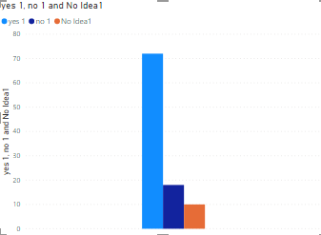

Question 3: Are you looking for ways to improve that?

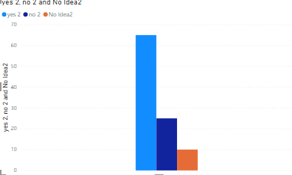

Questions 5: Are you addicted to social media or video games?

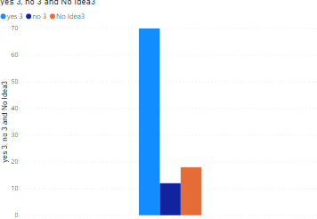

Questions 7: Have you ever thought of turning them off to go to bed on time?

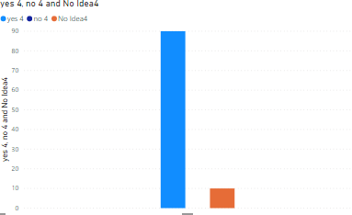

### 3.2 Discussion

In this study, there are some unforeseen risks: finding data to learn mobile programming, which takes a long time, and the framework of this project does not allow it so I can only learn the basics and simple concepts of mobile programming.

### 3.3 Recommendations

To complete this application, I need to find a teacher with an easy to understand and quick to learn the basics, besides to refer to some similar applications I need to find the source code of the application. easiest to understand to quickly grasp how they operate.

# D.Project Planning Management

## Project Overview

### 1.1 Current Situation and Disadvantages.

Here are some of the current user behaviors:

- addicted to social networks, games.

Young people spend too much time using social networks and playing video games, over time leading to addiction to them, leading to many negative effects for young people such as anxiety, depression, lazy communication, insomnia, feeling lonely.

- Loss of time control

from spending too much time on social media and games, leading to time spent on games encroaching on time spent sleeping and other activities.

Here are the disadvantages of the current situation:

- Young people don't have the rigor of sticking to the timetable they have set.

Our project is also reviewing:

- force users to stop using technology equipment in the specified time

- Use the calendar to set bedtime for each day

- looking for suitable music that can make users relax when they go to sleep.

### 1.2 The Proposed System

There are some suggestions for this project to build this application on desktop or mobile. We are looking at this to create an application that is most practical to the user.

**1.2.1 mobile app.**

- Convenient easy to use.

- suitable for the majority of customers.

- manage and control time using smart phone

- create a habit of going to bed on time.

**1.2.2 desktop app.**

- Only suitable for some customers who regularly use computers, laptops.

- Steam is not convenient to use gas.

- Manage and control time using computers, laptops.

- create a habit of going to bed on time.

* Through review and evaluation we decided to build a desktop app. Although the desktop app has a number of points no less than mobile apps, but similar applications on mobile have appeared quite a lot, but not on desktop.

### 1.3 Boundaries of the System

* Our target audience is students and office workers so most of them have computers or lap top, so they can all use our apps.
* The language of the system is Vietnamese.
* The complete product includes:

+ a desktop application

+ All the document involved.

### 1.4 Development Environment

#### 1.4.1 Hardware requirements

**For server**

|  |  |  |
| --- | --- | --- |
| **Windows** | **Minimum Requirements** | **Recommended** |
| **Internet Connection** | Wi-Fi Connection 2Mb | Wi-Fi Connection 12MB |
| **Operating System** | Windows Server 2008 Enterprise | Windows Server 2012 Enterprise |
| **Computer Processor** | Intel Xeon M3 2.53GHz | Intel Xeon M5 3.0GHz |
| **Computer Memory** | 1 GB | 2GB |

Table 3: Hardware Requirement for **server**

#### 1.4.2 Software requirements

* Window Server 2008 Enterprise: operating system and platform for deploy.

- Visual studio .net Framework 4.6: used to implement application.

## Project organization

### 2.1 Software Process Model

The waterfall model is a classical model used in system development life cycle to create a system with a linear and sequential approach. It is termed as waterfall because the model develops systematically from one phase to another in a downward fashion. This model is divided into different phases and the output of one phase is used as the input of the next phase. Every phase has to be completed before the next phase starts and there is no overlapping of the phases.

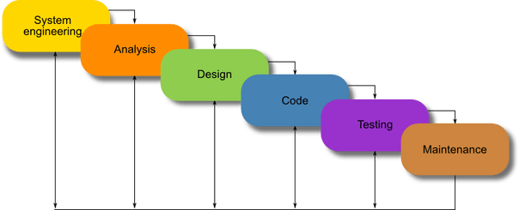

**Figure 11: Waterfall Development Model**

### 2.2 Role and responsibilities

|  |  |  |  |
| --- | --- | --- | --- |
| **No** | **Full name** | **Role in Group** | **Responsibilities** |
| 1 | Ngô Quỳnh Bảo Trâm | Supervisor | * Specify user requirement * Control the development process * Support about technique and business analysis * Review document |
| 2 | Nguyễn hoàng tuấn vũ | Developer, Tester | * Managing process * Dividing tasks * GUI design * Create test plan * Clarifying requirements * Prepare document * Coding * Testing |

**Table 5: Role and Responsibilities**

## Project Works Plan

### 3.1 Work Breakdown Structure

The work breakdown structure identifies the project’s tasks to provide a framework for organizing and managing the work of the project.

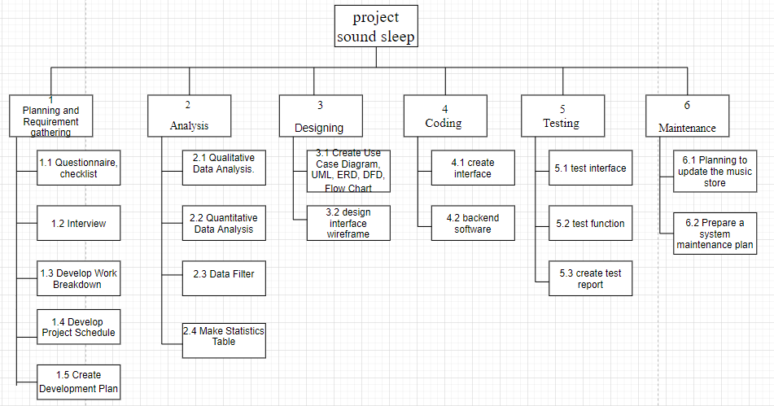

### 3.2 Gantt Chart

**Gantt Chart**

The Gantt chart graphically represents a project by showing each task as a horizontal bar whose length is the time needed to complete the task.

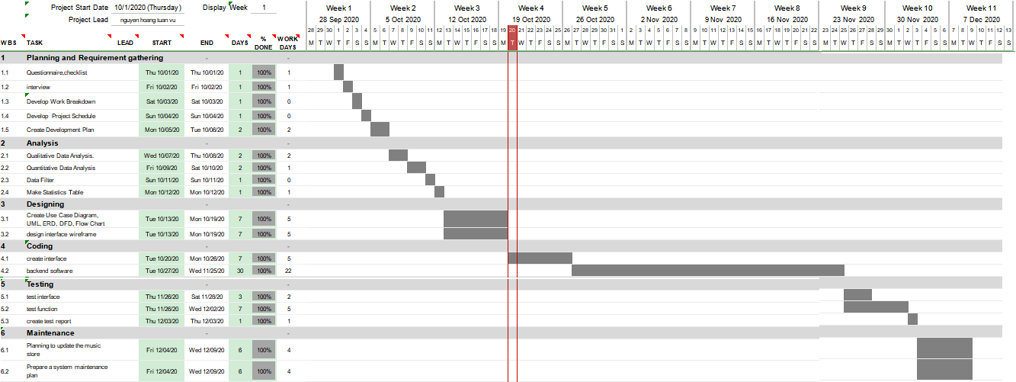

**Figure 10: Gantt Chart**

**Project Schedule**

The project schedule includes milestones, task dependencies, task duration, delivery dates, and staff resources assigned to complete the tasks.

|  |  |  |  |
| --- | --- | --- | --- |
| Task Name | Duration(day) | Start | Finish |
| **Planning and Requirement gathering** | | | |
| Questionnaire,checklist | 1 | Fri 10/02/20 | Fri 10/02/20 |
| interview | 1 | Sat 10/03/20 | Sat 10/03/20 |
| Develop Work Breakdown | 1 | Sun 10/04/20 | Sun 10/04/20 |
| Develop Project Schedule | 1 | Mon 10/05/20 | Tue 10/06/20 |
| Create Development Plan | 2 | Wed 10/07/20 | Thu 10/08/20 |
| **Analysis** | | | |
| Qualitative Data Analysis. | 2 | Wed 10/07/20 | Thu 10/08/20 |
| Quantitative Data Analysis | 2 | Fri 10/09/20 | Sat 10/10/20 |
| Data Filter | 1 | Sun 10/11/20 | Sun 10/11/20 |
| Make Statistics Table | 1 | Mon 10/12/20 | Mon 10/12/20 |
| **Designing** | | | |
| Create Use Case Diagram, UML, ERD, DFD, Flow Chart | 7 | Tue 10/13/20 | Mon 10/19/20 |
| design interface wireframe | 7 | Tue 10/13/20 | Mon 10/19/20 |
| **Coding** | | | |
| create interface | 7 | Tue 10/20/20 | Mon 10/26/20 |
| backend software | 30 | Tue 10/27/20 | Wed 11/25/20 |
| **Testing** | | | |
| test interface | 3 | Thu 11/26/20 | Sat 11/28/20 |
| test function | 7 | Thu 11/26/20 | Wed 12/02/20 |
| create test report | 1 | Thu 12/03/20 | Thu 12/03/20 |
| **Maintenance** | | | |
| Planning to update the music store | 6 | Fri 12/04/20 | Wed 12/09/20 |
| Prepare a system maintenance plan | 6 | Fri 12/04/20 | Wed 12/09/20 |

## Tools and Techniques

* Front-end technologies: none.
* Back-end technologies: C#.
* Database Management System: none.

## Coding Convention

Use C# coding convention to develop application.

Summary:

* Naming Convention.
  + use PascalCasing for class names and method names.
  + use camelCasing for local variables and method arguments.
  + do not use Hungarian notation or any other type identification in identifiers
  + avoid using Abbreviations. Exceptions: abbreviations commonly used as names, such as Id, Xml, Ftp, Uri
  + use PascalCasing for abbreviations 3 characters or more
  + do not use Underscores in identifiers. Exception: you can prefix private static variables with an underscore.

# E.Requirement Analysis

## User Requirement Specification

### 1.1 Guest Requirement

The guest is the only one using the system. The function guest can use:

* Set the start and end times for a break.
* choose music and relax.

## System Requirement Specification

### 2.1 External Interface Requirement

#### 2.1.1 User Interface

The general requirement for the graphical user interface is that the GUI should be simple, clear, Maintain consistency, Use colors and textures in harmony. Smart font selection, size and text arrangement, always quick and clear user feedback, intuitive and reminiscent of layout.

### 2.2 System Overview Use Case

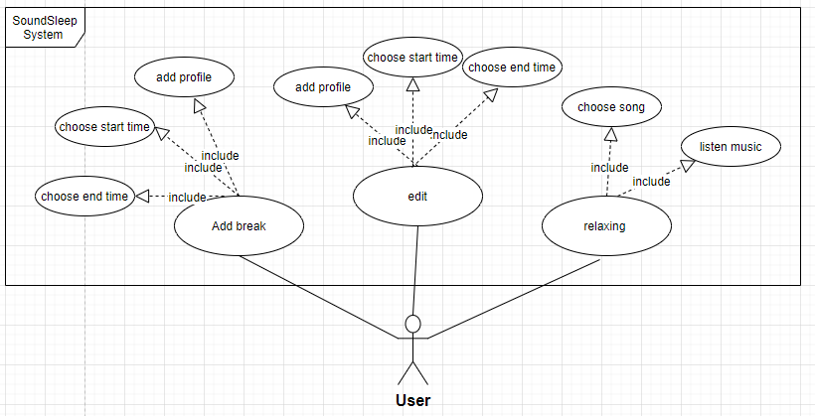

**Figure 12: System Overview Use Case**

#### 2.2.1 <Guest> add break Use Case Diagram

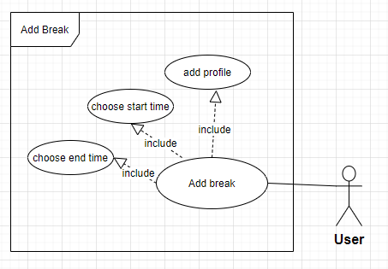

**Figure 4: <Guest> add break use case diagram**

**Use Case Specification**

|  |  |  |  |
| --- | --- | --- | --- |
| **USE CASE -1 SPECIFICATION** | | | |
| **Use-case No.** | SLP001 | **Use-case Version** | 2.0 |
| **Use-case Name** | Add break | | |
| **Author** | Nguyen hoang tuan vu | | |
| **Date** | 22/01/15 | **Priority** | High |
| **Actor:**  Guest  **Summary:**  This use case allows guest to add a break to the system.  **Goal:**  Allow guest add break to the system.  **Triggers**   * Guest press “+” button on form main screen.   **Preconditions:**   * N/A   **Post Conditions:**   * **On Success**: Guest added a break in to the system. * **On Failure**: Show error message.   **Main Success Scenario:**   |  |  |  | | --- | --- | --- | | Step | Actor Action | System Response | | 1 | Input information | System will display add screen:  - “profile”: textbox, min length 1, max length 50.  - “start time”: combobox,  + Hour: min length: 0, max length 23.  + minute: min length: 0, max length 50.  - “end time”: combobox,  + Hour: min length: 0, max length 23.  + minute: min length: 0, max length 50. | | 2 | Press save button | System will navigate to Home screen and add a break. |   **Alternative Scenario:**   * -N/A   **Exceptions:**   |  |  |  | | --- | --- | --- | | No | Actor Action | System Response | | 1 | Guest lefts “profile” or “start time and end time” textboxes blank. | Show message: “please input full information”. | | 2 | Guest press “cancel” button | System will navigate to Home screen. |   **Relationships:**   * N/A   **Business Rules:**  - User must enter sufficient information to setup a break.  - If the guest enters lack of information, setup cannot be broken. | | | |

#### 2.2.2 <Guest> Edit Use Case Diagram

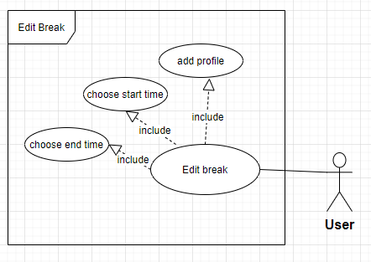

**Figure 5: <Guest> Edit use case diagram**

|  |  |  |  |
| --- | --- | --- | --- |
| **USE CASE -2 SPECIFICATION** | | | |
| **Use-case No.** | SLP002 | **Use-case Version** | 2.0 |
| **Use-case Name** | Edit break | | |
| **Author** | Nguyen hoang tuan vu | | |
| **Date** | 13/04/15 | **Priority** | High |
| **Actor:**  Guest  **Summary:**  This use case allows guest Edit break infomation in system.  **Goal:**  Allow guest Edit break in the system.  **Triggers**   * Guest press break on listbox on screen.   **Preconditions:**   * N/A   **Post Conditions:**   * **On Success**: break will be edited. * **On Failure**: Show error message.   **Main Success Scenario:**   |  |  |  | | --- | --- | --- | | Step | Actor Action | System Response | | 1 | Press breakon listbox | System will display add screen:  - “profile”: textbox, min length 1, max length 50.  - “start time”: combobox,  + Hour: min length: 0, max length 23.  + minute: min length: 0, max length 50.  - “end time”: combobox,  + Hour: min length: 0, max length 23.  + minute: min length: 0, max length 50. | | 2 | Guest input new information into textbox and press “save” button | System will navigate to form main screen and break has been edited. |   **Alternative Scenario:**   * -N/A   **Exceptions:**   |  |  |  | | --- | --- | --- | | No | Actor Action | System Response | | 1 | Guest lefts “profile” or “start time and end time” textboxes blank. | Show message: “please input full information”. | | 2 | Guest press “cancel” button | System will navigate to Home screen. |   **Relationships:**   * N/A   **Business Rules:**  - User must enter sufficient information to setup a break.  - If the guest enters lack of information, setup cannot be broken. | | | |

#### 2.2.3 <Guest> Relax Use Case Diagram

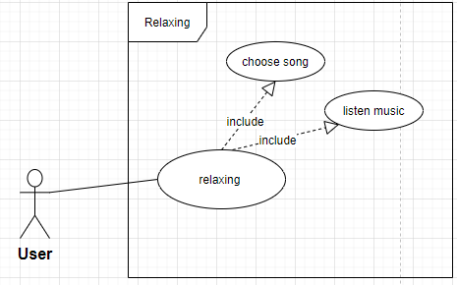

**Figure 5: <Guest> Relax use case diagram**

|  |  |  |  |
| --- | --- | --- | --- |
| **USE CASE -2 SPECIFICATION** | | | |
| **Use-case No.** | EPS002 | **Use-case Version** | 2.0 |
| **Use-case Name** | Register | | |
| **Author** | Duong Le Dinh Khang | | |
| **Date** | 13/04/15 | **Priority** | High |
| **Actor:**  Guest  **Summary:**  This use case allows guest listen to music before sleep.  **Goal:**  Allow guest relax before falling asleep.  **Triggers**   * When it comes to the time that the user has previously set, the system will automatically redirect to the music screen.   **Preconditions:**   * N/A   **Post Conditions:**   * **On Success**: When the time is up, navigate to the music screen. * **On Failure**: Show error message.   **Main Success Scenario:**   |  |  |  | | --- | --- | --- | | Step | Actor Action | System Response | | 1 |  | System will display Register screen:  List music: listbox  countdown timer : countdown time to the end. |   **Alternative Scenario:**   * N/A   **Exceptions:**  - N/A  **Relationships:**   * N/A   **Business Rules:**   * This page only works when the user has set up the minus time. * when the time comes, the page will be enabled automatically. * we have provided some soft music, but if they are not suitable for the user, then they can choose the music they like. | | | |

## Non-Functional Requirement

### 3.1 Usability

* Support devices: PC, Laptop.
* Support OS: windows, IOS, Linux.
* Fast request response time

### 3.2 Reliability

* Trusted app, does not advertise any trade marks, does not mention political news, does not retrieve user information. This application is very reliable to use.

### 3.3 Availability

* Users need an internet connection to use all functions of the system in the best way.
* Users can install and use the application by many devices such as laptop, pc, or tablet.

### 3.4 Security

* + The system will not access any of the user's information.

### 3.5 Maintainability

* + The source code is clear, easy to understand, and easy to fix. Simple structure and design, easy to modify

### 3.6 Portability

* + The system can be compatible with many operating systems and devices.

### 3.7 Performance

* + Fast server response, low network latency, high rendering performance.

## Conceptual Diagram

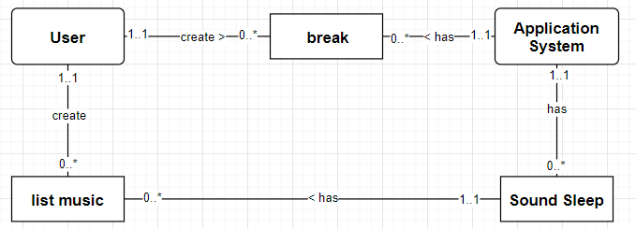

**Figure 14: Conceptual Diagram**

**DATA DICTIONARY**

|  |  |
| --- | --- |
| **Entity Data dictionary: describe content of all entities** | |
| Entity Name | Description |
| User | Describe all users in the system. |
| Break | Describe all breaks in the system. |
| Application System | Describe the system's processing system |
| Sound Sleep | Describe the music playback system that helps users relax |
| List music | Describe list music in the system. |

**Table 8: Data Dictionary**

# F.Software Design Description

## 1. Design Overview

* This document describes the technical and user interface design of EPS System. It includes the architectural design, the detailed design of common functions and business functions.
* The architectural design describes the overall architecture of the system and the architecture of each main component and subsystem.
* The detailed design describes static and dynamic structure for each component and functions. It includes class diagrams, class explanations and sequence diagrams for each use cases.
* The database design describes the relationships between entities and details of each entity.
* Document overview:
* Section 2: gives an overall description of the system architecture design.
* Section 3: gives component diagrams that describe the connection and integration of the system.
* Section 4: gives the detail design description, which includes class diagram, class explanation, and sequence diagram to details the application functions.
* Section 5: describe a fully attributed ERD.

## System Architectural Design().

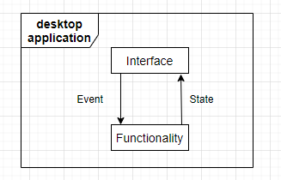

**Figure 15: System Architectural**

### 2.1 Web application architecture description

* .

## Detailed Description

### 3.1 Sequence Diagram

#### 3.1.1 <Guest> add breaks.

**Summary:** This diagram shows how to guest add break into system.

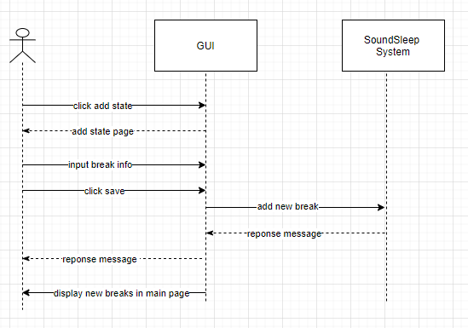

Figure 29: <Guest> add breaks

#### 3.1.2 <Guest> Edit Break.

**Summary:** This diagram shows how to guest edit breaks.

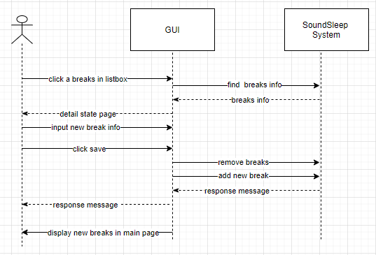

Figure 30: <Guest> Edit breaks.

#### 3.1.3 <Guest> Sound Sleep.

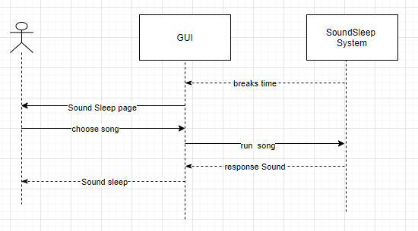

**Figure 16: Class Diagram**

## User Interface Design

### 4.1 Interface Design

#### 4.1.1 Home Page.

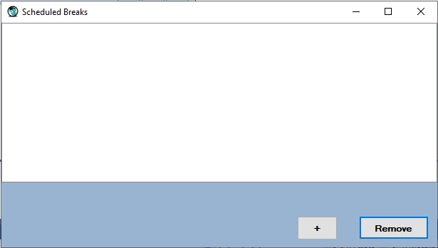

Figure 1: Home page.

**Fields**

|  |  |  |  |  |  |  |  |
| --- | --- | --- | --- | --- | --- | --- | --- |
| **No** | **Field Name** | **Description** | **Read only** | **Mandatory** | **Control Type** | **Data Type** | **Length** |
| 1 | List breaks | Fill List of breaks | No | Yes | Listbox | String | N/A |

**Buttons/Hyperlinks**

|  |  |  |  |  |
| --- | --- | --- | --- | --- |
| **No** | **Function** | **Description** | **Validation** | **Outcome** |
| 2 | Add | navigate to the extra breaks page | N/A | screen navigation to add breaks page |
| 3 | Remove | Delete breaks | N/A | delete the selected breaks from the system |

#### 4.1.2 Add Breaks Page.

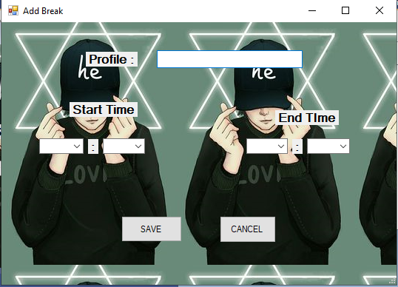

Figure 2: add breaks page

**Fields**

|  |  |  |  |  |  |  |  |
| --- | --- | --- | --- | --- | --- | --- | --- |
| **No** | **Field Name** | **Description** | **Read only** | **Mandatory** | **Control Type** | **Data Type** | **Length** |
| 1 | profile | Name of Breaks | No | N/A | textbox | String | N/A |
| 2 | Start time | Time to start breaks | No | N/A | combobox | String | N/A |
| 3 | End time | Time to finish breaks | No | N/A | textbox | String | N/A |

**Buttons/Hyperlinks**

|  |  |  |  |  |
| --- | --- | --- | --- | --- |
| **No** | **Function** | **Description** | **Validation** | **Outcome** |
| 1 | Save | Click to save the breaks information to the system | N/A | Transfer to home page and show breaks on list box. |
| 3 | Cancel | interrupt adding breaks process | N/A | Transfer to home page. |

#### 4.1.3 Sound Sleep page.

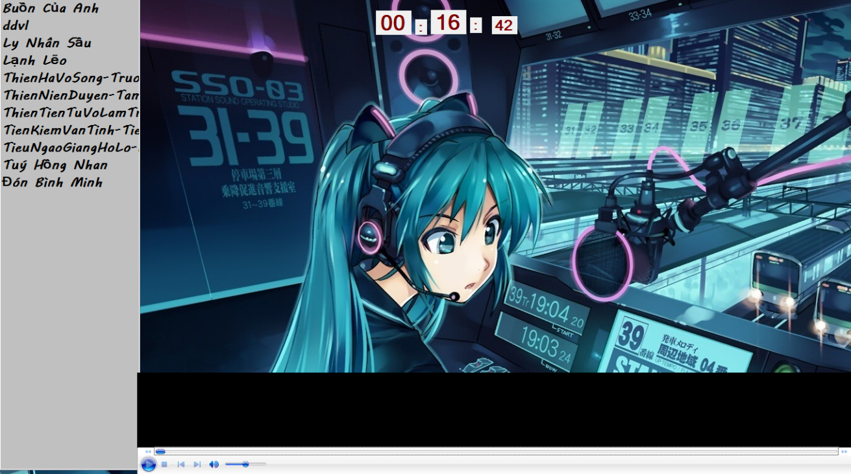

**Fields**

|  |  |  |  |  |  |  |  |
| --- | --- | --- | --- | --- | --- | --- | --- |
| **No** | **Field Name** | **Description** | **Read only** | **Mandatory** | **Control Type** | **Data Type** | **Length** |
| 1 | List music | List of music | No | N/A | listbox | String | N/A |
| 2 | Time remaining | Time remaining to finish Sound Sleep | No | N/A | label | String | N/A |

# G.System Implementation & Test

## Introduction

### 1.1 Overview

This section contains in detail of all necessary information about system implementation includes all test plans, test cases, test results and test environment.

### 1.2 Test Approach

- Goal: To test the whole system based on the core flow.

- Method: System testing, Black box testing.

## Performance Measurement

The performance of this system will depend on the number of schedules included in the system. The more system schedules the heavier.

## Test Plan

### 3.1 Features to be tested:

We will test the entire system based on the following core workflow:

* + User: add breaks, edit breaks, start sound sleep.

## System Testing Test Case

### 4.1 User core flow.

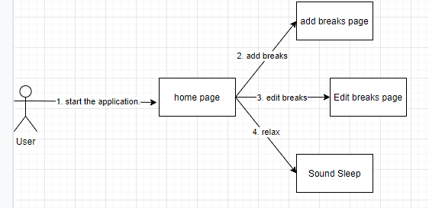

**Figure 23: <guest> User Core Flow.**

#### 4.1.1 Add breaks.

|  |  |  |  |  |  |  |  |
| --- | --- | --- | --- | --- | --- | --- | --- |
| **ID** | **Test Case Description** | **Test Case Procedure** | **Expected output** | **Inter-test Case**  **Dependence** | **Result** | **Test Date** | **Note** |
| A001 | user creates a breaks. | 1. user click add in home page. 2. User input all inforation 3. Press “save”. | * Display message and navigation back to the homepage, breaks appear on the list box. | N/A | Passed | 30/11/ 2020 | None |
| A002 | user creates a breaks but do not input full information. | 1. user click add in home page. 2. User input all inforation but Leave the profile box blank. 3. Press “save”. | * System will display error message. | N/A | Passed | 30/11/ 2020 | None |
| A003 | user creates a breaks but do not input full information. | 1. user click add in home page.   2. User input all inforation but Leave the “start time” box blank.  3. Press “save”. | * System will display error message. | N/A | Passed | 30/11/ 2020 | None |

#### 4.1.2 Edit Breaks.

|  |  |  |  |  |  |  |  |
| --- | --- | --- | --- | --- | --- | --- | --- |
| **ID** | **Test Case Description** | **Test Case Procedure** | **Expected output** | **Inter-test Case Dependence** | **Result** | **Test Date** | **Note** |
| EO01 | User editing break information. | 1. user press a breaks on listbox. 2. User input new information. 3. Press “save”. | * Display message and navigation back to the homepage, Edited breaks appear on the list box. | N/A | Passed | 30/11/2020 | None |
| E002 | User editing break information,  but click cancel halfway | 1. user press a breaks on listbox. 2. User input new profile. 3. Press “cancel”. | * Screen navigation back to the homepage. | N/A | Passed | 30/11/2020 | None |

#### 4.1.3 Relax.

|  |  |  |  |  |  |  |  |
| --- | --- | --- | --- | --- | --- | --- | --- |
| **ID** | **Test Case Description** | **Test Case Procedure** | **Expected output** | **Inter-test Case Dependence** | **Result** | **Test Date** | **Note** |
| EO01 | User selects music on list box. | 1. user click a song on listbox. | * the song will be played immediately. | N/A | Passed | 30/11/2020 | None |
| E002 | user want to exit SoundSleep mode. | 1. user click an other app. | * the screen will immediately return to SoundSleep mode. | N/A | Passed | 30/11/2020 | None |

# H.Communicate research outcomes

## Goal

The goal of this presentation was to introduce people to digital wellbeing, a sleep time management application. Its effect is to help users go to bed at the right time and at regular intervals every day, application limitations and improvements could develop in the future. I also cover techniques and how I develop projects.

1. **Audience**

- Stakeholders: Teachers, Students, Business.

-Characteristics and Expectations:

+ Students: They have technical knowledge and related knowledge, know English and to understand English slides or documents that I present more easily, they are interested in the benefits of the project or My extensive techniques.

+ Teacher: They have deep technical knowledge, they want to listen to my research, algorithm, architecture, content ...

+ Enterprises: they may have technical knowledge or not, they want to know what my project is and how I can do it.

1. **Medium**

Written word, spoken work, body language, presentation slide, report, schema, summary content table presentation. With teacher, I will prepare document for them, to let they know and understand my project.

1. **Execution & Evaluation**

**Execution**

1. Overview

* Introduction wellbeing
* Introduction project
* Advantages of the project

1. How could I do that

* System architecture
* Technology, tool

1. Limit and future plan

* cannot completely prevent the user from shutting down and reusing technology equipment.
* The application is quite simple, not competitive when it comes to market.
* Add function to use time statistics of equipment.
* completely restrict the user continuing to use device during breaks.

- Conclusion

## Evaluation

The more and more abuse of social media and technology devices makes users more susceptible to dependence and loss of control over their daily schedule of activities, namely bedtime. From that problem I decided to develop an application that helps users control their behavior, ensure health. Present to the audience an overview of the product, architecture, strengths, weaknesses, and future development plans

## Summary

|  |  |  |  |  |  |  |  |  |
| --- | --- | --- | --- | --- | --- | --- | --- | --- |
| **Audience** | **Key messages** | **Intended outcomes** | **Timing** | **Content** | **Resource implications** | **Channels** | **Owner** | **Evidence** |
| Student, Teacher, Enterprise | The reason why I choose this project. | Listen | All Time | The reason why that I choose this project. | With presentation include image, everyone can understand content | Document, Presentation | Nguyen hoang tuan vu | Document, slide, extension |
| Student, Teacher, Enterprise | Advantages of the project | Listen | All Time | The advantages as project bring for people. | With presentation include image, everyone can understand content | Document, Presentation | Nguyen hoang tuan vu | Document, slide, website |
| Student, Teacher, Enterprise | System architecture | Listen and ask relevant question | Half Time | The system architecture and technology of project | With presentation include image and document, teacher can understand content | Document, Presentation | Nguyen hoang tuan vu | Document, slide, website |
| Student, Teacher, Enterprise | Limit and Future plan | Listen and ask relevant question | All Time | future development limits and plans will | With presentation include image and document, teacher can understand content | Document, Presentation | Nguyen hoang tuan vu | Document, slide, website |

**I.Evaluating a research project**

## 1. Reflect on the effectiveness of research methods applied for meeting objectives of the business research project.

In order to achieve the Project's Business Research Goals, in the first phase of the project I have chosen the questionnaire research method and interview. Most of the current problems have been resolved.

The strength of the interview method is that we can obtain more detailed and complete data and we can discuss more deeply about the wishes of the users, besides this method also saves costs and costs. spend less time.

The strength of the questionnaire approach is that we can collect more data in less time. Surveying online survey software is fast and cost-effective. In addition, many survey software comply with important data privacy and security regulations.

Based on the results achieved, I find this project very feasible and pioneering and needs to be quickly implemented. Some small details and functions of the system I will change and evolve accordingly after consulting with the gathered comments.

## Consider alternative research methodologies and lessons learnt in view of the outcomes

Based on the questionnaire and interview method, we can understand the needs and wants of the users. There are still gaps in the research process to evaluate whether a product really works well for its purpose. The additional use of experimental methods to research can test whether the product really works well to help users manage their time using technology equipment.

After this project, I understood more about the applications of technology that really help us a lot in our life and work in the future. Although the application started with only a few fairly simple features, it was also the first step in a way to apply digital wellbeing on computers. It is meaningful to create products that are accepted and used by people, giving me the motivation to continue to improve in the future.

When I picked up and started planning my project, I didn't know much about desktop applications and had to learn about it. Instructions on how to create a desktop application with lots of advanced applications are rare. In the near future, I may be able to research and develop additional features for the application such as screen time statistics or applications in the device

This project has many flaws and few functions, but if you are one of those people who are spending hours using technology devices regardless of time, this is really an application worth your time to experience.

but also in foreign countries, Southeast Asian countries, possibly further than Asia or around the world. Besides, there is no limit on the number of bookings. There are trips that suit everyone within their budget. And above all, there are more detailed schedules, such as introducing famous places to visit, supplementing the foods they should enjoy, the specialty items in their area. At the same time support users to book rooms, airline tickets in the most convenient way. In short, through this project, it helped me gain experience on many things. Such as how to do a research paper on the degree of rationality, must be conducted to be effective. As well as solving, difficulties in research. At the same time, it also helps me have a lot of experience in traveling, such as where to go and is reasonable with a certain budget. Should stay at the hotel, homestay is both cheap and beautiful. Eat something special. And above all, travel experiences through expanded ideas contributed by everyone.