Student: Nguyễn Hồng Phát

ID: SE63348

Class: SE1262

# Assignment

## Dimensional model

### OJT (on-the-job training) results

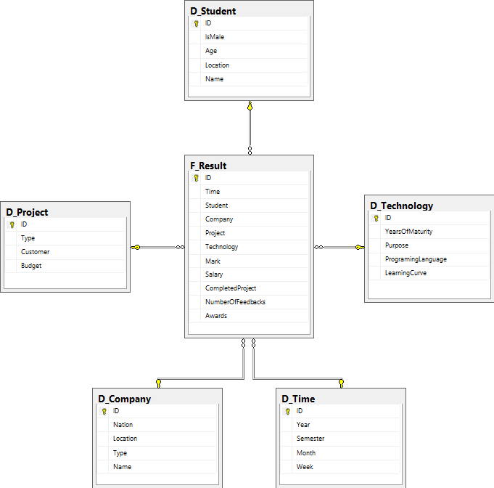

### Satisfaction of students in OJT semester

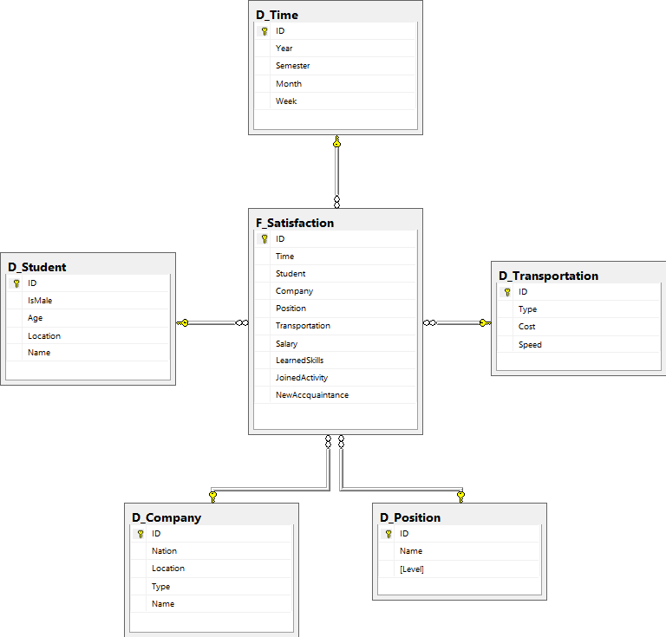

### Effect of OJT process to result of post-subjects (academic subjects after OJT)

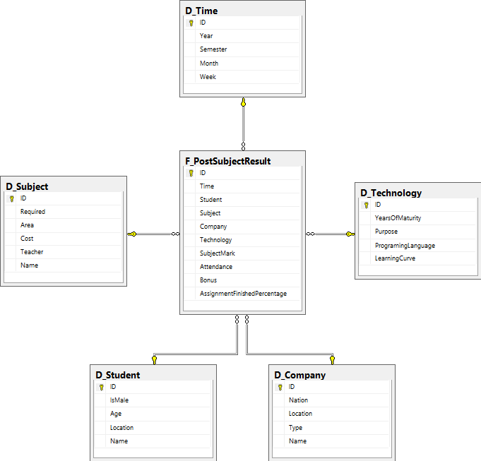

## Implement the model under MS SQL Server



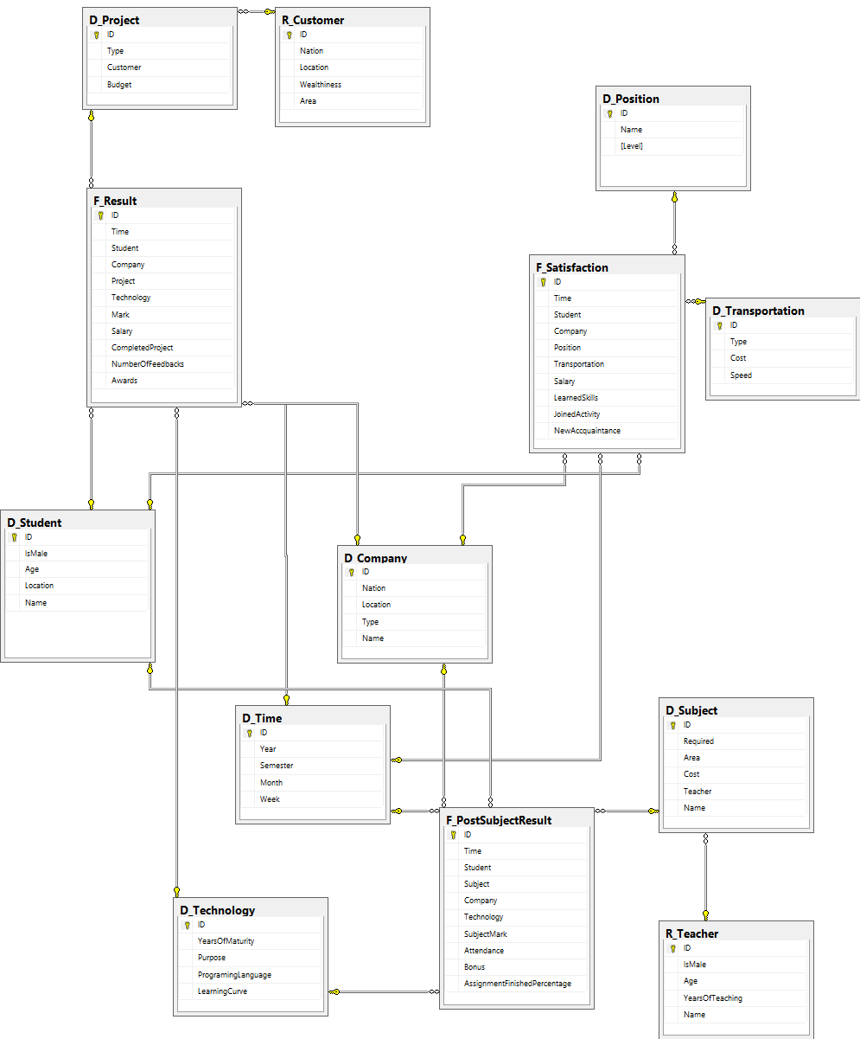

## Write at least 5 SQL SELECT statements and 5 stored procedures

### SQL SELECT

#### Where is the place that most students prefer taking OJT at?

SELECT TOP 1 c.Location, COUNT(f.Student) as 'Number of students'

FROM F_Result f, D_Company c

WHERE f.Company = c.ID

GROUP BY c.Location

ORDER BY 'Number of students' DESC

Result:



#### Numbers of Male and Female Students that have 6+ mark on the Summer 2019 OJT

SELECT COUNT(*) AS 'Number of Students that have 6+ mark', s.IsMale

FROM F_RESULT r, D_Student s, D_Time t

WHERE r.Student = s.ID AND r.Mark >= 6 AND r.Time = t.ID AND t.Semester = 'Summer' AND t.Year = 2019

GROUP BY s.IsMale

Result:

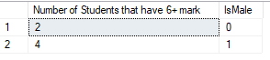

#### List these students who go to work by Bus and joined at least 2 activity

SELECT f.JoinedActivity, s.* FROM F_Satisfaction f, D_Transportation t, D_Student s

WHERE f.Transportation = t.ID AND f.JoinedActivity >= 2 AND s.ID = f.Student

Result:

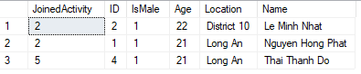

#### What is the Company that Students have the most salary

SELECT f.Salary as 'Highest salary', c.* FROM F_Result f, D_Company c

WHERE f.Company = c.ID AND f.Salary = (SELECT MAX(Salary) FROM F_Result)

Result:



#### Average post subject’s finish percentage of assignment per Programing Language used at OJT

SELECT t.ProgramingLanguage, AVG(f.AssignmentFinishedPercentage) AS 'Average Assignment Finish Rate'

FROM F_PostSubjectResult f, D_Technology t

WHERE f.Technology = t.ID

GROUP BY t.ProgramingLanguage

Result:

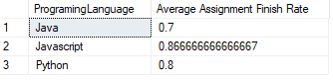

### Stored Procedures

#### Average OJT salary by transportation

CREATE PROCEDURE AverageSalaryPerTransportation(@transportation AS VARCHAR(100))

AS

BEGIN

SELECT AVG(f.Salary) as 'Average Salary' FROM F_Satisfaction f, D_Transportation t

WHERE f.Transportation = t.ID AND t.Type = @transportation

GROUP BY t.Type

END;

Execute:

EXEC AverageSalaryPerTransportation 'Bus'

Result:



#### List of students who joined an OJT at a defined semester

CREATE PROCEDURE ListStudents(@semester AS NCHAR(20), @year AS INT)

AS

BEGIN

SELECT s.* FROM F_Result f, D_Student s, D_Time t

WHERE t.Semester = @semester AND t.Year = @year AND s.ID = f.Student AND t.ID = f.Time

END;

Execute:

EXEC ListStudents 'Summer', 2019

Result:

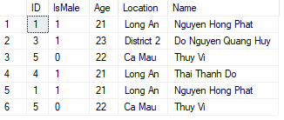

#### Numbers of Male and Female Students that have at least @minMark mark

CREATE PROCEDURE CountStudents(@minMark AS FLOAT)

AS

BEGIN

SELECT COUNT(*) AS 'Number of students', s.IsMale

FROM F_RESULT r, D_Student s

WHERE r.Student = s.ID AND r.Mark >= @minMark

GROUP BY s.IsMale

END;

Execute:

EXEC CountStudents 7

Result:



#### Programing language that have more than @x students used at OJT

CREATE PROCEDURE FindProgramingLanguage(@x AS FLOAT)

AS

BEGIN

SELECT t.ProgramingLanguage, COUNT(f.Student) AS NumberOfStudents FROM F_Result f, D_Technology t

WHERE f.Technology = t.ID

GROUP BY t.ProgramingLanguage

HAVING COUNT(f.Student) > @x

END;

Execute:

EXEC FindProgramingLanguage @x = 1

Result:

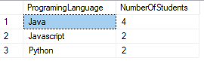

#### Which company that make the most absent student at the @subject subject after OJT

CREATE PROCEDURE CompanyMakeAbsent(@subject AS NCHAR(20))

AS

BEGIN

SELECT TOP 1 c.*, (30 - f.Attendance) AS Absent FROM F_PostSubjectResult f, D_Subject s, D_Company c

WHERE f.Subject = s.ID AND f.Company = c.ID AND s.Name = @subject

ORDER BY Absent DESC

END;

Execute:

EXEC CompanyMakeAbsent 'XML'

Result:

