**Assignment**

**Star schema**:

I used SQL server to implement this assignment. I have designed five model.

1. **FactOJT** (Id, StudentId, CompanyId, TrainingId, SemesterId, RatingOfStudents, RatingOfBussiness, ViolateTheRegulations, NumberOfPraticeDays, NumberOfHolidayAllowed, NumberOfReprimands, FocedLeave, AspirationsToReturnToTheCompany)
2. **Company** (id, Name, Address, Phone, Email)
3. **Semester** (id, Name, Year, Grade)
4. **Student** (id, Name, Specialized, Curriculum, Address, Phone, Email)
5. **Training Area** (id, Name, Description)

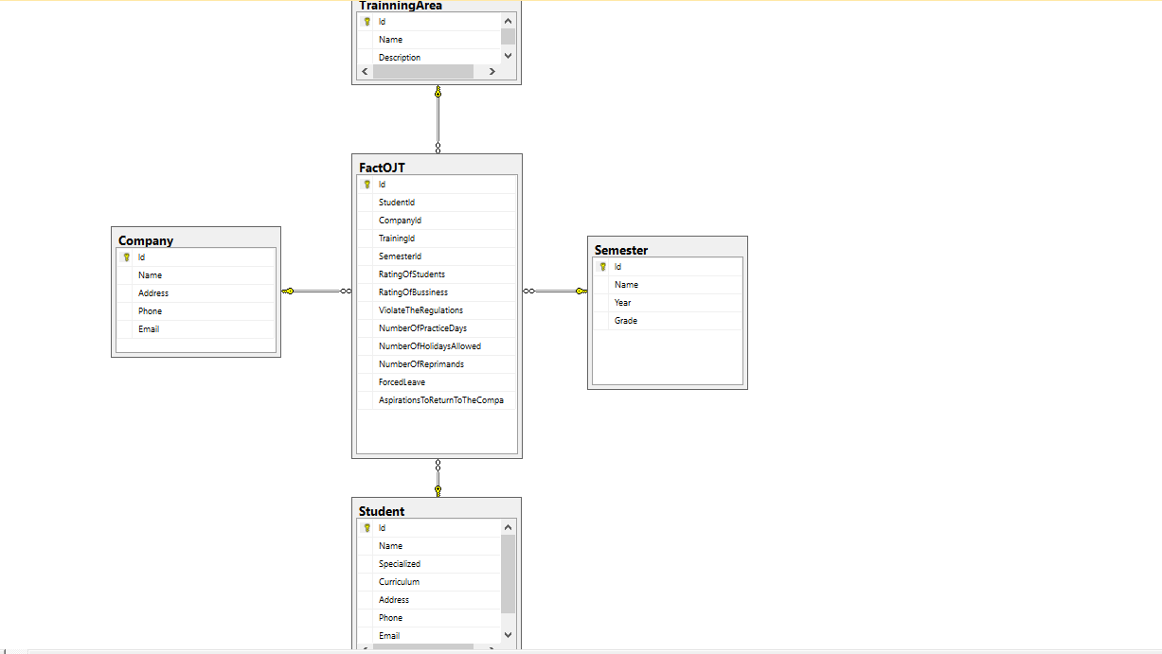

Query 1: Xem điểm OJT của mỗi sinh viên từ mỗi công ty:

SELECT Student.Id, Student.Name, FactOJT.RatingOfBussiness FROM Student

INNER JOIN FactOJT ON Student.Id = FactOJT.StudentId

ORDER BY FactOJT.RatingOfBussiness desc

Kết quả:

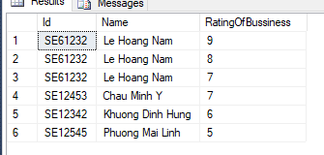

Procedure 1: Xem điểm OJT của 1 sinh viên :

CREATE Procedure [dbo].[GetOJTPointOfAStudent]

@studentid varchar(255)

AS

SELECT Student.Id, Student.Name, FactOJT.RatingOfBussiness

FROM Student

INNER JOIN FactOJT ON Student.Id=FactOJT.StudentId

WHERE Student.Id=@studentid

Kết Quả:

**CALL** GetOJTPointOfAStudent(**‘SE12453’**)

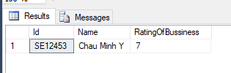

Query 2: Điểm OJT của mỗi công ty được sinh viên vote:

SELECT Company.Name, SUM(FactOJT.RatingOfStudents) as Score

FROM Company

INNER JOIN FactOJT ON Company.Id = FactOJT.CompanyId

GROUP BY Company.Name

Kết quả:

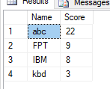

Procedure 2: Xem công ty thực tập của 1 sinh viên

CREATE Procedure [dbo].[GetCompanyOfAStudent]

@studentid varchar(255)

AS

SELECT Student.Id, Student.Name, Company.Name

FROM Company, Student

WHERE Student.Id=@studentid AND Company.Id IN

(SELECT FactOJT.CompanyId

FROM FactOJT

WHERE FactOJT.StudentId=@studentid)

Kết quả:

**call** GetCompanyOfAStudent(**'SE12453'**)

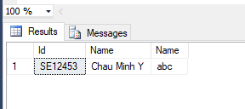

Query 3: Xem các công ty mà một sinh viên đi thực tập:

SELECT Student.Id, Student.Name, Company.Name

FROM Company, Student

WHERE Student.Id='SE61232'AND Company.Id IN

(SELECT FactOJT.CompanyId

FROM FactOJT

WHERE FactOJT.StudentId='SE61232')

Kết quả:

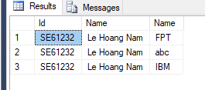

Procedure 3: Xem số sinh viên đi thực tập ở 1 công ty:

CREATE PROCEDURE [dbo].[GetTotalStudentDoOJTOfACompany]

@company_name varchar(255)

AS

SELECT Company.Name, COUNT(FactOJT.StudentId) AS Number

From Company, FactOJT

WHERE Company.Name=@company_name AND FactOJT.CompanyId=Company.Id

GROUP BY Company.Name

Kết quả:

**call** GetTotalStudentDoOJTOfACompany(**'abc'**)

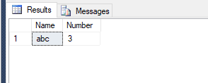

Query 4: Xem số lượng sinh viên sẵn sàng quay trở lại mỗi công ty

SELECT Company.Name, COUNT(FactOJT.AspirationsToReturnToTheCompany) as Comback

FROM FactOJT, Company

WHERE FactOJT.CompanyId=Company.Id AND FactOJT.AspirationsToReturnToTheCompany=1

GROUP BY Company.Name

Kết quả:

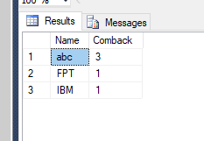

Procedure 4: Xem điểm OJT của tất cả các công ty:

CREATE PROCEDURE [dbo].[SelectOJTPointOfAllCompany]

AS

BEGIN

SELECT Company.Name, SUM(FactOJT.RatingOfStudents) as Score

FROM Company

INNER JOIN FactOJT ON Company.Id = FactOJT.CompanyId

GROUP BY Company.Name

END

Kết quả:

**call** SelectOJTPointOfAllCompany()

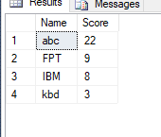

Query 5: Xem số lượng sinh viên đi thực tập ở 1 công ty:

SELECT Company.Name, COUNT(FactOJT.StudentId) AS Number

From Company, FactOJT

WHERE Company.Name='abc' AND FactOJT.CompanyId=Company.Id

GROUP BY Company.Name

Kết quả:

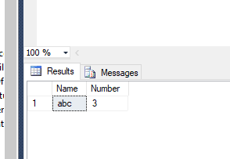

Procedure 5: Xem số lượng sinh viên sẽ quay lại của 1 công ty

CREATE Procedure [dbo].[GetNumberWillingToStayOfACompany]

@company_name varchar(255)

AS

SELECT Company.Name, COUNT(FactOJT.AspirationsToReturnToTheCompany) as Comback

FROM FactOJT, Company

WHERE Company.Name=@company_name AND FactOJT.CompanyId=Company.Id AND FactOJT.AspirationsToReturnToTheCompany=1

GROUP BY Company.Name

Kết quả:

**call** GetNumberWillingToStayOfACompany(**‘FPT’**)

