Name: LÂM THANH TÙNG

Mssv: SE61895

### Lab1 : DIMENSIONAL ANALYSIS

**Business-dimensional models**

TREATMENT

SUPPORT

**SATISFACTION**

EXPERIENCE

ENVIROMENT

RELATIVE

EXCITIMENT IN LEARNING

**EFFECT**

EDUCATION PROGRAM

EXCITIMENT IN WORK

FIELDS

TIME

**OJT RESULT**

SKILL

SIZE OF BUSINESS

CAREER ORIENTATION

**Information packages to analyze**

- OJT (on-the-job training) results

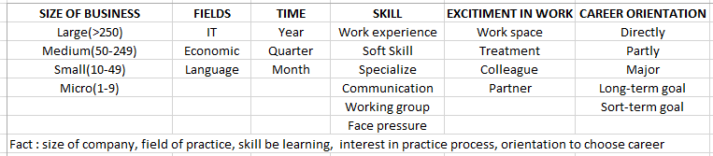

- Satisfaction of students in OJT semester

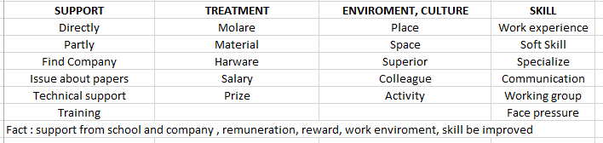

- Effect of OJT process to result of post-subjects (academic subjects after OJT)

