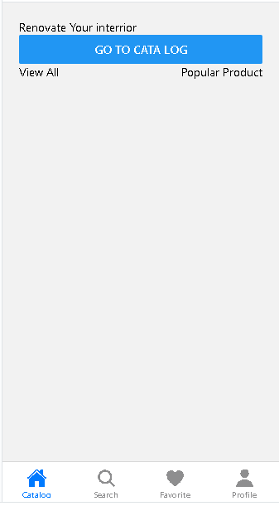

const Tab = createBottomTabNavigator();

const Stack = createStackNavigator();

// BottomTabNavigator cho HomeScreen

const BottomTabNavigator = () => (

<Tab.Navigator

initialRouteName="Catalog"

screenOptions={({ route }) => ({

headerShown: false,

tabBarIcon: ({ focused, color, size }) => {

let iconName;

if (route.name === 'Catalog') {

iconName = focused ? 'home' : 'home-outline';

} else if (route.name === 'Search') {

iconName = focused ? 'search' : 'search';

}

else if (route.name ==="Favorite")

{

iconName = focused ? 'heart' :'heart';

}

else if (route.name ==="Profile")

{

iconName = focused ? 'person' :'person';

}

return <Ionicons name={iconName} size={size} color={color} />;

},

})}

>

<Tab.Screen name="Catalog" component={Home} />

<Tab.Screen name="Search" component={Product} />

<Tab.Screen name="Favorite" component={Last} />

<Tab.Screen name="Profile" component={Profile} />

</Tab.Navigator>

);