Melon
ML Model Evaluation

Version <1.0>

Revision History
Date | Version | Description | Author
03/07/2026 | 1 | This consist dataset design and evaluation for all ML models in the project | Trần Tạ Quang Minh

Table of Contents
1. Introduction 4
2. Model Description 4
2.1 System-Wide AI Component Overview 4
2.2 Selection Rationale 5
2.3 Evaluated Model Details 5
2.3.1 Rubric Classifier (rubric_classifier) 5
2.3.2 Problem Parser (test_parser) 6
2.3.3 Question Generator (QA_generator) 6
3. Experimental Design 6
3.1 Datasets 6
3.2 Models and Baselines 7
3.3 Performance Metrics 7
3.4 Environment Setup 8
4. Results 8
4.1 Rubric Classifier 8
4.2 Problem Parser 10
4.3 Question Generator 10
4.4 Cross-Component Latency 12
5. Conclusion 13
Model Evaluation

1. Introduction
This document presents a systematic evaluation of the core machine learning components deployed in the Melon AI Learning App, an adaptive mathematics tutoring platform for Vietnamese primary-school students in Grades 4 and 5. The objective is to assess whether each AI component meets the minimum quality thresholds required for production deployment, to identify failure patterns, and to propose targeted improvements.
The Melon AI platform integrates multiple large language models (LLMs) consumed through third-party cloud APIs. No model weights are hosted, trained, or fine-tuned locally; instead, the team optimizes task performance through prompt engineering, structured output enforcement, and domain-specific context construction. The evaluation therefore measures task-level output quality - classification accuracy, extraction correctness, and generation quality - rather than model-internal metrics such as perplexity or training loss.
Three core AI components are evaluated: the Rubric Classifier, the Problem Parser , and the Question Generator. These were selected because they directly determine the quality of educational content served to students. The remaining AI components (tutoring chatbot, multimodal answer evaluator, speech-to-text, text-to-speech) serve auxiliary or interactive functions and are excluded from this evaluation.

2. Model Description

2.1 System-Wide AI Component Overview
The Melon AI Learning App deploys eight AI model instances across seven distinct features. All models are accessed as statically deployed managed API services with fixed version identifiers.
Component | Base Model | Provider / API | Function
Rubric Classifier | GPT-4o | OpenAI via OpenRouter | Bloom’s taxonomy classification of math questions
Problem Parser (OCR stage) | Gemini 2.5 Pro | Google via OpenRouter | Optical character recognition of scanned exam PDFs
Problem Parser (Parsing stage) | GPT-4.1 | OpenAI via OpenRouter | Structured extraction of question fields from OCR text
Question Generator | GPT-4o | OpenAI via OpenRouter | MCQA generation from curriculum topics
AI Tutoring Chat | GPT-4o-mini | OpenAI direct API | Streaming conversational tutoring for children
Multimodal Answer Evaluator | Gemini 2.0 Flash | Google Generative AI SDK | Evaluates children’s drawn and spoken answers
Speech-to-Text | Whisper-1 | OpenAI direct API | Transcribes student voice input
Text-to-Speech | eleven_multilingual_v2 | ElevenLabs API | Synthesizes Vietnamese speech from text

2.2 Evaluated Model Details

2.2.1 Rubric Classifier (rubric_classifier)
- Base Model: GPT-4o via OpenRouter
- Temperature: 0.1 (near-deterministic for classification consistency)
- Output Format: JSON with response_format: { type: "json_object" }
- Task: Given a Vietnamese math question (stem, choices, grade level, section type), classify it into one of four Bloom’s cognitive levels: nhan_biet (Knowledge), thong_hieu (Comprehension), van_dung (Application), van_dung_cao (Analysis/Synthesis).
- Prompt Configuration: The system prompt contains explicit definitions for each Bloom’s level with concrete mathematical examples from the Vietnamese Grade 4-5 curriculum, classification rules prioritizing cognitive demand over question length, and a mandatory output schema { rubricLevel, confidence, reasoning }. The prompt is mentioned explicitly in the Appendix section.

2.2.2 Problem Parser (test_parser)
- Stage 1 - OCR: Gemini 2.5 Pro via OpenRouter. Processes scanned PDF pages rendered as PNG images (up to 12 pages), extracting raw text, mathematical formulas, table structures, and illustration bounding boxes with batched processing.
- Stage 2 - Structured Parsing: GPT-4.1 via OpenRouter (temperature 0.1). Receives OCR text and produces structured JSON per question, handling three question types: multiple-choice, fill-in, and open-ended. Extracts fields including stem, choices[], answer, answerText, rubricLevel, concepts[], and cropBox.
- Pipeline: PDF → page rendering (PyMuPDF) → image slicing → batch OCR → text aggregation → structured extraction → JSON output.

2.2.3 Question Generator (QA_generator)
- Base Model: GPT-4o via OpenRouter
- Temperature: 0.7 (higher creativity for diverse question generation)
- Task: Given a mathematics topic and grade level, generate a set of multiple-choice questions (MCQA) with four choices (A/B/C/D), a correct answer, and an explanation.
- Prompt Configuration: The system prompt instructs the model to act as a Vietnamese primary-school math teacher, requiring that each correct answer be mathematically accurate, each distractor be a plausible result of common student mistakes (same unit, same data type), and no two answers be simultaneously correct. Output is enforced as a JSON object containing a questions array. The prompt is mentioned explicitly in the Appendix section.

3. Experimental Settings

3.1 Datasets
Three custom benchmark datasets were constructed. All datasets are authored in Vietnamese and reflect the Grade 4-5 mathematics curriculum.
Rubric Classifier Benchmark (rubric_classifier_benchmark.json). 40 Vietnamese math questions with a balanced distribution of 10 questions per Bloom’s cognitive level. Questions include both multiple-choice and short-answer formats across Grade 4 and Grade 5 content. Ground-truth labels were manually assigned by team members and cross-validated for consensus. The balanced distribution prevents majority-class bias and ensures per-class metrics are meaningful.
PDF Parser Test Document. A programmatically generated PDF using PyMuPDF simulating a Vietnamese math exam page (“DE KIEM TRA TOAN LOP 5”) containing three questions across different section types (multiple-choice, fill-in, open-ended) and one vector-drawn circle illustration. Ground truth includes three expected questions with known stems, answer keys, and choice structures.
QA Generator Topic Benchmark (qa_generator_benchmark.json). Five curriculum topics spanning Grade 4-5 content:
Topic | Grade | Description
Phan so va phep chia so tu nhien | 4 | Fraction representation, comparison, addition and subtraction
So thap phan va cac phep tinh | 5 | Decimal reading, writing, comparison, and arithmetic operations
Dien tich hinh thang | 5 | Trapezoid area formula S = (a+b) x h / 2, inverse problems
Chu vi va dien tich hinh tron | 5 | Circle circumference C = d x 3.14 and area S = r x r x 3.14
Van toc, quang duong, thoi gian | 5 | Motion formulas v = s/t, s = v x t, t = s/v, unit conversion
For each topic, the generator produces 5 MCQA questions. The evaluation assesses structural validity deterministically and answer correctness and distractor quality via an independent LLM as a Judge.

3.2 Metrics
Classification accurate (rubric_classifier): Overall Accuracy, Macro F1-Score (unweighted average across four classes), per-class Precision, Recall, and F1-Score, and High-Confidence Accuracy (accuracy restricted to predictions with self-reported confidence >= 0.8).
Extraction quality (test_parser): Question Detection Rate (detected questions divided by actual questions), Field Extraction Accuracy (fraction of correctly extracted structural fields across all detected questions), and Image Detection (whether the parser successfully identifies illustration regions).
Generation quality (QA_generator): Structural Validity (fraction of generated questions containing a valid stem, exactly 4 choices A/B/C/D, and a valid answer key, checked deterministically), Answer Correctness (fraction of questions where the marked correct answer is mathematically correct, evaluated by an independent LLM Judge using GPT-4o at temperature 0.0), and Distractor Plausibility (fraction of questions where all three wrong answers are plausible but definitively incorrect, evaluated by the same LLM Judge).
Qualitative observations (all components): JSON parse success rate and notable error patterns are reported as qualitative findings.

3.3 Environment Setup
Evaluation was conducted on a local window laptop, running Python 3.12, using a single automated script (run-ml-evaluation.py). Key libraries: requests, numpy, pandas, matplotlib, seaborn, PyMuPDF 1.27.2. All API calls route through OpenRouter. The LLM Judge uses GPT-4o at temperature 0.0. Classification metrics (Precision, Recall, F1, Confusion Matrix) were implemented in pure Python. Total evaluation runtime: approximately 158 seconds.

4. Results

4.1 Rubric Classifier
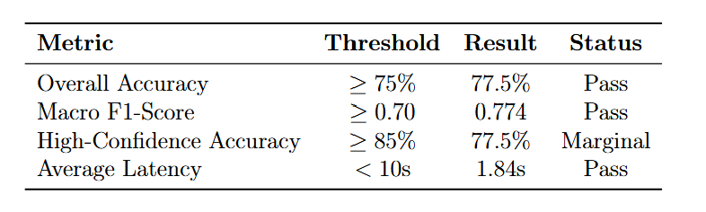
Table 1. Rubric Classifier aggregate metrics.
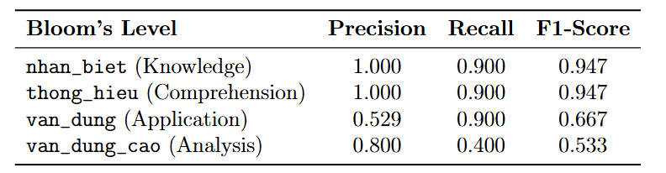Table 2. Rubric Classifier per-class metrics.
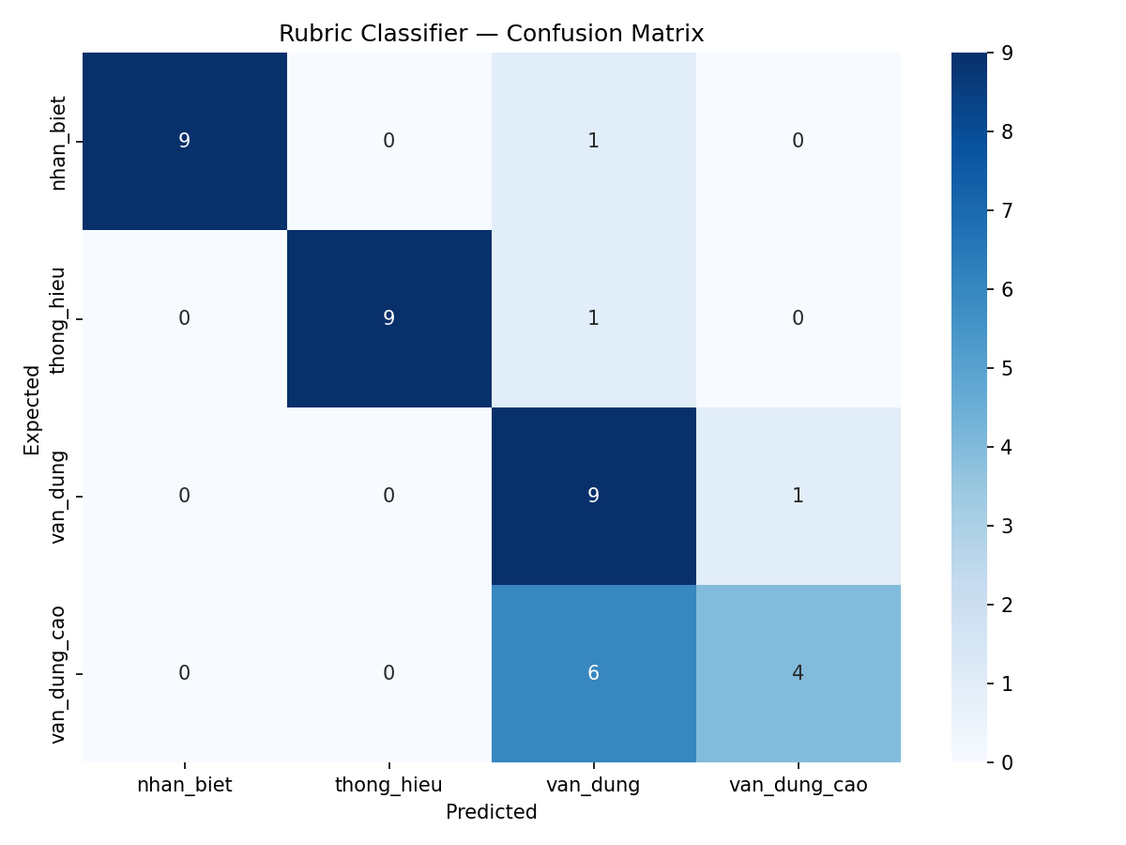
Figure 1. Confusion matrix on 40 benchmark questions. Rows represent ground-truth labels; columns represent predictions.

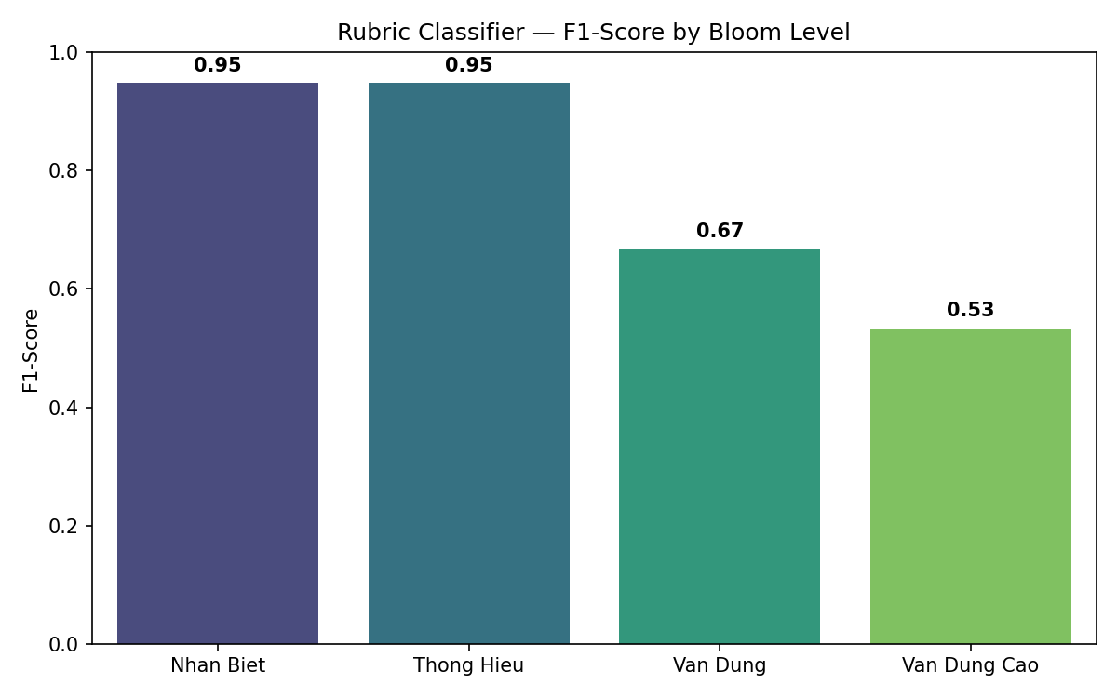
Figure 2. Per-class F1-Score.
Figure 1 shows the confusion matrix. The dominant error pattern is the misclassification of van_dung_cao questions as van_dung: 6 out of 10.
The classifier exceeds both the 75% accuracy and 0.70 Macro F1 thresholds. The primary concern is the van_dung_cao recall of 0.400, meaning 6 of 10 advanced questions are misclassified downward. This error is conservative - downgrading rather than upgrading difficulty - which is less harmful in a tutoring context. The High-Confidence Accuracy (77.5%) misses the 85% target, indicating the model’s confidence scores do not reliably differentiate borderline cases. All 40 API calls returned valid JSON (100% parse success).

4.2 Problem Parser
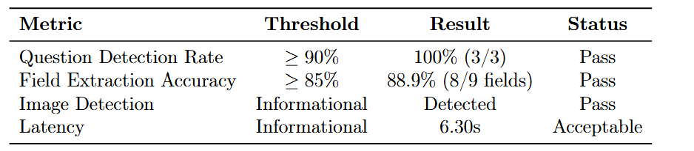
Table 3. Problem Parser metrics.
The parser correctly identified all three questions and extracted 8 of 9 structural fields. The single extraction error was a minor field-level mismatch. Notably, the parser successfully detected the circle illustration region in this run, producing a valid image reference. The two-stage pipeline design is validated: Gemini 2.5 Pro handles visual text recognition and GPT-4.1 handles structured information extraction. All API responses returned valid JSON.

4.3 Question Generator
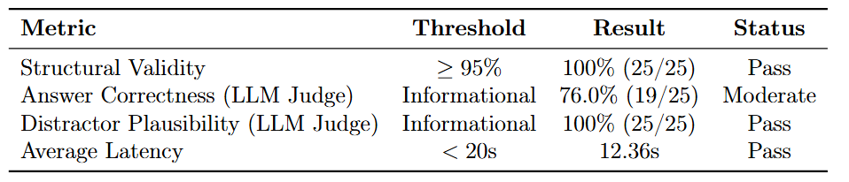
Table 4. QA Generator metrics.

Topic | Answer Correctness | Distractor Plausibility
Phan so va phep chia so tu nhien | 3/5 (60%) | 5/5 (100%)
So thap phan va cac phep tinh | 5/5 (100%) | 5/5 (100%)
Dien tich hinh thang | 2/5 (40%) | 5/5 (100%)
Chu vi va dien tich hinh tron | 5/5 (100%) | 5/5 (100%)
Van toc, quang duong, thoi gian | 4/5 (80%) | 5/5 (100%)
Table 5. QA Generator per-topic LLM Judge results.
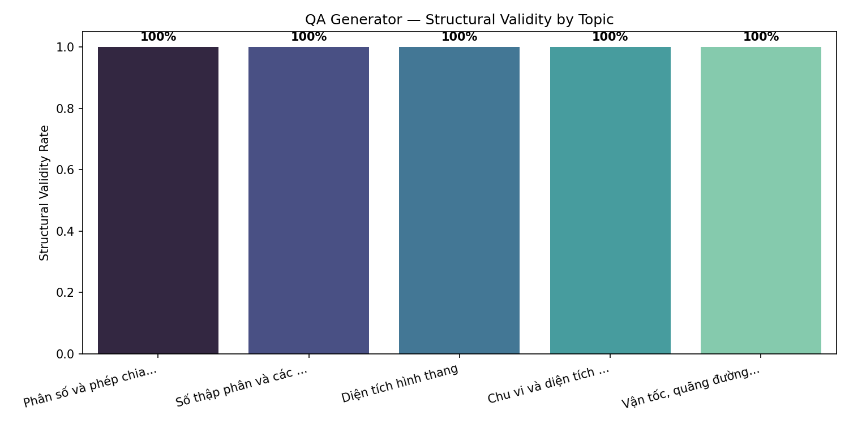
Figure 3. Structural validity rate by topic. All topics achieve 100% valid MCQA structure.

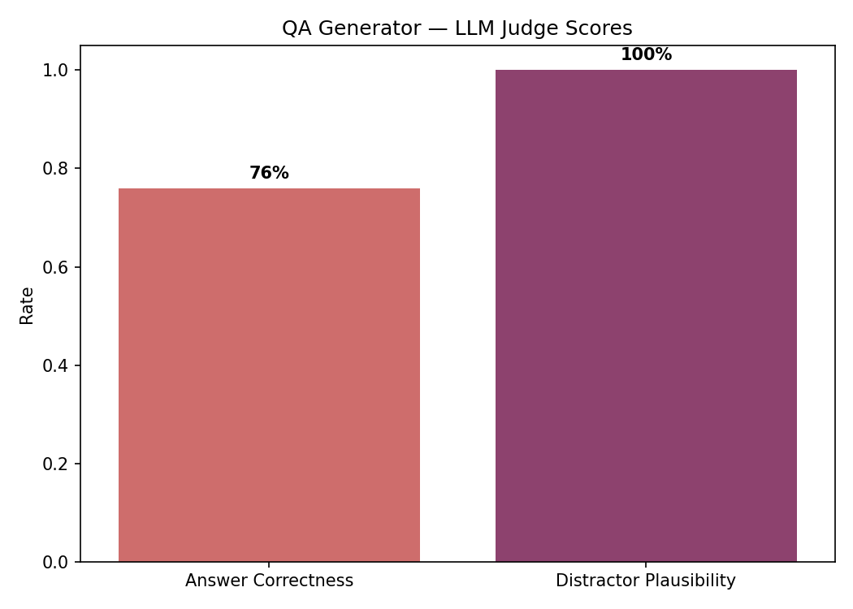
Figure 4. LLM Judge scores across 25 generated questions.
The generator achieves perfect structural validity (100%) - every generated question contains a valid stem, exactly four choices labeled A through D, and a valid answer key. Distractor plausibility is also perfect (100%), confirming that all distractors are semantically reasonable and of the same type as the correct answer. Answer correctness is moderate at 76%, with errors concentrated in the geometry-related topics (Trapezoid Area: 40%, Fractions: 60%). The LLM Judge identified cases where the model applied formulas incorrectly or produced computational errors, particularly in multi-step problems involving area calculations. All 25 generation calls and 5 judge calls returned valid JSON.

4.4 Cross-Component Latency
Figure 5 compares average response latency across all three components.
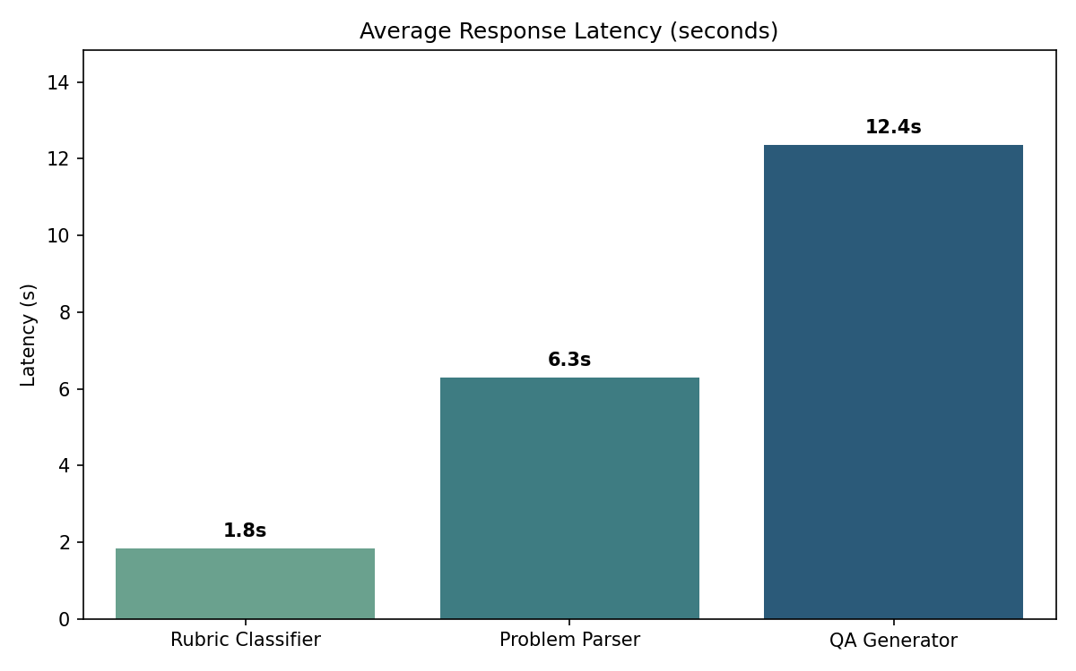
Figure 5. Average response latency by component. The Rubric Classifier achieves near-instant classification at 1.84 seconds. The QA Generator takes approximately 12 seconds for producing 5 complete questions per call. All latencies are within acceptable thresholds.

5. Conclusion
This evaluation assessed three core AI components using custom benchmark datasets representative of the Vietnamese primary-school mathematics domain.
The Rubric Classifier achieves 77.5% accuracy and 0.774 Macro F1, exceeding the acceptance thresholds of 75% and 0.70. Classification of lower Bloom’s levels is near-perfect (F1 > 0.94), while the van_dung/van_dung_cao boundary remains the primary error source with 6 of 10 advanced questions misclassified downward.
The Problem Parser achieves 100% question detection and 88.9% field extraction accuracy, exceeding both thresholds. The two-stage pipeline (Gemini 2.5 Pro for OCR, GPT-4.1 for structured parsing) successfully handles mixed-content Vietnamese exam pages including illustration detection.
The QA Generator produces structurally perfect MCQA output (100% valid structure, 100% distractor plausibility) but achieves 76% answer correctness. Errors are concentrated in geometry topics requiring multi-step calculations, where the model occasionally applies formulas incorrectly.
Limitations: (1) the Rubric Classifier confuses van_dung and van_dung_cao, reflecting inherent ambiguity at the application/analysis boundary; (2) the QA Generator’s answer correctness drops to 40% for geometry problems involving area formulas; (3) the Problem Parser test document is synthetic - validation with real scanned exams is needed; (4) evaluation datasets are relatively small.
Proposed improvements: (1) augment the Rubric Classifier’s prompt with contrastive examples targeting the van_dung/van_dung_cao distinction; (2) add a post-generation verification step for the QA Generator that re-checks mathematical computations before presenting questions to students; (3) expand datasets to 100+ items per component; (4) conduct human evaluation with practicing teachers.

5. Appendix

5.1 Rubric Classifier - GPT-4o
Rubric System Prompt:
Bạn là chuyên gia giáo dục Toán tiểu học Việt Nam (lớp 4–5). Nhiệm vụ: phân loại câu hỏi Toán theo 4 cấp độ nhận thức Bloom.

## CẤP ĐỘ PHÂN LOẠI

### 1. nhan_biet - Nhận biết
Yêu cầu nhớ lại, nhận dạng kiến thức đã học.
- Nhận dạng hình học cơ bản (hình vuông, hình chữ nhật, hình tròn…)
- Đọc, viết, so sánh số
- Nhắc lại công thức, quy tắc
- Tính toán 1 bước đơn giản (cộng, trừ, nhân, chia trực tiếp)
- Đổi đơn vị đo đơn giản (1 bước)
- Nhận dạng phân số, số thập phân

### 2. thong_hieu - Thông hiểu
Yêu cầu hiểu ý nghĩa, giải thích, áp dụng trực tiếp vào bài quen thuộc.
- Giải thích vì sao, chứng minh đơn giản
- Áp dụng trực tiếp công thức (chu vi, diện tích, thể tích) vào bài đã biết dạng
- Tính toán 2 bước
- So sánh, sắp xếp với lý giải
- Đọc bảng/biểu đồ và trả lời câu hỏi trực tiếp

### 3. van_dung - Vận dụng
Yêu cầu áp dụng kiến thức vào tình huống mới hoặc bài toán thực tế.
- Bài toán có lời văn thực tế (mua bán, đo đạc, thời gian…)
- Kết hợp nhiều kiến thức/phép tính (3+ bước)
- Bài toán tìm x với phương trình đơn giản
- Bài toán hình học cần suy luận (tính cạnh rồi mới tính diện tích)
- Bài toán tỉ lệ, trung bình cộng có ngữ cảnh

### 4. van_dung_cao - Vận dụng cao
Yêu cầu phân tích, tổng hợp, sáng tạo, giải quyết vấn đề phức tạp.
- Bài toán nhiều bước phức tạp, cần lập luận logic chặt chẽ
- Bài toán có nhiều cách giải, cần chọn cách tối ưu
- Bài toán mở, không có khuôn mẫu sẵn
- Bài toán đố, bài toán nâng cao, olympiad
- Bài toán kết hợp nhiều chủ đề (hình học + số học + đo lường)
- Bài toán yêu cầu giải thích chiến lược, phản biện

## QUY TẮC
1. Chỉ trả về JSON, KHÔNG giải thích thêm ngoài JSON.
2. Nếu câu hỏi không rõ ràng hoặc không đủ thông tin, đặt confidence thấp (< 0.5).
3. Phân loại dựa trên YÊU CẦU NHẬN THỨC của câu hỏi, không phải độ dài.
4. Một câu hỏi ngắn vẫn có thể là vận dụng cao nếu yêu cầu tư duy sâu.`

User prompt
Phân loại câu hỏi Toán lớp {grade} sau:

Phần: {section}
Loại: {type}
Nội dung gốc:
"""
{stem}
"""

Trả về JSON duy nhất:
{
"rubricLevel": "nhan_biet | thong_hieu | van_dung | van_dung_cao",
"confidence": 0.0-1.0,
"reasoning": "Giải thích ngắn gọn"
}

5.2 QA Generator - GPT-4o

Rubric System Prompt:
Bạn là giáo viên Toán tiểu học Việt Nam chuyên soạn đề kiểm tra Toán lớp {grade}.
Nhiệm vụ: Tạo đúng {count} câu hỏi trắc nghiệm MCQA cho chủ đề "{topic}".

Kiến thức cần kiểm tra:
{description}

Mỗi câu hỏi PHẢI có:
- stem: nội dung câu hỏi rõ ràng, chính xác về mặt Toán học
- choices: đúng 4 lựa chọn A, B, C, D
- answer: đáp án đúng A/B/C/D
- answerText: nội dung đáp án đúng
- explanation: giải thích ngắn cách giải

Quy tắc quan trọng:
- Đáp án đúng phải chính xác về mặt Toán học.
- 3 đáp án nhiễu phải hợp lý, cùng đơn vị/cùng kiểu số, không vô nghĩa.
- Đáp án nhiễu nên là kết quả từ lỗi tính toán phổ biến của học sinh.
- Không được có 2 đáp án cùng đúng.

Trả về JSON:
{"questions": [...]}

User prompt
Hãy tạo {count} câu hỏi trắc nghiệm Toán lớp {grade}
về chủ đề "{topic}".

Nội dung gốc:
"""
{stem}
"""

Trả về JSON duy nhất:
{
"rubricLevel": "nhan_biet | thong_hieu | van_dung | van_dung_cao",
"confidence": 0.0-1.0,
"reasoning": "Giải thích ngắn gọn"
}

