Software Architecture Document — v3
Project: Melon
App Version: 2.0
Date: June 2026
Revision History
Date | Version | Description | Author
Apr 2026 | 1.0 | Initial SAD — Modular Monolith (NestJS) + React SPA + AWS | Team
May 2026 | 2.0 | ADR-002: Next.js 16 replaces Vite+React+NestJS for Phase 1 (PA2). Firebase Storage replaces AWS S3/CloudFront. Vercel replaces AWS ECS/Fargate. Phase 1 backend implemented as Next.js Route Handlers. NestJS Modular Monolith retained as Phase 2 target architecture. | Team
1. Architecture Overview
1.1 High-Level Architecture Style
(Updated) — Melon App adopts a Hybrid Split-Stack Architecture. The system is composed of a Next.js 16 (App Router) frontend that handles user interface and request orchestration, and a high-performance FastAPI (Python) backend dedicated to AI-intensive workloads (RAG processing, LLM orchestration, and Media synthesis). This approach isolates complex AI logic into a specialized Python environment while maintaining a seamless, full-stack web experience.
1.2 Architecture Justification Matrix
(Unchanged from v2)
1.3 Core Architecture Principles
(Updated) — Separation of Concerns, API-First, Polyglot Micro-services (TypeScript + Python), AI Encapsulation, Child Safety by Design.
Added — ADR-002 (Update):
ADR-002: Evolution to Hybrid Next.js + FastAPI Stack
Initially, a unified Next.js Monolith was proposed to reduce deployment overhead. However, as the RAG (Retrieval-Augmented Generation) and AI logic became more complex, the team decided to introduce a specialized FastAPI backend in Sprint 3.
Next.js (Web Layer): Handles the Neobrutalism UI, User State (Zustand), and acting as a secure Proxy/Gateway for API requests.
FastAPI (AI Engine): Provides a robust Python environment for heavy AI tasks, leveraging better libraries for PDF extraction and Vector Search (ChromaDB).
Target Architecture: This hybrid model still aligns with the Phase 2 goal of a Modular Monolith, as the FastAPI services can be easily integrated into the final production cluster.
2. System Context Diagram
2.1 Actors
(Unchanged from v1) — Child, Parent/Guardian, Teacher (Phase 2), Admin, System (Cron Jobs).
2.2 External Services & Integrations
(Updated) — To support complex RAG logic, high-performance AI processing, and Multimodal Vision capabilities, the orchestration of external services is split between Frontend pre-processing and the dedicated Python FastAPI Backend.
Service | Provider | Purpose | Status
LLM (Chat/Quiz) | OpenAI GPT-4o-mini | AI Tutor chat, quiz generation, and Multimodal Layout Analysis (Vision). | Implemented (Proxy via FastAPI)
Image Pre-processing | Cloudinary SaaS | On-the-fly image enhancement, sharpening (e_sharpen:100), and grayscale conversion to optimize OCR/Vision accuracy. | Implemented (Frontend)
Text-to-Speech | ElevenLabs API | High-fidelity lesson narration and character voices. | Implemented (Proxy via FastAPI)
Vector Store | Pinecone (Starter) | PDF embeddings for RAG | Implemented (via FastAPI)
Embeddings | Custom Hash Embedding | PDF chunk vectorization | Implemented (via FastAPI)
Object Storage | Firebase Storage | PDFs, avatars — replaces AWS S3 | Ready (lib/storage/upload.ts)
CDN / Hosting | Vercel | SPA + API hosting — replaces AWS ECS/CloudFront | Config: infra/vercel.json
Internal Backend | Python FastAPI | Dedicated engine for PDF processing (PyMuPDF), RAG logic, and AI service coordination. | Implemented (src/melon-ai-backend)
Auth | Firebase Auth | Email/password, Google SSO | Context ready, needs keys
Email | Resend.com (Phase 2) | OTP, progress reports — replaces Amazon SES | Phase 2
Monitoring | Vercel Analytics (free) | Page performance — replaces Grafana | Phase 2
Error Tracking | Sentry.io | Frontend error capture | Phase 2
Payments | Stripe (Phase 2) | Subscription management | Phase 2

2.3 System Context
(Updated):
The system context has evolved to a multi-tiered communication flow:
- Child/Parent interacts with the Next.js Web App (Frontend).
- The Next.js API Layer acts as a Secure Proxy/Gateway, verifying authentication and forwarding specialized requests.
- The Python FastAPI Backend executes the core AI logic (RAG, PDF extraction, LLM prompting).
- External AI Providers (OpenAI, ElevenLabs) and Vector DB (Pinecone) are consumed via the Python layer to ensure optimal library support (PyMuPDF, LangChain).
- All generated content is stored in Firebase Storage and delivered back to the client.

3. Component Architecture

3.1 Frontend — Next.js 16 App Router
The frontend architecture has transitioned from a standalone React SPA to the Next.js App Router framework. This shift leverages Server Components for performance and integrates a cohesive Neobrutalism design system defined via Tailwind CSS v4 tokens.
Route / Component | Responsibility & Technical Implementation
app/page.tsx | Landing page featuring Neobrutalism hero sections, CTA modules, and Framer Motion animated feature cards.
app/lessons/[id]/page.tsx | Interactive lesson player: Manages slide states, renders RAG-generated quizzes, and hosts the Cosmo AI Tutor widget.
app/progress/page.tsx | Child dashboard: Visualizes XP progress, level status, earned badges, and activity logs via the gamification-store.
app/parent/page.tsx | Parent analytics: Utilizes Recharts to display AreaCharts and BarCharts for study time and accuracy tracking.
app/admin/pdf-upload/page.tsx | RAG Ingestion interface: Handles PDF uploads to Firebase Storage and triggers the Pinecone vectorization pipeline.
components/auth/AuthModal.tsx | Role-based 2-step authentication: Includes role selection (Kid/Parent/Admin) and COPPA-compliant consent logic.
components/ai/AITutorWidget.tsx | AI Tutor "Cosmo" widget: Implements Server-Sent Events (SSE) for real-time streaming of AI responses.
components/admin/ | AdminShell.tsx and AdminGuard.tsx: Implements role-aware layout wrappers and client-side route protection for administrative paths.
components/shared/ | Core Neobrutalism UI library: NbButton (bold-shadow buttons), NbPill (status badges), and XPBar (progress visualization).
lib/gamification/store.ts | Global state management via Zustand: Tracks Melon Points and XP with localStorage persistence for Phase 1.
app/globals.css | Design System implementation: Centralized CSS variables for Neobrutalism tokens and typography (Lexend Mega, Space Grotesk).
components/problems/ProblemParserPanel.tsx | OCR Ingestion & Pre-processing: Integrates upload logic and applies Cloudinary transformations (e_improve, e_sharpen:100, e_grayscale) to enhance image quality before forwarding the URL to the Python API Backend.

3.2 Backend — Next.js API Proxy
(Updated) — The Phase 1 backend utilizes Next.js Route Handlers strictly as a Secure API Gateway & Proxy. It does not perform heavy data processing; instead, it handles Firebase Auth verification, request validation, payload packaging (e.g., forwarding optimized Cloudinary image URLs), and secure routing to the dedicated Python FastAPI server.
Route Handler | Responsibilities & Data Processing | Maps to NestJS Module
api/v1/ai/chat/route.ts | Orchestrates GPT-4o-mini SSE streams; applies OpenAI Moderation API pre-checks on all inbound/outbound text. | AIGatewayModule
api/v1/ai/tts/route.ts | ElevenLabs integration: Computes SHA256 cache keys, persists audio to Firebase Storage, and returns download URLs. | AIGatewayModule
api/v1/rag/ingest/route.ts | RAG Pipeline: pdf-parse extraction → 500-char chunking → OpenAI Embedding → Pinecone upsert. | RAGModule
api/v1/rag/quiz/route.ts | Performs Pinecone semantic retrieval; prompts GPT-4o-mini for structured JSON quiz generation. | RAGModule
api/v1/ai/moderate/route.ts | Dedicated endpoint for OpenAI Moderation API to ensure P0 content safety across all features. | AIGatewayModule

3.3 AI Services Layer
(Updated) — AI logic has been decoupled from the Next.js API routes and encapsulated into a dedicated Python Service Layer. This allows the system to utilize high-performance AI libraries and maintain clean separation between web orchestration and machine learning workloads.
Service | Responsibility & Implementation
LLM Service | Handles prompt engineering and structured JSON output for gpt-4o-mini. Logic located in services/llm_service.py.
Vision & OCR Service | Orchestrates image-to-text, mathematical layouts, and table extraction. Uses Google Gemini 2.5 Pro (via OpenRouter) for high-accuracy OCR. Logic located in services/problem_parser_service.py
RAG Service | Manages the document intelligence pipeline, including PDF text extraction and vector similarity search. Logic located in services/rag_service.py.
TTS Service | Orchestrates neural speech synthesis via ElevenLabs API and handles byte-stream processing. Logic located in services/tts_service.py.

3.4 Python FastAPI Backend
To leverage the superior Python AI ecosystem, a dedicated FastAPI backend has been implemented (src/melon-ai-backend). This layer is responsible for compute-intensive RAG pipelines and LLM orchestration.
Component / Service | Responsibility & Implementation
main.py | Entry point for the FastAPI server; handles CORS and internal routing.
api/endpoints.py | Defines the REST API contract for ingestion, quiz generation, and speech synthesis.
services/rag_service.py | Implements the RAG pipeline: PDF extraction (PyMuPDF), chunking, and Vector Store interaction.
services/llm_service.py | Orchestrates GPT-4o-mini prompts for generating pedagogically accurate lessons and quizzes.
services/tts_service.py | Integrates with ElevenLabs API for high-fidelity speech synthesis.

3.5 Infrastructure Components
(Unchanged from v2) — The infrastructure utilizes a Cloud-Native / BaaS (Backend-as-a-Service) model to ensure high availability and rapid development cycles.
Component | Phase 1 (Implemented) | Phase 2 (Planned)
Hosting | Vercel: Edge/Node runtime with auto-deployment from the main GitHub branch. | Vercel or AWS ECS Fargate
File Storage | Firebase Storage: Handles PDF learning materials and user-uploaded avatars. | Firebase Storage or AWS S3
Authentication | Firebase Auth: Manages identity, session persistence, and Google SSO. | Firebase Auth
Data Persistence | localStorage (Mock persistence for user, lessons, and progress stores). | Firestore or PostgreSQL (RDS)
Caching | In-process memory caching for TTS audio URLs and AI response metadata. | Redis (ElastiCache)
Vector Database | Pinecone: Low-latency retrieval of vectorized educational content. | Pinecone
CI/CD | GitHub Actions: Executes npm run lint and npm run type-check on Pull Requests. | GitHub Actions → Vercel Deploy
AI Backend Hosting | Vercel Python Runtime / Render: For FastAPI. | AWS ECS Fargate

4. Data Flow Design

4.1 Lesson Interaction Flow
In Phase 1, the lesson interaction flow operates primarily on the client-side with mock persistence.
Step 1: The user selects a lesson from app/lessons/page.tsx.
Step 2: The system retrieves lesson metadata from lib/lessons/mock-lessons.ts.
Step 3: Student progress (XP, level, and badge completion) is tracked and updated in the Zustand store (lib/gamification/store.ts).
Step 4: Data is persisted to the browser's localStorage to maintain state across sessions during the initial development phase.

4.2 AI Generation Flow — Text-to-Speech (TTS)
The TTS flow is optimized for cost-efficiency and performance through a multi-layered caching strategy.
Step 1: The Child taps the “Read Aloud” button in the lesson player.
Step 2: The Frontend sends a POST request to the Next.js Proxy (/api/v1/ai/tts).
Step 3: The Next.js Proxy validates the session and forwards the payload to the FastAPI Backend (/tts).
Step 4: The FastAPI backend computes a SHA256 hash of the text.
- Cache HIT: Returns the existing Firebase Storage URL immediately.
- Cache MISS: Proceeds to call the ElevenLabs API.
Step 5: FastAPI receives the audio buffer, uploads it to Firebase Storage, and returns the public URL to Next.js.
Step 6: Next.js delivers the URL back to the Frontend for playback.

4.3 PDF → Quiz RAG Pipeline
(Updated) — This flow utilizes the specialized Python environment for robust document intelligence.

Phase A — Ingestion (Content Processing):
Step 1: The Admin uploads a PDF through the dashboard; the file is stored in Firebase Storage.
Step 2: The dashboard triggers the Next.js Ingestion Proxy (/api/v1/rag/ingest).
Step 3: Next.js proxies the request to the FastAPI RAG Service.
Step 4: FastAPI uses PyMuPDF to extract text, performs 500-char chunking, and generates embeddings via OpenAI.
Step 5: The vectors are upserted into Pinecone with associated metadata.

Phase B — Multimodal Vision Analysis (Problem Solving from Images/PDFs):
Step 1: User/Admin uploads a math problem image or PDF document.
Step 2: Next.js Frontend applies Cloudinary transformation filters to maximize image clarity before forwarding.
Step 3: Next.js forwards the request to the FastAPI Vision Service (/api/v1/problems/parse).
Step 4: FastAPI uses google/gemini-2.5-pro (via OpenRouter) to transcribe Vietnamese exam text, recognizing mathematical equations, stacked fractions, and table layouts.
Step 5: FastAPI reconstructs the document structure and parses the response into a strictly typed JSON schema containing the questionSet and questions array.

Phase C — Quiz Generation (Interaction):
Step 1: Student starts a lesson; Frontend calls the Next.js Quiz Proxy (/api/v1/rag/quiz).
Step 2: Next.js forwards the request to the FastAPI LLM Service.
Step 3: FastAPI performs semantic retrieval from Pinecone and sends context to GPT-4o-mini.
Step 4: FastAPI parses the response into a structured JSON quiz and returns it to the student.

5. Deployment Diagram
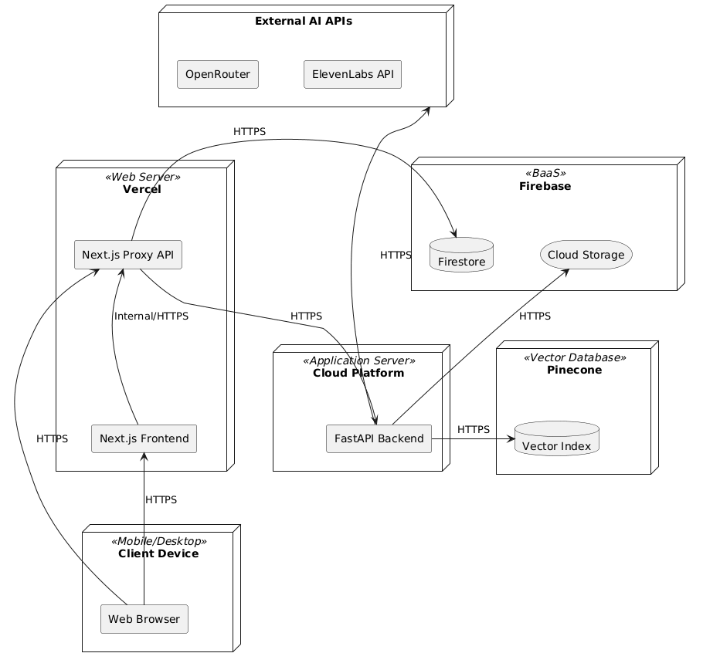

Node Descriptions:
- Client Device: Represents user devices (desktop, mobile, or tablet) running a Web Browser. The browser runs the Next.js Frontend UI and makes API calls.
- Vercel (Web Server): Cloud hosting platform for the Next.js application. It serves the React-based frontend and hosts the Next.js Proxy API to route requests securely to other backend services.
- Cloud Platform (Application Server): Hosts the FastAPI Backend (written in Python) which handles intensive tasks such as AI processing, RAG (Retrieval-Augmented Generation), TTS (Text-to-Speech), and LLM orchestrations.
- Firebase (BaaS): Serves as the primary data persistence layer. Firestore is used for NoSQL structured data (users, lessons, progress, gamification), and Firebase Storage stores static assets, audio files, and generated images.
- Pinecone (Vector Database): A specialized cloud database used by the FastAPI backend to store and query high-dimensional vector embeddings for RAG-based context retrieval.
- External AI APIs: External third-party services like ElevenLabs (for high-quality TTS) and OpenRouter (for accessing models like GPT-4o-mini).

6. Technology Stack

6.1 Frontend
The frontend is built as a highly interactive Next.js application, utilizing a Neobrutalism design system characterized by high-contrast colors, thick borders, and heavy shadows.
Technology | Justification
Next.js 16 (App Router) | Provides a unified framework for SSR, React Server Components, and API Route Handlers, significantly reducing architectural complexity.
React 19 + TypeScript | Leverages the latest React features and strict typing for maintainable, component-driven development.
Tailwind CSS v4 | Utilizes the next-generation CSS engine for high-performance styling; Neobrutalism design tokens are centralized in app/globals.css.
shadcn/ui (Radix UI) | Provides accessible, headless UI primitives customized with Neobrutalism overrides (NbButton, NbPill, NbCard).
Framer Motion | Powers smooth, physics-based transitions for lesson slides and interactive gamification elements.
Recharts | Generates dynamic, responsive data visualizations for the Parent Dashboard (AreaChart, BarChart).
Zustand | Chosen for lightweight, modular state management of user profiles and gamification progress.
TanStack Query v5 | Manages server-state synchronization, caching, and loading states for AI-generated content.
Firebase Auth & Storage | Handles secure user authentication (Google SSO) and persistent storage for PDF lesson materials.
Cloudinary (SaaS) | Provides on-the-fly Image Transformation. Applying URL-based filters minimizes payload size and offloads image enhancement tasks entirely from the backend servers.

6.2 Backend (Phase 2 Target)
Phase 1 (Current): The backend utilizes a Python FastAPI engine (src/melon-ai-backend) to handle compute-intensive AI tasks and PDF processing, with Next.js serving as an API Proxy.
Phase 2 Target: (Unchanged from v1) — The long-term target is a NestJS 10 Modular Monolith utilizing TypeORM for data persistence and BullMQ for asynchronous AI task processing.

6.3 AI Stack
The AI layer is orchestrated via Python (FastAPI) and direct API integrations to provide high-quality educational interactions.
Service | Technology | Purpose
Language Model | OpenAI GPT-4o-mini | Powers the Cosmo AI Tutor chat and RAG-based quiz generation.
Embeddings | facebook/contriever | Generates 1536-dimension vectors for PDF document chunking.
Content Safety | OpenAI Moderation API | Mandatory P0 safety filter for all user prompts and AI responses.
Speech Synthesis | ElevenLabs API | High-fidelity Text-to-Speech (TTS) for lesson narration.
Vector Search | Pinecone (Serverless) | Provides low-latency semantic retrieval for the RAG pipeline.

6.4 Database & Storage
The data strategy evolves from client-side mocks to a distributed cloud database architecture.
Category | Phase 1 (Current) | Phase 2 (Target)
Relational Data | localStorage (via Zustand persistence) | PostgreSQL 15 (AWS RDS)
NoSQL Data | Mock JSON objects | Firebase Firestore
Caching | In-process memory (Audio URL cache) | Redis 7 (ElastiCache)
Object Storage | Firebase Storage | Firebase Storage or AWS S3
Vector DB | Pinecone | Pinecone

7. ML Model Analysis
The Melon AI Learning App uses five pre-trained AI models accessed through third-party APIs: GPT-4o-mini for AI tutoring chat, Whisper-1 for speech-to-text, Gemini 2.0 Flash for multimodal answer evaluation and rubric classification, eleven_multilingual_v2 from ElevenLabs for text-to-speech, and GPT-4o-mini via OpenRouter for RAG-based quiz generation. None of these models are hosted on team infrastructure. All are consumed as managed cloud services with no local GPU, no stored model weights, and no inference runtime managed by the team.
7.1 Static vs. Dynamic Deployment
All models are deployed statically. The model version for each service is fixed either as a hardcoded identifier in the source file or as an environment variable set before deployment. The system does not perform dynamic model selection, A/B routing, or automatic version switching at runtime. Any model version change requires a code or configuration update followed by a deliberate redeployment.
7.2 Retraining, Fine-Tuning, Revision and Redeployment
The team does not perform model training or fine-tuning. All models are pre-trained and accessed via API. Instead of modifying model weights, the team improves model accuracy for each task by carefully designing system prompts, providing sufficient domain context, and iteratively revising both the prompt content and inference parameters such as temperature. For example, the rubric classifier is given a detailed Vietnamese-language prompt with explicit definitions and examples for each Bloom's level, the answer evaluator is provided with the question, expected answer, lesson context, and leniency instructions, and the quiz generator is given the retrieved document context alongside strict grounding rules. When a model underperforms on a specific task, the team identifies which part of the prompt or context is insufficient, revises it, and re-evaluates against the test set until the output meets the acceptance threshold. All prompt changes are committed to version control and treated as model revisions.
7.2 Evaluate
We evaluate three core AI components: the rubric classifier, the RAG-based MCQA quiz generator, and the OCR-based PDF problem parser.
- The rubric classifier is evaluated on a subset of our own mathematics problem bank — approximately fifty Vietnamese math questions from grades four and five, manually labeled by team members across four Bloom's taxonomy levels and resolved by consensus. Classification accuracy must reach at least 75%, macro F1-score at least 0.70.
- The RAG quiz generator outputs strictly in MCQA format: one correct answer and three distractors. It is evaluated on fifty questions generated from five of our own lesson PDFs, ten per document, each manually reviewed against the source. Answer accuracy and groundedness must each reach at least 90%. Distractor relatedness is assessed using a natural language inference approach: each distractor must be semantically in-domain and share the same entity type as the correct answer, but must not be entailed by the source passage as correct. The distractor relatedness acceptance rate must be at least 80%.
- The PDF problem parser uses Gemini 2.5 Pro for OCR and GPT-4.1 for structured extraction via OpenRouter. Since both are pretrained, we report their published benchmarks as the baseline expectation: Gemini 2.5 Pro achieves approximately 94% on DocVQA and over 90% on OCRBench. The team additionally tested on thirty scanned Vietnamese math exam pages from our own uploaded problem sets. Field extraction accuracy — the percentage of question stems, choices, and answer keys extracted correctly — must reach at least 85%, and the question detection rate must reach at least 90%.
8. Deployment Architecture
8.1 Cloud Infrastructure
Updated from v1 — Vercel replaces AWS ECS/RDS/ElastiCache/S3/CloudFront:
Resource | Configuration
Hosting | Vercel — connect GitHub repo, auto-deploy on push to main
I Backend Hosting | Vercel Python Runtime / Render — dedicated environment for FastAPI engine
Config | infra/vercel.json: framework: nextjs, regions: sin1
Environment vars | Set in Vercel dashboard (never in code)
File storage | Firebase Storage — same project as Auth
CDN | Vercel Edge Network (global, built-in)

8.2 CI/CD Pipeline
Updated from v1:
Developer pushes to feature branch → PR opened
GitHub Actions: npm run lint && npm run type-check → must pass
PR merged to main → Vercel auto-deploys (preview URL per PR, production on main)
Zero-downtime: Vercel atomic deployments — old version serves until new is healthy
8.3 Environment Strategy
Environment | Infrastructure | Purpose
Development | localhost:3000 via npm run dev & localhost:8000 via uvicorn (FastAPI) | Individual dev. .env.local with real or mock keys
Preview | Vercel Preview URL (per PR) | Team review and testing
Production | Vercel Production (main branch) | End users

