Software Architecture Document — v2
Project: Melon
App Version: 2.0
Date: May 2026
Revision History
Date | Version | Description | Author
Apr 2026 | 1.0 | Initial SAD — Modular Monolith (NestJS) + React SPA + AWS | Team
May 2026 | 2.0 | ADR-002: Next.js 16 replaces Vite+React+NestJS for Phase 1 (PA2). Firebase Storage replaces AWS S3/CloudFront. Vercel replaces AWS ECS/Fargate. Phase 1 backend implemented as Next.js Route Handlers. NestJS Modular Monolith retained as Phase 2 target architecture. | Team
1. Architecture Overview
1.1 High-Level Architecture Style
(Updated) — Melon App adopts a Hybrid Split-Stack Architecture. The system is composed of a Next.js 16 (App Router) frontend that handles user interface and request orchestration, and a high-performance FastAPI (Python) backend dedicated to AI-intensive workloads (RAG processing, LLM orchestration, and Media synthesis). This approach isolates complex AI logic into a specialized Python environment while maintaining a seamless, full-stack web experience.
1.2 Architecture Justification Matrix
(Unchanged from v1)
1.3 Core Architecture Principles
(Updated) — Separation of Concerns, API-First, Polyglot Micro-services (TypeScript + Python), AI Encapsulation, Child Safety by Design.
Added — ADR-002 (Update):
ADR-002: Evolution to Hybrid Next.js + FastAPI Stack
Initially, a unified Next.js Monolith was proposed to reduce deployment overhead. However, as the RAG (Retrieval-Augmented Generation) and AI logic became more complex, the team decided to introduce a specialized FastAPI backend in Sprint 3.
Next.js (Web Layer): Handles the Neobrutalism UI, User State (Zustand), and acting as a secure Proxy/Gateway for API requests.
FastAPI (AI Engine): Provides a robust Python environment for heavy AI tasks, leveraging better libraries for PDF extraction and Vector Search (ChromaDB).
Target Architecture: This hybrid model still aligns with the Phase 2 goal of a Modular Monolith, as the FastAPI services can be easily integrated into the final production cluster.
2. System Context Diagram
2.1 Actors
(Unchanged from v1) — Child, Parent/Guardian, Teacher (Phase 2), Admin, System (Cron Jobs).
2.2 External Services & Integrations
(Updated) — To support complex RAG logic and high-performance AI processing, the orchestration of external services has moved from Next.js directly to a dedicated Python FastAPI Backend.
Service | Provider | Purpose | Status
LLM (Chat/Quiz) | OpenAI GPT-4o-mini | AI Tutor chat, quiz generation | Implemented (Proxy via FastAPI)
Text-to-Speech | ElevenLabs API | High-fidelity lesson narration and character voices. | Implemented (Proxy via FastAPI)
fVector Store | Pinecone (Starter) | PDF embeddings for RAG | Implemented (via FastAPI)
Embeddings | facebook/contriever | PDF chunk vectorization | Implemented (via FastAPI)
Object Storage | Firebase Storage | PDFs, avatars — replaces AWS S3 | Ready (lib/storage/upload.ts)
CDN / Hosting | Vercel | SPA + API hosting — replaces AWS ECS/CloudFront | Config: infra/vercel.json
Internal Backend | Python FastAPI | Dedicated engine for PDF processing (PyMuPDF), RAG logic, and AI service coordination. | Implemented (src/melon-ai-backend)
Auth | Firebase Auth | Email/password, Google SSO | Context ready, needs keys
Email | Resend.com (Phase 2) | OTP, progress reports — replaces Amazon SES | Phase 2
Monitoring | Vercel Analytics (free) | Page performance — replaces Grafana | Phase 2
Error Tracking | Sentry.io | Frontend error capture | Phase 2
Payments | Stripe (Phase 2) | Subscription management | Phase 2

2.3 System Context
(Updated):
The system context has evolved to a multi-tiered communication flow:
- Child/Parent interacts with the Next.js Web App (Frontend).
- The Next.js API Layer acts as a Secure Proxy/Gateway, verifying authentication and forwarding specialized requests.
- The Python FastAPI Backend executes the core AI logic (RAG, PDF extraction, LLM prompting).
- External AI Providers (OpenAI, ElevenLabs) and Vector DB (Pinecone) are consumed via the Python layer to ensure optimal library support (PyMuPDF, LangChain).
- All generated content is stored in Firebase Storage and delivered back to the client.

3. Component Architecture

3.1 Frontend — Next.js 16 App Router
The frontend architecture has transitioned from a standalone React SPA to the Next.js App Router framework. This shift leverages Server Components for performance and integrates a cohesive Neobrutalism design system defined via Tailwind CSS v4 tokens.
Route / Component | Responsibility & Technical Implementation
app/page.tsx | Landing page featuring Neobrutalism hero sections, CTA modules, and Framer Motion animated feature cards.
app/lessons/[id]/page.tsx | Interactive lesson player: Manages slide states, renders RAG-generated quizzes, and hosts the Cosmo AI Tutor widget.
app/progress/page.tsx | Child dashboard: Visualizes XP progress, level status, earned badges, and activity logs via the gamification-store.
app/parent/page.tsx | Parent analytics: Utilizes Recharts to display AreaCharts and BarCharts for study time and accuracy tracking.
app/admin/pdf-upload/page.tsx | RAG Ingestion interface: Handles PDF uploads to Firebase Storage and triggers the Pinecone vectorization pipeline.
components/auth/AuthModal.tsx | Role-based 2-step authentication: Includes role selection (Kid/Parent/Admin) and COPPA-compliant consent logic.
components/ai/AITutorWidget.tsx | AI Tutor "Cosmo" widget: Implements Server-Sent Events (SSE) for real-time streaming of AI responses.
components/admin/ | AdminShell.tsx and AdminGuard.tsx: Implements role-aware layout wrappers and client-side route protection for administrative paths.
components/shared/ | Core Neobrutalism UI library: NbButton (bold-shadow buttons), NbPill (status badges), and XPBar (progress visualization).
lib/gamification/store.ts | Global state management via Zustand: Tracks Melon Points and XP with localStorage persistence for Phase 1.
app/globals.css | Design System implementation: Centralized CSS variables for Neobrutalism tokens and typography (Lexend Mega, Space Grotesk).

3.2 Backend — Next.js API Proxy
The Phase 1 backend is implemented as Next.js Route Handlers running on the Node.js runtime. These routes handle AI orchestration, vector database interactions, and administrative tasks.
Route Handler | Responsibilities & Data Processing | Maps to NestJS Module
api/v1/ai/chat/route.ts | Orchestrates GPT-4o-mini SSE streams; applies OpenAI Moderation API pre-checks on all inbound/outbound text. | AIGatewayModule
api/v1/ai/tts/route.ts | ElevenLabs integration: Computes SHA256 cache keys, persists audio to Firebase Storage, and returns download URLs. | AIGatewayModule
api/v1/rag/ingest/route.ts | RAG Pipeline: pdf-parse extraction → 500-char chunking → OpenAI Embedding → Pinecone upsert. | RAGModule
api/v1/rag/quiz/route.ts | Performs Pinecone semantic retrieval; prompts GPT-4o-mini for structured JSON quiz generation. | RAGModule
api/v1/ai/moderate/route.ts | Dedicated endpoint for OpenAI Moderation API to ensure P0 content safety across all features. | AIGatewayModule

3.3 AI Services Layer
(Updated) — AI logic has been decoupled from the Next.js API routes and encapsulated into a dedicated Python Service Layer. This allows the system to utilize high-performance AI libraries and maintain clean separation between web orchestration and machine learning workloads.

Service | Responsibility & Implementation
LLM Service | Handles prompt engineering and structured JSON output for gpt-4o-mini. Logic located in services/llm_service.py.
RAG Service | Manages the document intelligence pipeline, including PDF text extraction and vector similarity search. Logic located in services/rag_service.py.
TTS Service | Orchestrates neural speech synthesis via ElevenLabs API and handles byte-stream processing. Logic located in services/tts_service.py.

3.4 Python FastAPI Backend
To leverage the superior Python AI ecosystem, a dedicated FastAPI backend has been implemented (src/melon-ai-backend). This layer is responsible for compute-intensive RAG pipelines and LLM orchestration.
Component / Service | Responsibility & Implementation
main.py | Entry point for the FastAPI server; handles CORS and internal routing.
api/endpoints.py | Defines the REST API contract for ingestion, quiz generation, and speech synthesis.
services/rag_service.py | Implements the RAG pipeline: PDF extraction (PyMuPDF), chunking, and Vector Store interaction.
services/llm_service.py | Orchestrates GPT-4o-mini prompts for generating pedagogically accurate lessons and quizzes.
services/tts_service.py | Integrates with ElevenLabs API for high-fidelity speech synthesis.

3.5 Infrastructure Components
The infrastructure utilizes a Cloud-Native / BaaS (Backend-as-a-Service) model to ensure high availability and rapid development cycles.
Component | Phase 1 (Implemented) | Phase 2 (Planned)
Hosting | Vercel: Edge/Node runtime with auto-deployment from the main GitHub branch. | Vercel or AWS ECS Fargate
File Storage | Firebase Storage: Handles PDF learning materials and user-uploaded avatars. | Firebase Storage or AWS S3
Authentication | Firebase Auth: Manages identity, session persistence, and Google SSO. | Firebase Auth
Data Persistence | localStorage (Mock persistence for user, lessons, and progress stores). | Firestore or PostgreSQL (RDS)
Caching | In-process memory caching for TTS audio URLs and AI response metadata. | Redis (ElastiCache)
Vector Database | Pinecone: Low-latency retrieval of vectorized educational content. | Pinecone
CI/CD | GitHub Actions: Executes npm run lint and npm run type-check on Pull Requests. | GitHub Actions → Vercel Deploy
AI Backend Hosting | Vercel Python Runtime / Render: For FastAPI. | AWS ECS Fargate

4. Data Flow Design

4.1 Lesson Interaction Flow
In Phase 1, the lesson interaction flow operates primarily on the client-side with mock persistence.
Step 1: The user selects a lesson from app/lessons/page.tsx.
Step 2: The system retrieves lesson metadata from lib/lessons/mock-lessons.ts.
Step 3: Student progress (XP, level, and badge completion) is tracked and updated in the Zustand store (lib/gamification/store.ts).
Step 4: Data is persisted to the browser's localStorage to maintain state across sessions during the initial development phase.

4.2 AI Generation Flow — Text-to-Speech (TTS)
The TTS flow is optimized for cost-efficiency and performance through a multi-layered caching strategy.
Step 1: The Child taps the “Read Aloud” button in the lesson player.
Step 2: The Frontend sends a POST request to the Next.js Proxy (/api/v1/ai/tts).
Step 3: The Next.js Proxy validates the session and forwards the payload to the FastAPI Backend (/tts).
Step 4: The FastAPI backend computes a SHA256 hash of the text.
- Cache HIT: Returns the existing Firebase Storage URL immediately.
- Cache MISS: Proceeds to call the ElevenLabs API.
Step 5: FastAPI receives the audio buffer, uploads it to Firebase Storage, and returns the public URL to Next.js.
Step 6: Next.js delivers the URL back to the Frontend for playback.

4.3 AI Generation Flow — Image Generation
Status: Phase 2 (Unchanged from v1). This feature is planned for subsequent sprints and will utilize OpenAI's DALL-E 3 API.

4.4 PDF → Quiz RAG Pipeline
(Updated) — This flow utilizes the specialized Python environment for robust document intelligence.

Phase A — Ingestion (Content Processing):
Step 1: The Admin uploads a PDF through the dashboard; the file is stored in Firebase Storage.
Step 2: The dashboard triggers the Next.js Ingestion Proxy (/api/v1/rag/ingest).
Step 3: Next.js proxies the request to the FastAPI RAG Service.
Step 4: FastAPI uses PyMuPDF to extract text, performs 500-char chunking, and generates embeddings via OpenAI.
Step 5: The vectors are upserted into Pinecone with associated metadata.

Phase B — Quiz Generation (Interaction):
Step 1: The student starts a lesson; the Frontend calls the Next.js Quiz Proxy (/api/v1/rag/quiz).
Step 2: Next.js forwards the request to the FastAPI LLM Service.
Step 3: FastAPI performs semantic retrieval from Pinecone and sends the context to GPT-4o-mini.
Step 4: FastAPI parses the AI response into a structured JSON quiz and returns it via the Next.js Proxy to the student.

5. Detailed Design
5.1 Database Design
Key Tables Description
- users: Stores authentication credentials. Differentiates between PARENT and ADMIN via the role field.
- kid_profiles: Linked to a parent account. Holds gamification states like total_xp and customization details like avatar_url.
- lessons: Stores the structured content of each educational module. The content_blocks (JSONB) allows flexible UI rendering of slides, text, and media.
- lesson_progress: A junction table that tracks a child's interaction with a specific lesson, including their quiz score upon completion.
- badges & kid_badges: Implements the achievement system. badges defines the rules, while kid_badges logs when a specific child met those rules.
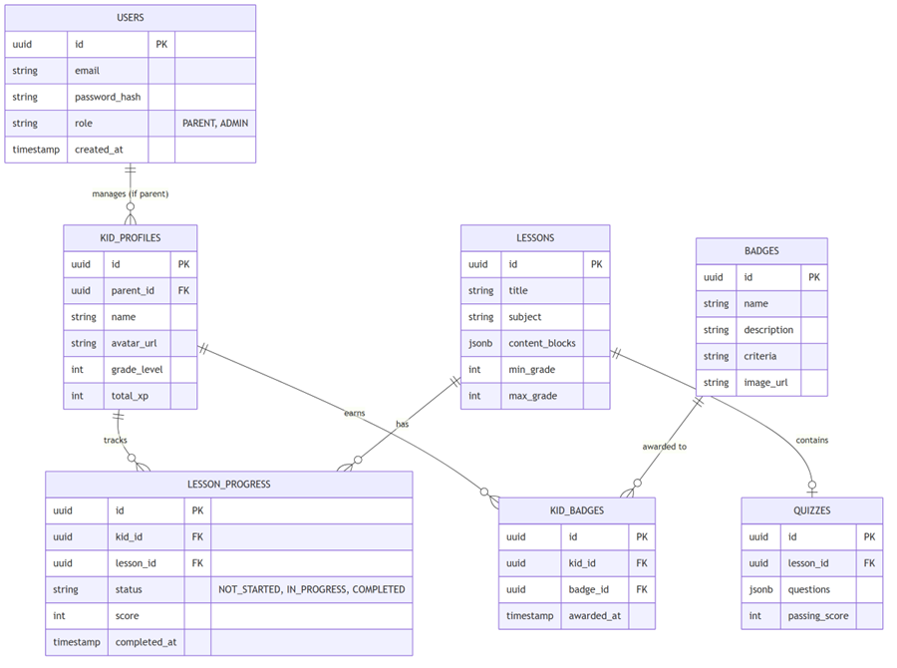

5.2 OOP Class Diagrams
OOP Class Components Description
1. User Management Component
- User: Represents the core authentication entity. Parents and Admins hold full User records.
- KidProfile: Represents the child's profile linked to a parent's User account. Stores gamification stats (XP, grade level).
- UserController & UserService: Handle HTTP requests and business logic for registration and profile updates.
2. Lesson Management Component
- Lesson: Stores metadata and JSON content blocks (slides, text, images) for learning materials.
- Quiz: Associated with a lesson to evaluate learning outcomes.
- LessonProgress: Tracks exactly where a kid is within a lesson and their final quiz score.
3. Gamification Component
- Badge: Defines achievements (e.g., "Math Master" requiring 5 math lessons completed).
- GamificationService: The core engine that runs after a lesson finishes to add XP and evaluate if any new Badge should be awarded.
4. AI Integration Component
- AITutorService: Manages streaming chat completions for "Cosmo" the AI tutor.
- RAGService: Handles chunking, embedding, and retrieving relevant educational content from Pinecone to feed into the LLM.
- TTSClient: Wrapper around ElevenLabs to read lesson content or AI responses aloud.
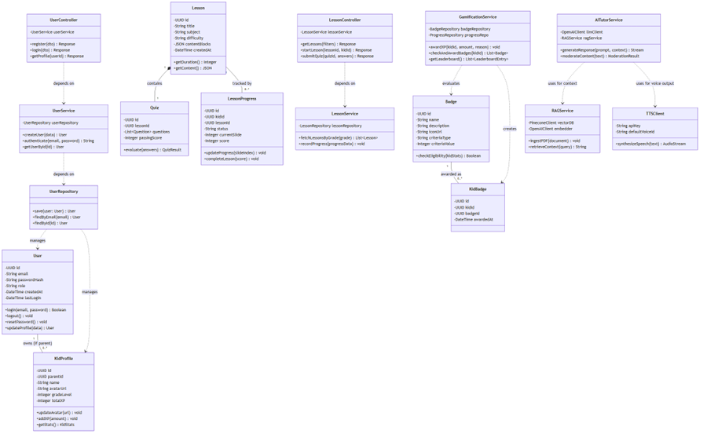

5.3 UI Design
1. Landing Page
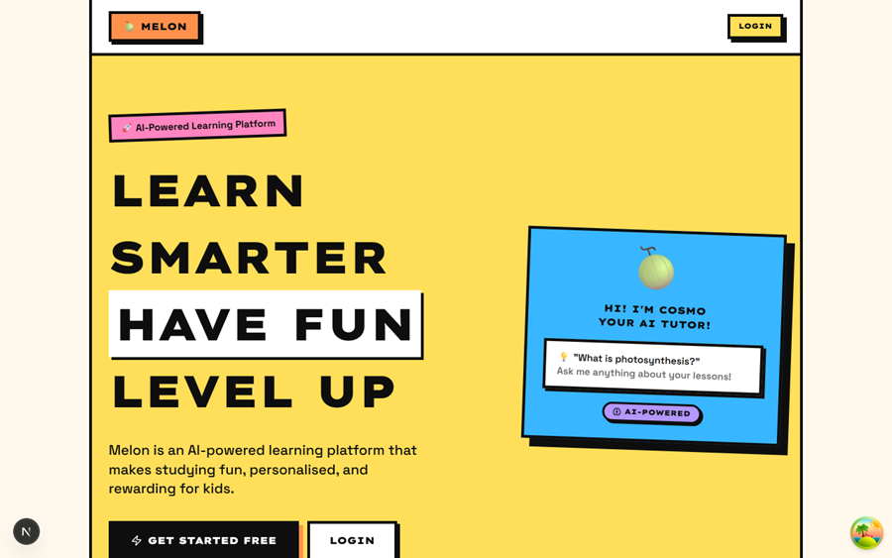
2. Kid Dashboard
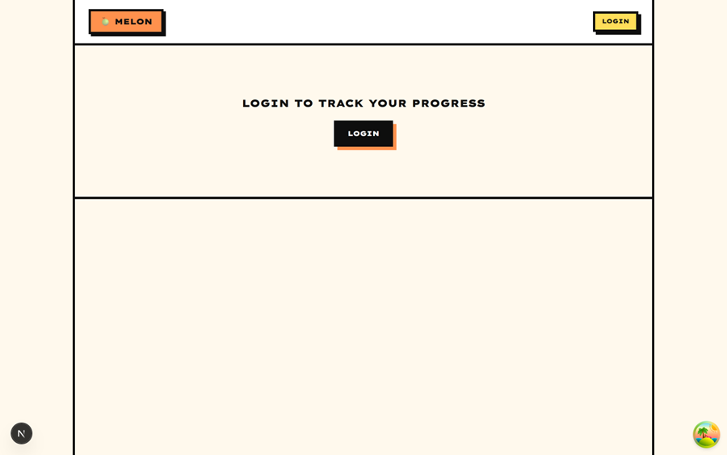
3. Lesson Player
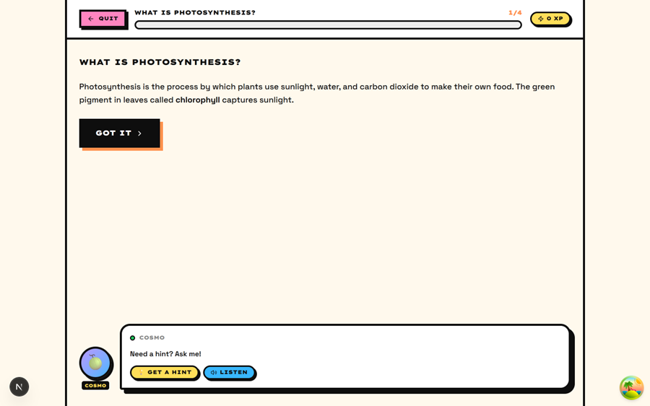
4. Parent Dashboard

5. Badge Cabinet
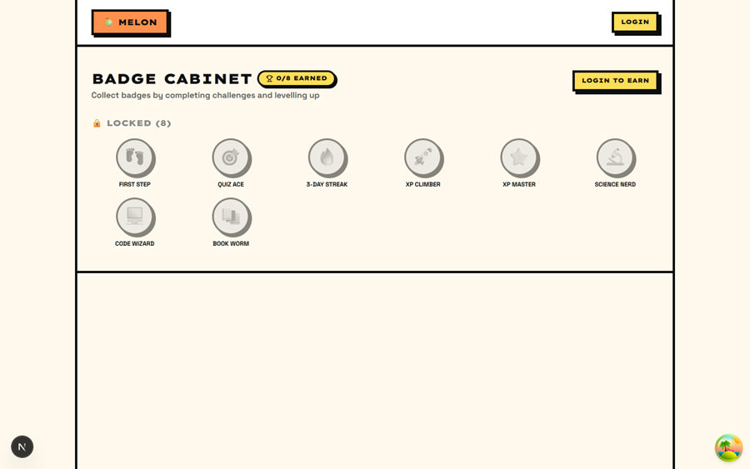

6. Technology Stack

6.1 Frontend
The frontend is built as a highly interactive Next.js application, utilizing a Neobrutalism design system characterized by high-contrast colors, thick borders, and heavy shadows.
Technology | Justification
Next.js 16 (App Router) | Provides a unified framework for SSR, React Server Components, and API Route Handlers, significantly reducing architectural complexity.
React 19 + TypeScript | Leverages the latest React features and strict typing for maintainable, component-driven development.
Tailwind CSS v4 | Utilizes the next-generation CSS engine for high-performance styling; Neobrutalism design tokens are centralized in app/globals.css.
shadcn/ui (Radix UI) | Provides accessible, headless UI primitives customized with Neobrutalism overrides (NbButton, NbPill, NbCard).
Framer Motion | Powers smooth, physics-based transitions for lesson slides and interactive gamification elements.
Recharts | Generates dynamic, responsive data visualizations for the Parent Dashboard (AreaChart, BarChart).
Zustand | Chosen for lightweight, modular state management of user profiles and gamification progress.
TanStack Query v5 | Manages server-state synchronization, caching, and loading states for AI-generated content.
Firebase Auth & Storage | Handles secure user authentication (Google SSO) and persistent storage for PDF lesson materials.

6.2 Backend (Phase 2 Target)
Phase 1 (Current): The backend utilizes a Python FastAPI engine (src/melon-ai-backend) to handle compute-intensive AI tasks and PDF processing, with Next.js serving as an API Proxy.
Phase 2 Target: (Unchanged from v1) — The long-term target is a NestJS 10 Modular Monolith utilizing TypeORM for data persistence and BullMQ for asynchronous AI task processing.

6.3 AI Stack
The AI layer is orchestrated via Python (FastAPI) and direct API integrations to provide high-quality educational interactions.
Service | Technology | Purpose
Language Model | OpenAI GPT-4o-mini | Powers the Cosmo AI Tutor chat and RAG-based quiz generation.
Embeddings | facebook/contriever | Generates 1536-dimension vectors for PDF document chunking.
Content Safety | OpenAI Moderation API | Mandatory P0 safety filter for all user prompts and AI responses.
Speech Synthesis | ElevenLabs API | High-fidelity Text-to-Speech (TTS) for lesson narration.
Vector Search | Pinecone (Serverless) | Provides low-latency semantic retrieval for the RAG pipeline.

6.4 Database & Storage
The data strategy evolves from client-side mocks to a distributed cloud database architecture.
Category | Phase 1 (Current) | Phase 2 (Target)
Relational Data | localStorage (via Zustand persistence) | PostgreSQL 15 (AWS RDS)
NoSQL Data | Mock JSON objects | Firebase Firestore
Caching | In-process memory (Audio URL cache) | Redis 7 (ElastiCache)
Object Storage | Firebase Storage | Firebase Storage or AWS S3
Vector DB | Pinecone | Pinecone

7. ML Model Analysis

7.1. RAG Embedding Model: facebook/contriever
Used in services/rag_service.py to convert uploaded PDF chunks and user queries into semantic vector embeddings.
How it works: PDF text is extracted, split into small chunks, tokenized, passed through Contriever, and mean-pooled into one embedding vector per chunk. Query text is embedded in the same way, then compared with stored vectors to retrieve relevant context.
Why chosen: Contriever supports meaning-based search, so the app can find relevant learning material even when the user topic does not exactly match the document wording.
Advantages: semantic retrieval, local Hugging Face support, no custom training required, useful for grounding LLM output in uploaded material.
Limitations: retrieval depends on chunk quality, CPU inference can be slow, and it cannot understand non-text PDF content such as diagrams unless extracted as text.

7.2. Lesson Generation Model: openai/gpt-4o-mini via OpenRouter
Used in services/llm_service.py to generate child-friendly multiple-choice questions.
How it works: the backend sends a prompt containing the topic, retrieved context, and required MCQ format. The LLM generates questions, choices, and answers, then the backend parses the text into structured JSON.
Why chosen: GPT-4o-mini provides strong text generation with lower cost and latency than larger models, and OpenRouter makes API integration straightforward.
Advantages: fluent educational language, flexible question generation, can use RAG context, fast API-based integration.
Limitations: may hallucinate, may break the required output format, depends on API availability/rate limits, and generated content should be reviewed for correctness and age suitability.

7.3. Image Generation Model: runwayml/stable-diffusion-v1-5
Used in services/image_service.py to create cartoon-style educational illustrations for generated questions.
How it works: Stable Diffusion starts from random noise and gradually denoises it into an image guided by a text prompt such as a cartoon illustration about the lesson topic and question.
Why chosen: Stable Diffusion v1.5 is open source, widely supported by Hugging Face diffusers, and can generate custom visuals locally.
Advantages: creates unique lesson images, reduces manual asset creation, supports child-friendly illustration prompts, and can run locally with enough hardware.
Limitations: needs strong compute resources, CPU generation is slow, images may contain visual errors, text inside images is unreliable, and torch.float16 can be problematic on CPU-only systems.

7.5. Text-to-Speech Model: eleven_multilingual_v2
Used in services/tts_service.py to convert generated lesson text into MP3 audio.
How it works: the backend sends text to the ElevenLabs API. The model synthesizes speech and returns audio bytes, which are saved as an MP3 file for the frontend.
Why chosen: it provides natural multilingual speech, useful for young learners, accessibility, and listening-based learning.
Advantages: clear voice quality, multilingual support, simple API integration, and helpful for children who benefit from audio learning.
Limitations: requires internet and an ElevenLabs API key, may have usage costs/rate limits, pronunciation can vary, and the current code does not expose voice, speed, or pronunciation controls.

8. Deployment Architecture
8.1 Cloud Infrastructure
Updated from v1 — Vercel replaces AWS ECS/RDS/ElastiCache/S3/CloudFront:
Resource | Configuration
Hosting | Vercel — connect GitHub repo, auto-deploy on push to main
I Backend Hosting | Vercel Python Runtime / Render — dedicated environment for FastAPI engine
Config | infra/vercel.json: framework: nextjs, regions: sin1
Environment vars | Set in Vercel dashboard (never in code)
File storage | Firebase Storage — same project as Auth
CDN | Vercel Edge Network (global, built-in)

8.2 CI/CD Pipeline
Updated from v1:
Developer pushes to feature branch → PR opened
GitHub Actions: npm run lint && npm run type-check → must pass
PR merged to main → Vercel auto-deploys (preview URL per PR, production on main)
Zero-downtime: Vercel atomic deployments — old version serves until new is healthy
8.3 Environment Strategy
Environment | Infrastructure | Purpose
Development | localhost:3000 via npm run dev & localhost:8000 via uvicorn (FastAPI) | Individual dev. .env.local with real or mock keys
Preview | Vercel Preview URL (per PR) | Team review and testing
Production | Vercel Production (main branch) | End users

