Melon
Software Architecture Document
Version 3.0 - June 2026
Table of Contents
Update this table in Word to refresh page numbers.

Introduction

Purpose
This Software Architecture Document describes the architecture of Melon, an AI-assisted learning application for children, parents, and administrators. It provides the architecture baseline for implementation, review, and future planning.

Scope
The scope covers the web application, API proxy layer, Python AI backend, storage services, vector search, external AI integrations, deployment topology, and implementation structure. The document emphasizes architecturally significant decisions: the Hybrid Split-Stack Architecture, child-safety controls, AI service encapsulation, Firebase/Vercel infrastructure choices, and the FastAPI-based RAG and media processing backend.
Out of scope are full use-case specifications, detailed UI prototype walkthroughs, and operational runbooks. Those details remain in their dedicated requirements, prototype, and management documents.

Overview
Melon currently follows a Hybrid Split-Stack Architecture. The user-facing layer is a Next.js 16 application using the App Router, React, TypeScript, Tailwind CSS v4, and a Neobrutalism design system. Next.js Route Handlers act as secure API gateway and proxy endpoints. AI-heavy processing is delegated to a dedicated Python FastAPI backend that owns RAG ingestion, quiz generation, text-to-speech orchestration, OCR/problem parsing, and LLM prompt execution.
The system relies on Firebase Auth and Firebase Storage for identity and object storage, Vercel for web hosting and preview deployment, Pinecone or a vector store for semantic retrieval, Cloudinary for image preprocessing, OpenAI/OpenRouter for language and vision-related AI tasks, and ElevenLabs for text-to-speech. The architecture preserves the Phase 2 direction of stronger backend modularization while keeping Phase 1 deployable with cloud-native and managed services.

Architectural Goals and Constraints

Goals
Goal | Architectural response
Provide a child-friendly learning experience | Keep lesson playback, gamification, dashboards, and AI tutor interactions in the Next.js frontend with reusable UI components and role-aware shells.
Isolate AI complexity | Put RAG, LLM orchestration, TTS, and problem parsing inside the Python FastAPI backend so the web layer remains focused on user experience, authentication, and request routing.
Keep the architecture API-first | Use REST/SSE-style API boundaries between the browser, Next.js proxy routes, FastAPI services, and external providers.
Support safe AI interactions for children | Apply moderation and safety checks to user prompts and model responses; route flagged content to administrative review flows.
Enable rapid deployment and review | Use Vercel previews for the Next.js application and managed services for storage, authentication, and external AI capabilities.
Preserve future extensibility | Keep the Phase 2 modular backend target viable by mapping proxy/API responsibilities to logical backend modules such as AI Gateway, RAG, User, Lesson, Progress, and Gamification.

Constraints
Constraint | Impact
Web-first delivery | The primary client runs in a browser on desktop, tablet, or mobile devices; the frontend must remain responsive and accessible.
Managed cloud dependencies | Firebase, Vercel, Cloudinary, Pinecone, OpenAI/OpenRouter, and ElevenLabs are external dependencies and require environment configuration, API keys, rate-limit handling, and failure handling.
Polyglot stack | TypeScript/Next.js and Python/FastAPI must communicate through explicit HTTP contracts; shared assumptions must be reflected in request and response schemas.
Phase 1 persistence | Some user, lesson, and progress data can rely on mocks or localStorage during Phase 1, while production targets Firestore or PostgreSQL for durable persistence.
Child safety and privacy | Authentication, role separation, content moderation, and parent oversight influence API design, UI flows, and data retention decisions.
AI cost and latency | TTS caching, RAG retrieval, prompt design, and server-side proxying are required to control response time, provider cost, and output quality.
Deployment simplicity | The architecture favors Vercel, Firebase, and managed AI APIs in the current phase rather than self-hosted infrastructure or local model serving.

Core Architecture Principles
The core architecture principles are Separation of Concerns, API-First design, Polyglot Microservices across TypeScript and Python, AI Encapsulation, and Child Safety by Design. These principles keep UI, proxy, AI compute, data storage, and safety responsibilities explicit and independently maintainable.

Architecturally Significant Decisions
The major decision in the latest version is ADR-002: Evolution to a Hybrid Next.js + FastAPI Stack. Earlier architecture options favored a unified application to reduce deployment overhead, but the increased complexity of RAG, PDF extraction, multimodal parsing, and AI orchestration justified a specialized Python service.
Next.js owns the web layer, user state, route-level UI composition, role-aware navigation, and secure API proxy routes. FastAPI owns the AI engine, where Python libraries are more suitable for PDF processing, vector retrieval, OCR-related pipelines, and model orchestration. This split keeps the UI responsive and maintainable while giving the AI layer a technology environment aligned with its workload.

System Context
The system context is a multi-tiered communication flow: children and parents interact with the Next.js Web App; the Next.js API layer acts as a secure proxy and gateway; the Python FastAPI backend executes RAG, PDF extraction, LLM prompting, TTS, and problem parsing; external AI providers and vector storage are consumed through the backend; generated content is stored in Firebase Storage and delivered back to the client.

Actors
Actor | Role in the system
Child | Uses lessons, quizzes, AI Tutor Cosmo, TTS playback, gamification, progress, leaderboard, and practice flows.
Parent/Guardian | Manages child profiles, links family accounts, and reviews learning reports and progress.
Teacher | Planned Phase 2 actor for learning-support and content workflows.
Admin | Uploads materials, manages lesson catalog data, runs RAG ingestion, and reviews flagged AI content.
System | Runs automated moderation, background processing, and scheduled jobs.

External Services and Integrations
External integrations are split between frontend preprocessing, Next.js proxy responsibilities, and the dedicated Python FastAPI backend.
Service | Provider | Purpose | Status
LLM (Chat/Quiz) | OpenAI GPT-4o-mini / OpenRouter | AI Tutor chat, quiz generation, and multimodal layout analysis. | Implemented via proxy/FastAPI
Image Pre-processing | Cloudinary SaaS | On-the-fly image enhancement, sharpening, and grayscale conversion to optimize OCR/Vision accuracy. | Implemented in frontend
Text-to-Speech | ElevenLabs API | High-fidelity lesson narration and character voices. | Implemented via FastAPI
Vector Store | Pinecone or local vector store | Stores PDF embeddings for RAG retrieval. | Implemented via FastAPI
Embeddings | Custom hash embedding / embedding service | PDF chunk vectorization and query embedding. | Implemented via FastAPI
Object Storage | Firebase Storage | Stores PDFs, avatars, generated audio, and uploaded assets. | Ready
CDN / Hosting | Vercel | Hosts the Next.js application and API proxy layer. | Configured for web deployment
Internal Backend | Python FastAPI | Dedicated engine for PDF processing, RAG logic, problem parsing, TTS, and AI service coordination. | Implemented
Auth | Firebase Auth | Email/password, Google SSO, and authenticated user sessions. | Context ready; keys required
Email | Resend.com | OTP and progress reports. | Phase 2
Monitoring | Vercel Analytics | Page and application performance monitoring. | Phase 2
Error Tracking | Sentry.io | Frontend error capture and debugging. | Phase 2
Payments | Stripe | Subscription management. | Phase 2

Technology Stack

Frontend
Technology | Justification
Next.js 16 (App Router) | Provides a unified framework for React Server Components, route handlers, and reduced architectural complexity.
React 19 + TypeScript | Supports maintainable component-driven development with strict typing.
Tailwind CSS v4 | Centralizes Neobrutalism tokens in global styles with a high-performance styling pipeline.
shadcn/ui (Radix UI) | Provides accessible headless UI primitives customized through Neobrutalism components.
Framer Motion | Powers interactive lesson and gamification transitions.
Recharts | Renders parent dashboard analytics charts.
Zustand | Stores user profile and gamification state with lightweight persistence.
TanStack Query v5 | Manages server-state synchronization, caching, and loading states.
Firebase Auth & Storage | Handles authentication and persistent storage for learning materials and generated assets.
Cloudinary | Performs URL-based image enhancement before OCR/vision parsing.

Backend and AI Stack
Area | Technology | Purpose
Web/API proxy | Next.js Route Handlers | Validates requests, protects secrets, and forwards specialized work to FastAPI.
AI backend | Python FastAPI | Runs compute-intensive AI, RAG, TTS, and OCR/problem parsing workloads.
Phase 2 backend target | NestJS 10 Modular Monolith | Long-term modular backend target with TypeORM and BullMQ for durable data and async processing.
Language model | GPT-4o-mini via OpenAI/OpenRouter | AI tutor chat, RAG quiz generation, and structured educational content.
Speech synthesis | ElevenLabs eleven_multilingual_v2 | Text-to-speech lesson narration and AI response audio.
Content safety | OpenAI Moderation API or equivalent | Mandatory safety filter for child-facing prompts and responses.
Vector search | Pinecone | Low-latency semantic retrieval for RAG context.

Database and Storage
Category | Phase 1 | Phase 2 Target
Relational data | localStorage / mock persistence through Zustand | PostgreSQL 15 or managed relational database
NoSQL data | Mock JSON and local browser state | Firebase Firestore
Caching | In-process memory for audio URLs and AI metadata | Redis or managed cache
Object storage | Firebase Storage | Firebase Storage or AWS S3
Vector database | Pinecone or local vector store | Pinecone managed vector database

Use-Case Model
The use-case model below summarizes the system actors and major user goals that shape the architecture.
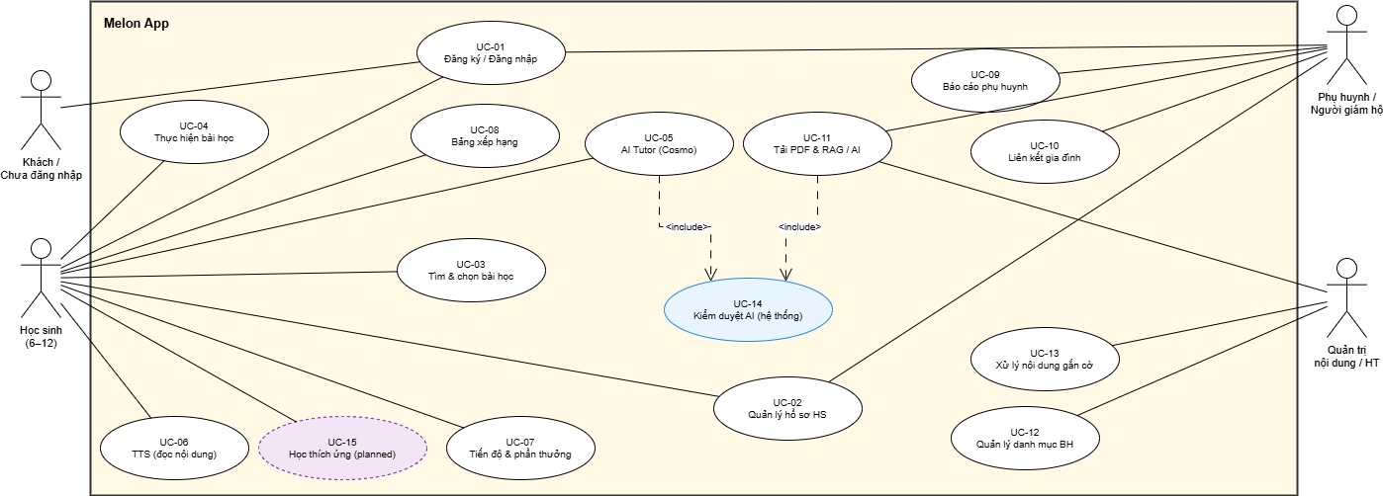
Use-case model diagram

Actors
Actor | Architectural relevance
Child | Uses lessons, quizzes, gamification, TTS, AI tutor, practice, leaderboard, and profile flows.
Parent/Guardian | Manages child profiles, reviews progress, links family accounts, and supervises learning outcomes.
Admin | Uploads and manages learning content, runs RAG ingestion, reviews flagged content, and manages catalog data.
Teacher | Planned or Phase 2 actor for content and learning-support workflows.
System | Runs automated moderation, background processing, and scheduled or asynchronous jobs.
External Services | Authentication, storage, AI, vector search, OCR/vision, TTS, email, monitoring, and payment providers.

Use-Case Summary
ID | Use case | Primary actor | Architectural relevance
UC-01 | Register / Sign in | Parent, Child | Requires Firebase Auth integration, role resolution, session handling, and guarded UI routes.
UC-02 | Manage student profile | Child, Parent | Requires profile storage, avatar handling, parent permissions, and personalization inputs.
UC-03 | Browse and select lesson | Child | Requires lesson catalog data, filtering, lesson metadata, and transition into the lesson player.
UC-04 | Complete lesson | Child | Requires slide rendering, quiz interaction, local/progress persistence, XP updates, and lesson completion events.
UC-05 | Use AI Tutor Cosmo | Child | Requires API proxying, streaming AI responses, moderation, prompt context, and safe response rendering.
UC-06 | Listen with TTS | Child | Requires /api/v1/ai/tts, FastAPI TTS orchestration, ElevenLabs integration, audio caching, and Firebase Storage URLs.
UC-07 | View progress, XP, and badges | Child | Requires gamification state, progress summaries, badge rules, and dashboard visualization components.
UC-08 | View leaderboard | Child | Requires ranking data, score normalization, and safe public display of child-facing profile data.
UC-09 | View parent learning report | Parent | Requires parent dashboard routes, child-progress aggregation, charts, and role-based access.
UC-10 | Link family accounts | Parent, Child | Requires account relationship modeling, parent-child authorization checks, and safe invitation or linking flows.
UC-11 | Upload material and generate review content | Admin | Requires upload handling, Firebase Storage, RAG ingestion, vector indexing, and quiz generation.
UC-12 | Manage lesson catalog | Admin | Requires content-management routes, lesson metadata validation, publishing state, and catalog synchronization.
UC-13 | Handle flagged content | Admin | Requires moderation logs, review queues, audit records, and administrative actions.
UC-14 | Automated AI moderation | System | Requires safety-by-default moderation in AI request and response flows.
UC-15 | Adaptive learning recommendation | Child | Planned capability requiring durable progress data and recommendation logic.

Logical View

Architecture Overview
Melon is structured as a set of cooperating components connected through browser, HTTP, REST, SSE, storage, and managed-service interfaces. The browser renders the Next.js UI. Next.js Route Handlers protect and normalize API calls. The FastAPI backend performs AI-heavy processing. Storage, authentication, vector search, and external AI providers are accessed through controlled service boundaries.

Component: Frontend - Next.js 16 App Router
The frontend uses Next.js 16 App Router with React 19, TypeScript, Tailwind CSS v4, shadcn/Radix primitives, Framer Motion, Recharts, Zustand, and TanStack Query. It renders the learning experience, dashboards, authentication flows, admin screens, and shared UI components.
Route or component | Responsibility
src/web/app/page.tsx | Landing page and primary entry experience.
src/web/app/lessons/page.tsx and lesson detail flows | Lesson browsing and interactive lesson playback.
src/web/app/progress/page.tsx | Child dashboard for XP, level, badges, and activity state.
src/web/app/parent/page.tsx | Parent analytics and study-progress reporting with charts.
src/web/app/admin/page.tsx and admin routes | Administrative access to upload, content, and management workflows.
src/web/components/auth/AuthModal.tsx | Role-aware authentication modal and consent-oriented flow.
src/web/components/ai/AITutorWidget.tsx | Cosmo AI tutor UI with streaming AI response support.
src/web/components/problems/ProblemParserPanel.tsx | Problem-image/PDF upload, Cloudinary preprocessing, and parsing request flow.
src/web/components/shared/* | Neobrutalism UI primitives such as buttons, pills, stat cards, guards, avatars, and XP bars.

Component: Next.js API Proxy
The Next.js API layer acts as a Secure API Gateway & Proxy. It validates requests, protects secrets from the browser, normalizes payloads, forwards AI-heavy work to FastAPI, and maps Phase 1 route handlers to longer-term backend module responsibilities.
API route | Responsibility
src/web/app/api/v1/ai/chat/route.ts | Streams AI tutor responses and applies safety checks.
src/web/app/api/v1/ai/tts/route.ts | Proxies TTS requests and supports audio URL generation/caching behavior.
src/web/app/api/v1/ai/moderate/route.ts | Moderates text for child-safety workflows.
src/web/app/api/v1/ai/transcribe/route.ts | Supports speech-to-text or transcription-related AI workflows.
src/web/app/api/v1/ai/evaluate-checkpoint/route.ts | Evaluates checkpoint answers and learning progress interactions.
src/web/app/api/v1/problems/parse/route.ts | Sends optimized problem images/PDF references to the FastAPI parsing service.
src/web/app/api/v1/rag/ingest/route.ts | Starts RAG ingestion for uploaded learning material.
src/web/app/api/v1/rag/ingest/[jobId]/route.ts | Reads ingestion job state.
src/web/app/api/v1/rag/quiz/route.ts | Requests RAG-grounded quiz generation.
src/web/app/api/v1/progress/* | Saves and retrieves progress and lesson completion state.

Component: Python FastAPI Backend
The FastAPI backend is the AI engine of the system. It provides a Python runtime for libraries and workflows that are less suitable for the web layer, including PDF extraction, vector retrieval, LLM prompt orchestration, TTS, and structured problem parsing.
Backend module | Responsibility
src/melon-ai-backend/main.py | FastAPI application entry point, CORS setup, and endpoint registration.
src/melon-ai-backend/api/endpoints.py | REST API contract for AI, RAG, quiz, TTS, and parsing operations.
src/melon-ai-backend/services/rag_service.py | PDF text extraction, chunking, vector-store interaction, and retrieval support.
src/melon-ai-backend/services/llm_service.py | Prompt orchestration and structured educational content generation.
src/melon-ai-backend/services/tts_service.py | ElevenLabs integration and speech synthesis workflow.
src/melon-ai-backend/services/problem_parser_service.py | OCR/vision-oriented problem parsing and structured extraction.

Component: AI Services Layer
The AI Services Layer encapsulates provider-specific behavior so frontend and proxy code do not depend directly on model APIs. It includes LLM chat/quiz generation, RAG retrieval, content moderation, multimodal problem parsing, speech synthesis, and caching decisions.
Service | Provider or technology | Purpose
LLM chat and quiz generation | OpenAI GPT-4o-mini / OpenRouter | AI tutor chat, RAG-based quiz generation, and structured learning content.
Vision/problem parsing | Gemini/OpenRouter-style multimodal model access | Transcribes and structures Vietnamese math problem images or PDFs.
Content safety | OpenAI Moderation API or equivalent safety checks | Blocks or flags unsafe input and output for child-facing flows.
Text-to-speech | ElevenLabs API | Generates high-quality lesson narration and AI response audio.
Vector retrieval | Pinecone or local vector store | Stores and retrieves embeddings for RAG grounding.
Image preprocessing | Cloudinary | Applies sharpening, improvement, grayscale, and similar transformations before OCR or vision parsing.

ML Model Analysis
The Melon AI Learning App uses five pre-trained AI models accessed through third-party APIs: GPT-4o-mini for AI tutoring chat, Whisper-1 for speech-to-text, Gemini 2.0 Flash for multimodal answer evaluation and rubric classification, eleven_multilingual_v2 from ElevenLabs for text-to-speech, and GPT-4o-mini via OpenRouter for RAG-based quiz generation. None of these models are hosted on team infrastructure. All are consumed as managed cloud services with no local GPU, no stored model weights, and no inference runtime managed by the team.

Static vs. Dynamic Deployment
All models are deployed statically. The model version for each service is fixed either as a hardcoded identifier in the source file or as an environment variable set before deployment. The system does not perform dynamic model selection, A/B routing, or automatic version switching at runtime. Any model version change requires a code or configuration update followed by a deliberate redeployment.

Retraining, Fine-Tuning, Revision and Redeployment
The team does not perform model training or fine-tuning. All models are pre-trained and accessed via API. Instead of modifying model weights, the team improves model accuracy for each task by carefully designing system prompts, providing sufficient domain context, and iteratively revising both the prompt content and inference parameters such as temperature. For example, the rubric classifier is given a detailed Vietnamese-language prompt with explicit definitions and examples for each Bloom's level, the answer evaluator is provided with the question, expected answer, lesson context, and leniency instructions, and the quiz generator is given the retrieved document context alongside strict grounding rules. When a model underperforms on a specific task, the team identifies which part of the prompt or context is insufficient, revises it, and re-evaluates against the test set until the output meets the acceptance threshold. All prompt changes are committed to version control and treated as model revisions.

Evaluation
We evaluate three core AI components: the rubric classifier, the RAG-based MCQA quiz generator, and the OCR-based PDF problem parser.
1. The rubric classifier is evaluated on a subset of our own mathematics problem bank - approximately fifty Vietnamese math questions from grades four and five, manually labeled by team members across four Bloom's taxonomy levels and resolved by consensus. Classification accuracy must reach at least 75%, macro F1-score at least 0.70.
2. The RAG quiz generator outputs strictly in MCQA format: one correct answer and three distractors. It is evaluated on fifty questions generated from five of our own lesson PDFs, ten per document, each manually reviewed against the source. Answer accuracy and groundedness must each reach at least 90%. Distractor relatedness is assessed using a natural language inference approach: each distractor must be semantically in-domain and share the same entity type as the correct answer, but must not be entailed by the source passage as correct. The distractor relatedness acceptance rate must be at least 80%.
3. The PDF problem parser uses Gemini 2.5 Pro for OCR and GPT-4.1 for structured extraction via OpenRouter. Since both are pretrained, we report their published benchmarks as the baseline expectation: Gemini 2.5 Pro achieves approximately 94% on DocVQA and over 90% on OCRBench. The team additionally tested on thirty scanned Vietnamese math exam pages from our own uploaded problem sets. Field extraction accuracy - the percentage of question stems, choices, and answer keys extracted correctly - must reach at least 85%, and the question detection rate must reach at least 90%.

Component: Infrastructure and Data Components
The current architecture uses a Cloud-Native / BaaS model.
Component | Phase 1 role | Phase 2 direction
Hosting | Vercel hosts the Next.js app and preview deployments. | Vercel or AWS ECS Fargate, depending on operational needs.
Authentication | Firebase Auth provides identity, session, and SSO support. | Firebase Auth remains viable for production.
Object storage | Firebase Storage stores PDFs, avatars, generated audio, and uploaded assets. | Firebase Storage or AWS S3.
Data persistence | Local mocks and browser/local persistence support Phase 1 flows. | Firestore or PostgreSQL for durable production records.
Caching | In-process or simple URL cache for generated AI assets. | Redis or managed cache for cross-instance reliability.
Vector database | Pinecone or vector storage supports RAG retrieval. | Managed vector database remains part of the AI architecture.
CI/CD | GitHub Actions and Vercel preview deployments. | GitHub Actions plus production deployment gates.

Detailed Design Diagrams
The following diagrams describe the database, class, and UI views that support the logical architecture.
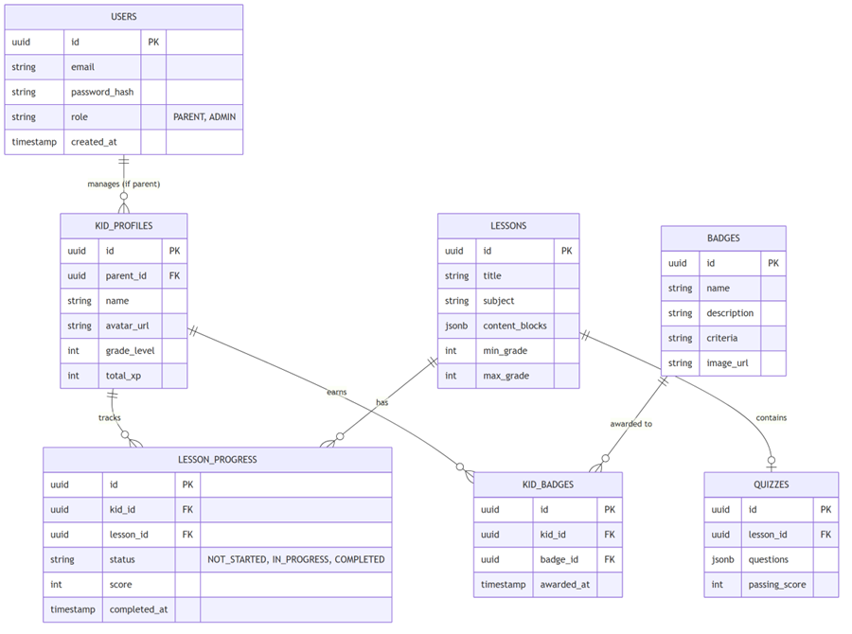
Database design diagram
The database design centers on users, kid profiles, lessons, lesson progress, badges, and kid badges. The model separates authentication identity from child learning profiles and keeps lesson progress and gamification state explicit.
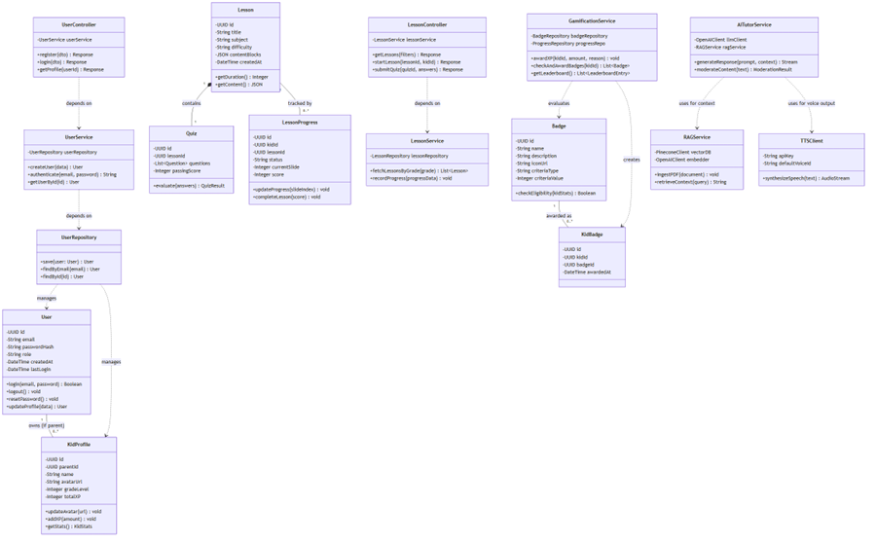
OOP class diagram
The class-level view groups responsibilities into User Management, Lesson Management, Gamification, and AI Integration. These groups map cleanly to the logical components described above.

UI Design
The following UI diagrams connect frontend components to user-facing screens.
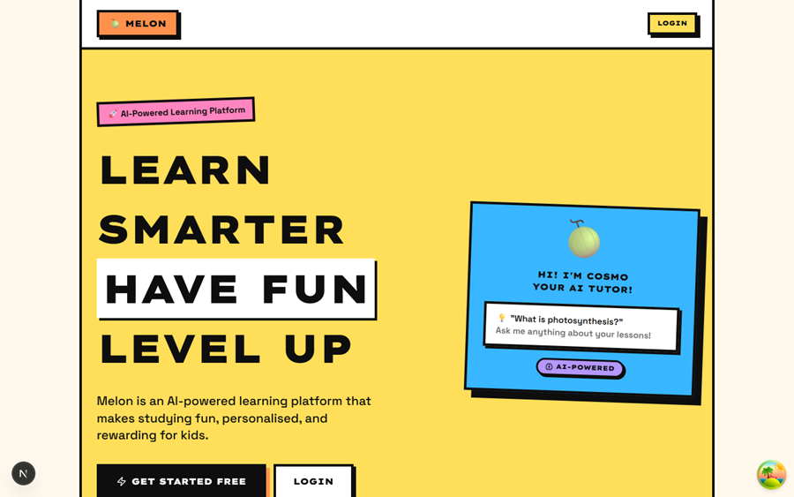
Landing page UI

Kid dashboard UI
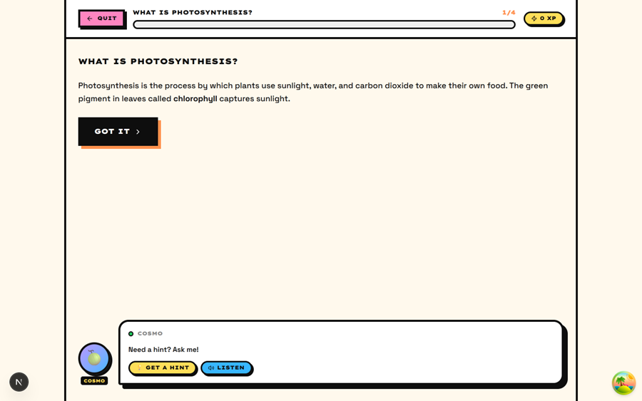
Lesson player UI

Parent dashboard UI
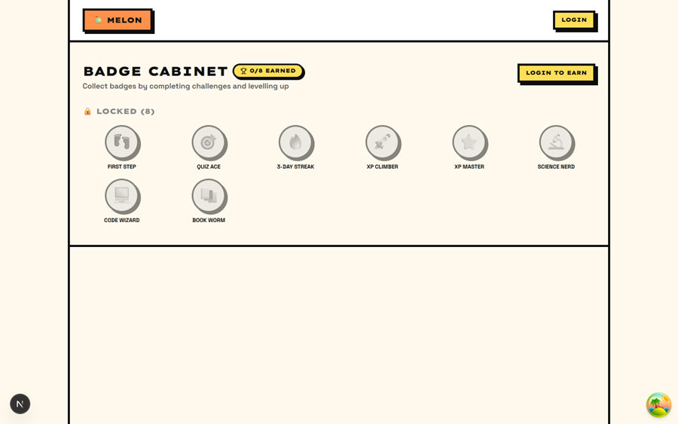
Badge cabinet UI

Data Flow Design

Lesson Interaction Flow
In Phase 1, lesson interaction operates primarily on the client side with mock persistence.
Step 1: The user selects a lesson from the lessons page.
Step 2: The system retrieves lesson metadata from the local lesson data layer.
Step 3: Student progress, XP, level, and badge completion are tracked and updated in the Zustand gamification store.
Step 4: Data is persisted to browser localStorage during the initial development phase.

AI Generation Flow - Text-to-Speech (TTS)
The TTS flow is optimized for cost-efficiency and performance through a multi-layered caching strategy.
Step 1: The child taps the Read Aloud button in the lesson player.
Step 2: The frontend sends a POST request to the Next.js proxy route /api/v1/ai/tts.
Step 3: The Next.js proxy validates the request and forwards the payload to the FastAPI backend.
Step 4: FastAPI computes a SHA256 hash of the text and checks the audio cache.
Cache HIT: FastAPI returns the existing Firebase Storage URL immediately.
Cache MISS: FastAPI calls the ElevenLabs API to synthesize speech.
Step 5: FastAPI receives the audio buffer, uploads it to Firebase Storage, and returns the public URL to Next.js.
Step 6: Next.js delivers the URL back to the frontend for playback.

PDF to Quiz RAG Pipeline
This flow uses the specialized Python environment for robust document intelligence.
Phase A - Ingestion: The admin uploads a PDF, the file is stored in Firebase Storage, Next.js starts ingestion, FastAPI extracts text with PyMuPDF, chunks the content, generates embeddings, and upserts vectors into Pinecone with metadata.
Phase B - Multimodal Vision Analysis: A user or admin uploads a math problem image or PDF, the frontend applies Cloudinary transformations, Next.js forwards the optimized asset, and FastAPI uses a multimodal model through OpenRouter to transcribe Vietnamese exam text, equations, stacked fractions, and tables into structured JSON.
Phase C - Quiz Generation: A student starts a lesson, the frontend calls the Next.js quiz proxy, FastAPI retrieves relevant context from Pinecone, prompts GPT-4o-mini, validates the structured quiz JSON, and returns the result to the student.

Deployment
The current deployment model maps the browser client, Next.js web/proxy layer, FastAPI backend, Firebase, vector database, and external AI providers to separate runtime nodes.
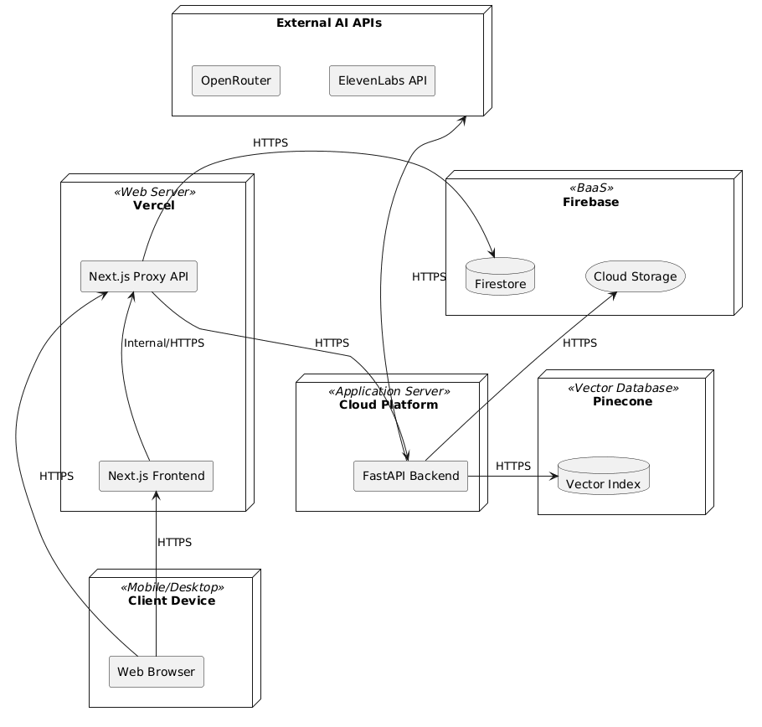
Deployment diagram

Node Descriptions
Node | Responsibility
Client Device | Runs a modern web browser on desktop, mobile, or tablet. The browser renders the Next.js frontend and makes HTTPS API calls.
Vercel Web Server | Hosts the Next.js application, serves frontend assets, runs proxy route handlers, and creates preview/production deployments from GitHub.
Cloud Application Server | Hosts the FastAPI backend for AI processing, RAG, TTS, LLM orchestration, and problem parsing.
Firebase BaaS | Provides authentication and storage services. Firestore is the target for structured data, while Firebase Storage handles PDFs, avatars, audio, and generated assets.
Pinecone Vector Database | Stores and queries vector embeddings for RAG-based retrieval.
External AI APIs | Provide LLM, moderation, OCR/vision, and TTS capabilities, including OpenAI/OpenRouter and ElevenLabs.

Cloud Infrastructure
Vercel replaces the earlier AWS ECS/RDS/ElastiCache/S3/CloudFront assumption for the current deployment model.
Resource | Configuration
Hosting | Vercel connected to the GitHub repository with automatic deployment on push to main.
AI Backend Hosting | Vercel Python Runtime, Render, or equivalent dedicated environment for the FastAPI engine.
Configuration | vercel.json or deployment configuration declares the Next.js framework and preferred deployment region.
Environment variables | Configured in the deployment dashboard and never committed to source code.
File storage | Firebase Storage under the same Firebase project as authentication.
CDN | Vercel Edge Network for globally distributed frontend assets.

Deployment Environment Strategy
Environment | Infrastructure | Purpose
Development | localhost:3000 for Next.js and localhost:8000 for FastAPI. | Individual development using local .env values or mock keys.
Preview | Vercel Preview URL per pull request. | Team review, UI validation, and integration testing.
Production | Vercel Production deployment from the main branch plus hosted FastAPI backend. | End-user runtime environment.

CI/CD
Developers work on feature branches and open pull requests. GitHub Actions run linting and type checking. After merge to the main branch, Vercel creates an atomic deployment so the previous healthy deployment remains available until the new deployment is ready.

Implementation View

Repository Structure
This section outlines the physical folder structure of the code repository, reflecting the Hybrid Split-Stack architecture (Next.js frontend/proxy and Python FastAPI backend).
Melon-App/
├── src/
│ ├── web/ # Next.js 16 Web Application & Proxy Layer
│ │ ├── app/ # Next.js App Router (Pages & API Route Handlers)
│ │ │ ├── api/v1/ # Next.js API Routes (Secure Proxy Node)
│ │ │ ├── admin/ # Admin Dashboard (PDF/Image upload interfaces)
│ │ │ ├── lessons/ # Interactive Lesson Player UI & Drag-Drop logic
│ │ │ └── globals.css # Neobrutalism Design System Tailwind tokens
│ │ ├── components/ # Modular Reusable React UI Components
│ │ │ ├── shared/ # Core Neobrutalism UI (NbButton, NbCard, NbPill)
│ │ │ ├── ai/ # AI Tutor widget (Cosmo Chat UI)
│ │ │ └── problems/ # OCR Ingestion frontend panels
│ │ └── lib/ # Framework Core Utilities & Client State
│ │ ├── gamification/ # Zustand global state (XP, Badges, LocalStorage)
│ │ └── auth/ # Firebase Auth configurations
│ │
│ └── melon-ai-backend/ # Python FastAPI Standalone AI Compute Engine
│ ├── main.py # FastAPI application bootstrapper & CORS setups
│ ├── api/ # REST API Controller mappings
│ │ └── endpoints.py # Routes for RAG, TTS, and Vision parsing
│ └── services/ # Domain Business Logic & AI Services
│ ├── llm_service.py # GPT-4o-mini structured prompt logic
│ ├── rag_service.py # Custom Hash Embedding & Pinecone logic
│ ├── problem_parser_service.py # Gemini 2.5 Pro Multimodal OCR & LaTeX compiler
│ └── tts_service.py # ElevenLabs raw byte stream processing
│
├── infra/ # Cloud System configuration deployments (vercel.json)
└── package.json # Node.js workspace dependencies

Frontend Implementation
The frontend is organized around route-level pages and reusable components. src/web/app contains top-level user flows such as home, lessons, progress, parent dashboard, badges, leaderboard, family, profile, practice, and admin. src/web/components/layout provides role-specific shells and navigation. src/web/components/shared provides reusable design-system components such as buttons, pills, guards, stat cards, avatar pickers, and XP bars. src/web/components/ui contains the shadcn/Radix primitive layer.
State and business logic are kept under src/web/lib. Gamification state is handled through src/web/lib/gamification, lessons through src/web/lib/lessons, authentication through src/web/lib/auth, persistence/progress through src/web/lib/progress, and uploads/storage through src/web/lib/storage.

API Implementation
The Next.js API routes under src/web/app/api form the web-facing contract. Authentication, parent-child relationships, question attempts, uploads, progress, AI chat, TTS, moderation, transcription, exercise generation, problem parsing, RAG ingestion, and RAG quiz generation are exposed through route handlers.
These route handlers should remain thin. Their main responsibilities are validating input, resolving authenticated context, protecting secrets, applying safety checks where appropriate, and forwarding specialized AI work to FastAPI.

FastAPI Implementation
The FastAPI backend is implemented under src/melon-ai-backend. main.py starts the application. api/endpoints.py defines API routes. Service modules implement the core AI behavior:
Service file | Responsibility
services/rag_service.py | PDF ingestion, text extraction, chunking, vector storage, and retrieval.
services/llm_service.py | LLM prompt execution and structured output generation.
services/tts_service.py | TTS provider calls and audio generation flow.
services/problem_parser_service.py | Multimodal problem parsing and structured question extraction.
Generated artifacts and local runtime data are separated into backend upload, generation, and vector-store directories. Production deployments should replace local runtime persistence with managed storage and configured provider services.

Implementation Constraints
Secrets must stay in environment variables and must not be exposed to the browser. Frontend code must call internal Next.js API routes instead of calling AI providers directly. FastAPI endpoints should return structured JSON responses so the frontend can render predictable UI states. AI-generated outputs should be moderated, parsed, and validated before being shown to child users. Long-running ingestion or generation operations should expose status or retry behavior when response latency exceeds normal interactive thresholds.

