Instructions for Manuscript for JSCE Journals/ Author Guidelines for Manuscript Preparation for JSCE

Taro DOBOKU1, Hanako YOTSUYA2 and John SMITH3

1 Student, Advanced Course of Civil Eng., National Institute of Technology, Kumamoto College
(Yotsuya 1, Shinjuku-ku, Tokyo 160-0004, Japan)
E-mail:doboku@jsce.ac.jp
2Student, Dept. of Civil Eng., Doboku Corporation
(13-5, Mitsuya 6, Shinjuku-ku, Tokyo 160-0004, Japan)
E-mail:hanako@jsce.co.jp
3 Professor, Inst., Industrial Science, University of Tokyo
(7-22-1 Roppongi, Minato-ku, Tokyo 106-8558. Japan)
E-mail:smith@jsce.or.jp

This template is prepared for your preparation of manuscript for JSCE journals. It provides instructions: page layout, font style, size and others. You may use it to create your own manuscript by replacing the relevant text with your own, using “cut & paste.”
The Abstract should be justified, leaving a 30 mm margin on the left and right sides. Font should be a 10-point Times-New-Roman. The length should be 300 words or less.

Key Words : times, italic, 10pt, one blank line below abstract, indent if key words exceed one line

1. TITLE PAGE

The first page consists of two parts:
(a) Front matters : single column (title, author(s), affiliation(s), contact address(es), E-mail address(es), abstract, key words) E-mail address should be indicated in a separate, independent line.
(b) Main text in double columns.
The journal name, volume and issue numbers and the date of issue should be aligned right in the top margin. Page numbers are to be put in the bottom margins of the manuscript. Some word processing softwares do not allow texts in both single and double columns to be put together in one file, and thus, create two separate files for the title page.

(1) Layout and fonts for the front matters
Left and right margins for the front matters are equally set at 30 mm, The front matters are, thus, to be laid-out within the borders narrower than those for the main text.
The front matters include the followings:
(About 10 mm blank space)
Title in Times-New-Roman, 18pt, bold
(About 15mm blank space)
Author(s) in Times-New-Roman, 12pt.
(About 5 mm blank space)
Affiliation(s) in Times-New-Roman, 9pt.
E-mail address(es) in Times-New-Roman, 9pt
(About 10 mm blank space)
Abstract in Times-New-Roman, 10pt, max. 300 words,
(1 line spacing) and
About 5 Key Words in Times-Italic, 10pt,
(max. 2 blank lines).
The name(s) and affiliation(s) of the author(s) should be numbered in order of appearance as shown above. The title 'Key Words' is bold and italic.

(2) Layout and fonts of the main text
The text should be placed about 1cm below the key words. Left and right margins for the text are equally set at 20 mm. The text, in double columns put side by side with 6 mm gap in between, must be single-spaced with double spacing between chapters. Use 11pt Times-New-Roman font for the text.

(3) page number
Page numbers should be center-aligned and should appear at the bottom of each page. Since these pieces of information will be notified by the secretariat of JSCE before completing the final manuscripts, leave the blanks as they are, and number the pages tentatively from 1.
2. ORDINARY PAGES
Table 1 Caption should be centered, but if it is long, it should be indented like this.

Specimen No. Heights (m) Width (m)
1 1.45 0.25
2 1.75 0.40
3 1.90 0.65

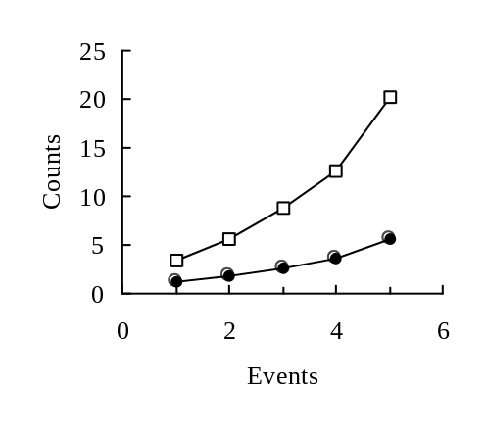
Fig.2 Place the caption below the drawing.

Case 2
Case 1

In ordinary pages, the text must be placed within borders immediately below 19mm top margin. The other layout is same as the main text in the title page.

(1) Footnotes and remarks
Avoid using footnotes and/or remarks. If any, try to explain it in the text, or in appendices.

3. HEADINGS (INDENT LIKE THIS SAMPLE IF IT IS LONG)

(1) Main heading
Capital letters in 12pt bold face fonts should be used for main headings (chapter titles) that follow the chapter numbers as is shown in this example. Leave double and single spacing of lines before and after every main heading.

(2) Sub-headings for sections
The sub-headings for sections, in 10pt. bold face fonts, with their initial letters capitalized, are preceded by parenthesized section number like (2). Leave single spacing of line before every sub-
heading.
a) Sub-headings for sub-sections
They are written just as the sub-headings for sections are done, but follow alphabets with right parentheses. No spacing of lines is left before and after every sub-heading.

4. MATHEMATICS

Use special high quality fonts for all mathematical equations in the text. Some equations may be placed off the text as:
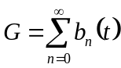 (1a)
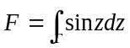 (1b)

and some appear in the text as. C_{D}, α (z) If their quality is not satisfactory, the manuscript may not be accepted. Numbered equations ((1a) and (1b) for example) should be center-aligned. The equation numbers in parentheses should be placed flush right.

5. FIGURES AND TABLES

(1) Location of figures and tables
Figures, tables and photographs should be inserted at the upper or lower part of the page where reference is first made to them. Do not place them altogether at the end of the manuscript.
Figures or tables should occupy the whole width of a column, as shown in Table 1 or Fig.2 in this example, or the whole width over two columns. Do not place any text besides figures or tables. Insert about one to two lines spacing above the main text.

(2) Fonts and captions
Do not use too small characters in figures and tables. At least, the letters should be larger than those in the captions (9 pt). Captions should be centered, but long captions must be indented like an example of Table 1. The heading of captions is 9pt bold face.

6. CITATION AND REFERENCE LIST

All the references must be numbered in the order of appearance in the article and the right parenthesized numbers are used at the text where it is referred like this1). The reference list must be summarized at the end of the main text. Use 9pt font for the list. The reference list is followed by the date of acceptance with one line spacing between them as shown in the present sample.

ACKNOWLEDGMENT: Acknowledgment should follow Conclusions and its text should be preceded by bold face heading directly.

APPENDIX A APPENDIX

Appendix should be placed between Acknowledg-
ment and References.

REFERENCES
- Miles, J. W. : On the generation of surface waves by shear flows, J. Fluid Mech., Vol. 3, Pt. 2, pp. 185-204, 1957.
- Miche, M. : Amortissement des houles dans le do-maine de l’eau peu profonde, La Houile Blanche, No. 5, pp. 726-745, 1956.
- Gresho, P. M., Chan, S. T., Lee, R. L. and Upson, C. D. : A modified finite element method for solving the time-
dependent incompressible Navier-Stokes equations, part 1, Int. J. Numer. Meth. Fluids, Vol. 4, pp. 557-598, 1984.
- Shepard, F. P. and Inman, D. L. : Nearshore water circulation related to bottom topogrphy and wave refraction, Trans. AGU., Vol. 31, No. 2, 1950.
- Smith, W. : Cellular phone positioning and travel times estimates, Proc. of 8th ITS World Congress, CD-ROM, 2000.

(Received July 1, 2009)

