

**Name: Azzam**

**Price: 1400$/hour**

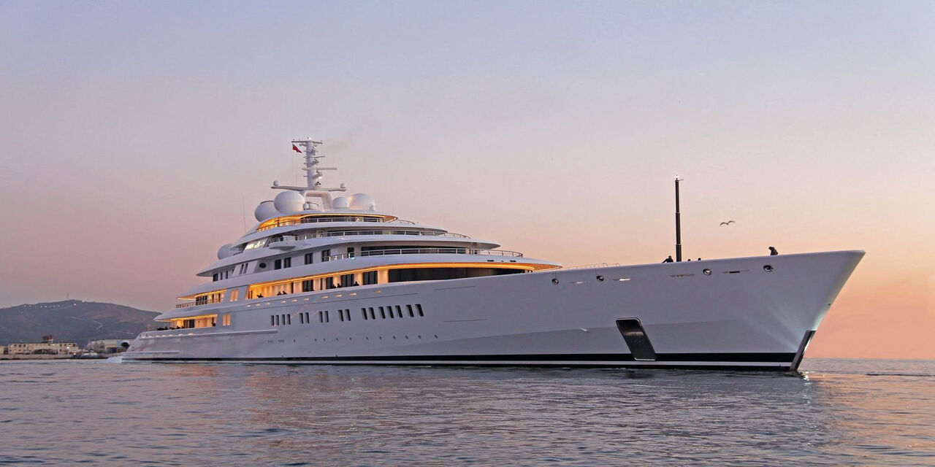

-The world´s longest yacht, at 180.65 meters, with a top speed of over 30 knots, Azzam is a truly extraordinary luxury gigayacht. Her outstanding characteristics even include her exceptionally short building time of less than three years from keel laying to delivery, in 2013

-Engineer and principal designer Mubarak Saad al Ahbabi set out to build a large yacht with an innovative and timeless design that would be able to travel at high speed in warm and shallow waters. The bold and elegant exterior by Nauta Yachts incorporates many elements of visionary modern design. Renowned French designer Christophe Leoni conceived a sophisticated interior with luxurious décor inspired by the Empire style of the early 19th century.

|  |  |
| --- | --- |
|  |  |
|  |  |
|  |  |
|  |  |

***​​DESCRIPTION***

|  |  |  |  |
| --- | --- | --- | --- |
|  | **Long 180.6m** |  | **Wide 20.8m** |
|  | **18 Room** |  | **36 Owner & guest** |
|  | **1 x 300 HP** |  | **12 - 34 Knots** |
|  | **Day Charter** |  | **30 L/h** |

ROAD CHARTER

»» Sightseeing on the Saigon River by yacht in 2 hours.  
1. Sunset and city night life.  
2. Enjoy the freedom & fresh air.  
  
»» Saigon – Can Gio Mangrove Forest 4 hours.  
1. Enjoy the mangrove forest and the life of local fisherman.  
2. Buy and cook local seafood from the forest fisherman. The special seafood of brackish water.  
3. Sunset on the river  
4. Night life of the city  
  
»» Saigon – Vung Tau City  
1. The trip will go through Can Gio Mangrove Forest.  
2. Swimming in the open sea (near the coastine)  
3. Sunset on the river  
4. Night life of the city