

**Name: Eclipse**

**Price: 1380$/hour**

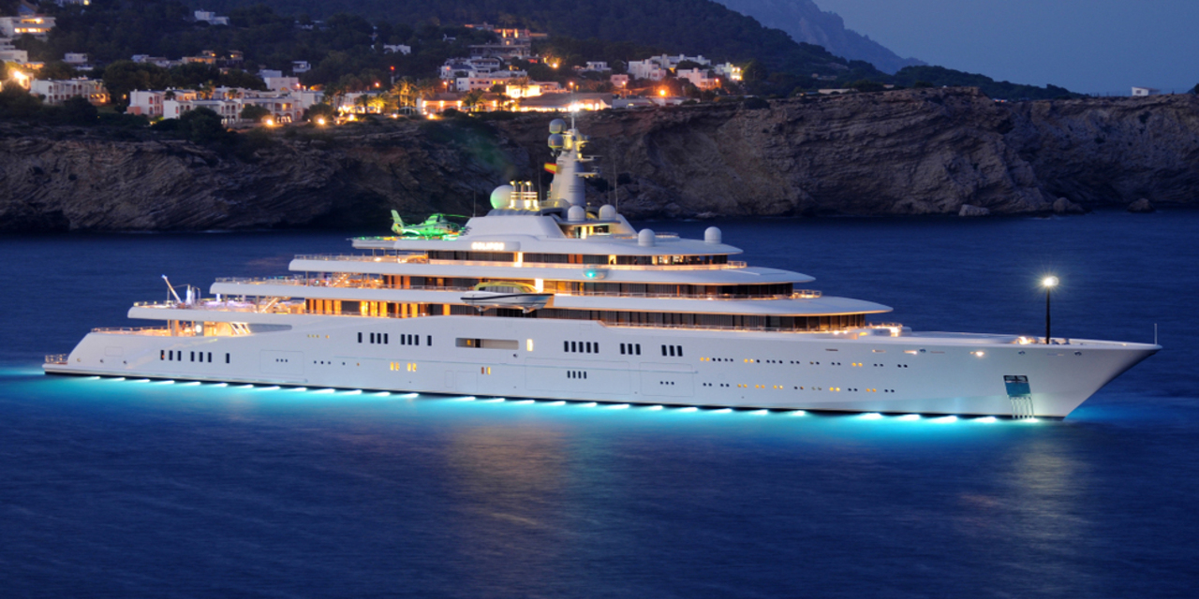

-The multi-award winning 162.5m/533'2" motor yacht 'Eclipse' was built by Blohm + Voss in Germany at their Hamburg shipyard. Her interior is styled by English designer design house Terence Disdale and she was delivered to her owner in October 2010. This luxury vessel's exterior design is the work of Terence Disdale and she was last refitted in 2015.

-Eclipse is built with a steel hull and aluminium superstructure, with teak decks. Powered by twin diesel-electric Wartsila (VEM, synchron) 16-cylinder 8,717hp engines running at 180rpm, she comfortably cruises at 20 knots, reaches a maximum speed of 21 knots with a range of up to 6,000 nautical miles from her 1,000,000 litre fuel tanks at 21 knots. Eclipse features at-anchor stabilizers providing exceptional comfort levels. Her water tanks store around 150,000 Litres of fresh water. She was built to Lloyds Register ✠ 100A1 SSC Yacht (p) Mono G6, ✠ LMC UMS, PSMR -DP (AM), Ice Class 1D, EP classification society rules..

|  |  |  |  |
| --- | --- | --- | --- |
|  | **Long 162.5m** |  | **Wide 22.4m** |
|  | **18 Room** |  | **36 Guests** |
|  | **1 x 300 HP** |  | **21 Knots** |
|  | **Day Charter** |  | **30 L/h** |

***​DESCRIPTION***

ROAD CHARTER

»» Sightseeing on the Saigon River by yacht in 2 hours.  
1. Sunset and city night life.  
2. Enjoy the freedom & fresh air.  
  
»» Saigon – Can Gio Mangrove Forest 4 hours.  
1. Enjoy the mangrove forest and the life of local fisherman.  
2. Buy and cook local seafood from the forest fisherman. The special seafood of brackish water.  
3. Sunset on the river  
4. Night life of the city  
  
»» Saigon – Vung Tau City  
1. The trip will go through Can Gio Mangrove Forest.  
2. Swimming in the open sea (near the coastine)  
3. Sunset on the river  
4. Night life of the city