

**Name: Margaret**

**Price: 1650$/hour**

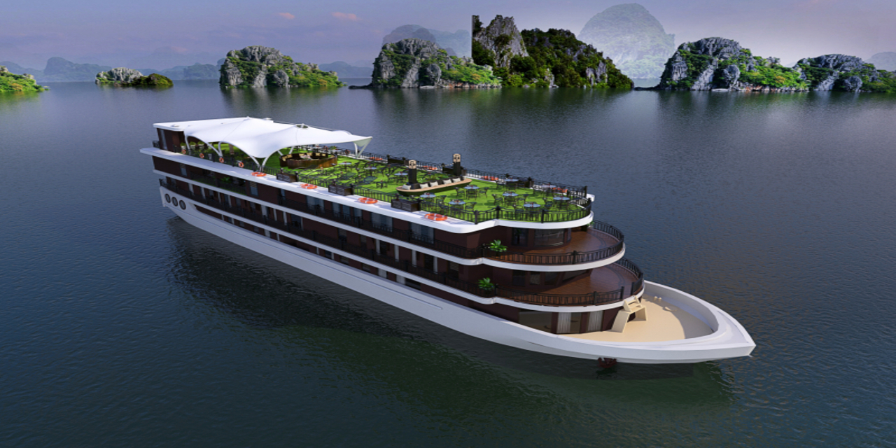

-Margaret yacht is considered one of the symbols of the intersection between classic and modern room design styles. On the yacht, there are a total of 25 luxury rooms with an area of ​​about 22-25 meters, which are spread evenly on the 1st, 2nd and 3rd floors of the yacht.

In addition, the restaurant system is arranged on the 3rd floor with a very large area of ​​about 200 square meters with a scientific and aesthetic layout to help you feel more about the luxury of a luxury yacht. 5-star standard but has the most affordable tour price in the Halong cruise system. In addition, the cruise is also a highlight to optimize time when traveling on a cruise with famous destinations such as: Sung Sot Cave - The largest and most beautiful cave of Halong Bay, Titop Island is the place. You can see Halong from above and immerse yourself in the clear blue water of the sea here, kayaking at Luon cave - One of the largest water-transporting caves of Halong Bay (5-star yachts will usually charge you a fee). extra money when kayaking) helps you have the most unforgettable experience of one of the most famous landscapes in Vietnam.

|  |  |
| --- | --- |
|  |  |
|  |  |
|  |  |
|  |  |

|  |
| --- |
| ***​*** |
|  |
|  |

***​DESCRIPTION***

|  |  |  |  |
| --- | --- | --- | --- |
|  | **Long 50m** |  | **Wide 10m** |
|  | **25 Room** |  | **48 Owner & guest** |
|  | **1 x 300 HP** |  | **12 - 34 Knots** |
|  | **Day Charter** |  | **30 L/h** |

ROAD CHARTER

»» Sightseeing on the Saigon River by yacht in 2 hours.  
1. Sunset and city night life.  
2. Enjoy the freedom & fresh air.  
  
»» Saigon – Can Gio Mangrove Forest 4 hours.  
1. Enjoy the mangrove forest and the life of local fisherman.  
2. Buy and cook local seafood from the forest fisherman. The special seafood of brackish water.  
3. Sunset on the river  
4. Night life of the city  
  
»» Saigon – Vung Tau City  
1. The trip will go through Can Gio Mangrove Forest.  
2. Swimming in the open sea (near the coastine)  
3. Sunset on the river  
4. Night life of the city