

**Name: PurSuit C 310**

**Price: 900$/hour**

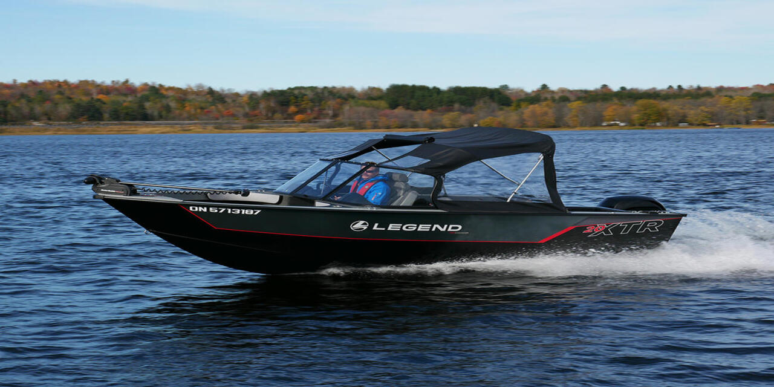

The Alumacraft Trophy 205 represents the next frontier in heavy-gauge aluminum fishing boats. It is built with the latest livewell technology, comes with spacious storage for all your fishing gear, as well as adjustable ergonomic seating for those long days spent out on the water.

The Ranger VX1888 WT aluminum boat is an absolute beast. It has a deep-V hull that’s designed to cut through the water and deliver an unprecedented amount of stability even in the roughest of conditions. It also has plenty of storage for fishing gear, as well as spacious baitwells and livewells..

|  |  |
| --- | --- |
|  |  |
|  |  |
|  |  |
|  |  |

|  |
| --- |
| ***​*** |
|  |
|  |

***​ ​DESCRIPTION***

|  |  |  |  |
| --- | --- | --- | --- |
|  | **Long 8m** |  | **Wide 2.5m** |
|  | **1 Room** |  | **8 Guests** |
|  | **1 x 300 HP** |  | **69.54 km/h** |
|  | **Day Charter** |  | **30 L/h** |

ROAD CHARTER

»» Sightseeing on the Saigon River by yacht in 2 hours.  
1. Sunset and city night life.  
2. Enjoy the freedom & fresh air.  
  
»» Saigon – Can Gio Mangrove Forest 4 hours.  
1. Enjoy the mangrove forest and the life of local fisherman.  
2. Buy and cook local seafood from the forest fisherman. The special seafood of brackish water.  
3. Sunset on the river  
4. Night life of the city  
  
»» Saigon – Vung Tau City  
1. The trip will go through Can Gio Mangrove Forest.  
2. Swimming in the open sea (near the coastine)  
3. Sunset on the river  
4. Night life of the city