

**Name: Spencer 70 IBS**

**Price: 500$/hour**

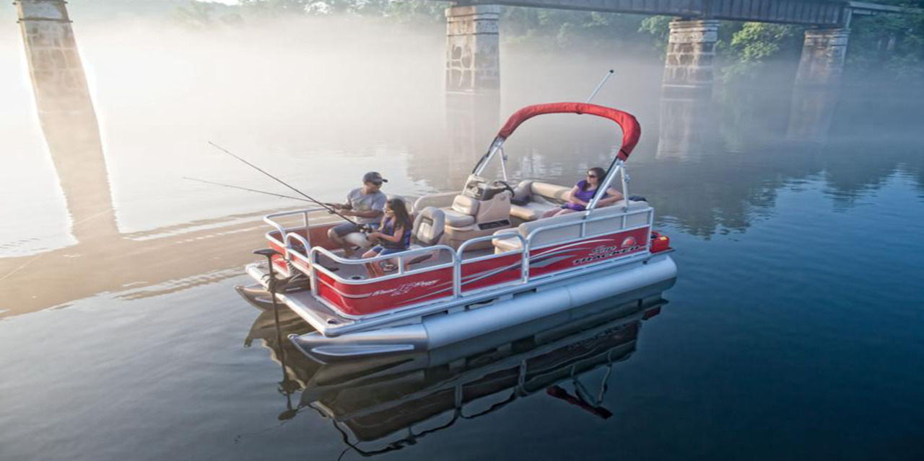

The Spencer 70 IPS takes the great value provided by the base model and expands it with a Bimini top, Bluetooth® stereo system and tinted windscreen.

In addition, the deck is 16' long and 8' wide, providing a spacious, stable platform for a variety of activities. Fishing? Dual bow fishing chairs provide comfortable spots to cast away the day, and a forward-console livewell/seat is perfect for placing your keepers. There is also rod storage at the console. Relaxing? The aft L-lounge is plush and ready—and also provides storage below. Swimming? Three gates provide quick access to the water, and the aft platform also has a fold-down reboarding ladder.

|  |  |
| --- | --- |
|  |  |
|  |  |
|  |  |
|  |  |

|  |
| --- |
| ***​*** |
|  |
|  |

***​ ​DESCRIPTION***

|  |  |  |  |
| --- | --- | --- | --- |
|  | **Long 8m** |  | **Wide 2.5m** |
|  | **1 Room** |  | **8 Guests** |
|  | **1 x 300 HP** |  | **69.54 km/h** |
|  | **Day Charter** |  | **30 L/h** |

ROAD CHARTER

»» Sightseeing on the Saigon River by yacht in 2 hours.  
1. Sunset and city night life.  
2. Enjoy the freedom & fresh air.  
  
»» Saigon – Can Gio Mangrove Forest 4 hours.  
1. Enjoy the mangrove forest and the life of local fisherman.  
2. Buy and cook local seafood from the forest fisherman. The special seafood of brackish water.  
3. Sunset on the river  
4. Night life of the city  
  
»» Saigon – Vung Tau City  
1. The trip will go through Can Gio Mangrove Forest.  
2. Swimming in the open sea (near the coastine)  
3. Sunset on the river  
4. Night life of the city