

**Name: Tiara 4300 Open**

**Price: 1000$/hour**

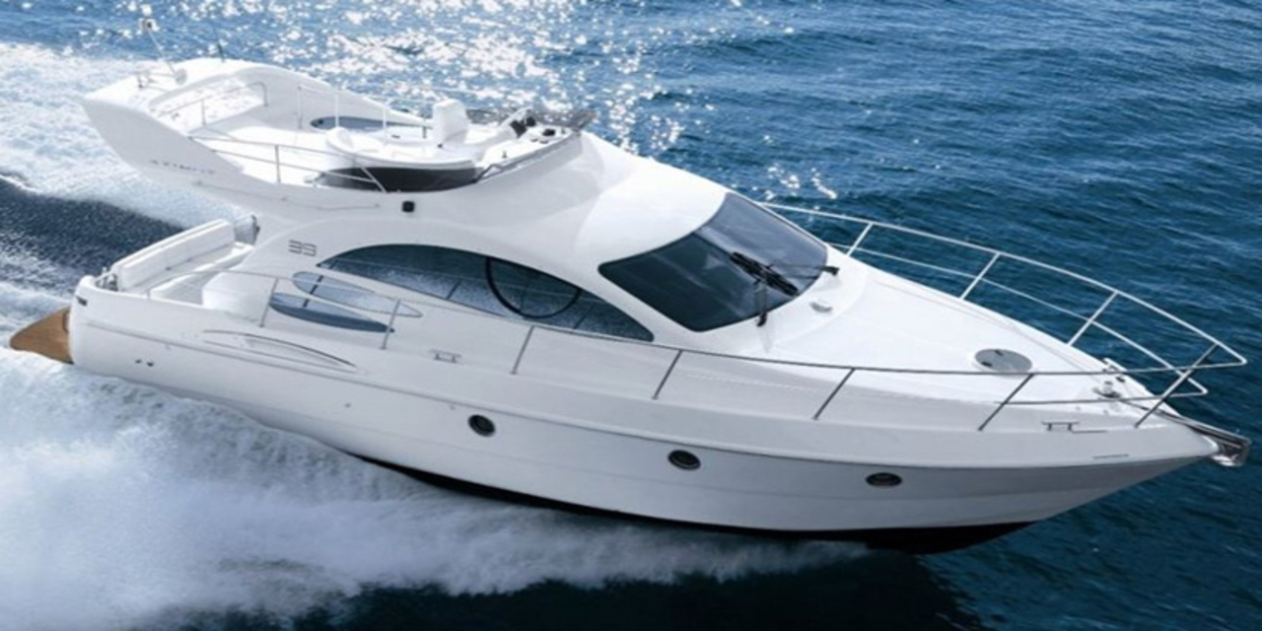

Tyee, the Chinook word for chief, is just that – the head of its class. Big water action and intense fishing is where the Tyee really shines. It also plays a dual role of the perfect family boat for trips to the lake or a sunny day enjoying water sports.

Tyee, the Chinook word for chief, is just that – the head of its class. Big water action and intense fishing is where the Tyee really shines. It also plays a dual role of the perfect family boat for trips to the lake or a sunny day enjoying water sports. With I-beam construction and heavy-duty treated transom, the Tyee provides ultimate toughness while offering unmatchable finesse and comfort. For family or for fish, the Tyee commands the water.

|  |  |
| --- | --- |
|  |  |
|  |  |
|  |  |
|  |  |

|  |
| --- |
| ***​*** |
|  |
|  |

***​ ​DESCRIPTION***

|  |  |  |  |
| --- | --- | --- | --- |
|  | **Long 8m** |  | **Wide 2.5m** |
|  | **1 Room** |  | **8 Guests** |
|  | **1 x 300 HP** |  | **69.54 km/h** |
|  | **Day Charter** |  | **30 L/h** |

ROAD CHARTER

»» Sightseeing on the Saigon River by yacht in 2 hours.  
1. Sunset and city night life.  
2. Enjoy the freedom & fresh air.  
  
»» Saigon – Can Gio Mangrove Forest 4 hours.  
1. Enjoy the mangrove forest and the life of local fisherman.  
2. Buy and cook local seafood from the forest fisherman. The special seafood of brackish water.  
3. Sunset on the river  
4. Night life of the city  
  
»» Saigon – Vung Tau City  
1. The trip will go through Can Gio Mangrove Forest.  
2. Swimming in the open sea (near the coastine)  
3. Sunset on the river  
4. Night life of the city