TRƯỜNG CAO ĐẲNG CÔNG NGHỆ THỦ ĐỨC
KHOA CÔNG NGHỆ THÔNG TIN
--------------------------------

BÁO CÁO KẾT THÚC MÔN HỌC
Lập trình di động trên iOS

Ứng dụng FoodShop

Giảng viên hướng dẫn: Tiêu Kim Cương
Sinh viên thực hiện:
- Nguyễn Minh Tiến
- Phan Ngọc Luân
- Đào Văn Chung
- Nguyễn Hữu Thắng

- Cao Minh Hiếu

- Nguyễn Huỳnh Quốc Trung

Tp. Hồ Chí Minh, ngày 26 tháng 6 năm 2021
NHẬT KÝ HOẠT ĐỘNG NHÓM

Stt | Họ và tên | Công việc đã thực hiện | Nhóm đánh giá  (Tính theo %) | Chữ ký
1 | Nguyễn Minh Tiến
2 | Phan Ngọc Luân
3 | Đào Văn Chung
4 | Nguyễn Hữu Thắng
5 | Cao Minh Hiếu
6 | Nguyễn Huỳnh Quốc Trung

MỤC LỤC

DANH MỤC BẢNG BIỂU, HÌNH VẼ, SƠ ĐỒ 4
CHƯƠNG 1. MỞ ĐẦU 5
1. Giới thiệu môn học và nhóm thực hiện 5
2. Mô tả ứng dụng 5
3. Sự cần thiết của ứng dụng 5
CHƯƠNG 2. PHÂN TÍCH THIẾT KẾ HỆ THỐNG 6
2.1 Phân tích hệ thống 6
2.2 Thiết kế hệ thống 6
CHƯƠNG 3. CÀI ĐẶT VÀ KIỂM THỬ 7
3.1 Cài đặt 7
3.2 Kiểm thử 7
CHƯƠNG 4. KẾT QUẢ ĐẠT ĐƯỢC 8
4.1 Kết quả đạt được 8
4.2 Các kết luận và kiến nghị 8
PHỤ LỤC 9
TÀI LIỆU THAM KHẢO 10

DANH MỤC BẢNG BIỂU, HÌNH VẼ, SƠ ĐỒ

CHƯƠNG 1. MỞ ĐẦU

1. Giới thiệu môn học và nhóm thực hiện
- Giới thiệu môn học
- Lập trình iOS nằm trong hệ thống lập trình mobile đang được coi là ngành công nghệ hot nhất ngày nay. Lập trình ứng dụng iOS chính là việc xây dựng và phát triển ứng dụng tương thích với hệ điều hành này thông qua ngôn ngữ lập trình Swift được sáng tạo độc quyền bởi Apple.
- Nhóm thực hiện
- Công nghệ ngày nay càng phát triển, mỗi người chúng ta không ai là không có điện thoại bên mình. Lại vào thời điểm giản cách xã hội, các hình thức mua bán online ngày càng được phát triển. Cho nên hôm nay nhóm chúng em sẽ xây dựng ứng dụng đặt đồ ăn trên điện thoại dành cho hệ điều hành iOS.

2. Mô tả ứng dụng
- Ứng dụng cho phép người dùng xem thông tin chi tiết các món ăn bao gồm giá cả và mô tả các món ăn.
- Người dùng có thể đặt các món ăn sau khi đã lựa chọn các món ăn phù hợp với mình.

3. Sự cần thiết của ứng dụng
- Vì để đáp ứng nhu cầu ăn uống của khách hàng trong thời điểm giản cách xã hội nên ứng dụng rất cần thiết để khách hàng đặt mua những món ăn yêu thích mà không cần ra khỏi nhà.

CHƯƠNG 2. PHÂN TÍCH THIẾT KẾ HỆ THỐNG

2.1 Phân tích hệ thống
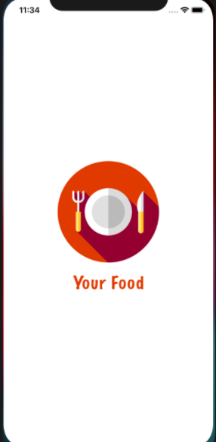
Image1: First Screen

Feature/Component #2: MyMobile Onboards Screen

Onboards Interfaces

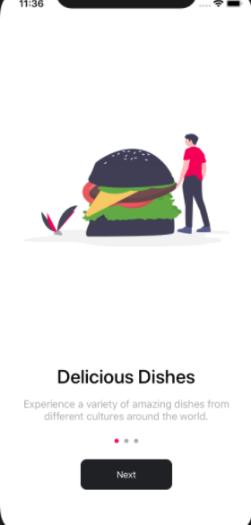
Image2 : onboard screen 1
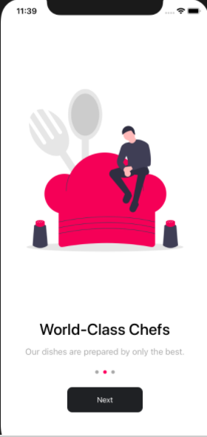
Image3 : onboard screen 2
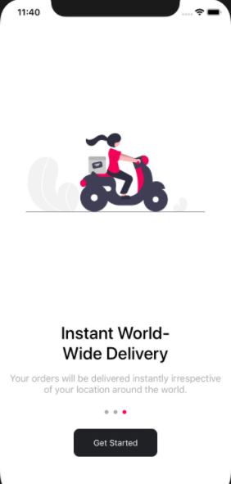
Image4 : onboard screen 3

Functional Requirements
Item | Description | Action | Response
MyMobile onBoard Screen | MyMobile onBoard Screen has :  - Screen  - button ‘Next’ and  - 1 button”Get Stared” ,  - solgan,images logo | N/A | N/A
Image logo ,  Slogan | Display the store's maxim, increasing the customer's eye-catching when entering the application | N/A | N/A
Next button | On every 1st and 2nd Onboardscreen, there will be a next button | Click on Next button | Convert from this screen to the other screen(screen 1 to screen 2..)
GetStared button | Appears on the last screen of onboard | Click on GetStared button | After select started. It will switch to the main screen of the application

Feature/Component #3: MyMobile Home screen

Home Interfaces
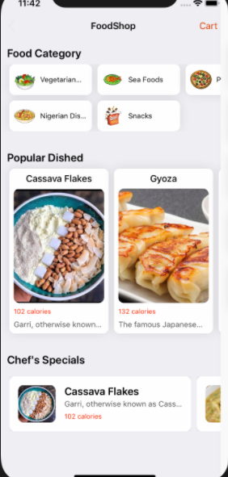
Image 5 : home screen

    - Functional Requiements

Item | Description | Action | Response
MyMobile Home Screen | MyMobile Home Screen has :  - Name shop  - FoodCategory  - Popular Dished  - Chef’s Specials  - Cart | N/A | N/A
Name shop | The name of the app | N/A | N/A
FoodCategory | Display the food items in the shop | When Tap on the Category box on the screen | Show the foods of that category
Cart | Contains customer orders | Tap cart lable on the home screen | Displays a list of orders that have been placed
Popular Dished | show the dishes with the most views and orders | Tap on the dish in the popular dishes box | Show that product information
Chef’s Specials | Display the special dishes that the shop has for sale today | Tap on the dish in the Chef’s Specials box | Show that product information

Feature/Component #4: MyMobile Food Category Screen

Food Category Interfaces

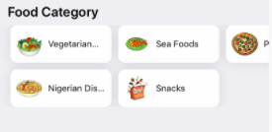
Image 6 : Food Category

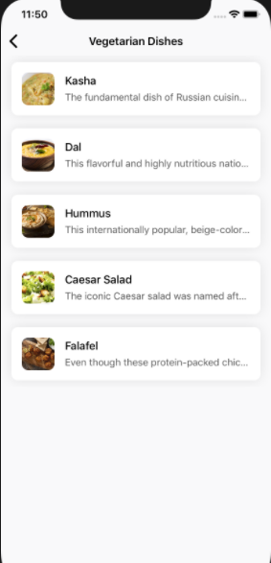
Image 7 : screen vegetarian dishes

Functional Requirements
Item | Description | Action | Response
MyMobile Category Interfaces Screen | MyMobile Category Interfaces Screen has :  - Names of menu items available in the store | Tap on any category box | Show products in that category
List of dishes | Dishes in the selected list | Tap on any Dishes in the selected list in the category box | Show that product information

Feature/Component #5: MyMobile Cart Screen

Cart Interfaces
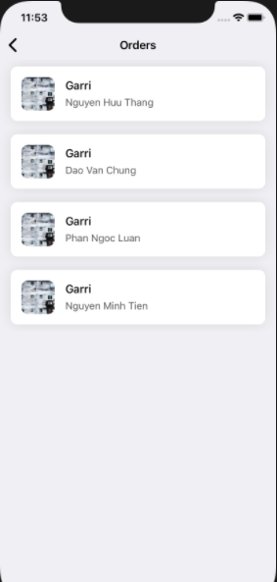
Image 8 : Cart screen

Functional Requirements

Item | Description | Action | Response
MyMobile Cart Screen | MyMobile Cart Interfaces Screen has :  - Dishes Name  - Customer Name | Tap on any oder | Display information about that product

Feature/Component #5: MyMobile Product detail Screen

Product-Detail Interfaces

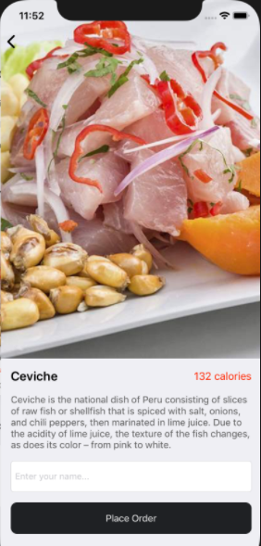
Image 9 : product detail screen

Functional Requirements
Item | Description | Action | Response
MyMobile Product-Detail Screen | MyMobile Product-Detail Interfaces Screen has :  - Dishes images  - Dishes name  - Dishes Price  - Detailed Product Description  - Lable Name Order  - Button Order | Enter customer name  Tap on button Place Oder | Display information about that product  Customer's name will be transferred to the shopping cart

Feature/Component #6: MyMobile Popular Dished Screen

Popular Dished Interfaces
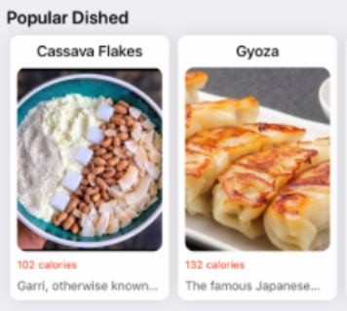
Image 10 : Popular Dished screen

Image 11 : product detail screen

Functional Requirements
Item | Description | Action | Response
MyMobile Popular Dished Screen | - Display information about the most viewed and purchased products | Tap on any product on Popular Dished box | Display information about that product

Feature/Component #6: MyMobile Chef’s Specials Screen

Chef’s Specials Interfaces

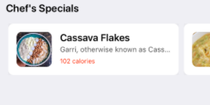
Image 12 : Chef’s Specials screen

Image 13 : product detail screen

Functional Requirements

Item | Description | Action | Response
MyMobile Chef’s Specials Screen | MyMobile Chef’s Specials Screen has :  - List of items that will be sold today | Tap on any product on Chef’s Specials box | Show that product information

2.2 Thiết kế hệ thống
Mục này mô tả SDS của hệ thống

Introduction
This document outlines the requirements for the production and design of "foodie" software for the ios operating system. The product will have 2 main functions: "view" and "order". The user interface will be easy to use and allow users to switch between pages
- Goals and objectives
- The goal of this project is to create an application that competes with existing food selling applications.

- Software context
- The big picture of this project will be to feed anyone who has access to an ios device

Major constraints
- First time should write in swift language, so it's still difficult

Data design

Internal software data structure
The data of each function will mainly be kept separate. Each function will use the most appropriate method to store their data. All data will be stored in function specific variables

Architectural design

Program Structure
Customer after accessing the application. Will be able to view the dishes and order them in the fastest way

Architecture diagram
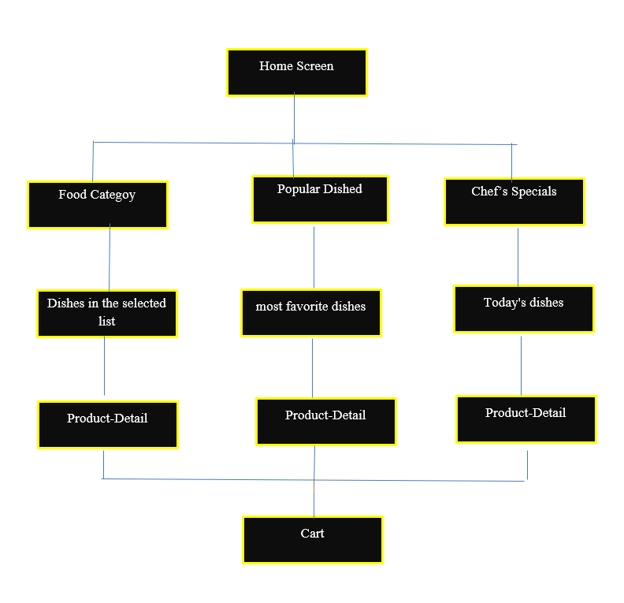

Image 14 : Architecture diagram

Schedule
The development of this program will go through three main cycles. The first cycle is the Documentation Phase, where the Software Design and Requirements Documents are built. These documents will provide the team with a layout for each module and a diagram of how everything works together. The second cycle will be the actual coding of each module (and subroutines). This involves members completing assigned subscreen interfaces. This includes individual submenus, modular design, and modular testing. At the end of this cycle, they expect to have standalone displays ready for system integration. The third and final cycle requires total system integration and testing. During this phase, all screens and function menus are integrated and tested. If time permits, interface improvements and documentation updates can be made in advance during this time.

7.1. Scheduling diagram

ID | Task Name | Start | Finish | Duration
1 | Requirements Doc | 15/4/2021 | 30/4/2021 | 10day
2 | Write SRS | 20/4/2021 | 25/4/2021 | 3 day
3 | Software design | 17/04/2021 | 30/04/2021 | 5 day
4 | Design Onboard | 3/5/2021 | 4/5/2021 | 5 hour
5 | Design Home Screen | 3/5/2021 | 5/5/2021 | 1 day
6 | Design Food Category Screen | 4/5/2021 | 7/5/2021 | 1 day
7 | Design Product detail Screen | 4/5/2021 | 7/5/2021 | 2 day
8 | Design Popular Dished Screen | 4/5/2021 | 7/5/2021 | 1 day
9 | Design Chef’s Specials Screen | 4/5/2021 | 7/5/2021 | 1day
10 | Design Cart Screen | 4/5/2021 | 10/5/2021 | 2 day
11 | Check out the design screens | 11/5/2021 | 20/5/2021 | 5 day
12 | connect to firebase | 20/5/2021 | 15/6/2021 | 15 day
13 | Input datas | 15/6/2021 | 16/6/2021 | 1 hour
14 | write SDS | 15/6/2021 | 20/6/2021 | 5 day
15 | Demo application and fix error | 20/6/2021 | 26/6/2021 | 6 day

Definition of milestones

8.1. Requirements Doc

receive relevant documents , and read and understand it in the time allotted

8.2. Software design

- Plan time, analyze and design the interface for the application according to the requirements of srs

Component-level design
- Our system is based on a main menu through which individual pages can be accessed.

9.1 Description for Onboard Screen
- Display the store's maxim, increasing the customer's eye-catching when entering the application

9.2. Processing narrative for Onboard Screen
- After entering the application, the customer will see the application introduction screen.
- The user can press “next” to go to the next screen, until the start button “Get Started”

Image15: First Screen

Image 16: onboard Screen

.
Image 17: onboard Screen

Image18: onboard screen 3

  - Description for Home Screen

- MyMobile Home Screen has:
- Name shop: The name of the app
- FoodCategory: Display the food items in the shop. When Tap on the Category box on the screen it show the foods of that category
- Popular Dished: Show the dishes with the most views and orders. When tap on the dish in the popular dishes box, Show that product information
- Chef’s Specials: Display the special dishes that the shop has for sale today. When Tap on the dish in the Chef’s Specials box, show that product information
- Cart: Contains customer orders. When tap cart lable on the home screen, displays a list of orders that have been placed

Image19 : home screen

  - Description for Food Category
- Food Category has:
- Name of the type foods: Display the food items in the shop. When tap on the Category box on the screen it show the foods of that category.
- List of dishes: Display the list of dishes of the selected dish type. When selecting a dish, the details of that dish will be displayed.
Image 20 : Food Category
Image 21 : screen vegetarian dishes

  - Description for product -detail 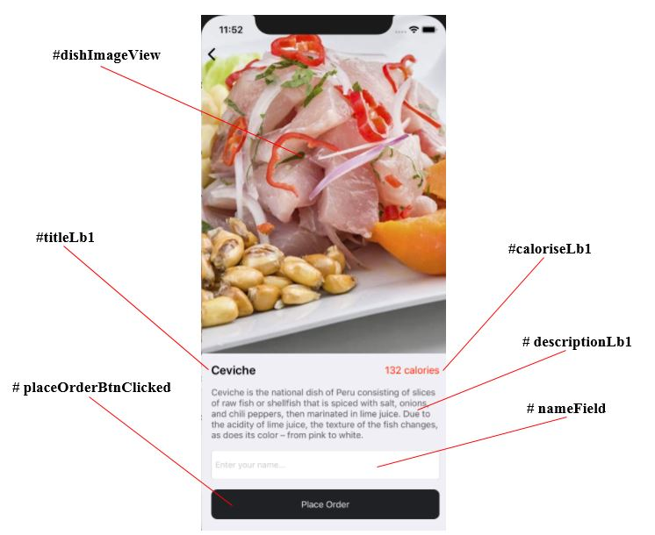

Image 22 : Product-detail

Description: Product name(titleLb1) + Product prices(caloriseLb1) + Product description(descriptionLb1)
Confirmation function: Customer name (nameField) + Confirm button(placeOrderBtnClicked)

#Description:
Product name: Help you know about the name of the dish you clicked on.
Product prices: Help you know about the price of the food that we are selling. Product description: Help you better understand the food you are watching in a close looking and easy to understand way.

#Tutorial to order:
You just need to enter your name in the Customer namer  click on Place Order  Your dish will be added Order List.

  - Description for Popular Dished Screen

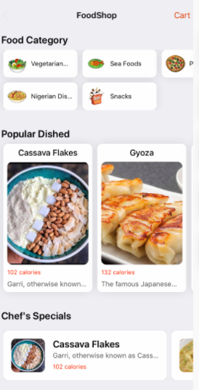

Image 23 : Home Screen

+ Show full information : Popular dish category , Price , Dish Name , Dish Details Image , Use horizontal scroll bar to view more dishes .II. Phân tích giao diện
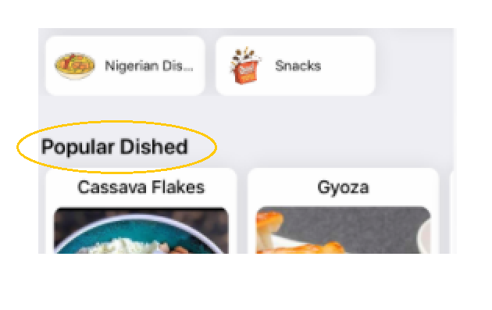

Image 24 : Popular Dished

+ Popular Dished is a type of dish in 2 categories Special and Popular of the software, Popular Dished is a popular dish and with a stable price and a number of regular buyers, it should be listed on the list of popular dishes. Out .
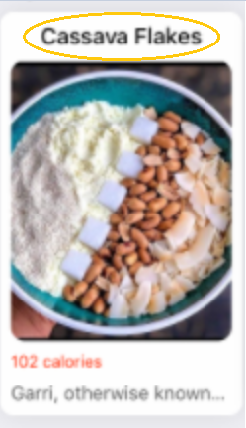

Image 25 : Name Dished

+ Cassava Flakes is the name of the dish .
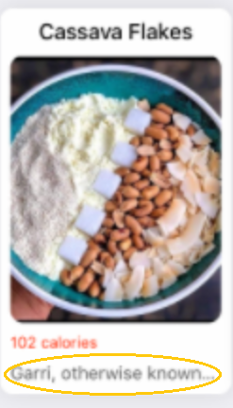

Image 26 : detailed description Dished

+ The above is the product details you can click on this category to see full information as well as the price of this dish.
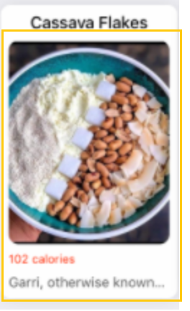

+ This section is Collectionviewcellclick for customers to select to see more details about the product as well as place an order..
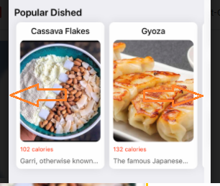
+ You can use the mouse pointer in the arrow direction to activate the scroll bar and see more dishes nhiều .

  - Description for Chef’s Specials Screen
- MyMobile Chef’s Specials Screen has :
- List of items that will be sold today . When Tap on any product on Chef’s Specials box . Result show that product information

  - Description for Cart Screen

· Functional Requirements
Item | Description | Action | Response
"Enter name" TextInput | Used to enter the username, if not entered, the message "Please enter information" | Enter a name | The name will be displayed in TextInput
"Place Order" Button | Used to transfer information "user name", "dish name" and display it on the list order page | Tap to switch pages | Switch to the Order screen

- Order Interface:

· Functional Requirements
Item | Description | Action | Response
"Username" Label | Used for display | display | Show the user name that just ordered the item
"Name " Label | Used for display | display | Show The name of the ordered item
“Food photos”ImageView | Used for display | display | Show a picture of the item you just ordered
"Dish Information" Button | Used to switch to the dish details screen | Tap | Go to the dish details screen

CHƯƠNG 3. CÀI ĐẶT VÀ KIỂM THỬ

3.1 Cài đặt
Mô tả cách thức hiện thực hoá cho từng Activity, Service… của hệ thống

3.2 Kiểm thử

Test Case product- detail

Title | Area | Steps | Expected Results | Results
dishImageView | Dish Detail View Controller | N/A | Hiển thị hình ảnh | PASS
titleLb1 | Dish Detail View Controller | N/A | Display title / product name | PASS
caloriseLb1 | Dish Detail View Controller | N/A | Display product prices | PASS
descriptionLb1 | Dish Detail View Controller | N/A | Display product description | PASS
nameField | Dish Detail View Controller | Click on nameField   Enter customer name | Customer name | PASS
placeOrderBtnClicked (Place Order) | Dish Detail View Controller | Enter customer name + click on Place Order | Navigate to Order List. | PASS

CHƯƠNG 4. KẾT QUẢ ĐẠT ĐƯỢC

4.1 Kết quả đạt được
When you click on the app icon, the app will appear a welcome screen with the app icon and name
After that, The system will display the onboarding screen to briefly introduce the application, there are a total of 3 onboarding screens

At the bottom of the screen, show the next button so that the user can go to the next onboard screen, when reaching the 3rd onboard screen, the “next” button will become the “button”, clicking the get started button will go to the main screen of the app.
at the main screen, showing 3 views in order from top to bottom, list of dishes, popular dishes and special dishes. The title of this screen is FoodShop, with a label cart in the upper right corner.
When clicking on any dish category, the system will lead to a page displaying all the dishes in that category
The dishes in the list will be displayed as TableViewCell with photo, name and a small description. Click on any TableViewCell, the system will take the user to the detail screen of that dish.
The detail screen shows the full content of the selected dish, full size photo, name, full description, price.
The detail screen shows the full content of the selected dish, large image, name, full description, price, the bottom of the screen will have an input field and a Place order button, the user will enter the name in the field. input and click the place order button, the system will save the dish information in that detail screen and the user information into firebase, then display the order list on the cart screen.
The cart screen displays the list of orders placed in the form of TableViewCell, 1 TableViewCell will display the image of the dish, the name of the item and the name of the orderer, clicking on any order will lead the user to the item's detail page eat in that order.
In the view of popular dishes, the system will display the dishes that are popular in the app as a collection view, dish information will be displayed including name, photo, price and a small description.
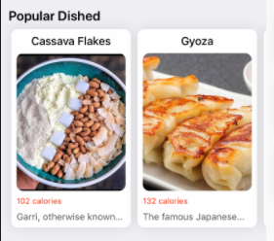
Select on any item will lead the user to the detail screen of that dish.
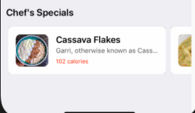
In the view of special dishes, the system will display special dishes in the app as a collection view cell, dish information will be displayed including name, photo, price and a small description, Select on any item will lead the user to the detail screen of that dish.

4.2 Các kết luận và kiến nghị
- Những điểm đã làm được
- Những điểm chưa làm được
- Các chức năng bổ sung nếu có thêm thời gian…

PHỤ LỤC

TÀI LIỆU THAM KHẢO

