

**DMS Renovation**

**Software Requirement Specification**

**Project Code: DMS1**

**Document Code: DMS1_SRS_DefectManagement_v1.0**

**Ho Chi Minh, May 2014**

**RECORD OF CHANGE**

*A - Added M - Modified D - Deleted

|  |  |  |  |  |
| --- | --- | --- | --- | --- |
| **Effective Date** | **Changed Items** | **A* M, D** | **Change Description** | **New Version** |
| 01-May-14 | First release | A |  | 1.0 |
|  |  |  |  |  |
|  |  |  |  |  |
|  |  |  |  |  |
|  |  |  |  |  |
|  |  |  |  |  |
|  |  |  |  |  |
|  |  |  |  |  |
|  |  |  |  |  |
|  |  |  |  |  |
|  |  |  |  |  |
|  |  |  |  |  |
|  |  |  |  |  |

**SIGNATURE PAGE**

|  |  |  |
| --- | --- | --- |
| **ORIGINATOR:** | Vo Quoc Bao | 01-May-14 |
| **REVIEWERS:** |  |  |
| **APPROVAL:** |  |  |

# TABLE OF CONTENT

TABLE OF CONTENT 4

1. DEFECT MANAGEMENT 5
   1. Add Defect 5
   2. Attachment screen 12
   3. Defect List screen 17
   4. Defect View Or Edit screen 24
   5. Batch Update Defect screen 31
   6. Export Defect 34
   7. Defect lifecycle 37
2. OTHERS REQUIREMENT 39
   1. Header of page 39
   2. Data Format 41
   3. Order of reference data 41
   4. Timeout requirement 47

# DEFECT MANAGEMENT

Defect management is the heart of DMS. It contains following functionalities:

* + Add Defect
  + Attachment
  + Defect List
  + Defect View Or Edit
  + Batch Update Defect
  + Export Defect

## Add Defect

### Overview

This screen is used to add new defect to DMS

### Actors

All project members can add defect to DMS

### Use-case diagrams



Add Defect

Permitted user

### Pre-condition

User must be logged in

### Post-condition

New defect was added into database.

### Triggers

* + - * + De the “Add New” button on the Defect View or Edit screen
        + Go to menu Manage Defect from page header of any page, click on the hyper-link “New Defect”

### Workflows

|  |  |  |
| --- | --- | --- |
| **Scenario** | **Actor** | **System** |
| 1. User successfully add new defect | 1.1. Go to this screen | 1.2. Display “Add defect” screen. |
| 1.3 At any time, user can attach file by clicking “Attach file” button  Attachment is optional | 1.4 Submit to “Attach file” screen.  After user attached file, return to “Add new defect” screen with current status and values of all fields and control except change in attachment area. |
| 1.5 Fill in mandatory fields and optional fields (not required) and click “Save” button | 1.6 Validate mandatory fields and valid format.  All fields are valid, new defect will be saved into database and continue to display “Add defect” screen for the next new defect |
| 2. User inputs invalid data | 2.1 Refer to step 1.1 | 2.2 Refer to step 1.2 |
| 2.3 Refer to step 1.3 | 2.4 Validate mandatory fields and valid format  If there are still errors, dialog error messages of invalid fields will be displayed at the center of screen |

* + 1. **External interfaces**
       1. **Prototype:**

Add Defect

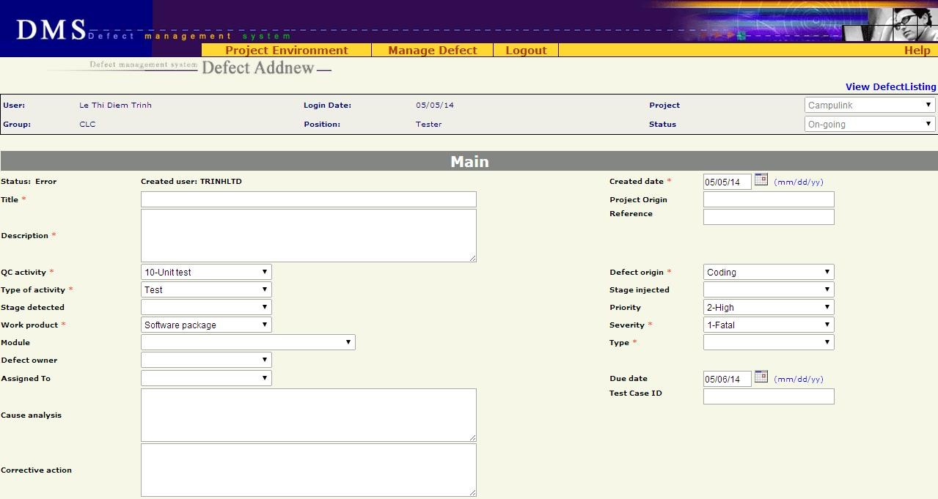

Button



Attachment

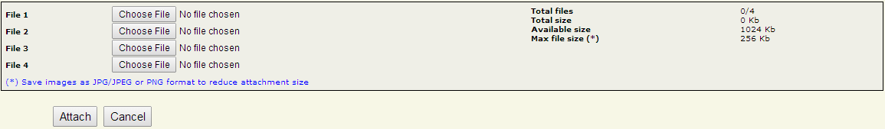

### Screen description

|  |  |  |  |  |  |  |
| --- | --- | --- | --- | --- | --- | --- |
| **No** | **Field name** | **Control type** | **Required** | **Data type** | **Default value** | **Description** |
| **Defect detail** | | | | | | |
| 1 | Status | Label | Yes | Text | Error | Status of the defect. |
| 2 | Created user | Label | Yes | Text | Logged- in user | Member who created the defect and all other members of project |

|  |  |  |  |  |  |  |
| --- | --- | --- | --- | --- | --- | --- |
| 3 | Created Date | Text field | Yes | Date | Today | Date when the defect was recorded in DMS  Date format mm/dd/yy |
| 4 | Title | Text field | Yes | Text | Blank | A short & brief description of the defect for quick recognition  Maximal 150 characters |
| 5 | Project Origin | Text field | No | Text | Blank | Maximal 50 characters |
| 6 | Description | Text area | Yes | Text | Blank | Full description of the defect, often the steps to reproduce the defect |
| 7 | Reference | Text field | No | Text | Blank | Maximal 30 characters |
| 8 | QC Activity | Combo box | Yes | Text | 10-Unit test | QC activity in which the defect is found |
| 9 | Defect Origin | Combo box | Yes | Text | Coding | Process of defect |
| 10 | Type of activity | Combo box | Yes | Text | Test | Defect type of current project |
| 11 | Stage Injected | Combo box | No | Text | Blank | Stage injected of current project |
| 12 | Stage Detected | Combo box | No | Text | Blank | Stage detected of current project |
| 13 | Priority | Combo box | No | Text | 2-High | Indicate how urgent the defect needs to be fixed |
| 14 | Work Product | Combo box | Yes | Text | Software package | Work product in which the defect is found. It is high level CI |

|  |  |  |  |  |  |  |
| --- | --- | --- | --- | --- | --- | --- |
| 15 | Severity | Combo box | Yes | Text | 1-Fatal | Severity of defects in current project |
| 16 | Module | Combo box | No | Text | Blank | Module of defect in current project |
| 17 | Type | Combo box | Yes | Text | Blank | Type of defect |
| 18 | Defect Owner | Combo box | No | Text | Blank | List all members of the project. |
| 19 | Assigned To | Combo box | No | Text | Blank | List all members of the project. |
| 20 | Due Date | Text field | No | Date | Today+1 | Deadline of defect fixing. Date format mm/dd/yy |
| 21 | Cause Analysis | Text area | No | Text | Blank | Description of the cause of defect |
| 22 | Test Case ID | Text field | No | Text | Blank | ID of test case in which the defect was found  Maximal 50 characters |
| 23 | Corrective Action | Text area | No | Text | Blank | Actions/steps to correct the defect |
| **Button** | | | | | | |
| 24 | Save | Button | Yes | N/A | N/A | Save new defect to database and go to “Add Defect” screen |
| 25 | Defect List | Button | Yes | N/A | N/A | Return to “Defect List” screen corresponding to previous  selected query (All defects / All Open Defects / All Leakage |

|  |  |  |  |  |  |  |
| --- | --- | --- | --- | --- | --- | --- |
|  |  |  |  |  |  | Defects / Public or Private Query) |
| 26 | Attach file | Button | Yes | N/A | N/A | Go to “Attach file” screen |

* + 1. **Business descriptions**

|  |  |  |  |
| --- | --- | --- | --- |
| **No** | **Name** | **Control Type** | **Description** |
| **Defect detail** | | | |
| 1 | QC Activity | Combo box | When “QC Activity” changes, appropriate values of “Type of Activity” will be automatically generated |
| 2 | Type of Activity | Combo box | This information won’t be inputted by user.  System will add Type of Activity information according to QC Activity |
| 3 | Stage Detected - Injected | Combo box | Information of 2 stages will come from FI accordant to “today” |
| 4 | Priority | Combo box | Priority of defect |
| 5 | Work Product | Combo box | Work product in project |
| 6 | Severity | Combo box | Severity of defect |
| 7 | Module | Combo box | Available values are automatically got from another Project management tool  From this available values, list all appropriate “Modules” of “Work Product” |
| 8 | Type | Combo | List all defect types of system |

|  |  |  |  |
| --- | --- | --- | --- |
|  |  | box |  |
| 9 | Created user | Combo box | User can choose any member of project |
| 10 | Assigned to | Combo box | User can choose any member of project |
| 11 | Defect Owner | Combo box | User can choose any member of project |
| 12 | Defect ID | Text | This number is automatically generated whenever a new defect is added. Defect ID counter will not be reset. |
| 13 | Re-opened | N/A | This property is not displayed in screen. It will be automatically set to 0 each time a new defect is created. |
| 14 | Translation status | Hidden | Available values are: Not translated, Translated, Reviewed  This field is automatically set to “Not translated” whenever a new defect is created |
| 15 | Due Date | Text | Default value is today + 1 |
| 16 | Defect Title | Text | Focus on Defect Title item at the first load |
| **Button** | | | |
| 17 | Defect list | Button | Return to “List Defect” screen of previous chosen query (All Defects, All Open Defects, …) |
| 18 | Attach file | Button | Go to attachment screen |

* + 1. **User-validation rules**

|  |  |  |
| --- | --- | --- |
| **No** | **Validation rule** | **Message Code** |

|  |  |  |
| --- | --- | --- |
| 1 | Combo box is required | ERR_REQUIRED_QC_ACTIVITY ERR_REQUIRED_ORIGIN ERR_REQUIRED_TYPE_ACTIVITY ERR_REQUIRED_WP ERR_REQUIRED_SEVERITY  ERR_REQUIRED_TYPE |
| 2 | Date format mm/dd/yy | ERR_FORMAT_DATE_CREATED ERR_FORMAT_DATE_DUE |
| 3 | Text field/text area is required | ERR_REQUIRED_CREATED_DATE ERR_REQUIRED_TITLE  ERR_REQUIRED_DESCRIPTION |
| 4 | Created date is greater than current date | ERR_CONSTRAINT_DATE_CREATED_TODAY |
| 5 | Created date is greater than Due Date | ERR_CONSTRAINT_DATE_CREATED_DUE |
| 6 | Length of input fields are over limitation | No message, auto trim string |

* + 1. **Related use-cases**
* List defect
* Attach file

## Attachment screen

### Overview

This function is described for the updating/attaching some files to a defect while user creates a new defect or updates an existing defect. In this screen, user will

have information on attachments of the defect, including: total number of attached file(s), total size of attached file(s) and available size for next attachment.

### Actors

All users who have permission to attach files to a defect.

### Use – case diagram



«uses»

Attach file

Calculate volumn remained

Permitted user

* + - 1. ***Pre-condition***
* The actor has successfully logged into the system.
* There’s enough available space for attachment
  + - 1. ***Post-condition***

N/A

* + - 1. ***Triggers***

From Add Defect, Defect View Or Edit screen, user clicks on the Attach file button to view Attach files screen.

### Workflows

* + - 1. ***Scenario 1 – Valid Attachment***

|  |  |
| --- | --- |
| **Actor** | **System** |
| 1. From Add Defect, Defect View Or Edit screen, user clicks on the  **Attach File** button | 2. Display Attach files screen |
| 3. User choose some files by  clicking on the Choose file button to open Choose File dialog |  |
| 4. After choosing file, User clicks on **Attach** button | 5. Validate all inputs  - If all inputs are valid  ➔ Upload files to server and display Upload Attachment Result screen with successful message |
| 6. On Upload Attachment result screen, user clicks on **Done**  button. | 7. Return to the Add Defect, Defect View Or Edit screen |

* + - 1. ***Scenario 2 – Invalid Attachment***

|  |  |
| --- | --- |
| **Actor** | **System** |
| Step 1, 2, 3 – refer to scenario 1 | |
| Step 4 – refer to scenario 1 | 5. Validate all inputs  - If any input is invalid  ➔ Go to Upload Attachment Result screen with fail message |
| 6. On Upload Attachment result screen, user clicks on **Done** button. | 7. Return to the Add Defect, Defect View Or Edit screen |

* + 1. **External interfaces**
       1. ***Prototype***

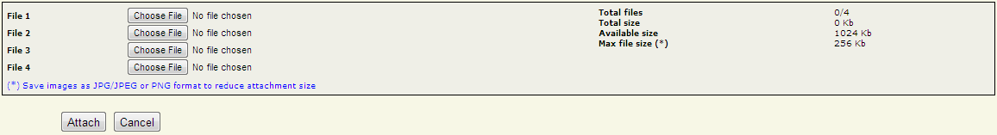

**Figure: Attach file screen**



**Figure: Upload attachment result screen**

* + - 1. ***Screen Description***

This function uses two screens: Upload Attachment screen, Upload Attachment result screen

* + - * 1. ***Attach file screen***

|  |  |  |  |  |  |  |
| --- | --- | --- | --- | --- | --- | --- |
| **No** | **Field name** | **Control type** | **Data type** | **Default Value** | **Require** | **Functional Description/(*) Tool tip** |
| 1 | File X | Label Area | Text | Blank | Yes | There are always 4 file browsing item in this screen |
| 2 | Total files, Total size, Available Size, Max file size (*) | Label Area | Text | N/A | Yes | Information includes:   * Total uploaded files, * Total size of attached files * Available size for next attachment * Maximum uploaded file |

|  |  |  |  |  |  |  |
| --- | --- | --- | --- | --- | --- | --- |
|  |  |  |  |  |  | size |
| 3 | Attach | Button | Control | N/A | Yes | Upload the chosen file(s) to server. |
| 4 | Cancel | Button | Control | N/A | Yes | Reset and close the dialog to return to Add Defect,  Defect View Or Edit screen |

* + - * 1. ***Upload Attachment result screen***

|  |  |  |  |  |
| --- | --- | --- | --- | --- |
| **No** | **Field name** | **Control type** | **Data type** | **Functional Description/(*) Tool tip** |
| 1 | File(s) attached successfully | Label Area | Text | Incase success when attaching file   * New files = number of attached file * New size = Total size of attached files * Total files = <number attached file>/4 * Total size = Total size (old & new) Kb * Available size = <1024 – Total size> Kb |
| 1 | Attach failed due to error | Label Area | Text | Incase fail when attaching file   * New files = 0 * New size = 0 Kb * Total files = 0/4 * Total size = 0 Kb * Available size = 1024 Kb |
| 2 | Done | Button | Control | Return to Add Defect, Defect View Or Edit screen with the new attachment list |

* + 1. **Business Description**
       1. ***Upload Attachment screen***

|  |  |  |
| --- | --- | --- |
| **No** | **Name** | **Business rules** |
| 1 | Upload/ Attachment screen  **General constraints** | * Limitation for file size = 256 Kb * Limitation for number of file = 4 * Total size of all attachments doesn’t exceed 1024 Kb * To reduce size of attachment, save images as JPG, JPEG or PNG format * In addition, attachment can be any format such as   .doc, .xls, .txt, .zip, .rar… |

|  |  |  |
| --- | --- | --- |
| **No** | **Name** | **Business rules** |

|  |  |  |
| --- | --- | --- |
| **No** | **Name** | **Business rules** |
| 1 | From Add Defect, Defect View Or Edit screen, user clicks on **Attach File** button. | Display Upload Attachment screen ➔ open Choose file dialog to browse the required file to attach |
| 2 | In Upload Attachment screen: User clicks on **Cancel** button | Reset and close the dialog to return to Add Defect, Defect View Or Edit screen |
| 3 | - User clicks on **Attach** button - If all the file paths are valid, the file size is not bigger than the limitation of attachment for a defect and the available space is enough  ➔ The chosen file(s) uploaded to server. If upload run successfully  ➔ Display **Upload Attachment screen – result** | |
| 4 | File name | File name of the attachment must be different to old attachments’ name |

* + - 1. ***Upload Attachment result screen***
* **Control area**

|  |  |  |
| --- | --- | --- |
| **No** | **Name** | **Business rules** |
| 1 | User clicks on **Done**  button | Return to Add Defect, Defect View Or Edit screen with the new attachment list |

* + 1. **User validation rules**

|  |  |  |
| --- | --- | --- |
| **No** | **Error type** | **Message Code** |
| 1 | user did not select any file for  attachment when clicking Attach button | ERR_REQUIRED_ATTACHMENT_FILE |
| 2 | Total size is over the limitation (1024 Kb) | ERR_FILE_OVER_AVAILABLE_SIZE |
| 3 | file size is over the limitation (256 Kb) | ERR_FILE_OVER_MAX_FILE_SIZE |
| 4 | File name is same to old attachment’s name in the project | ERR_EXISTED_FILE_NAME |

* + 1. **Related use-cases**
* Defect View Or Edit
* Add new Defect

## Defect List screen

### Overview

This screen displays a list of defects matching a previously chosen query and specific search criteria if filter was applied.

### Actors

All users can view defect list

### Use-case diagram



List Defect

Permitted User

### Pre-condition

User must be logged-in.

### Post-condition

List of suitable defects was displayed.

### Triggers

* User selects a query of listing in homepage
* User clicks Defect List button in Add Defect and Update Defect screens

### Workflows

* + - 1. **Scenario 1 (Fixed Query - Filter)**

|  |  |
| --- | --- |
| **Actor** | **System** |
| 1. User click on a fixed query (All Defects, All Open Defects, All Leakage Defects) | 1. The corresponding list defect is displayed with the set of criteria as follows:    * Defect Owner    * Status |

|  |  |
| --- | --- |
|  | * Module Code * Assigned To * Severity * Type * Created By * Reference * Defect Origin * Stage Detected * Stage Injected * QC Activity * Created From * Created To * Work Product * Fixed From * Fixed To * Priority * DefectID * Test Case ID * Title |
| 3. User enters information related to searching defects in the **Filter** section. |  |
| 4. User click on the button “Search” | 5. The corresponding list defect is displayed on a table |

* + 1. **GUI**
       1. **Prototype**

Filter:

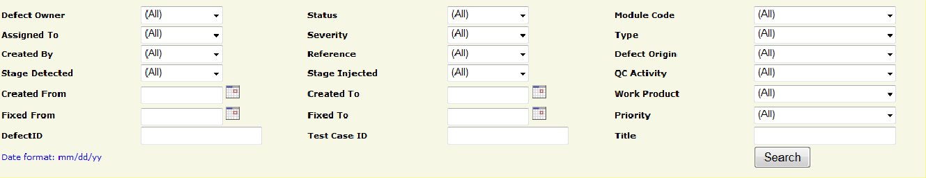

List defects:

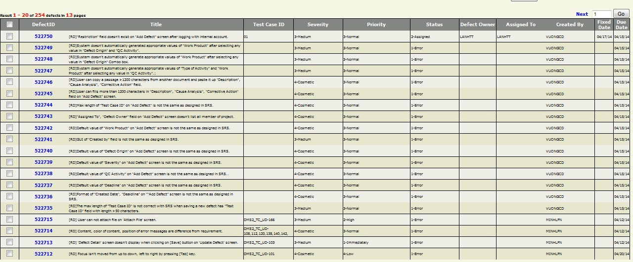

Control area:

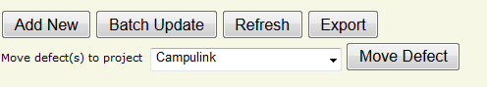

### Screen Description

* + - * 1. **Zone 1 - filter**

|  |  |  |  |  |  |  |
| --- | --- | --- | --- | --- | --- | --- |
| **No** | **Field Name** | **Control Type** | **Data Type** | **Defaul t Value** | **Require d** | **Functional Description/(*)ToolTip** |
| 1 | Defect Owner | Combo box | Text | All | No | Owner of defects searching. List all members of the project. Besides, it has 2 more items: (All) and None |
| 2 | Status | Combo box | Text | All | No | Status of defect. Depend on project model. Besides, it has 1 more item: (All) |
| 3 | Module Code | Combo box | Text | All | No | Module which contain defects user wants to search. Besides, it has 2 more items: (All) and (None) |
| 4 | Assigned To | Combo box | Text | All | No | List of all members of the project. Besides, it has 2 more items: (All) and (None) |
| 5 | Severity | Combo box | Text | All | No | Severity of defects in current  project, similar to current DMS values. Besides, it has 1 more |

|  |  |  |  |  |  |  |
| --- | --- | --- | --- | --- | --- | --- |
|  |  |  |  |  |  | item: (All) |
| 6 | Type | Combo box | Text | All | No | Defect type of the defects searching, similar to current DMS values.  Besides, it has 1 more item: (All) |
| 7 | Created By | Combo box | Text | All | No | Member who creates the defect is selected in the list of all members of the project... Besides, it has 2 more items: (All) |
| 8 | Reference | Combo box | Text | All | No |  |
| 9 | Defect Origin | Combo box | Text | All | No | Indicates the actual process that caused the defect, similar to current DMS values.  Besides, it has 1 more item: (All) |
| 10 | Stage Detected | Combo box | Text | All | No | Stage of project when defect is detected |
| 11 | Stage Injected | Combo box | Text | All | No | Stage of project when defect is resolved |
| 12 | QC Activity | Combo box | Text | All | No | QC Activity of defects searching, similar to current DMS values.  Besides, it has 1 more item: (All) |
| 13 | Created From | Text field | Date | Blank | No | Minimal creation date of the defects searching  Current date format of project |
| 14 | Created To | Text field | Date | Blank | No | Maximal creation date of the defects searching  Current date format of project |
| 15 | Work Product | Combo box | Text | All | No | Work Product in which found the defects, similar to current DMS values.  Besides, it has 1 more item: (All) |
| 16 | Fixed From | Text field | Date | Blank | No | Minimal fixed date of the defects searching  Current date format of project |
| 17 | Fixed To | Text field | Date | Blank | No | Maximal fixed date of the defects searching  Current date format of project |

|  |  |  |  |  |  |  |
| --- | --- | --- | --- | --- | --- | --- |
| 18 | Priority | Combo box | Text | All | No | List priority that the defect need to be resolved. Besides, it has 2 more items: (All) and None |
| 19 | Defect ID | Text field | Text | Blank | No | The beginning value that the defects searching contains |
| 20 | Test Case ID | Text field | Text | Blank | No | The Test Case ID which found the defects |
| 21 | Title | Text field | Text | Blank | No | The title that defects searching contains |
| 22 | Search | Button | Contr ol |  | No | Button allows user to search defects by selected criteria |
| 23 | Date format | Text | Text | mm/dd/ yy | Yes | Date format of displayed date value |

* + - * 1. **Zone 2 - Paging area**

|  |  |  |  |  |  |  |
| --- | --- | --- | --- | --- | --- | --- |
| **No** | **Field name** | **Control Type** | **Data Type** | **Default Value** | **Required** | **Functional Description/(*)ToolTip** |
| 1 | Go | Button |  |  |  | Go to selected page in paging mode |
| 2 | Selected page | Text field | Text | 1 | Yes | Selected page value in paging mode |
| 3 | Prev | Link | Image |  |  | Go to previous page in paging |
| 4 | Next | Link | Image |  |  | Go to next page in paging |

* + - * 1. **Zone 3 – Defects listing area**

|  |  |  |  |  |  |  |
| --- | --- | --- | --- | --- | --- | --- |
| **No** | **Field Name** | **Control Type** | **Data Type** | **Default Value** | **Required** | **Functional Description/ (*)ToolTip** |
| 1 | Check | Check box | Boolean | False | No | Selected defects will be used for batch update functionality |
| 2 | Defect ID | Link | Text |  | No | Link to “Defect View Or Edit” page |
| 3 | Title | Text | Text |  | No | Short description of content of defect |
| 4 | Test Case  ID | Text | Text |  | No | ID of test case that found the defect |
| 5 | Severity | Text | Text |  | No | Severity of defect |
| 6 | Priority | Text | Text |  | No | Priority of defect |

|  |  |  |  |  |  |  |
| --- | --- | --- | --- | --- | --- | --- |
| 7 | Status | Text | Text |  | No | Status of defect |
| 8 | Defect  owner | Text | Text |  | No | Owner of defect |
| 9 | Assigned  To | Text | Text |  | No | Who is assigned to fix defect |
| 10 | Created By | Text | Text |  | No | Who created defect |
| 11 | Fixed Date | Text | Date |  | No | Date when defect was fixed  Current date format of project |
| 12 | Due Date | Text | Date |  | No | Deadline for defect fixing  Current date format of project |

* + - * 1. **Zone 4 – Control area**

|  |  |  |  |  |  |  |
| --- | --- | --- | --- | --- | --- | --- |
| **No** | **Field Name** | **Control Type** | **Data Type** | **Default Value** | **Required** | **Functional Description/(*)ToolTip** |
| 1 | Add New | Button | Text | N/A | N/A | Link to create new defect page |
| 2 | Batch  Update | Button | Text | N/A | N/A | Submit selected defects to batch update page |
| 3 | Refresh | Button | Text | N/A | N/A | Refresh the page |
| 4 | Export | Button | Text | N/A | N/A | Permit user to export defects to excel file |
| 5 | Move  defect(s) to project | Combo box | Text | N/A | N/A | Destination projects for moving defects |
| 6 | Move Defect | Button | Text | N/A | N/A | Permit QA to move defects to selected project (visible with QA only) |

* + 1. **Business description**
       1. **Zone 1 - Filter**

|  |  |  |
| --- | --- | --- |
| **No** | **Field Name** | **Business Rules** |
| 1 | Assigned To, Created By, Defect Owner | - Combo box contains all users assigned to the project |
| 2 | Status | - Combo box contains a list of defect status |

|  |  |  |
| --- | --- | --- |
| 3 | Severity | - Combo box contains a list of defect severity values |
| 4 | Module Code | * Combo box “Module Code” contains a list of module code values * At the first load, Module code combo box contains all modules |
| 5 | QC Activity | - Combo box contains a list of QC Activity values |
| 7 | Priority | - Combo box Priority contains a list of Priority values |
| 9 | Type | - Combo box contains a list of defect type values |
| 10 | Defect Origin | - Combo box contains a list of Origin values |
| 12 | Work Product | - Combo box contains a list of Work Product values |
| 13 | DefectID | - Search all defects that begin with inputted value |
| 14 | Defect Owner | - Combo box contains all members of the selected project |
| 16 | Title | Search all defects which have relative value with inputted value |
| 17 | Test Case ID | Search relative value |

* + - 1. **Zone 2 – Defects listing area**

|  |  |  |
| --- | --- | --- |
| **No** | **Field Name** | **Business Rules** |
| 1 | Check | * Used for “Batch Update” * If user clicks the check icon on the header row, all check boxes will be checked |
| 2 | DefectID | * Link to “Defect View Or Edit” page * Refer to use-case “Defect View Or Edit” * If user clicks the icon “DefectID” on the header row , all values of the result table will be sorted by this field |
| 3 | Title | - If user clicks the icon “Title” on the header row , all values of the result table will be sorted by this field |
| 4 | Test Case ID | - If user clicks the icon “Test Case ID” on the header row , all values of the result table will be sorted by this field |
| 5 | Severity | - If user clicks the icon of this field on the header row , all values of the result table will be sorted by this field |
| 6 | Priority |
| 7 | Status |
| 8 | Defect Owner |
| 9 | Assigned To |
| 10 | Created By |
| 11 | Fixed Date |
| 12 | Due Date |

* + 1. **User – validation rules**

|  |  |  |
| --- | --- | --- |
| **No** | **Validation rule** | **Message Code** |
| 1 | Date format mm/dd/yy | ERR_FORMAT_DATE_CREATED_FROM ERR_FORMAT_DATE_CREATED_TO ERR_FORMAT_DATE_FIXED_FROM  ERR_FORMAT_DATE_FIXED_TO |
| 2 | Created From Date > Created To Date | ERR_CONSTRAINT_DATE_CREATED_FROMTO |
| 3 | Fixed From Date > Fixed To Date | ERR_CONSTRAINT_DATE_FIXED_FROMTO |
| 4 | Input data that is characters/specific characters/negative number is filled in “DefectID” | ERR_DEFECT_ID_INVALID |
| 5 | Selected page is out of range or not a positive number | ALT_PAGE_INVALID |
| 6 | No defect is checked to batch update | ALT_REQUIRED_DEFECT |

* + 1. **Related use-cases**
* Add defect
* Defect View Or Edit
* Batch update
* Export defect

## Defect View Or Edit screen

### Overview

With this function, user can update existed defect and save the modification. All members of project can update the defect.

### Actors

All project members can update defect.

### Use-case diagram



Update Defect

Permitted user

### Pre-condition

User must be logged-in the system.

### Post-condition

N/A

### Triggers

* User clicks on Defect ID in defects list screen

### Workflows

|  |  |
| --- | --- |
| **Actor** | **System** |
| 1. Go to “Defect View Or Edit” screen | 2. Display “Defect View Or Edit” screen with all available data fields related to a specific actor  Display current values of defect for user to update |
| 3. Update value of data fields & click “Save” button | 4. Validate data fields  If all fields are valid, defect will be updated in database and go to the page “Defect List” |

* + 1. **External interfaces**
       1. **Prototype**

Defect View Or Edit

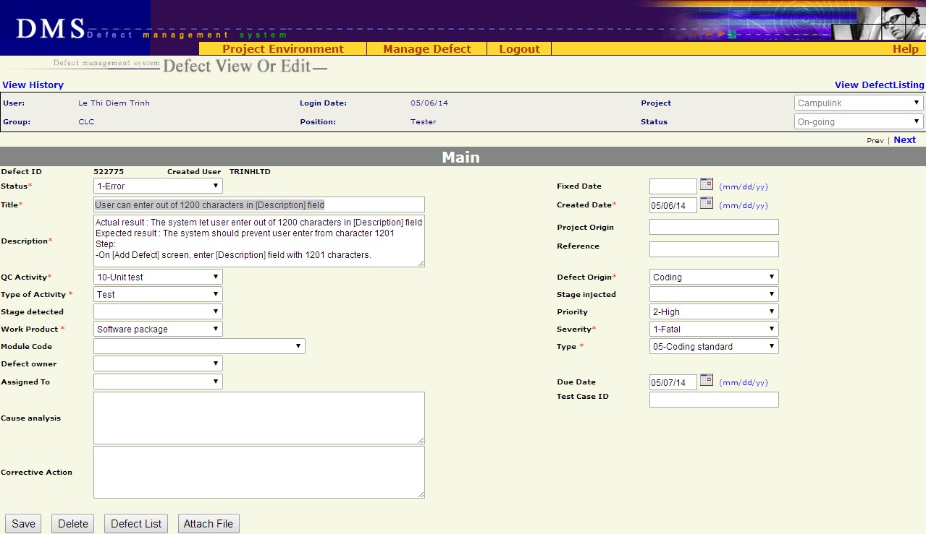

### Screen descriptions

|  |  |  |  |  |  |  |
| --- | --- | --- | --- | --- | --- | --- |
| **No** | **Field name** | **Control Type** | **Required** | **Data type** | **Default value** | **Description** |
| **Defect detail** | | | | | | |
| 1 | Status | Label | Yes | Text | Current Value | Status of the defect. |
| 2 | Fixed Date | Text field | No | Date | Blank | Date when the defect was fixed  Date format mm/dd/yy |
| 3 | Title | Text field | Yes | Text | Current Value | A short & brief description of the defect for quick recognition |
| 4 | Created Date | Text field | Yes | Date | Current Value | Date when the defect was recorded in DMS  Date format mm/dd/yy |

|  |  |  |  |  |  |  |
| --- | --- | --- | --- | --- | --- | --- |
| 5 | Description | Text area | Yes | Text | Current Value | Full description of the defect, often the steps to reproduce the defect |
| 6 | Project Origin | Text field | No | Text | Current Value |  |
| 7 | Reference | Text field | No | Text | Current Value |  |
| 8 | QC Activity | Combo box | Yes | Text | Current Value | QC activity in which the defect is found |
| 9 | Defect Origin | Combo box | Yes | Text | Current Value | Process of defect |
| 10 | Type of activity | Combo box | Yes | Text | Current Value | Defect type of current project |
| 11 | Stage Injected | Combo box | No | Text | Current Value | Stage injected of current project |
| 12 | Stage Detected | Combo box | No | Text | Current Value | Stage detected of current project |
| 13 | Priority | Combo box | No | Text | Current Value | Indicate how urgent the defect needs to be fixed |
| 14 | Work Product | Combo box | Yes | Text | Current Value | Work product in which the defect is found. It is high level CI |
| 15 | Severity | Combo box | Yes | Text | Current Value | Severity of defects in current project |
| 16 | Module Code | Combo box | No | Text | Current Value | Module of defect in current project |

|  |  |  |  |  |  |  |
| --- | --- | --- | --- | --- | --- | --- |
| 17 | Type | Combo box | Yes | Text | Current Value | Type of defect |
| 18 | Defect Owner | Combo box | No | Text | Current Value | List all members of the project. |
| 19 | Assigned To | Combo box | No | Text | Current Value | List all members of the project.  If combo box “Assigned To” is chosen, status will be changed to Assigned by system |
| 20 | Due Date | Text field | No | Date | Current Value | Deadline of defect fixing. Date format mm/dd/yy |
| 21 | Cause Analysis | Text area | No | Text | Current Value | Description of the cause of defect |
| 22 | Test Case ID | Text field | No | Text | Current Value | ID of test case in which the defect was found  Maximal 50 characters |
| 23 | Corrective Action | Text area | No | Text | Current Value | Actions/steps to correct the defect |
| **Button** | | | | | | |
| 24 | Save | Button | N/A | N/A | N/A | Save current defect to database and return to “List defect” screen |
| 25 | Delete | Button | N/A | N/A | N/A | Delete current defect |
| 26 | Defect list | Button | N/A | N/A | N/A | Return to “Defect List” screen corresponding to previous selected query (All defects / All  Open Defects / All Leakage Defects / Public or Private |

|  |  |  |  |  |  |  |
| --- | --- | --- | --- | --- | --- | --- |
|  |  |  |  |  |  | Query) |
| 27 | Attach file | Button | N/A | N/A | N/A | Submit the defect to “Attach file” screen |

* + 1. **Business descriptions**

|  |  |  |
| --- | --- | --- |
| **No** | **Name** | **Description** |
| **Defect detail** | | |
| 1 | Assigned To | User can choose any member of project |
| 2 | Module Code | Available values are automatically got from another Project management tool  From this available values, list all appropriated “Modules” of “Work Product” |
| 3 | Type | List all defect types of system |
| 4 | Title | Can be updated by all members of project |
| 5 | Description | Can be updated by all members of project |
| 6 | Defect Owner | List all members of team that are assigned to project |
| 7 | Due Date | Default value is today+1 if there is no value for this field |
| 8 | Title | Focus on Defect Title item at the first load |
| 9 | Corrective Action | If Status is changed to “3-Pending”, “4-Tested”, “5-Accepted” or “6- Cancelled” then “Corrective Action” must be filled. |
| **Button** | | |

|  |  |  |
| --- | --- | --- |
| 10 | Save | Validate all fields  If all fields are valid, save the defect in database and go to “Add Defect” screen. Save all information in Update screen including comment (if any) |
| 11 | Delete | Delete the defect from database and go to “Defect List” screen. |
| 12 | Defect List | Move to “Defect List” screen |
| 13 | Attach file | Only Created user, Assignee and full-right users (PM, PTL, QA) can use this functionality  Submit the defect to “Attach file” screen |

* + 1. **User-Validation rules**

|  |  |  |
| --- | --- | --- |
| **No** | **Validation rule** | **Error message ID** |
| 1 | Combo box is required | ERR_REQUIRED_STATUS ERR_REQUIRED_QC_ACTIVITY ERR_REQUIRED_DEFECT_ORIGIN ERR_REQUIRED_TYPE_ACTIVITY ERR_REQUIRED_WP ERR_REQUIRED_SEVERITY  ERR_REQUIRED_TYPE |
| 2 | Date format mm/dd/yy | ERR_FORMAT_DATE_CREATED  ERR_FORMAT_DATE_FIXED ERR_FORMAT_DATE_DUE |
| 3 | Text field/text area is required | ERR_REQUIRED_TITLE ERR_REQUIRED_CREATED_DATE |

|  |  |  |
| --- | --- | --- |
|  |  | ERR_REQUIRED_DESCRIPTION |
| 4 | Created date is greater than current date | ERR_CONSTRAINT_DATE_CREATED_TODAY |
| 5 | Fixed date is greater than current date | ERR_CONSTRAINT_DATE_FIXED_TODAY |
| 6 | Created date is greater than fixed date | ERR_CONSTRAINT_DATE_CREATED_FIXED |

* + 1. **Related use-cases**
* List defect
* Attach file

## Batch Update Defect screen

### Overview

This function permit user to update concurrently some defects of the same batch. User must select defects from List Defect screen before using Batch Update.

### Actors

All users who have permission on Batch update functionality (defined in RMS)

### Use - case diagram



Batch Update

Permitted user

* + - 1. ***Pre-condition***
* The actor has successfully logged into the system.
* User has selected at least one defect to update
  + - 1. ***Post-condition***

N/A

### Triggers

From List Defect screen, user selects some necessary defects for updating and clicks on Batch Update button.

### Workflows

* + - 1. ***Scenario – Batch update***

|  |  |
| --- | --- |
| **Actor** | **System** |
| 1. From List Defect screen, user selects some necessary defects for updating |  |
| 2. User clicks on **Batch Update** button. | 3. Display Batch Update screen |
| 4. User change some necessary fields of the selected defects |  |
| 5. User clicks on **Save** button | 6. Save all modifications and return to List Defect screen. |

* + 1. **External interfaces**
       1. ***Prototype***

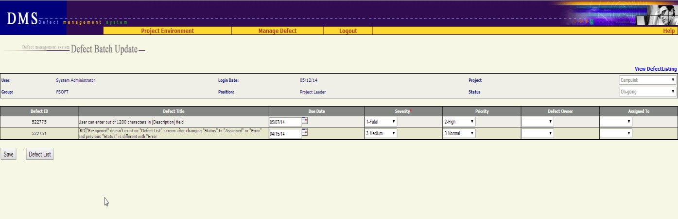

* + - 1. ***Screen Description***

Each defect is listed here with following information:

|  |  |  |  |  |  |  |
| --- | --- | --- | --- | --- | --- | --- |
| **No** | **Field name** | **Control type** | **Data type** | **Default value** | **Require** | **Functional Description/(*) Tool tips** |
| 1 | Defect ID | Label | Text | Copy from  previous | N/A | ID number of defect Cannot be edited |
| 2 | Defect  Title | Label | Text | Copy from  previous | N/A | This is a brief description about defect  Cannot be edited |

|  |  |  |  |  |  |  |
| --- | --- | --- | --- | --- | --- | --- |
| 3 | Due Date | Text box | Text | Copy from previous | No | This is the date on which the defect should be fixed   * Associated with a date picker calendar * format dd/mm/yy |
| 4 | Severity | Combo  box | Text | Copy from  previous | Yes | Severity of defect |
| 5 | Priority | Combo  box | Text | Copy from  previous | No | Priority of defect |
| 6 | Defect  Owner | Combo  box | Text | Copy from  previous | No | This field indicates who is owner of the defect  List all members of the project |
| 7 | Assigned  to | Combo  box | Text | Copy from  previous | No | This field indicates who will be responsible for fixing the defect List all members of the project |

### Business Description

* + - 1. ***Data fields***

|  |  |  |
| --- | --- | --- |
| **No** | **Name** | **Business rules** |
| 1 | Defect Owner | User can assign owner for defect to any member of project |
| 2 | Assigned To | User can assign defect to any member of project |

* + - 1. ***Control area***

|  |  |  |
| --- | --- | --- |
| **No** | **Name** | **Business rules** |
| 1 | From List Defect screen, user clicks on **Batch Update**  button | Go to Batch Update screen with the list of selected defects |
| 2 | At Batch Update screen, user clicks on **Defect List**  button | Return to List Defect screen without saving any thing |
| 3 | User clicks on **Save**  button | Save all changes and return to List Defect screen |

* + 1. **User validation rules**

|  |  |  |
| --- | --- | --- |
| **No** | **Error type** | **Message Code** |

|  |  |  |
| --- | --- | --- |
| 1 | Due date is in invalid format | ERR_FORMAT_DATE_DUE |

* + 1. **Related use-cases**
* Defect List

## Export Defect

### Overview

This screen allows user to export defects list retrieved from “Defect List” screen.

### Actors

All users who has permission on Export functionality

### Use-case diagram



Save Template

Delete Template

Load Template

List all fields

Permitted user

Export Defect

* + - 1. **Pre-condition**

User must be logged-in.

### Post-condition

Defects were exported to a file.

### Triggers

In “Defect List” screen, user click “Export” button.

### Workflow

|  |  |
| --- | --- |
| **Actor** | **System** |
| 1/ Click “Export” button from “Defect List” screen | 2/ Defect which are being displayed in “Defect List” is exported  The exported file is saved in download link of browser.  Type of file: excel |

* + 1. **External interfaces**
       1. **Prototype**

Defect is exported to excel file

### File description

|  |  |  |
| --- | --- | --- |
| **No** | **Field name** | **Description** |
| 1 | # |  |
| 2 | DefectID |  |
| 3 | Title |  |
| 4 | Test Case ID |  |
| 5 | Severity |  |
| 6 | Priority |  |
| 7 | Status |  |
| 8 | Defect Owner |  |
| 9 | Assign To |  |

|  |  |  |
| --- | --- | --- |
| 10 | Created By |  |
| 11 | Create Date |  |
| 12 | Fixed Date |  |
| 13 | Due Date |  |
| 14 | Description | - |
| 15 | Project Origin |  |
| 16 | Reference |  |
| 17 | QC Activity |  |
| 18 | Defect Origin |  |
| 19 | Activity Type |  |
| 20 | Stage Injected |  |
| 21 | Stage Detected |  |
| 22 | Work Product |  |
| 23 | Module |  |
| 24 | Defect Type |  |
| 25 | Corrective Action |  |
| 26 | Closed Date |  |

|  |  |  |
| --- | --- | --- |
| 27 | Cause Analysis |  |

* + 1. **User – validation rules**

|  |  |  |
| --- | --- | --- |
| **No** | **Name** | **Message Code** |
| 1 | Export list is empty | ALT_REQUIRED_EXPORT_LIST |

* + 1. **Related use-cases**
* Defect List

## Defect lifecycle

### Defect lifecycle:



Error

Assigned

Pending

Accepted

Cancelled

Tested

**Figure 2.1.1: Defect life cycle**

**Description:**

1. A problem is logged into DMS -> status = Error
2. PM/PTL verify the logged problem
   1. It’s really a bug - assign to Developer fix -> change status = Assigned 2.2) It’s NOT a bug -> change status = Cancelled

2.3) It’s really a bug but no need fix at this project (by any reason) -> change status = Accepted

1. Developer fix bug -> change status = Pending
2. Tester verify bug again
   1. Bug is really fixed -> change status = Tested
   2. Bug is NOT fixed yet -> change status = Error again

|  |  |  |  |  |  |  |  |
| --- | --- | --- | --- | --- | --- | --- | --- |
| Current status | Next status | | | | | |  |
| Relationship | 1-Error | 2-Assigned | 3-Pending | 4-Tested | 5-Accepted | 6-Canceled | End |
| 1-Error |  | x |  |  | x | x |  |
| 2-Assigned |  |  | x |  |  |  |  |
| 3-Pending | x |  |  | x |  |  |  |
| 4-Tested |  |  |  |  |  |  | x |
| 5-Accepted |  |  |  |  |  |  | x |
| 6-Cancelled |  |  |  |  |  |  | x |

# OTHERS REQUIREMENT

## Header of page

### Overview

Always display Header in all screens.

### External interfaces

* + - 1. **Prototype:**

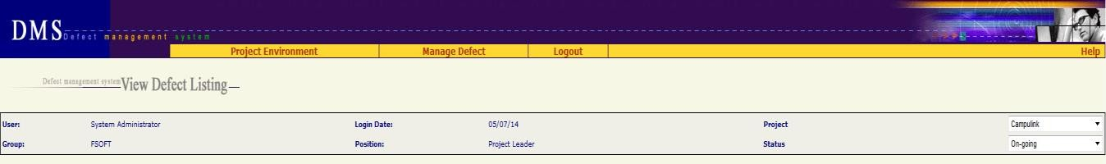

* + - 1. **Screen description**

|  |  |  |  |  |
| --- | --- | --- | --- | --- |
| **No** | **Field name** | **Control type** | **Data type** | **Description** |
| 1 | Project Environment | Menu | Text |  |
| 2 | Assign User | Menu | Text | Submenu of “Project Environment” menu |
| 3 | Work Product | Menu | Text | Submenu of “Project Environment” menu |
| 4 | Module | Menu | Text | Submenu of “Project Environment” menu |
| 5 | Setup Environment | Menu | Text | Submenu of “Project Environment” menu |
| 6 | Mange Defect | Menu | Text |  |
| 7 | Manage Views | Menu | Text | Submenu of “Mange Defect” menu |

|  |  |  |  |  |
| --- | --- | --- | --- | --- |
|  |  |  |  | Go to Home page |
| 8 | New Defect | Menu | Text | Submenu of “Mange Defect” menu Go to Add New defect screen |
| 9 | Manage Planned Defect | Menu | Text | Submenu of “Mange Defect” menu |
| 10 | Project Summary | Menu | Text | Submenu of “Mange Defect” menu |
| 11 | Import Defect | Menu | Text | Submenu of “Mange Defect” menu |
| 12 | Logout | Menu | Text | Logout system, go to Login screen |
| 13 | Help | Menu | Text | Download & open file “Guideline_Defect Management System.doc” |
| 14 | Defect management system <screen name> | Label | Text |  |
| 15 | User | Label | Text | Value = type of login user |
| 16 | Group | Label | Text | Value = group of login user |
| 17 | Login Date | Label | Text | Value = today  Date format = mm/dd/yy |
| 18 | Position | Label | Text | Role of login user |
| 19 | Project | Combo box | Text | List of project which login user is assigned  Default value = the current project |

|  |  |  |  |  |
| --- | --- | --- | --- | --- |
| 20 | Status | Combo box | Text | Status of project  Default value = the current status of project |

## Data Format

* + 1. **Date/Time Format**

Default date format is mm/dd/yy For example: 05/29/14

Default time format is hh:mm:ss For example: 07:23:55

### Number Format

No zero at prefix

File size: xx.x KB For example: 192.3 KB

Available size: xx KB For example: 456 KB Order number has no comma separated For example: 12345 Decimal places of % is 1 For example: 25.7%

## Order of reference data

### QC Activity

1. Unit test (Type of Activity = Test)
2. Integration test (Type of Activity = Test)
3. System test (Type of Activity = Test)
4. Acceptance test (Type of Activity = Test)
5. Regression test (Type of Activity = Test)
6. After release test (Type of Activity = Test)
7. Other test (Type of Activity = Test)
8. Prototype test (Type of Activity = Test)
9. Document review (Type of Activity = Review)
10. Code review (Type of Activity = Review) 22-After release review (Type of Activity = Review) 23-Prototype review (Type of Activity = Review)

24-Other review (Type of Activity = Review) 30-Quality gate inspection (Type of Activity = Inspection) 31-Final inspection (Type of Activity = Inspection)

32Other inspection (Type of Activity = Inspection)

33-UT inspection (Type of Activity = Inspection)

1. Baseline audit (Type of Activity = Audit)
2. Other audit (Type of Activity = Audit)

### Defect Origin

Administration Coding

Collaborator Management Configuration Management Contract Management Correction

Customer Support Deployment Design

Document Control Facility Management IS Management Internal Audit Management Review

Other Prevention

Process Improvement Project Management Quality Control Quality Planning Recruitment Requirement Retirement

Staff Management Student Management Subcontract Management Technology management Test

Training

### Type of Activity

1. Review
2. Test
3. Inspection
4. Audit

### Stage Injected / Stage Detected

<blank>

1-Initiation 2-Definition 3-Solution

1. Construction
2. Transition
3. Termination Definition&Solution Initiation&Definition Release 1

Release 2

Release 3

Release 4

Release 5

Release 6 Solution&Construction

### Priority

<blank>

1-Immediately 2-High

3-Normal 4-Low

### Work product

Acceptance note Architectural design Audit program Audit record

Audit report Baseline Audit Baseline report CM Plan Change request

Coding convention Configuration Status Report Contract

Customer Satisfaction Survey DAR Report

DP Plan DP report

Database Deployment package Design prototype Detailed design

Final inspection Handover note IP

IP database Installation manual Integration test case Integration test plan Integration test report Meeting minutes Others

PCB

PQA report Pilot plan Pilot record Pilot report Plan

Process assets Process database Program

Project assests Project database Project plan Project record Project report Proposal Prototype

QA report

QA review record QDS

Quality control report Quality gate record Record

Release note Report

Requirement prototype Resource and environment Review TestCase

Review record SQA report SRS

Service Level Agreement Software module Software package Support Diary

System description System test case System test plan

System test report Test data

Test plan Test script

Traceability matrix Training course Training material Training records URD

Unit test case Unit test plan Unit test report Use case

User manual and WO

### Severity

1. Fatal
2. Serious 3-Medium 4-Cosmetic

### Module / Module Code

<Blank>

<List of module which got from another Project management tool>

### Type

01-Functionality (Other) 011-Req misunderstanding 012-Feature missing

013-Coding logic 014-Business logic 02-User Interface 03-Performance 04-Design issue

05-Coding standard 06-Document

07-Data & Database integrity 08-Security & Access Control 09-Portability

10-Other 11-Tools

### Defect owner, Assigned To,

All member of project are ordered by alphabet :

<Blank>

<Member 1>

…..

<Member n>

### Status

1. Error
2. Assigned 3-Pending 4-Tested

5-Accepted 6-Canceled

## Timeout requirement

All screens have timeout of 1 hour

After timeout, user has to re-login, and does his/her previous step by step once again.

## Message list

|  |  |
| --- | --- |
| **Message Code** | **English Content** |
| ERR_FORMAT_DATE_CREATED | Created Date is invalid |
| ERR_FORMAT_DATE_CREATED_FROM | "From Created Date" is invalid. |
| ERR_FORMAT_DATE_CREATED_TO | "To Created Date" is invalid. |
| ERR_FORMAT_DATE_FIXED | "Fixed Date" is invalid. |
| ERR_FORMAT_DATE_FIXED_FROM | "From Fixed Date" is invalid. |
| ERR_FORMAT_DATE_FIXED_TO | "To Fixed Date" is invalid. |
| ERR_FORMAT_DATE_DUE | "Deadline" is invalid. |
| ERR_REQUIRED_SEVERITY | "Severity" is required |
| ERR_REQUIRED_TYPE | "Type" is required |
| ERR_REQUIRED_TYPE_ACTIVITY | "Type of Activity" is required |
| ERR_REQUIRED_QC_ACTIVITY | "QC Activity" is required |
| ERR_REQUIRED_ORIGIN | "Defect Origin" is required |
| ERR_REQUIRED_WP | "Work Product" is required |
| ERR_REQUIRED_CREATED_DATE | "Created Date" is required |

|  |  |
| --- | --- |
| ERR_REQUIRED_TITLE | "Title" is required |
| ERR_REQUIRED_DESCRIPTION | "Description" is required |
| ERR_REQUIRED_STATUS | Ignore this message because status cannot be blank |
| ERR_REQUIRED_DEFECT_ORIGIN | Ignore this message because defect origin cannot be blank |
| ERR_DEFECT_ID_INVALID | Defect ID must be positive number |
| ERR_REQUIRED_ATTACHMENT_FILE | Please select at least one file to attach |
| ERR_FILE_OVER_AVAILABLE_SIZE | Attachment size exceeds available space |
| ERR_FILE_OVER_MAX_FILE_SIZE | Attach size exceeded |
| ERR_EXISTED_FILE_NAME | The attached file already exists! |
| ERR_CONSTRAINT_DATE_CREATED_FROMTO | "From Created Date" cannot be later than "To Created Date" |
| ERR_CONSTRAINT_DATE_FIXED_FROMTO | "From Fixed Date" cannot be later than "To Fixed Date" |
| ERR_CONSTRAINT_DATE_CREATED_TODAY | "Created Date" cannot be later than today |
| ERR_CONSTRAINT_DATE_CREATED_DUE | "Created Date" cannot be later than "Deadline" |
| ERR_CONSTRAINT_DATE_CREATED_FIXED | "Created Date" cannot be later than fixed date |
| ERR_CONSTRAINT_DATE_FIXED_TODAY | "Fixed Date" cannot be later than today |
| ALT_PAGE_INVALID | Your number is out of range |
| ALT_REQUIRED_DEFECT | Defect(s) is required |
| ALT_REQUIRED_EXPORT_LIST | Some items must be selected |