

Detailed design:

PRICE VARIaNCE REPORT
MSS

 | Security classification: | CONFIDENTIAL
 | Document code: | N/A
 | Last updated by: | Tri Nguyen-Huu
 | Effective date: | May 20, 2022
 | Version: | 0.3
 | Template ID: | Bestarion.QM.TEM.002-ODT_Base_Template-2_2

DOCUMENT CONTROL
Version | Change description | Changed by | Date | Approved by | Date
0.1 | Price Variance Report Level 1 | TriNH | May 17, 2022 | N/A | N/A
0.2 | Price Variance Report Level 1 | TriNH | May 20, 2022 | N/A | N/A
0.3 | Price Variance Report Level 1 | TriNH | May 24, 2022 | N/A | N/A

TEMPLATE CONTROL
Version | Change description | Changed by | Date | Approved by | Date
0.1 | Initiate and add content | DongNC | Apr 20, 2022 | N/A | N/A
TABLE OF CONTENTS
1. Introduction 5
1.1. Purpose 5
1.2. Scope 5
2. Design Considerations 5
2.1. Assumptions 5
2.2. Constraints 5
3. Architecture 6
3.1. System Design 6
4. Component Design 7
4.1. Price Variance Level 1 7
4.2. Price Variance Level 2 8
4.3. Price Variance Level 3 9
5. Software Interface Design 10
5.1. Web Pages In A Tree 10
5.2. Description 12
5.3. User Interface 12
5.3.1. Price Variance Report Level 1 Screen 12
5.3.2. Price Variance Report Level 1 With Filter Screen 12
5.3.3. Price Variance Report Level 2 Screen 13
5.3.4. Price Variance Report Level 2 With Filter Screen 14
5.3.5. Price Variance Report Level 3 Screen 15
5.3.6. Price Variance Report Level 3 With Filter Screen 15
6. Class Diagrams 16
6.1. Price Variance Class Diagram Level 1 16
6.2. Price Variance Class Diagram Level 2 16
6.3. Price Variance Class Diagram Level 3 17

INDEX OF TABLES

INDEX OF ILLUSTRATION
Illustration 1: Block diagram for Price Variance Diagram Report 6
Illustration 2: Sequence diagram for Price Variance Report Level 1 7
Illustration 3: Sequence diagram for Price Variance Report Level 2 8
Illustration 4: Sequence diagram for Price Variance Report Level 3 9
Illustration 5: A tree of pages 10
Illustration 6: Scheme of the main web pages 11
Illustration 7: Price Variance Report Level 1 screen 12
Illustration 8: Price Variance Report Level 1 with filter screen 13
Illustration 9: Price Variance Report Level 2 13
Illustration 10: Price Variance Report Level 2 with filter screen 14
Illustration 11: Price Variance Report Level 3 screen 15
Illustration 12: Price Variance Report Level 3 with filter screen 15
Illustration 13: Price Variance Report Level 1 class diagram 16
Illustration 14: Price Variance Report level 2 class diagram 16
Illustration 15: Price Variance Report level 3 class diagram 17

Introduction
The document is to show variance from purchased items with 3 or more different prices in the period.
The document should be able to show the variance, drill down to the detail and filter at vendor summary, item summary and purchase history level.

Purpose
Price variance is important for budgeting and planning purposes, particularly when companies are deciding what quantities of items to order.

Scope
This document gives a detailed description of the software architecture of the MSS system. It specifies the structure and design of some of the modules discussed in the Requirement Spec/ WI #NO. It also displays some of the use cases that had transformed into sequential and activity diagrams. The class diagrams show how the programming team would implement the specific module.

Design Considerations

Assumptions
The user of MSS system is aware of basic operations of a computer and web pages.
The user also understands the standard terms used for operation.

Constraints
N/A

Architecture

System Design
The block diagram below shows the principal parts of the system and their interactions
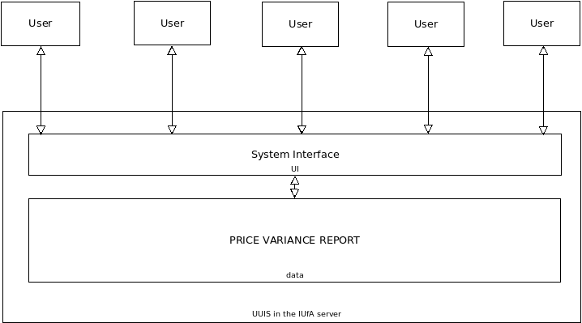Illustration 1: Block diagram for Price Variance Diagram Report

Component Design

Price Variance Level 1
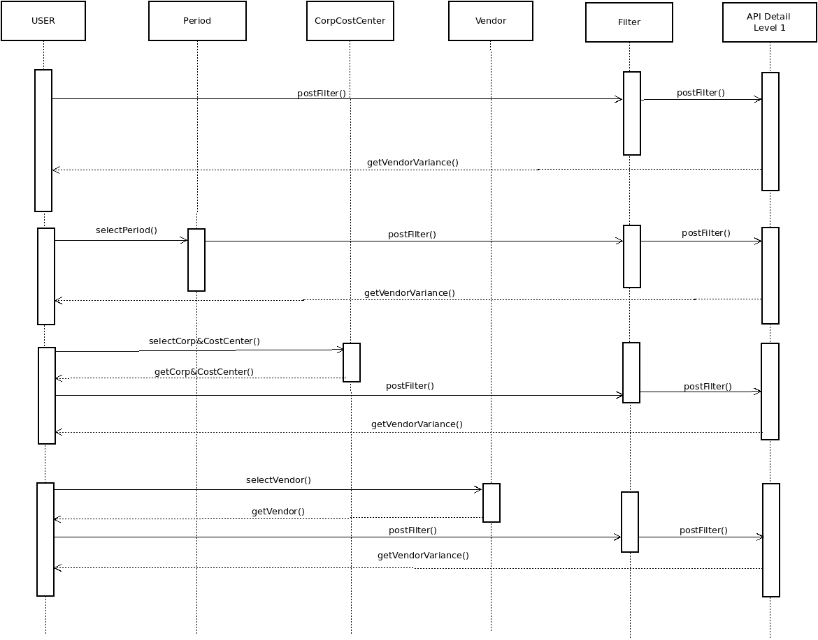Illustration 2: Sequence diagram for Price Variance Report Level 1

Price Variance Level 2
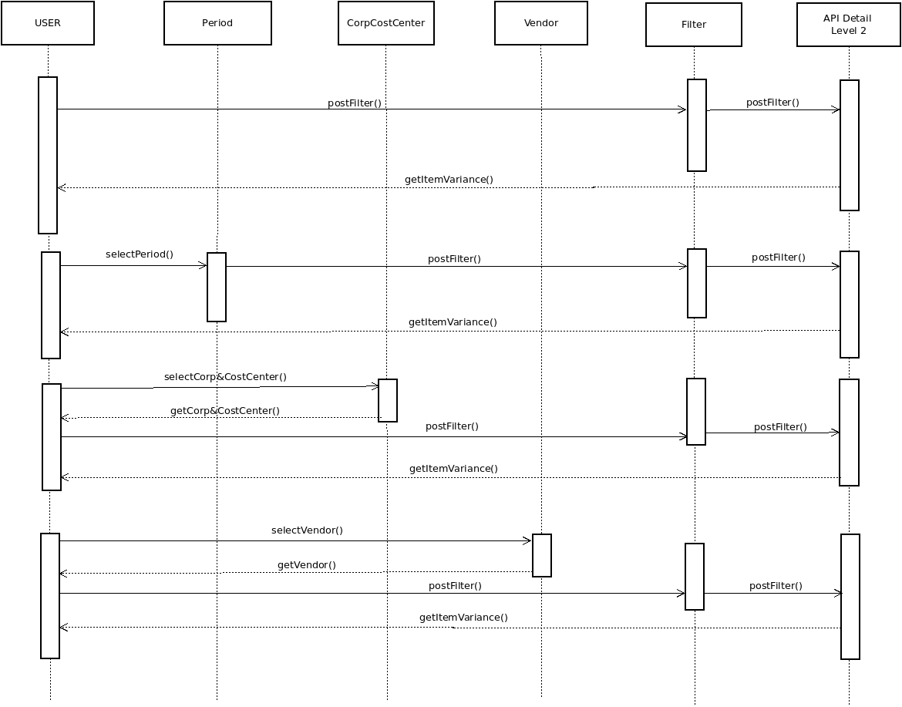Illustration 3: Sequence diagram for Price Variance Report Level 2

Price Variance Level 3
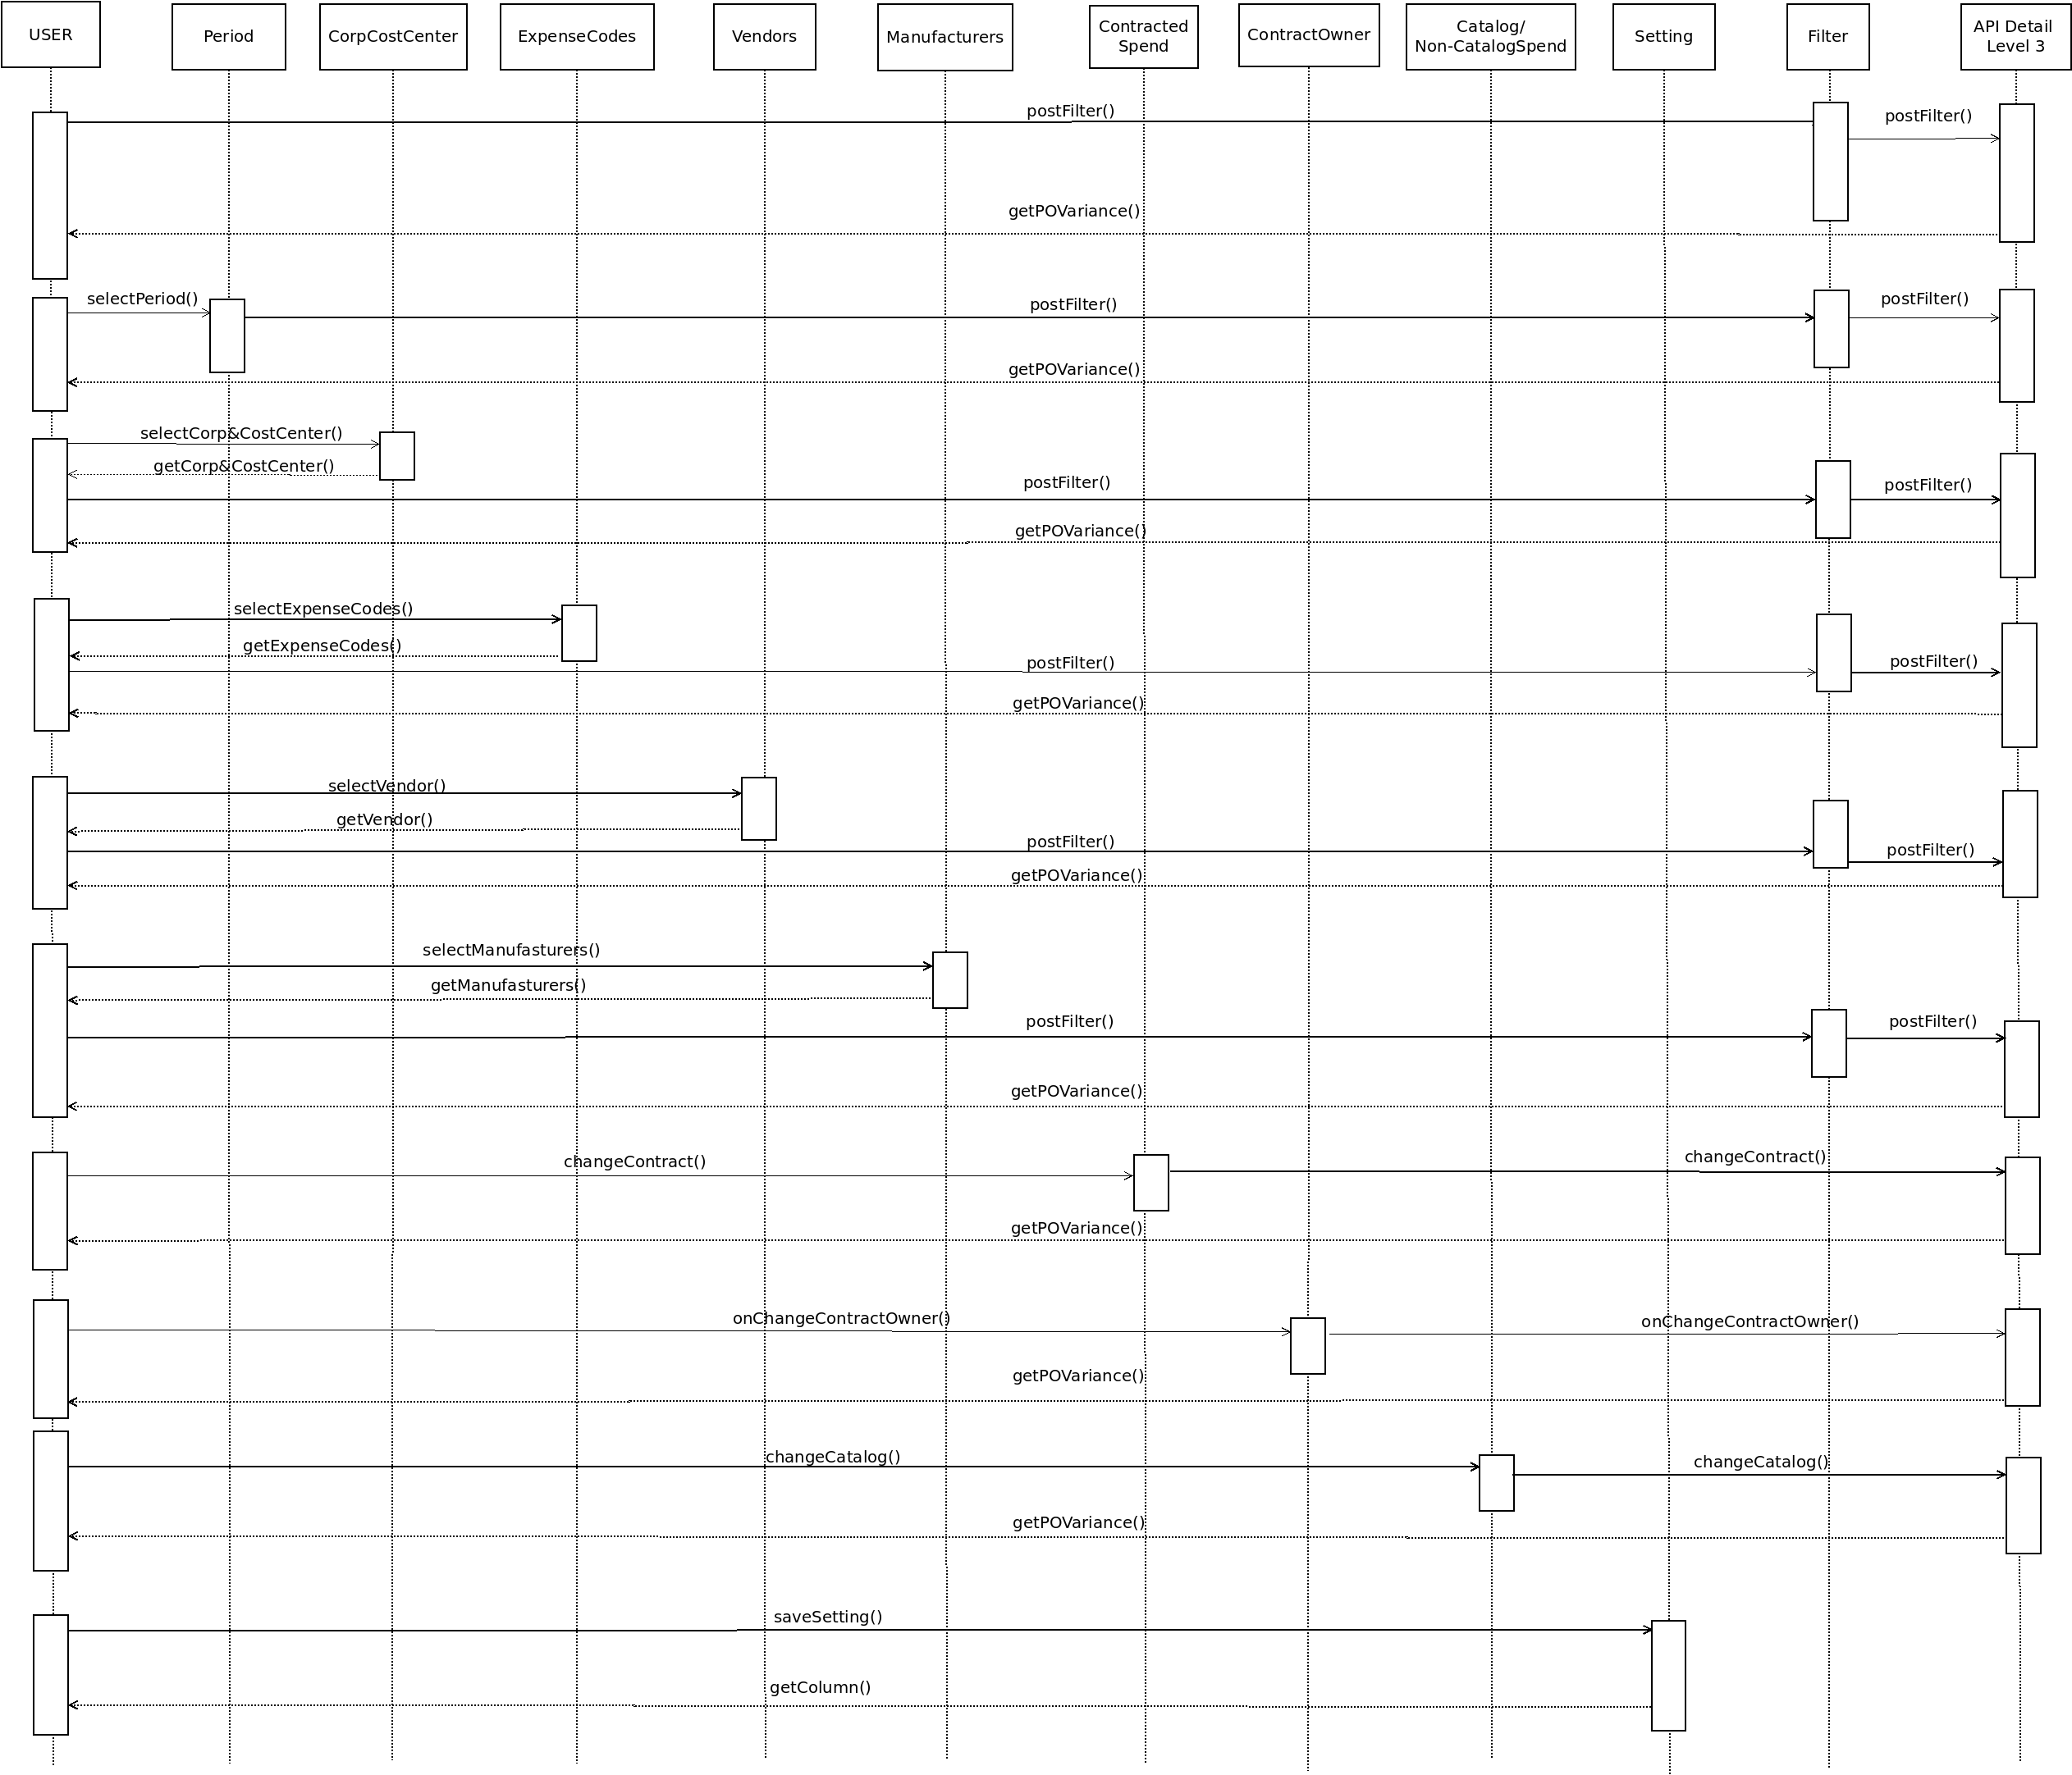Illustration 4: Sequence diagram for Price Variance Report Level 3

Software Interface Design

Web Pages In A Tree

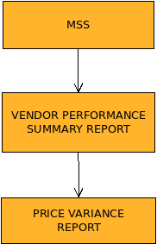Illustration 5: A tree of pages
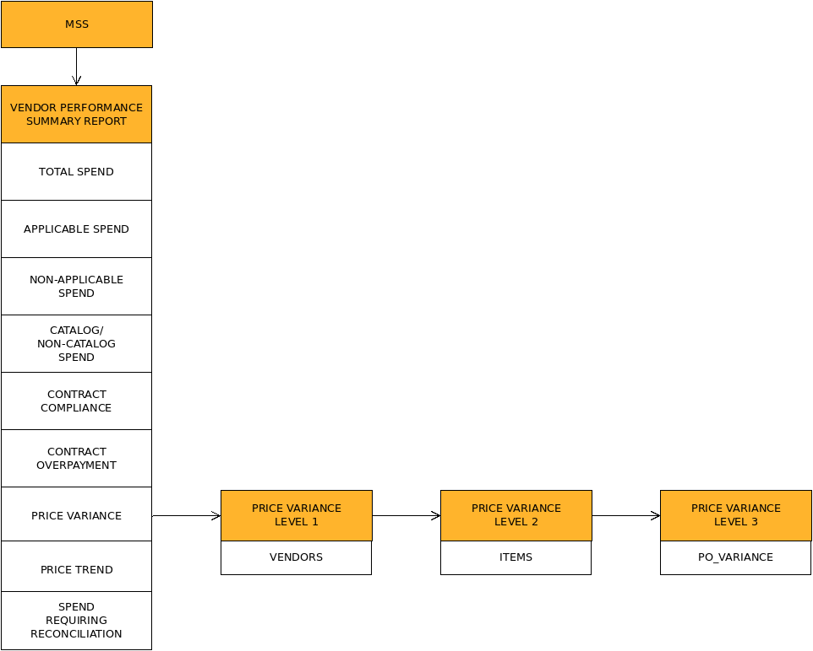Illustration 6: Scheme of the main web pages

Description
Firstly, you must have an account to log in to the of the “MSS” program system. After we log in successfully, the system will allow next we to “Vendor Performance Summary Report”. In there, we will watch a lot of spending reports. To access “Price Variance Report”, we have to click a number in Price Variance. Now, we are in Price Variance Level 1 and we can operate columns in the table includes: Total Spend, Variance, %Variance,… and so on. Besides, We can click a number in the Variance column in Price Variance from 3 to 10+ toward Price Variance Level 2. After we click it, we are in level 2 of the report. In there, we can watch items of the vendor we chose. Next, go to Price Variance Level 3, we have to click a number of “No. of Purchases” in the table. In level 3, we can find all information fully of items.

User Interface

Price Variance Report Level 1 Screen

Price Variance Report Level 1 With Filter Screen
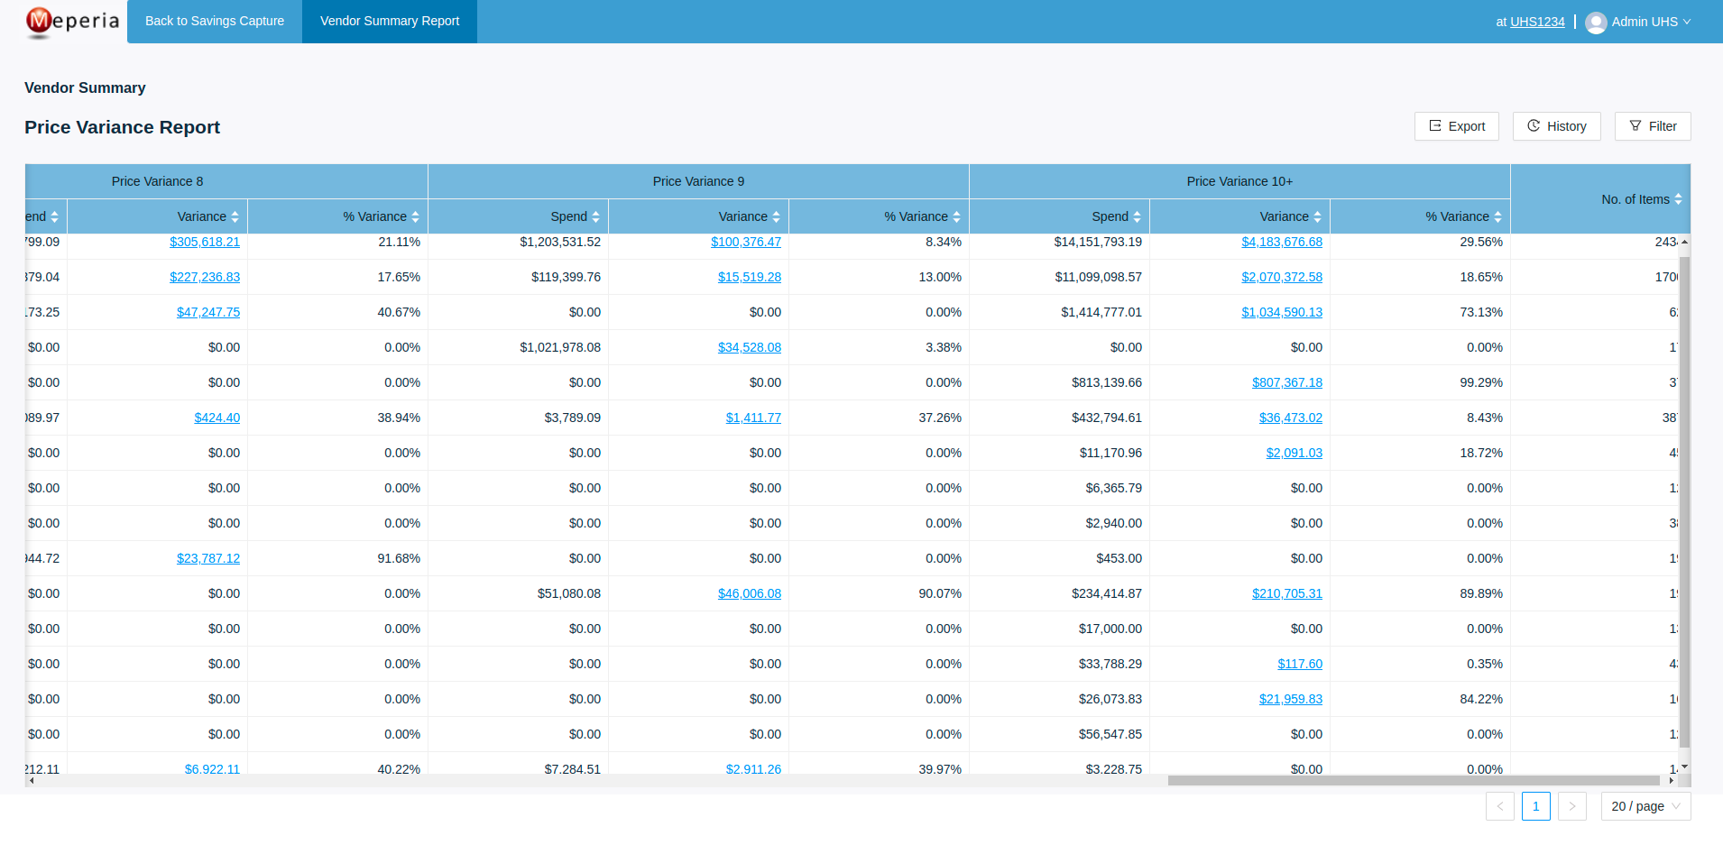Illustration 7: Price Variance Report Level 1 screen

Price Variance Report Level 2 Screen
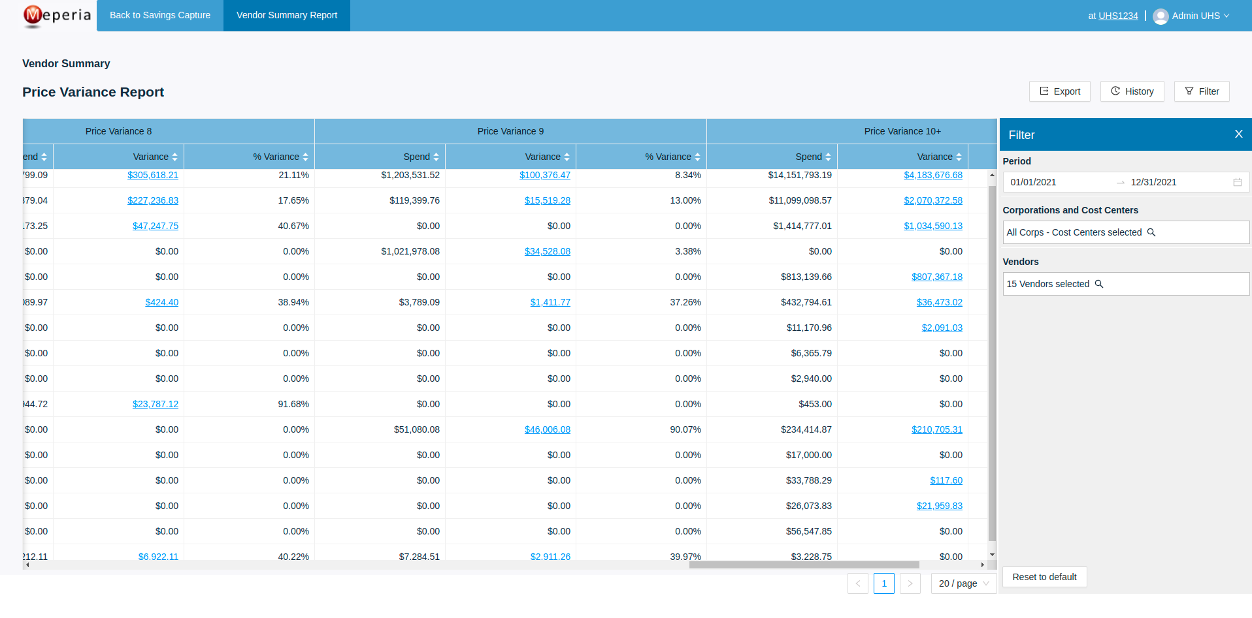Illustration 8: Price Variance Report Level 1 with filter screen
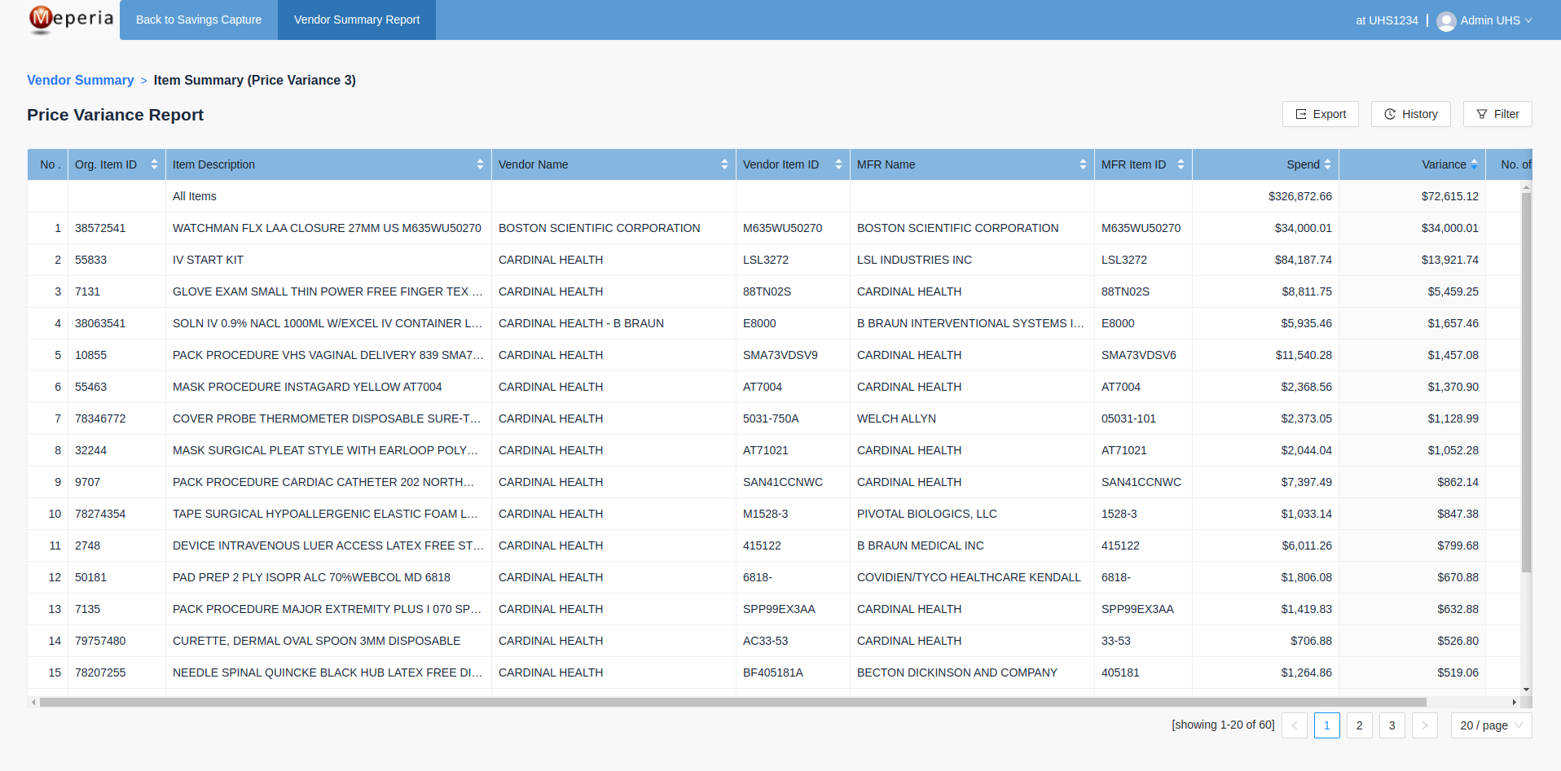Illustration 9: Price Variance Report Level 2

Price Variance Report Level 2 With Filter Screen
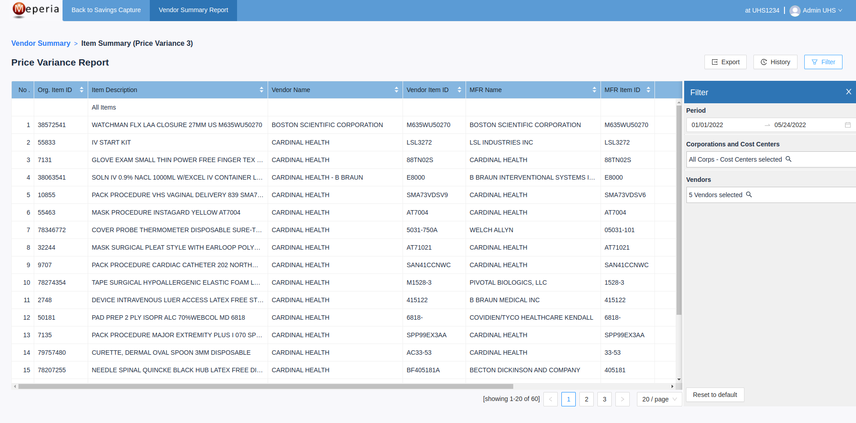Illustration 10: Price Variance Report Level 2 with filter screen

Price Variance Report Level 3 Screen
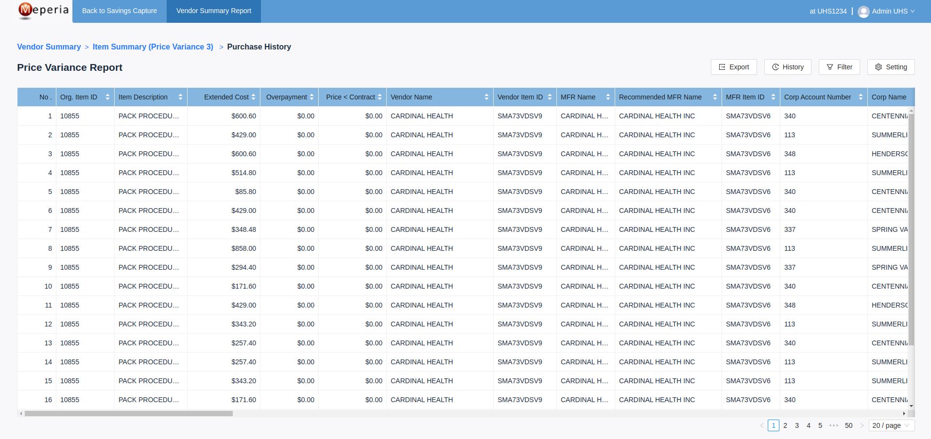Illustration 11: Price Variance Report Level 3 screen

Price Variance Report Level 3 With Filter Screen
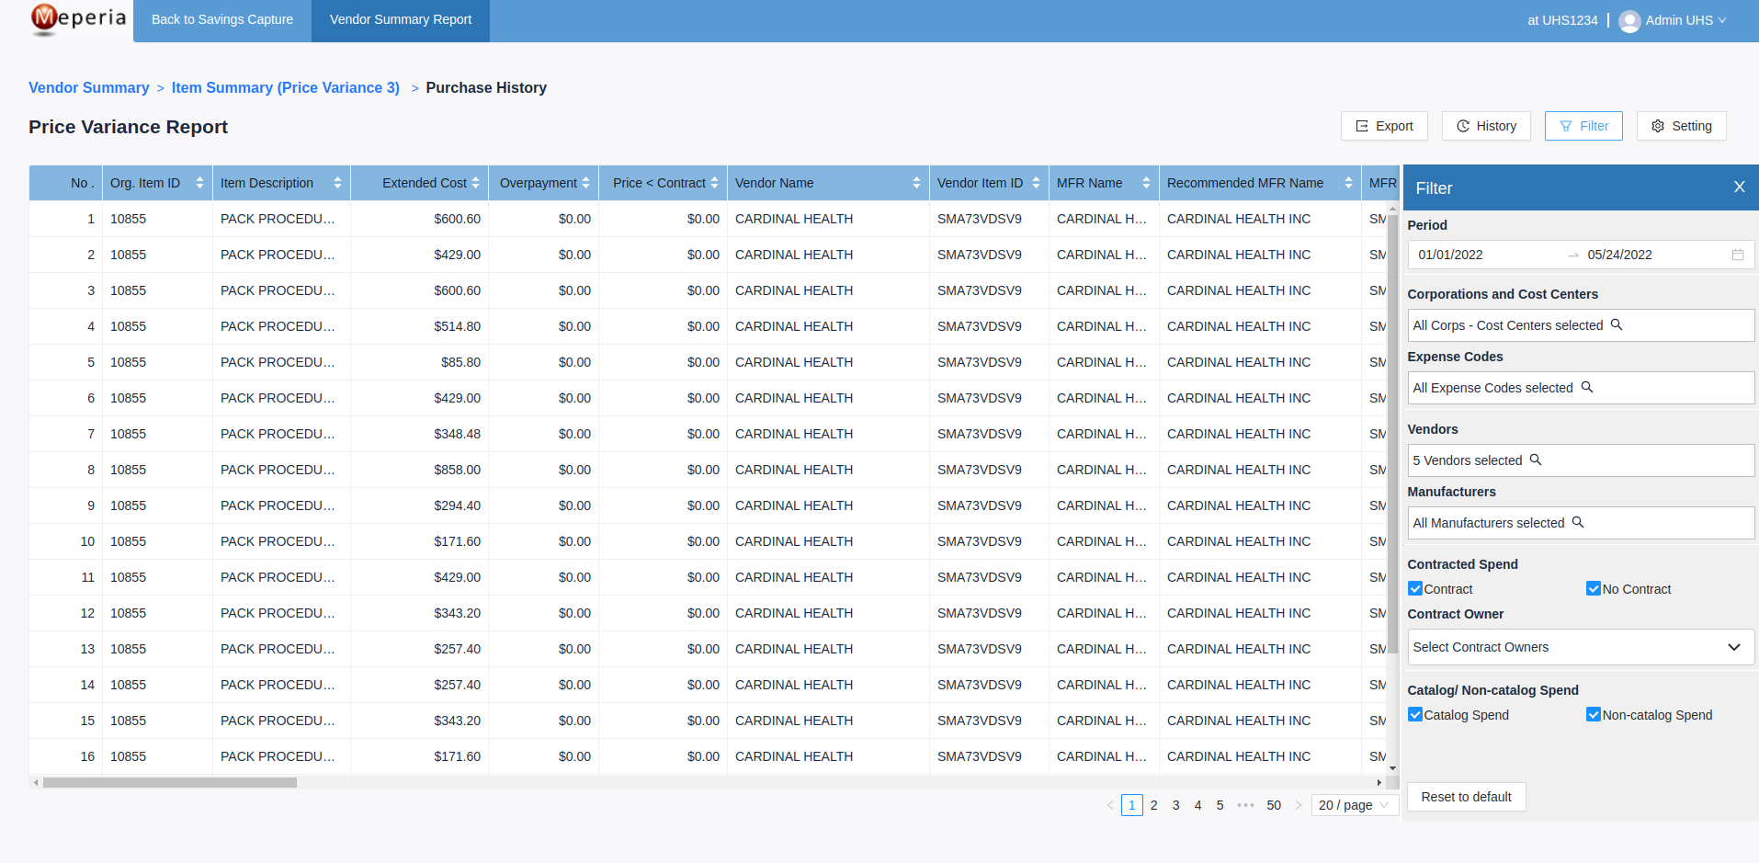Illustration 12: Price Variance Report Level 3 with filter screen

Class Diagrams

Price Variance Class Diagram Level 1

Price Variance Class Diagram Level 2
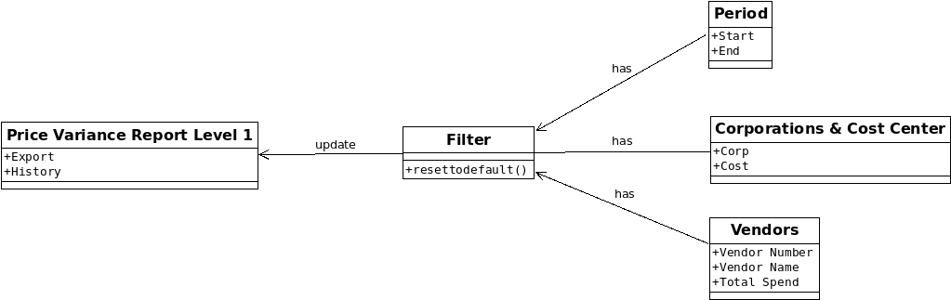Illustration 13: Price Variance Report Level 1 class diagram
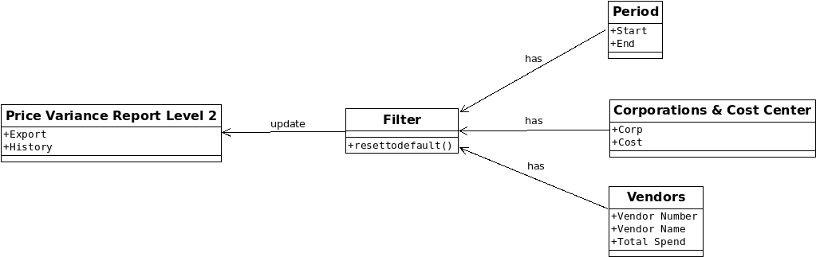Illustration 14: Price Variance Report level 2 class diagram

Price Variance Class Diagram Level 3
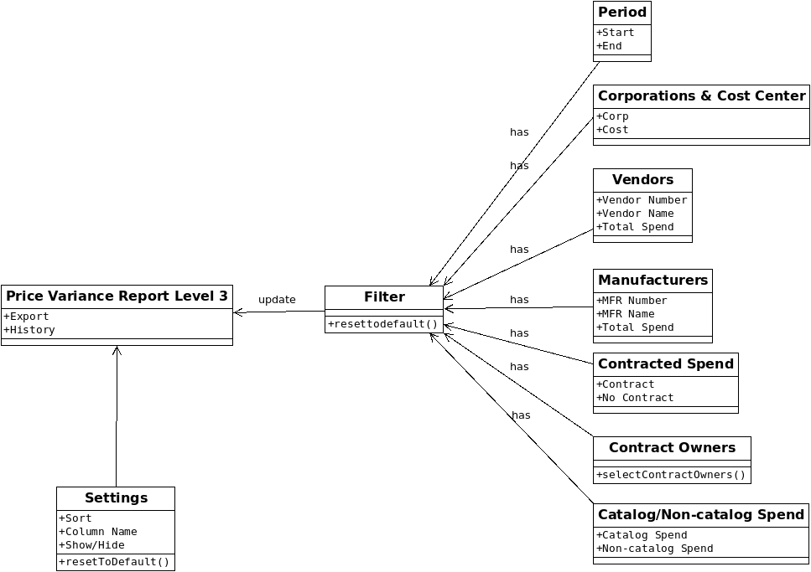Illustration 15: Price Variance Report level 3 class diagram

