

Detailed design:

SPEND REQUIRING

RECONCILIATION REPORT
MSS

 | Security classification: | CONFIDENTIAL
 | Document code: | N/A
 | Last updated by: | Tri Nguyen-Huu
 | Effective date: | Jun 07, 2022
 | Version: | 0.3
 | Template ID: | Bestarion.QM.TEM.002-ODT_Base_Template-2_2

DOCUMENT CONTROL
Version | Change description | Changed by | Date | Approved by | Date
0.1 | Spend Requiring Reconciliation Report Level 1 | TriNH | Jun 07, 2022 | N/A | N/A
0.2 | Spend Requiring Reconciliation Report Level 2 | TriNH | Jun 12, 2022 | N/A | N/A
0.2 | Spend Requiring Reconciliation Report Level 3 | TriNH | Jun 15, 2022 | N/A | N/A

TEMPLATE CONTROL
Version | Change description | Changed by | Date | Approved by | Date
0.1 | Initiate and add content | DongNC | Apr 20, 2022 | N/A | N/A
TABLE OF CONTENTS
1. Introduction 5
1.1. Purpose 5
1.2. Scope 5
2. Design Considerations 5
2.1. Assumptions 5
2.2. Constraints 5
3. Architecture 6
3.1. System Design 6
7
4. Component Design 7
4.1. Spend Requiring Reconciliation Level 1 8
4.2. Spend Requiring Reconciliation Level 2 9
4.3. Spend Requiring Reconciliation Level 3 10
5. Software Interface Design 11
5.1. Web Pages In A Tree 11
5.2. Description 13
5.3. User Interface 14
5.3.1. Spend Requiring Reconciliation Report Level 1 Screen 14
5.3.2. Spend Requiring Reconciliation Report Level 1 With Filter Screen 14
5.3.3. Spend Requiring Reconciliation Report Level 2 Screen From PO Lines Requiring Reconciliatoin 15
5.3.4. Spend Requiring Reconciliation Report Level 2 Screen From Requiring Reconciliation (INV Price > PO Price/ INV Price < PO Price) 16
5.3.5. Spend Requiring Reconciliation Report Level 3 Screen 17
5.3.6. Spend Requiring Reconciliation Report Level 3 With Filter Screen 17
6. Class Diagrams 18
6.1. Spend Requiring Reconciliation Class Diagram Level 1 18
6.2. Spend Requiring Reconciliation Class Diagram Level 2 18
6.3. Spend Requiring Reconciliation Class Diagram Level 3 19

INDEX OF TABLES

INDEX OF ILLUSTRATION
Illustration 1: Block diagram for Spend Requiring Reconciliation Diagram Report 6
Illustration 2: Sequence diagram for Spend Requiring Reconciliation Report Level 1 7
Illustration 3: Sequence diagram for Spend Requiring Reconciliation Report Level 2 8
Illustration 4: Sequence diagram for Spend Requiring Reconciliation Report Level 3 9
Illustration 5: A tree of pages 10
Illustration 6: Scheme of the main web pages 11
Illustration 7: Spend Requiring Reconciliation Report Level 1 screen 14
Illustration 8: Spend Requiring Reconciliation Report Level 1 with filter screen 14
Illustration 9: Spend Requiring Reconciliation Report Level 2 15
Illustration 10: Spend Requiring Reconciliation Report Level 2 with filter screen 16
Illustration 11: Spend Requiring Reconciliation Report Level 3 screen 17
Illustration 12: Spend Requiring Reconciliation Report Level 3 with filter screen 17
Illustration 13: Spend Requiring Reconciliation Report Level 1 class diagram 18
Illustration 14: Spend Requiring Reconciliation Report level 2 class diagram 18
Illustration 15: Spend Requiring Reconciliation Report level 3 class diagram 19

Introduction
Spend Requiring Reconciliation report show the PO lines where INV price is different from PO Price and the difference between the prices

Purpose
Spend Requiring Reconciliation report help users identify and quantify the PO lines where INV price is different from PO price and the difference between the prices, so that users can gain an insight on these PO lines for the reconciliation process

Scope
This document gives a detailed description of the software architecture of the MSS system. It specifies the structure and design of some of the modules discussed in the Requirement Spec/ WI #217044. It also displays some of the use cases that had transformed into sequential and activity diagrams. The class diagrams show how the programming team would implement the specific module.

Design Considerations

Assumptions
The user of MSS system is aware of basic operations of a computer and web pages.
The user also understands the standard terms used for operation.

Constraints
N/A

Architecture

System Design
The block diagram below shows the principal parts of the system and their interactions
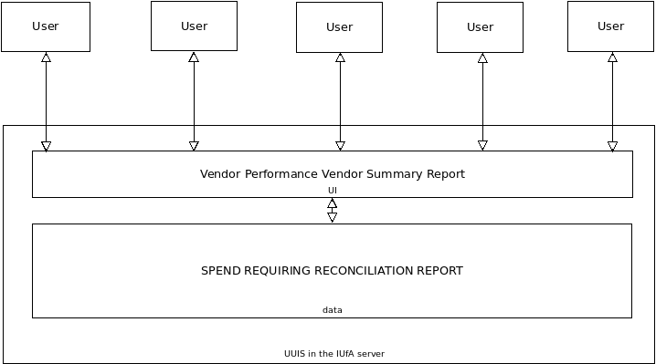Illustration 1: Block diagram for Spend Requiring Reconciliation Diagram Report

Component Design

Spend Requiring Reconciliation Level 1
Illustration 2: Sequence diagram for Spend Requiring Reconciliation Report Level 1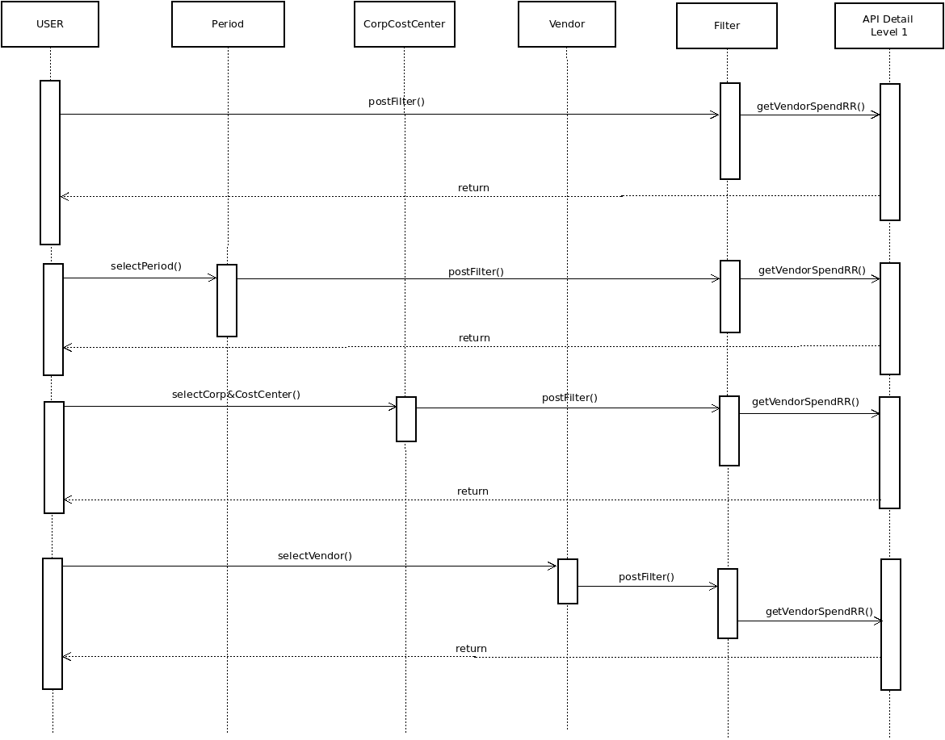

Spend Requiring Reconciliation Level 2
Illustration 3: Sequence diagram for Spend Requiring Reconciliation Report Level 2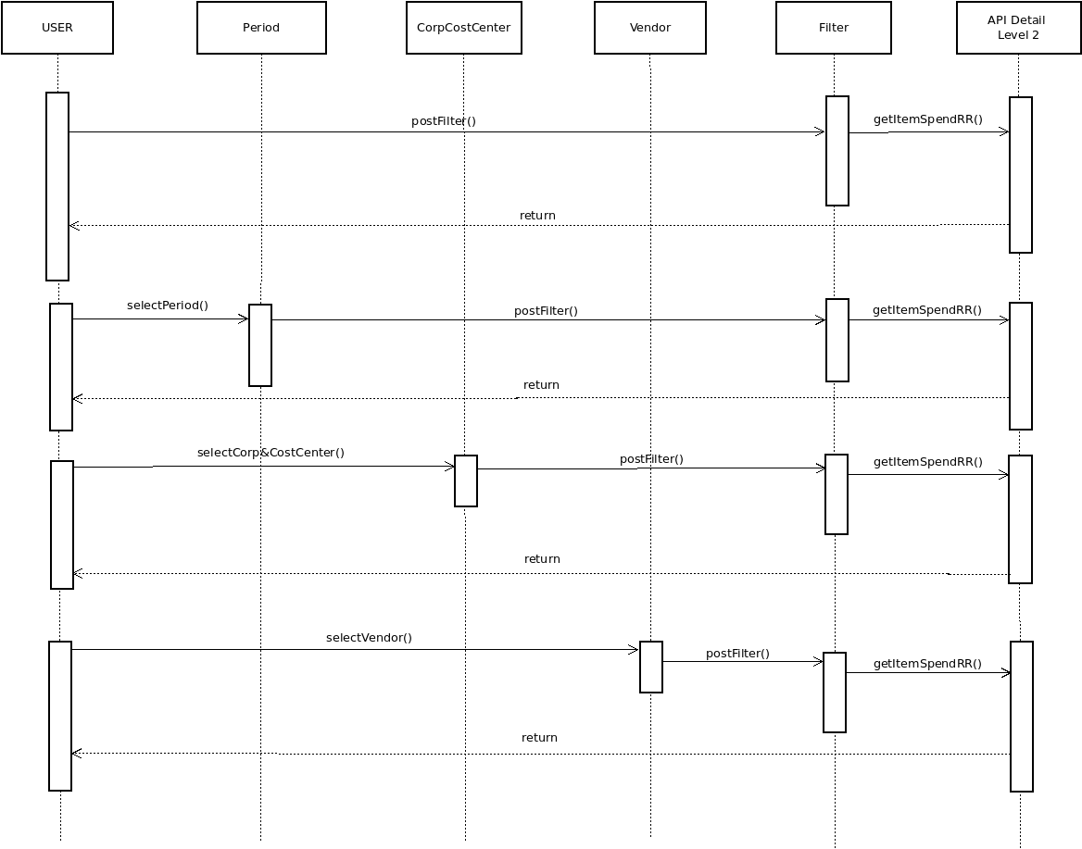

Spend Requiring Reconciliation Level 3
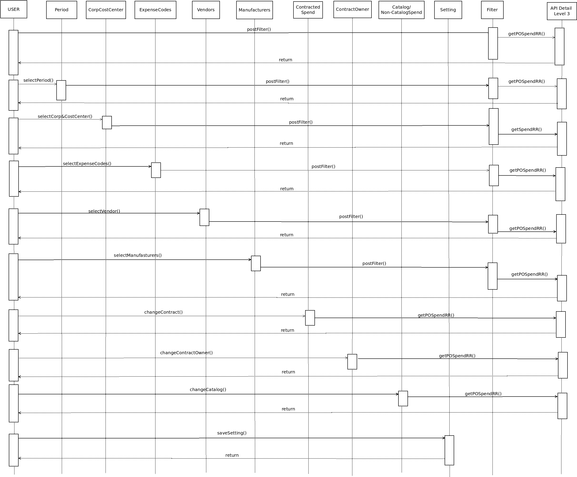Illustration 4: Sequence diagram for Spend Requiring Reconciliation Report Level 3

Software Interface Design

Web Pages In A Tree

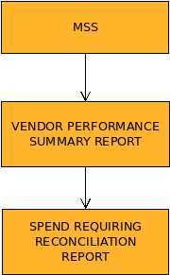Illustration 5: A tree of pages
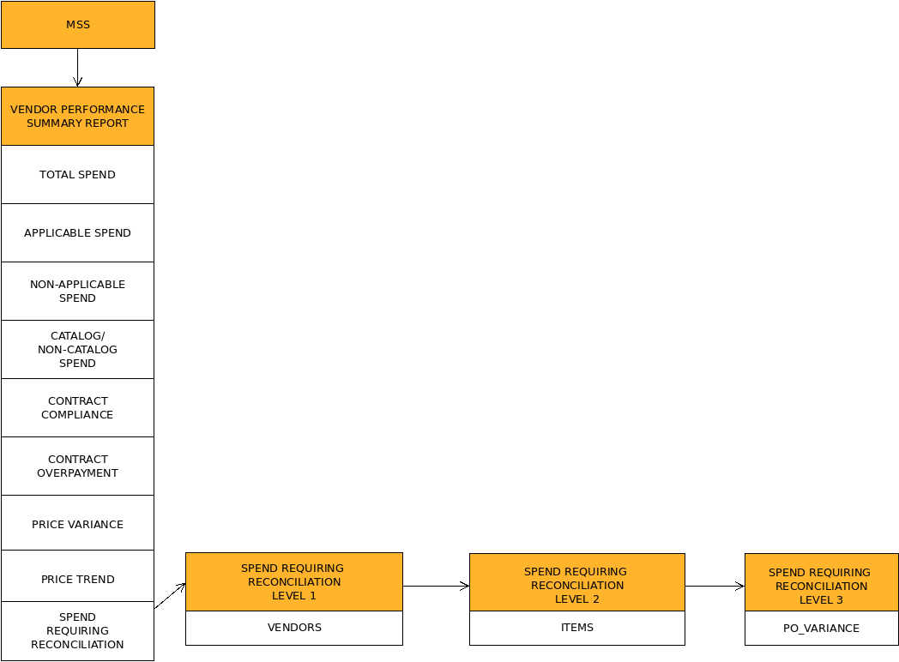Illustration 6: Scheme of the main web pages

Description
Firstly, you must have an account to log in to the of the “MSS” program system. After we log in successfully, the system will allow next we to “Vendor Performance Summary Report”. In there, we will watch a lot of spending reports. To access “Spend Requiring Reconciliation Report”, we have to click a number in Spend Requiring Reconciliation. Now, we are in Spend Requiring Reconciliation Level 1 and we can operate columns in the table includes: # of PO Lines, # PO Lines Requiring Reconciliation,… and so on. Besides, We can click a blue number in columns in Spend Requiring Reconciliation toward Spend Requiring Reconciliation Level 2. After we click it, we are in level 2 of the report. In there, we can watch items of the vendor we chose. Next, go to Spend Requiring Reconciliation Level 3, we have to click a number of “No. of Purchases” in the table. In level 3, we can find all information fully of items.

User Interface

Spend Requiring Reconciliation Report Level 1 Screen

Spend Requiring Reconciliation Report Level 1 With Filter Screen
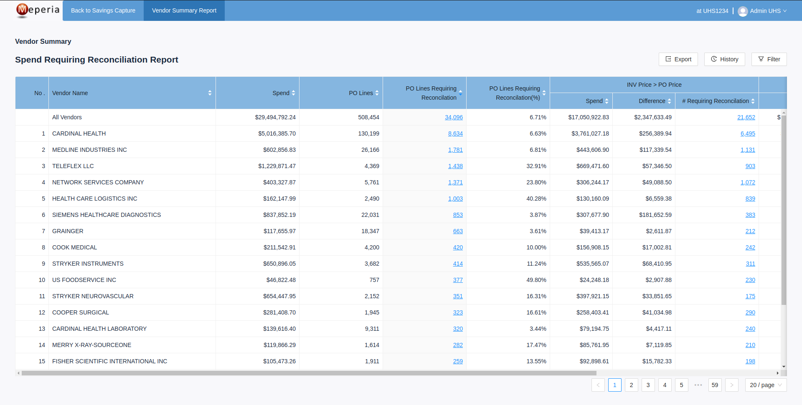Illustration 7: Spend Requiring Reconciliation Report Level 1 screen

Spend Requiring Reconciliation Report Level 2 Screen From PO Lines Requiring Reconciliatoin
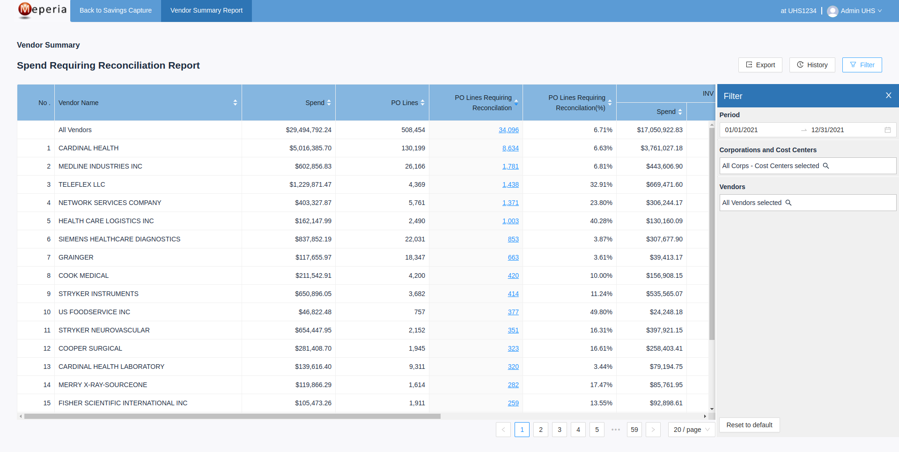Illustration 8: Spend Requiring Reconciliation Report Level 1 with filter screen
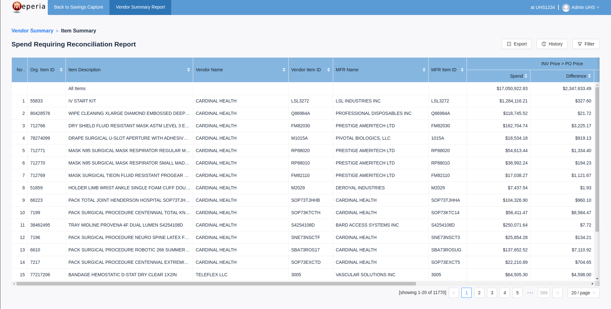Illustration 9: Spend Requiring Reconciliation Report Level 2 from PO Lines Requiring Reconciliation

Spend Requiring Reconciliation Report Level 2 Screen From Requiring Reconciliation (INV Price > PO Price/ INV Price < PO Price)
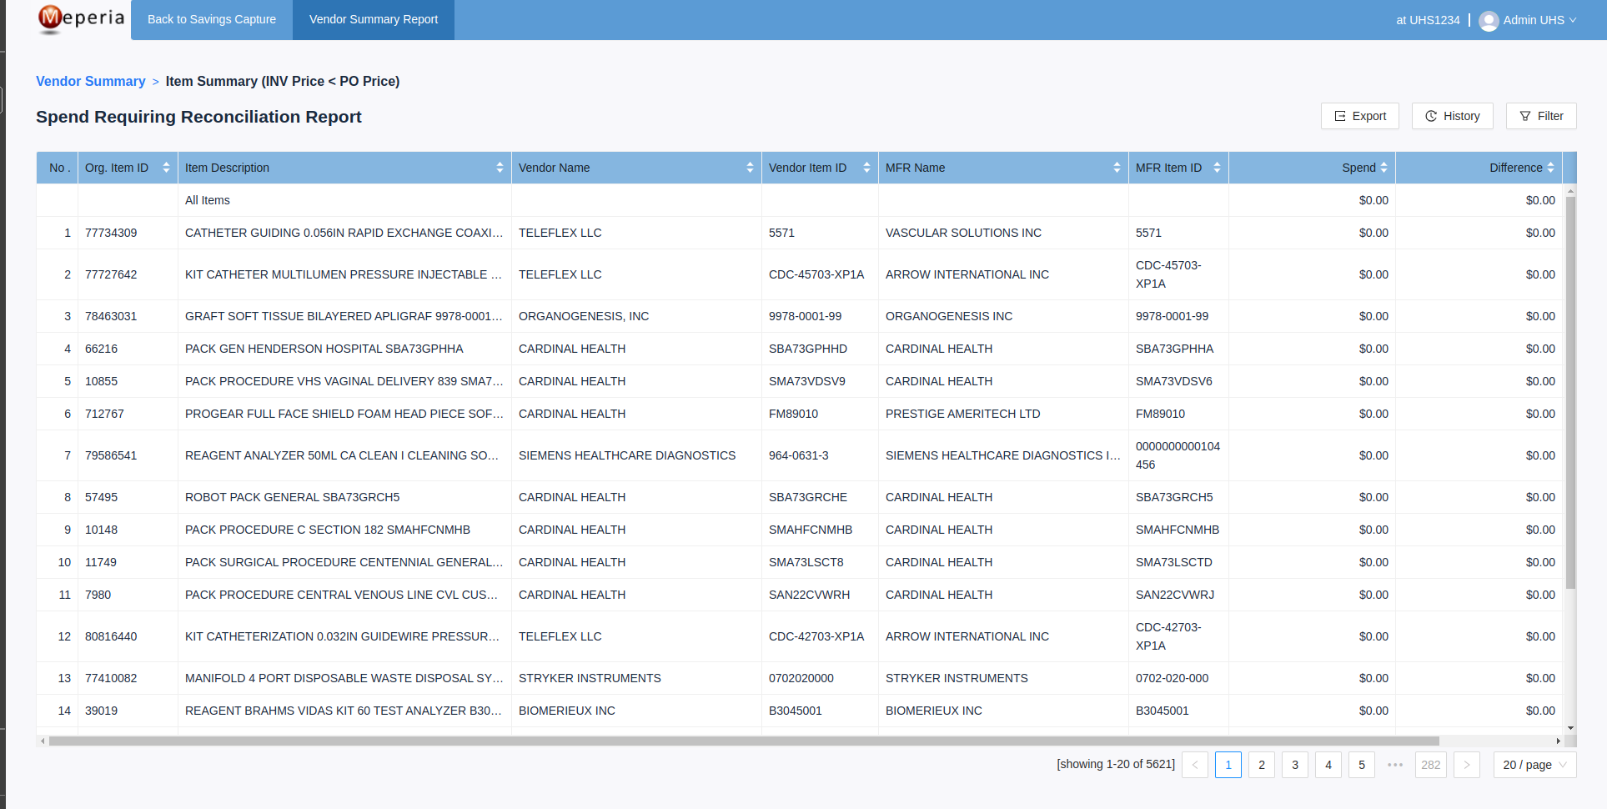Illustration 10: Spend Requiring Reconciliation Report Level 2 Screen From Requiring Reconciliation

Spend Requiring Reconciliation Report Level 3 Screen
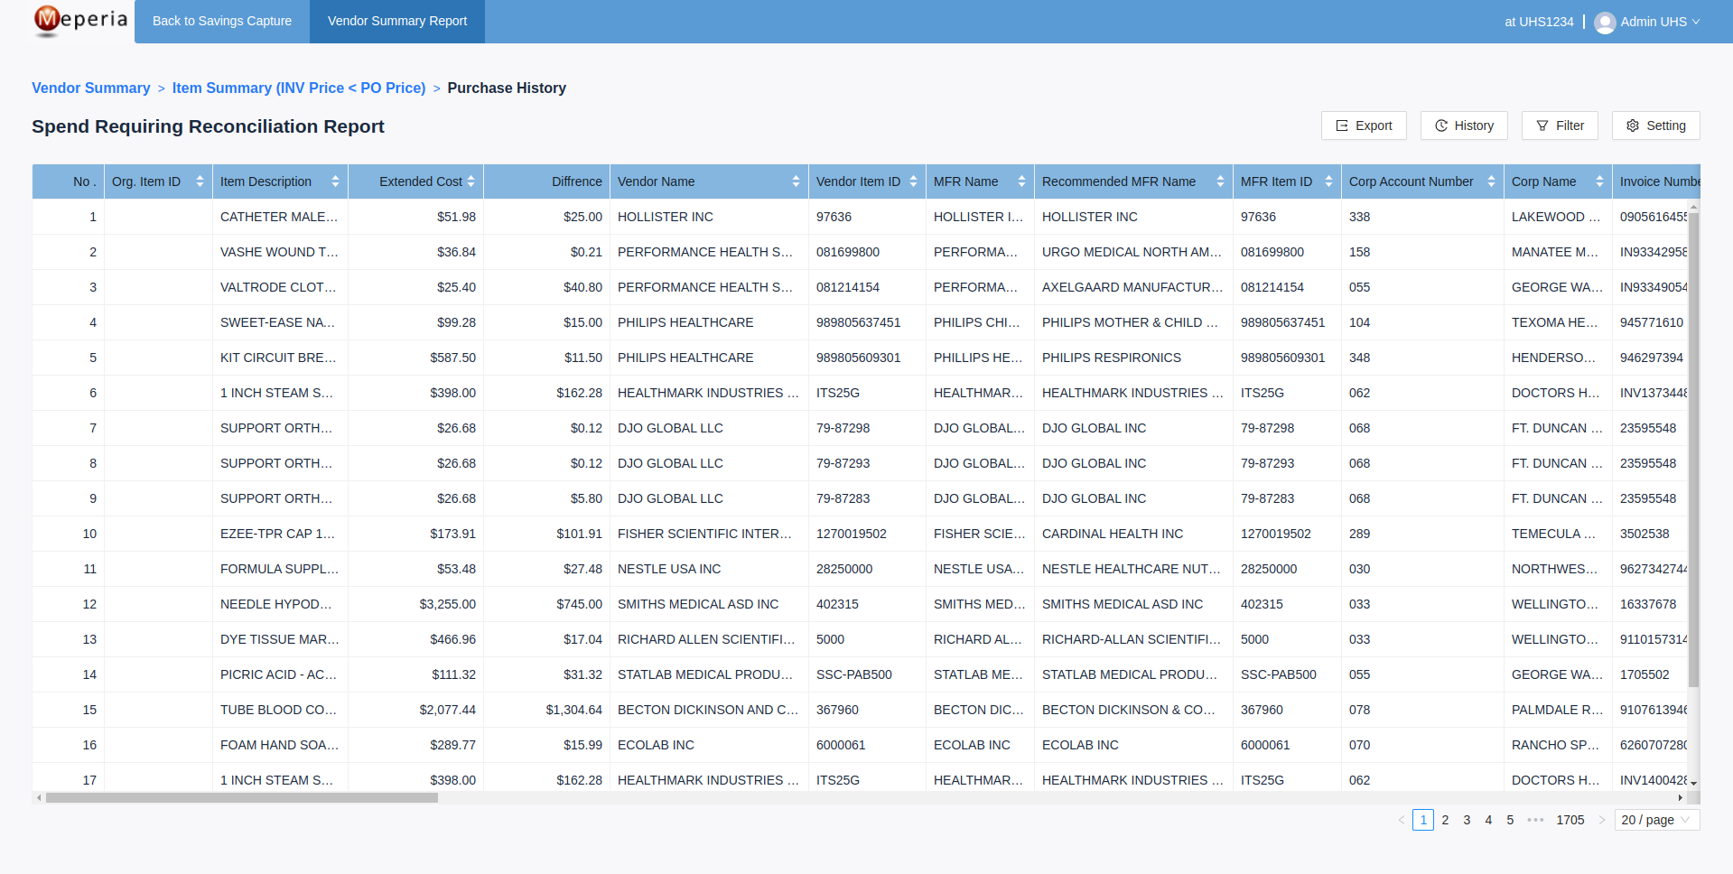Illustration 11: Spend Requiring Reconciliation Report Level 3 screen

Spend Requiring Reconciliation Report Level 3 With Filter Screen
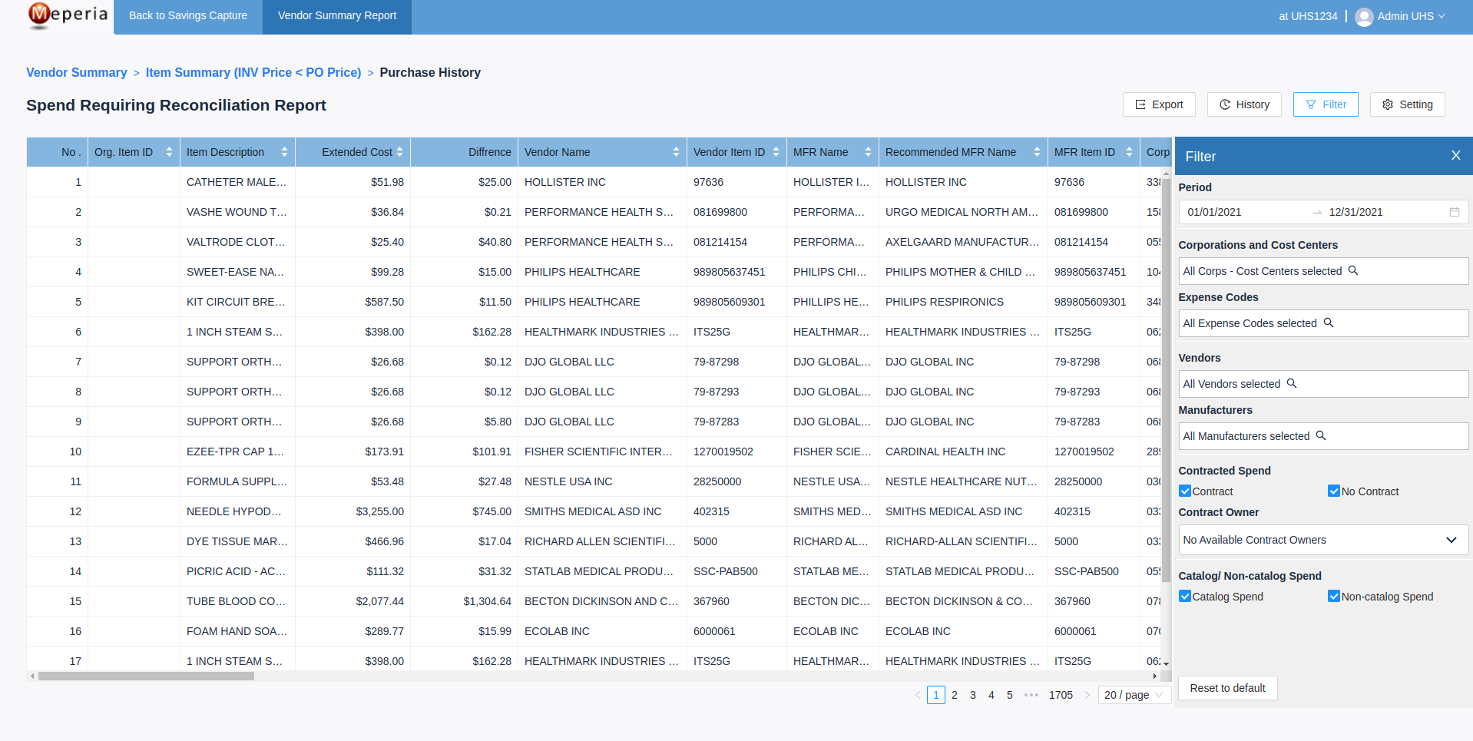Illustration 12: Spend Requiring Reconciliation Report Level 3 with filter screen

Class Diagrams

Spend Requiring Reconciliation Class Diagram Level 1

Spend Requiring Reconciliation Class Diagram Level 2
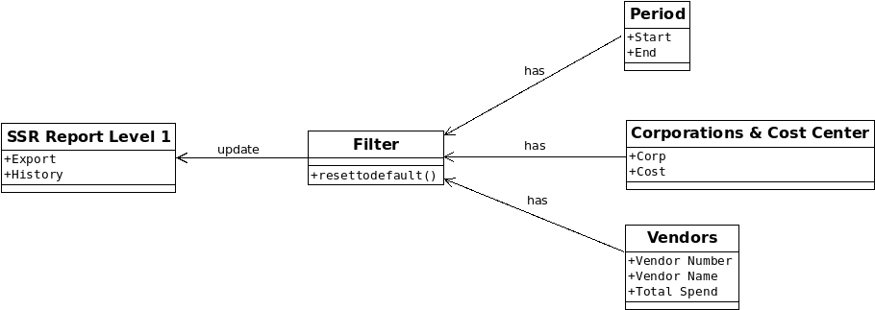Illustration 13: Spend Requiring Reconciliation Report Level 1 class diagram
Illustration 14: Spend Requiring Reconciliation Report level 2 class diagram 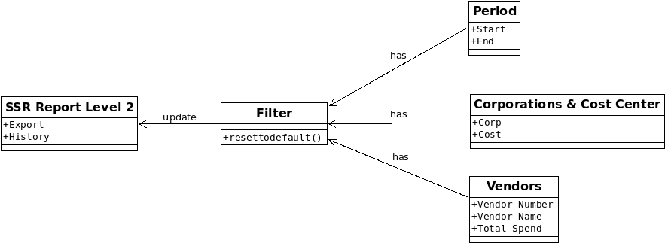

Spend Requiring Reconciliation Class Diagram Level 3
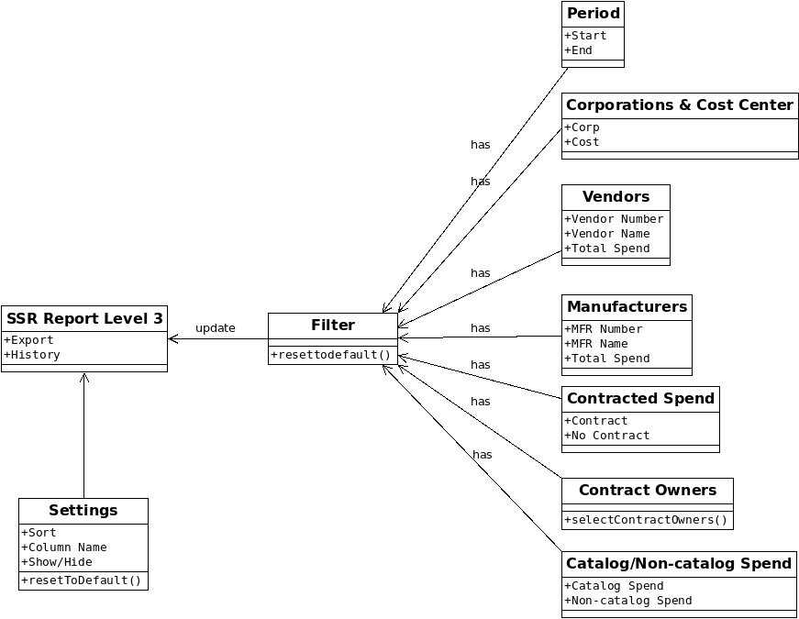Illustration 15: Spend Requiring Reconciliation Report level 3 class diagram

