Abstract

Perform system and requirement analysis of BestPurchase app. Providing mission statement, user stories, analysis the functional requirements. Developing the state transition diagram for BestPurchase as well as creating GUI sketch.

Vincent Nguyen

nvui@bu.edu

System and requirements analysis

Table of Contents

Assumptions/Scope 1

1. Overview/Mission Statement 2

2. User Stories 2

1.1 First User Story 2

1.2 Second User Story 2

3. Functional Requirements 2

4. Use Cases 2

1.3 First Use Case 3

1.4 Second Use Case 4

5. State Transition Diagram 5

6. Sub-States 6

7. GUI Sketch 7

8. Non-Functional Requirements 7

Conclusion 8

References based on Research 9

Evaluation 10

**Table of Figures**

Figure 1: Example of Mobile retail app 1

Figure 2: State transition diagram of BestPurchase 5

Figure 3: State transition diagram with sub-states of BestPurchase 6

Figure 4: GUI sketch of BestPurchase 7

Last Updated 4/25/2022

# Assumptions/Scope

In no more than a few sentences outline your scope. Provide a scenario and what your project will focus on. A bulleted list is fine.

The BestPurchase app’s scope is to provide a platform for customers to shop for groceries from difference stores in one go via phone or website. The BestPurchase allows users to explore products, choose items, place orders, and have orders deliver to their home. The BestPurchase also provide scheduling delivery services.

Figure 1: Example of Mobile retail app

# Overview/Mission Statement

BestPurchase is an app to help family shopping online, then order and get home delivery groceries from different stores in the nearby location. BestPurchase allows users to compare and order items online from different stores and have them delivered to their home. BestPurchase also allows users to schedule delivery the groceries.

# User Stories

## First User Story

As a gaming streamer, I want to able to order groceries from difference local stores without shopping physically, so that I can save more time and focus on streaming more.

## Second User Story

As a housewife, I want to be able to quickly compare the item prices in the different supermarkets and stores online, so that I can save time and money for my family.

# Functional Requirements

* BestPurchase will allow customer to create an account.
* BestPurchase will allow customer to shop on different stores.
* BestPurchase will allow customer choose store to shop.
* BestPurchase will allow customer to input their contact information.
* BestPurcahse will allow customer to checkout to pay in advance using credit card or pay by cash later.
* BestPurchase will allow customer to choose payment method such as in person or online.
* BestPurchase will allow customer to search product.
* BestPurchase will allow customer to choose delivery or pick up option.
* BestPurchase will allow customer to give feedback on the quality of delivery.
* BestPurchase will allow customer to schedule their delivery.
* BestPurchase will allow customer to see the deals on different stores.
* BestPurchase will allow customer to add items to the cart.
* BestPurchase will allow customer to delete items from the cart.

# Use Cases

## First Use Case

Yellow: Class

Red: Attribute

Blue: Method

|  |  |  |
| --- | --- | --- |
| Use case Name | Online shopping and payment. | |
| Actor: | Customer | |
| Description: | The customer using BestPurchase to shop online across stores and make payment for all products from different store on BestPurchase | |
| Pre-condition: | The customer has downloaded and installed BestPurchase app. The customer also created an account with all of input information such as name, address, payment methods etc. and logged into their account on BestPurchase. The customer is in delivery service area. | |
| Step # | Actor | System |
| 1 | The customer navigates to the homepage | BestPurchase shows all the stores which are available. |
| 2 | The customer chooses the store | BestPurchase displays all the available shopping options such as shop in general, categories, deals, and buy it again. It also shows delivery window time for that store. |
|  | The customer chooses “shop in general” option. | BestPurchase displays all of products which are available in that store. |
| 3 | The customer selects the products | BestPurchase acknowledges the products and add selected products to the cart. |
| 4 | The customer clicks on “cart” | BestPurchase navigates to cart. All the selected products and its quantity and price are displayed. |
| 5 | The customer clicks on “Checkout” | BestPurchase shows all delivery information such as address, delivery time, contact and payment method for customer to review. |
| 6 | The customer selects a delivery time slot | BestPurchase confirms the delivery time slot |
| 7 | The customer chooses payment method such as pay online now or pay in person later | BestPurchase confirm the payment. |
| 8 | The customer places order | BestPurchase processes the payment and confirms the payments and notify to the customer. |
| Alternate Courses: | If there is no delivery time slot now. BestPurchase app will show the message” Delivery is not available. Please come back later ”. | |

## Second Use Case

|  |  |  |
| --- | --- | --- |
| **Use case Name** | Item recommendations | |
| **Actor:** | Customer | |
| **Description:** | The customer using BestPurchase to shop online across stores and doing payment for all items from different store on BestPurchase. It also gives personalized product recommendations for customer based on their previous order | |
| **Pre-condition:** | The customer has downloaded and installed BestPurchase app. The customer also created an account with all of input information such as name, address, payment methods etc. and logged into their account on BestPurchase. The customer is in delivery service area. | |
| **Step #** | **Actor** | **System** |
| 1 | The customer navigates to the homepage | BestPurchase shows all the stores which are available for order. |
| 2 | The customer chooses the store | BestPurchase displays all the available options such as shop in general, categories, deals, and buy it again. It also shows delivery window time for that store. |
| 3 | The customer chooses “shop in general” option. | BestPurchase displays all of items which are available in that store. |
| 4 | The customer selects the products | BestPurchase acknowledges the products and add selected products to the cart. |
| 5 |  | BestPurchase analyzes customer’ current selected product and their purchase history and preferences. |
| 6 |  | BestPurchase pops out item recommendations. |
| 7 | The customer reviews the items recommendation and decide whether add them to the cart. | BestPurchase acknowledges the added items |
| 8 | The customer processes normal checkout |  |
| Alternate Courses: |  |  |

# State Transition Diagram

Figure 2: State transition diagram of BestPurchase

# Sub-States

Figure 3: State transition diagram with sub-states of BestPurchase

# GUI Sketch

Products Search bar

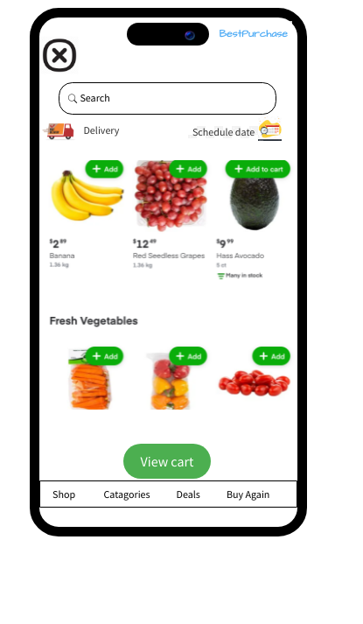

Figure 4: GUI sketch of BestPurchase

Shopping options icons

View cart icon is the shopping cart

List of products

Schedule date will allow user to choose date for delivering

Delivery will allow user to choose their address

# Non-Functional Requirements

1. BestPurchase must not experience any interruptions more than 5 second.

This non - functional requirement is very important for the BestPurchase because if the app experiences downtime, I will lead to customers dissatisfaction. I will also reduce customer engagement to the application. A large percentage of these users might leave the application or delete the application if they continue experience interruptions. They will also give negative reviews, as result, the business will have higher chance to lose their prospect customers.

1. BestPurchase must be secured to protect user’s data such as address, phone number and payment information.

This non - functional requirement is also very important for the BestPurchase because BestPurchase collects information from the customers. If those data are leaked, I will lead to serious problem such as cyber-attack. Protecting customer’s data, I will also protect BestPurchase’s business from the lawsuit, reputation, and brand value.

# Conclusion

In conclusion, this assignment performs the system and requirement analysis for BestPurchase. It indentify the key features and functional and non-functional requirements of the BestPurchase. The analysis considered the needs of customers and use cases which illustrates who customer interact with BestPurchase. This assignment also creates state transition diagram and GUI sketch for BestPurchase.

# References based on Research

Show that you used a wide variety of resources by listing them below and clearly indicating in the body above where you used. Make sure to use proper referencing in your paper. We suggest using APA format, but other formats are fine as long as it clearly distinguishes your work from work of others in your response—be mindful of plagiarism rules.

[1] Dennis, A., Wixom, B. H., Tegarden, D. (02/2015). Systems Analysis and Design: An Object-Oriented Approach with UML, 5th Edition.

[2] Williams, Dawson Lee. (2017). Module 0. Executive Writing Video.

[3] Williams, Dawson Lee. Week 3 Class Lecture. Boston University MET CS 682 O1

[4] Arakelian, A. Week 3 Assignment Preview. Boston University MET CS 682 O1

[5] Impact of website downtime <https://www.freshworks.com/website-monitoring/prevent-website-downtime/>

[6] Protecting personal data <https://www.packetlabs.net/posts/customers-personal-data/#:~:text=When%20you%20protect%20your%20customer's,protect%20yourself%20from%20costly%20lawsuits>.

[7] Mobile retail app picture. <https://www.thinkwithgoogle.com/future-of-marketing/creativity/mobile-retail-apps-and-sites-designing-better-experience-for-shoppers/>