Assignment 3

1/26/17

Write an *Eliza* application that fulfills the postcondition specifications below given the precondition.

Each part will build mostly on the previous one. All builds should be submitted, and are weighted equally. The key to evaluating each part of the assignment is on the table in the Syllabus page, under Grading.

# Build 1

Implement the functionality specified below. You may use *int*(), which returns an integer form of a string argument and *str*(), which returns a string form of an integer argument.

*# Eliza300  
# Intent: A list of helpful actions that a troubled person could take. Build 1*possible_actions = [**'taking up yoga.'**, **'sleeping eight hours a night.'**, **'relaxing.'**,   
 **'not working on weekends.'**, **'spending two hours a day with friends.'**]  
  
**'''  
Precondition: possible_actions is the list defined above  
  
Postconditions:  
1. (Welcome): A welcome message is on the console  
2. (user_complaint): user_complaint is the user's response to a prompt for the  
user's complaint  
3. (how_long): how_long is the user's string response to "How many months have  
you experienced ...?" AND Eliza300 sympathized, mentioning the duration  
4. (Advice):  
EITHER how_long < 3 AND "Please return in * months" is on the console where *  
is 3-how_long  
OR how_long >= 3 AND The phrases in possible_action are on separate lines  
on the console, each preceded by "Try ".   
'''**

**'''**

Here is an example of the interaction:

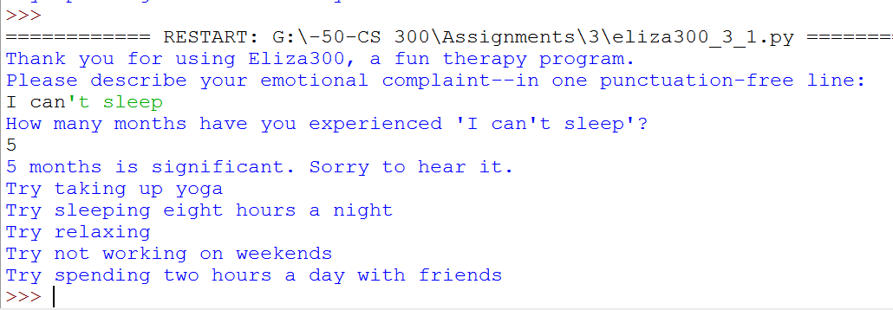

# Build 2

Implement the functionality specified below.

*# Eliza300  
# Intent: A list of helpful actions that a troubled person could take. Build 2*possible_actions = [**'taking up yoga'**, **'sleeping eight hours a night'**, **'relaxing'**,   
 **'not working on weekends'**, **'spending two hours a day with friends'**]  
  
**'''  
Precondition: possible_actions is the list defined above  
  
Postconditions:  
  
1. (Welcome): A welcome message is on the console  
  
2. (user_complaint): user_complaint is the user's response to  
"Please describe your emotional complaint--in one punctuation-free line: "  
  
3. (how_long): how_long is the user's string response to  
"How many months (between 1 and 99) have you experienced ...?"  
  
4. (Month validity): EITHER how_long has the requested form  
OR this terminated AND "Sorry, illegal input. Eliza is quitting; run Eliza again."  
is on the console  
  
5. (Advice):  
EITHER how_long < 3 AND "Please return in * months" is on the console where *  
is 3-how_long  
OR how_long >= 3 AND The phrases in possible_action are on separate lines  
on the console, each preceded by "Try ".  
'''**

Here are examples of the interaction and note the tip that follows it:

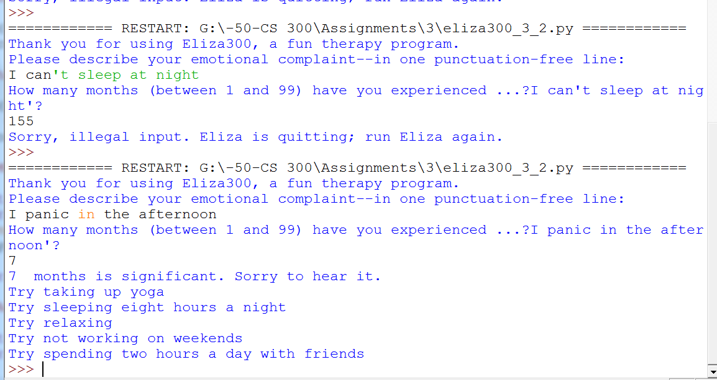

Depending on how you approach this problem, you may find the following information useful: 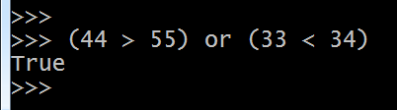

# Build 3

Implement the following specifications:

*# Eliza300  
# Intent: A list of helpful actions that a troubled person could take. Build 2*possible_actions = [**'taking up yoga'**, **'sleeping eight hours a night'**, **'relaxing'**,   
 **'not working on weekends'**, **'spending two hours a day with friends'**]  
  
**'''  
Precondition: possible_actions is the list defined above  
  
Postconditions:  
  
1. (Welcome): A welcome message is on the console  
  
2. (user_complaint): user_complaint is the user's response to  
"Please describe your emotional complaint--in one punctuation-free line: "  
  
3. (how_long): how_long is the user's string response to  
"How many months (between 1 and 99) have you experienced ...?"  
  
4. (Month validity): EITHER how_long has the requested form  
OR this terminated AND "Sorry, illegal input. Eliza is quitting; run Eliza again."  
is on the console  
  
5. (Advice): EITHER how_long >= 3  
OR "Please return in * months" is on the console where * is 3 - how_long  
  
6. (actions_not_taken): actions_not_taken consists of the actions (elements) in  
possible_actions that the user answered 'n' to when questioned "Have you tried..."  
  
7. (Summarized): Eliza300 recommended that the user take the actions in  
actions_not_taken  
'''**

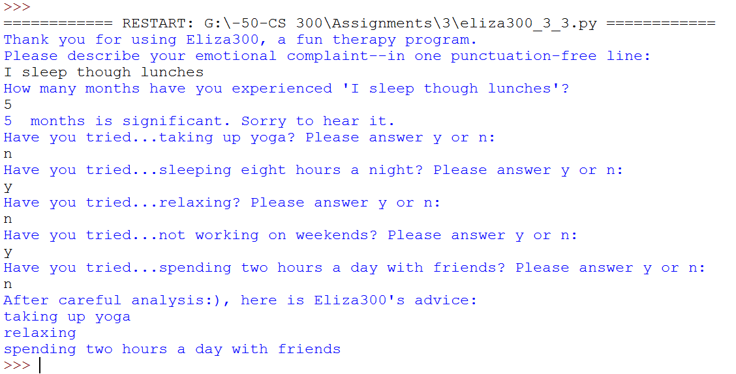

Depending on how you implement this, you may find the following useful:

