Run first time:

|  |  |  |  |  |  |  |  |  |  |  |
| --- | --- | --- | --- | --- | --- | --- | --- | --- | --- | --- |
| *n*  *Algorithm* | 10000 | 20000 | 30000 | 40000 | 50000 | 60000 | 70000 | 80000 | 90000 | 100000 |
| insertion | 12 | 24 | 51 | 99 | 149 | 212 | 289 | 380 | 500 | 593 |
| merge | 3 | 2 | 3 | 3 | 5 | 6 | 6 | 8 | 8 | 8 |
| quick | 3 | 2 | 1 | 2 | 2 | 4 | 4 | 4 | 5 | 6 |
| heapsort | 2 | 2 | 4 | 3 | 4 | 5 | 6 | 7 | 8 | 9 |

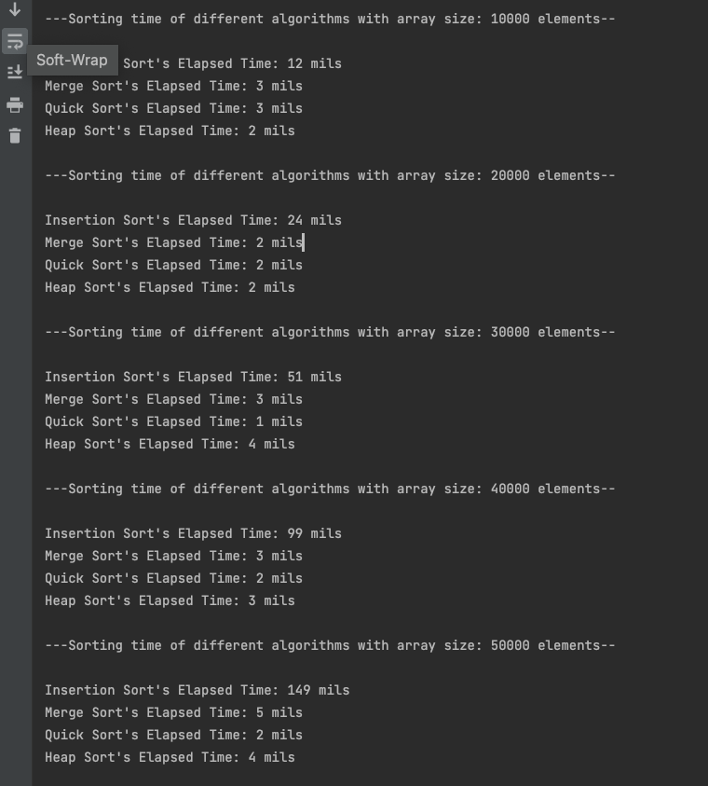

Second time:

|  |  |  |  |  |  |  |  |  |  |  |
| --- | --- | --- | --- | --- | --- | --- | --- | --- | --- | --- |
| *n*  *Algorithm* | 10000 | 20000 | 30000 | 40000 | 50000 | 60000 | 70000 | 80000 | 90000 | 100000 |
| insertion | 12 | 25 | 53 | 94 | 158 | 231 | 321 | 422 | 533 | 658 |
| merge | 2 | 2 | 2 | 4 | 4 | 6 | 7 | 8 | 8 | 9 |
| quick | 2 | 1 | 2 | 2 | 3 | 3 | 3 | 5 | 5 | 5 |
| heapsort | 2 | 2 | 3 | 3 | 4 | 5 | 6 | 6 | 8 | 9 |

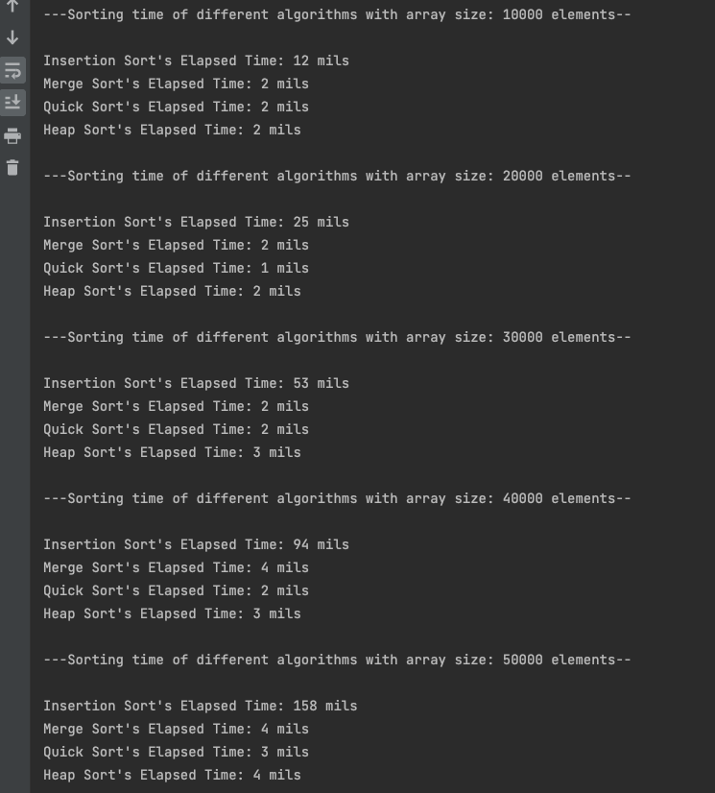

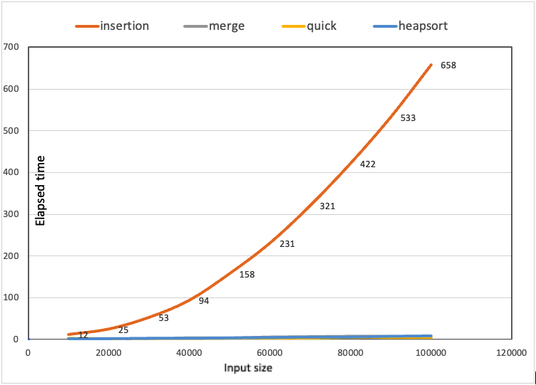

Discussion:

After running the code for 2 time, it is noticeable that insertion sort increases significantly when we increase input size and it takes longest time than merge sort, quick sort and heap sort and those sorting algorithms not quite stable and increase elapsed time not much when we increase the input size. Another factor which contributes to this different is insertion sort time complexity is O(n^2) versus O(nlogn) in the merge sort, quick sort, and heap sort. I also notice that the quick sort is slightly perform better than merge sort and heap sort and it is the fastest elapsed time compared to all sorting algorithms above. Merge sort and heap sort are quite the same.