I have run my file for two times with the result below:

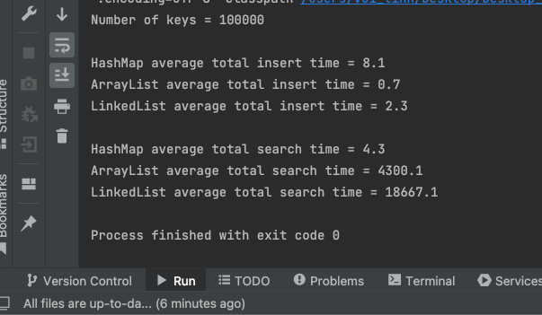

As we can see the result above for calculating the average times of insertion, search using three data structures such as HasMap, ArrayList, LinkedList. Firstly, considering to insertion time, the result demonstrates that insertion time of ArrayList is the fastest and insertion time of HashMap is the slowest, LinkedList is in the middle. But those data structures don’t have too much different about insertion time. On the other hand, when we consider into searching time, it is easy to notice that HashMap’s searching time is the fastest and is extremely faster than others two. HashMap’s searching time is approximately 1000 times faster than ArrayList and more than 4000 times faster than linkedList. The lowest searching time data structure is LinkedList.

In conclusion, in the 3 data structures such as HashMap, ArrayList and LinkedList. ArrayList is the most efficient data structure when we use to insert large number of keys and Hashmap is the most efficient data structure when we use to search key.