

COVID-19 Case Fatality Rate until 17 May, 2020

DSB-ADS42

NGUYEN Minh Huy | 3690954 | 5/17/2020

# Introduction

There is a straightforward question that most people would like to answer. If somebody gets COVID-19 contaminated, how likely is that person to die?

That is a simple question, but surprisingly difficult to answer.

This is where we explain why. The "case fatality rate," the "crude mortality rate" and the "infection fatality rate" will be discussed, and why they're all different.

The key point is that the “case fatality rate”, the most commonly discussed measure of the risk of dying, is not the answer to the question, for two reasons. One, it relies on the number of confirmed cases, and many cases are not confirmed; and two, it relies on the total number of deaths, and with COVID-19, some people who are sick and will die soon have not yet died. These two facts mean that it is extremely difficult to make accurate estimates of the true risk of death.

## The case fatality rate (cfr)

In the media, it is often the case-fatality rate that is mentioned when the risk of death from COVID-19 is discussed.1 This measure is sometimes referred to as the case-fatality risk or the case-fatality ratio or CFR.

But this is not the same as the risk of death for an infected person – although, unfortunately, it is often suggested by journalists. It's relevant and important, but it's far from the whole story.

It is very easy to calculate the CFR. You take the number of people who died, and you divide it by the total number of people diagnosed with the disease. So if 10 people died and 100 people were diagnosed with the disease, the CFR is [10/100] or 10%.

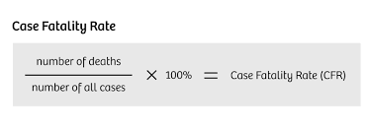But it’s important to note that it is the ratio between the number of confirmed deaths from the disease and the number of confirmed cases, not total cases. That means that is is not the same as - and, in fast-moving situations like COVID-19, probably not even very close to - the true risk for an infected person.

## The current case fatality rate of covid-19

We should stress again that there is no single figure of CFR for any particular disease. The CFR varies by location and is typically changing over time.

As this paper shows, CFRs vary widely between countries, from 0.2% in Germany to 7.7% in Italy. But it says that this is not necessarily an accurate comparison of the true likelihood that someone with COVID-19 will die of it.

We do not know how many cases are asymptomatic versus symptomatic, or whether the same criteria for testing are being applied between countries. Without better and more standardized criteria for testing and for the recording of deaths, the real mortality rate is unknown. As the paper says, to understand the differences in CFR and how they should guide decision-making, we need better data.

But if we’re careful to acknowledge its limitations, CFR can help us to better understand the severity of the disease and what we should do about it.

This chart shows how these early CFR values compare. You can see the total number of confirmed cases of COVID-19 (on the x-axis, going across) versus the total number of deaths (on the y-axis, going up).

The second and third charts show how the CFR has changed over time in countries that have had over 100 confirmed cases.

I have excluded countries that still have a relatively small number of confirmed cases because CFR is a particularly poor metric to understand mortality risk with small sample size.

We see this if we look at the trajectory of cases and deaths in Iran: on February 24th it had 2 confirmed cases and 2 deaths, an implausible CFR of 100%. With time its CFR begins to fall, as the number of confirmed cases increases. By the time it has seen hundreds of cases, the CFR drops to around the level seen in other countries.

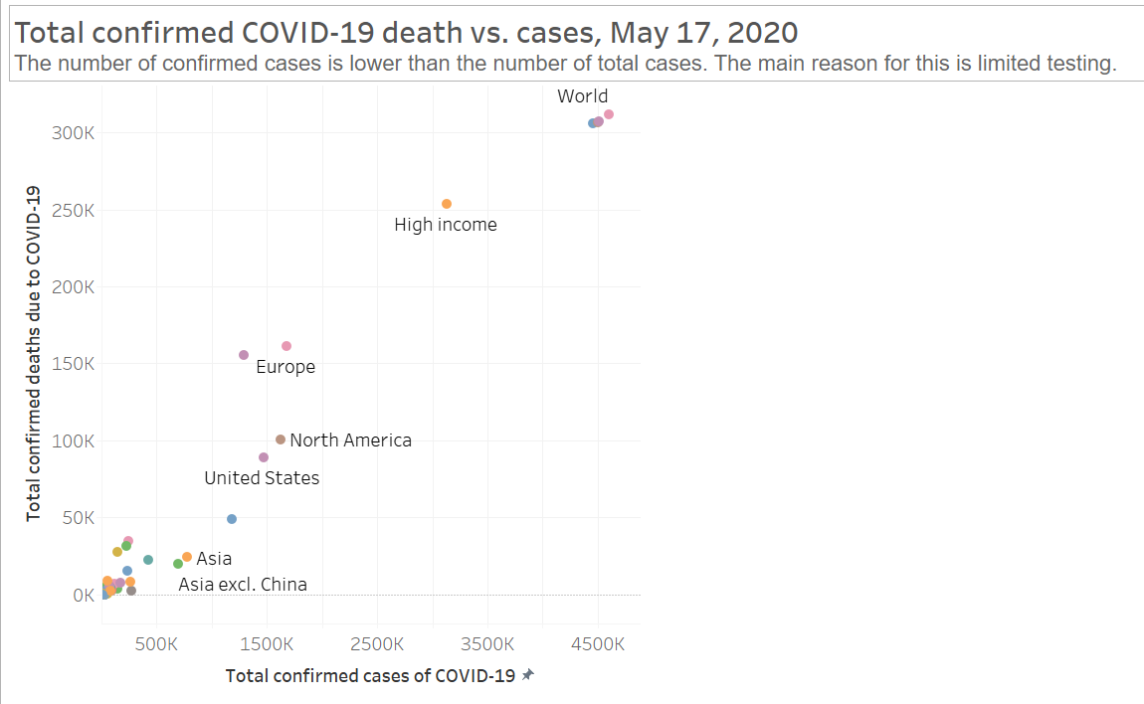

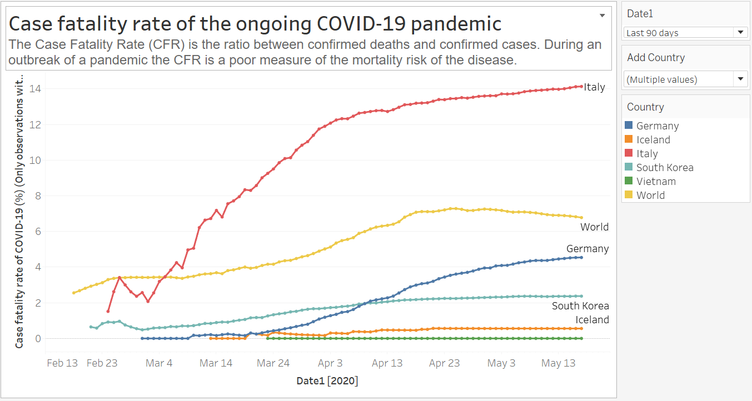

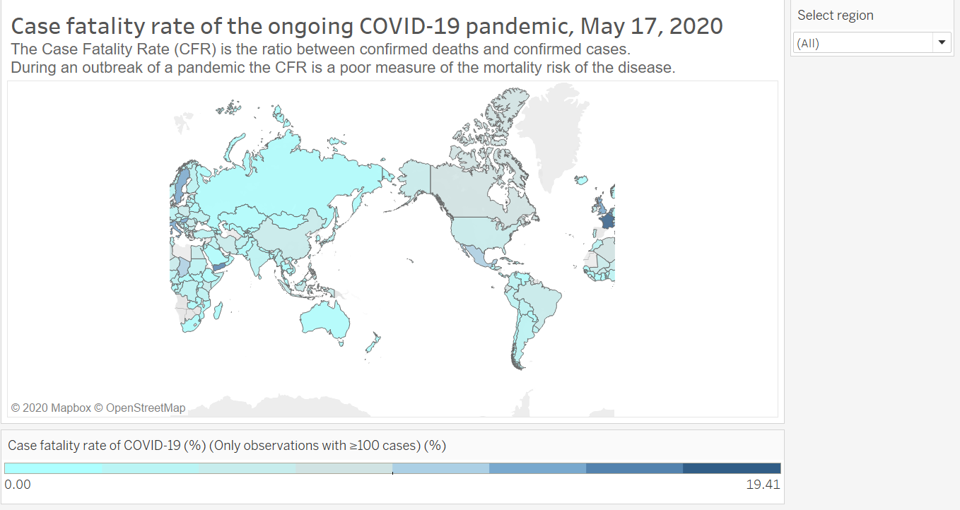

## data sources

D:\Learning Document\ADSB\Challenge\coronavirus-cfr.csv

D:\Learning Document\ADSB\Challenge\covid-19-total-confirmed-cases-vs-total-confirmed-deaths.csv

**Design choice**: Tableau 2010

## Conclusion

The SDG number 3: Good Health and Well-being is a very hard goal to achieved for everyone in the future. This data storytelling project not only focus on what we can do to not underestimate the COVID-19 but also a warning for us to protect our-self better in the future against other diseases.