Họ Tên: Phạm Công Nguyên

Lớp: 11_ĐH_THMT

MSSV: 1150080027

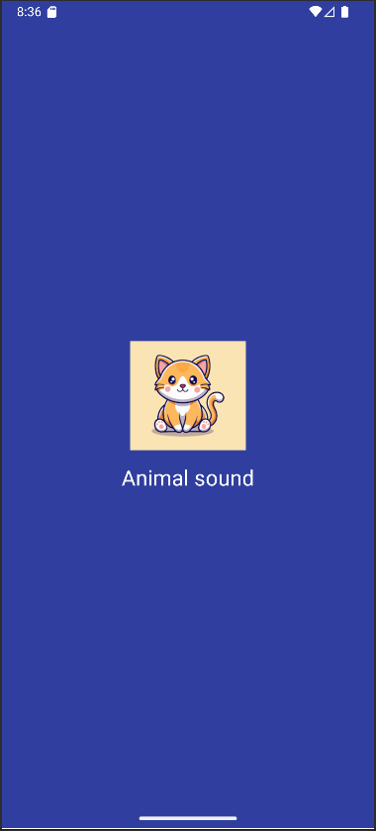

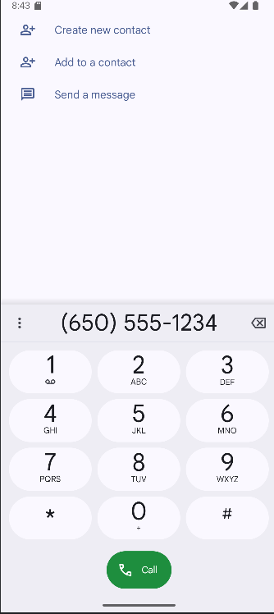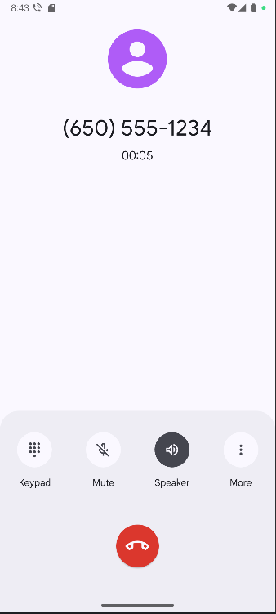

**M000ActSplash.java**

package com.example.myapplication;  
  
import android.app.Activity;  
import android.os.Bundle;  
import android.view.View;  
import android.widget.ImageView;  
  
import java.util.Random;  
  
public class M000ActSplash extends Activity {  
  
 // Dùng 1 icon có sẵn để tránh thiếu resource  
 private final int[] animalIcons = { R.drawable.*ic_cat* };  
 private final int[] bgColors = {  
 0xFF303F9F, 0xFF00695C, 0xFF4E342E  
 };  
  
 @Override  
 protected void onCreate(Bundle savedInstanceState) {  
 super.onCreate(savedInstanceState);  
 setContentView(R.layout.*m000_act_splash*);  
  
 Random rd = new Random();  
 int color = bgColors[rd.nextInt(bgColors.length)];  
 int icon = animalIcons[rd.nextInt(animalIcons.length)];  
  
 View root = findViewById(android.R.id.*content*);  
 root.setBackgroundColor(color);  
 ((ImageView) findViewById(R.id.*imgAnimal*)).setImageResource(icon);  
  
 View overlay = findViewById(R.id.*loading*);  
 overlay.setVisibility(View.*VISIBLE*);  
 overlay.postDelayed(() -> overlay.setVisibility(View.*GONE*), 2000);  
 }  
}

**M001ActProfile.java**

package com.example.myapplication;  
  
import android.app.Activity;  
import android.content.Intent;  
import android.net.Uri;  
import android.os.Bundle;  
  
public class M001ActProfile extends Activity {  
 @Override  
 protected void onCreate(Bundle savedInstanceState) {  
 super.onCreate(savedInstanceState);  
 setContentView(R.layout.*m001_act_profile*);  
  
 findViewById(R.id.*btnCall*).setOnClickListener(v -> {  
 Intent i = new Intent(Intent.*ACTION_DIAL*, Uri.*parse*("tel:6505551234"));  
 startActivity(i);  
 });  
 }  
}

**MainActivity.java**

package com.example.myapplication;  
  
import android.content.Intent;  
import android.os.Bundle;  
import androidx.appcompat.app.AppCompatActivity;  
  
public class MainActivity extends AppCompatActivity {  
 @Override  
 protected void onCreate(Bundle savedInstanceState) {  
 super.onCreate(savedInstanceState);  
 setContentView(R.layout.*activity_main*);  
  
 findViewById(R.id.*btnSplash*).setOnClickListener(v ->  
 startActivity(new Intent(this, M000ActSplash.class)));  
  
 findViewById(R.id.*btnProfile*).setOnClickListener(v ->  
 startActivity(new Intent(this, M001ActProfile.class)));  
 }  
}

**activity_main.xml**

<?xml version="1.0" encoding="utf-8"?>  
<LinearLayout xmlns:android="http://schemas.android.com/apk/res/android"  
 android:layout_width="match_parent"  
 android:layout_height="match_parent"  
 android:padding="24dp"  
 android:gravity="center"  
 android:orientation="vertical">  
  
 <Button  
 android:id="@+id/btnSplash"  
 android:layout_width="match_parent"  
 android:layout_height="wrap_content"  
 android:text="Open Splash (Animal sound)"/>  
  
 <Button  
 android:id="@+id/btnProfile"  
 android:layout_width="match_parent"  
 android:layout_height="wrap_content"  
 android:text="Open Profile"  
 android:layout_marginTop="12dp"/>  
</LinearLayout>

**Item_loading.xml**

<?xml version="1.0" encoding="utf-8"?>  
<LinearLayout xmlns:android="http://schemas.android.com/apk/res/android"  
 android:layout_width="match_parent"  
 android:layout_height="match_parent"  
 android:gravity="center"  
 android:background="@color/overlay"  
 android:orientation="vertical">  
  
 <ProgressBar  
 android:id="@+id/pb"  
 android:layout_width="60dp"  
 android:layout_height="60dp"  
 android:indeterminate="true"  
 android:indeterminateTint="@color/white"/>  
  
 <TextView  
 android:layout_width="wrap_content"  
 android:layout_height="wrap_content"  
 android:text="@string/txt_loading"  
 android:textColor="@color/white"  
 android:textSize="20sp"  
 android:layout_marginTop="12dp"/>  
</LinearLayout>

**m000_act_splash.xml**

<?xml version="1.0" encoding="utf-8"?>  
<FrameLayout xmlns:android="http://schemas.android.com/apk/res/android"  
 android:layout_width="match_parent"  
 android:layout_height="match_parent">  
  
 <include layout="@layout/m000_act_splash_content"/>  
  
 <include  
 android:id="@+id/loading"  
 layout="@layout/item_loading"  
 android:visibility="gone"/>  
</FrameLayout>

**m000_act_splash_content.xml**

<?xml version="1.0" encoding="utf-8"?>  
<LinearLayout xmlns:android="http://schemas.android.com/apk/res/android"  
 android:layout_width="match_parent"  
 android:layout_height="match_parent"  
 android:background="@color/primaryDark"  
 android:gravity="center"  
 android:orientation="vertical">  
  
 <ImageView  
 android:id="@+id/imgAnimal"  
 android:layout_width="128dp"  
 android:layout_height="128dp"  
 android:src="@drawable/ic_cat" />  
  
 <TextView  
 android:layout_width="wrap_content"  
 android:layout_height="wrap_content"  
 android:layout_marginTop="10dp"  
 android:text="@string/app_name"  
 android:textColor="@color/white"  
 android:textSize="24sp" />  
</LinearLayout>

**m001_act_profile.xml**

<?xml version="1.0" encoding="utf-8"?>  
<LinearLayout xmlns:android="http://schemas.android.com/apk/res/android"  
 xmlns:app="http://schemas.android.com/apk/res-auto"  
 android:layout_width="match_parent"  
 android:layout_height="match_parent"  
 android:background="#FAFAFA"  
 android:orientation="vertical">  
  
 <FrameLayout  
 android:layout_width="match_parent"  
 android:layout_height="350dp">  
  
 <ImageView  
 android:id="@+id/imgBg"  
 android:layout_width="match_parent"  
 android:layout_height="300dp"  
 android:scaleType="centerCrop"  
 android:src="@drawable/bg_avatar" />  
  
 <TextView  
 android:layout_width="wrap_content"  
 android:layout_height="wrap_content"  
 android:layout_gravity="bottom"  
 android:layout_marginStart="70dp"  
 android:layout_marginBottom="90dp"  
 android:text="Ali Connors"  
 android:textColor="@android:color/white"  
 android:textSize="40sp" />  
  
 <ImageView  
 android:id="@+id/btnStar"  
 android:layout_width="80dp"  
 android:layout_height="80dp"  
 android:layout_gravity="end|bottom"  
 android:layout_marginEnd="20dp"  
 android:layout_marginBottom="10dp"  
 android:background="@drawable/bg_oval"  
 android:padding="20dp"  
 android:src="@drawable/ic_star"  
 app:tint="@android:color/white"/>  
 </FrameLayout>  
  
 <TableRow  
 android:layout_width="match_parent"  
 android:layout_height="wrap_content"  
 android:padding="20dp">  
  
 <ImageView  
 android:id="@+id/btnCall"  
 android:layout_width="60dp"  
 android:layout_height="60dp"  
 android:padding="10dp"  
 android:src="@drawable/ic_phone"  
 app:tint="@color/overlay"/>  
  
 <LinearLayout  
 android:layout_width="match_parent"  
 android:layout_height="wrap_content"  
 android:layout_marginStart="30dp"  
 android:orientation="vertical">  
  
 <TextView  
 android:layout_width="match_parent"  
 android:layout_height="wrap_content"  
 android:text="(650) 555-1234"  
 android:textSize="20sp"/>  
  
 <TextView  
 android:layout_width="match_parent"  
 android:layout_height="wrap_content"  
 android:layout_marginTop="5dp"  
 android:text="Mobile"  
 android:textSize="18sp"  
 android:textColor="#979797"/>  
  
 <View  
 android:layout_width="match_parent"  
 android:layout_height="0.5dp"  
 android:layout_marginTop="30dp"  
 android:background="#979797"/>  
 </LinearLayout>  
 </TableRow>  
  
 <TableRow  
 android:layout_width="match_parent"  
 android:layout_height="wrap_content"  
 android:padding="20dp">  
  
 <ImageView  
 android:layout_width="60dp"  
 android:layout_height="60dp"  
 android:padding="10dp"  
 android:src="@drawable/ic_email"  
 app:tint="@color/indigo"/>  
  
 <LinearLayout  
 android:layout_width="match_parent"  
 android:layout_height="match_parent"  
 android:layout_marginStart="30dp"  
 android:orientation="vertical">  
  
 <TextView  
 android:layout_width="match_parent"  
 android:layout_height="wrap_content"  
 android:text="aliconnors@example.com"  
 android:textSize="20sp"/>  
  
 <TextView  
 android:layout_width="match_parent"  
 android:layout_height="wrap_content"  
 android:layout_marginTop="5dp"  
 android:text="Mobile"  
 android:textSize="18sp"  
 android:textColor="#979797"/>  
 </LinearLayout>  
 </TableRow>  
</LinearLayout>

**AndroidManifest.xml**

<?xml version="1.0" encoding="utf-8"?>  
<manifest package="com.example.myapplication" xmlns:android="http://schemas.android.com/apk/res/android">  
  
 <application  
 android:allowBackup="true"  
 android:label="@string/app_name"  
 android:icon="@mipmap/ic_launcher"  
 android:roundIcon="@mipmap/ic_launcher_round"  
 android:supportsRtl="true"  
 android:theme="@style/Theme.MyApp">  
  
 <activity  
 android:name=".M001ActProfile"  
 android:theme="@style/Full_Screen" />  
  
 <activity  
 android:name=".M000ActSplash"  
 android:noHistory="true"  
 android:theme="@style/Full_Screen" />  
  
 <activity android:name=".MainActivity"  
 android:exported="true">  
 <intent-filter>  
 <action android:name="android.intent.action.MAIN"/>  
 <category android:name="android.intent.category.LAUNCHER"/>  
 </intent-filter>  
 </activity>  
  
 </application>  
</manifest>