De Anza College

CIS 22C – Spring 2016

Team 4

PROGRAM DEMONSTRATION

Kevin Nguyen

Ka U (Johnny) Ieong

Bret Farley

Minting Ye

1. Execute the program

Main menu should look like this:

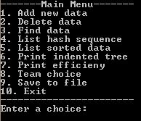

1. Try invalid menu selections

Purpose: menu will only work by entering characters 1-10

* + **Enter “asdf”**
  + **Enter “0”**
  + **Enter “11”**
  + **Enter “191”**
  + **Enter “ASDF”**
  + **Return to main menu**

1. Try showing data of empty tree/hash table

Purpose: Show that no data has been entered, nothing to print

* + **Enter “4”**
  + **Press any key to exit**
  + **Enter “6”**
  + **Enter “1” or “2” or “3”**
  + **Press any key to exit**
  + **Return to main menu**

1. Add data

Purpose: Show how to add data – 2 options

Manually – add a player manually; requires entering name, team, and all stats

Use default file – uses the default input file we created i.e. “RB_stats_2015.txt”

* + **Enter “1”**

Menu options now show:



* **Enter “2” – use the default data file “RB_stats_2015.txt”**
* **Return to the main menu**

1. Find data
   * **Enter “3”**
   * **Type in: “Devonta Freeman”**
   * Output should show as follows:

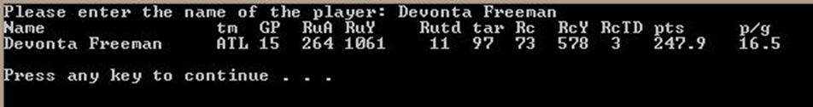

* **Return to main menu**

1. List hash sequence
   * **Enter “4”**
   * Output should show hashTable contents:

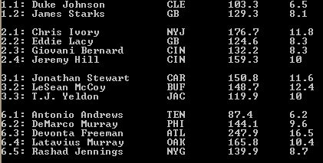

*Only shows a portion of the screen here

*Note that each slot is maintained alphabetically in sorted order

* **Return to main menu**

1. List sorted data
   * **Enter “5”**
   * **Enter “1”, “2”, or “3”**
   * Output is sorted alphabetically or numerically in descending order depending on choice

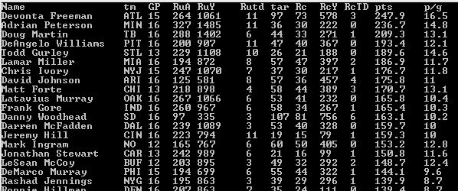

* + **Return to main menu**

1. List indented tree
   * **Enter “6”**
   * **Enter “1”, “2”, or “3”**
   * Output is sorted by whatever option and prints a horizontal indented AVL

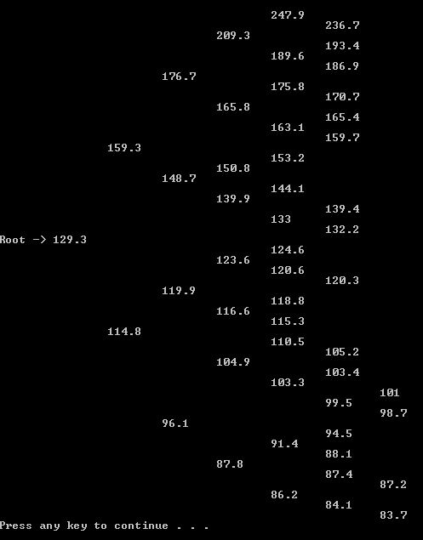

* + **Return to Menu**

1. Delete Data
   * **Enter “2”**
   * **Enter “Devonta Freeman”**
   * **Return to main menu**
   * **Try finding him (step 5)**
   * **List sorted data by points (step 7)**
   * **Print indented tree by points (step 8)**
2. Add “Devonta Freeman” manually
   * **Enter “1”**
   * **Enter “1”**
   * **Manually enter the following stats for Devonta Freeman**

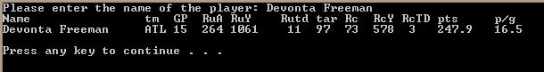

* + **Try finding him (step 5)**
  + **List sorted data by points (step 7)**
  + **Print indented tree by points (step 8)**

1. Add “Latavius Murray” manually to show collision resolution
   * **List hash table data**
   * **Note: Latavius Murray and Devonta Freeman are on the same table index (6)**
   * **Return to main menu**
   * **Enter “1”**
   * **Enter “1”**
   * **Manually enter the following stats for “Latavius Murray”**

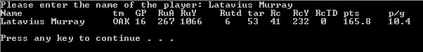

* + **List hash table data (6)**

1. Delete “Latavius Murray”
   * **Utilize same steps in step 9 but with “Latavius Murray”**
2. Compare two players
   * **At main menu, select “compare”**
   * **Enter “Latavius Murray”**
   * **Enter “Devonta Freeman”**

C:\Users\Kevin\AppData\Local\Microsoft\Windows\INetCache\Content.Word\Capture.jpg

1. Print efficiency
   * Select print efficiency option from menu
2. Exit
   * Exit the program – program automatically saves to the same file