Internal Specification

Development of SPIDCTL model for E2x, U2A and U2B
(v1.3)

Summary:
This document describes the Detail Specification of SPIDCTL model for U2B, U2A and E2x

Relative Document

Reference Manuals
No. | Title name | Document number | Description | Path
1 | SC-HEAP_E3 common requirement (v1.0) | - | The common requirement  (File: Common_Requirement_RVC.pdf) | SPO: RVC-DMS  1. General Documents/ESW/MCU_SW/01_Automotive_Software_Tool/01_Automotive_Software_Tool_1/01_MCU_Modeling/INPUT
2 | SC-HEAP_E3 Modeling guideline (Rev. 7.00) | IDF-14-010278-01 | This document describes the Guideline for peripheral macro  development which is connected to SC-HEAP_E3 simulator  (File: SC-HEAP_E3_Modeling_Guideline.pdf)
3 | SC-HEAP_E3 BUS I/F outline | LLWEB-00010925  ZSG-F31-12-0029-01 | The document describes the outline of bus I/F applied to SC-HEAP_E3  (File: scheap_e3_bus_if_outline_E.pdf)
4 | SC-HEAP_E3 PYTHON I/F function specification (v3.0) | LLWEB-00105192  MSS-SG-12-0062-03 | The document describes how to use python interface  (File: SC-HEAP_E3 Python IF_t.pdf)
5 | RH850/U2A-EVA Group User Manual: Hardware | r01uh0864ej0061-rh850u2a(Rev.0.61  Jun, 2019) | Hardware user’s manual of SPID.  (File: r01uh0864ej0061-rh850u2a.pdf) | Server:  /shsv/MobAP2/prj_MCS/02_projects/2020/rel/202001_prj_MCS_U2A_SPID/Input
6 | RH850/E2x-FCC2 User’s manual: Hardware | r01uh0770ej0060-e2x-fcc2_E2UH_E2H(Rev.0.60 Feb 2019) | Hardware user’s manual of SPID.  (File: r01uh0770ej0060-e2x-fcc2_E2UH_E2H.pdf)
7 | RH850/E2x-FCC2 User’s manual: Hardware | r01uh0771ej0060-e2x-fcc2_E2GUH_E2GH(Rev.0.60 Feb 2019) | Hardware user’s manual of SPID.  (File: r01uh0771ej0060-e2x-fcc2_E2GUH_E2GH.pdf)
8 | SPIDCTL model detail requirement | REQ-MCS-20001_SPIDCTL  (*) | Detail requirement of SPIDCTL model  (File: REQ-MCS-20001_SPIDCTL.xlsx) | SVN:  http://172.29.139.78/mcu_modeling_01/release/docs/REQ/2020/20001_U2A_SPIDCTL
9 | U2B/HWUM | r01uh0924ej0040-rh850u2b  Rev: 040 | U2B/HWUM  (r01uh0924ej0040-rh850u2b.pdf) | Server:  \\rvc-vnas-01\MobAP2\prj_MCS\06_From_REL\20210301_U2BxHWUM0.4\r01uh0924ej0040-rh850u2b.pdf
. Note: (*) Refer to DEV-MCS-20001_SPIDCTL for version number.

Contents
1. Model summary 5
2. Supported features 5
3. Block diagram 6
4. List of registers 7
5. List of implemented ports 11
6. Direction for users 12
6.1. File structures 12
6.2. Input/Output file 13
6.3. How to connect Verification Environment 13
6.4. Commands and parameters 15
6.5. Message style 17
6.5.1. Register RW messages 17
6.5.2. Help messages 17
6.5.3. Error and debugging messages 19
6.5.4. List of error and debugging messages 19
6.6. Define macro and template 22
7. Flow diagrams 23
7.1. Sequence diagram of reset port handling 23
7.2. Sequence diagram of clock port handling 24
7.3. Sequence diagram of Python IF handling 24
7.4. Sequence diagram of register reading 25
7.5. Sequence diagram of register writing 26
7.6. Flow of callback function of register SPID writing 27
7.7. Flow of callback function of register SPID Mask writing 28
7.8. Flow of callback function of register SPID Mask Lock writing 29
7.9. Flow of callback function of register SPID Key code protection writing 30
7.10. Flow process update SPID value. 31
7.11. Flow of reset 32
7.12. Flow of Python IF 33
8. Function description 34
8.1. List of public/private function in SPIDCTL class 34
8.2. List of public/private function in SPIDCTL_Func class 35
8.3. List of public function in SPIDCTL_AgentController class 36
9. Limitation 37
10. Appendix 38

Index of Figures
Figure 3-1: Block diagram of SPIDCTL model 6
Figure 6-1: File structure of SPIDCTL model 12
Figure 7-1: Sequence diagram of reset port handling 23
Figure 7-2: Sequence diagram of clock handling 24
Figure 7-3: Sequence diagram of Python IF handling 24
Figure 7-4: Sequence diagram of register reading 25
Figure 7-5: Sequence diagram of register writing 26
Figure 7-6: Flow of callback function of register SPID writing 27
Figure 7-7: Flow of callback function of register SPID Mask writing 28
Figure 7-8: Flow of callback function of register SPID Mask Lock writing 29
Figure 7-9: Flow of callback function of register SPID Key code protection writing 30
Figure 7-10: Flow process update SPID value. 31
Figure 7-11: Flow of reset 32
Figure 7-12: Flow of Python IF 33
Figure 10-1: U2B Initial value of SPID 38
Figure 10-2: U2A Initial value of SPID 39
Figure 10-3: E2x Initial value of SPID 40

Index of Tables
Table 2.1: List of supported features in SPIDCTL model 5
Table 4.1: List of registers in SPIDCTL model 7
Table 4.2: Base address of registers 10
Table 5.1: List of implemented ports in SPIDCTL model 11
Table 6.1: File description for SPIDCTL 13
Table 6.2: List of supported parameters 15
Table 6.3: List of supported commands 15
Table 6.4: Dump Register RW message description 17
Table 6.5: Dump parameter help message description 17
Table 6.6: Dump command help message description 19
Table 6.7: Error and debugging message description 19
Table 6.8: Error and debugging message in SPIDCTL model 19
Table 8.1: List of public functions in SPIDCTL class 34
Table 8.2: List of private functions in SPIDCTL class 34
Table 8.3: List of public functions in SPIDCTL_Func class 35
Table 8.4: List of private functions in SPIDCTL_Func class 35
Table 8.5: List of public functions in SPIDCTL_AgentController class 36
Table 9.1: Limitation of model 37

Model summary
- SPIDCTL is a SystemC model supporting U2B, U2A and E2x platforms, presents for System Protection Identifier module. This model is used for supervising SPIDs which can be used by specific BusMasters.
- In this design, the followings are supported in SPIDCTL model:
  - 32-bit width of APB bus.
  - One target socket for access registers inside. Refer chapter 3 for detail.
  - Both loosely time mode (LT) and approximately time (AT) mode are supported.
  - Little endian mode as the endian of APB bus interface.
  - Parameters/Commands of Python IF to control operation of SPIDCTL model. Refer to chapter parameters/commands for more detail.

Supported features
Table 2.1: List of supported features in SPIDCTL model
Feature | Description |  | HWM Reference
Feature | Hardware | Model | HWM Reference
Operating frequency (PCLK) | - Clock source CLK_HBUS | Unlimited frequency
Asynchronous reset (Reset) | - | Asynchronous
High flexibility | - SPID of each bus master is configurable by software with high flexibility according to user’s system. | <- | [5] Chapter 44.5.3.1 Overview  [9] Section 55.5.3.1 Overview
Assign SPID to bus master | - It is possible to assign one SPID to one bus master or assign one SPID to several bus masters. | <- | [5] Chapter 44.5.3.1 Overview  [9] Section 55.5.3.1 Overview
Limit SPID by mask register | - It is possible to limit SPID that each bus master uses by SPIDMASK register. Moreover, this configuration can be locked. | <- | [5] Chapter 44.5.3.1 Overview  [9] Section 55.5.3.1 Overview
Security purpose | - The lock function prevents unauthorized use of SPID for security purpose. | <- | [5] Chapter 44.5.3.1 Overview  [9] Section 55.5.3.1 Overview
Note: “<-”: same as hardware manual

Block diagram

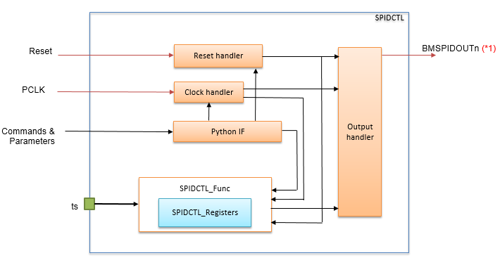
Figure 3-1: Block diagram of SPIDCTL model
Explanation:
- The SPIDCTL model has sub-blocks inside:
  - Reset Handler: checks the reset port, the reset command from Python IF to reset the model.
  - Clock Handler: checks the input clock, the clock command from Python IF to generate the period of operation clock.
  - Python IF: with parameters/commands supports controlling SPIDCTL.
  - SPIDCTL_Func: has registers inside. Its controls operation of SPIDCTL module.
  - Output handler: control the output port.
- Target socket 'ts': APB interface to access model's registers.
Note: (*1) n =0~63.

List of registers
- Table 4.2 lists all registers in SPIDCTL model.
Table 4.2: List of registers in SPIDCTL model
Register name | Address Offset | Initial value | Size(Byte) | Write access size (bits) | Read access size (bits) | R/W | Bit position | Bit name |  | Operation | Support
 |  |  |  |  |  |  |  | HWM | Model | Operation | Support
BMnSPID  (BusMaster n SPID Register)(*1) | <SPIDCTL_base> + n * 0x4 (*1) | (*2) | 4 | 8/16/32 | 8/16/32 | R/W | [4:0] | SPID | <- | SPID for each bus master.  These bits are set the SPID of each bus master. | Yes
BMnSPIDMSK  (Bus Master n SPID Mask Register) (*1) | <SPIDCTL_base> + 0x100 + n * 0x4 (*1) | 0xFFFFFFFF | 4 | 8/16/32 | 8/16/32 | R/W | [31:0] | SPIDMSK | <- | Set inhibition of SPID value which that each bus master can use.  Each bit corresponds to a single SPID value  0: The bus master cannot use this SPID. Setting of this SPID is inhibited.  1: The bus master can use this SPID. Setting of this SPID is not inhibited. | Yes
BMnSPIDMSKLOCK  (Bus Master n SPID Mask Lock Register)(*1) | <SPIDCTL_base> + 0x200 + n * 0x4 (*1) | 0x0 | 4 | 8/16/32 | 8/16/32 | RW | [0] | LOCK | <- | Set write mask to each BMSPIDMSKn.  0: Register BMSPIDMSKn can be re-written  1: Any further write to the register BMSPIDMSKn is ignored.  This bit can be cleared by Power On Reset, System Reset 1, System Reset 2, Application Reset and DeepSTOP Reset. | Yes
SPIDKCPROT  (SPID Key Code Protection Register) | <SPIDCTL_base> + 0x300 | 0x0 | 4 | 32 | 8/16/32 | RW | [31:1] | KCPROT | <- | Enable or disable modification of the KCE bit.  The value written is not retained. These bits are always read as 0. | Yes
 |  |  |  |  |  |  | [0] | KCE | <- | Key Code Enable bit  0: Disable write access of protected registers.  1: Enable write access of protected registers. | Yes
GTMSPIDAS0  (GTM SPID Module Assignment Setting Register 0) | 0xFFF50000 + 0x18 | 0x76543210 | 4 | 8/16/32 | 8/16/32 | RW | [30:28] | CL7 | <- | Select the SPID module assign to cluster 7.  0: SPID module(n=10)  1: SPID module(n=11)  2: SPID module(n=12)  3: SPID module(n=13)  4: SPID module(n=14)  5: SPID module(n=15)  6: SPID module(n=16)  7: SPID module(n=17) | No
 |  |  |  |  |  |  | [26:24] | CL6 | <- | Select the SPID module assign to cluster 6.  0: SPID module(n=10)  1: SPID module(n=11)  2: SPID module(n=12)  3: SPID module(n=13)  4: SPID module(n=14)  5: SPID module(n=15)  6: SPID module(n=16)  7: SPID module(n=17) | No
 |  |  |  |  |  |  | [22:20] | CL5 | <- | Select the SPID module assign to cluster 5.  0: SPID module(n=10)  1: SPID module(n=11)  2: SPID module(n=12)  3: SPID module(n=13)  4: SPID module(n=14)  5: SPID module(n=15)  6: SPID module(n=16)  7: SPID module(n=17) | No
 |  |  |  |  |  |  | [18:16] | CL4 | <- | Select the SPID module assign to cluster 4.  0: SPID module(n=10)  1: SPID module(n=11)  2: SPID module(n=12)  3: SPID module(n=13)  4: SPID module(n=14)  5: SPID module(n=15)  6: SPID module(n=16)  7: SPID module(n=17) | No
 |  |  |  |  |  |  | [14:12] | CL3 | <- | Select the SPID module assign to cluster 3.  0: SPID module(n=10)  1: SPID module(n=11)  2: SPID module(n=12)  3: SPID module(n=13)  4: SPID module(n=14)  5: SPID module(n=15)  6: SPID module(n=16)  7: SPID module(n=17) | No
 |  |  |  |  |  |  | [10:8] | CL2 | <- | Select the SPID module assign to cluster 2.  0: SPID module(n=10)  1: SPID module(n=11)  2: SPID module(n=12)  3: SPID module(n=13)  4: SPID module(n=14)  5: SPID module(n=15)  6: SPID module(n=16)  7: SPID module(n=17) | No
 |  |  |  |  |  |  | [6:4] | CL1 | <- | Select the SPID module assign to cluster 1.  0: SPID module(n=10)  1: SPID module(n=11)  2: SPID module(n=12)  3: SPID module(n=13)  4: SPID module(n=14)  5: SPID module(n=15)  6: SPID module(n=16)  7: SPID module(n=17) | No
 |  |  |  |  |  |  | [2:0] | CL0 | <- | Select the SPID module assign to cluster 0.  0: SPID module(n=10)  1: SPID module(n=11)  2: SPID module(n=12)  3: SPID module(n=13)  4: SPID module(n=14)  5: SPID module(n=15)  6: SPID module(n=16)  7: SPID module(n=17) | No
GTMSPIDAS0  (GTM SPID Module Assignment Setting Register 0) | 0xFFF50000 + 0x1C | 0x00000010 | 4 | 8/16/32 | 8/16/32 | RW | [6:4] | CL9 | <- | Select the SPID module assign to cluster 9.  0: SPID module(n=10)  1: SPID module(n=11)  2: SPID module(n=12)  3: SPID module(n=13)  4: SPID module(n=14)  5: SPID module(n=15)  6: SPID module(n=16)  7: SPID module(n=17) | No
 |  |  |  |  |  |  | [2:0] | CL8 | <- | Select the SPID module assign to cluster 8.  0: SPID module(n=10)  1: SPID module(n=11)  2: SPID module(n=12)  3: SPID module(n=13)  4: SPID module(n=14)  5: SPID module(n=15)  6: SPID module(n=16)  7: SPID module(n=17) | No
Note: “<-”: Same as hardware manual.
(*1): n = 0 to 63
(*2): Refer 10. Appendix: Initial value of SPID
Register base address:

Table 4.3: Base address of registers
Base Address Name | Base Address
SPIDCTL_base | FF0A 8000H

List of implemented ports
- Table 5.4 lists implemented ports in SPIDCTL model.
Table 5.4: List of implemented ports in SPIDCTL model
Signal name |  | I/O | Type | Initial | Active | Sync. clock | Description | Support
HWM | Model
Clock/reset
- | PCLK | In | sc_in<sc_dt::uint64> | - | - | - | Operation clock source | Yes
- | Reset | In | sc_in<bool> | HIGH | low level | - | Reset signal | Yes
APB I/F
- | ts | In/Out | TlmTargetSocket<32> | - | - | - | Target socket of APB bus interface to access to registers of model | Yes
BMnSPIDOUT
BMnSPIDOUT | BMSPIDOUT[64] | Out | sc_out<unsigned char>(*2) | (*1) | - | PCLK | SPID output value. | Yes
Note: (*1): Refer 10. Appendix: Initial value of SPID
(*2): Match with SPID input port of SPID Modifier model.

Direction for users

File structures
PY_SPIDCTL.h
PY_SPIDCTL.cpp
Python.h
SPIDCTL.h

SPIDCTL.h
SPIDCTL.cpp
SPIDCTL_Func.h
BusSlaveBase.h
global.h
re_define.h
SPIDCTL_AgentController.h
Common.h

rvc_common_model.h
rvc_common_model.cpp

SPIDCTL_Func.h
SPIDCTL_Func.cpp
SPIDCTL_AgentController.h
global.h

BusSlaveFuncIf.h
spidctl_regif.h
spidctl_regif.cpp
re_register.h
reg_super.h

Legend:
A
B
File A includes file B
B
A
A is header file, B is implementation file

Figure 6-2: File structure of SPIDCTL model
Table 6.5: File description for SPIDCTL
No. | File name | Version | Developed/ Reused/  Generated | Description
1 | PY_SPIDCTL.h | - | Developed | Header file of Python Interface of SPIDCTL model
2 | PY_SPIDCTL.cpp | - | Developed | Implementation file of Python Interface of SPIDCTL model
3 | SPIDCTL.h | - | Developed | Header file of SPIDCTL model
4 | SPIDCTL.cpp | - | Developed | Implementation file of SPIDCTL model
5 | SPIDCTL_Func.h | - | Developed | Header file of SPIDCTL function block
6 | SPIDCTL_Func.cpp | - | Developed | Implementation file of SPIDCTL function block
7 | SPIDCTL_AgentController.h | - | Developed | Header file includes virtual functions which are implemented in SPIDCTL model
8 | spidctl_regif.h | - | Generated (*1) | Header file of SPIDCTL registers’ interface
9 | spidctl_regif.cpp | - | Generated (*1) | Implementation file of SPIDCTL registers’ interface
10 | Python.h | - | Reused | Header file of python library.
11 | re_register.h | v2016_09_21 | Reused | Header file of the re_register class.
12 | re_register.cpp | v2016_09_21 | Reused | Implement the attributes and the operations of common register class.
13 | reg_super.h | v2016_09_21 | Reused | General class for models to access to the memory array.
14 | BusSlaveBase.h | - | Reused | Header file of BusSlaveBase class.
15 | BusSlaveFuncIf.h | - | Reused | Header file of BusSlaveFuncIf class.
16 | re_define.h | - | Reused | Define common define macro, enum and so on
17 | rvc_common_model.cpp | - | Reused | Implementation file of common APIs
18 | rvc_common_model.h | - | Reused | Header file of common APIs
19 | global.h | - | Reused | Header file contains common macros
20 | Common.h | - | Reused | Header file for token converting APIs

Note:
(*1) File with format *_regif.h/cpp in table above are generated from Register IF Generator tool v2020_03_20.

Input/Output file
- There is no input/output file.

How to connect Verification Environment
- The following steps should be done to connect SPIDCTL into environment.
  - Declare an instance of the SPIDCTL class in environment.
spidctl = new SPIDCTL("spidctl", 0, 0, config_file);

Config file format:
[SPID_BUS_MASTER] = (x, y)
- x: Register position.
- y: Initial value.

Example: config file for U2B
[SPID_BUS_MASTER] = (10, 10)
[SPID_BUS_MASTER] = (11, 10)
[SPID_BUS_MASTER] = (12, 10)
[SPID_BUS_MASTER] = (13, 10)
[SPID_BUS_MASTER] = (14, 10)
[SPID_BUS_MASTER] = (15, 10)
[SPID_BUS_MASTER] = (16, 10)
[SPID_BUS_MASTER] = (17, 10)
[SPID_BUS_MASTER] = (18, 11)
[SPID_BUS_MASTER] = (19, 11)
[SPID_BUS_MASTER] = (20, 12)
[SPID_BUS_MASTER] = (21, 12)
[SPID_BUS_MASTER] = (22, 13)
[SPID_BUS_MASTER] = (23, 14)
[SPID_BUS_MASTER] = (24, 15)
[SPID_BUS_MASTER] = (27, 18)
[SPID_BUS_MASTER] = (28, 19)
[SPID_BUS_MASTER] = (32, 23)
[SPID_BUS_MASTER] = (33, 24)
[SPID_BUS_MASTER] = (34, 25)
[SPID_BUS_MASTER] = (35, 26)
[SPID_BUS_MASTER] = (36, 26)
[SPID_BUS_MASTER] = (37, 26)
[SPID_BUS_MASTER] = (43, 31)

Example: config file for E2x
[SPID_BUS_MASTER] = (19, 19)
[SPID_BUS_MASTER] = (21, 21)
[SPID_BUS_MASTER] = (22, 22)
[SPID_BUS_MASTER] = (23, 23)
[SPID_BUS_MASTER] = (24, 24)
[SPID_BUS_MASTER] = (26, 26)

  - Connect the target socket of SPIDCTL instance to corresponding initiator socket.
  - Connect reset/clock port of SPIDCTL to corresponding ports.
  - Connect output ports to corresponding ports.

Commands and parameters
- Users set parameters/commands to the SPIDCTL via Python IF to control operation. Table 6.6 and Table 6.7 list supported parameters/commands in SPIDCTL model.
Table 6.6: List of supported parameters
Parameter | Type | Default | Description
SPIDCTL_MessageLevel | string | fatal|error | Select debug message level (“fatal”, “error”, “warning”, “info”).  One or more than levels can be connected by vertical bar.  Example “fatal|error”:  SCHEAP.SPIDCTL_MessageLevel("RH850.spidctl", "fatal|error")
SPIDCTL_DumpRegisterRW | bool | false | Dump register access information when registers are accessed.  + false: Not dump register access information  + true: Dump register access information  Example:  SCHEAP.SPIDCTL_DumpRegisterRW("RH850.spidctl"," false")
SPIDCTL_EnableRegisterMessage | bool | true | Dump info/warning/error message of register IF  + false: Not dump info/warning/error message of register IF  + true: Dump info/warning/error message of register IF  Example  SPIDCTL_EnableRegisterMessage("RH850.spidctl", "true")

Table 6.7: List of supported commands
Command | Type | Argument | Description
SPIDCTL_DumpStatusInfo | void | - | Dump the status information of the SPIDCTL.  Example:  SCHEAP.SPIDCTL_DumpStatusInfo("RH850.spidctl")
SPIDCTL_AssertReset | void | reset_name,  start-time,  period | Assert and de-assert reset signal  + std::string <reset_name>: name of reset signal ("Reset")  + double <start-time>: the time until asserting reset signal from current time. The unit is "ns"  + double <period>: the time from asserting reset signal to de-assert it. The unit is "ns"  Example:  SCHEAP.SPIDCTL_AssertReset("RH850.spidctl","Reset",10,10)
SPIDCTL_SetCLKFreq | void | clock_name,  freq,  unit | Set frequency value to these blocks  + std::string <clock_name>: name of clock signal ("PCLK")  + sc_dt::uint64 <freq>: clock frequency  + std::string <unit>: frequency unit ("Hz", "KHz", "MHz" or "GHz")  Example:  SCHEAP.SPIDCTL_SetCLKFreq("RH850.spidctl","PCLK",1000000,"Hz")
SPIDCTL_GetCLKFreq | void | clock_name | Get frequency value of these blocks  + std::string <clock_name>: name of clock signal ("PCLK")  Example:  SCHEAP.SPIDCTL_GetCLKFreq("RH850.spidctl","PCLK")
SPIDCTL_ForceRegister | void | reg_name, value | Force register with setting value  + std::string <reg_name>: name of register  + unsigned int <value>: value which is set to register  Example:  SCHEAP.SPIDCTL_ForceRegister("RH850.spidctl", "BMSPIDMSK00", 0xFFFFFFFF)
SPIDCTL_ReleaseRegister | void | reg_name | Release register from force value  + std::string <reg_name>: name of register  Example:  SCHEAP.SPIDCTL_ReleaseRegister("RH850.spidctl ", "BMSPIDMSK00")
SPIDCTL_WriteRegister | void | reg_name,  value | Write a value to register  + std::string <reg_name>: name of register  + unsigned int <value>: value which is set to register  Example:  SCHEAP.SPIDCTL_WriteRegister("RH850.spidctl","BMSPIDMSK00",0x00000001)
SPIDCTL_ReadRegister | void | reg_name | Read a value from register  + std::string <reg_name>: name of register  Example:  SCHEAP.SPIDCTL_ReadRegister("RH850.spidctl","BMSPIDMSK00")
SPIDCTL_ListRegister | void | - | Dump register names of model  Example:  SCHEAP.SPIDCTL_ListRegister("RH850.spidctl")
SPIDCTL_Help | void | type | Dump the direction how to use python interface parameters and commands  + std::string <type>: "parameters" or "commands"  Example:  SCHEAP.SPIDCTL_Help("RH850.spidctl","parameters")

Note:
How to disable message in register IF use SPIDCLT_EnableRegisterMessage parameter.
Step 1: Not define -DREGIF_SC_REPORT when compile environment.
Step 2: In test pattern python file, disable register message before setting message level.
The SPIDCTL_EnableRegisterMessage() is required to set before SPIDCTL_MessageLevel().
If not, register messages in register IF will be dumped.

Example:
SCHEAP.SPIDCTL_EnableRegisterMessage("RH850.spidctl", "false")
SCHEAP.SPIDCTL_MessageLevel("RH850.spidctl", "info|error|warning|fatal")

Message style

Register RW messages
Table 6.8: Dump Register RW message description
Condition | This message is output when registers are accessed and parameter SPIDCTL_DumpRegisterRW is set “true”.
Output | This message is printed to standard output (console).
Format: Info: <hier_instance_name>: [<time>ps] REG [<reg_name>] R Size = <size> Addr = <reg_address> Data = <reg_value>
Info: <hier_instance_name>: [<time>ps] REG [<reg_name>] W Size = <size> Addr = <reg_address> Data = <reg_value> : <old_value> => <new_value>
Example:
Info: SPIDCTL: [ 2900000 ps] REG [BMSPID00] R Size= 4 Addr= 0xFF0A8000 Data= 0x1
Info: SPIDCTL: [ 3270000 ps] REG [BMSPID00] W Size= 4 Addr= 0xFF0A8000 Data= 0x1 : 0x00 => 0x01
Tag name | Description
hier_instance_name | Hierarchy instance name of SPIDCTL model is being used.
time | Simulation time
reg_name | Name of accessed register.
size | Register size.
address | Register address.
value | Register value.
old_value | Register's value before writing.
new_value | Register's value after writing.

Help messages
Table 6.9: Dump parameter help message description
Condition | This message is dumped out when command SPIDCTL_Help is called with “parameters” argument.
Output | This message is printed to standard output (console).  The help message is used for Python Interface.
--- parameters ---
SPIDCTL_MessageLevel (“SPIDCTL instance”, “fatal|error|warning|info”) Set debug message level (Default: fatal|error).
SPIDCTL_DumpRegisterRW (“SPIDCTL instance”, “true/false”) Enable/disable dumping access register (Default: false).
SPIDCTL_EnableRegisterMessage (“SPIDCTL instance”, “true/false”) Enable/disable info/warning/error message of register IF (Default: true).

Table 6.10: Dump command help message description
Condition | This message is dumped out when command SPIDCTL_Help is called with “commands” argument.
Output | This message is printed to standard output (console).  The help message is used for Python Interface.
--- commands ---
SPIDCTL_DumpStatusInfo (“SPIDCTL instance”) Dump the status information of the SPIDCTL model.
SPIDCTL_AssertReset (“SPIDCTL instance”, “reset_name”, start_time, period) Assert and de-assert reset signal.
SPIDCTL_SetCLKFreq (“SPIDCTL instance”, “clock_name”, freq, “unit”) Set clock frequency value of model.
SPIDCTL_GetCLKFreq (“SPIDCTL instance”, “clock_name”) Get clock frequency value of model.
SPIDCTL_ForceRegister (“SPIDCTL instance”, “reg_name”, value) Force a register with setting value.
SPIDCTL_ReleaseRegister (“SPIDCTL instance”, “reg_name”) Release a register from force value.
SPIDCTL_WriteRegister (“SPIDCTL instance”, “reg_name”, value) Write a value to a register.
SPIDCTL_ReadRegister (“SPIDCTL instance”, “reg_name”) Read value from a register.
SPIDCTL_ListRegister (“SPIDCTL instance”) Dump register names of model.

Error and debugging messages
Table 6.11: Error and debugging message description
Condition | This message's kind is output when error occurs or some important events occur. It's depended on setting of parameter SPIDCTL_MessageLevel.  Detailed conditions are described in the “Description” column of Table 6.12
Output | This message is printed to standard output (console).
Format: <severity>: <hier_instance_name>: [<time><unit>] <Message content>
Example: Info: SPIDCTL: [ 2900000 ps] Cannot write during reset period
Tag name | Description
Severity | Kind of message's severity
hier_instance_name | Hierarchy instance name of SPIDCTL model is being used.
Time | Simulation time
Unit | Simulation time's unit
Message content | Message content (message list is described in Table 6.12)

List of error and debugging messages
Table 6.12: Error and debugging message in SPIDCTL model
No. | Severity | Message | Description
1 | error | Invalid access address 0x%08X with access size %d bytes | User access to model's register with wrong aligned address  %08X: address  %d: number of access bytes
2 | error | Invalid access address 0x%08X | Users access the model with invalid address  %08X: address
3 | error | Cannot find the object of <model name> class | Users call PythonIF with wrong object of <model name> class
4 | error | <command name> has too much arguments | Dump this message when number of input arguments is incorrect.

5 | error | <command name> command needs an argument [true/false] | Dump this message when input argument is missed.
6 | error | Reading access size to %s at address 0x%08X is wrong: %d byte(s). | Users read the value from registers with invalid size.  %s: register name  %8X: address  %d: number of bytes
7 | error | Writing access size to %s at address 0x%08X is wrong: %d byte(s). | Users write the value to registers with invalid size.  %8X: address  %d: number of bytes
8 | warning | The <model name>_<command name> has not any arguments | Users call PythonIF of <model name>_<command name> with any argument. The argument should be not input.
9 | warning | The arguments of <command name> are wrong | Users call PythonIF of <command name> with wrong arguments
10 | warning | The name (%s) of <model name>_Help argument is wrong (commands or parameters). | Users call <model name>_Help command with invalid argument. It must be “commands” or “parameters”
11 | warning | Register name <register_name> is invalid | Dump this message when register name is invalid.
12 | warning | Should read all bit in a register | Dump this message when users read register with access size less than supported access size.
13 | warning | %s forbids to write %X | Dump this message when a read-only bit is written value.  %s: bit name  %X: written value.
14 | warning | Cannot access register when clock is 0 | Register is written when clock PCLK is 0
15 | warning | Cannot read register when clock is 0 or in reset state. | Register is read when clock PCLK is 0 or Reset port is asserted
16 | warning | Cannot write 1 to reserved bit. | Users write 1 to reserved area in a register.
17 | warning | Cannot write during reset period | Dump this message when users write to register during reset period of Reset.
18 | warning | %s is blocked writing from Bus I/F. | Access write to register which it is locked by <model name>_ForceRegister.

19 | warning | Clock name (%s) is invalid. | Dump this message when users call <model_name>_SetCLKFreq or <model_name>_GetCLKFreq with wrong clock name.  %s: invalid clock name.
20 | warning | Invalid argument: <command name> <argument name> | Users call <command name> with invalid argument
21 | warning | The reset name (%s) is wrong. It should be Reset | Users call AssertReset with wrong reset name.
22 | warning | The software reset of Reset is called in the reset operation of the model. So it is ignored. | The reset command is called in reset operation of model.
23 | info | Initialize %s (%08x) | This message is dumped when initializing value of register during reset period.  %s: register’s name.  %08X: register value.
24 | info | %s frequency is zero | Dump this message when any clock is set frequency 0.
25 | info | Reset period of %s is over. | Reset period of a reset name which is set by AssertReset is over.
26 | info | The model is reset by AssertReset command of %s. | Users call AssertReset command for a reset name and reset operation is accepted after specified time at first argument of <model name>_AssertReset.
27 | info | The model will be reset (%s) for %f ns after %f ns. | Users call AssertReset command for Reset with start reset time and reset period.
28 | info | The reset port %s is asserted. | Users activate Reset port
29 | info | The reset port %s is de-asserted. | Users deactivate Reset port
30 | info | %s frequency is %0.0f %s | Users set frequency to PCLK clock.
31 | info | <model name>_EnableRegisterMessage %s | This message is dumped when users call <model name>_EnableRegisterMessage without argument.
32 | warning | Cannot write to %s register while key code is disabled. | This message is dumped when write SPID Mask register with protection mode is ON.
33 | warning | Cannot write to BMSPIDMSK%02d when BMSPIDMSKLOCK%02d is locked | This message is dumped when write SPID Mask register when it is locked by corresponding SPID Mask Lock register.
34 | warning | Invalid setting. The default initial value will be used. | This message is dumped when configuration file setting is invalid.

Define macro and template
- In this design, there is no macro.
- In this design, there is no template.

Flow diagrams

Sequence diagram of reset port handling
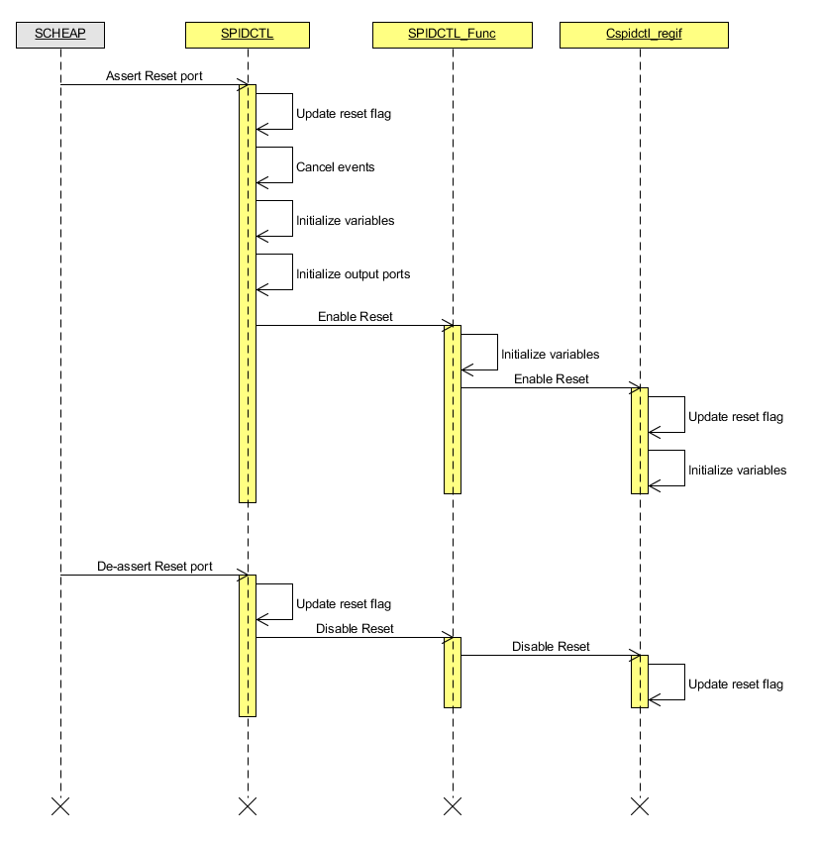
Figure 7-3: Sequence diagram of reset port handling
Explanation:
- When reset port is asserted: cancel events, initialize variables, initialize output ports, update reset flag value
- When reset port is de-asserted: update reset flag value

Sequence diagram of clock port handling
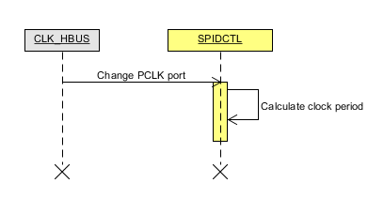
Figure 7-4: Sequence diagram of clock handling
Explanation:
- When the value of clock source port PCLK is changed, clock period is re-calculated.

Sequence diagram of Python IF handling
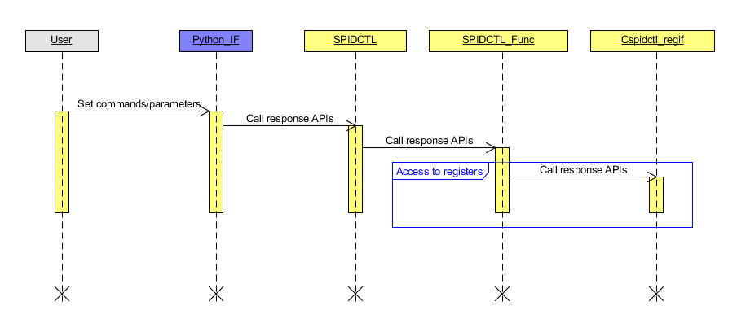
Figure 7-5: Sequence diagram of Python IF handling
Explanation:
- When user sets a Python IF command or parameter, the corresponding API is called.

Sequence diagram of register reading
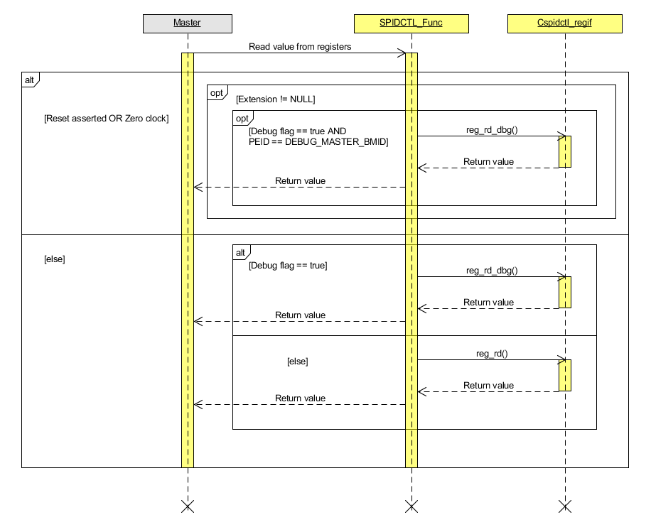
Figure 7-6: Sequence diagram of register reading
Explanation:
- If the current condition is reset port asserted or zero clock, and extension is not NULL, only software debugger (Debug flag == true and PEID == DEBUG_MASTER_BMID) can read the value of register by reg_rd_dbg() function (DEBUG_MASTER_BMID = 0xFF).
- Otherwise, the corresponding function is called based on debug flag.

Sequence diagram of register writing
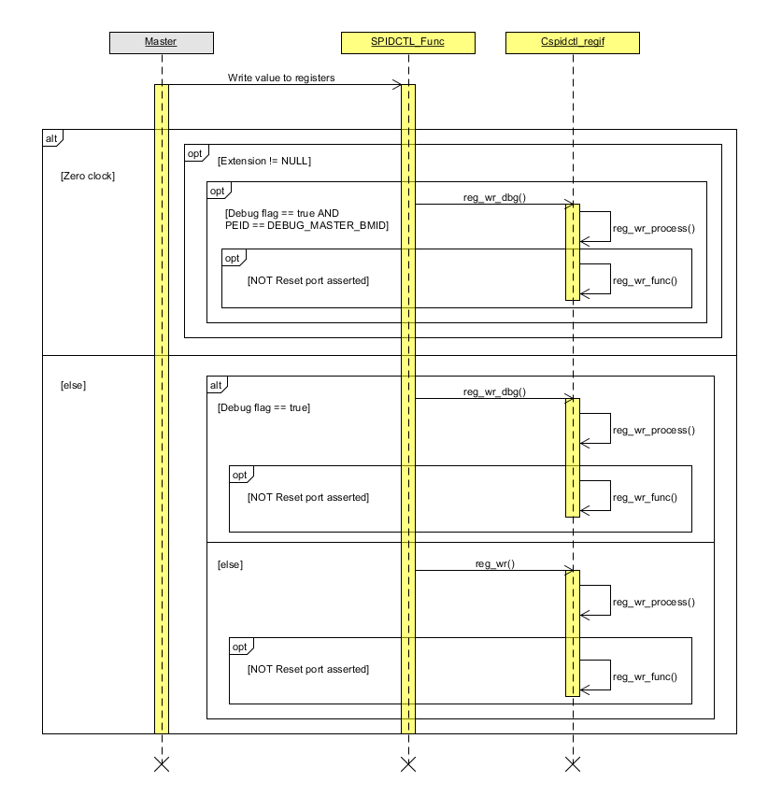
Figure 7-7: Sequence diagram of register writing
Explanation:
- If the current condition is zero clock, and extension is not NULL, only Software debugger (Debug flag == true and PEID == DEBUG_MASTER_BMID) can write to register (DEBUG_MASTER_BMID = 0xFF).
- Else, the corresponding function is called based on debug flag.
- If not reset port asserted, the value is written to register.

Flow of callback function of register SPID writing
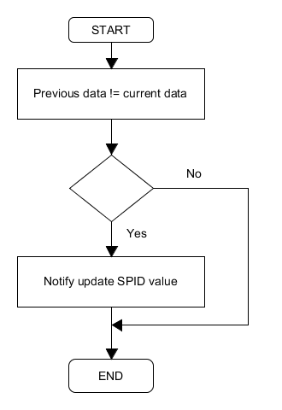
Figure 7-8: Flow of callback function of register SPID writing
Explanation:
- If previous data is different current data, notify process update SPID value to update model’s output ports.
- Else, model does nothing.

Flow of callback function of register SPID Mask writing
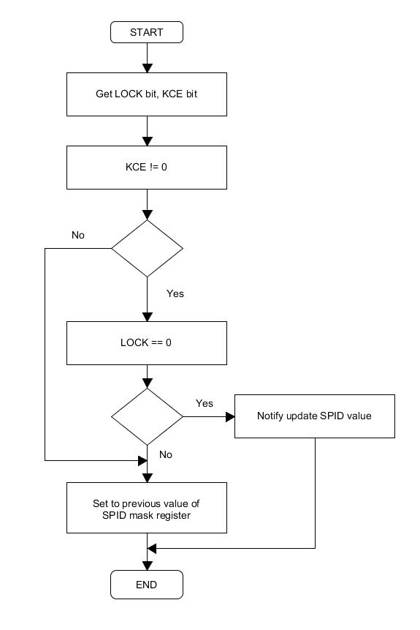
Figure 7-9: Flow of callback function of register SPID Mask writing
Explanation:
- If LOCK bit is zero and KCE bit is non-zero, notify process update SPID value to update model’s output ports.
- Else, set to previous value of SPID mask register.

Flow of callback function of register SPID Mask Lock writing
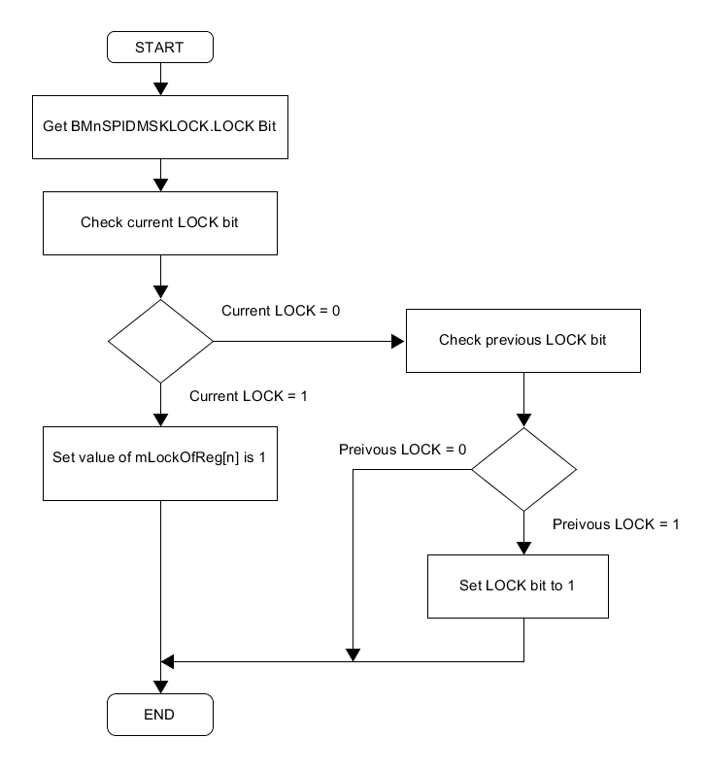
Figure 7-10: Flow of callback function of register SPID Mask Lock writing
Explanation:
- Figure above describes operations when model receives a writing access to LOCK bit.
- If current LOCK bit is written with value is 1, model sets value of mLockOfReg [n] is 1.
- Else, set LOCK bit to 1 in case previous LOCK bit is 1, else model does nothing.
- Only Reset port of model can reset LOCK bit and mLockOfReg.

Flow of callback function of register SPID Key code protection writing
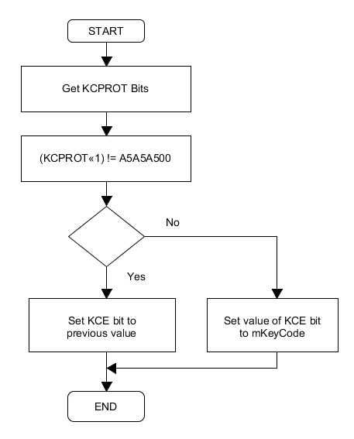
Figure 7-11: Flow of callback function of register SPID Key code protection writing
Explanation:
- Figure above describes operations when model receives a writing access to KCE bit.
- After write KCE bit, callback function will set KCE bit to previous value in case user write invalid KCPROT value.
- Else, model sets value of KCE bit to mKeyCode variable.

Flow process update SPID value.
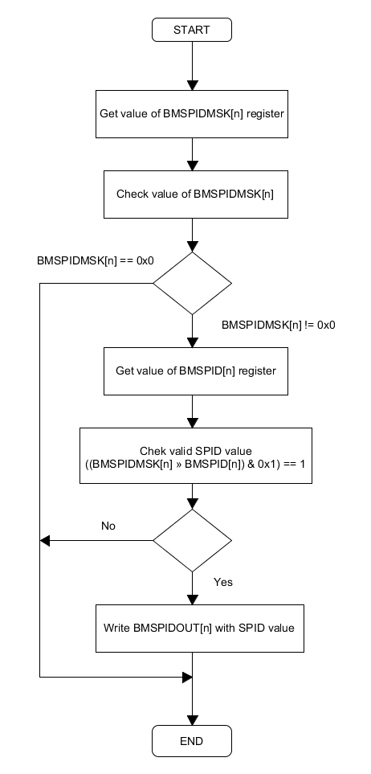
Figure 7-12: Flow process update SPID value.
Explanation:
- Figure above describes operations when model receives notify update SPID value.
- If BMSPIDMSK is zero, model does nothing.
- Else, check SPID whether valid or not. If valid, write SPID value into output port BMSPIDOUT. Else, model does nothing.

Flow of reset
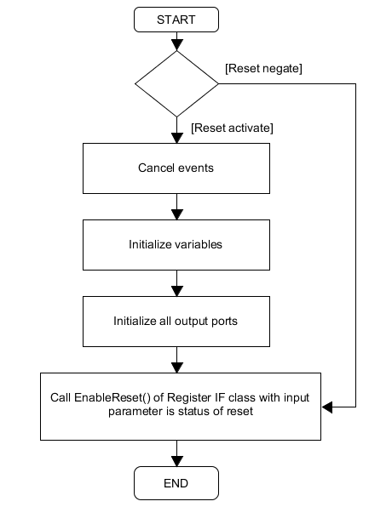
Figure 7-13: Flow of reset
Explanation:
- Figure above describes operation of SPIDCTL model when the Reset port is changed value.
- If Reset port is activated:
  - All events related to AssertReset command are canceled. Events related to operations are canceled.
  - Most of variables (except variable related to reset/clock) are initialized.
  - Output port is written initial value.
  - The EnableReset() function of register I/F class is called with input parameter is the status of reset.

Flow of Python IF
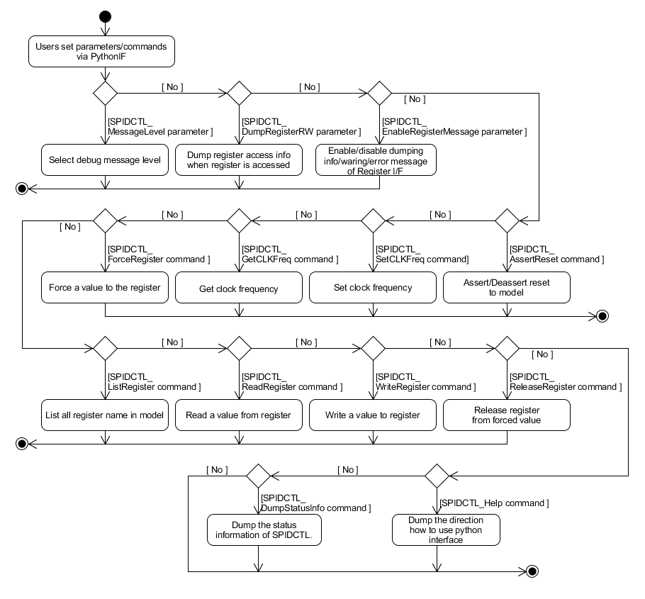
Figure 7-14: Flow of Python IF
Explanation:
- Figure above describes operation of Python IF when users set/call parameters/commands of SPIDCTL model.
- Refer to chapter Commands and parameters for more detail about functions of them.

Function description

List of public/private function in SPIDCTL class
Table 8.13: List of public functions in SPIDCTL class
No. | Function name | Description
1 | SPIDCTL (sc_module_name name, const unsigned int rLatency, const unsigned int wLatency, const char *config_file); | Constructor of SPIDCTL class
2 | ~SPIDCTL (); | Destructor of SPIDCTL class
3 | void SetMessageLevel (const std::string msg_lv); | Set message level (fatal, error, warning, info)
4 | void DumpRegisterRW (const std::string is_enable); | Enable/ Disable dumping message when users access registers
5 | void EnableRegisterMessage (const std::string is_enable); | Enable/disable info/warning/error message of register IF
6 | void DumpStatusInfo (void); | Dump value of all status registers.
7 | void AssertReset (const std::string reset_name, const double start_time, const double period); | Assert reset by software
8 | void SetCLKFreq (const std::string clock_name, const sc_dt::uint64 freq, const std::string unit); | Set clock value and clock unit
9 | void GetCLKFreq (const std::string clock_name); | Get clock value
10 | void ForceRegister (const std::string reg_name, const unsigned int reg_value); | Force value to register
11 | void ReleaseRegister (const std::string reg_name); | Release forced value after forcing registers
12 | void WriteRegister (const std::string reg_name, const unsigned int reg_value); | Write value to registers by software
13 | void ReadRegister (const std::string reg_name); | Read value of register by software
14 | void ListRegister (void); | List registers name of whole model
15 | void Help (const std::string type); | Dump help message of all parameters or commands
Table 8.14: List of private functions in SPIDCTL class
No. | Function name | Description
1 | void HandlePCLKSignalMethod (void); | Handle PCLK clock
2 | void HandleResetSignalMethod (void); | Handle Reset signal
3 | void HandleResetHardMethod(void); | Process reset function when reset signal is active
4 | void HandleResetCmdMethod (void); | Process reset function when reset command is active
5 | void CancelResetCmdMethod (void); | Cancel reset function when reset command is active
6 | void EnableReset (const bool is_active); | Enable/ Disable reset
7 | void Initialize(void); | Initialize variables
8 | void CancelEvents(void); | Cancel events when reset is assert
9 | bool CheckClockPeriod(void); | Check a clock period is valid or equals to 0
10 | bool GetResetStatus(void); | Get reset status
11 | void NotifyUpdateSPIDValue(unsigned int Index); | Notify SPID and SPID mask registers are written
12 | void HandleSPIDCTLMethod(unsigned int spid_id); | Handle update SPID value of model
13 | bool IsKeyCodeEnable(void); | Get the KCE bit status in model.
14 | void SetKeyCodeEnable(bool isEnable); | Set value the KCE bit status into model.
15 | bool IsMaskLocked(unsigned int RegIndex); | Get the LOCK bit status in model.
16 | void SetMaskLocked(unsigned int RegIndex, bool isLocked); | Set status of LOCK bit into model.
17 | bool GetArrCfgValue(std::string s, unsigned int *arr) | Return array of interger from given string.
18 | void ReadConfigFile(const char *config_file) | Get parameter from config file.
19 | std::string GetStrBetweenTwoStr(const std::string &s, const std::string &start_delim, const std::string &stop_delim) | Get string between two string.

List of public/private function in SPIDCTL_Func class
Table 8.15: List of public functions in SPIDCTL_Func class
No. | Function name | Description
1 | SPIDCTL_Func (std::string name, SPIDCTL_AgentController *SPIDCTLAgentControllerPtr); | Constructor of SPIDCTL_Func class
2 | ~SPIDCTL_Func (); | Destructor of SPIDCTL_Func class.
3 | void EnableReset (const bool is_active); | Enable/ Disable reset
4 | void RegisterHandler (const std::vector<std::string>& args); | Handle commands access to register.
5 | void read (unsigned int offsetAddress, TlmBasicPayload& trans, BusTime_t* t, bool debug); | Overwrite virtual functions of BusSlaveFuncIf class
6 | void write (unsigned int offsetAddress, TlmBasicPayload& trans, BusTime_t* t, bool debug); | Overwrite virtual functions of BusSlaveFuncIf class
7 | void DumpStatusInfo(void); | Dump register info
8 | unsigned int GetSPIDReg_SPIDBit(unsigned int index); | Get SPID value at SPID Register’s index
9 | unsigned int GetSPIDMskReg(unsigned int index); | Get SPID mask value at SPID Mask Register’s index
Table 8.16: List of private functions in SPIDCTL_Func class
No. | Function name | Description
1 | void Initialize(void); | Initialize variables
2 | void cb_BMSPID_SPID(RegCBstr str); | Callback function of SPID registers.
3 | void cb_BMSPIDMSK_SPIDMSK(RegCBstr str); | Callback function of SPID mask registers
4 | void cb_BMSPIDMSKLOCK_LOCK(RegCBstr str); | Callback function of LOCK bit in SPID mask lock registers.
5 | void cb_SPIDKCPROT_KCE (RegCBstr str); | Callback function of KCE bit in SPIDKCPROT register.
6 | void InitializeBMSPIDn(void); | Set initial value for BMSPIDn registers

List of public function in SPIDCTL_AgentController class
Table 8.17: List of public functions in SPIDCTL_AgentController class
No. | Function name | Description
1 | SPIDCTL_AgentController(std::string name): rvc_common_model(name); | Constructor of SPIDCTL_AgentController class.
2 | virtual ~ SPIDCTL_AgentController(void); | Destructor of SPIDCTL_AgentController class.
3 | virtual bool CheckClockPeriod(void) = 0; | Virtual function is used to check clock period value
4 | virtual bool GetResetStatus(void) = 0; | Virtual function is used to check reset status
5 | virtual void NotifyUpdateSPIDValue (unsigned int Index) = 0; | Virtual function is used to notify SPID and SPID mask registers are written
6 | virtual bool IsKeyCodeEnable(void) = 0; | Virtual function is used to get the KCE bit status in model.
7 | virtual void SetKeyCodeEnable(bool isEnable) = 0; | Virtual function is used to set value the KCE bit status into model.
8 | virtual bool IsMaskLocked(unsigned int RegIndex) = 0; | Virtual function is used to get the LOCK bit status in model.
9 | virtual void SetMaskLocked(unsigned int RegIndex, bool isLocked) = 0; | Virtual function is used to set value the LOCK bit status into model.

Limitation
- Table below list all limitation of this model (comparing with HW).
Table 9.18: Limitation of model
No. | HWM | Model | HW Reference
1 | SPIDCTL module have I/F to output BMnSPIDMSK values to IPs which have internal-SPID-register. | SPIDCTL module does NOT have I/F to output BMnSPIDMSK values to IPs which have internal-SPID-register.  This point will be update in next SPIDCTL maintenance. | [9] 55.5.3.3. List of Registers  [5] 44.5.3.2. List of Registers  [6] 40.5.2.2. List of Registers

Appendix
Initial value of SPID
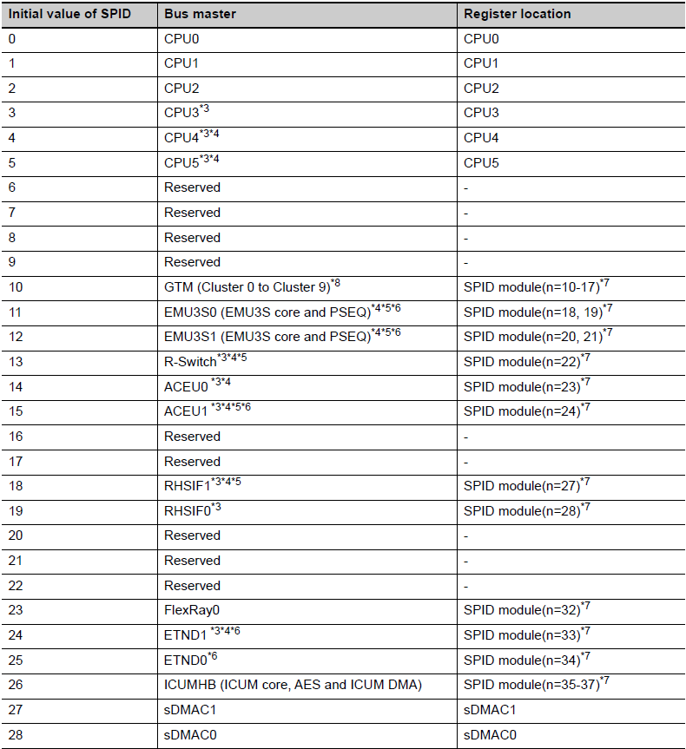
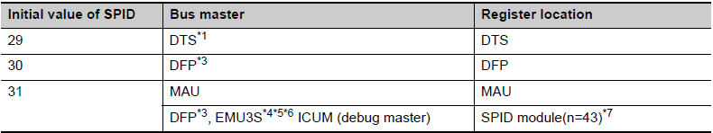
Figure 10-15: U2B Initial value of SPID
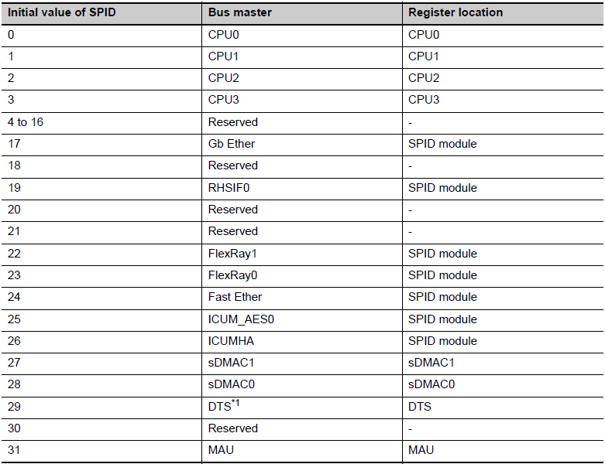
Figure 10-16: U2A Initial value of SPID

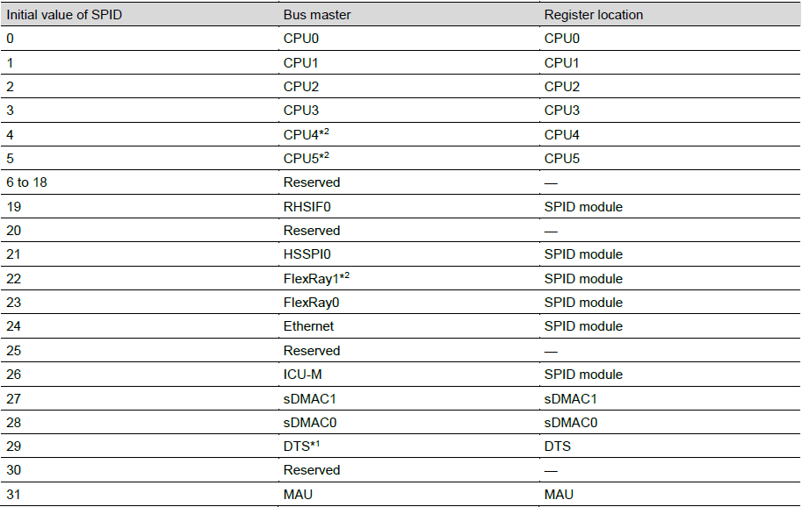
Figure 10-17: E2x Initial value of SPID

Note: The default initial value in this model when config_file setting is not input is:
- BMnSPID = n when n = [0:31]
- BMnSPID = 31 when n > 31
Revision History
Rev. | Modified Contents | Approved by RVC | Checked | Created
1.0 | Create new. | Chuong Le  Jan/15/2020 | Khoa Nguyen  Jan/09/2020 | Anh Nguyen  Jan/03/2020
1.1 | Update ticket Redmine #117906  Figure 3-1 :  - Add note (*1)  Update after coding  Table 8.14 :  - Add arguments for function NotifyUpdateSPIDValue.  Table 8.17.  - Add arguments for function NotifyUpdateSPIDValue. | Chuong Le  Feb/04/2020 | Khoa Nguyen  Jan/17/2020 | Anh Nguyen  Jan/16/2020
1.2 | Update for U2B HWUM v0.40  - Add description for U2B in Cover page, summary, header and Model summary.  - Update Note in Block diagram.  - Add GTMSPIDAS0, GTMSPIDAS1 and update Note in Table 4.1  - Update Note, Reset port Active, and BMSPIDOUT range and Initial in Table 5.1  - Update rvc_common_model inherit, add Common.h and remove SPIDCTL_cmdif.h in Figure 6.1.  - Add rvc_common_model.cpp, Common.h, and remove SPIDCTL_cmdif.h and OSCI2.h inTable 6.1 .  - Add functions No. 17, 18, 19 in Table 8.2  - Add function No. 6 in Table 8.4.  - Update Copyright  - Update Reqtify ID and Reference. | Chuong Le  Nov/17/2021 | Duong Phan  Nov/12/2021 | Minh Ha  Nov/10/2021
1.3 | - Update message No. 15, remove message No. 13 and add message No. 34 in Table 6.8  - Add limitation in Table 9.1 | Chuong Le  Nov/22/2021 | Duong Phan  Nov/20/2021 | Minh Ha  Nov/18/2021

Copyright(c) 2020-2021 Renesas Electronics Corporation. All rights reserved.

