HASH Generator Functional Specification

Rev. 1.00

2021.05.09

This document describes functional specification of HASH generator module (HAGE).

【References】

* N/A

|  |  |  |  |  |
| --- | --- | --- | --- | --- |
| Rev. | Issued on | Section | Revised on | Revised by |
| 0.01 | 2021.05.09 | ALL | Newly created | Bac Huynh |
|  |  |  |  |  |

Table of Contents

1. Overview 3

1.1 Features 3

1.2 HASH function 3

1.3 Block Diagram 4

1.4 Interface 4

1.5 Register Configuration 4

2. Register Description 5

2.1 HAGE Control Register (HAGECR) 5

2.2 HAGE Seed Register (HAGESEED) 6

2.3 HAGE Input Data Register (HAGEIDAT) 6

2.4 HAGE Output Data Register (HAGEODAT) 7

2.5 HAGE Source Address Register (HAGESRCADD) 7

2.6 HAGE Destination Address Register (HAGEDSTADD) 8

2.7 HAGE DMA Data Length Register (HAGEDL) 8

3. Operation 9

3.1 HASH generator performance 9

3.2 Block by block mode 9

3.3 DMA mode 9

# Overview

## Features

HAGE is a simple 32-bits HASH function generator

* Configurable seed with register
* Single block mode
* DMA mode (pre-fetch 128-bit data equivalent to 4 data blocks)
* Interrupt when computation finish (1 block in single block mode, whole message in DMA mode)

## HASH function

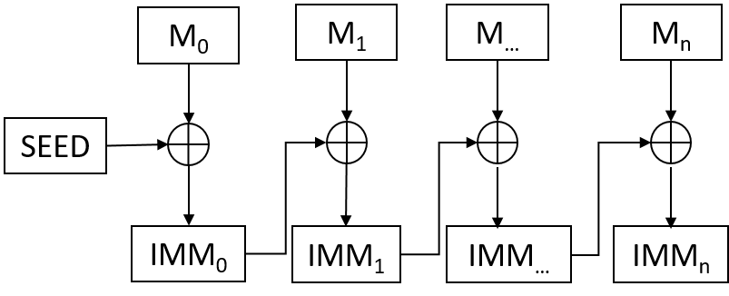

Figure 1‑1 Hash function

Explanation:

* SEED: initial block (32 bit)
* M0, M1…Mn: input data block (32 bit)
* IMM0, IMM1…IMMn: immediate result of block (32 bit)
* Formula:

If (n = 0)

IMMn = Mn XOR SEED

Else

IMMn = Mn XOR IMMn-1

Example:

* Message: 0x0001020304050607
* Seed: 0x12345678
* Result:
  + IMM0 = 0x00010203 XOR 0x12345678 = 0x1235547B
  + IMM1 = 0x04050607 XOR 0x1235547B = 0x1630527C

## Block Diagram

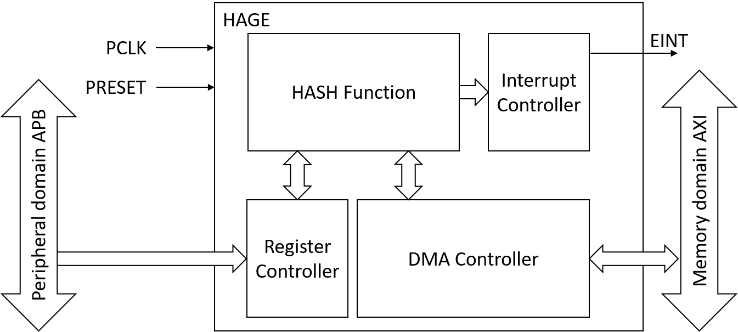

Figure 1‑2 Block diagram

## Interface

Interface list of HAGE.

|  |  |  |  |  |  |
| --- | --- | --- | --- | --- | --- |
| **I/F** | **Direction** | **Sync** | **Active** | **Initial** | **Description** |
| PCLK | Input | - | - | - | System clock |
| PRESET | Input | - | HIGH | - | Asynchronous reset |
| EINT | Output | PCLK | HIGH | LOW | HASH generate complete interrupt |
| APB Slave | Input | - | - | - | 32 bit APB slave (register controller) |
| AXI Master | Input/Output | - | - | - | 128 bit AXI master (read/write memory) |

Table 1‑1 HAGE Interfaces

## Register Configuration

HAGE base address: 0xFFBF0000

|  |  |  |  |  |  |  |
| --- | --- | --- | --- | --- | --- | --- |
| **Symbol** | **Offset** | **R/W** | **Access Size** | | | **Description** |
| **8** | **16** | **32** |
| HAGECR | xxx_base+0x00 | R/W | ✔ | ✔ | ✔ | Control register |
| HAGESEED | xxx_base+0x04 | R/W | - | - | ✔ | Seed setup register |
| HAGEIDAT | xxx_base+0x08 | R/W | - | - | ✔ | Input data register |
| HAGEODAT | xxx_base+0x0C | R/W | - | - | ✔ | Output data register |
| HAGESRCADD | xxx_base+0x10 | R/W | - | - | ✔ | DMA source address |
| HAGEDSTADD | xxx_base+0x14 | R/W | - | - | ✔ | DMA destination address |
| HAGEDL | xxx_base+0x18 | R/W | - | - | ✔ | DMA data length |

Table 1‑2 HAGE Register Configuration

# Register Description

Explanation of abbreviation of register

Initial value : Value of the register after power-on reset

- : Undefined value

R/W : The bit or field is readable and writable.

R : The bit or field is readable only. When writing to the register, write 0 to it.

## HAGE Control Register (HAGECR)

|  |  |  |  |  |  |  |  |  |  |  |  |  |  |  |  |  |
| --- | --- | --- | --- | --- | --- | --- | --- | --- | --- | --- | --- | --- | --- | --- | --- | --- |
|  |  |  |  |  |  |  |  |  |  |  |  |  |  |  |  |  |
| Bit: | 31 | 30 | 29 | 28 | 27 | 26 | 25 | 24 | 23 | 22 | 21 | 20 | 19 | 18 | 17 | 16 |
|  |  |  |  |  |  |  |  |  |  |  |  |  |  |  |  |  |
|  | - | - | - | - | - | - | - | DMASTR | - | - | - | - | - | - | PLL | |
|  |  |  |  |  |  |  |  |  |  |  |  |  |  |  |  |  |
| Initial value: | 0 | 0 | 0 | 0 | 0 | 0 | 0 | 0 | 0 | 0 | 0 | 0 | 0 | 0 | 0 | 0 |
| R/W: | R | R | R | R | R | R | R | R/W | R | R | R | R | R | R | R/W | R/W |
|  |  |  |  |  |  |  |  |  |  |  |  |  |  |  |  |  |
| Bit: | 15 | 14 | 13 | 12 | 11 | 10 | 9 | 8 | 7 | 6 | 5 | 4 | 3 | 2 | 1 | 0 |
|  |  |  |  |  |  |  |  |  |  |  |  |  |  |  |  |  |
|  | - | - | - | - | - | - | - | EINT_MSK | - | - | - | - | - | HASHOUT | MODSEL | NEW_SEED |
|  |  |  |  |  |  |  |  |  |  |  |  |  |  |  |  |  |
| Initial value: | 0 | 0 | 0 | 0 | 0 | 0 | 0 | 0 | 0 | 0 | 0 | 0 | 0 | 0 | 0 | 0 |
| R/W: | R | R | R | R | R | R | R | R/W | R | R | R | R | R | R/W | R/W | R/W |

|  |  |  |  |  |
| --- | --- | --- | --- | --- |
| **Bit** | **Bit Name** | **Initial Value** | **R/W** | **Description** |
| 31 to 25 | - | All 0 | R | Reserved. These bits are always read as 0. The write value should always be 0.If a value other than 0 is written, correct operation cannot be guaranteed. |
| 24 | DMASTR | 0 | R/W | Start DMA transfer  0: No DMA transfer, write 0 when operating will force stop DMA operation  1: Start DMA transfer, auto set to 0 when DMA operation finish |
| 23 to 18 | - | All 0 | R | Reserved. These bits are always read as 0. The write value should always be 0.If a value other than 0 is written, correct operation cannot be guaranteed. |
| 17, 16 | PLL | All 0 | R/W | Increate HASH block computation speed by PLL  0b00: 1 x PCLK  0b01: 4 x PCLK  0b10: 8 x PCLK  Others are prohibited |
| 15 to 9 | - | All 0 | R | Reserved. These bits are always read as 0. The write value should always be 0.If a value other than 0 is written, correct operation cannot be guaranteed. |
| 8 | EINT_MSK | 0 | R/W | Mask EINT interrupt  0: No mask  1: Masked interrupt |
| 7 to 2 | - | All 0 | R | Reserved. These bits are always read as 0. The write value should always be 0.If a value other than 0 is written, correct operation cannot be guaranteed. |
| 2 | HASHOUT | 0 | R/W | Write HASH final result to destination memory (DMA mode only)  0: No transfer data to memory  1: Transfer data to memory |
| 1 | MODSEL | 0 | R/W | Mode select  0: Block by block mode  1: DMA mode |
| 0 | NEW_SEED | 0 | R/W | New seed indicator  0: No new seed available. Compute on previous intermediate data  1: New seed available. Clear to 0 when seed is used |

## HAGE Seed Register (HAGESEED)

|  |  |  |  |  |  |  |  |  |  |  |  |  |  |  |  |  |
| --- | --- | --- | --- | --- | --- | --- | --- | --- | --- | --- | --- | --- | --- | --- | --- | --- |
|  |  |  |  |  |  |  |  |  |  |  |  |  |  |  |  |  |
| Bit: | 31 | 30 | 29 | 28 | 27 | 26 | 25 | 24 | 23 | 22 | 21 | 20 | 19 | 18 | 17 | 16 |
|  |  |  |  |  |  |  |  |  |  |  |  |  |  |  |  |  |
|  | SEED | | | | | | | | | | | | | | | |
|  |  |  |  |  |  |  |  |  |  |  |  |  |  |  |  |  |
| Initial value: | 0 | 0 | 0 | 0 | 0 | 0 | 0 | 0 | 0 | 0 | 0 | 0 | 0 | 0 | 0 | 0 |
| R/W: | R/W | R/W | R/W | R/W | R/W | R/W | R/W | R/W | R/W | R/W | R/W | R/W | R/W | R/W | R/W | R/W |
|  |  |  |  |  |  |  |  |  |  |  |  |  |  |  |  |  |
| Bit: | 15 | 14 | 13 | 12 | 11 | 10 | 9 | 8 | 7 | 6 | 5 | 4 | 3 | 2 | 1 | 0 |
|  |  |  |  |  |  |  |  |  |  |  |  |  |  |  |  |  |
|  | SEED | | | | | | | | | | | | | | | |
|  |  |  |  |  |  |  |  |  |  |  |  |  |  |  |  |  |
| Initial value: | 0 | 0 | 0 | 0 | 0 | 0 | 0 | 0 | 0 | 0 | 0 | 0 | 0 | 0 | 0 | 0 |
| R/W: | R/W | R/W | R/W | R/W | R/W | R/W | R/W | R/W | R/W | R/W | R/W | R/W | R/W | R/W | R/W | R/W |

|  |  |  |  |  |
| --- | --- | --- | --- | --- |
| **Bit** | **Bit Name** | **Initial Value** | **R/W** | **Description** |
| 31 to 0 | SEED | All 0 | R/W | HASH seed data |

## HAGE Input Data Register (HAGEIDAT)

|  |  |  |  |  |  |  |  |  |  |  |  |  |  |  |  |  |
| --- | --- | --- | --- | --- | --- | --- | --- | --- | --- | --- | --- | --- | --- | --- | --- | --- |
|  |  |  |  |  |  |  |  |  |  |  |  |  |  |  |  |  |
| Bit: | 31 | 30 | 29 | 28 | 27 | 26 | 25 | 24 | 23 | 22 | 21 | 20 | 19 | 18 | 17 | 16 |
|  |  |  |  |  |  |  |  |  |  |  |  |  |  |  |  |  |
|  | DATA_IN | | | | | | | | | | | | | | | |
|  |  |  |  |  |  |  |  |  |  |  |  |  |  |  |  |  |
| Initial value: | 0 | 0 | 0 | 0 | 0 | 0 | 0 | 0 | 0 | 0 | 0 | 0 | 0 | 0 | 0 | 0 |
| R/W: | R/W | R/W | R/W | R/W | R/W | R/W | R/W | R/W | R/W | R/W | R/W | R/W | R/W | R/W | R/W | R/W |
|  |  |  |  |  |  |  |  |  |  |  |  |  |  |  |  |  |
| Bit: | 15 | 14 | 13 | 12 | 11 | 10 | 9 | 8 | 7 | 6 | 5 | 4 | 3 | 2 | 1 | 0 |
|  |  |  |  |  |  |  |  |  |  |  |  |  |  |  |  |  |
|  | DATA_IN | | | | | | | | | | | | | | | |
|  |  |  |  |  |  |  |  |  |  |  |  |  |  |  |  |  |
| Initial value: | 0 | 0 | 0 | 0 | 0 | 0 | 0 | 0 | 0 | 0 | 0 | 0 | 0 | 0 | 0 | 0 |
| R/W: | R/W | R/W | R/W | R/W | R/W | R/W | R/W | R/W | R/W | R/W | R/W | R/W | R/W | R/W | R/W | R/W |

|  |  |  |  |  |
| --- | --- | --- | --- | --- |
| **Bit** | **Bit Name** | **Initial Value** | **R/W** | **Description** |
| 31 to 0 | DATA_IN | All 0 | R/W | Data in use in block by block mode |

## HAGE Output Data Register (HAGEODAT)

|  |  |  |  |  |  |  |  |  |  |  |  |  |  |  |  |  |
| --- | --- | --- | --- | --- | --- | --- | --- | --- | --- | --- | --- | --- | --- | --- | --- | --- |
|  |  |  |  |  |  |  |  |  |  |  |  |  |  |  |  |  |
| Bit: | 31 | 30 | 29 | 28 | 27 | 26 | 25 | 24 | 23 | 22 | 21 | 20 | 19 | 18 | 17 | 16 |
|  |  |  |  |  |  |  |  |  |  |  |  |  |  |  |  |  |
|  | DATA_OUT | | | | | | | | | | | | | | | |
|  |  |  |  |  |  |  |  |  |  |  |  |  |  |  |  |  |
| Initial value: | 0 | 0 | 0 | 0 | 0 | 0 | 0 | 0 | 0 | 0 | 0 | 0 | 0 | 0 | 0 | 0 |
| R/W: | R/W | R/W | R/W | R/W | R/W | R/W | R/W | R/W | R/W | R/W | R/W | R/W | R/W | R/W | R/W | R/W |
|  |  |  |  |  |  |  |  |  |  |  |  |  |  |  |  |  |
| Bit: | 15 | 14 | 13 | 12 | 11 | 10 | 9 | 8 | 7 | 6 | 5 | 4 | 3 | 2 | 1 | 0 |
|  |  |  |  |  |  |  |  |  |  |  |  |  |  |  |  |  |
|  | DATA_OUT | | | | | | | | | | | | | | | |
|  |  |  |  |  |  |  |  |  |  |  |  |  |  |  |  |  |
| Initial value: | 0 | 0 | 0 | 0 | 0 | 0 | 0 | 0 | 0 | 0 | 0 | 0 | 0 | 0 | 0 | 0 |
| R/W: | R/W | R/W | R/W | R/W | R/W | R/W | R/W | R/W | R/W | R/W | R/W | R/W | R/W | R/W | R/W | R/W |

|  |  |  |  |  |
| --- | --- | --- | --- | --- |
| **Bit** | **Bit Name** | **Initial Value** | **R/W** | **Description** |
| 31 to 0 | DATA_OUT | All 0 | R/W | Result of each data block calculation.  Result is updated to this register for each block HASH computation |

## HAGE Source Address Register (HAGESRCADD)

|  |  |  |  |  |  |  |  |  |  |  |  |  |  |  |  |  |
| --- | --- | --- | --- | --- | --- | --- | --- | --- | --- | --- | --- | --- | --- | --- | --- | --- |
|  |  |  |  |  |  |  |  |  |  |  |  |  |  |  |  |  |
| Bit: | 31 | 30 | 29 | 28 | 27 | 26 | 25 | 24 | 23 | 22 | 21 | 20 | 19 | 18 | 17 | 16 |
|  |  |  |  |  |  |  |  |  |  |  |  |  |  |  |  |  |
|  | SRC_ADDR | | | | | | | | | | | | | | | |
|  |  |  |  |  |  |  |  |  |  |  |  |  |  |  |  |  |
| Initial value: | 0 | 0 | 0 | 0 | 0 | 0 | 0 | 0 | 0 | 0 | 0 | 0 | 0 | 0 | 0 | 0 |
| R/W: | R/W | R/W | R/W | R/W | R/W | R/W | R/W | R/W | R/W | R/W | R/W | R/W | R/W | R/W | R/W | R/W |
|  |  |  |  |  |  |  |  |  |  |  |  |  |  |  |  |  |
| Bit: | 15 | 14 | 13 | 12 | 11 | 10 | 9 | 8 | 7 | 6 | 5 | 4 | 3 | 2 | 1 | 0 |
|  |  |  |  |  |  |  |  |  |  |  |  |  |  |  |  |  |
|  | SRC_ADDR | | | | | | | | | | | | | | - | - |
|  |  |  |  |  |  |  |  |  |  |  |  |  |  |  |  |  |
| Initial value: | 0 | 0 | 0 | 0 | 0 | 0 | 0 | 0 | 0 | 0 | 0 | 0 | 0 | 0 | 0 | 0 |
| R/W: | R/W | R/W | R/W | R/W | R/W | R/W | R/W | R/W | R/W | R/W | R/W | R/W | R/W | R/W | R | R |

|  |  |  |  |  |
| --- | --- | --- | --- | --- |
| **Bit** | **Bit Name** | **Initial Value** | **R/W** | **Description** |
| 31 to 2 | SRC_ADDR | All 0 | R | Source address |
| 1 to 0 | - | All 0 | R | Reserved. These bits are always read as 0. The write value should always be 0.If a value other than 0 is written, correct operation cannot be guaranteed. |

## HAGE Destination Address Register (HAGEDSTADD)

|  |  |  |  |  |  |  |  |  |  |  |  |  |  |  |  |  |
| --- | --- | --- | --- | --- | --- | --- | --- | --- | --- | --- | --- | --- | --- | --- | --- | --- |
|  |  |  |  |  |  |  |  |  |  |  |  |  |  |  |  |  |
| Bit: | 31 | 30 | 29 | 28 | 27 | 26 | 25 | 24 | 23 | 22 | 21 | 20 | 19 | 18 | 17 | 16 |
|  |  |  |  |  |  |  |  |  |  |  |  |  |  |  |  |  |
|  | DST_ADDR | | | | | | | | | | | | | | | |
|  |  |  |  |  |  |  |  |  |  |  |  |  |  |  |  |  |
| Initial value: | 0 | 0 | 0 | 0 | 0 | 0 | 0 | 0 | 0 | 0 | 0 | 0 | 0 | 0 | 0 | 0 |
| R/W: | R/W | R/W | R/W | R/W | R/W | R/W | R/W | R/W | R/W | R/W | R/W | R/W | R/W | R/W | R/W | R/W |
|  |  |  |  |  |  |  |  |  |  |  |  |  |  |  |  |  |
| Bit: | 15 | 14 | 13 | 12 | 11 | 10 | 9 | 8 | 7 | 6 | 5 | 4 | 3 | 2 | 1 | 0 |
|  |  |  |  |  |  |  |  |  |  |  |  |  |  |  |  |  |
|  | DST_ADDR | | | | | | | | | | | | | | - | - |
|  |  |  |  |  |  |  |  |  |  |  |  |  |  |  |  |  |
| Initial value: | 0 | 0 | 0 | 0 | 0 | 0 | 0 | 0 | 0 | 0 | 0 | 0 | 0 | 0 | 0 | 0 |
| R/W: | R/W | R/W | R/W | R/W | R/W | R/W | R/W | R/W | R/W | R/W | R/W | R/W | R/W | R/W | R | R |

|  |  |  |  |  |
| --- | --- | --- | --- | --- |
| **Bit** | **Bit Name** | **Initial Value** | **R/W** | **Description** |
| 31 to 2 | DST_ADDR | All 0 | R | Destination address |
| 1 to 0 | - | All 0 | R | Reserved. These bits are always read as 0. The write value should always be 0.If a value other than 0 is written, correct operation cannot be guaranteed. |

## HAGE DMA Data Length Register (HAGEDL)

|  |  |  |  |  |  |  |  |  |  |  |  |  |  |  |  |  |
| --- | --- | --- | --- | --- | --- | --- | --- | --- | --- | --- | --- | --- | --- | --- | --- | --- |
|  |  |  |  |  |  |  |  |  |  |  |  |  |  |  |  |  |
| Bit: | 31 | 30 | 29 | 28 | 27 | 26 | 25 | 24 | 23 | 22 | 21 | 20 | 19 | 18 | 17 | 16 |
|  |  |  |  |  |  |  |  |  |  |  |  |  |  |  |  |  |
|  | DATA_LEN | | | | | | | | | | | | | | | |
|  |  |  |  |  |  |  |  |  |  |  |  |  |  |  |  |  |
| Initial value: | 0 | 0 | 0 | 0 | 0 | 0 | 0 | 0 | 0 | 0 | 0 | 0 | 0 | 0 | 0 | 0 |
| R/W: | R/W | R/W | R/W | R/W | R/W | R/W | R/W | R/W | R/W | R/W | R/W | R/W | R/W | R/W | R/W | R/W |
|  |  |  |  |  |  |  |  |  |  |  |  |  |  |  |  |  |
| Bit: | 15 | 14 | 13 | 12 | 11 | 10 | 9 | 8 | 7 | 6 | 5 | 4 | 3 | 2 | 1 | 0 |
|  |  |  |  |  |  |  |  |  |  |  |  |  |  |  |  |  |
|  | DATA_ LEN | | | | | | | | | | | | | | | |
|  |  |  |  |  |  |  |  |  |  |  |  |  |  |  |  |  |
| Initial value: | 0 | 0 | 0 | 0 | 0 | 0 | 0 | 0 | 0 | 0 | 0 | 0 | 0 | 0 | 0 | 0 |
| R/W: | R/W | R/W | R/W | R/W | R/W | R/W | R/W | R/W | R/W | R/W | R/W | R/W | R/W | R/W | R/W | R/W |

|  |  |  |  |  |
| --- | --- | --- | --- | --- |
| **Bit** | **Bit Name** | **Initial Value** | **R/W** | **Description** |
| 31 to 0 | DATA_LEN | All 0 | R/W | Number of data block to digest in HASH function |

# Operation

## HASH generator performance

HASH block generating capacity depends on it HASHCLK = PCLK x PLL. Each block computation and update to HAGEODAT register after 1 HASHCLK period.

## Block by block mode

Manual HASH digest by writing each block to data register

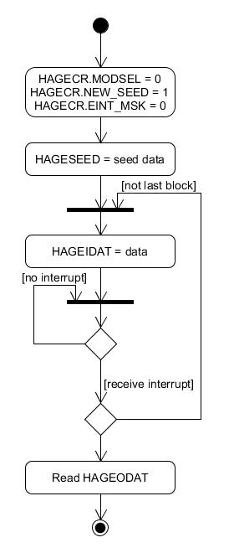

Figure 3‑1 Block by block mode operation flow

## DMA mode

HASH digest by DMA transfer. Result can be selected to transfer to memory or read directly in HAGEODAT register

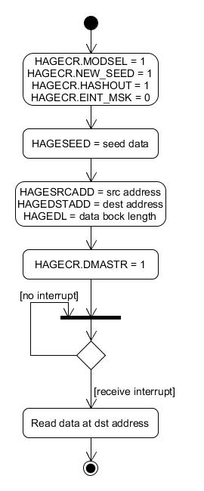

Figure 3‑2 DMA mode with result to memory