

**CAPSTONE PROJECT 1**

**sds**

**PROPOSAL DOCUMENT**

**Traveling 360° View Tour**

Version 1.0

Date: Aug 29, 2018

**MENTOR: MSc. Huy Nguyen Dang Quang**

**PROJECT GROUP: Group 17**

**GROUP’S MEMBER**: Nghia Nguyen Huu

Tri Truong Cong Minh

Bao Luu Quoc

Hung Nguyen Kim

**INTERNATIONAL SCHOOL**

**Project Information**

|  |  |  |  |  |  |
| --- | --- | --- | --- | --- | --- |
| **Project acronym** | TVT | | | | |
| **Project Tittle** | Traveling 360° View Tour | | | | |
| **Start Date** | Aug 22, 2018 | | **End Date** | | Dec 10, 2018 |
| **Lead Institution** | International School, Duy Tan University | | | | |
| **Project Mentor & contact details** | Msc. Huy, Nguyen Dang Quang  Email: [huyndq@duytan.edu.vn](mailto:huyndq@duytan.edu.vn)  Tel: 0935525354 | | | | |
| **Team Leader & contact details** | Hung, Nguyen Kim  Email: nguyenkimhung1221@gmail.com  Tel: 01654006417 | | | | |
| **Team members** | **Name** | **Email** | | **Tel** | |
| Nghia, Nguyen Huu | nghianguyenhuu848[@gmail.com](mailto:truongtanluan1996@gmail.com) | | 0971262523 | |
| Tri, Truong Cong Minh | truongcminhtri1512@gmail.com | | 01216800655 | |
| Bao, Luu Quoc | luubao2811[@gmail.com](mailto:nguyenminhnhatdtu@gmail.com) | | 01222071366 | |

**Proposal Document**

|  |  |  |  |
| --- | --- | --- | --- |
| **Document Title** | Proposal Document |  |  |
| **Reporting Period** | August, 2018 |  |  |
| **Author(s) &**  **project** | Nghia, Nguyen Huu,  Member | |  |
| **Team Information** | **Name** | **Role** |  |
| Hung, Nguyen Kim | Team Leader |  |
| Nghia, Nguyen Huu | Member |  |
| Tri, Truong Cong Minh | Member |  |
| Bao, Luu Quoc | Member |  |
| **Date** | Aug 29, 2018 | **Filename** | TVT_Proposal_v1.0.docx |
| **Access** | Project and CMU Program | |  |

**REVISION HISTORY**

|  |  |  |  |
| --- | --- | --- | --- |
| **Version** | **Person** | **Date** | **Description** |
| v1.0 | Group | Aug 29, 2018 | Draft for Document |
|  |  |  |  |
|  |  |  |  |

**Document Approvals**

The following signatures are required for approval of this document.

|  |  |  |
| --- | --- | --- |
| MSc. Huy, Nguyen Dang Quang  *Mentor* |  | Date: Aug 29, 2018 |
| Hung, Nguyen Kim  *Team Leader* |  | Date: Aug 29, 2018 |

Table of Contents

1. Introduction 1

1.1 Purpose 1

1.2 Scope 1

1.3 References 1

2. Product Overview 2

2.1 Project definition 2

2.2 User Needs 2

2.3 Prior Art 3

2.4 Proposed Solution 3

2.4.1 Project goal 4

2.4.2 System Overview 4

2.4.3 Technical Constrains 7

3. Master Plan 8

3.1 SDLC – Waterfall Model 8

3.2 Organization Management 8

3.3.1 Human Resource 8

3.3.2 Cost Estimate 9

# Introduction

## 1.1 Purpose

The purpose of the Proposal document is to:

* Help understand business need, problems or situation related to the initialization and construction projects.
* Provide solutions for business needs and show the overview of system context and architecture.
* Provide overview about resources, schedule, solution and budget for the project.

## 1.2 Scope

This document provides an overview of project will be developed. It includes the description of:

* Business need
* Proposed solution
* Introduction Life Cycle for this project
* Resource for project
* Schedule
* Stakeholder and User
* Technology
* Some constraints that involved in the project.

The document provides a comprehensive master plan for each phase of software development based on the processes that have been selected.

This document is made for senior management to put forward a proposal.

## References

|  |  |  |
| --- | --- | --- |
| **No.** | **References** | **Document Information** |
| 1 | **Waterfall Model** | https://www.tutorialspoint.com/sdlc/sdlc_waterfall_model.htm |
| 2 |  |  |

# Product Overview

## Project definition

Vietnam is a developing country with huge demand for entertainment, especially in the field of tourism. TVT will bring convenience to travelers in finding everything they want like tickets, flights, tours related, hotel booking ... and put directly through the website.

## User Needs

***Business Problems:***

* With the development of many types of smartphones and information technology today, open up great opportunities for travel industry with online booking service.
* In fact, the current trend of booking tours on the internet for tourism activities is increasing rapidly. Not only that, in Vietnam, many people also have the habit of looking for information on tours, hotels, resort resorts on major tourism websites and then decide to book tours.
* Nowadays, the tourism industry will be able to grow and continue to reach higher levels of service and demand.
* With thousands of tours updated daily, even hours with good quality. Tourists must consider choosing a tour that fits their budget.

***Business Need:***

* Tourists want a realistic view of where they are going to travel with 360° View Tour
* Customers expect to have a communication environment among the tourists, simplifying booking tours.
* Capture more useful information, as most tours, current travel trends and the future, updated information about Vietnam tourism and the world.
* Tourism information such as transportation, price, hotel…
* Tourists want to recommend places that match their budget.
* Tourists want to search for locations on Google Maps, and they can easily search for results that match their location or other locations.
* Tourists can rating/comment on the service they have used and share with everyone.
* Content management system allows to add, edit, and delete content easily. User-friendly control panel.
* With 360° live image, the reality of our website will be like your real life experience, like traveling at home, so tourists can be more confident in booking

## Prior Art

With popular travel sites like Booking.com, Traveloka.com, Ivivu.com,... it has quite a full range of features such as booking tours, hotels. With our system like these sites, our website is more visual, which is a 360° overview of the travel destination as well as the hotel you are experiencing.

## Proposed Solution

To solve the current needs of the user and website, our group decided to developing a website with the functions below:

* View 360°: Tourists have a more realistic view of the place to visit.
* Suggest location in the cost range: When customers enter the cost of travel available, the system will suggest some locations that match those costs.
* Search engine: Allows customers to search by relevant keyword, search destination, tour ...
* Booking tour: Allow customers to book online tour at home, without login account by booking tour with the information box is set up on the website.
* Rating / Comment: The rating function allows users to submit a 1 to 5 star spell to any service on the system, users are commited / commented on a travel product after use. Use their personal account on the system.
* Google Maps: Gives customers the ability to search for locations on Google Maps, and they can easily search for results that match their location or other locations. Each tour, which has a map on the map, makes it easy to see the locations of the places they are looking for.
* Product Category: Product cataloging functions based on categories, cities or regions. Customers can display products in a list or table.
* Add, remove, manage tours, reservations: Admin can add unlimited number of products and settings for each item. With each tour / room / place added, the system will automatically add that product name into the search filter.
* Blogs / News: The Blog / News page, which gives Administrators the right to add, edit, and delete posts on the blog. Upload Images and Content and Manage Posts by category.
* Discount Codes: Customizable program discounts are in percentage or in certain numbers. Make special discounts for special occasions. Show tours, room rates outside the Home ...

### Project goal

The goal of project is to build the Traveling Website with 360° View Tour, provide the necessary information for the selection of tourist sites with diverse tour system. The friendly interface makes it easy to choose the tour and book tours with attractive promotions.

Five main features that meet business need within budget and schedule:

1. **Search information:** Allows customers to search by relevant keywords, search destinations, tours, etc. Integrated search engine optimization, using the optimal filter to search places, tours to meet the needs of users (such as price, location, functionality).
2. **Booking Online:** Allow customers to book online tour at home, without login account by booking tour with the information box is set up on the website.
3. **Suggest Destination:** Customers enter the cost of travel available, the system will suggest some locations that match those costs.
4. **Business Management:** The system can help user to manage business information.
5. **System Management:** Manage and maintain whole the system.

### System Overview

#### 2.4.2.1 System context

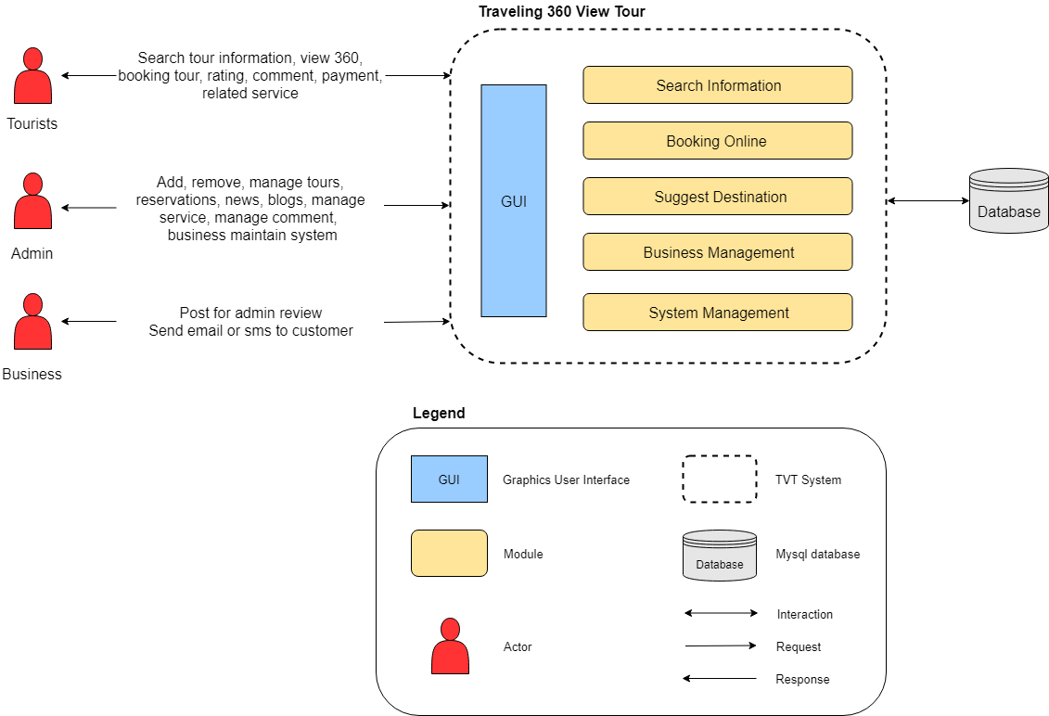

***Picture 1: System Context Overview***

#### 2.4.2.2 System context description

* Tourists:
* 360° view tour
* Tourists can see each tour or all tours
* At each tour tourists can book tours
* Tourists can search tours by price, location, ...
* Tourists can rating/comment on the service they have used and read other’s review
* Account registration
* Log in and use the services of the website
* Administrator:
* Manage user account
* Allows Administrators to add, edit, and delete blog posts. Upload images and content and manage posts by category
* Update customer feedback to the database
* Allows Administrators to add, edit, and delete tours to the database
* Allow post tour or not
* View the booked tour, confirm or cancel the booking
* Operation and maintenance of the system
* Business:
* Post to admin review
* Send email or SMS to customer

### Technical Constrains

**Technical to develop**

* Language: HTML5/CSS3, Javascript, JSP/Servlet
* Framework: Spring Framework
* Operating system: Multi-platform
* Develop tool: Eclipse
* Database Management System: MySQL

**Environment**

* Web browsers: Internet Explorer, Mozilla Firefox, Apple Safari, Google Chrome, and so on.
* Operation systems: Microsoft Windows, Linux, and Mac.

**Other Constraints**

* Resource: 4 people.
* Budget: Limited.
* Time: The project must be completed within 14 weeks.
* Area: Danang city.

# Master Plan

## 3.1 SDLC – Waterfall Model

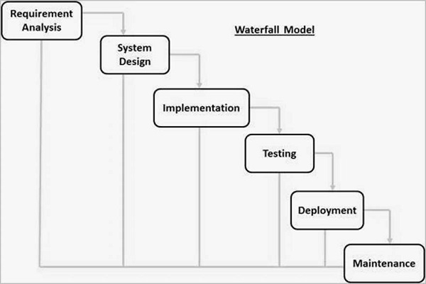

## 3.2 Organization Management

### 3.3.1 Human Resource

|  |  |  |  |
| --- | --- | --- | --- |
| **Full Name** | **Phone** | **Email** | **Position** |
| Huy, Nguyen Dang Quang | 0935525354 | [huyndq@duytan.edu.vn](mailto:huyndq@duytan.edu.vn) | Mentor |
| Hung, Nguyen Kim | 01654006417 | nguyenkimhung1221@gmail.com | Leader |
| Nghia, Nguyen Huu | 0971262523 | nghianguyenhuu848[@gmail.com](mailto:truongtanluan1996@gmail.com) | Member |
| Tri, Truong Cong Minh | 01216800655 | truongcminhtri1512@gmail.com | Member |
| Bao, Luu Quoc | 01222071366 | luubao2811[@gmail.com](mailto:nguyenminhnhatdtu@gmail.com) | Member |

### 

### 3.3.2 Cost Estimate

***3.3.2.1.*** **Cost Person/Hours**

|  |  |  |
| --- | --- | --- |
| **Full Name** | **Role** | **Salary Rate (USD/hour)** |
| Hung, Nguyen Kim | Team Leader | 1 |
| Nghia, Nguyen Huu | Team Member | 1 |
| Tri, Truong Cong Minh | Team Member | 1 |
| Bao, Luu Quoc | Team Member | 1 |

***3.*3.2.2. Total Cost Estimate**

|  |  |  |  |
| --- | --- | --- | --- |
| **No** | **Criteria** | **Price** | **Total (USD)** |
| 1 | Working hours | 1 | 1176 |
| 4 | PC’s depreciation | 19.65 | 78.6 |
| **Total cost** | | | 1254.6 |

|  |  |  |
| --- | --- | --- |
| **Description** | **Amount** | **Unit** |
| Number of members | 4 | Person |
| Number of working hour per day | 3 | Hours |
| The cost per hour per member | 1 | USD |
| The duration of the project | 14 | Weeks |
| Price of each computer | 550 | USD |
| The lifelong of each computer | 7 | Years |
| The time to use of each computer | 14 | Weeks |
| The number of working days | 98 | Days |

**- Explain:**

* + - PC's depreciation = 550/(12*7)*3 =19.65
    - Amount of working hours = 4 members * 3 hours * 98 days.