Lab 1 Questionnaire | Comp 412, Fall 2017
Name: | Vi Nguyen
Net ID: | vkn1
Date Submitted: | September 27, 2017

Implementation Discussion

- Provide a high-level description of the register allocation algorithm that you implemented. Highlight any differences between your allocator and the method discussed in class.
Do not use pseudo code. Do not include descriptions of your scanning or parsing algorithms.
Register allocation occurs in two main phases: (1) renaming and (2) bottom-up register allocation.
During renaming, the algorithm iterates backwards over the block (from last instruction to first instruction) and assigns virtual registers to each source register. Additionally, the algorithm computes live ranges (to eventually compute MAXLIVE) and next uses.
For each instruction the algorithm encounters, it updates and kills register “defs” and updates register “uses.” During updates, the algorithm will first check if the source register (SR) has a virtual register (VR) assigned to it already. If it does not, the algorithm will assign a VR to the SR. Then, whenever the algorithm encounters the same SR in the code, it will rename it to that VR. Additionally, the algorithm will note that the next use for the instruction is the last use of the SR, and then set the last use of the SR to the number of the instruction we are currently inspecting.
During the renaming process, the algorithm will also compute MAXLIVE, the maximum number of live ranges at any given point in time. It does this by maintaining a set of live values. Whenever a register is used, it is added to the set of live values, and it is removed when it is defined (since we are iterating backwards over the block). Then, we maintain record of the largest size that the live values set ever reaches—MAXLIVE.
During bottom-up register allocation on k physical registers, the algorithm iterates forward over the block (from first instruction to last instruction). First, the algorithm will check if MAXLIVE is larger than k. If MAXLIVE is larger than k, then the algorithm will reserve one register for spilling. Otherwise, if MAXLIVE is less than or equal to k, then the algorithm will not need to spill, since the number of virtual registers used during renaming will “fit” into the number of physical registers provided.
For each instruction the algorithm encounters, it “ensures” a physical register for register uses. Then, if the register uses have no next use, it will free those physical registers. Then, the algorithm will allocate a physical register for a register def.
When “ensuring” a physical register, the algorithm will check if the VR already has a physical register assigned to it. If it does, it will simply use that physical register. If the VR does not have a PR assigned to it, then it will allocate a physical register to it.
When allocating, the algorithm will first check if there is a free PR. If there is a free PR, the algorithm will simply use that free PR. Otherwise, it will spill the physical register whose next use is farthest in the future and use that PR. When data that has been spilled is needed again, it will be restored into a PR before its use.
This method of bottom-up register allocation both allocates physical registers and inserts spill and restore code into the ILOC.
The main difference between my allocator and the method discussed during class is the fact that I chose not to use a linked list to maintain the list of operations, instead opting for a Python list.

- Briefly describe your key design decisions. Do not include a detailed description of the data structures, classes, fields, and methods that you implemented.
Whenever I needed to map integer values (e.g. SRtoVR, last use, VRtoSpillAddress, etc.) I used an array where the indices of the array correspond to the “keys” and the actual values in the array are the corresponding “values,” if it were a hash-map. For example, in my SRtoVR array, SRtoVR[i] gives the VR that corresponds to SR i.
For my intermediate representation of ILOC, I chose to construct an array (a Python list) of objects called “IROperand”. The “IROperand” class contains data on a specific line of ILOC, including the opcode and up to three “Op” objects. The “Op” class contains information about the source, virtual, and physical registers used by the “IROperand.”
I insert spill code by reconstructing the list of “IROperands” during bottom-up allocation. I copy “IROperands” from the renamed IR and add spill/restore code as necessary during the allocation process.
For bottom-up allocation, I maintain another data structure called “RegClass”, which stores data about which physical registers are in use, and which virtual registers are using those physical registers.
- When your allocator must spill, how does it choose the value to spill? How does it break “ties” in that metric?
When spilling, the allocator will select the the physical register that is assigned to the virtual register that has the farthest next use (i.e. the next use of that PR is the farthest in the future). My allocator breaks ties (in the case that more than one PR has the same farthest next use) arbitrarily and will simply select one of the registers with the farthest next use.

- State the asymptotic complexity and expected case complexity of your register allocator.
During the renaming phase, the allocator iterates through each line of input code once, and performs constant-time operations on each line. Therefore, the renaming phase will run in O(n) time, where n is the number of lines of input code.

During the bottom-up allocation phase, the allocator iterates through each line of input code once, and performs constant-time operations on each line. Therefore, the bottom-up allocation phase will run in O(n) time, where n is the number of lines of input code.

Since the allocator runs these two phases sequentially, the allocator has a total runtime of O(n).

Thus, the asymptotic and expected case complexity of my allocator is O(n).
Quantitative Results
Effectiveness refers to the speed at which the allocated code runs.
Efficiency refers to the speed at which your allocator runs.
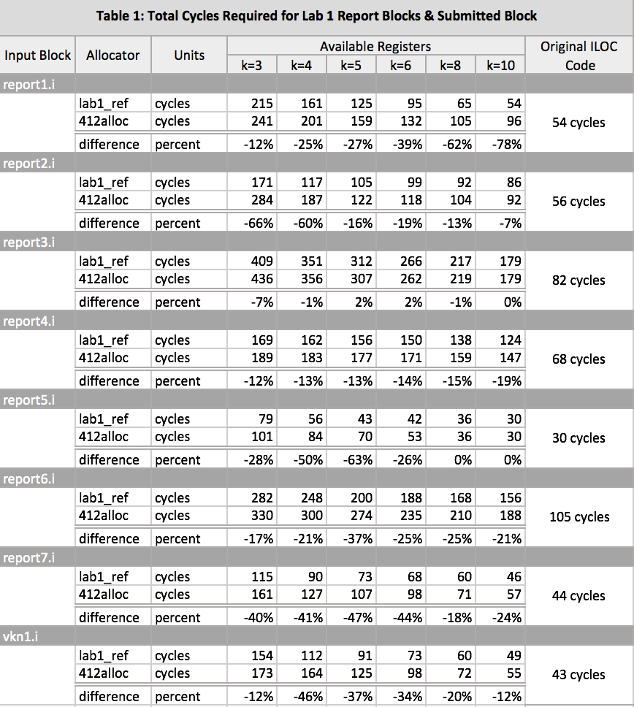
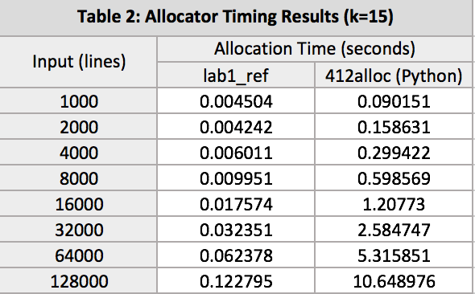
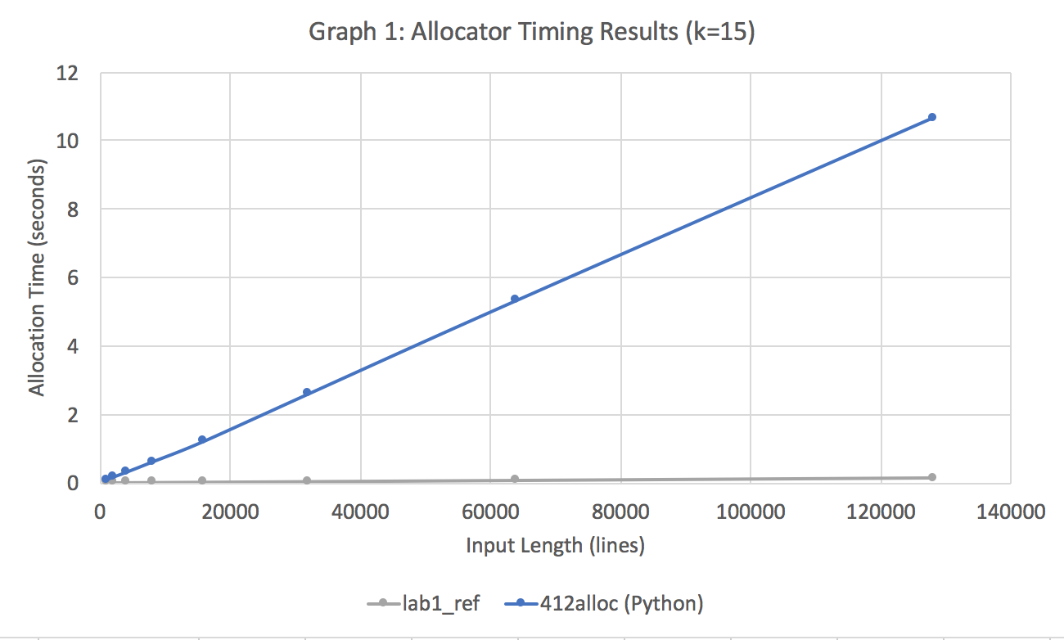

- With reference to Table 1, which shows the effectiveness of your allocator:
- Discuss the results. In particular, how well did your allocator perform versus the reference implementation in terms of correctness and effectiveness? Justify your answer quantitatively.
My allocator runs as well as the reference allocator in terms of correctness, as it returns the correct results (or at least the same as the reference allocator).

In terms of effectiveness, it does slightly worse, producing code that generally requires more cycles to run. On average, it produces code that requires 25% more cycles than the reference allocator.

- Were there blocks where you felt your allocator did particularly well?
My allocator did particularly well on report3, on which it beat the reference allocator in a few cases and produced code that, on average, ran on only 1% more cycles than the reference allocator.

- Were there blocks where you felt your allocator did particularly poorly?
My allocator did particularly poorly on report1 and report7, producing code that, on average, ran on 40% and 36% more cycles, respectively, than the reference allocator.

- What changes did you make to your allocator to improve its effectiveness?
The biggest thing I did to improve my allocator’s effectiveness was implementing rematerialization. Before implementing rematerialization, my allocator was producing code that ran on approximately 50-100% more cycles than the reference allocator.

- With reference to Table 2 and your graph:
  - How well did your allocator perform versus the reference implementation in terms of efficiency? Justify your answer quantitatively.
If your allocator is written in C, C++, Java, Haskell, OCaml, Python, Ruby, or R, refer to the allocator timing results shown in § A-4 of the lab handout when discussing the impact of your programming language choice on the efficiency of your allocator.
My allocator runs much less efficiently than the reference implementation. The reference implementation runs in about 0.009 seconds per 10,000 lines of ILOC code. In contrast, my allocator runs in about 0.8 seconds per 10,000 lines of ILOC code. Thus, my allocator runs about 89x slower than the reference implementation.
However, referencing § A-4 of the lab handout, my Python code runs about on par with the reference Python implementation. The reference Python 2015 implementation runs on 128,000 lines of code in approximately 7.5 seconds. The 2014 implementation runs in approximately 9.7 seconds. My allocator runs in about 10.6 seconds.

  - If your allocator is less efficient than the reference implementation, discuss the design decisions that you made when implementing your allocator that are most likely to account for the difference in efficiency.
One likely thing to account for the discrepancy in efficiency is that I chose to utilize a Python list rather than a linked list for my intermediate representation, since the Python list likely introduces additional computational overhead, since it is a dynamic array.
Additionally, the fact that I chose to reconstruct the IR during bottom-up allocation likely increased the runtime of my allocator, since it required the creation of an entirely new list of “IROperands.”

  - Are the timing results for your allocator consistent with the complexity analysis that you gave earlier? If not, explain why they are different. Justify your answer.
Yes, the timing results as consistent, as the resulting timing graph is linear.

- In your testing, did you identify specific ILOC blocks that demonstrated particular strengths of your allocator? If so, list the blocks and what features they demonstrated.
No, I did not identify any specific ILOC blocks that demonstrated particular strengths of my allocator.
Experience
- Did your implementation experience change your plans or your algorithms?
I originally intended to construct the list of operations as a linked list, as suggested in class. However, after implementing it using a simple Python list, I found it was simpler and not that inefficient, so I chose not to use a linked list, which I would have had to implement myself (and possibly have to deal with bugs from that).
Other than that, much of my algorithm remained the same during implementation.

- Based on your experience, would you use the same algorithm if you had to start from scratch? If not, what would you do?
I would likely use the same algorithm again, since it was effective and fairly simple to implement. Most of the headaches that I encountered during this project were as a result of personal misunderstanding and small bugs that snuck in, rather than due to the algorithm itself.

- How did your choice of implementation language affect your ability to complete the project on time?
I consider myself fairly fluent in Python, so implementing the allocator in Python definitely helped me complete the project on time.

- What advice would you give future COMP 412 students embarking on Lab 1?
My main advice would be to start early, since a lot of the code isn’t particularly hard, but it is time-consuming and easy to introduce small bugs, so it’s much better to work slowly and meticulously over the course of several days.

