Lab 3 Questionnaire | Comp 412, Fall 2017
Name: | Vi Nguyen
Net ID: | vkn1
Date Submitted:

Implementation Discussion

- Briefly describe the key design decisions you made in building your scheduler. Do not include a detailed description of the data structures, classes, fields, and methods that you implemented.
The key design decisions I made in building my scheduler were the implementation of the dependency graph, a list of serialization edges (as opposed to dependency edges), and a mapping of virtual registers to their values.
I implemented my dependency graph as a Python class called Node. Importantly, Node maintains a list of an operation’s successors and a list of an operation’s predecessors (which represents the dependency graph). Additionally, Node maintains information about an operation’s priority, the cycle in which it is scheduled to run, and the functional unit on which it will run.
Using a Python list, I maintain a set of the edges in the graph that are serialization edges (rather than dependence edges). This is mostly a hack, since the way that I implemented the dependency graph doesn’t distinguish between dependence edges and IO serialization edges. Therefore, I use this list to ensure that serialization edges have a different “delay” than dependence edges. For example, stores and loads have a latency of 5, but stores and loads that have serialization edges between them (rather than dependence edges) only need a delay of 1, since it is serialization, not dependence.
Using a Python list, I maintain a mapping of virtual registers to the value they contain. The scheduler populates this mapping while walking down the list of operations in order to build the dependency graph. This is required in order to determine the independent of memory operations, as discussed in my answer to question 4.

- How did you implement the ready and active queues (or lists, or sets, or …)?
I implemented both the ready and active queues as Python lists. To pull the operation with the highest priority from the ready queue, I used the Python `max` method, using the assigned priority of the op as the key.

- What priority function or functions does your scheduler use to determine which operation to schedule next? Does it use any tie-breakers? How does your scheduler ensure that the restricted operations—that is, load, store, and multiply—are scheduled legally?
The main priority function that my scheduler utilizes is latency-weighted depth. To compute this, the algorithm traverses the graph in a depth-first manner and assigns computes the furthest distance a given node (op) is from a root (where the weights on the edges correspond to the latencies of the operations).
To break ties, my scheduler uses the number of successors a given operation has, with operations with more successors getting higher priority.
The scheduler ensures that operations that are restricted to certain functional units are scheduled legally by maintaining a mapping of which functional units can perform which operations. Then, for each functional unit, when computing the operation with the highest priority in a ready queue, the scheduler only considers operations that can be run on that functional unit.
For example, because load/store/mult can only be run on a certain functional unit, they will never be considered to run on the other functional unit. Therefore, the scheduler ensures that no cycle can contain two loads/stores/mults.

- Does your scheduler perform any pruning on the dependence graph? If so, explain how you determine that an edge is not needed and any analysis that your scheduler performs to support that decision.
Yes, my scheduler performs pruning on the dependence graph. I remove edges between memory ops (that are added by the algorithm in order to ensure full latency) that are independent. Two memory ops are independent if they do not touch the same memory location. The operations that touch memory are (1) load vrY => vrZ, (2) store vrU => vrV, and (3) output x. Therefore, (1) and (2) are independent if the constants (addresses) stored in vrY and vrV are distinct, (1) and (3) are independent if x and the constant stored in vrY are distinct, and (2) and (3) are independent if x and the constant stored in vrV are distinct. If the value in a register is unknown, then the algorithm doesn’t make any assumptions about its independence.
In order make these decisions, my scheduler maintains information about what values are stored in which virtual registers. It maintains a mapping of virtual registers to values. For example, if a loadI op is encountered while constructing the dependency graph, the scheduler will map the register to the constant. Additionally, if the scheduler encounters an arithmetic operation (add, sub, mult, etc.), it will check if it has information about what values are stored in the “use” registers. If both “use” registers have values in the mapping of virtual registers to values, then the scheduler will perform that operation and map the “def” register to the resulting value. Then, using this mapping, the scheduler can determine if two memory operations are independent as described above.

- State the asymptotic complexity and expected case complexity of your register scheduler.
Let us discuss the scheduler’s complexity in the three distinct phases: building the dependency graph, computing priorities, and scheduling. Let n be the number of operations in the original ILOC code. Note that, as discussed in my previous lab report, that the complexity of renaming is O(n).
The asymptotic and expected case complexity of building the dependency graph is O(n), because the algorithm walks down the list of operations once and all of the computations performed on each operation are O(1).
Computing the priority is O(n) in both the asymptotic and expected case. In order to compute priority, the scheduler runs DFS, which is O(|E| + |V|). In this case, |V| = n. We can also assume that |E| in the dependency graph is O(n), since the dependency graph is likely sparse. Therefore, computing the priority is O(n).
Scheduling also has an expected complexity of O(n log n), because the outer while-loop will run O(n) times, since it will consume at most two operations per cycle. Choosing the operation with the highest priority, which occurs a constant number of times during each iteration of the while loop, has a complexity of O(lo n) in the worst-case where the ready queue has length n. However, this is not true in the expected case, where the length of the ready queue is much smaller than n. Within the while-loop, the for-loop that checks nodes in active has a worst-case of O(n), since it is possible that all of the nodes in a graph could be in active, but in expected case, the number of nodes in active will be much less than n. Therefore, in the worst case, scheduling has an asymptotic complexity of O(n^2 log n).
Therefore, my register scheduler has an expected case complexity of O(n) and an asymptotic complexity of O(n^2 log n).

Quantitative Results
Effectiveness refers to the speed at which the allocated code runs.
Efficiency refers to the speed at which your scheduler runs.

- With reference to Table 1, which shows the effectiveness of your scheduler:
- Discuss the results. In particular, how well did your scheduler perform versus the reference implementation in terms of correctness and effectiveness? Justify your answer quantitatively.
On average, my scheduler performed about 6% worse than the reference implementation in terms of effectiveness. In terms of correctness, my scheduler performed identically to the reference implementation, i.e. my scheduler produces correct ILOC code.

- Were there blocks where you felt your scheduler did particularly well?
My scheduler did particularly well on report16.i (11% better than reference) and report 19.i (10% better than reference).
Report 16 tests that unnecessary edges are removed from the dependency graph, so it makes sense that my scheduler does well on this test block, since a large part of my work towards improving the effectiveness of my scheduler was removing unnecessary edges from the dependence graph.

- Were there blocks where you felt your scheduler did particularly poorly?
My scheduler did particularly poorly on report 9.i (54% worse than reference).
According to the comments on Report 9, it “tests whether or not the scheduler can correctly identify that two registers contain values that are different offsets from the same memory value, and therefore must be different, so their stores and loads are independent of each other.” My scheduler cannot do this, which explains why it does so poorly on this particular test block.

- What changes did you make to your scheduler to improve its effectiveness?
The largest changes I made to my scheduler to improve its effectiveness were removing unnecessary edges from the dependence graph (as discussed in the previous section of this lab report) and playing with priority functions.

- With reference to Table 2 and your graph:
  - How well did your scheduler perform versus the reference implementation in terms of efficiency? Justify your answer quantitatively.
If your scheduler is written in C, C++, Java, Haskell, OCaml, Python, Ruby, or R, refer to the scheduler timing results shown in § A-4 of the lab handout when discussing the impact of your programming language choice on the efficiency of your scheduler.
In terms of efficiency, my scheduler allocates roughly 10,000 lines of input code per second. The reference implementation (in C) allocates roughly 1,111,111 lines of input code per second. Compared to lab3_ref, my scheduler is about 100x less efficient.
Referring to the 2015 Python scheduler in section A-4 of the lab handout, the reference Python scheduler allocates about 12,500 lines of input code per second. Thus, compared to the reference Python scheduler, my scheduler is about 1.25x less efficient.

  - If your scheduler is less efficient than the reference implementation, discuss the design decisions that you made when implementing your scheduler that are most likely to account for the difference in efficiency.
My choice to implement the dependency graph as a Python class likely decreased the efficiency of my scheduler. In particular, there are several points my scheduler where I access the same fields repeatedly (in an if-statement for example), which could potentially have decreased the efficiency of my code. If I had implemented the dependency graph primarily using Python lists, lookup likely would have been much more efficient.

  - Are the timing results for your scheduler consistent with the complexity analysis that you gave earlier? If not, explain why they are different. Justify your answer.
Yes, the timing results for my scheduler are consistent with the complexity analysis that I gave earlier. The timing results for my scheduler are approximately linear, and the complexity analysis I gave earlier predicted a complexity of O(n) in the expected case.

- In your testing, did you identify specific ILOC blocks that demonstrated particular strengths of your scheduler? If so, list the blocks and what features they demonstrated.
Report 16 demonstrated my scheduler’s ability to effectively remove unnecessary edges from the dependency graph.

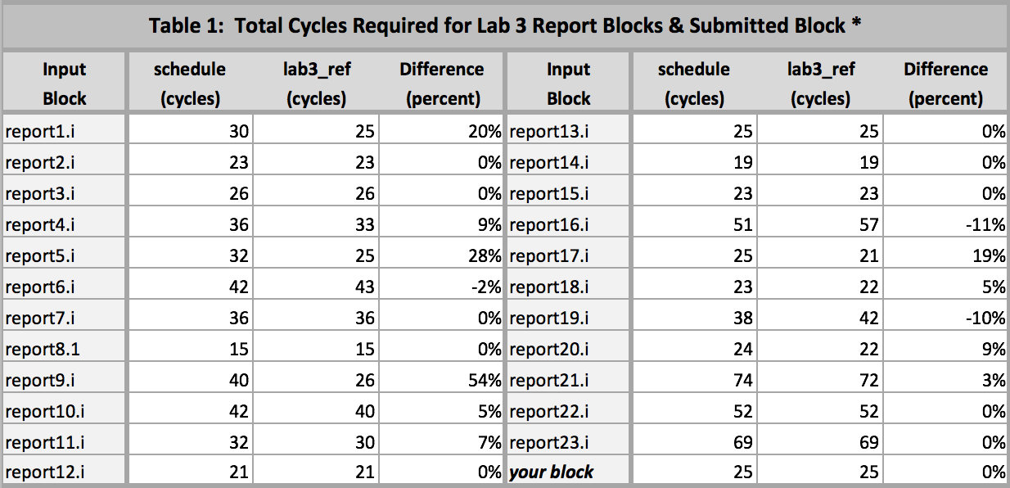

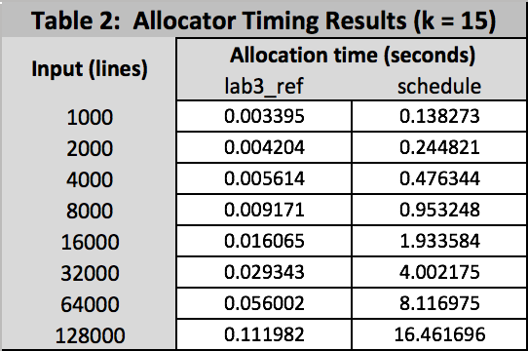

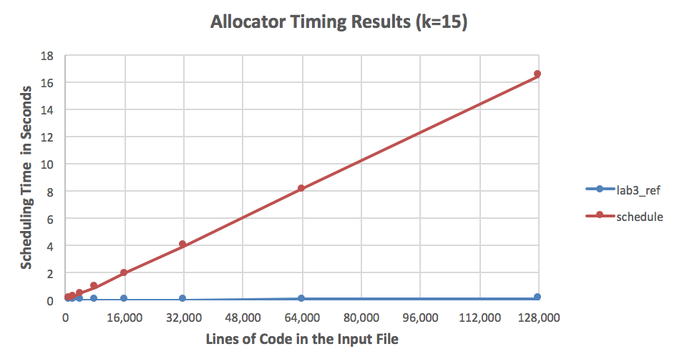

Experience
- Did your implementation experience change your plans or your algorithms?
Initially, I represented the dependency graph as an adjacency matrix, while I was implementing the “build dependency graph” phase of the project. However, when I had to compute priorities and schedule, I found that the adjacency matrix was too unwieldy for a lot of the operations and data I needed to perform during scheduling. Thus, I refactored my code and created a Node class, which greatly simplified my scheduling algorithm.

- Based on your experience, would you use the same algorithm if you had to start from scratch? If not, what would you do?
I would likely use the same algorithms if I had to start from scratch.

- How did your choice of implementation language affect your ability to complete the project on time?
I used Python to implement the scheduler, a language I have written thousands of lines of code in by this point, so implementation language was by no means a barrier to completing the project on time.

- What advice would you give future COMP 412 students embarking on Lab 3
This is cliché advice, but I would advise future COMP 412 students to start early on this lab. Even though there are only three main “phases” to this lab (building a dependence graph, computing priorities, and scheduling), they are all fairly intensive. Furthermore, the bugs in this project can be especially hard to track down, so make sure that your dot file outputs are giving you useful information. Additionally, make sure you understand the difference between serialization and dependence edges! This gave me a hard time, and resulted in my scheduler producing ineffective code until I figured out the difference. Finally, profilers are amazingly helpful in figuring out where your scheduler is bottlenecking when you’re trying to figure out why your scheduler is so inefficient with large inputs. Using the Python cProfile library saved me probably hours of headaches, because it told me exactly which methods were being called too many times.

That is, no cycle can contain two or more operations drawn from the set { load, store } or two multiplies.

