# Instruction Business Intelligence

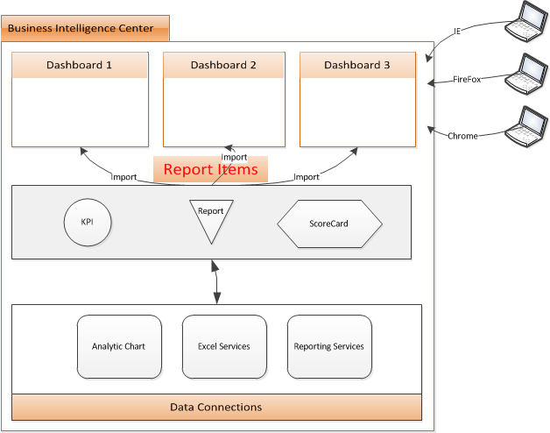

## Create a Dashboard Open the Dashboard Designer

At its most basic level, a dashboard is a just Web Part page that contains a collection of indicators, data, or graphics.

### Prerequisites for creating dashboards

1. Activate the SharePoint Server Publishing Infrastructure feature. PerformancePoint Services uses this feature to perform dashboard publishing.
2. Activate PerformancePoint Services Site Collection Features feature. This feature adds PerformancePoint content types and a Business Intelligence Center site template.
3. Activate the SharePoint Server Enterprise Site Collection Features feature. This feature enables Excel Services, Visio Services, and Access Services, included in the SharePoint Server Enterprise License.
4. Create a new Business Intelligence Center site by clicking Site Actions ➪ New Site, and then choose Business Intelligence template.
5. Create an Unattended Service Account.

In PerformancePoint Services, you create the unattended account directly in the PerformancePoint Services application settings.  
In this case, the password is stored in Secure Store Service and the actual username is stored in the PerformancePoint Services database.

An unattended account can be created using the following steps:

1. Browse to the **Central Administration Site**.
2. From the **Application Management** category, choose **Manage service applications**.
3. From the list of existing service applications, click **PerformancePoint Service Application**.
4. Click the **PerformancePoint Service Application Settings** link.
5. Specify the unattended service account for PerformancePoint and click OK.

### Install Dashboard Designer

1. In Internet Explorer, navigate to the **Business Intelligence Center** site that you must have created.
2. Click the Create Dashboards link, and then click **Start using PerformancePoint Service** link.

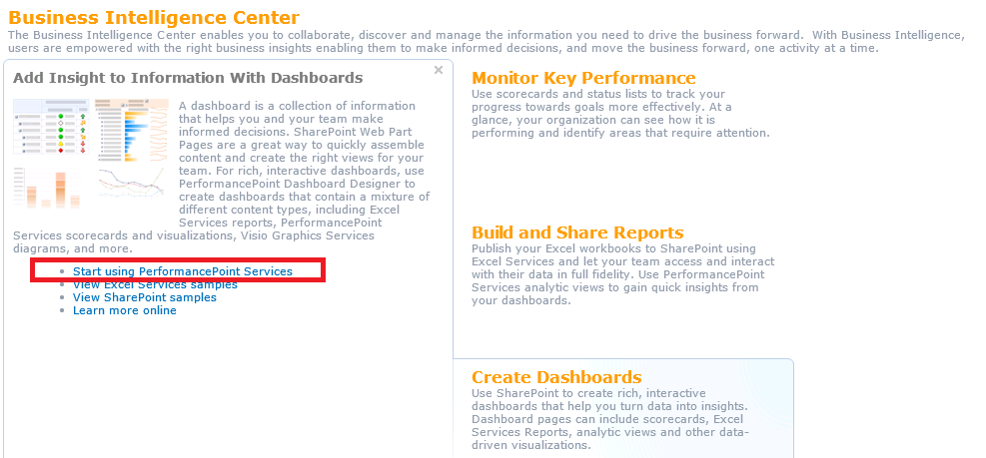

1. From the PerformancePoint Services page, click the big button that says **Run Dashboard Designer**. This will download and install the PerformancePoint Dashboard Designer to your workstation.  
   Once the executable fi le is downloaded and installed on your computer, the PerformancePoint Dashboard Designer appears. Once the Dashboard Designer is installed, you have an empty workspace. A workspace is a primary container for all of the elements that you can use to build your dashboard, and it keeps its content synched with the site from which it was launched.

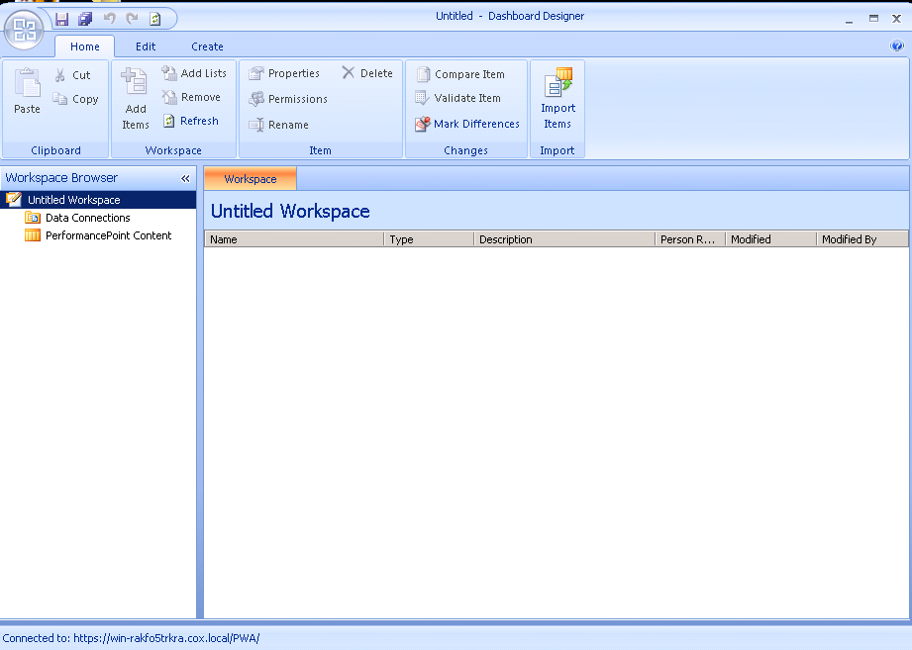

### Creating Your Dashboard

Before we get started with building a dashboad lets just create a Dashboard Datasource first. Let’s the types of Databases that you can use and there feature:

1. SharePoint Lists – Data contained in a SharePoint List on a SharePoint Site can be used in PerformancePoint Services by creating a SharePoint List data source in Dashboard Designer. Please Note that the data from SharePoint Lists can only be read. Modification to SharePoint List data must be done from SharePoint.
2. Excel Services – Data in Excel files published to Excel Services on a SharePoint Site can be used in PerformancePoint Services by creating an Excel Services data source. Supported published data can only be read in PerformancePoint Services. Published parameter values can be modified from the Dashboard Designer. If you use an Excel Services parameter in calculating a KPI, it is easy to make additional changes. PerformancePoint Services supports the following Excel Services components: Named Ranges, Tables and Parameters.
3. Excel workbooks – You may use the content of an actual Excel file as a data source in PerformancePoint ServicesPerformancePoint Service by creating an Excel Workbook data source connection and select only the data that is to be used. The original Excel file will be independent from the PerformancePoint copy. PerformancePoint Services 2010 supports Excel 2007 and Excel 2010 workbooks as data sources
4. SQL Server tables – You can create a data source connection to a SQL Server database and use the data within PerformancePoint Services. SQL tables and SQL views are supported data sources within PerformancePoint Services.
5. Analysis Services – Use data residing in a SQL Server Analysis Services cube in PerformancePoint Services by creating a data connection to the source. PerformancePoint Services lets you map the desired time dimension and the required level of detail for its hierarchies to the internal PerformancePoint Services Time Intelligence

### Create a Dashboard Datasource:

1. Right – click the Data Connections folder in the Workspace Browser, and then select New ➪ Data Source.

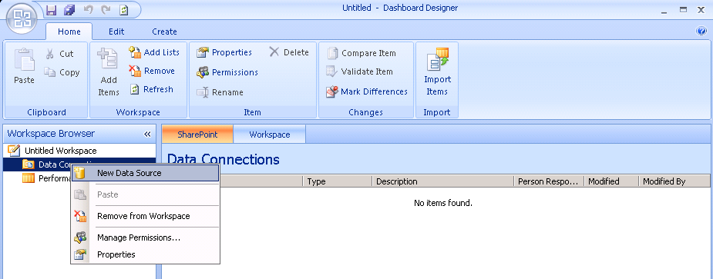

1. From the Select a Data Source Template menu, choose the Analysis Services template to create a datasource that connects to Microsoft SQL Server Analysis Services, and click OK. Next Configure the Connection Settings.
2. Watch for Cache Lifetime setting. The value of this textbox (in minutes) indicates the interval of refreshing the dashboard information from the backend datasource.
3. Click Test Data Source to make sure that your connection settings are correct.
4. Switch to the Properties tab and change the Name of your datasource.
5. Save the new datasource by right – clicking it in the Workspace Browser, and then selecting Save.

### Create a Dashboard

1. Right Click on PerformancePoint Content -> New -> Dashboard

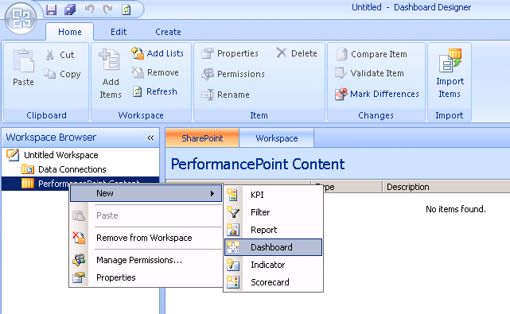

1. Choose template

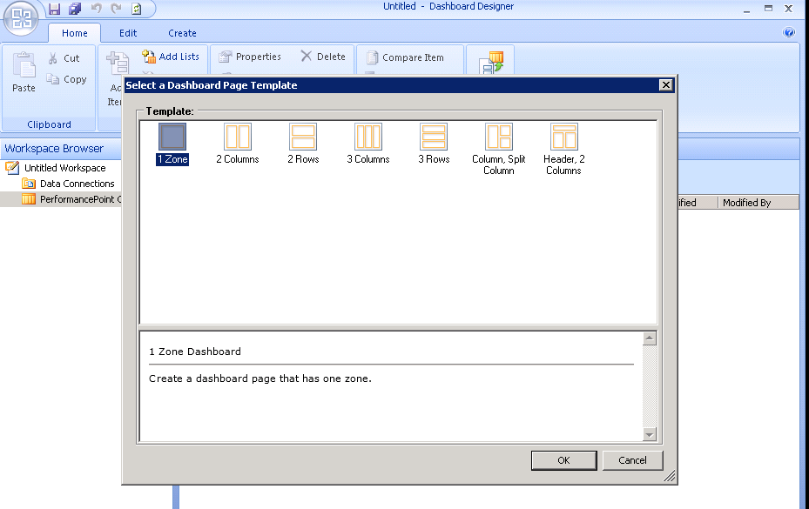

1. Drag drop items in right to dashboard

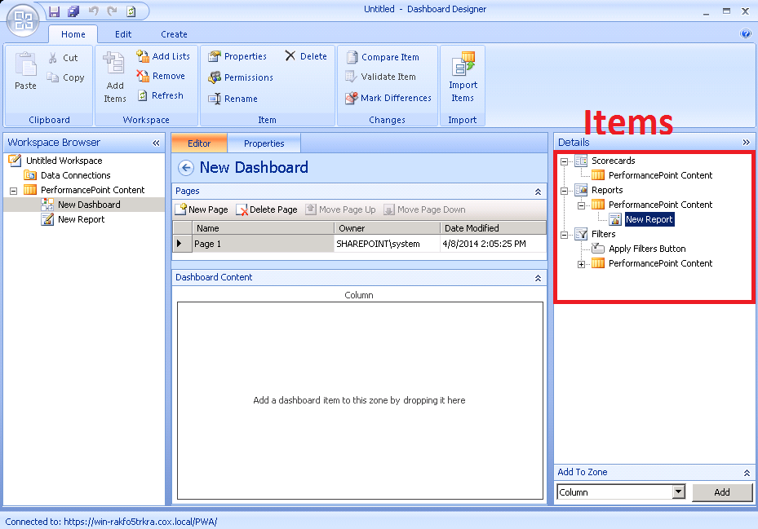

### Deploy Dashboard

1. Right Click on Dashboard -> Deploy to SharePoint

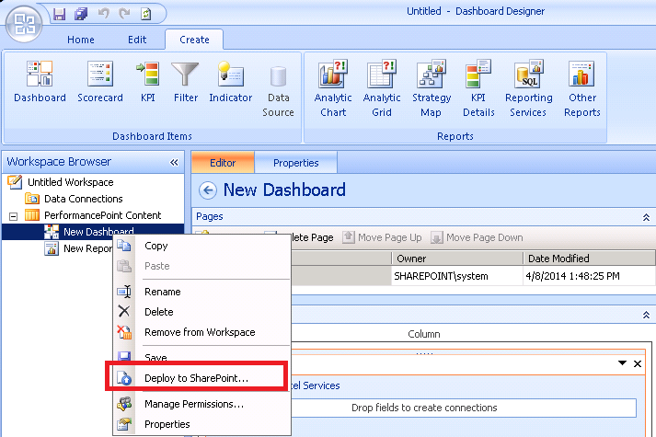

1. Choose Business Intelligence Center -> Dashboard. Choose master page then click OK

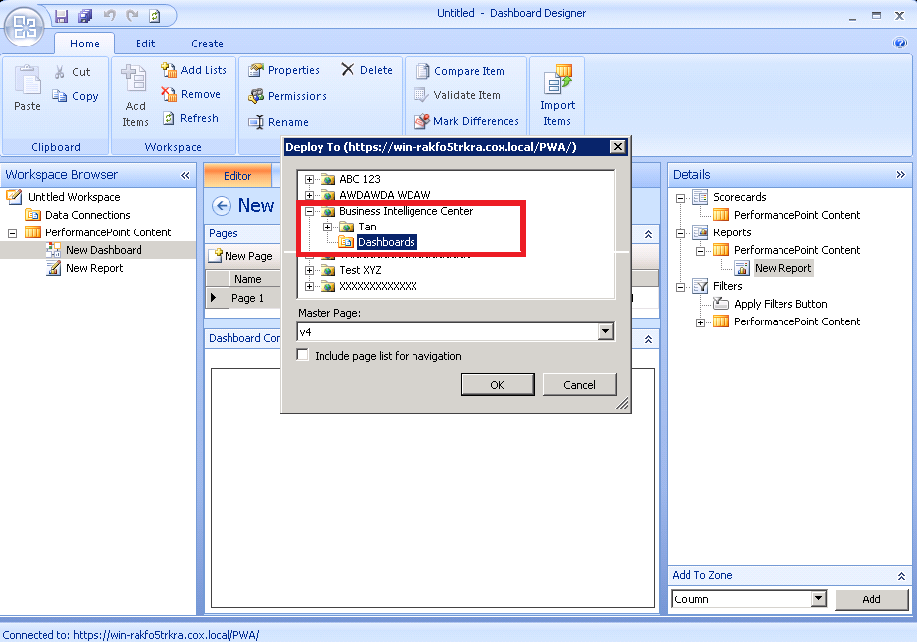

1. When deploy success, the browser will automatic open dashboard page

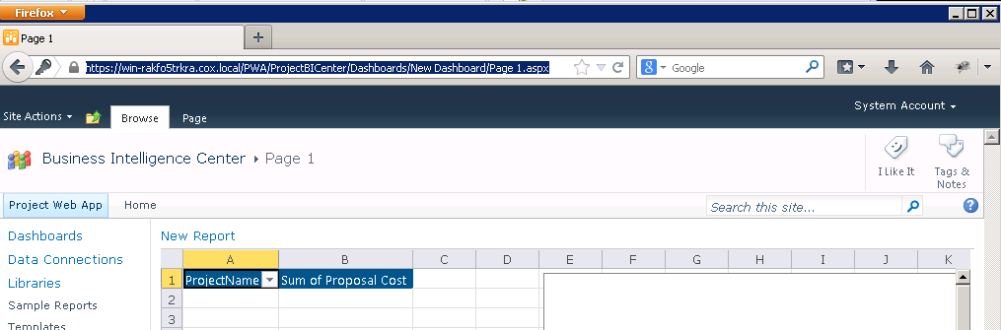

## Performance Point - what are the capabilities of Performance point and how would we incorporate this into our dashboards

To create a dashboard in SharePoint 2010, you would use the newly integrated part of the SharePoint Server 2010 Enterprise called PerformancePoint. PerformancePoint Services is a performance management service that you can use to monitor and analyze your business or you can say that, PerformancePoint Services is Microsoft’s dashboard delivery tool, which now is part of the SharePoint Server 2010 Enterprise platform. PerformancePoint Services enables you to create rich, context-driven dashboards that aggregate data and content to provide a complete view of how your business is performing at all levels.

### When do we use Performance Point Services?

* When we want to use Context-driven Dashboards across system.
* We need Transparency & accountability.
* We need to Create KPI from different sources.
* We use Performance Point Services when we need Multi-dimensional analysis for root cause.

### What will PerformancePoint give us?

* It provides us with flexible and easy-to-use tools for building Key Performance Indicators (KPIs), Scorecards, Analytic Charts and Grids, Reports, Filters and Dashboards.
  + **KPI’s** are indicators to measure certain goals in the company. We can create KPI’s from different back-end sources using Performance point.
  + **ScoreCard -** This is collection of KPIs. We drag-drop your KPI’s to a scorecard.
  + **Reports -** Lastly, we create reports to be added to your dashboard.
* Each of these components is unique to PerformancePoint Services and providing functionality that interacts with a server component that handles the hard parts like data connectivity and security.

### PerformancePoint Content list

The PerformancePoint Content list is designed to store the PerformancePoint Services scorecard and report elements that an analyst creates by using Dashboard Designer. For example, this illustration shows a PerformancePoint Content library that contains Key Performance Indicators (KPIs), a scorecard, and a report.

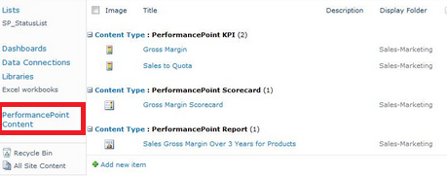

## Excel services - what are the capabilities and how would we incorporate into our dashboards

First introduced in SharePoint Server, [Excel Services](http://technet.microsoft.com/en-us/library/ee424401.aspx) provides server-side calculations and browser-based rendering of Excel workbooks. On the right is the architectural concept of Excel Services. In the core is Excel Calculation Service (ECS) which is the calculation engine. Excel Web Access (EWA) is a web part which displays and interacts with a workbook. The access to methods and objects is through APIs provided by Excel Web Services (EWS) hosted in SharePoint Services.

Excel Services allows a user to publish a workbook or selected spreadsheet cells as a webpage. Because the content is published without exposing the underlying business logic, intellectual properties are protected and as well applied in a standardized/consistent fashion. The motivation is to publish "one version of the truth" such that users always view a consistent set of values if published as read only, and results derived on business logic that is consistently defined. In a large organization, consistency and synchronicity are key productivity enablers which are many SharePoint features are about. Both Excel 2010 and Excel 2007 have the ability to publish an Excel workbook to a SharePoint site.

### Create a Report with Excel Service Type

1. Right Click PerformancePoint Content -> New -> Report

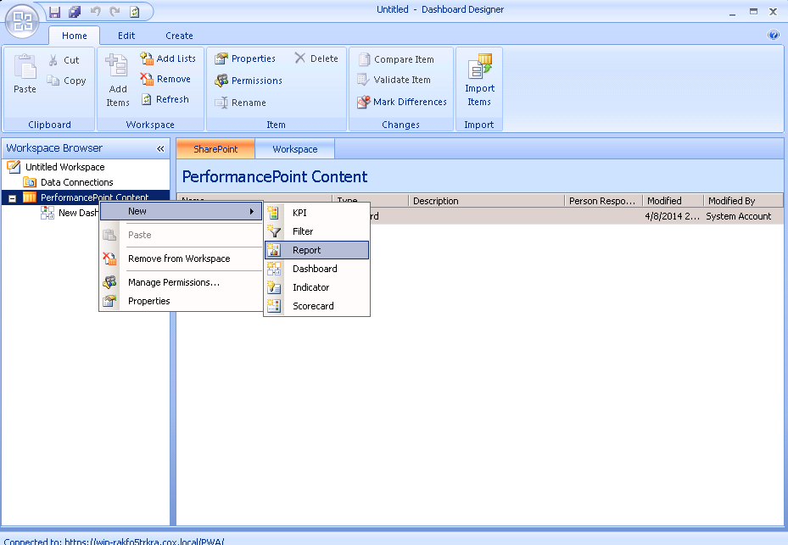

1. Choose Excel Service

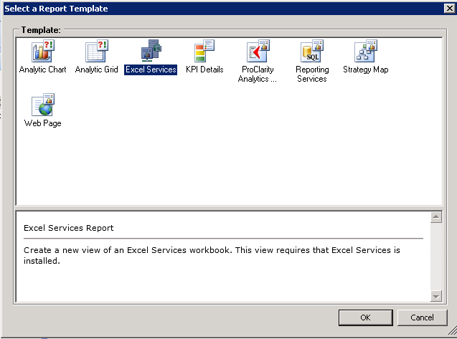

1. Input link of SharePoint Site( <sharepointsite url>/pwa/ProjectBICenter)

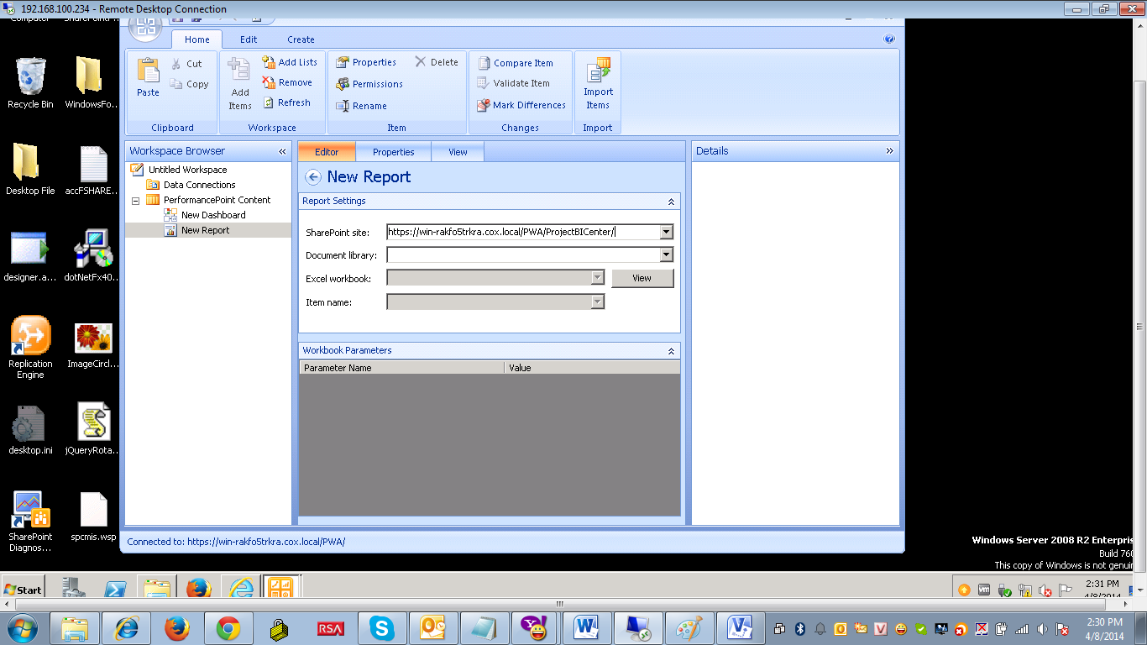

1. Choose **Sample Report** in Document library, then choose Excel workbook

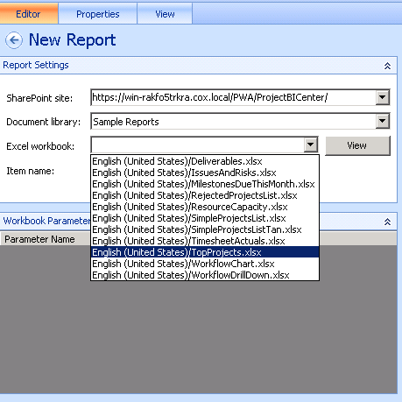

1. Now we can add this report to dashboard by drag drop

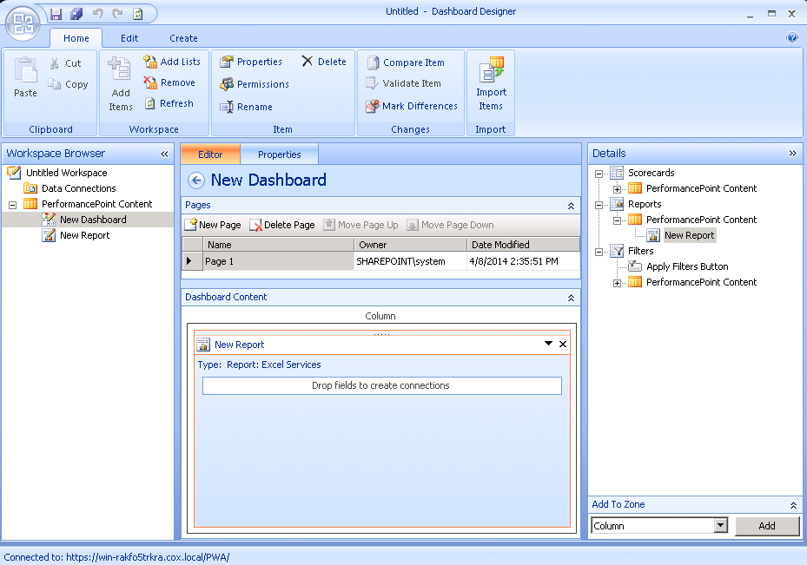

### Create Excel Workbook with Pivot

1. Go to **Sample Report** in navigation. Clone a file. Each file will have a different SQL statement. In this example I clone SimpleProjectList and rename to SimpleProjectListTan

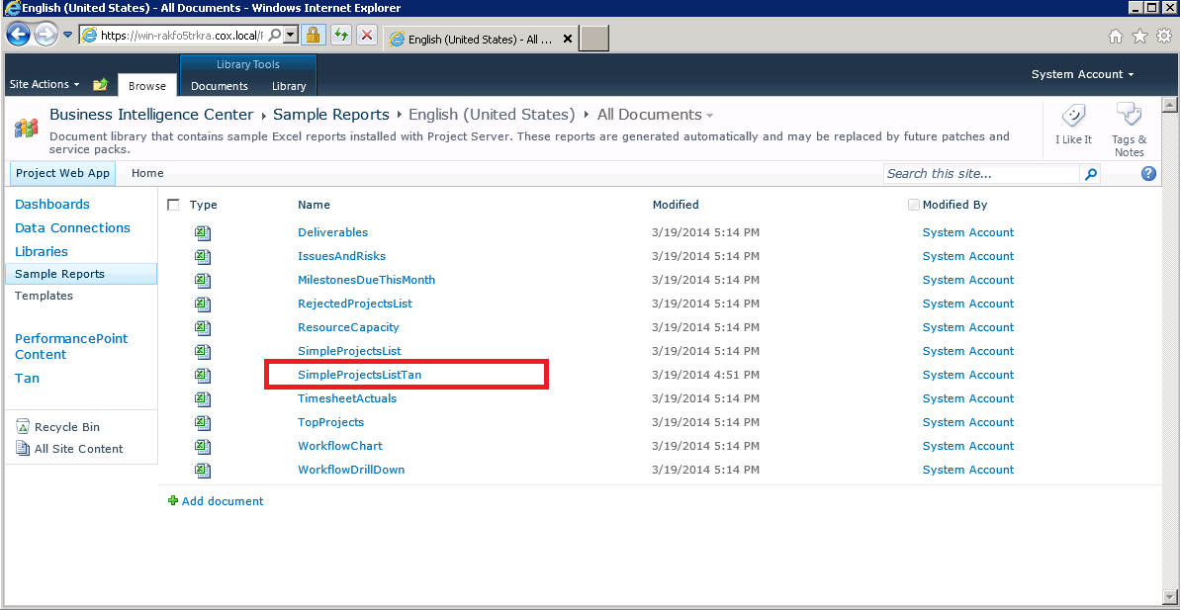

1. Click on that file and choose **Edit in M$ Excel**

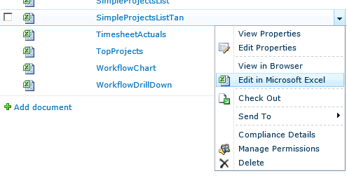

1. Excel will opened and you will see Pivot Table. Pivot is a presentation tools for excel workbook

Here are some example uses of pivot tables:

* Summarizing data like finding the average sales for each region for each product from a product sales data table.
* Listing unique values in any column of a table
* Creating a pivot report with sub-totals and custom formats
* Making a dynamic pivot chart
* Filtering, sorting
* Transposing data – *i.e.* moving rows to columns or columns to rows.

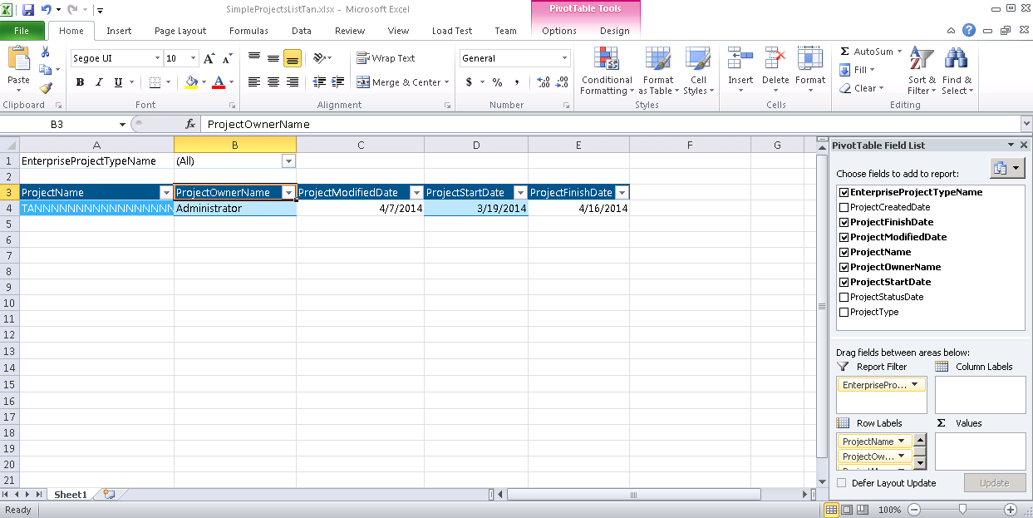

1. Click **Save** for update file to Sharepoint

## Data Connections library

The Data Connection library enables you to specify data source connections once, and then re-use them in any Web Part on the site. The Data Connection library supports PerformancePoint Data Sources, Office Data Connection (.odc) Files, and Universal Data Connection (UDC) files.

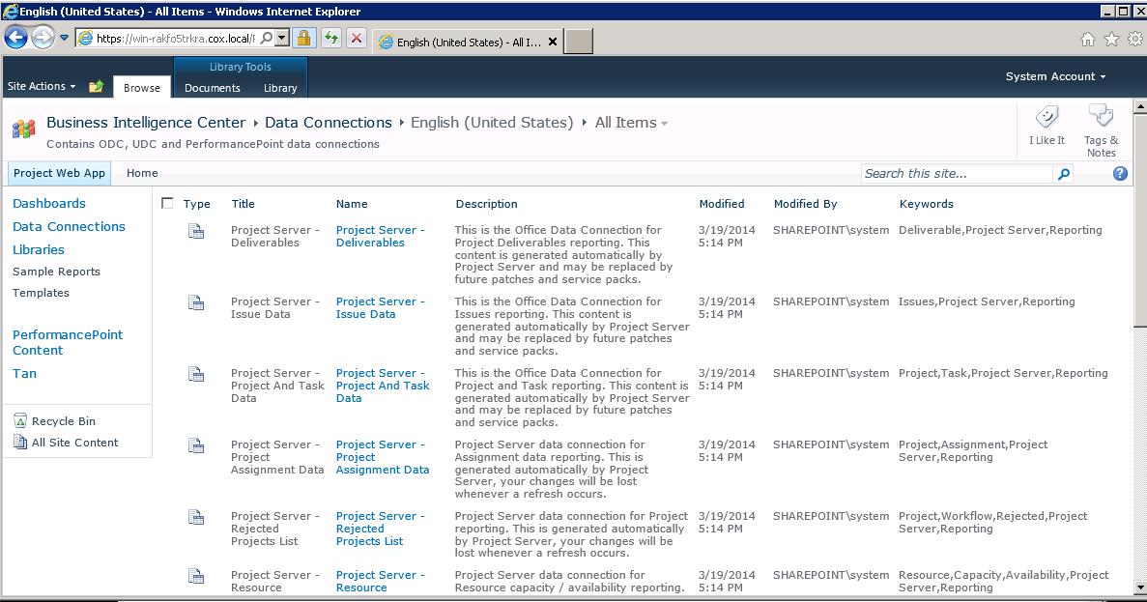

### Import Data Connection in Excel Workbook

1. Open a Excel file
2. Choose **Data** tab and click on **Connection** button

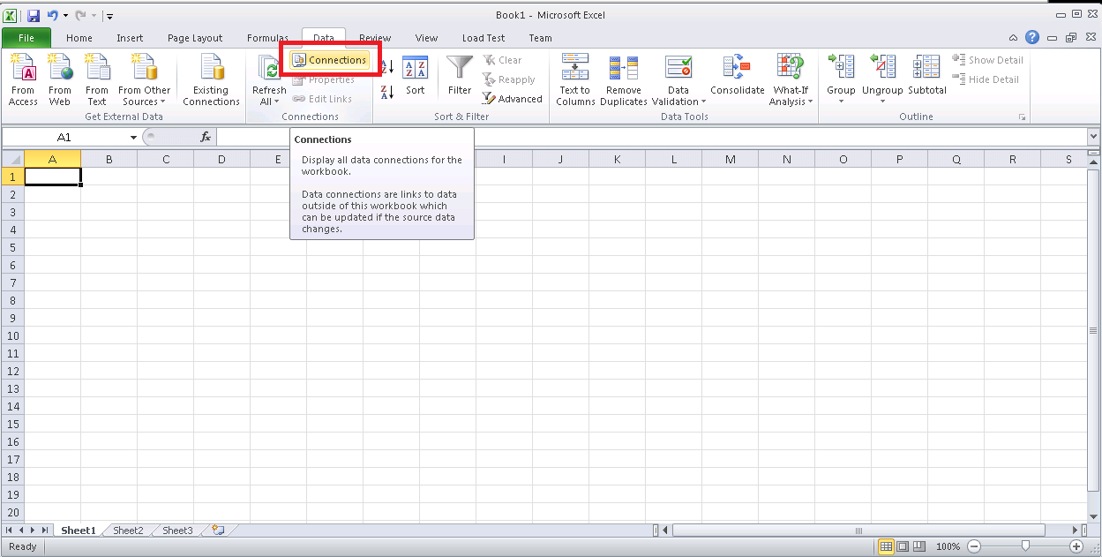

1. Click **Add**. Then click **Browse for more.** Put the link (ex : https://win-rakfo5trkra.cox.local/PWA/ProjectBICenter/Data Connections for PerformancePoint/English (United States) ). Choose a connection you want and click Open

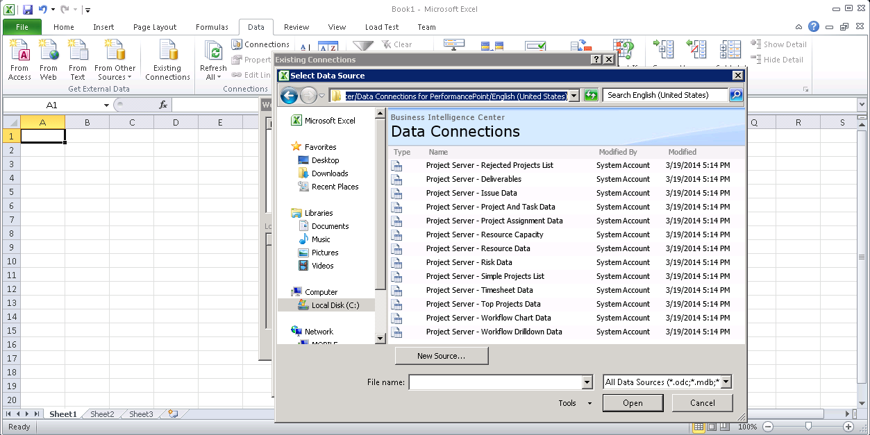

1. Click on **Data** tab and choose **Existing Connections.** Choose the data connection that u added above then **Open**

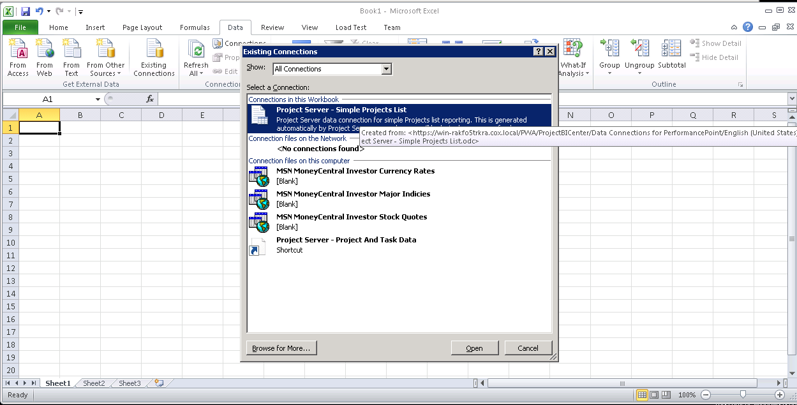

1. Choose the view data. In this case I choose PivotTable Report. Then **OK**

