**Nguyen Le Nam Anh**

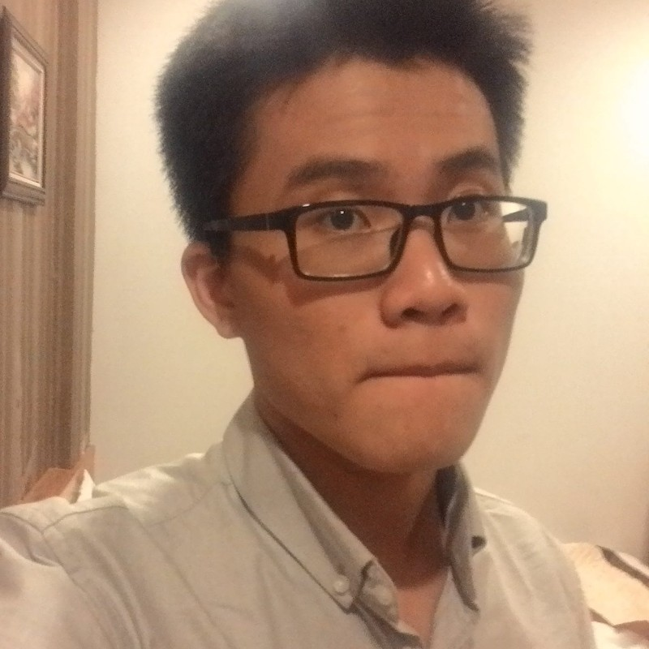

**PERSONAL DETAILS**

* Name **Nguyen Le Nam Anh**
* Nationality Vietnamese
* Date of birth 05/10/1998
* Sex Male
* Marital status Single
* Phone No. 0703620282
* Email nguyenlenamanh.2016@outlook.com

**EDUCATIONAL BACKGROUND**

* IUH UNIVERSITY (From 2016 To 2020) – Major: Software Engineering – Top 3 graduated students in 2020. GPA: 3.65. Degree grade: Excellent

**PROFESSIONAL SUMMARY**

* I am in top graduation in my university and currently working as .NET Developer at FSoft.
* Having been working in software development fields for more than 5 years.
* Have been working as a technical lead position for 2 projects in more than 2 years and got the technical lead role of a small team (6 persons) from the very first year of working is my pride.
* Love designing & architecture cloud-based solution.
* Follow philosophy “thinking before doing” due to laziness.
* I am considered a quick learner, a problem solver and tech lover by co-workers and leaders.
* Because I am a tech lover & creative person, so I always want to learn new technology and build something with it. So, if I can work in an environment full of new techs and problems then I will be extremely happy to work.

# ACHIEVEMENTS

* Got certification for successfully completing SOLUTION ARCHITECT of FPT Corporation
* Got excellent performance of month (July-2022)
* Became the member of Platinum Club 2022 (Top 3% best individuals among 23000 people)
* Got best performance of year (2021)
* Got best rookie of year (2020)
* Got TOEIC score: 840.
* Top 3 graduated students in 2020. GPA: 3.65. Degree grade: Excellent
* Got scholarship every single semester when was in university.

**SKILLS**

* .NET stacks: LinQ, Entity Framework, ASP.NET MVC, ADO.NET, SQL Server, Window form, WPF… (Main skill → Advanced Level)
* MERN stacks: Nodejs, Reactjs, MongoDB (Side skill → Intermediate level)
* Cloud stacks: AWS (EC2, S3, SQS, Lambda, …)
* General skills: Design pattern (have some knowledge about design patterns), system design (can designing & architecture cloud-based solution with cloud design pattern for best practice), database design skills, leader skills (have experience due to working as technical lead for more than 2 years)

# PROFESSIONAL EXPERIENCE

## 03/2023 – Now

**Working as Senior Developer at Call Journey   
Project:** VoiceAI

## Project Description:

* This project belongs to Call Journey, an Australian startup company that provides speech and text analytics services with help from ML and AI.
* Due to a startup company, this project leverages and applies recent technical stacks like (AWS cloud stacks, microservices, data pipelines…)
* Team size: 12 members

## Responsibilities

* My responsibility is maintaining existing source code and developing new features based on CTO expectations.
* Investigate solutions, provide it to CTO, implement, test, and deploy it.

## Technologies Used:

Software environment

* ASP.NET Web APIs (Hangfire for job scheduler, ffmpeg for voice redaction, ...)
* Aws services (lambda, API gateway, SNS, SQS…)
* Low code platform: Budibase
* Microservices, batch processing, ...

## 09/2021 – 03/2023

**Working as Technical Lead at FSoft   
Project:** DTH (Web App)

## Project Description:

* This project is about building a tax system for San Diego County. Due to it is a domain about taxes, it has very complex business that need a lot of time to meeting with San Diego County
* Team size: 24 members

## Responsibilities

* My responsibility is technical-business analysis. I will join the meeting with San Diego County to understand the expectation of them, then define the solution, break tasks, transfer to the development team, support team members, demo with County.
* Interview members for the team.
* Coding new features, and review code of team members
* Make everything working fine.

## Technologies Used:

Software environment

* ASP.NET Web APIs
* Azure (Blob, Service Bus, SQL servers, Memcached, …)
* Microservices, batch processing, ...

**08/2020 – 11/2021**

**Working as Technical Lead at FSoft**

**Project:** SSM (Web App)

**Project Description**:

* This project is about importing master data for Lixil management system, and it has difficult business logic. It requires good code reading skill & sql query reading skill to understand business logic.
* Team size: 6 members

## Responsibilities:

* Read source code to know business (reverse engineering) then transfer it for team members to implement.
* Research and build a structure that helps convert web form to MVC a lot simpler and less bugs.
* Fix critical bugs in production.
* Interview members for the team.

## Technologies Used:

* .NET Stacks: Webform, MVC, Sql Server, GCP (Storage, Load balancing, VM, …)

## 02/2019 – 07/2020

**Working as Junior Developer at FSoft**

**Project:** Lixil (Web App)  
**Project Description:**

* Migrate customer web app from VB to .net core 3.1.
* Team size: 12 members

## Responsibilities:

* Migrate backend from VB to C#
* Design and execute unit test (to confirm that your migrated code work)
* Migrate front end (webform to MVC using razor page)

## Technologies Used:

Software environment

* ASP.NET MVC
* SQL Server

**06/2018- 01/2019**

**Intern at Systra.co.jp**

**Project:** Unibo (Robot)

**Project Description**:

* Unibo (robot) recognizes elderly with their faces, then sends, receives data from the server and interacts with them in nursing homes.
* Team size: 6 members

## Responsibilities:

* Develop Face Recognition for Unibo with Azure Face API
* Design architecture for this project (MERN stack with Azure)
* Analysis and design database.
* Build backend services
* Learn how to use robot (customized version of node-RED)

## Technologies Used:

Software environment

* NodeJS
* Azure Face API